Metal and non-metal modified titania: the effect of phase composition and surface area on photocatalytic activity
Supplementary material
Boštjan Žener¹, Lev Matoh¹, Martin Reli², Andrijana Sever Škapin^{3,4}, Romana Cerc Korošec^{1*}

¹ Faculty of Chemistry and Chemical Technology, University of Ljubljana, Večna pot 113, 1000 Ljubljana, Slovenia;
² Institute of Environmental Technology, VŠB-Technical University of Ostrava, 17. listopadu 15/2172, Ostrava-Poruba, Czech Republic;
³ Slovenian National Building and Civil Engineering Institute, Dimičeva 12, 1000 Ljubljana, Slovenia
⁴ Faculty of Polymer Technology - FTPO, Ozare 19, 2380, Slovenj Gradec, Slovenia

E-mail: romana.cerc-korosec@fkkt.uni-lj.si

Synthesis description
TiO₂ was prepared via particulate sol–gel synthesis using a TiCl₄ precursor. In the first step of the synthesis, the precursor was dissolved in water which had been previously acidified with different volumes of concentrated HCl and 12 M solution of H₂SO₄. After the dissolution, different chemicals, which acted as sources of metal and nonmetal dopants (e.g., urea, thiourea, NH₄NO₃, H₂PtCl₆), and hydroxypropyl cellulose (HPC, an organic polymer, which increases the porosity of materials) were added. The prepared sols were air-dried to produce xerogels, which were then thermally treated for 2 hours in a muffle furnace at either 450 °C (synthesis involving HCl) or 600 °C (synthesis involving H₂SO₄), in order to promote the crystallization of amorphous TiO₂.
Synthesis involving HCl
5.52 mL of TiCl₄ was dissolved in a solution containing 90 mL of distilled water and 18 mL of concentrated HCl. After a day of stirring, 0.3 wt. % (relative to the mass of the sol) of HPC was added. These samples were then doped with urea and thiourea. The undoped sample was named REF, and the doped samples were named Urea_15 and Thiourea_15, respectively. The numbers describe the molar percentage of the added dopant, relative to TiO₂.
Synthesis involving H₂SO₄
3.68 mL of TiCl₄ was dissolved in a solution containing 60 mL of distilled water and differing volumes of 12 M H₂SO₄ (3.3 mL in sample S2 and 4.95 mL in sample S3). After one day of stirring, 0.3 wt. % (relative to the mass of the solution) of HPC was added.
Sample S3 was then doped with either 0.5 or 2 molar percentages (relative to TiO₂) of NH₄NO₃ (samples named S3_N0.5 and S3_N2) or with 15 molar % of urea or thiourea (samples named S3_urea15 and S3_thiourea15).
Samples named S3_N0.5 and S3_urea15 were additionally modified with platinum by adding 1, 2 or 3 molar% (relative to TiO₂) of H₂PtCl₆ into the solutions. Samples were named S3_N0.5+1%Pt, S3_N0.5+2%Pt, S3_N0.5+3%Pt, S3_urea15+1%Pt and S3_urea15+2%Pt, respectively.

Photocatalytic activity tests
The photocatalytic activity of samples were determined using FTIR spectroscopy by monitoring isopropanol degradation and acetone formation and degradation processes, exactly the areas of their characteristic peaks at 951 cm⁻¹ and 1207 cm⁻¹, respectively. In Figure S1 the examples of characteristic FTIR spectra at three diferent reaction times are presented. Figure S1.a presents characteristic FTIR spectrum and concentration profiles of isopropanol and acetone gained by calculated areas for characteristic peaks 1104 cm⁻¹, 951 cm⁻¹ for isopropanol and 1734 cm⁻¹ and 1207 cm⁻¹ for acetone at time when UV ligh was turn on. Equally, Figures S1.b and S1.c show the same combination of FTIR spectrum and concentration profiles, but at different times of reaction. It is evident that there are more characteristic peaks for both investigated compounds, but due to no overlapping we decided to monitor peaks at 951 cm⁻¹ for isopropanol and 1207 cm⁻¹ for acetone.
- 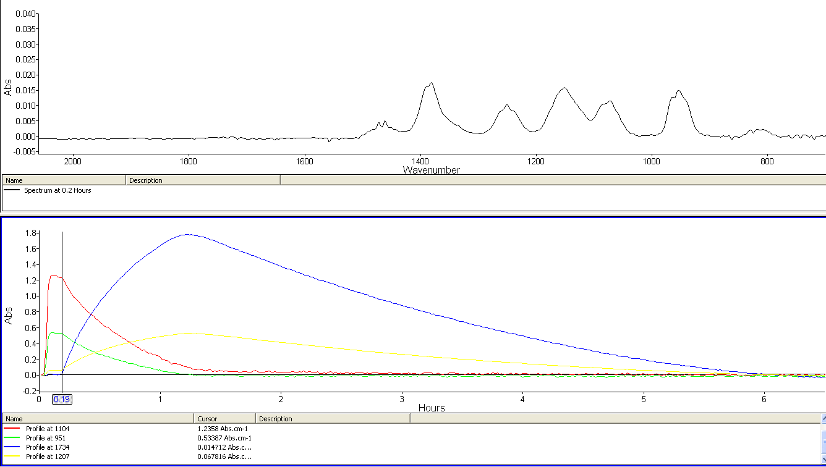
- 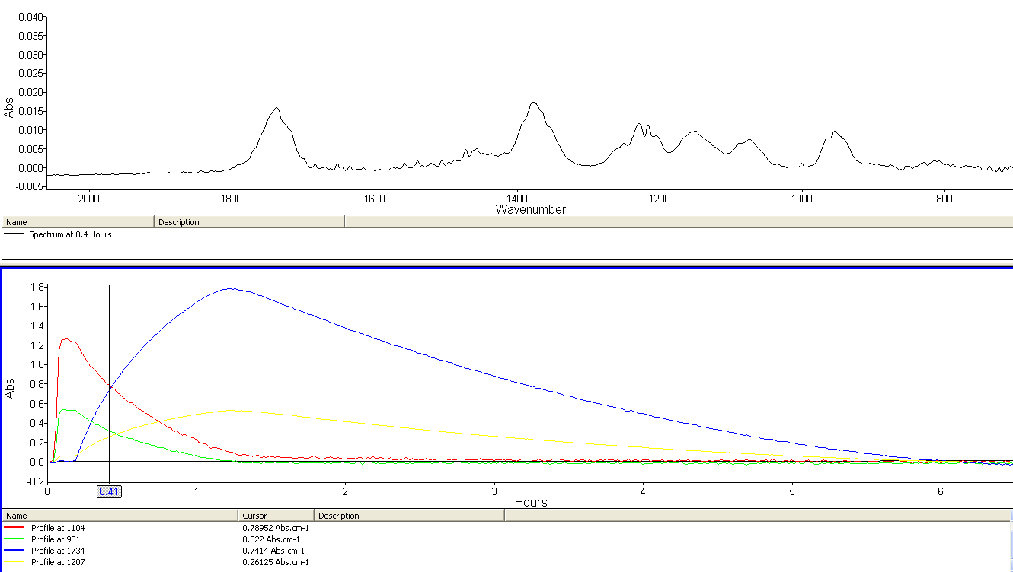
- 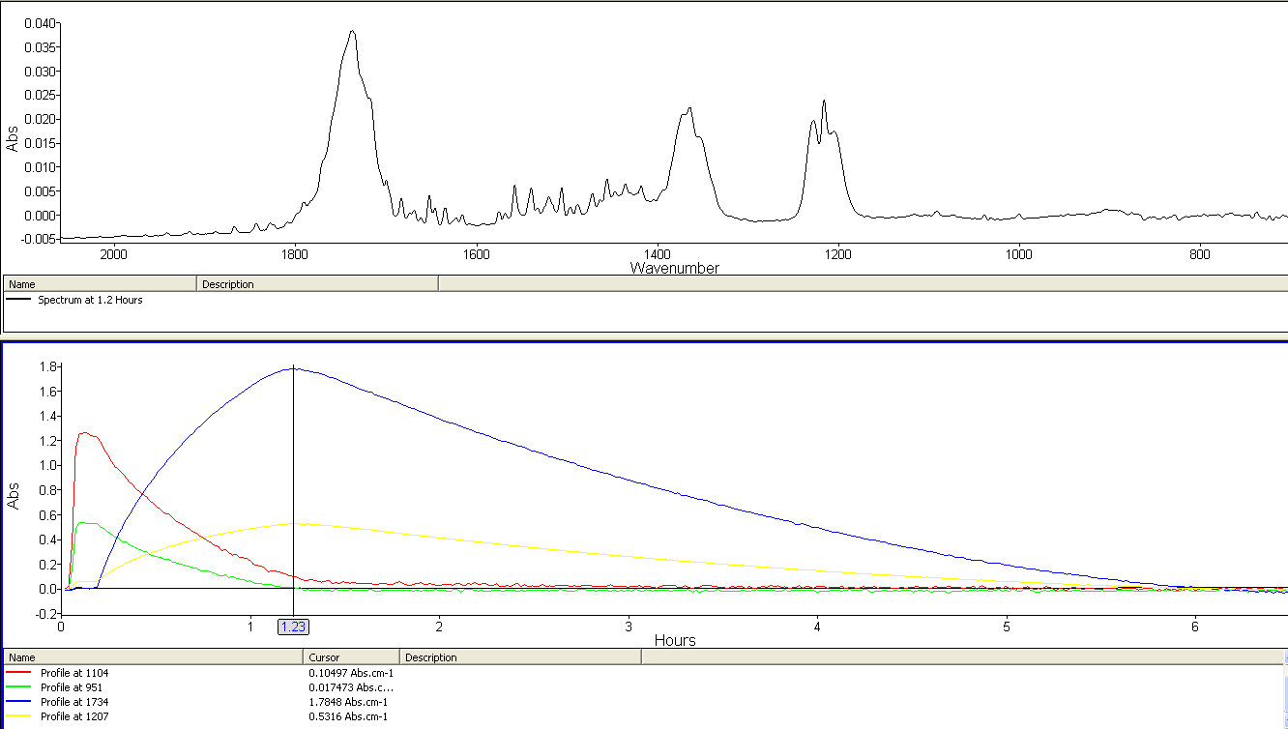
Figure S1. FTIR spetra and concentration profiles of isopropanol and acetone gained by calculated areas for characteristic peaks at three different times of reaction: (a) t = 0.19 h (light turn on), (b) t = 0.41 h and (c) t = 1.23 h.

