Metal Based Bioactive Nitrogen and Oxygen Donor Mono and Bis Schiff Bases: Design, Synthesis, Spectral Characterization, Computational Analysis and Antibacterial Screening
Sajjad Hussain Sumrra,^{1,}∗, Wardha Zafar,¹ Sabaahatul Ain Malik,¹ Khalid Mahmood,² Syed Salman Shafqat,³ Saira Arif¹
¹ Department of Chemistry, University of Gujrat, Gujrat 50700, Pakistan;
² Institute of Chemical Sciences, Bahauddin Zakariya University, Multan, Pakistan;
³ Department of Chemistry, Division of Science and Technology, University of Education, Lahore, Pakistan

Table S1. Selected bond lengths and bond angles of ligands (L¹)–(L²) and their selected transition metal complexes
Compounds | Bond lengths (Å) |  |  |  | Bond angles (°)
(L¹) | C4-N7  (1.403) | N7-C14  (1.279) | C11-O15  (1.369) | O15-H27  (0.998) | C4-N7-C14  (120.922) | H27-O15-C11  (110.172)
(L²) | C4-N14  (1.405) | N14-O24  (1.289) | C5-N13  (1.404) | N13-C15  (1.289) | C4-N14-O24  (120.951) | C5-N13-C15  (121.053)
(L²) | H42-O25  (0.993) | O25-C21  (1.336) | H37-O16  (0.995) | O16-C11  (1.340) | H42-O25-C21  (107.285) | H37-O16-C11  (107.451)
(2) | C4-N7  (1.472) | N7-C14  (1.301) | C21-N24  (1.484) | N24-C31  (1.284) | C4-N7-C14  (116.502) | C11-O15-Mn37  (109.260)
(2) | N7-Mn37  (1.901) | N24-Mn37  (1.889) | O15-Mn37  (1.820) | O32-Mn37  (1.834) | C21-N24-C31  (116.281) | C28-O32-Mn37  (112.816)
(2) | C11-O15  (1.433) | C28-O32  (1.435)
(3) | C4-N7  (1.455) | N7-C14  (1.326) | C21-N24  (1.466) | N24-C31  (1.321) | C4-N7-C14  (114.119) | C11-O15-Co37  (130.313)
(3) | N7-Co37  (1.856) | N24-Co37  (1.862) | O15-Co37  (1.784) | O32-Co37  (1.782) | C21-N24-C31  (113.050) | C28-O32-Co37  (130.154)
 | C11-O15  (1.320) | C28-O32  (1.325)
(4) | C4-N7  (1.455) | N7-C14  (1.326) | C21-N24  (1.466) | N24-C31  (1.321) | C4-N7-C14  (114.119) | C11-O15-Ni37  (130.313)
(4) | N7-Ni37  (1.836) | N24-Ni37  (1.837) | O15-Ni37  (1.785) | O32-Ni37  (1.781) | C21-N24-C31  (113.50) | C28-O32-Ni37  (130.154)
 | C11-O15  (1.320) | C28-O32  (1.325)
(7) | C6-N14  (1.424) | N14-C16  (1.318) | C5-N15  (1.425) | N15-C25  (1.319) | C6-N14-C16  (121.978) | C5-N15-C25  (121.741)
(7) | N14-V28  (2.064) | N15-V28  (2.058) | O17-V28  (1.896) | O26-V28  (1.918) | C12-O17-V28  (133.711) | C22-O26-V28  (133.479)
 | C12-O17  (1.319) | C22-O26  (1.308)
(11) | C6-N16  (1.420) | N16-C26  (1.315) | C7-N15  (1.423) | N15-C17  (1.316) | C6-N16-C26  (121.866) | C7-N15-C17  (120.231)
(11) | N15-Cu29  (1.930) | N16-Cu29  (1.922) | O27-Cu29  (1.911) | O18-Cu29  (1.918) | C23-O27-Cu29  (127.080) | C13-O18-Cu29  (113.314)
 | C13-O18  (1.311) | C23-O27  (1.302)
(12) | C6-N16  (1.413) | N16-C26  (1.304) | C7-N15  (1.430) | N15-C17  (1.321) | C6-N16-C26  (125.575) | C7-N15-C17  (117.054)
(12) | N15-Zn29  (2.190) | N16-Zn29  (2.944) | O18-Zn29  (1.903) | O27-Zn29  (1.850) | C23-O27-Zn29  (131.510) | C13-O18-Zn29  (104.134)
 | C13-O18  (1.316) | C23-O27  (1.310)
For numbering, refer Figure 1 & 2.

Table S2. NBO representative values for studied compounds
Compounds | Donor (i) | Type | Acceptor (j) | Type | E⁽²⁾ [kcal/mol] | E_{(j)}-E_{(i)} [a.u.] | F_{(I,j)}  [a.u.]
(L¹) | C₂-C₃ | π | C₁-C₆ | π* | 21.46 | 0.28 | 0.071
(L¹) | C₈-C₁₃ | π | C₉-C₁₀ | π* | 18.68 | 0.28 | 0.066
(L¹) | C₄-C₅ | π | C₁-C₆ | π* | 18.67 | 0.28 | 0.065
(L¹) | C₁₁-C₁₂ | π | N₇-C₁₄ | π* | 18.38 | 0.29 | 0.068
(L¹) | C₉-C₁₀ | π | C₈-C₁₃ | π* | 17.77 | 0.31 | 0.066
(L¹) | C₁-C₆ | π | C₂-C₃ | π* | 16.25 | 0.29 | 0.062
(L¹) | O₁₅ | LP (2) | C₁₁-C₁₂ | π* | 27.24 | 0.35 | 0.095
(L¹) | O₁₆ | LP (1) | C₁₁-C₁₂ | π* | 6.61 | 1.11 | 0.077
(L²) | C₂₁-C₂₂ | π | N₁₄-C₂₄ | π* | 21.54 | 0.27 | 0.071
(L²) | C₃-C₄ | π | C₁-C₂ | π* | 20.54 | 0.29 | 0.069
(L²) | C₅-C₆ | π | C₁-C₂ | π* | 20.54 | 0.29 | 0.069
(L²) | C₇-C₈ | π | C₉-C₁₀ | π* | 20.54 | 0.29 | 0.069
(L²) | C₁-C₂ | π | C₃-C₄ | π* | 20.09 | 0.28 | 0.067
(L²) | C₁₈-C₂₃ | π | C₁₉-C₂₀ | π* | 18.30 | 0.28 | 0.066
(L²) | C₁₉-C₂₀ | π | C₁₈-C₂₃ | π* | 17.61 | 0.30 | 0.065
(L²) | C₉-C₁₀ | π | C₇-C₈ | π* | 17.34 | 0.29 | 0.063
(L²) | C₁₂ | LP (1) | C₇-C₈ | π* | 65.17 | 0.15 | 0.105
(L²) | O₂₅ | LP (2) | C₂₁-C₂₂ | π* | 37.31 | 0.33 | 0.105
(L²) | O₂₆ | LP (2) | C₁₉-C₂₀ | π* | 29.99 | 0.34 | 0.095
(2) | C₂₉-C₃₀ | π | N₂₄-C₃₁ | π* | 18.39 | 0.22 | 0.082
(2) | C₁₂-C₁₃ | π | N₇-C₁₄ | π* | 16.39 | 0.24 | 0.081
(2) | C₈-C₉ | π | C₁₂-C₁₃ | π* | 13.63 | 0.26 | 0.078
(2) | C₂₅-C₂₆ | π | C₂₉-C₃₀ | π* | 12.51 | 0.25 | 0.074
(2) | C₅-C₆ | π | C₁-C₂ | π* | 11.00 | 0.27 | 0.071
(2) | C₂₂-C₂₃ | π | C₁₈-C₁₉ | π* | 10.49 | 0.27 | 0.069
(2) | C₁₀ | LP (1) | C₈-C₉ | π* | 39.85 | 0.15 | 0.112
(2) | C₂₇ | LP (1) | C₂₅-C₂₆ | π* | 36.81 | 0.15 | 0.109
(2) | N₃₄ | LP (1) | C₁₈-C₁₉ | π* | 22.49 | 0.26 | 0.103
(2) | N₁₇ | LP (1) | C₁-C₂ | π* | 21.67 | 0.27 | 0.102
(4) | C₂₉-C₃₀ | π | N₂₄-C₃₁ | π* | 38.68 | 0.21 | 0.082
(4) | C₂₅-C₂₆ | π | C₂₉-C₃₀ | π* | 25.28 | 0.26 | 0.074
(4) | C₂₂-C₂₃ | π | C₁₈-C₁₉ | π* | 22.32 | 0.27 | 0.072
(4) | C₂-C₃ | π | C₁-C₆ | π* | 20.26 | 0.28 | 0.070
(4) | C₄₋C₅ | π | C₁- C₆ | π* | 17.00 | 0.27 | 0.061
(4) | C₁₂ | LP (1) | N₇-C₁₄ | π* | 125.84 | 0.09 | 0.109
(4) | C₂₇ | LP (1) | C₂₅-C₂₆ | π* | 79.37 | 0.15 | 0.111
(4) | N₃₄ | LP (1) | C₁₈-C₁₉ | π* | 44.26 | 0.27 | 0.103
(4) | N₁₇ | LP (1) | C₁-C₆ | π* | 43.13 | 0.27 | 0.102
(4) | O₃₅ | LP (1) | O₃₆-H₆₂ | π* | 39.67 | 0.82 | 0.162
(4) | O₁₆ | LP (2) | C₉-C₁₀ | π* | 32.15 | 0.31 | 0.094
(7) | C₂₋C₃ | π | C₄-C₅ | π* | 10.64 | 0.26 | 0.068
(7) | C₄-C₅ | π | C₂-C₃ | π* | 9.85 | 0.29 | 0.067
(7) | C₆-C₇ | π | C₂-C₃ | π* | 9.85 | 0.29 | 0.067
(7) | C₈-C₉ | π | C₁₀-C₁₁ | π* | 9.24 | 0.28 | 0.066
(7) | C₁₉-C₂₄ | π | C₂₀-C₂₁ | π* | 8.62 | 0.28 | 0.064
(7) | C₁₀-C₁₁ | π | C₈-C₉ | π* | 8.48 | 0.29 | 0.063
(7) | C₂₃ | LP (1) | N₁₅-C₂₅ | π* | 69.47 | 0.09 | 0.114
(7) | C₁₃ | LP (1) | C₈-C₉ | π* | 27.97 | 0.15 | 0.099
(7) | O₂₇ | LP (1) | C₂₀-C₂₁ | π* | 17.53 | 0.30 | 0.096
(11) | C₂₄-C₂₅ | π | N₁₆-C₂₆ | π* | 17.72 | 0.22 | 0.079
(11) | C₆-C₇ | π | C₂-C₃ | π* | 12.02 | 0.26 | 0.073
(11) | C₃-C₄ | π | C₅-C₆ | π* | 10.35 | 0.27 | 0.067
(11) | C₅-C₆ | π | C₃-C₄ | π* | 9.93 | 0.28 | 0.067
(11) | C₇-C₈ | π | C₃-C₄ | π* | 9.77 | 0.28 | 0.067
(11) | C₂₀-C₂₁ | π | C₂₄-C₂₅ | π* | 9.63 | 0.28 | 0.067
(11) | C₂₂ | LP (1) | C₂₀-C₂₁ | π* | 41.41 | 0.15 | 0.112
(11) | C₁₄ | LP (1) | C₉-C₁₀ | π* | 30.58 | 0.15 | 0.101
(11) | O₁₈ | LP (1) | O₁-H₃₂ | π* | 13.53 | 0.85 | 0.137
(12) | C₂₀-C₂₁ | π | C₂₄-C₂₅ | π* | 23.42 | 0.27 | 0.073
(12) | C₉-C₁₀ | π | C₁₁-C₁₂ | π* | 20.45 | 0.28 | 0.069
(12) | C₄-C₅ | π | C₃-C₈ | π* | 19.93 | 0.28 | 0.067
(12) | C₃-C₈ | π | C₄-C₅ | π* | 19.26 | 0.28 | 0.066
(12) | C₆-C₇ | π | C₃-C₈ | π* | 18.61 | 0.28 | 0.066
(12) | C₁₁-C₁₂ | π | C₉-C₁₀ | π* | 14.41 | 0.30 | 0.059
(12) | C₁₄ | LP (1) | C₉-C₁₀ | π* | 64.55 | 0.15 | 0.103
(12) | O₁₉ | LP(2) | O₁-H₃₂ | π* | 21.03 | 0.75 | 0.114
(12) | O₂₈ | LP(1) | O₁-H₃₃ | π* | 12.97 | 0.91 | 0.097
(12) | O₂₇ | LP(1) | C₂₂-C₂₃ | π* | 8.98 | 0.79 | 0.076
LP, lone pair; (i) donor; (j) acceptor; E⁽²⁾, energy of hyperconjugative interaction (stabilization energy); E_{(j)}−E_{(i)}, energy difference between donor and acceptor i and j NBOs; F_{(i, j)}, Fock matrix element between i and j NBOs. For numbering, refer Figure 1 & 2.

Table S3. Mulliken atomic charges of the ligands (L¹) and its derived metal complexes
Ligand (L¹) |  | Complex (2) Mn |  | Complex (3) Co |  | Complex (3) Ni
Atoms | Mulliken charges | Atoms | Mulliken charges | Atoms | Mulliken charges | Atoms | Mulliken charges
C1 | -0.438264 | C1 | 0.064315 | C1 | 0.126955 | C1 | 0.344401
C2 | 0.237749 | C2 | -0.169711 | C2 | -0.192952 | C2 | -0.201878
C3 | 0.331103 | C3 | -0.242969 | C3 | -0.192978 | C3 | -0.195757
C4 | -0.531777 | C4 | 0.281189 | C4 | 0.143974 | C4 | 0.238158
C5 | 0.160215 | C5 | 0.164947 | C5 | -0.440259 | C5 | -0.227342
C6 | 0.094196 | C6 | -0.332523 | C6 | -0.186605 | C6 | -0.201878
N7 | 0.186478 | N7 | -0.779563 | N7 | -0.771568 | N7 | -0.797257
C8 | -0.347968 | C8 | -0.199281 | C8 | -0.193424 | C8 | -0.197004
C9 | 0.537168 | C9 | -0.213028 | C9 | -0.221629 | C9 | -0.216325
C10 | -0.411899 | C10 | 0.193537 | C10 | 0.288559 | C10 | 0.309321
C11 | -1.366736 | C11 | 0.212465 | C11 | 0.058828 | C11 | 0.354686
C12 | 1.614357 | C12 | -0.050459 | C12 | -0.040252 | C12 | -0.112120
C13 | 0.007502 | C13 | -0.203271 | C13 | -0.199352 | C13 | -0.192556
C14 | -0.328817 | C14 | 0.106413 | C14 | 0.170582 | C14 | 0.132859
O15 | 0.064092 | O15 | -0.564869 | O15 | -0.540451 | O15 | -0.670127
O16 | -0.164842 | O16 | -0.615742 | O16 | -0.562035 | O16 | -0.535553
N17 | 0.180835 | N17 | -0.705557 | N17 | -0.724469 | N17 | -0.831520
C18 | 0.176608 | C18 | 0.163802 | C18 | 0.135231 | C18 | 0.339706
H19 | 0.156937 | C19 | -0.183704 | C19 | -0.174371 | C19 | -0.200903
H20 | 0.175640 | C20 | -0.226089 | C20 | -0.230270 | C20 | -0.204662
H21 | 0.168101 | C21 | 0.194568 | C21 | 0.221960 | C21 | 0.114655
H22 | 0.152642 | C22 | -0.136273 | C22 | -0.079829 | C22 | -0.187020
H23 | 0.179052 | C23 | -0.126361 | C23 | -0.139214 | C23 | -0.210324
H24 | 0.160481 | N24 | -0.859054 | N24 | -0.869243 | N24 | -0.776410
H25 | 0.172133 | C25 | -0.192175 | C25 | -0.194903 | C25 | -0.203501
H26 | 0.038723 | C26 | -0.229623 | C26 | -0.227224 | C26 | -0.187551
H27 | 0.268936 | C27 | 0.190118 | C27 | 0.238138 | C27 | 0.289734
H28 | 0.239774 | C28 | 0.113878 | C28 | 0.061636 | C28 | 0.372376
H29 | 0.240679 | C29 | -0.143008 | C29 | -0.078937 | C29 | -0.109002
H30 | 0.183971 | C30 | -0.209574 | C30 | -0.205995 | C30 | -0.184455
H31 | 0.152924 | C31 | 0.114960 | C31 | 0.124388 | C31 | 0.179057
H32 | 0.150928 | O32 | -0.555584 | O32 | -0.606252 | O32 | -0.672327
- | - | O33 | -0.458136 | O33 | -0.564026 | O33 | -0.536877
- | - | N34 | -0.747656 | N34 | -0.732844 | N34 | -0.833463
- | - | O35 | -0.644013 | O35 | -0.650201 | O35 | -0.633057
- | - | O36 | -0.672922 | O36 | -0.652958 | O36 | -0.654785
- | - | Mn37 | 1.316301 | Co37 | 1.215756 | Ni37 | 0.841975
- | - | C38 | -0.516371 | C38 | -0.410000 | C38 | -0.331141
- | - | C39 | -0.371908 | C39 | -0.405793 | C39 | -0.364295
- | - | H40 | 0.194582 | H40 | 0.184504 | H40 | 0.166229
- | - | H41 | 0.194340 | H41 | 0.197788 | H41 | 0.184745
- | - | H42 | 0.191456 | H42 | 0.265362 | H42 | 0.226063
- | - | H43 | 0.299256 | H43 | 0.259000 | H43 | 0.179583
- | - | H44 | 0.181820 | H44 | 0.189090 | H44 | 0.182826
- | - | H45 | 0.185570 | H45 | 0.195644 | H45 | 0.189834
- | - | H46 | 0.179951 | H46 | 0.185979 | H46 | 0.179987
- | - | H47 | 0.204741 | H47 | 0.220843 | H47 | 0.224716
- | - | H48 | 0.265103 | H48 | 0.271897 | H48 | 0.308209
- | - | H49 | 0.282045 | H49 | 0.279606 | H49 | 0.303507
- | - | H50 | 0.178793 | H50 | 0.182066 | H50 | 0.176795
- | - | H51 | 0.180297 | H51 | 0.189647 | H51 | 0.218277
- | - | H52 | 0.228523 | H52 | 0.044091 | H52 | 0.245310
- | - | H53 | 0.229099 | H53 | 0.208704 | H53 | 0.165349
- | - | H54 | 0.182963 | H54 | 0.183172 | H54 | 0.180694
- | - | H55 | 0.185383 | H55 | 0.187777 | H55 | 0.198843
- | - | H56 | 0.177957 | H56 | 0.177280 | H56 | 0.179834
- | - | H57 | 0.202747 | H57 | 0.212796 | H57 | 0.227465
- | - | H58 | 0.260451 | H58 | 0.265897 | H58 | 0.304669
- | - | H59 | 0.275424 | H59 | 0.273115 | H59 | 0.307157
- | - | H60 | 0.425426 | H60 | 0.404229 | H60 | 0.410458
- | - | H61 | 0.397468 | H61 | 0.471905 | H61 | 0.363712
- | - | H62 | 0.463241 | H62 | 0.460495 | H62 | 0.385078
- | - | H63 | 0.372363 | H63 | 0.403657 | H63 | 0.218952
- | - | H64 | 0.291560 | H64 | 0.228195 | H64 | 0.199798
- | - | H65 | 0.269375 | H65 | 0.237896 | H65 | 0.195103
- | - | H66 | 0.230840 | H66 | 0.216873 | H66 | 0.199676
- | - | H67 | 0.400247 | H67 | 0.353249 | H67 | 0.259013
- | - | H68 | 0.358705 | H68 | 0.514272 | H68 | 0.178332
- | - | H69 | -0.256794 | H69 | 0.236998 | H69 | 0.391950
For numbering, refer Figure 1.

Table S4. Mulliken atomic charges of the ligands (L¹) and its derived metal complexes
Ligand (L²) |  | Complex (7) VO |  | Complex (11) Cu |  | Complex (12) Zn
Atoms | Mulliken charges | Atoms | Mulliken charges | Atoms | Mulliken charges | Atoms | Mulliken charges
C1 | -0.384762 | O1 | -0.385889 | O1 | -0.693630 | O1 | -0.676179
C2 | -0.345917 | C2 | -0.185286 | O2 | -0.663155 | O2 | -0.649970
C3 | -0.085307 | C3 | -0.184802 | C3 | -0.187138 | C3 | -0.187146
C4 | 0.179172 | C4 | -0.175362 | C4 | -0.187062 | C4 | -0.190895
C5 | 0.172610 | C5 | 0.271505 | C5 | -0.175439 | C5 | -0.175752
C6 | -0.106059 | C6 | 0.271081 | C6 | 0.278671 | C6 | 0.250380
C7 | -0.891949 | C7 | -0.174164 | C7 | 0.266311 | C7 | 0.251462
C8 | -0.463891 | C8 | -0.199162 | C8 | -0.179327 | C8 | -0.184778
C9 | 0.256400 | C9 | -0.193891 | C9 | -0.190564 | C9 | -0.185955
C10 | -0.850716 | C10 | -0.191038 | C10 | -0.203998 | C10 | -0.204200
C11 | 0.053660 | C11 | 0.330459 | C11 | -0.188731 | C11 | -0.187600
C12 | 1.042382 | C12 | 0.375811 | C12 | 0.271874 | C12 | 0.251680
N13 | 0.138807 | C13 | -0.095362 | C13 | 0.402578 | C13 | 0.311150
N14 | 0.130977 | N14 | -0.816907 | C14 | -0.104566 | C14 | -0.100944
C15 | -0.147560 | N15 | -0.820413 | N15 | -0.813645 | N15 | -0.679258
O16 | -0.315088 | C16 | 0.220650 | N16 | -0.821872 | N16 | -0.719682
O17 | -0.158984 | O17 | -0.657462 | C17 | 0.203640 | C17 | 0.148640
C18 | -0.563050 | O18 | -0.558949 | O18 | -0.681330 | O18 | -0.608317
C19 | 0.089288 | C19 | -0.191656 | O19 | -0.534107 | O19 | -0.534269
C20 | -0.414420 | C20 | -0.213913 | C20 | -0.199057 | C20 | -0.198530
C21 | -0.522791 | C21 | 0.325991 | C21 | -0.210449 | C21 | -0.213825
C22 | 1.118751 | C22 | 0.389643 | C22 | 0.293256 | C22 | 0.294822
C23 | -0.660681 | C23 | -0.092521 | C23 | 0.384320 | C23 | 0.386564
C24 | -0.190862 | C24 | -0.197397 | C24 | -0.100795 | C24 | -0.105704
O25 | -0.298117 | C25 | 0.219725 | C25 | -0.191672 | C25 | -0.191036
O26 | -0.164576 | O26 | -0.640492 | C26 | 0.212615 | C26 | 0.183686
C27 | -0.288592 | O27 | -0.529478 | O27 | -0.643967 | O27 | -0.654470
C28 | -0.288445 | V28 | 1.123309 | O28 | -0.547770 | O28 | -0.546446
H29 | 0.173012 | C29 | -0.359063 | Cu29 | 0.823119 | Zn29 | 0.657534
H30 | 0.171688 | C30 | -0.332561 | C30 | -0.381569 | C30 | -0.371536
H31 | 0.160591 | H31 | 0.199737 | C31 | -0.333033 | C31 | -0.329963
H32 | 0.162837 | H32 | 0.199568 | H32 | 0.395594 | H32 | 0.388855
H33 | 0.141854 | H33 | 0.198807 | H33 | 0.365600 | H33 | 0.394333
H34 | 0.166344 | H34 | 0.199540 | H34 | 0.364677 | H34 | 0.378272
H35 | 0.199556 | H35 | 0.178704 | H35 | 0.401272 | H35 | 0.427205
H36 | 0.146059 | H36 | 0.187393 | H36 | 0.194678 | H36 | 0.193608
H37 | 0.547356 | H37 | 0.207079 | H37 | 0.194601 | H37 | 0.192645
H38 | 0.170071 | H38 | 0.220376 | H38 | 0.194934 | H38 | 0.192443
H39 | 0.177627 | H39 | 0.187345 | H39 | 0.194474 | H39 | 0.200094
H40 | 0.137099 | H40 | 0.196048 | H40 | 0.176331 | H40 | 0.179441
H41 | 0.134100 | H41 | 0.179421 | H41 | 0.181815 | H41 | 0.183025
H42 | 0.559486 | H42 | 0.219704 | H42 | 0.200879 | H42 | 0.201097
H43 | 0.151257 | H43 | 0.192658 | H43 | 0.209249 | H43 | 0.200586
H44 | 0.157822 | H44 | 0.269296 | H44 | 0.181652 | H44 | 0.178261
H45 | 0.124280 | H45 | 0.211955 | H45 | 0.190715 | H45 | 0.187393
H46 | 0.181654 | H46 | 0.225624 | H46 | 0.176061 | H46 | 0.174032
H47 | 0.149643 | H47 | 0.196868 | H47 | 0.209452 | H47 | 0.204357
H48 | 0.147386 | H48 | 0.197470 | H48 | 0.198658 | H48 | 0.202032
- | - | - | - | H49 | 0.186709 | H49 | 0.196677
- | - | - | - | H50 | 0.245962 | H50 | 0.258921
- | - | - | - | H51 | 0.227107 | H51 | 0.217917
- | - | - | - | H52 | 0.203007 | H52 | 0.205655
- | - | - | - | H53 | 0.203067 | H53 | 0.203688
For numbering, refer Figure 2.

Table S5. Excitation energies, wavelengths, oscillator strengths and major contributions of ligands (L¹)-(L²) and their derived metal complexes
Comp. | No. | Excitation Energy (E^{DFT}) (cm⁻¹) | Calculated Wavelength (nm) | Oscillator Strength  (f ^{DFT}) | Major  Contributions (%) | Minor  Contributions (%)
(L¹) | 1 | 26289 | 380 | 0.5119 | H→L (95) | H-4→L (2)
(L¹) | 2 | 28992 | 344 | 0.0287 | H-1→L (96)
(L¹) | 3 | 34412 | 290 | 0.0292 | H-3→L (22), H→L+1 (73)
(L²) | 1 | 25240 | 396 | 0.0912 | H→L (94) | H-1→L (3)
(L²) | 2 | 26635 | 375 | 0.0865 | H-1→L (93) | H→L (3)
(L²) | 3 | 28089 | 356 | 0.1735 | H-2→L (91) | H-4→L (4)
(2) | 1 | 7792 | 683 | 0.0004 | H→L (93) | H→L+1 (6)
(2) | 2 | 9296 | 476 | 0.0038 | H→L+1 (61), H→L+2 (14) | H→L (5), H→L+3 (2), H→L+7,  H-1→L+6 (2), H→L (2), H→L+1 (3)
(2) | 3 | 10575 | 346 | 0.0001 | H→L+1 (31), H→L+2 (24) | H→L+3 (4), H→L+6 (4), H→L+7 (5),  H-1→L, H-1→L+6 (3), H→L (8), H→L+1 (6), H→L+3 (4), H→L+6 (2)
(3) | 1 | 3170 | 755 | 0.0012 | H→L (10), H→L (69) | H→L (6), H→L+1 (2),  H-2→L (3),  H-2→L+2 (2), H-2→L+4 (2), H-2→L+5 (4)
(3) | 2 | 3644 | 344 | 0.0002 | H→L (30),  H-1→L (47), H→L (11) | H→L+1 (9),  H-2→L (3), H→L+1 (2)
(4) | 1 | 11135 | 698 | 0.0012 | H-6→L+2 (10), H→L (11), H→L+2 (64) | H-1→L+2 (3)
(4) | 2 | 15291 | 454 | 0.0021 | H-3→L+2 (10), H-2→L+2 (35), H→L (17), H→L+1 (12) | H-5→L+2 (8), H-4→L+2 (6)
(4) | 3 | 16406 | 410 | 0.0032 | H-4→L+2 (20), H-3→L+2 (37), H-2→L+2 (10), H→L (12) | H-6→L+2 (4), H-3→L (2), H→L+1 (2)
(7) | 1 | 14131 | 707 | 0.0005 | H→L (10), H→L+1 (54), H→L+5 (10) | H→L+2 (8), H→L+4 (2), H→L+6 (7)
(7) | 2 | 14754 | 677 | 0.0001 | H→L (75) | H→L+1 (8), H→L+3 (2), H→L+10 (2), H→L+1 (2)
(7) | 3 | 15519 | 644 | 0.0 | H-1→L (32), H-1→L+1 (11), H→L (30), H→L+1 (11) | H-2→L+1 (6), H-1→L+1 (5)
(11) | 1 | 9016 | 709 | 0.0001 | H→L+2 (55) | H-5→L+2 (4), H-4→L+2 (5), H-3→L+2 (4), H-2→L+2 (7), H→L+1(5), H→L+4 (5), H→L+6 (2)
(11) | 2 | 10990 | 509 | 0.0001 | H-4→L+2 (11),  H-3→L+2 (26),  H-1→L+2 (31) | H-10→L+2 (2), H-6→L+2 (3), H-3→L+4 (3), H-1→L+1 (3), H-1→L+4 (3)
(11) | 3 | 13224 | 356 | 0.0005 | H-4→L+2 (26), H-2→L+2 (33) | H-7→L+2 (8), H-4→L+4 (3), H-3→L+2 (7), H-2→L+1 (2), H-2→L+4 (4)
(12) | 1 | 19031 | 525 | 0.0401 | H→L (92) | H-1→L (5)
(12) | 2 | 21568 | 463 | 0.0417 | H-1→L (77), H→L+1 (13) | H-2→L (3), H→L (6)
(12) | 3 | 22733 | 439 | 0.1117 | H-1→L (10), H→L+1 (82) | H-2→L (3)
H = HOMO, H-1 = HOMO-1, H-2 = HOMO-2, H-3 = HOMO-3, H-4 = HOMO-4, H-4 = HOMO-6, H-6 = HOMO-7, H-10 = HOMO-10, L = LUMO, L+1 = LUMO+1, L+2 = LUMO+2, L+3 = LUMO+3, L+4 = LUMO+4, L+6 = LUMO+6.

Table S6. Theoretical IR frequencies and vibrational assignments for ligand (L¹)
Mode | Frequency | Scaled f | Infrared | Vibrational Assignments
45 | 1021.76 | 995.40 | 0.3583 | ρC-H_{Aromatic}
46 | 1078.48 | 1050.65 | 2.8880 | ρC-H_{Aromatic} + vasNH₂
47 | 1089.09 | 1060.99 | 85.6596 | vsO-CH₃
48 | 1103.62 | 1075.15 | 32.9454 | δC-H_{Aromatic}
49 | 1148.75 | 1119.11 | 11.1702 | ρC-H_{Aromatic} + δC-H_{Aromatic} + vasNH₂
50 | 1169.00 | 1138.84 | 0.7753 | ρCH₃
51 | 1182.65 | 1152.14 | 51.7197 | ρC-H_{Aromatic} + δC-H_{Aromatic}
52 | 1188.20 | 1157.54 | 23.3209 | ρC-H_{Aromatic} + δC-H_{Aromatic}
53 | 1205.01 | 1173.92 | 1.4394 | vasCH₃
54 | 1215.72 | 1184.35 | 112.8788 | vsC-H_{Aromatic} + O-H
55 | 1245.61 | 1213.47 | 112.1740 | vsC-H_{Aromatic} + ρC-H_{Aromatic} + O-H + C-N
56 | 1257.70 | 1225.25 | 237.1578 | vsCH₃ + ρC-H_{Aromatic} + O-H
57 | 1287.85 | 1254.62 | 127.5949 | ρC-H_{Aromatic} + δC-H_{Azomethine}
58 | 1302.07 | 1268.48 | 155.4823 | ρC-H_{Aromatic} + vs NH₂
59 | 1316.39 | 1282.43 | 33.7932 | ρC-H_{Aromatic} + O-H
60 | 1317.96 | 1283.95 | 19.7276 | ρC-H_{Aromatic} + C-H_{Azomethine} + O-H
61 | 1351.76 | 1316.88 | 6.3488 | ρC-H_{Aromatic} + vasNH₂
62 | 1372.70 | 1337.29 | 54.6319 | vsC-H_{Aromatic} + C-H_{Azomethine} + O-H
63 | 1426.35 | 1389.55 | 17.7947 | vsC-H_{Aromatic} + C-H_{Azomethine} + O-H
64 | 1467.11 | 1429.26 | 1.9611 | ρC-H_{Aromatic} + δC-H_{Aromatic} + vasNH₂
65 | 1475.06 | 1437.00 | 26.8701 | vsCH₃
66 | 1487.84 | 1449.45 | 116.1429 | ρC-H_{Aromatic} + δC-H_{Aromatic} + vsCH₃ + C-H_{Azomethine}
67 | 1492.97 | 1454.45 | 8.7527 | δCH₃ + vasCH₃
68 | 1505.16 | 1466.32 | 23.0707 | ρC-H_{Aromatic} + δCH₃
69 | 1512.94 | 1473.91 | 77.7278 | ρC-H_{Aromatic} + C-H_{Azomethine} + O-H + vsCH₃
70 | 1537.19 | 1497.53 | 128.4698 | ρC-H_{Aromatic}
71 | 1605.14 | 1563.73 | 4.8060 | ρC-H_{Aromatic} + vasNH₂ + ρC=C
72 | 1612.91 | 1571.30 | 52.5592 | vsC=C + vsC=N + O-H
73 | 1632.32 | 1590.21 | 44.5323 | δNH₂ + vsC=N + O-H
74 | 1650.12 | 1607.54 | 6.0937 | δC-H_{Aromatic} + δNH₂ + O-H
75 | 1660.83 | 1617.98 | 84.0682 | vsC=N + δC-H_{Azomethine} + δNH₂
76 | 1675.02 | 1631.80 | 213.0667 | vsC=N + δC-H_{Azomethine}+ δNH₂
77 | 2961.00 | 2884.61 | 62.1592 | vsC-H_{Azomethine}
78 | 3001.37 | 2923.93 | 70.5017 | vsCH₃
79 | 3058.81 | 2979.89 | 38.8707 | vasCH₃
80 | 3133.73 | 3052.88 | 23.8758 | vasCH₃
81 | 3154.08 | 3072.70 | 21.6444 | vasC-H_{Aromatic}
82 | 3157.89 | 3076.42 | 23.8359 | vasC-H_{Aromatic}
83 | 3176.99 | 3095.03 | 9.5265 | vasC-H_{Aromatic}
84 | 3177.70 | 3095.71 | 7.1491 | vsC-H_{Aromatic}
85 | 3189.29 | 3107.01 | 5.8250 | vasC-H_{Aromatic}
86 | 3205.36 | 3122.66 | 1.7586 | vasC-H_{Aromatic}
87 | 3209.25 | 3126.45 | 9.6869 | vsC-H_{Aromatic}
88 | 3570.84 | 3478.71 | 43.1890 | vsNH₂
89 | 3669.34 | 3574.67 | 17.5488 | vasNH₂
90 | 3843.92 | 3744.75 | 55.8553 | vsO-H

Table S7. Theoretical IR frequencies and vibrational assignments for ligand (L²)
Mode | Frequency | Sclaed f | Infrared | Vibrational Assignments
70 | 1064.20 | 1036.74 | 19.5570 | ρC-H_{Aromatic} + δC-H_{Aromatic} + vsCH₃
71 | 1068.34 | 1040.78 | 11.2933 | ρC-H_{Aromatic} + δC-H_{Aromatic}
72 | 1104.89 | 1076.39 | 42.8977 | ρC-H_{Aromatic}
73 | 1105.37 | 1076.86 | 11.6542 | ρC- H_{Aromatic} H_{Aromatic} + δC-
74 | 1123.70 | 1094.71 | 21.2793 | ρC-H_{Aromatic} + δC-H_{Aromatic}
75 | 1128.71 | 1099.59 | 33.4504 | ρC-H_{Aromatic} + δC-H_{Aromatic}
76 | 1167.98 | 1137.84 | 2.7840 | vasCH₃
77 | 1168.04 | 1137.90 | 2.6150 | vasCH₃
78 | 1183.18 | 1152.65 | 1.8072 | ρC-H_{Aromatic} + δC-H_{Aromatic} + vsCH₃
79 | 1184.03 | 1153.49 | 1.1506 | ρC-H_{Aromatic} + δC-H_{Aromatic}
80 | 1191.73 | 1160.99 | 2.7519 | ρC-H_{Aromatic} + δC-H_{Aromatic} + vasCH₃
81 | 1206.98 | 1175.84 | 34.0118 | ρC-H_{Aromatic} + δC-H_{Aromatic} + vsCH₃
82 | 1211.57 | 1180.31 | 2.3647 | ρC-H_{Aromatic} + δC-H_{Aromatic} + vsCH₃
83 | 1215.91 | 1184.54 | 48.9962 | δC-H_{Aromatic} + vsCH₃
84 | 1228.10 | 1196.41 | 133.6195 | ρC-H_{Aromatic} + δC-H_{Aromatic} + vsC-N
85 | 1252.08 | 1219.78 | 18.3768 | δC-H_{Aromatic} + vsC-H_{Aliphatic}
86 | 1259.78 | 1227.28 | 37.5317 | δC-H_{Aromatic} + vsC-H_{Aliphatic} + vsC-N
87 | 1279.66 | 1246.65 | 120.2562 | δC-H_{Aromatic} + δCH₃+ vsO-H
88 | 1283.38 | 1250.27 | 408.6671 | δC-H_{Aromatic} + δCH₃+ δC-H_{Aliphatic}
89 | 1303.71 | 1270.08 | 46.8645 | δC-H_{Aromatic} + vsO-H + vsC-H_{Aliphatic}
90 | 1305.74 | 1272.05 | 4.9065 | δC-H_{Aromatic}
91 | 1314.61 | 1280.69 | 67.5455 | δC-H_{Aromatic} + vsO-H + vsC-C_{Aromatic}
92 | 1318.92 | 1284.89 | 12.5865 | δC-H_{Aromatic} + δC-H_{Aliphatic} + vsO-H + vsC-C_{Aromatic}
93 | 1342.91 | 1308.27 | 20.4169 | δC-H_{Aromatic} + δC-H_{Aliphatic} + vsO-H + vasC-C_{Aromatic}
94 | 1370.62 | 1335.26 | 18.3037 | δC-H_{Aliphatic} + δC-H_{Aromatic} + vsO-H + vasC-C_{Aromatic}
95 | 1396.37 | 1360.35 | 28.2183 | δC-H_{Aromatic} + vsC-H_{Aliphatic}
96 | 1398.54 | 1362.46 | 48.5629 | vsC-H_{Aliphatic}
97 | 1447.67 | 1410.32 | 19.7014 | vsO-H + vsCH₃+ δC-H_{Aromatic}
98 | 1453.45 | 1415.95 | 29.7322 | vasC-C_{Aromatic} + vsO-H + ρC-H_{Aromatic} + δCH₃
99 | 1469.88 | 1431.96 | 104.7175 | ρC-H_{Aromatic} + vasC-C_{Aromatic} + vsO-H + vasCH₃
100 | 1472.60 | 1434.61 | 17.4149 | ρC-H_{Aromatic} + vasC-C_{Aromatic}
101 | 1474.79 | 1436.74 | 60.7019 | ρC-H_{Aromatic} + vasC-C_{Aromatic} + δCH₃
102 | 1480.86 | 1442.65 | 60.2777 | δCH₃ + vsO-H
103 | 1488.86 | 1450.45 | 21.3195 | vasCH₃
104 | 1491.69 | 1453.21 | 237.0785 | δCH₃+ vasC-C_{Aromatic} + vsO-H
105 | 1492.28 | 1453.78 | 19.6067 | vasCH₃
106 | 1503.91 | 1465.11 | 9.9040 | vasCH₃ + ρC-H_{Aromatic}
107 | 1505.32 | 1466.48 | 8.3780 | vasCH₃ + ρC-H_{Aromatic}
108 | 1511.05 | 1472.07 | 11.8408 | ρCH₃
109 | 1524.44 | 1485.11 | 36.4991 | ρO-H + vsC=N + ρC-H_{Aromatic} + vasC-C_{Aromatic}
110 | 1528.43 | 1489.00 | 32.2542 | δO-H + ρC-H_{Aromatic} + vasC-C_{Aromatic}+ vsC=N
111 | 1602.91 | 1561.55 | 10.8713 | δO-H + vsC=N + δC-H_{Aromatic} + vasC-C_{Aromatic}
112 | 1608.97 | 1567.46 | 195.3216 | ρO-H + δC-H_{Aromatic} + vsC=N + vasC-C_{Aromatic}
113 | 1616.59 | 1574.88 | 26.8274 | ρO-H + δC-H_{Aromatic} + vasC-C_{Aromatic}
114 | 1620.29 | 1578.48 | 19.2900 | ρO-H + ρC-H_{Aromatic} + vasC-C_{Aromatic}
115 | 1651.83 | 1609.21 | 131.4926 | ρO-H + δC-H_{Aromatic} + vsC-C_{Aromatic}
116 | 1655.73 | 1613.01 | 251.7248 | ρO-H + δC-H_{Aromatic} + vsC=N + vsC-C_{Aromatic}
117 | 1659.74 | 1616.92 | 204.8257 | vsO-H + δC-H_{Aromatic} + δC-N + vasC-C_{Aromatic}
118 | 1662.05 | 1619.17 | 93.5343 | vsO-H + δC-H_{Aromatic} + vsC=N + vsC-C_{Aromatic}
119 | 3000.33 | 2922.92 | 70.9593 | vsCH₃
120 | 3017.46 | 2939.61 | 60.1252 | vsCH₃
121 | 3035.07 | 2956.76 | 26.9821 | vsC-H_{Aliphatic}
122 | 3035.30 | 2956.99 | 52.9995 | vsC-H_{Aliphatic}
123 | 3057.52 | 2978.64 | 37.0316 | vasCH₃
124 | 3102.39 | 3022.35 | 24.9496 | vasCH₃
125 | 3134.43 | 3053.56 | 18.3443 | vasCH₃
126 | 3137.44 | 3056.50 | 19.3871 | vasCH₃
127 | 3164.15 | 3082.51 | 10.8631 | vasC-H_{Aromatic}
128 | 3166.54 | 3084.84 | 3.2133 | vasC-H_{Aromatic}
129 | 3167.41 | 3085.69 | 4.2054 | vasC-H_{Aromatic}
130 | 3174.38 | 3092.48 | 460.3616 | vsO-H + vasC-H_{Aromatic}
131 | 3175.74 | 3093.81 | 21.3322 | vsO-H + vasC-H_{Aromatic}
132 | 3181.53 | 3099.45 | 14.2120 | vsO-H + vasC-H_{Aromatic}
133 | 3184.21 | 3102.05 | 14.9020 | vasC-H_{Aromatic}
134 | 3187.75 | 3105.51 | 16.0082 | vasC-H_{Aromatic}
135 | 3193.79 | 3111.39 | 27.2350 | vsC-H_{Aromatic}
136 | 3195.99 | 3113.54 | 10.5647 | vsC-H_{Aromatic}
137 | 3206.00 | 3123.29 | 376.4482 | sO-H + vasC-H_{Aromatic}
138 | 3208.58 | 3125.80 | 159.3166 | sO-H + vasC-H_{Aromatic}

Equations for Chemical Reactivity Parameters
The Koopman’s theorem illustrates the ionization potential by the negative value for HOMO, whereas the electron affinity by the negative value for LUMO [1].
IP = –E_{HOMO} EA = –E_{LUMO} Equation S1
Global reactivity parameters like the chemical hardness (ղ), chemical potential (μ), electro negativity (X) electrophilicity index (ɷ) and chemical softness (S) can be calculated using the energies of HOMO and LUMO orbitals [2] by the equations;
$$X=\frac{\left[IP+EA\right]}{2}=-\frac{\left[E_{LUMO}+E_{HOMO}\right]}{2}$$ |  | Equation S2
$$η=\frac{\left[IP-EA\right]}{2}=-\frac{\left[E_{LUMO}-E_{HOMO}\right]}{2}$$ |  | Equation S3
$$μ=\frac{E_{HOMO}{+E}_{LUMO}}{2}$$ |  | Equation S4
The global softness ($σ$) is defined by Equation 6 [3]
$$σ=\frac{1}{2η}$$ |  | Equation S5
 | Parr et al. introduced an electrophilicity index ($ω$) as described in following equation.
 | $$ω=\frac{μ^{2}}{2η}$$ | Equation S6

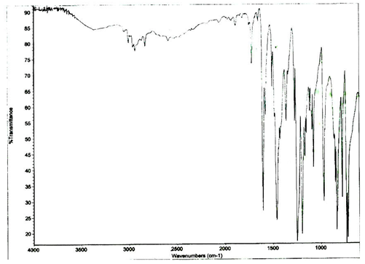
Figure S1. FT-IR spectrum of the ligand (L¹)

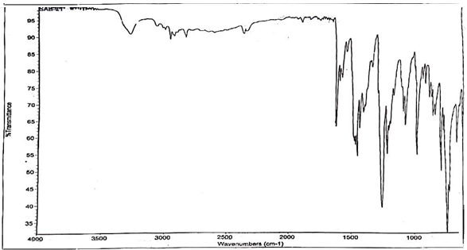
Figure S2. FT-IR spectrum of the ligand (L²)
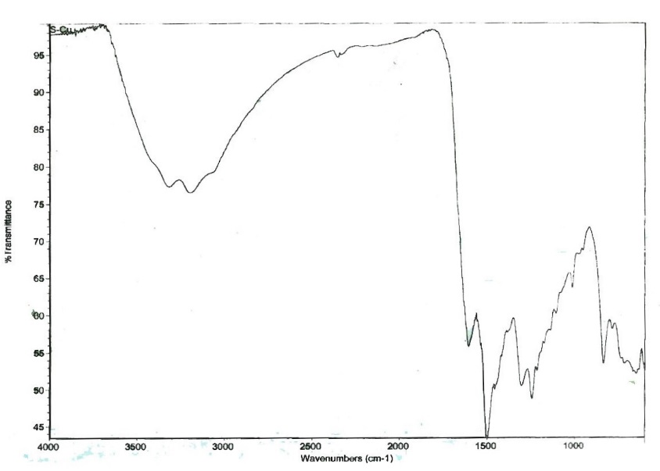
Figure S3. FT-IR spectrum of the Cu(II) complex (5)

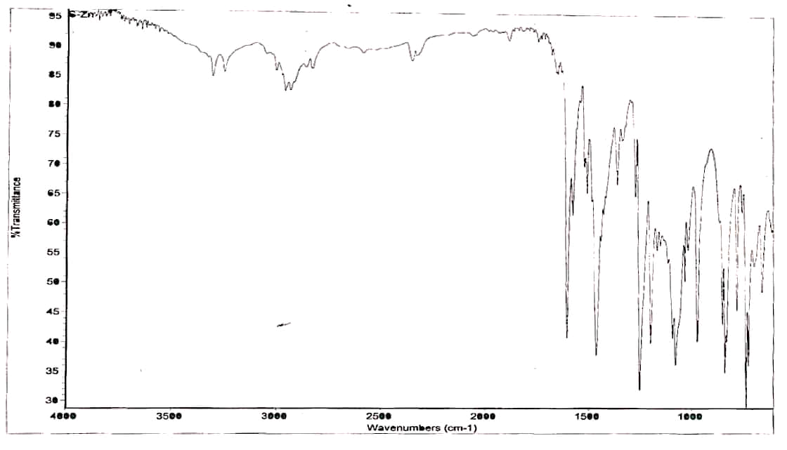
Figure S4. FT-IR spectrum of the Zn(II) complex (6)
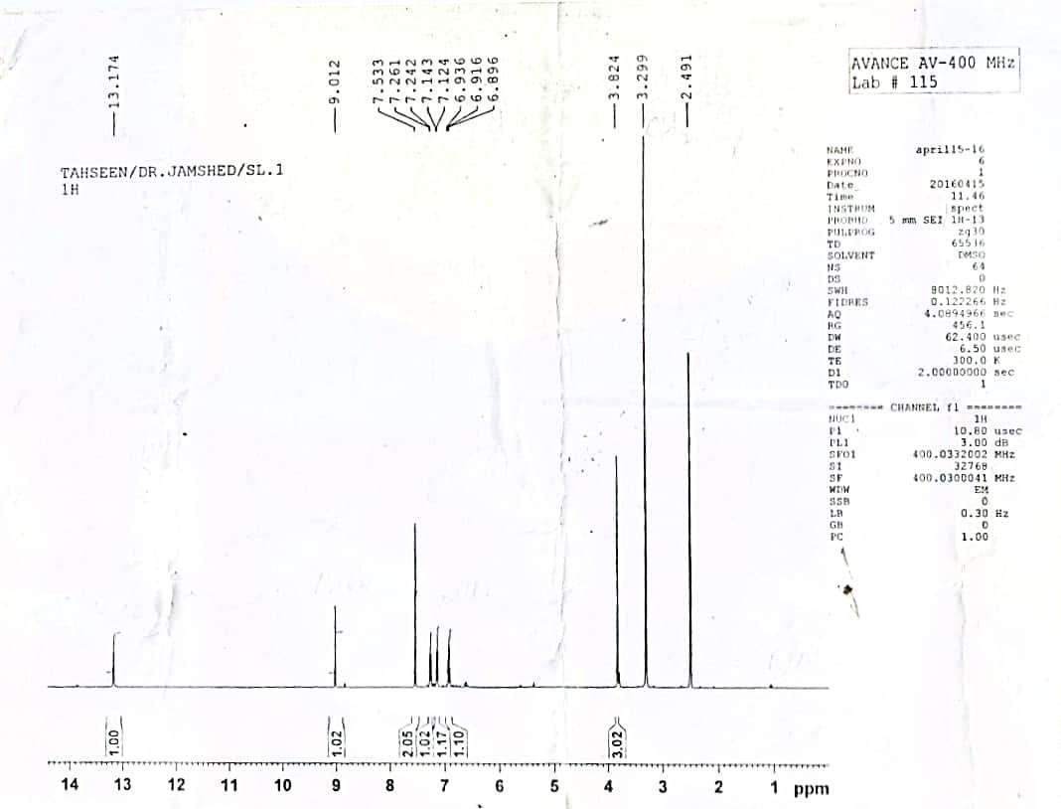
Figure S5. ¹H-NMR spectrum of the ligand (L¹)

Figure S6. ¹H-NMR spectrum of the ligand (L²)
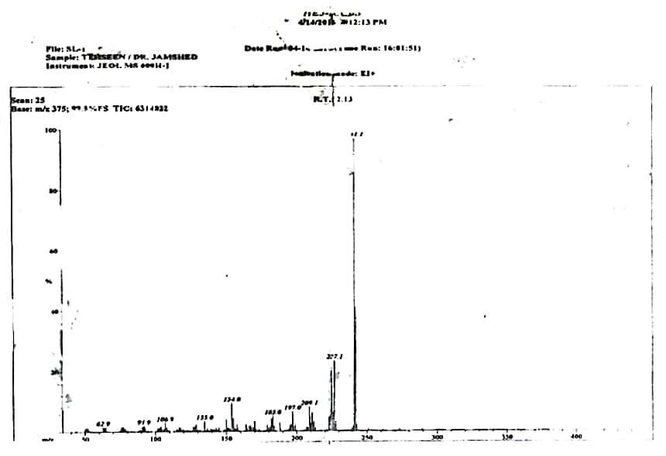
Figure S7. Mass spectrum of the ligand (L¹)
Figure S8. Mass spectrum of the ligand (L²)
Figure S9. Computed UV-Vis spectra of studied compounds

References
- V. Siva, S. S. Kumar, A. Shameem, M. Raja, S. Athimoolam, S. A. Bahadur, J. Mater. Sci. Mater. Electron. 2017, 28, 12484–12496. Doi: 10.1007/s10854-017-7070-8
- R. Vijayaraj, V. Subramanian, P. K. Chattaraj, J. Chem. Theory Comput. 2009, 5, 2744–2753. DOI: 10.1021/ct900347f
- P. K. Chattaraj, D. R. Roy, Chem. Rev. 2007, 107, PR46–PR74. Doi: 10.1021/cr078014b

*Corresponding author: E-mail: sajjadchemist@gmail.com/sajjadchemist@uog.edu.pk

