Figure legends

Fig. 1. (a) A conceptual schematic diagram of Continuous EO experimental setup, (b) Actual Experimental setup of continuous EO process: (1) RTB21 Wastewater Reservoir, (2) Peristaltic Pump, (3) DC Power Supply, (4) Electrochemical Cell, (5) Graphite Electrodes, and (6) Receiving cell

Fig. 2. Optimized architecture of ANN network for EO process.

Fig. 3. Effect of HRT (min) on Colour removal efficiency (%) and COD removal efficiency (%) at 7 pH, 200 A/m² CD, and 2 g/L NaCl concentration.

Fig. 4. Performance of ANN for colour removal efficiency

Fig. 5. Error histogram with 20 bins for the training, validation, and testing of ANN for colour removal efficiency prediction.

Fig. 6. ANN predictions of colour removal efficiency vs experimental data.

Fig. 7. Performance of ANN for COD removal efficiency.

Fig. 8. Error histogram with 20 bins for the training, validation and testing of ANN for COD removal efficiency prediction.

Fig. 9. ANN predictions of colour removal efficiency vs experimental data.

Fig. 10. Conceptual model of ANN-MOGA.

Fig. 11. Pareto front of solutions obtained from multi-objective optimization of colour removal efficiency and COD removal efficiency.

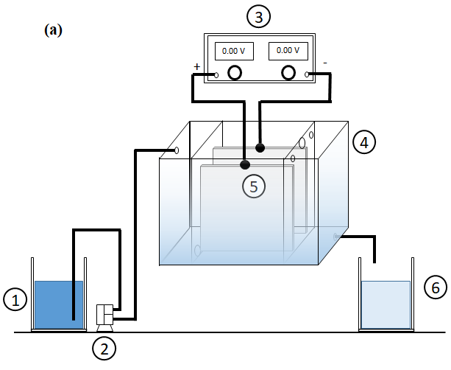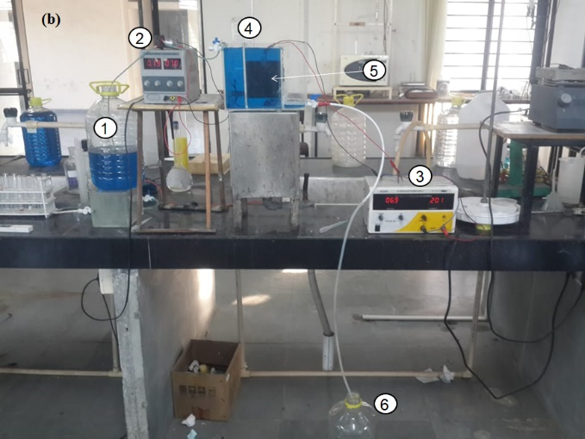

Fig. 1

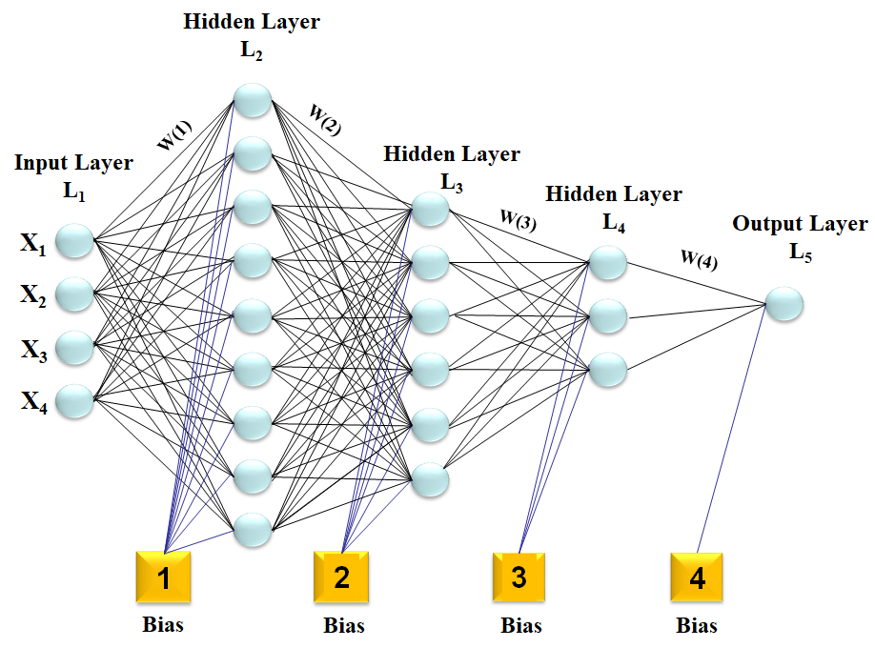

Fig. 2

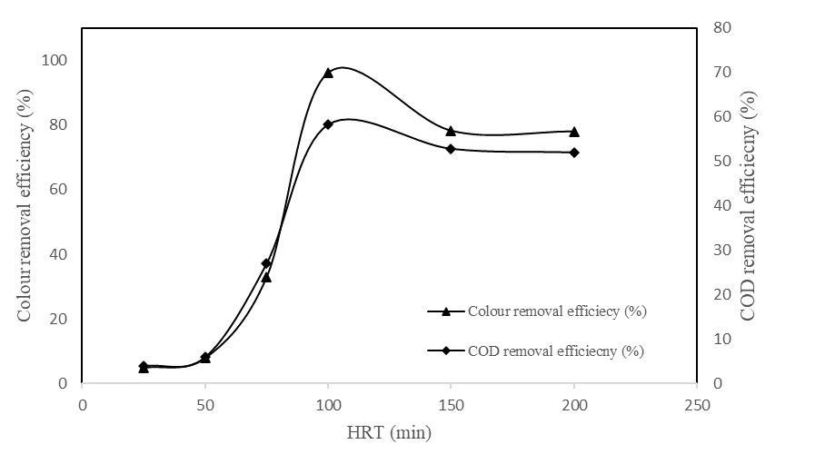

Fig. 3

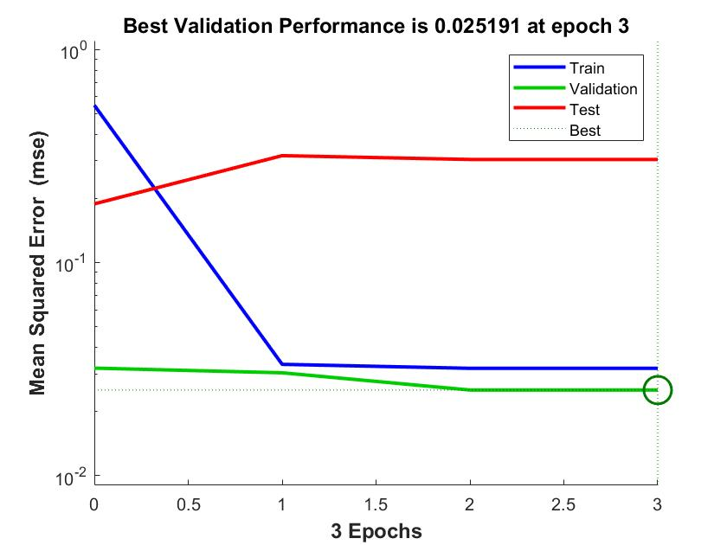

Fig. 4.

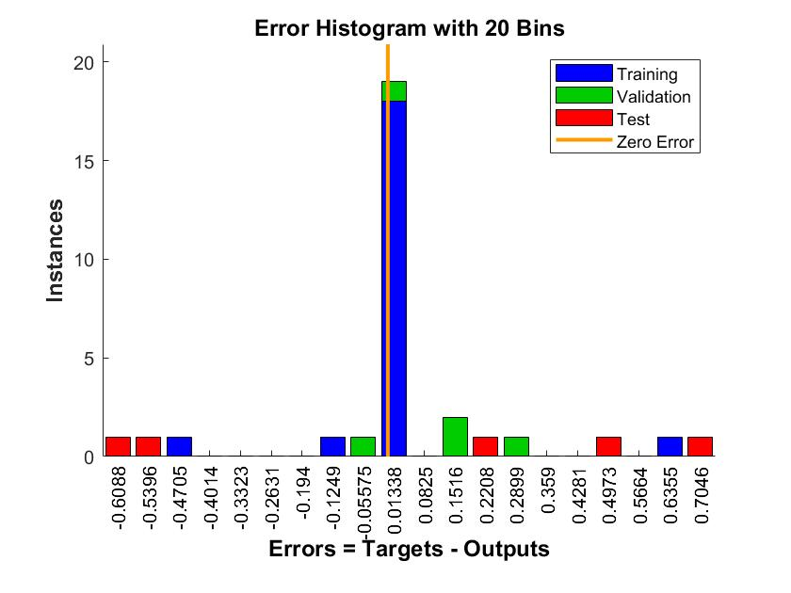

Fig. 5

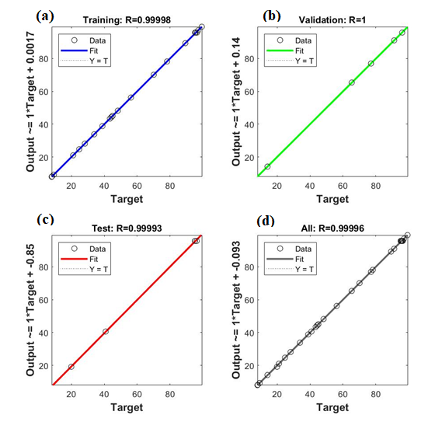

Fig. 6

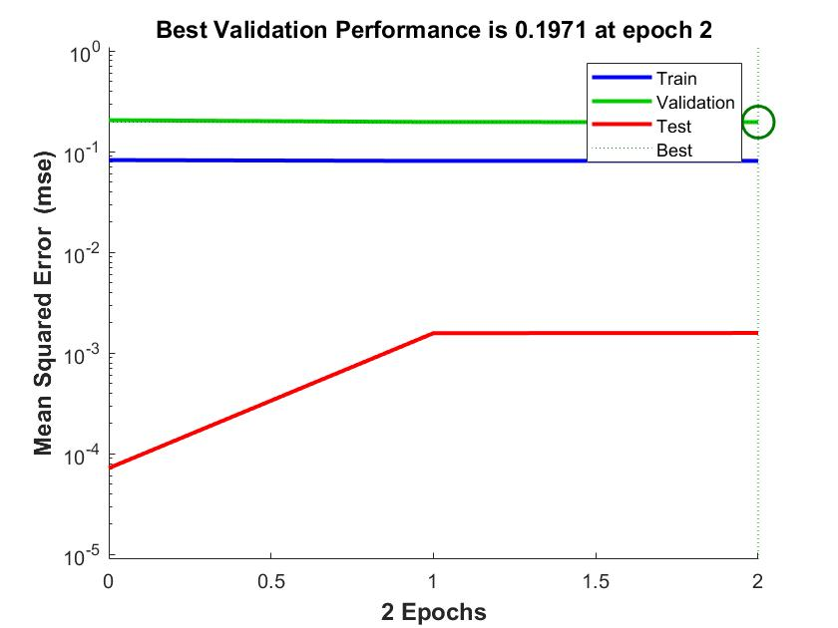

Fig. 7

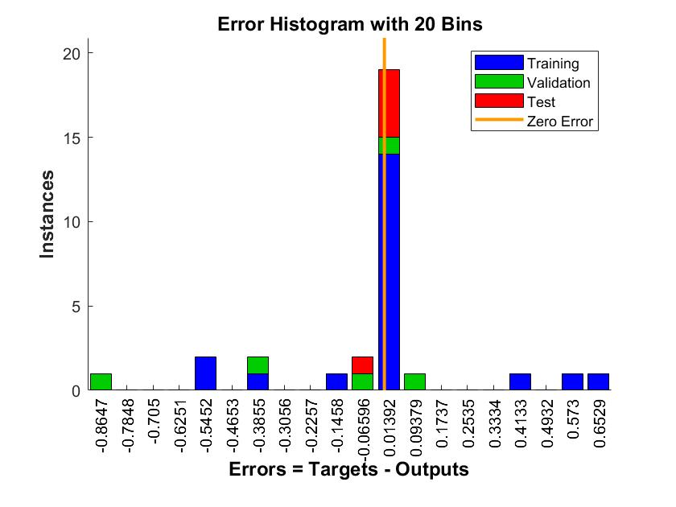

Fig. 8

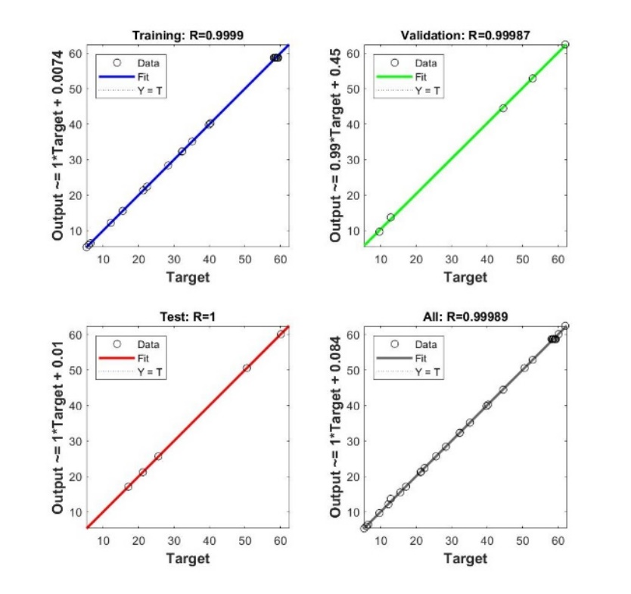

Fig. 9

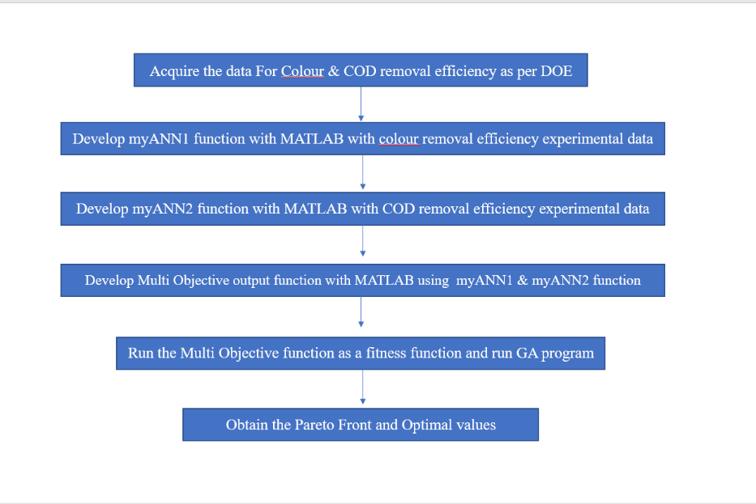

Fig. 10

Fig. 11

