The effect of Polyvinylpyrrolidone on the morphology of cerium carbonate crystals was studied by first principles
Deyun SUN ^{1,2,3}，Yanhong HU ^{1,2,3,*}，Mao TANG ^{1,2,3},Ze HU ^{1,2,3}，Peng LIU^{1,2,3}，
Zhaogang LIU ^{1,2,3}，Jinxiu WU^{1,2,3}
(1. College of Materials and Metallurgy, Inner Mongolia University of Science and Technology, Baotou 014010, China;
2.Key Laboratory of Rare Earth Hydrometallurgy and Light Rare Earth Application in Inner Mongolia Autonomous Region, Baotou 014010, China;
3.Key Laboratory of Green Extraction and Efficient Utilization of Light Rare Earth Resources, Ministry of Education, Baotou 014010, China;）
Abstract: The mechanism of controlling the morphology of cerium carbonate hydrate crystal by polyvinylpyrrolidone (PVP) can be divided into nucleation and growth. At the nucleation stage, the bonding changes of atoms in the system before and after the addition of precipitant ${CO }_{3}^{2-}$are calculated. It is found that the ketone group in PVP would preferentially combine with Ce³⁺ to form a complexes and provide a heterogeneous nucleation sites for the system. During the growth stage, by studying the energy change between the easily exposed crystal faces and the adsorption energy between PVP, determine the relative growth rate between the crystal planes, to simulate the process of crystal growth. It is found that when there is no PVP adsorption on the crystal surface, the surface energies of (120), (010) and (001) crystal faces are very different. When PVP is added to simulate adsorption, the order of adsorption energies is (120) > (010) > (001), and there is only 2eV error between (010) and (001) crystal faces. It is indicated that the growth of (120) crystal face is most impeded due to the adsorption of PVP during the growth of heterogeneous nucleation point, so that the probability of (120) crystal face is the largest under the equilibrium state, and finally the morphology of hexagonal flake cerium carbonate crystal with (120) crystal face as hypotenuse is formed.
Keywords: Cerium carbonate hydrate; First principles; Crystal growth; Density functional theory; Morphology control
1 Introduction
Using polymers as self-assembly templates to control the physical properties of materials provides a new idea for the artificial synthesis of crystal materials and bio-intelligent materials with special functions. The growth environment of crystals is complex, and its growth is not only controlled by thermodynamics, but also affected by factors such as kinetics and defect structure. The kinetic influence is mainly determined by the activation energy of nucleation, growth and phase transition. It is a multi-step reaction process. Each step may have a great impact on the final morphology of the crystal, making it difficult to predict correctly in theory. Utilizing the electrical properties of the polymer's carbon chain and functional groups, and the selective adsorption of the exposed crystal planes, the surface energy of the corresponding crystal planes can be changed, so that the activity of the crystal planes can be increased or decreased, so that the growth can be controlled, and finally the result will be changed crystal morphology. ¹⁻⁵ The adsorption energy and electronic structure of polymer on different crystal planes were calculated to find the most easily adsorbed crystal plane. The crystal morphology was simulated and predicted according to the crystal nucleation theory.⁶⁻¹⁰ With the help of molecular dynamics, Liu Ning et al. used molecular dynamics to study the crystal growth morphology of FOX-X crystals in H₂O/N, N-dimethylformamide, and found that (011), (10 -1) and (101) three crystal planes are the main growth planes of the crystal, and the final growth is a long prism shape. ¹¹⁻¹² Wu Donghai et al. used first-principles research methods to study the crystal structure of calcite CaCO₃ by constructing a crystal surface slab model for surface relaxation. The results show that the (0001) crystal plane has a higher surface energy, a smaller Fermi energy level (NEF) and charge density than the (1010) crystal plane, which makes the (0001) crystal plane grow slower. Showing the most stable surface properties.¹³ Balbuena Cristian et al. used molecular dynamics methods to study the synthesis of silver nanoparticles with polyvinylpyrrolidone as a capping agent, analyzed the nucleation of atomic groups and the subsequent growth of nanoparticle formation, and found the process of crystal formation follow Ostwald's law of phase transition and determine the transformation process of silver nanoparticle morphology.¹⁴ Li Erxiao and others by using molecular dynamics method, through the experiment and the method of computer simulation, the combination of polymer PVP in cerium carbonate was studied on the main directions of adsorption state, to verify that the PVP regulation of cerium carbonate crystal morphology, the study found that PVP is mainly adsorption in cerium carbonate crystal (010), (001) and (120) Planes, the three crystal, Before the addition of precipitant, PVP mainly complexed with PVP, and after the addition of precipitant, PVP reduced its crystal surface energy by adsorption on crystal face and finally exposed crystal face.¹⁵ In this paper, first-principles research methods were used to simulate the interaction mechanism between PVP and Ce³⁺ and H₂O molecules in aqueous solution before adding precipitant, and the adsorption process of PVP on the main crystal plane after adding precipitant. By analyzing its electronic structure and energy changes under different conditions, without the aid of experimental data, explain the transformation in the morphology of cerium carbonate crystals under the control of polymer PVP from an atomic point of view.¹⁶⁻²⁰
2 Computing Method
In this paper, the Vienna ab initio simulation package VASP code was used to perform DFT (density functional theory) calculations using the GGA (generalized gradient approximation) method,²¹⁻²⁶ and the LOBSTERsoftware package involving chemical bond analysis was used to study the nucleation and growth of cerium carbonate crystals with and without precipitators.^{27.28} Because Ce exists in the ionic state of +3 valence in the cerium carbonate crystal, there is only one electron in the 4f orbital, and along with the extreme shrinkage of the orbital radial distribution, it shows Similar to semi-core characteristics, so it does not participate in bond formation. ^{[28]} In view of the above situation, in the selection of the calculation method, the simplified pseudopotential that uses the f orbital electron of Ce as the inner electron, the other elements use the ordinary pseudopotential, and the PBEsol functional is used in the selection.²⁸ Other related calculation parameters are as follows: the energy of the plane wave truncation energy ENCUT is 350eV, and the K point in the Brillouin region is the Gamma point of grid a×K=20. The evaluation of the total energy convergence is based on 10⁻⁷eV /atom, which is interatomic. Therefore, in the simulation, In the constructed slab model, the convergence standard of adding force based on the density of 1g/cm³ is 0.05eV/$Å$. Considering that the atoms at the top and bottom layers of the crystal face of the cerium carbonate crystal are not the same, the crystal face dipole correction is introduced to correct the above problem.
During static calculation, the system before precipitation was an aqueous solution system of CeCl₃ and polymer PVP. In the constructed slab model, add 2 Ce, 6 Cl, 20 H₂O, 3 polymerized PVP polymer molecules according to the density of 1$g/{cm}^{3}$ to make them randomly distributed in the slab model. According to the above convergence criteria, the whole slab model was optimized, the COHP (crystal orbital Hamiltonian population) and ICOHP (integral of COHP) were calculated, and the interaction mechanism between PVP and other elements in the system was studied.^{29.30} In order to simulate the mechanism of PVP regulating cerium carbonate crystal after adding precipitant, the crystal structure of cerium carbonate derived from the ICSD (Inorganic Crystal Database) crystal library is shown in Figure 1. Three crystal planes (010), (001) and (120) which are easy to be exposed were selected. According to the atomic ratios of the cerium carbonate crystal, the crystal plane layer thickness of 9.3546Å, 9.037Å and 7.989Å was cut, respectively. And we put those atomic layers on the bottom to create a slab with a top vacuum layer 13Å thick. According to different thickness, the bottom of each crystal face is fixed in proportion to 60%, the rest is released, (001) crystal face is fixed from the bottom of 0-9.4Å thickness atoms; (010) The atoms of 0-5.4Å thickness are fixed from the bottom of the crystal plane; The atoms with the thickness of 0-4.8Å are fixed from the bottom of the crystal plane, and the whole slab configuration is optimized according to the above convergence criteria to meet the relevant convergence requirements.
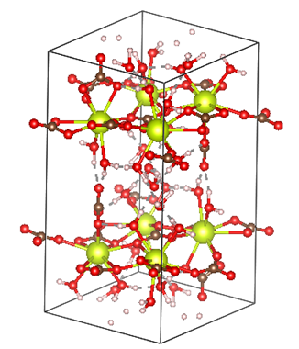
Figure 1 Ce₂(CO₃)₃ crystal structure diagram, in which the yellow ball represents the Ce element, and each Ce element is surrounded by 4 carbonate ions and 4 water molecules
In the AIMD（Ab Initio Molecular Dynamics） simulation, the nucleation and growth of ${Ce}_{2}{(CO_{3})}_{3}$ in solution synthesis is analyzed through molecular dynamics simulations. With this aim, a collection of ${Ce}^{3+}$、$CO_{3}^{2-}$ and $H_{2}O$ homogeneously distributed in the simulation box is used as the initial configuration. The temperature and density are controlled to 300 K and 1g/cm³, respectively, for all the simulations in the NVT ensembles, where these values are representative of the synthesis conditions in experiments. We analyze the temporal evolution of the system integrating the equations of motion of all the particles through an NVT ensemble at 300 K and 1 g/cm³, for a total time of 1500 ps. Periodic boundary conditions in three dimensions are applied in all the simulations.
In the optimization of the PVP molecule, considering the DFT calculation resources and the electronic structure analysis of the crystal surface, only the PVP polymer monomer (Figure 2) is used for structural optimization, and then the adsorption relationship with the crystal surface and the subsequent electronic structure analysis are studied.
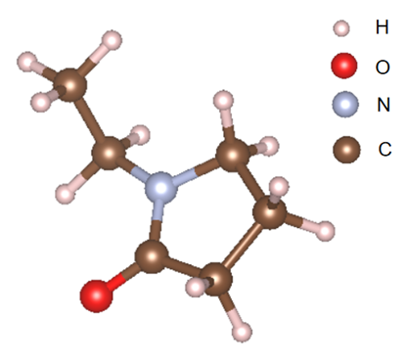
Figure 2 Schematic diagram of PVP monomer molecule
3 Results and Discussion
3.1 Mechanism study
3.1.1 The interaction mechanism of PVP in the system before precipitation
In the constructed slab model of PVP before precipitation, the results before and after optimization are shown in Figure 3. The relative comparison between the two shows that PVP, H₂O molecules and Cl⁻ in the system will gradually gather around Ce³⁺, in which the ketone group in PVP, O in H₂O molecules and Cl⁻ will interact around the center Ce³⁺. And there's a tendency to bond, and there's a hydrogen bond between the H atom in the water molecule and the ketone group in the PVP. As the atoms move to the position where the force is the least, the atoms in the entire system will aggregate toward the Ce³⁺ position to form the corresponding complex. Table 1 shows the ICOHP (Integrated COHP) and bond lengths between the main bonding atoms in the system. The analysis found that the stability of the chemical bond formed between PVP—Ce³⁺ is stronger than that of PVP—H₂O, between H₂O—H₂O. This shows that the bonding effect between Ce³⁺ and PVP is the greatest, so when no precipitation agent is added, the PVP molecules in the system will preferentially complex with Ce³⁺ to form a more stable complex.
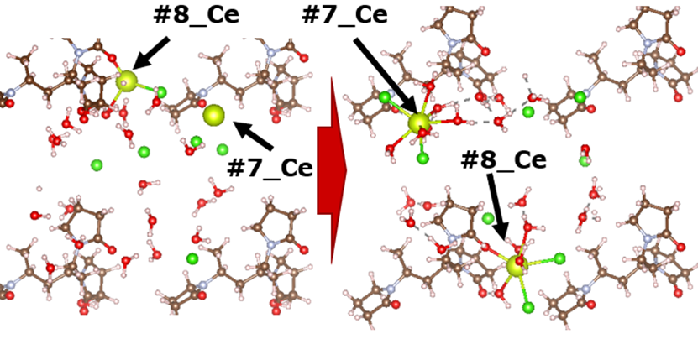
Figure 3 Optimization diagram of each atom in the system before precipitation
Table 1 The bond length and ICOHP value between each atom after the optimization before precipitation is completed
atomNU | atomNU | distance(Å) | -ICOHP(eV)
O in PVP | Ce³⁺ | 2.38 | -3.57
O in PVP | H₂O | 1.65 | -1.17
H₂O | H₂O | 1.86 | -0.90
3.1.2 Analysis of crystal plane easily exposed without polymer PVP
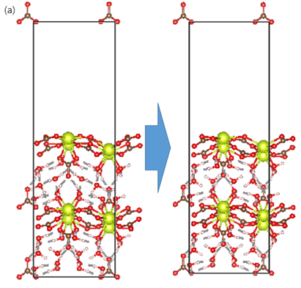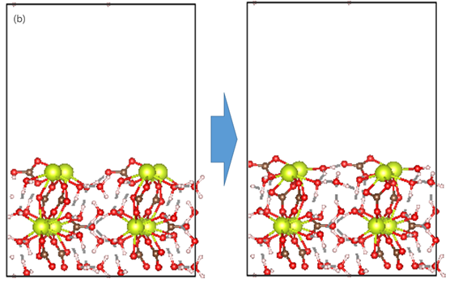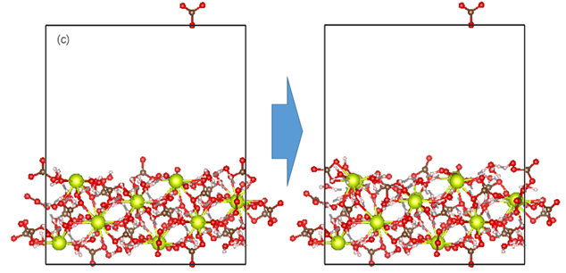
Figure 4 (a) cerium carbonate crystal (001) crystal plane before and after optimization, (b) cerium carbonate crystal (010) crystal plane before and after optimization, (c) cerium carbonate crystal (120) crystal plane before and after optimization
According to the research results of Li Erxiao and others,¹⁵ select the crystal planes that are easy to show in the PVP adsorption cerium carbonate crystal, and the (001), (010), (120) crystal planes before and after the optimization of each crystal plane cut out are shown in Figure 4. It is found that after the optimization of these three crystal planes, the reconstruction of the crystal planes has occurred, and the bonding distance between the surface layer atoms and the bottom layer atoms has slightly increased. This is because the top of the constructed surface is in a vacuum layer. The surface atoms are only subject to the interaction between themselves and the bottom atoms, resulting in different forces from the internal atoms.
The formula for calculating the surface energy of crystal plane is shown in Formula 1. ^{[31]} Where$σ$ is the surface energy of the crystal, $E^{rel}$ is the relaxation energy, indicates the energy released when the crystal plane is optimized to a stable state. $E_{surf}$ is the energy of the slab configuration after optimization, $N_{atoms}$ is the number of atoms in the slab configuration, $E_{bulk}$ is the energy of a single atom in the bluck structure, Represents the ratio of the energy of the unit cell to the number of atoms in the unit cell after optimization. The calculated results of (001) 、(010) and (120) crystal planes are shown in Table 2, the surface energy of the (120) crystal plane was the lowest, 9.48J/m², and its growth rate was the slowest; the (001) crystal plane had the highest energy, 17.1 J/m², and its growth rate was the fastest, and it is easy to reveal the order of growth speed between crystal planes is (001) > (010) > (120).
$σ=（1/2（E_{surf}-N_{atoms}*E_{bulk}）+E^{rel}）/A$ (Formula 1)
Table 2 Relative crystal plane parameters of crystal planes that are easy to show when PVP is not added
planes | E^{rel}(meV) | N_{atoms} | E_{surf}(eV) | E_{bulk}(eV) | A(Å²) | $σ$(J/m²)
001 | 2.19 | 152 | -766.41 | -6.11 | 77.23 | 17.1
010 | 3.94 | 152 | -748.27 | -6.11 | 133.29 | 11.1
120 | 1.36 | 304 | -1514.18 | -6.11 | 301.35 | 9.48

3.1.3Analysis of crystal planes easily revealed after adding polymer PVP
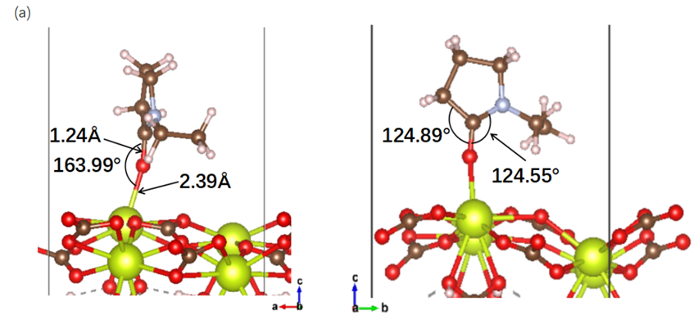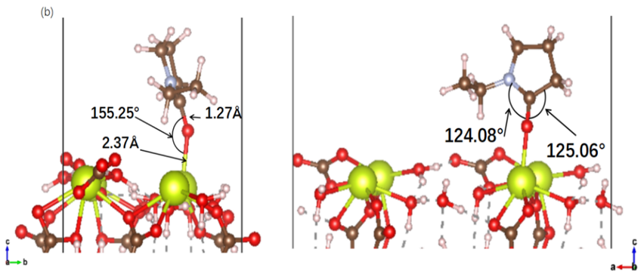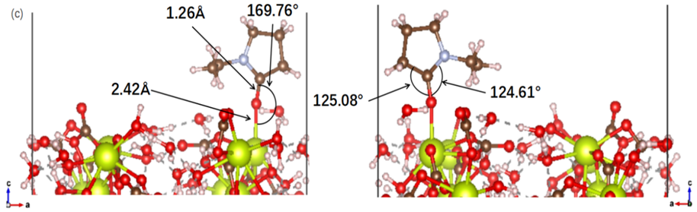
Figure 5 (a) The best adsorption structure of PVP monomer on the surface of stoichiometric cerium carbonate (001), showing two side views in the plane model, (b) the best PVP monomer on the surface of stoichiometric cerium carbonate (010) Adsorption structure, showing two side views in the plane model, (c) the best adsorption structure of PVP monomer on the surface of stoichiometric cerium carbonate (120), showing two side views in the plane model
Figure 5 shows the adsorption structure diagram of the PVP monomer on the (001), (010), (120) crystal planes of cerium carbonate crystals after calculation by DFT. In terms of bond length, the O contained in the ketone group in the PVP monomer and the (010) crystal plane exposed to the Ce³⁺ formed Ce-O bonds bond length is the smallest, 2.37 Å, and the longest bond length formed by (120) crystal plane, 2.42Å。The Ce-O bonds after adsorption is shorter than the Ce-O bonds in the cerium carbonate crystal. From the analysis of the C-O bonds length inside the PVP monomer, it is found that, except for the (001) crystal plane adsorption which causes the C-O bonds bond length to remain unchanged, the (010) and (120) crystal plane adsorption will cause the C-O bonds bond length to be elongated. From the analysis of the Ce-O-C bonds angle formed by the adsorption of Ce³⁺ from the PVP monomer ketone group, it is found that the bond angle formed by the adsorption of the (010) crystal plane is the smallest, 155.25°, and the bond angle formed by the adsorption of the (120) crystal plane is the largest, 169.76 °. From the analysis of the bond angles of O-C-N bonds and O-C-C bonds formed inside the PVP monomer after adsorption, it is found that both the bond angle of O-C-N bonds and the bond angle of O-C-C bonds after adsorption are smaller than the corresponding bond angle before adsorption， because the Ce-O bonds formed by the ketone group and Ce³⁺ in the PVP monomer has a certain interaction with the C and N connected to the O inside the PVP monomer after adsorption, which makes the bond angle generally smaller.
The adsorption energy of the molecules adsorbed on the crystal surface calculation is shown in formula 2,³¹ where $E_{bind}$ is the adsorption energy of PVP adsorbs the cerium carbonate crystal face, $E_{tot}$ is the total energy of the system after PVP adsorbs the cerium carbonate crystal face, and $E_{solv}$ is the single point energy of the PVP monomer. $E_{surf}$ is the total energy of the cerium carbonate crystal face system without adsorption of PVP monomer. The crystal planes calculated according to Formula 2 are shown in Table 3. The adsorption energy of each crystal plane is analyzed. When the adsorption energy is positive, additional absorption energy is required for the occurrence of adsorption, and when the adsorption energy is negative, the energy is released. Based on the definition of adsorption can be found that no matter which crystal and the adsorption of PVP monomer can negative. It shows that the PVP monomer needs to release energy after adsorbing (001), (010), (120) crystal planes, compare the size of the adsorption can be found (120) crystal plane can maximum adsorption, (001), (010) crystal plane of adsorption can only about 2eV energy difference between, the indicates that PVP molecules are more likely to adsorb (120) crystal planes during the growth of cerium carbonate crystals, and inhibit the growth of crystal planes so that they can eventually be exposed.
(Formula 2)
Table 3 After adding PVP, PVP monomer and easy to show surface adsorption related energy parameter table
planes | E_{tot}(eV) | E_{solv}(eV) | E_{surf}(eV) | E_{bind}(eV)
001 | -1023.43 | -110.31 | -768.60 | -144.51
010 | -1008.87 | -110.31 | -752.21 | -146.34
120 | -1930.42 | -110.31 | -1527.74 | -292.37

3.1.4 Electronic structure analysis of the growth mechanism of cerium carbonate crystals regulated by PVP
In order to further study the interaction mechanism between PVP and cerium carbonate crystal surface, the COHP value of PVP monomer adsorption on different crystal faces was calculated, and its electronic structure was analyzed. When cerium ions are exposed on the crystal surface, the central cerium ion loses two water molecular ligands along the +b axis, which reduces the original 10-ligand structure (Figure 6a) to an 8-ligand structure (Figure 6b), and appears the phenomenon of coordination unsaturation has a greater tendency to be adsorbed by the polar element O in the system.
The COHP of each crystal plane adsorbed by PVP is shown in Figure 7，the COHP value of each crystal plane adsorbed by PVP monomer is analyzed. It is found that the three crystal planes (001), (010), and (120) have basically the same bonding conditions after adsorption of the PVP monomer, only when the (100) crystal surface is adsorbed, a negative peak of -COHP value appears near the fermi level, which indicates that there is an unstable component at this position. Because the peak is small, it almost has no effect on the bonding stability. Comparing the ICOHP value after PVP adsorption on each crystal plane, the ICOHP value of (120) crystal plane is the smallest, which is -3.49eV, indicating that the stability of PVP monomer and (120) crystal plane adsorption is the strongest.
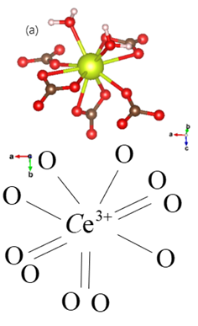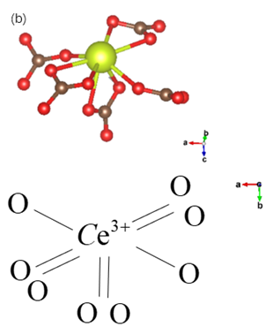
Figure 6 (a) 10 ligand structure diagram; (b) 8 ligand structure diagram
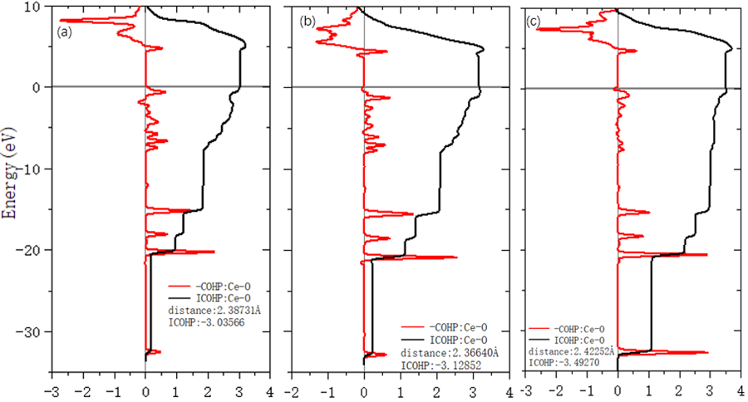
Figure 7 (a) PVP monomer adsorption (001) crystal plane COHP map, (b) PVP monomer adsorption (010) crystal plane COHP map, (c) PVP monomer adsorption (120) crystal plane COHP map
3.1.5 AIMD simulates PVP to regulate the growth process of cerium carbonate crystals
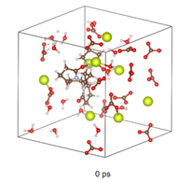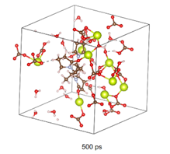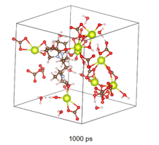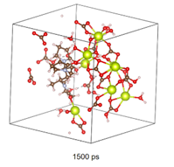
Figure 8 Snapshot of AIMD simulation of PVP-controlled cerium carbonate crystal growth process at 300K
In this section, an ab initio molecular dynamics（AIMD）method is used to simulate the process of PVP regulating the growth of cerium carbonate crystals at the atomic scale. Figure 8 shows a sequential snapshot of the complex formed by ${CO}_{3}^{2-}$ and PVP and Ce³⁺ from the initial state to 1500ps. In the initial state, the atoms are uniformly distributed in the system. With the passage of simulation time, ${CO}_{3}^{2-}$ gradually shifts to the heterogeneous nucleation site formed between PVP and Ce³⁺. When the simulation time reaches 1500ps, it can be seen that growth of cerium carbonate crystals along the PVP adsorption direction is inhibited, leading to the growth of cerium carbonate crystals in other directions.
3.2 Simulation of PVP Controlling Cerium Carbonate Crystal Growth Process
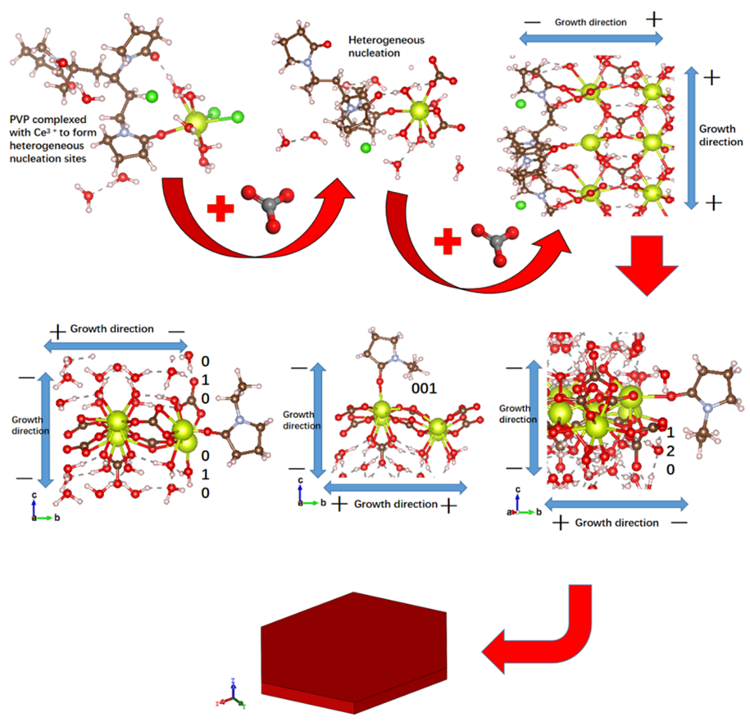
Figure 9 Process diagram of PVP regulating cerium carbonate crystal growth
Figure 9 is a simulation process diagram of using polymer PVP liquid phase precipitation method to control the morphology of cerium carbonate crystals, which is mainly divided into the following three stages:
1.In the first stage, CeCl₃, PVP and H₂O are added to the slab configuration and optimized to a stable state. The ketone groups in the system and PVP will preferentially form complexes, providing heterogeneous nucleation sites for subsequent crystal crystallization.
2.In the second stage, with the addition of precipitant, the complex formed by PVP
and Ce³⁺ is combined to produce heterogeneous nucleation. With the continuous addition of the precipitating agent, ${CO}_{3}^{2-}$combines at the heterogeneous nucleation point where PVP molecules are adsorbed and gradually grows into cerium carbonate crystals. However, during the growth process, ${CO}_{3}^{2-}$ will combine with the heterogeneous nucleation points according to the symmetry of the cerium carbonate crystal PBNB, which leads to the inhibition of the growth of the (010) crystal plane along the $±c$ axis and the +b axis, (001) The crystal plane is suppressed along the $±c$ axis direction, the growth of (120) crystal plane along axis (210) and ± c axis was inhibited, and (120) adsorption capacity of the crystal plane and PVP is the strongest, and the growth rate is the slowest, which leads to the highest probability of (120) crystal face appearing in the system.
3. In the third stage, after crystal gradually fills the whole solution system, each crystal face fragment will combine with each other. According to the classical crystal growth theory,³² the crystal face with a faster growth rate will disappear, while the crystal face with a slower growth rate will eventually remain, because the PVP molecules are adsorbed on the (120) crystal plane and hinder the (120) crystal plane. Compared with other crystal planes such as (001) and (010) crystal planes, the growth rate of (120) crystal plane is the slowest, so the (120) crystal plane has a greater probability of being retained, so that each crystal face finally grows around the (120) crystal face into a hexagonal plate-shaped cerium carbonate crystal.
3.3 Experimental verification analysis
3.3.1 SEM analysis of products in different growth stages of cerium carbonate crystals
Figure 10 shows the carbonic acid prepared by using the liquid phase precipitation method in the experiment, CeCl₃ is the Ce source, PVP is the template, NH₄HCO₃ is the precipitant, the SEM image of the cerium carbonate crystal morphology prepared when the Ce³⁺ concentration is 0.03M, the pH value of the initial solution is 2, and the R value (The ratio of ${CO}_{3}^{2-}$to Ce³⁺) is about 2:1. Figure 10 (a) is the SEM image obtained when the precipitating agent (NH₄HCO₃) is added dropwise for 10 minutes. At this time, the cerium carbonate crystals are slightly rounded at both ends, slender and fusiform, without obvious edges and corners. This is because the reaction has just started. Cerium carbonate crystal grows into an amorphous state, and the crystal lattice is not perfect yet. Figure 10 (b) is the SEM image obtained when the precipitating agent (NH₄HCO₃) is dropped for 30 minutes. The cerium carbonate crystals have been transformed from the original fusiform shape to the angular, narrow and long hexagonal flake. With the extension of the precipitant dropping time, the morphology of the cerium carbonate crystals remained in the shape of hexagonal flake, and the length of each side changed significantly. The length of the sides on both sides of the tip part gradually became longer, and the length of the length direction gradually became shorter. Indicating that the growth process of cerium carbonate crystals is regulated by PVP. At the beginning of the reaction, because the reaction speed is too fast, PVP has not yet played a regulatory role. Cerium carbonate crystals rapidly nucleate and grow into a long and narrow spindle shape. As the reaction progresses, PVP is selectively adsorbed on the crystal surface of cerium carbonate, which makes Cerium carbonate crystals eventually grow into hexagonal flake.
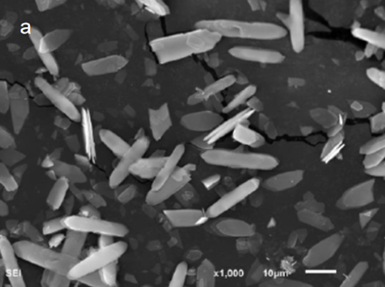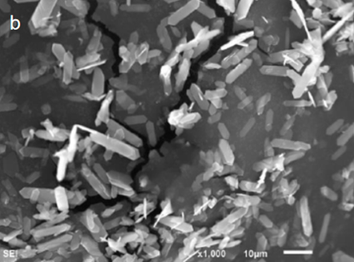
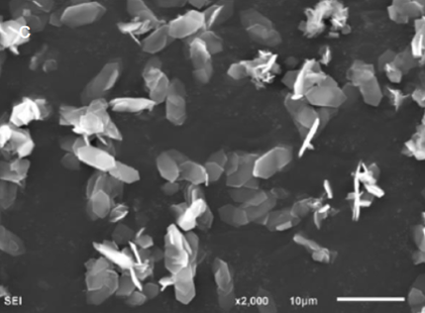
Figure 10 SEM images of different reaction stages of cerium carbonate crystals: (a) 10 min, (b) 30 min, (c) 50 min
3.3.2 Analysis of crystal morphology
Figure 11 shows the transmission electron microscopy (TEM) of the hexagonal flake cerium carbonate crystal. From the figure, it can be measured that the angles formed by each plane of the hexagonal flake cerium carbonate crystal are about 90° and 135°. Since the cerium carbonate crystal belongs to the orthorhombic system, formula 3 can be used to calculate the angle of each crystal plane, where cos φ is the cosine of the angle between the two crystal planes, $\left(h_{1} k_{1} l_{1}\right)$，$\left(h_{2} k_{2} l_{2}\right)$ is the crystal plane index of two crystal planes. The unit cell parameters obtained from PDF card (#38-0377) are: a = 9.482 Å, b = 16.938 Å, c = 8.965 Å. The cosine values of the angles between the crystal planes are listed in Table 4.
$cosφ=\frac{\frac{h_{1}h_{2}}{a^{2}}+\frac{k_{1}k_{2}}{b^{2}}+\frac{l_{1}l_{2}}{c^{2}}}{\sqrt{\left(\frac{h_{1}^{2}}{a^{2}}+\frac{k_{1}^{2}}{b^{2}}+\frac{l_{1}^{2}}{c^{2}}\right)×\left(\frac{h_{2}^{2}}{a^{2}}+\frac{k_{2}^{2}}{b^{2}}+\frac{l_{2}^{2}}{c^{2}}\right)}}$ (Formula 3)
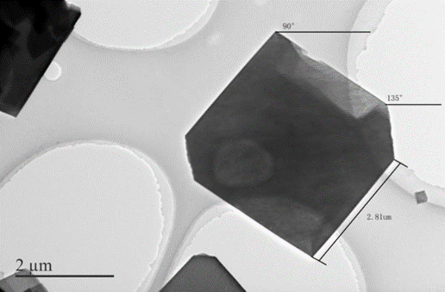
Figure 11 Transmission electron microscope image of hexagonal flake cerium carbonate crystal

Table 4 Cosine value of the included angle of each crystal plane of cerium carbonate
 | 020 | 200 | 002 | 040 | 220 | 022 | 041 | 202 | 240 | 222 | 151 | 103 | 160 | 242 | 340
200 | 0
002 | 0 | 1
040 | 1 | 0 | 0
220 | 0.488 | 0 | 0.872 | 0.488
022 | 0.468 | 0.834 | 0 | 0.468 | 1
041 | 0.904 | 0.427 | 0 | 0.904 | 0.800
202 | 0 | 0.727 | 0.687 | 0 | 0.642 | 0.599 | 0.280
240 | 0.746 | 0 | 0.666 | 0.746 | 0.349 | 0.946 | 0.953 | 0.458
222 | 0.359 | 0.678 | 0.641 | 0.359 | 0.767 | 0.735 | 0.589 | 0.933 | 0.458
151 | 0.877 | 0.335 | 0.317 | 0.887 | 0.711 | 0.710 | 0.939 | 0.461 | 0.875 | 0.749
103 | 0 | 0.954 | 0.301 | 0 | 0.843 | 0.262 | 0.126 | 0.900 | 0.655 | 0.840 | 0.415
160 | 0.958 | 0 | 0.285 | 0.958 | 0.448 | 0.717 | 0.991 | 0.196 | 0.697 | 0.527 | 0.941 | 0.269
242 | 0.610 | 0.576 | 0.545 | 0.610 | 0.794 | 0.773 | 0.779 | 0.793 | 0.839 | 0.959 | 0.907 | 0.705 | 0.755
340 | 0.598 | 0 | 0.810 | 0.598 | 0.280 | 0.991 | 0.873 | 0.551 | 0.435 | 0.729 | 0.785 | 0.756 | 0.571 | 0.801
061 | 0.954 | 0.300 | 0 | 0.954 | 0.712 | 0.467 | 0.871 | 0.218 | 0.900 | 0.546 | 0.947 | 0.100 | 1 | 0.754 | 0.795
The diffraction pattern of hexagonal flake cerium carbonate crystal is shown in Figure 12. According to the measurement of the ruler in the diffraction pattern from near to far, the distance R between the surrounding spots and the central spot is calculated, according to d=1/R, the crystal plane spacing d of each spot around the center diffraction spot is calculated, and the PDF card（#38-0377）of the cerium carbonate crystal is found to preliminarily determine the crystal plane represented by each spot. According to the angles of crystal planes measured in Figure 9, looking up Table 4 can finally determine that the sides of the hexagonal flake cerium carbonate crystal are (002), (040), and (240) respectively.
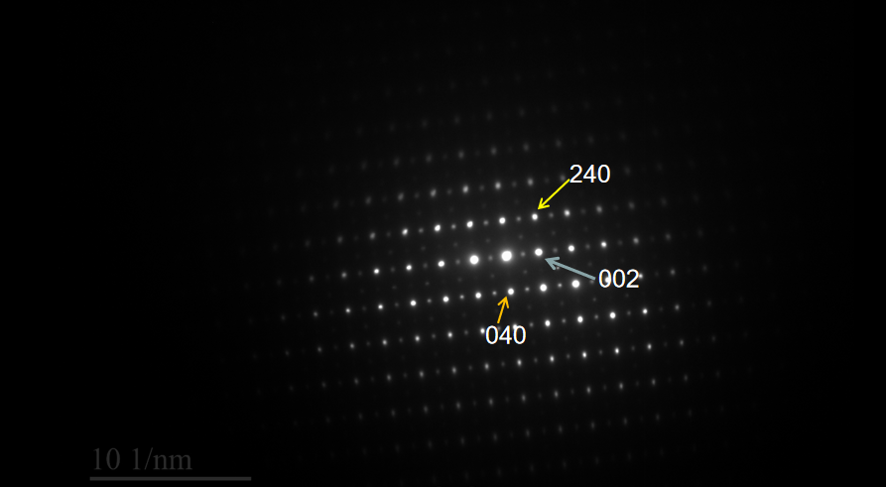
Figure 12 Diffraction pattern of hexagonal flake cerium carbonate crystal
Figure 13 shows the X-ray diffraction pattern (XRD) of cerium carbonate crystals under the control of polymer PVP. The four strongest peaks are (020), (040), (060), and (200) crystal planes. These four crystal planes belong to the {100} crystal plane family. Because (240) crystal plane is inclined plane of hexagonal flake crystal, the intensity of (240) crystal plane peak is relatively weak in XRD, therefore, the hexagonal flake cerium carbonate crystal with (240) crystal plane as inclined plane and {100} crystal plane group as top and side can be seen in the SEM.
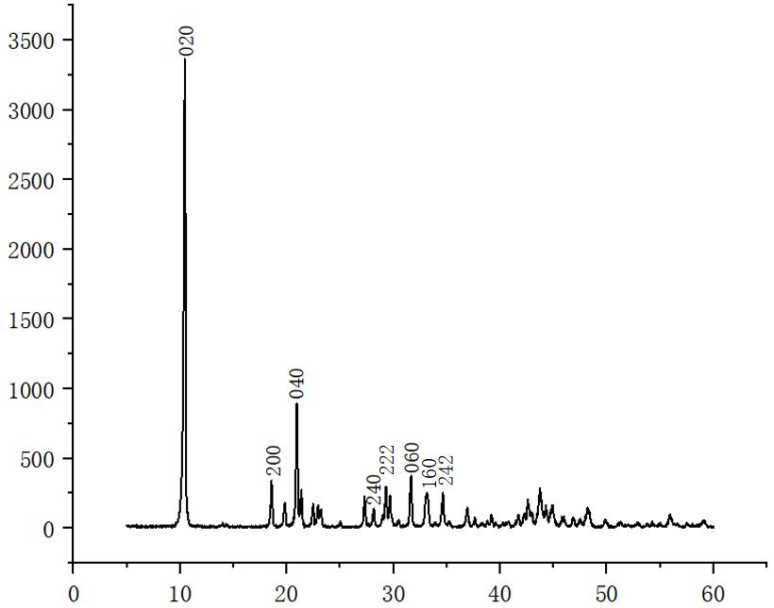
Figure 13 XRD pattern of hexagonal flake cerium carbonate crystal
4 Summarize
In this paper, the influence of PVP on the morphology of cerium carbonate crystals in the nucleation and growth stages of PVP is studied by the method of computer simulation, combined with DFT theory and first principles. Through the analysis of the bonding situation, the electronic structure analysis after the interaction of (001), (010), (120) crystal faces, and the relative adsorption energy changes of each crystal face after adsorption, the interaction mechanism is studied, predict the crystal morphology and verify it through experiments, and the conclusions are as follows:
1.In the absence of precipitant, the ability of PVP to form complex complexes with Ce³⁺ in the system is stronger than that of O in water molecules, which indicates that PVP will preferentially complex with Ce³⁺ after adding solution, and act as the nucleation point for heteronormative of cerium carbonate crystals.
2.Calculate the surface energy of (120), (001), (010) three easy-to-display crystal faces of unadsorbed PVP and find that (120) the surface energy of the crystal surface is the lowest, followed by (010), and the highest is (001), indicating that when the polymer is not added, each crystal surface grows at a large rate during crystal growth. The small sort is (120) < (001) < (010). After adding the PVP polymer, the order of the adsorption energy of each crystal surface is arranged as follows: (120) > (001) > (010), and the bonding stability arrangement between PVP and the crystal surface is (120) > (001)> (010), indicating that PVP is highly adsorbed on (120) crystal surfaces. The sequence that causes the growth rate between the crystal surfaces is (120) < (001) < (010), and eventually form a six-sided sheet-like cerium carbonate crystal.
5 Conclusions
The morphology of cerium carbonate crystal controlled by PVP was simulated by computer. When adding PVP without precipitating agent, the ketone group in PVP would preferentially complex with Ce³⁺ to form a complex. After adding precipitant, heterogeneous nucleation points of cerium carbonate crystal would be formed around the complex and grow gradually around the nucleation points. By calculating the interaction relationship between exposed Ce³⁺ and polymer PVP on three crystal faces of cerium carbonate (120), (010) and (001), it is found that the absolute value of adsorption energy of (120) crystal surface is the largest, and the gap of adsorption energy of (010) and (001) is only about 2eV, which indicates that the adsorption of PVP in the growth process of cerium carbonate crystal is due to the adsorption of PVP. The growth resistance of the (120) plane is much greater than that of the (010) and (001) plane, In the equilibrium state, the probability appears of the (120) crystal plane is the greatest, and the hexagonal plate-like cerium carbonate crystal structure that grows around the (120) crystal plane will eventually appear.

Acknowledgments
The financial support from National Science Foundation of China (21666029); Ministry of education innovation team project (IRT1065); Inner Mongolia Natural Science Foundation (2016MS0223); grassland talents individual training project, is gratefully acknowledged.
References
1. T Li. Study on the reaction crystallization process and crystal morphology control of cerium carbonate. South China University of Technology, Guangzhou, 2020.
2. YH Hu, M Li, ZG Liu, MT Wang, NN Sun, CC Liu. Preparation of cerium carbonate with special morphology controlled by nonylphenol polyoxyethylene ether. Rare Earth 34.06(2013):7-12. doi:10.16533/j.cnki.15-1099/tf.2013.06.004.
3. QY Shao. Cerium dioxide crystallization kinetics and its controllable preparation. Inner Mongolia University of Technology, Hohhot,2014.
4. XZ Wang, T Li, Y Zhang, YL He, QS Liu, H Zhang, P Wang, ZH Xiao. Research on the Reaction Crystallization Process of Cerium Carbonate and PAT-based Crystal Morphology Control. China Rare Earth Society 2020 Academic Annual Conference and Jiangxi (Ganzhou) Summary of the Conference on Green Development and Efficient Utilization of Rare Earth Resources. Ed., 2020, 255-256.
5. M Li, YH Hu, ZG Liu, MT Wang, ZX Duan. Study on the morphology control of cerium carbonate crystals. Abstracts of the 30th Academic Annual Meeting of the Chinese Chemical Society-Eighth Session: Rare Earth Materials Chemistry and Applications. Ed., 2016, 110.
6. Alkanes - Methane; Studies from Kyushu University Further Understanding of Methane, Adsorption and Activation of Methane on the (110) Surface of Rutile-type Metal Dioxides. Chemicals & Chemistry,2018.
7. WL Li, Ertural Christina, Bogdanovski Dimitri, J Li, Dronskowski Richard. Chemical Bonding of Crystalline LnB6 (Ln = La-Lu) and Its Relationship with Ln2B8 Gas-Phase Complexes. Inorganic chemistry 57.20(2018). doi:10.1021/acs.inorgchem.8b02263.
8. L.I. Karaouzène, A.E. Merad,T. Ouahrani,M.R. Boufatah. (BN) 1 /(InN) 1, (AlN) 1 /(InN)1 and (GaN) 1 /(InN) 1 (001) superlattices: An opto-electronic and bonding properties. Optik 168. (2018). doi:10.1016/j.ijleo.2018.04.067.
9 Q. Li, M. Rellan-Pineiro, N. Almora-Barrios, M. Garcia-Rates, I.N. Remediakis, N. Lopez, Shape control in concave metal nanoparticles by etching. Nanoscale 9.35(2017): doi:10.1039/c7nr03889e.
- H Wan, XW Liu, M Qing, Q Peng, Y Zhang, S Liu, H Wang, XD Wen,
Yang, YW Li, Surface Structure and Morphology Evolution of Iron Boride under DynamicConditions: A Theoretical Study. Applied Surface Science. (2020):doi:10.1016/j.apsusc.2020.146462.
11. N Liu, C Zhou, ZK Wu, YJ Shu, BZ Wang, QL Zhao, WL Wang. Prediction of the crystalline morphology of FOX-7 in H₂O/DMF solvent. Energetic materials, 2018, 26(06): 471-476.
12. N Liu, BZ Wang, YJ Shu, ZK Wu, Q Zhou, QL Zhao, WL Wang. Molecular dynamics simulation of crystal morphology of FOX-7. Acta Pedagogics and Explosives,2016,39(02):40-44.
13. DH Wu, ZF Tong, TP Luo, L Shao, HC Wang, LT Wei, BY Tang. Study the surface energy and electronic structure of CaCO₃ based on first principles. Journal of Materials Science and Engineering,2015,33(06): 857-861+809.
14. Balbuena Cristian, Gianetti Melisa Mariel, Soulé Ezequiel Rodolfo. Molecular dynamics simulations of the formation of Ag nanoparticles assisted by PVP. Physical chemistry chemical physics: PCCP 23.11(2021): doi:10.1039/D1CP00211B.
15. EX Li. MS simulation study of PVP regulating the growth mechanism of cerium carbonate. Inner Mongolia University of Science and Technology,Baotou, 2019.
16. YF Yu. Theoretical study on the epitaxial growth kinetics of graphene on Ni (111) surface. Shandong University, Jinan,2020.
17. SL Yuan, H Zhang, DJ Zhang. Molecular simulation: theory and experiment.
Beijing: Chemical Industry Press, 2016: 162.
18. JT Cai, DX Li, BL Liu, BS Guo, DQ Wei, H Wang. Molecular dynamics simulation of controlled crystallization of urea (520) crystal plane. CIESC Journal, 2019, 70(1): 128-135.
19. XQ Tang, XM Liu, Y Chen, JH Chen. Density functional theory study on lead activation and xanthate adsorption on sphalerite surface. Nonferrous Metal Engineering , 11.03(2021):90-95. doi:CNKI:SUN:YOUS.0.2021-03-014..
20. Q Ren, Y Liu, T Gao, ZX Zhou, CS Zhao, HF Chai. Study on the crystal structure and density functional theory of diethyl 2,2-bis (4-chloro-2-fluorobenzyl) malonate. Journal of Synthetic Crystals, 50.02(2021):338-344. doi:10.16553/j.cnki.issn1000-985x.2021.02.01.
21. Kresse, G.; Hafner, J. Ab initio molecular dynamics for liquid metals. Phys. Rev. B: Condens. Matter Mater. Phys. 1993, 47, 558−561.
22. Kresse, G.; Furthmüller, J. Efficiency of ab-initio total energy calculations for metals and semiconductors using a plane-wave basis set. Comput. Mater. Sci. 1996, 6, 15−50.
23. Kresse, G.; Joubert, D. From ultrasoft pseudopotentials to the projector augmented-wave method. Phys. Rev. B: Condens. Matter Mater. Phys. 1999, 59, 1758−1775.
24. Blöchl. Projector augmented-wave method. Physical review. B, Condensed matter,1994,50(24):
25. G Wang, M Zhou, Goettel, J. T, Schrobilgen, G. J, J Su, J Li, Schlöder, T, Riedel, S. Identification of an iridium-containing compound with a formal oxidation state of IX. Nature 514.7523(2014): doi:10.1038/nature13795.
26. Perdew, Burke, Ernzerhof. Generalized Gradient Approximation Made Simple. Physical review letters,1996,77(18):
27. S Maintz, VL Deringer, AL Tchougréeff, R Dronskowski. Analytic projection from plane-wave and PAW wavefunctions and application to chemical-bonding analysis in solids. J. Comput. Chem. 2013, 34, 2557−2567.
28. S Maintz, VL Deringer, AL Tchougréeff, R Dronskowski. LOBSTER: A tool to extract chemical bonding from plane-wave based DFT. J. Comput. Chem. 2016, 37, 1030−1035.
29. R Dronskowski, PE Blöchl, Crystal orbital Hamilton populations (COHP): energy-resolved visualization of chemical bonding in solids based on density-functional calculations. J.Phys.Chem.1993, 97, 8617−8624.
30. VL Deringer, AL Tchougréeff, R Dronskowski. Crystal orbital Hamilton population (COHP) analysis as projected from plane-wave basis sets. J. Phys. Chem. A 2011, 115,5461−5466.
31. DS Sholl, JA Steckel. Density Functional Theory:A Practical Introduction. John Wiley & Sons, Inc.:2009-03-30.
32. T Zhou. Theoretical research on solvation growth and morphology control of TKX-50. North University of China, Jilin,2020.

