SUPPORTING INFORMATION
(E)-1-(4-Hydroxyphenyl)-3-(substituted-phenyl)prop-2-en-1-ones: Synthesis, In Vitro Cytotoxic Activity and Molecular Docking Studies
Lütfiye Sirka,¹ Hacer Doğan,¹ Mehmet Refik Bahar,² Eray Çalışkan,³ Suat Tekin,⁴ Harun Uslu,⁵ Kenan Koran,^{1,}* Süleyman Sandal,⁴ Ahmet Orhan Görgülü⁶

¹ Firat University, Faculty of Science, Department of Chemistry, 23119, Elazığ, Turkey

² Osmaniye Korkut Ata University, Faculty of Health Sciences, Department of Nutrition and Dietetics, 80010, Osmaniye, Turkey

³ Bingol University, Faculty of Science, Department of Chemistry, 12000, Bingol, Turkey

⁴ Inonu University, Faculty of Medicine, Department of Physiology, 44280, Malatya, Turkey

⁵ Firat University, Vocational School of Health Services, Department of Anesthesiology, 23600, Elazığ, Turkey
⁶ Marmara University, Faculty of Arts and Sciences, Department of Chemistry, 34722, Istanbul, Turkey
*Corresponding Author; Firat University, Firat University, Faculty of Science, Chemistry Department, 23119, Elazığ, Turkey; E-mail address: kkoran@firat.edu.tr (Kenan Koran)
- FT-IR, ¹H and ¹³C-APT NMR Spectra of Compounds
  - FT-IR, ¹H and ¹³C-APT NMR Spectra of (E)-1-(4-Hydroxyphenyl)-3-(3-methoxyphenyl)prop-2-en-1-one (2)
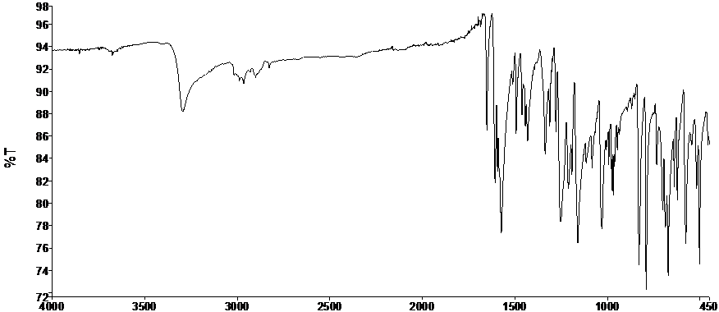
Figure S1. FT-IR spectrum of 2 (ATR)

Figure S2. ¹H-NMR spectrum of 2 (DMSO-d₆)
Figure S3. ¹³C-APT NMR spectrum of 2 (DMSO-d₆)

  - FT-IR, ¹H and ¹³C-APT NMR Spectra of (E)-1-(4-Hydroxyphenyl)-3-(2,4-dimethoxyphenyl)prop-2-en-1-one (3)
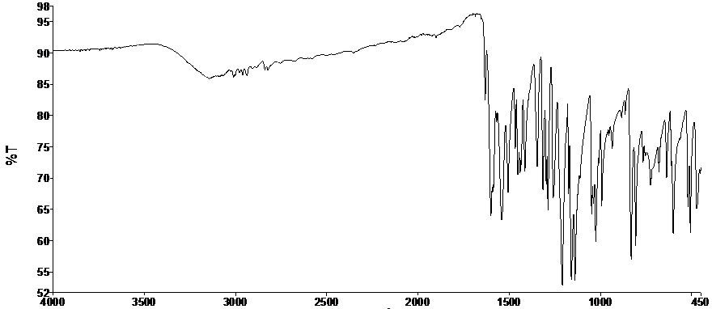
Figure S4. FT-IR spectrum of 3 (ATR)

Figure S5. ¹H-NMR spectrum of 3 (DMSO-d₆)
Figure S6. ¹³C-APT NMR spectrum of 3 (DMSO-d₆)
  - FT-IR, ¹H and ¹³C-APT NMR Spectra of (E)-1-(4-Hydroxyphenyl)-3-(3,4-dimethoxyphenyl) prop-2-en-1-one (4)
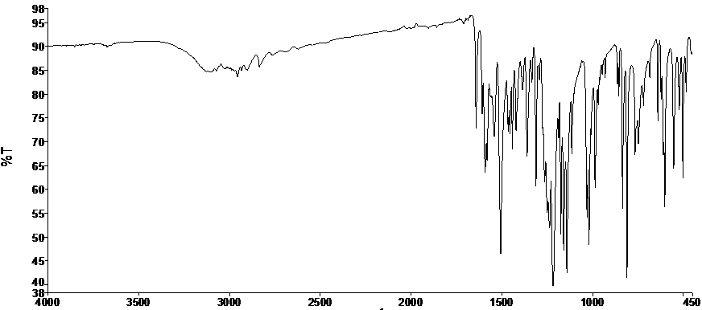
Figure S7. FT-IR spectrum of 4 (ATR)

Figure S8. ¹H-NMR spectrum of 4 (DMSO-d₆)
Figure S9. ¹³C-APT NMR spectrum of 4 (DMSO-d₆)

  - FT-IR, ¹H and ¹³C-APT NMR Spectra of (E)-1-(4-Hydroxyphenyl)-3-(2,3,4-trimethoxyphenyl) prop-2-en-1-one (5)
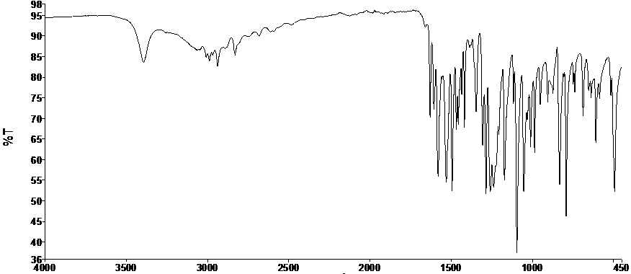
Figure S10. FT-IR spectrum of 5 (ATR)
Figure S11. ¹H-NMR spectrum of 5 (DMSO-d₆)
Figure S12. ¹³C-APT NMR spectrum of 5 (DMSO-d₆)
  - FT-IR, ¹H and ¹³C-APT NMR Spectra of (E)-1-(4-Hydroxyphenyl)-3-(2,4,5-trimethoxyphenyl) prop-2-en-1-one (6)
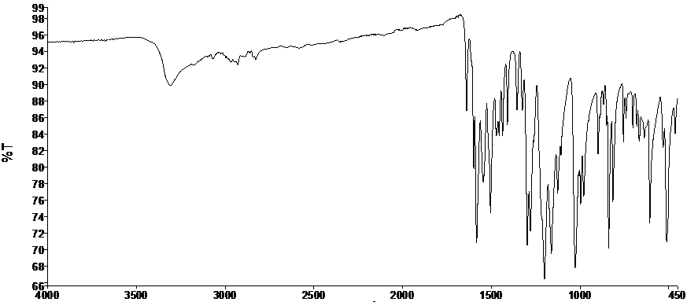
Figure S13. FT-IR spectrum of 6 (ATR)

Figure S14. ¹H-NMR spectrum of 6 (DMSO-d₆)
Figure SS15. ¹³C-APT NMR spectrum of 6 (DMSO-d₆)

  - FT-IR, ¹H and ¹³C-APT NMR Spectra of (E)-1-(4-Hydroxyphenyl)-3-(1,1′-biphenyl)prop-2-en-1-one (7)
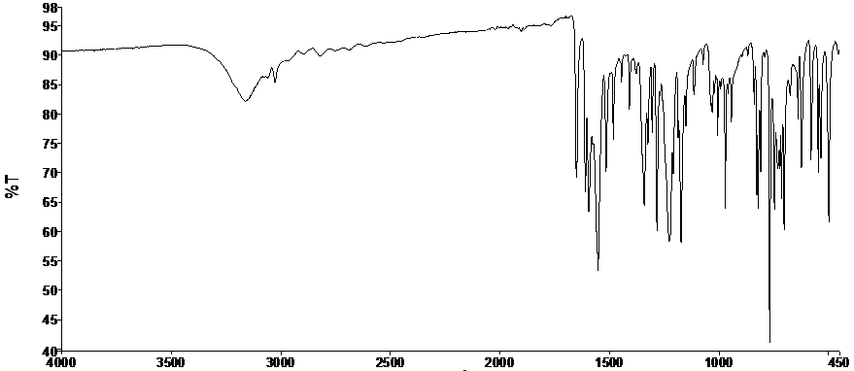
Figure S16. FT-IR spectrum of 7 (ATR)
Figure S17. ¹H-NMR spectrum of 7 (DMSO-d₆)
Figure S18. ¹³C-APT NMR spectrum of 7 (DMSO-d₆)
  - FT-IR, ¹H and ¹³C-APT NMR Spectra of (E)-1-(4-Hydroxyphenyl)-3-(3,5-difluorophenyl) prop-2-en-1-one (8)
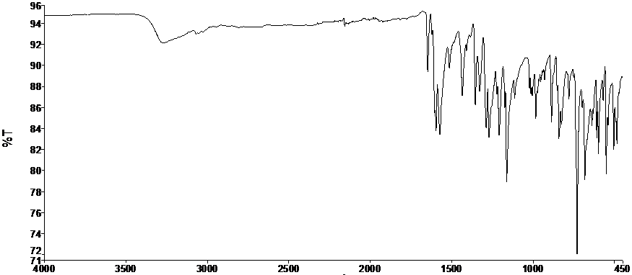
Figure S19. FT-IR spectrum of 8 (ATR)

Figure S20. ¹H-NMR spectrum of 8 (DMSO-d₆)VV
Figure SS21. ¹³C-APT NMR spectrum of 8 (DMSO-d₆)

  - FT-IR, ¹H and ¹³C-APT NMR Spectra of (E)-1-(4-Hydroxyphenyl)-3-(2-fluoro-4-chlorophenyl)prop-2-en-1-one (9)
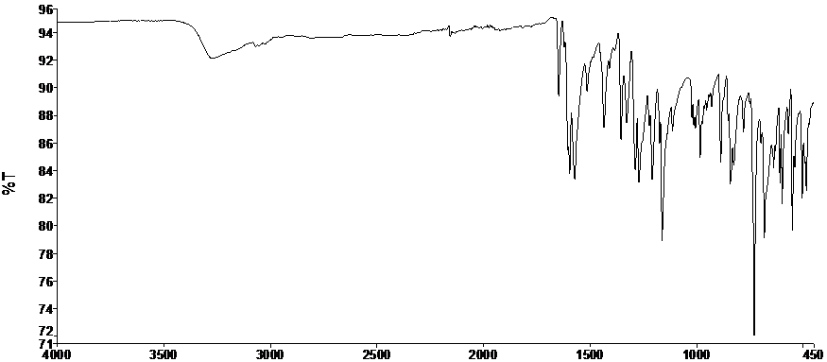
Figure S22. FT-IR spectrum of 9 (ATR)
Figure SSS23. ¹H-NMR spectrum of 9 (DMSO-d₆)
Figure S24. ¹³C-APT NMR spectrum of 9 (DMSO-d₆)
  - FT-IR, ¹H and ¹³C-APT NMR Spectra of (E)-1-(4-Hydroxyphenyl)-3-(3-(trifluoromethyl)phenyl)prop-2-en-1-one (10)
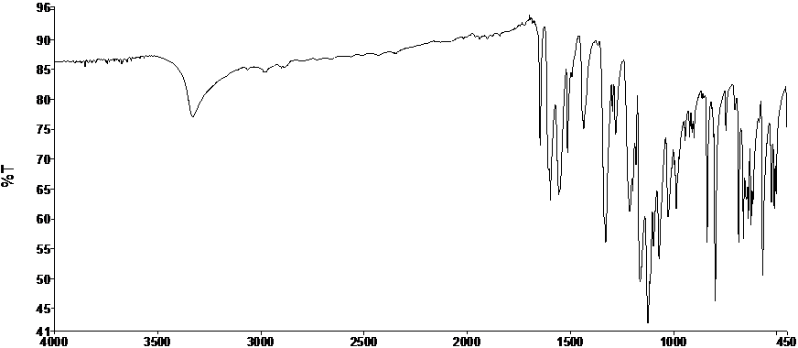
Figure S25. FT-IR spectrum of 10 (ATR)

Figure S26. ¹H-NMR spectrum of 10 (DMSO-d₆)
Figure S27. ¹³C-APT NMR spectrum of 10 (DMSO-d₆)

  - FT-IR, ¹H and ¹³C-APT NMR Spectra of (E)-1-(4-Hydroxyphenyl)-3-(3-(trifluoromethyl)-4-chlorophenyl)prop-2-en-1-one (11)
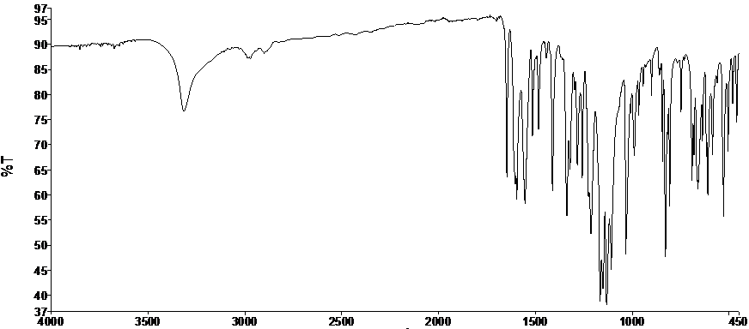
Figure S28. FT-IR spectrum of 11 (ATR)
Figure S29. ¹H-NMR spectrum of 11 (DMSO-d₆)

Figure S30. ¹³C-APT NMR spectrum of 11 (DMSO-d₆)

