A Novel All-Solid-State PVC-Membrane Potentiometric Dopamine-Selective Sensor Based on Molecular Imprinted Polymer

Nurşen Dere¹, Zuhal Yolcu² and Murat Yolcu^{2*}

¹Giresun University, Center Research Laboratory Application and Research Center, Giresun /Turkey
²Giresun University, Science and Arts Faculty, Chemistry Department, Giresun /Turkey

*Corresponding author: E-mail: murat.yolcu@giresun.edu.tr

Abstract
A novel all-solid-state polyvinylchloride (PVC) membrane potentiometric dopamine-selective microsensor was constructed based upon dopamine-imprinted polymer used as the ionophore in the membrane structure. The optimum membrane composition was determined as 4% (w/w) MIP, 69% (w/w) bis(2-ethylhexyl) sebacate (DOS), 26% (w/w) PVC, and 1% (w/w) potassiumtetrakis(4-chlorophenyl) borate (KTpClPB). The detection limit of the microsensor was determined to be 3.71×10⁻⁷ mol.L⁻¹. The microsensor exhibited a super-Nernstian response for dopamine over the concentration range of 10⁻¹−10⁻⁶ mol.L⁻¹, with a short response time (<15 s) and a slope of 60.3±1.3 mV per decade (R²: 0,9998) over seven weeks. The microsensor was effectively performed in a pH range of 4.0−8.0. The microsensor has been successfully demonstrated for the determination of dopamine in a pharmaceutical drug sample. The obtained results were in good harmony with the UV-Vis results at a confidence level of 95%.

Keywords: dopamine; all-solid-state microsensor; molecular imprinted polymer; potentiometry

1. Introduction
Dopamine (Figure 1) is one of the most important neurotransmitters that play specific roles in various physiological and pathological processes in the central nervous, cardiovascular, hormonal and renal systems of the human body, modulated by their levels in various brain tissues.¹⁻³ Determination of dopamine is important in the diagnosis, monitoring and prevention of certain diseases, such as Parkinson's, schizophrenia, HIV infections, hyperuricemia, and a type of arthritis.⁴ There are many instrumental methods for dopamine determination, such as chromatography,⁵ fluorimetry,⁶ colorimetry,⁷ spectrophotometry,⁸ and electrochemistry.⁹ These methods require both expensive equipment and complex sample preparation, and time. Electrochemical methods have several advantages compared to expensive instrumental methods. Especially, when evaluated in terms of ion-selective electrodes; electrochemical methods provide superiority such as short response time, low detection limit, simple design, low cost, wide operating range, high selectivity, minimum sample pretreatment, accuracy and precision, easy measurement process.¹⁰
The molecular imprinting method involves the polymerization of a functional monomer and crosslinker around a template which is removed using different solvents after the synthesis process.¹¹ This technique is a very suitable method for polymeric material formation with molecular recognition cavities created by the addition of template molecules during the process.¹² As a result, MIPs provide a wide range of binding sites with various affinities and selectivity that are interrelated to the template molecule in size, functionality, and shape.¹³ The imprinted polymers have several advantages such as good physical and chemical stability, high selectivity and low cost.¹⁴⁻¹⁶ MIPs are widely used in drug release,¹⁷ solid-phase extraction,¹⁸ enzyme mimics,¹⁹ chromatographic separation,²⁰ cancer biomarkers,²¹ and sensors.²² Different potentiometric sensors based on MIP have been reported.²³⁻²⁵
In this work, a novel potentiometric dopamine-selective microsensor, that is all-solid-state PVC-membrane type, was designed using dopamine-imprinted polymer (DOP-IP) as an ionophore. The performance of the sensor was investigated in detail. The microsensor was successfully used for dopamine determination in the content of the commercial drug sample. The potentiometric results were compared with the UV-Vis spectroscopic results at 95% confidence level.

Figure 1. Molecular structure of dopamine (3,4-(dihydroxy phenyl) ethylamine)

2. Experimental
2. 1. Reagents
Dopamine (DOP), methacrylic acid (MA), azobisisobutyronitrile (AIBN), ethylene glycol dimethacrylate (EGDMA), ethanol (EtOH), methanol, acetic acid, tetrahydrofuran (THF), high molecular weight polyvinylchloride (PVC), o-nitrophenyl octyl ether (NPOE), bis(2-ethylhexyl) sebacate (DOS), dibutyl sebacate (DBS), potassium tetrakis (4-chlorophenyl) borate (KTpClPB), graphite, solvents and all other salts were purchased from Sigma-Aldrich. Epoxy resin (Ultrapure SU 2227) and hardener (Desmodur RFE) were supplied from Victor and Bayer AG, respectively.

2. 2. Apparatus
A multi-channel potentiometer supported by a computer program device and designed in our laboratory was used for the potentiometric measurements. Ag/AgCl electrode (Basi-MF-2079-RE-5B) was operated as a reference electrode. A Jenway 3040 model ion analyser was used for pH measurements. A Shimadzu AUX220 model analytical balance was used for measuring weight. A Kubota 4200 model centrifuge was used for centrifugation. Deionized water was supplied from a Sartorius Stedim Ariium 611UV model ultra-deionized water device. A Memmer (GmbH & Co. KG D.91126 Typ: WNB 14) shaker was used for the removal of dopamine molecules from the polymer. The solutions were homogenized using an Ultrasonic LC30 (Germany) stirrer. A Jeol JSM-6610 model instrument was used for scanning electron microscopy (SEM) analysis. A Thermo Scientific Evaluation Array UV-Vis spectrophotometer was used for the spectroscopic determination of dopamine.

2. 3. Synthesis of Dopamine-Imprinted Polymer
The dopamine-imprinted polymer (DOP-IP) was synthesized according to the method described in the literature.²⁶ 59 mg dopamine, 0.4 mL MA ve 1.24 mL EGDMA was dissolved in 6.2 mL EtOH in a 50 mL glass bottle. The mixture, pure nitrogen gas passed through for 20 min, was sonicated in a water bath for 30 min. Then 0.02 mg AIBN was added in the mixture. The mixture was heated to 60 °C in a thermostatically adjusted oil bath on a magnetic stirrer for 21 hours. A colorless translucent bulk of solid polymer was obtained. Polymer particles containing dopamine molecules (DOP-P) were washed with EtOH and filtered. Methanol/acetic acid (90/10; v/v) solution was repeatedly used for removal of the dopamine molecules until not detecting any dopamine in the filtered solution by UV-Vis method. Final polymer particles (DOP-IP) were then vacuum dried at 50 °C. The non-imprinted polymer (NIP) was synthesized by following the same procedure without dopamine.

Figure 2. Schematic representation of the DOP-IP preparation process

2. 4. Fabrication of All-Solid-State Dopamine-Selective Microsensor
The all-solid-state dopamine selective microsensor used was manufactured according to the method described in our previous study.²⁷ The first stage of sensor production, which occurs in two steps; involves the preparation of 50 % graphite, 35 % epoxy and 15 % hardener in THF. On the second step; A copper wire of about 10 mm length and 2 mm radius is dipped into this mixture several times until a thickness of about 0.5 mm is obtained, and it is left to dry for a day under laboratory conditions. In the second stage; containing a selective membrane mixture. This cocktail mix prepared in 2.5 mL THF (4-6 (w/w) DOP-IP, 67−69% (w/w) NPOE, DOS or DBS, 26−27% (w/w) PVC and 1% (w/w)) KTpClPB) was dipped 4-5 times on the solid contact surface formed in the first stage and the prepared sensor was left to dry under laboratory conditions for 1 day. After these procedures, the performances of the microsensor were investigated in detail.

3. Results And Discussion
3. 1. SEM Analysis
Scanning Electron Microscopy (SEM) was used for the investigation of surface morphologies of the polymers (NIP, DOP-P and DOP-IP). Figure 2a-f shows the relevant SEM images with the structural differences of the particles. When the general surface morphology is examined; it is seen that the polymers have different particle sizes, however, have spherical shapes as similarities. The NIP particles (Figure 3e-f) are substantially larger in size than the MIP particles (Figure 3a-d). Moreover, it is seen that an enhanced surface area and pores were observed on the DOP-IP surface (Figure 3c-d) than the DOP-P surface (Figure 3a-b). This situation can be considered as a result of the imprinting process. Consequently, the relatively porous surfaces of DOP-IP possess the and specific cavities suitable interaction sites for the sorption of dopamine molecules.

3. 2. Optimum Membrane Composition
It is known that PVC-membrane sensors are significantly dependent not only on the structure of the ionophores but also on the ratio of membrane components, polymers, plasticizers and other additives. These effects on sensors; in addition to lowering the detection limit of the sensors, also increases the sensitivity and selectivity. The effects of PVC membrane components on the potentiometric response of the DOP-selective microsensor were investigated using different plasticizers (NPOE, DOS and DBS) and the results are summarized in Table 1. It can be seen that the best potentiometric performances (slope, detection limit, linear range) are for sensor number-II compared to the others. The potentiometric performance of the DOP-selective microsensor, which was prepared according to the optimum membrane composition, was investigated in more detail.

Figure 3. SEM images of the DOP-P (a, b), DOP-IP (c, d), and NIP (e, f)

Table 1. Potentiometric performance characteristics of DOP-selective microsensors
No | Membrane Composition (%w/w) |  |  |  |  |  |  | Potentiometric Behavior
No | PVC | NPOE | DOS | DBS | KTpClPB | MIP |  | Slope, mV/decade* | Linear range, mol/L⁻¹ | Detection limit, mol.L⁻¹
I | 26 | 69 | - | - | 1 | 4 |  | 49.6±2.6 | 10⁻¹−10⁻⁵ | 5.30×10⁻⁷
II | 26 | - | 69 | - | 1 | 4 |  | 60.3±1.3 | 10⁻¹−10⁻⁶ | 3.71×10⁻⁷
III | 26 | - | - | 69 | 1 | 4 |  | 45.3±2.5 | 10⁻¹−10⁻⁵ | 5.72×10⁻⁶
VI | 26 | 67 | - | - | 1 | 6 |  | 40.7±2.8 | 10⁻¹−10⁻⁴ | 2.84×10⁻⁵
V | 26 | - | 67 | - | 1 | 6 |  | 50.6±2.2 | 10⁻¹−10⁻⁴ | 6.22×10⁻⁵
VI | 26 | - | - | 67 | 1 | 6 |  | 42.1±3.0 | 10⁻¹−10⁻⁴ | 4.87×10⁻⁵
VII | 27 | 69 | - | - | - | 4 |  | 45.1±1.8 | 10⁻¹−10⁻⁵ | 2.62×10⁻⁶
VIII | 27 | - | 69 | - | - | 4 |  | 53.8±1.6 | 10⁻¹−10⁻⁶ | 4.95×10⁻⁷
IX | 27 | - | - | 69 | - | 4 |  | 44.3±2.1 | 10⁻¹−10⁻⁵ | 1.36×10⁻⁶
*The average value of three determinations ± standard deviation
The potentiometric response of the DOP-selective microsensor was investigated in the standard dopamine solutions prepared in the concentration range of 10⁻⁸−10⁻¹ mol.L⁻¹ (Figure 4). It was determined that the sensor exhibited a linear response to dopamine as a super Nernst behaviour (60.3±1.3 mV) in the concentration range of 10⁻¹–10⁻⁶ mol.L⁻¹ with a lower detection limit of 3.71×10⁻⁷ mol.L⁻¹ and a short response time (t₉₅) of <15 s according to the IUPAC recommendations.²⁸ The calibration graphs of microsensors prepared with DOP-IP and NIP are shown in Figure 5. The performance of the DOP-IP-based sensor is better than the NIP-based sensor, and it can be said that this situation in the NIP sensor is due to the non-specific interaction on the NIP surface.

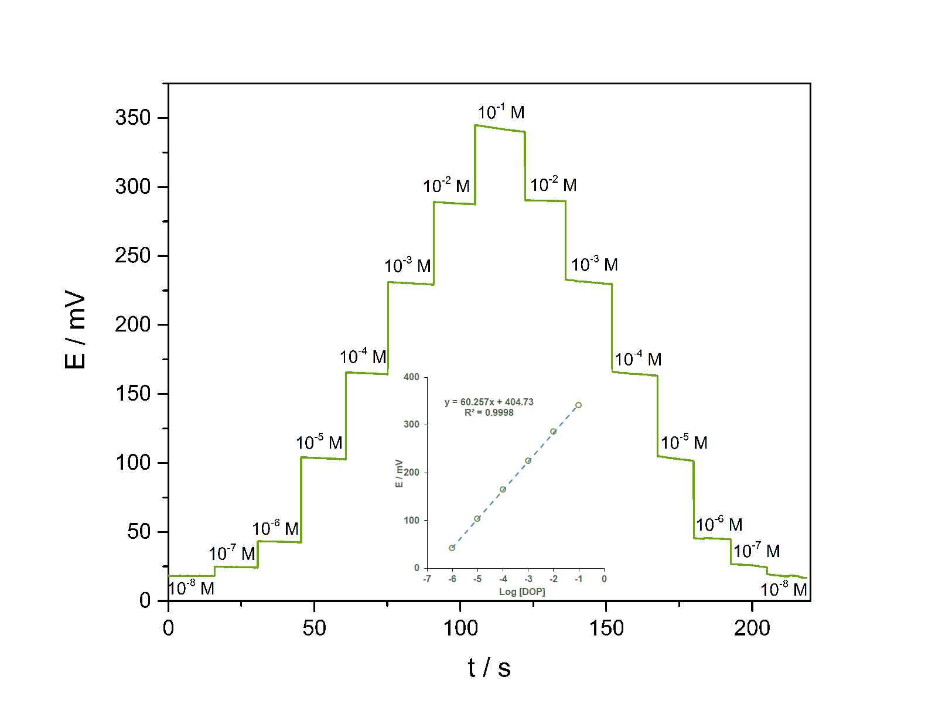
Figure 4. Potentiometric responses and calibration plot of the DOP-selective microsensor

Figure 5. Calibration curves of the DOP-selective sensors based on MIP (●) and NIP (▲)
3. 3. Repeatability and lifetime
The repeatability of the DOP-selective microsensor was investigated. For this purpose; the measurements were repeatedly taken in the concentration range of 10⁻⁶−10⁻¹ mol.L⁻¹ dopamine. The obtained potential-time graph is shown in Figure 6. It can be seen from Figure 6, the behaviour of the developed sensor is highly reproducible.

Figure 6. Reproducibility measurements of the DOP-selective microsensor

In order to determine the lifetime of the developed DOP-selective microsensor, the changes in the detection limit and slope values of the sensor have been monitored for two months. For this purpose, measurements were taken in standard dopamine solutions in the linear operating range of the DOP-selective microsensor on certain days and the obtained slope values against time are shown in Figure 7. As can be seen from Figure 7, especially after 42 days, a significant drift in the slopes indicates that the stability of the sensor has deteriorated (the initial slope value of 60.3 mV/decade decreased to 53.1 mV/decade). Therefore, the lifetime of the sensor was estimated to be about 6 weeks.

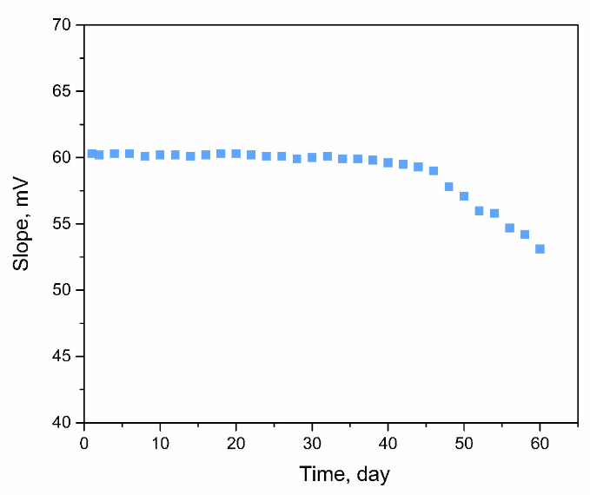
Figure 7. Slope values of the DOP-selective microsensor against time

3. 4. Selectivity
The selectivity coefficients of the DOP-selective microsensor were calculated by using the separate solution method (SSM).²⁸ The obtained logarithmic selectivity coefficients (${Log K}_{DOP, X^{n+} }^{pot}$) for dopamine molecules over other ions and molecules (X^{n+}) are summarized in Table 2. The prepared sensor exhibited high selectivity for dopamine over the commonly encountered and tested different species.

Table 2. Selectivity coefficients of the DOP-selective microsensor
Types | $${Log K}_{DOP, X^{n+} }^{pot}$$ |  | Types | $${Log K}_{DOP, X^{n+} }^{pot}$$
K⁺ | -2.08 |  | Zn²⁺ | -2.79
Li⁺ | -1.74 |  | Ba²⁺ | -2.67
Na⁺ | -2.52 |  | Ni²⁺ | -2.15
NH4⁺ | -2.11 |  | Cd²⁺ | -3.03
Ca²⁺ | -2.93 |  | Co²⁺ | -2.28
Mg²⁺ | -2.33 |  | Cr³⁺ | -2.06
Cu²⁺ | -2.49 |  | Fe³⁺ | -1.91
Ag⁺ | -3.02 |  | Pb²⁺ | -3.05
Fructose | -3.25 |  | Glucose | -3.18
Urea | -3.17 |  | Lactose | -2.01
Triethanolamine | -2.05 |  | Thiourea | -3.49
Ascorbic acid | -1.88 |  | Thioacetamide | -3.18

3. 5. pH Effect
In order to examine the effect of pH on sensor responses, 1.0×10⁻³ mol.L⁻¹ dopamine solutions were examined in the pH range of 3.0−11.0 (Figure 8). It can be seen from Figure 8, the sensor potential remained significantly unchanged in the pH range of 4.0−8.0. However, the increase in potential values at low pH values (< 4.0) can be explained by the interaction of hydronium ions on the sensor membrane, as interference, and the decrease in potential values at high pH values (> 8) can be explained by the interference of hydroxyl ions. Therefore, the pH: 4.0-8.0 range can be considered as the optimum operating range for the proposed sensor.

Figure 8. Effect of pH on the dopamine-selective sensor response

3. 6. Temperature Effect
Temperature is another important property for electrochemical sensors. To determine the optimum temperature range of the developed microsensor, the temperatures of the DOP solution were changed from 5 °C to 70 °C. The potential measurements for 10⁻² mol.L⁻¹ DOP solution are shown in Figure 9. As can be seen from Figure 9; the DOP-selective microsensor can be able to operate in the temperature range of 5−30 °C (± 2 mV) approximately without significant changes on the performance of the microsensor. The performance of the sensor is affected above 30 °C by the temperatures. In addition, it was determined that the sensor was deformed above 30 °C.²⁹

Figure 9. Effect of temperature on the sensor performance

3. 7. Sample Analysis
The electroanalytical applicability of prepared DOP-selective microsensor, the dopamine content in the pharmaceutical drug sample was determined by the proposed microsensor. For this purpose, the drug sample was diluted with deionized water (1:100) before measurements. The obtained potentiometric results were compared with the results obtained with UV-Vis. The relative error, t-test and f-test values were calculated and summarized in Table 3. As can be seen from Table 3, the t-test and f-test values calculated at the 95% confidence level are lower than the t_{critical} (4.3) and f_{critical} (19.0) values, respectively. As a result, it can be concluded that there are no significant differences between the results of potentiometry and UV-Vis methods. It can be seen that the average value obtained by the proposed sensor was in satisfactory agreement with the labeled value (relative error less than 5%).

Table 3. Determination of DOP in the drug sample
Sample | Label value | Amounts of DOP (ppm) *
Sample | Label value | Potentiometry | UV-Vis | E_{ra} (%) | t-test | f-test
Dopasel® | 400.0 | 417.2±4.6 | 412.5±2.5 | 4,25 | 3,06 | 3,39
* The average values (ppm) of three determinations ± standard deviation. E_{ra} is the relative error for the potentiometry versus label value. t-student’s and f-test level (critical) values are 4.30 and 19.00 at 95% confidence, respectively.

3. 8. Comparison of the proposed sensor with the other DOP-selective sensors
The comparison of the developed sensor with both MIP-based and traditional ionophore-based dopamine-selective sensors available in the literatüre (Table 4). The developed sensor is considered to be comparable to the previously reported sensors in most cases.

Table 4. Comparation of the DOP-selective microsensor in the literature
Ref | Slope, mV/decade | Linear range, mol/L | Response time, s | pH range | Detection limit, mol/L
³⁰ | 53.85 | 1×10⁻⁵−1×10⁻¹ | NR | 5.5−7.5 | 5.8×10⁻⁶
³¹ | NR | 5×10⁻⁶−8×10⁻⁵ | NR | 6.5 | 2.1×10⁻⁶
³² | 54.00 | 2×10⁻⁷−1×10⁻⁵ | <10 | 7.0 | 1.5×10⁻⁷
³³ | 56.50 | 3×10⁻⁴−1×10⁻² | NR | 4.5 | 8.0×10⁻⁵
³⁴ | 43.80 | 3×10⁻⁵−1×10⁻³ | <10 | 4.0-8.5 | 1.3×10⁻⁵
³⁵ | 59.16 | 3×10⁻⁵−3×10⁻³ | 500 | 5.0−7.7 | 2.0×10⁻⁸
³⁶ | 53.30 | 7×10⁻⁵−3×10⁻¹ | 10-15 | 2.0−10.0 | 4.5×10⁻⁵
³⁷ | 56.20 | 6×10⁻⁴−1×10⁻¹ | 10 | 3.5−6.0 | 5.0×10⁻⁵
This work | 60.28 | 1×10⁻⁶−1×10⁻¹ | <15 | 4.0−8.0 | 8.4×10⁻⁷

4. Conclusions
In the current study, a novel all-solid-state type PVC membrane DOP-selective potentiometric microsensor was developed based on DOP-imprinted polymer. The DOP-selective microsensor was also successfully applied for the rapid, accurate, selective and reproducible determination of dopamine in the drug sample. The obtained potentiometric results were found to be compatible with the results obtained by UV-Vis. The developed sensor has the advantages of fast response time, low detection limit, wide linear range, ease to preparation and low cost. Therefore, the microsensor can be considered to be a notable addition to the list of dopamine selective sensors.

Acknowledgments
The authors acknowledge support by the Giresun University Scientific Research Projects Commission Presidency (project no: FEN-BAP-C-281119-81).

5. References
- B. J. Venton and R. M. Wightman, Anal. Chem. 2003, 75, 414A-421A.
- M. Jaber, S. W. Robinson, C. Missale and M. G. Caron, Neuropharmacology 1996, 35, 1503-1519.
- J. M. Wilson, S. Sanyal and H. H. M. Van Tol, Eur. J. Pharmacol. 1998, 351, 273-286.
- R. M. Wightman, L. J. May and A. C. Michael, Anal. Chem. 1988, 60, A769-&.
- C. Muzzi, E. Bertocci, L. Terzuoli, B. Porcelli, I. Ciari, R. Pagani and R. Guerranti, Biomed. Pharmacother. 2008, 62, 253-258.
- H. Y. Wang, Y. Sun and B. Tang, Talanta 2002, 57, 899-907.
- L. Liang, Z. H. Zhao, F. G. Ye and S. L. Zhao, New J. Chem. 2021, 45, 6780-6786.
- M. Maminski, M. Olejniczak, M. Chudy, A. Dybko and Z. Brzozka, Anal. Chim. Acta 2005, 540, 153-157.
- H. S. Wang, T. H. Li, W. L. Jia and H. Y. Xu, Biosens. Bioelectron. 2006, 22, 664-669.
- L. Wu, L. Y. Feng, J. S. Ren and X. G. Qu, Biosens. Bioelectron. 2012, 34, 57-62.
- L. M. Kindschy and E. C. Alocilja, Transactions of the ASAE 2004, 47, 1375-1382.
- P. Y. Chen, P. C. Nien and K. C. Ho, in: J. Brugger and D. Briand (Eds.): Proceedings of the Eurosensors Xxiii Conference, Elsevier Science Bv, Amsterdam, 2009, pp. 285-288.
- Konishi, S. Takegami and T. Kitade, Anal. Sci. 2019, 35, 1111-1115.
- T. Alizadeh and L. Allahyari, Electrochim. Acta 2013, 111, 663-673.
- D. Kumar and B. B. Prasad, Sens. Actuator B-Chem. 2012, 171, 1141-1150.
- M. B. Gholivand, M. Torkashyand and G. Malekzadeh, Anal. Chim. Acta 2012, 713, 36-44.
- J. Hu, H. Dai, Y. B. Zeng, Y. W. Yang, H. L. Wang, X. D. Zhu, L. Li, G. B. Zhou, R. Y. Chen and L. H. Guo, Nanomaterials 2019, 9, 11.
- S. G. Ge, M. Yan, X. L. Cheng, C. C. Zhang, J. H. Yu, P. N. Zhao and W. G. Gao, J. Pharm. Biomed. Anal. 2010, 52, 615-619.
- M. Salgarello, G. Visconti and L. Barone-Adesi, Aesthet. Plast. Surg. 2013, 37, 1061-1062.
- S. M. Borisov, T. Mayr, G. Mistlberger, K. Waich, K. Koren, P. Chojnacki and I. Klimant, Talanta 2009, 79, 1322-1330.
- Y. T. Wang, Z. Q. Zhang, V. Jain, J. J. Yi, S. Mueller, J. Sokolov, Z. X. Liu, K. Levon, B. Rigas and M. H. Rafailovich, Sens. Actuator B-Chem. 2010, 146, 381-387.
- M. Yolcu and N. Dere, Can. J. Chem. 2018, 96, 1027-1036.
- H. Kamel, F. T. C. Moreira, S. A. A. Almeida and M. G. F. Sales, Electroanalysis 2008, 20, 194-202.
- M. Rizk, S. S. Toubar, H. E. E.-D. Sayour, D. Mohamed and R. M. Touny, Eur. J. Chem. 2014, 5, 18-23.
- R. N. Liang, L. S. Chen and W. Qin, Sci. Rep. 2015, 5, 1-9.
- Royani, Widayani, M. Abdullah and Khairurrijal, Int. J. Electrochem. Sci. 2014, 9, 5651-5662.
- Isildak, M. Yolcu, O. Isildak, N. Demirel, G. Topal and H. Hosgoren, Microchim. Acta 2004, 144, 177-181.
- R. P. Buck and E. Lindner, Pure Appl. Chem. 1994, 66, 2527-2536.
- Dybko, Sensors 2001, 1, 29-37.
- He, G. Li, Y. Wang and W. J. Zhou, Meas. Sci. Technol. 2021, 32, 7.
- Wang, L. B. Qi and R. N. Liang, Anal. Methods 2021, 13, 620-625.
- H. Kamel, A. G. E. Amr, N. H. Ashmawy, H. R. Galal, M. A. Al-Omar and A. Y. A. Sayed, Polymers 2020, 12, 13.
- M. Durka, K. Durka, A. Adamczyk-Wozniak and W. Wroblewski, Sensors 2019, 19, 11.
- T. J. Yin and W. Qin, Sens. Lett. 2013, 11, 607-612.
- M. Pesavento, G. D'Agostino, R. Biesuz, G. Alberti and A. Profumo, Electroanalysis 2012, 24, 813-824.
- N. M. Kholoshenko, S. S. Ryasenskii and I. P. Gorelov, Pharm. Chem. J. 2006, 40, 334-336.
- M. Othman, N. M. H. Rizka and M. S. El-Shahawi, Anal. Sci. 2004, 20, 651-655.

