Statistical Optimization of As(V) Adsorption Parameters onto Hybrid cross-linked Bio polymer-epichlorohydrin/Fe₃O₄ Nanocomposite using Box-Behnken Design

Vijayanand Nagarajan*¹, Raja Ganesan¹ , Srinivasan Govindan² , Prabha Govind³
*¹ Anna University,Faculty of Chemistry, Paavai Engineering College, Namakkal 637018, TN, INDIA
¹ Anna University,Faculty of Chemical Engineering, Paavai Engineering College, Namakkal 637018, TN,INDIA
² Anna University,Department of Applied Science and Technology, Alagappa College of Technology,Chennai 600005 INDIA
*Corresponding author:E-mail: vijayanandnagarajanpec@paavai.edu.in
Phone: +91 8344488356

Abstract
This paper aims in the preparation of magnetite-doped particle carboxymethylchitosan nanocomposite cross linked with epichlorohydrin (CMC-EPC/INC) and its evaluation for the removal of As(v) from an aqueous solution. The adsorption parameters were optimized by using response surface methodology through Box-Behnken design model which shows high correlation coefficient (R²=0.9406), and a predictive quadratic polynomial model equation. Interruption of adsorption by the parameters is governed by Analysis of variance and Fischer’s F - test. Optimal conditions, including adsorbent dosage, pH, temperature, initial ion concentration and contact time in the process were found to be 0.7 g, pH 6.5, 308K, 10 mg/L and 60 min respectively. Langmuir isotherm model fitted better compared to the Freundlich model having a maximum adsorption capacity of 28.99 mg/g, a high regression coefficient value of 0.9988, least chi-square value of 0.1781. The process was found to follow monolayer adsorption and pseudo-second-order kinetics. Thermodynamic parameters indicate the process is spontaneous, endothermic and physisorption in nature. Competing anions did not hinder any reduction in the adsorption behavior of arsenic.Successful regeneration of the adsorbent implies its applicability to the removal of arsenic from real life wastewater.

Keywords: Biosorption; isotherm; kinetics; thermodynamic; optimization; response surface methodology.

1.Introduction
Arsenic is a pervasive element in the environment and has been known as a notorious toxic substance to man and living organisms for centuries.¹ Groundwater Arsenic is primarily associated with oxidative weathering and geochemical reaction of reactive carbon induce mobilization of arsenic in the sediments.² Arsenic contaminated groundwater affects over 100 million people in Bangladesh, West Bengal, China, Mexico, Chile, Myanmar, and United states.³ Long term exposure to arsenic in drinking water causes skin diseases (pigmentation, dermal hyperkeratosis, skin cancer), cardiovascular, neurological, renal, respiratory and black foot diseases, as well as lung, liver, kidney and prostate cancers.⁴ To protect public health, the World Health Organization has set a provisional guideline limits of 10µg/L for arsenic in drinking water which was afterward adopted by the European Union and India.⁵ The removal of Arsenic by Co-precipitation, flotation, ion-exchange, ultra-filtration, and reverse osmosis⁶ have been received more attention due to its high concentration efficiency.⁶ Several adsorbents have been found suitable for arsenic removal counting activated carbon,⁷ activated alumina,⁸ red mud,⁹ etc., In the last decade developments in the knowledge of biosorption exposed high adsorption capacities, low costs and regenerability of natural biosorption materials.¹⁰ However, challenges encountered for biosorbents with high uptake, low cost and as well as in understanding the mechanism of reaction.Chitosan is produced from N-deacetylation of chitin, a major component of crustacean shell and fungal biomass, available from seafood processing wastes. Due to the presence of hydroxyl and amine group, it possess good sorption capacity for heavy metal ions through complexation reaction¹¹. However, in practical application the hydrophilic property of chitosan is deceasing, that requires a Chemical modification to improve its nature of hydrophilic property and adsorption capacity. Carboxymethyl chitosan (CMC) is an amphiprotic chitosan derivative, which contains hydroxyl (-OH), carboxyl(-COOH) and amine (-NH₂) groups in the molecule can be a substitute for chitosan. But, it has poor chemical stability.¹² To overcome these limitations of CMC biopolymer, crosslinking reaction is carried out with the agents like, glutaraldehyde, glyoxal, and ethylene glycol diglycidyl ether(EDGE), but these cross-linking agents block the amino (NH₂) functional group in CMC backbone.¹³ Therefore, epichlorohydrin (EPC) as a mono functional cross linking agent was an effective substitute that will not bind to amino groups in CMC biopolymer and improve the hydrophilic property of CMC and provide enough adsorption sites for increasing adsorption capacity.¹⁴ Nowadays, the CMC-EPC composite biomaterials were synthesized and applied for the adsorption process due to a fact of high desirability exist between inorganic arsenic species and iron.¹⁵ This behavior advanced to develope Fe (III)-bearing materials like hematite,¹⁶ ferrihydrite,¹⁷ and iron-doped activated carbons for arsenic adsorption¹⁸. Thus, the objective of the present study is to prepare and evaluate a hybrid composite biopolymer of crosslinked epichlorohydrin/Fe₃O₄ nanocomposite (CMC-EPC/INC) for removal of As(V).The adsorption key parameters such as adsorbent dosage, initial metal ion concentration, solution pH, working temperature were optimized by using Response Surface Methodology (RSM) through Box-Behnken design model (BBM). The Langmuir and Freundlich isotherm models were applied to evaluate the adsorption equilibrium. Kinetic studies, thermodynamic property and desorption experiments were carried and discussed.

- Experimental
  - Material
Carboxymethylchitosan (CMC, MW= 2.65×10⁵), Epichlorohydrin (EPC), Ferric chloride hexahydrate (FeCl₃.6H₂O), Ferrous chloride tetrahydrate (FeCl₂.4H₂O), Sodium hydrogen arsenate (Na₂HAsO₄.7H₂O),1-ethyl-3-carbodiimide hydrochloride (EDC), N-hydroxyl succinimide (NHS), Sodium hydroxide and acetic acid were of analytical grade, acquired from Sigma Aldrich. Stock As(V) solution (1000mg/L) were prepared from sodium hydrogen arsenate. All the reagents and glassware were prepared with de-ionized water.
  - Preparation of Fe₃O₄ nanoparticles
Fe₃O₄ nanoparticles synthesized,¹⁹ by taking 0.02 moles of FeCl₃.6H₂O and 0.01moles of FeCl₂.4H₂O dissolved in 100mL of deionized water at 30ºC, under vigorous stirring precipitation occurs by the addition of 1M NaOH after 60min. Then it was heated to 60ºC for 3h under the pH±12. After cooled the solution to room temperature, the precipitate was collected by a magnet and washed with deionized water until the pH reached neutral. Finally, it was washed with acetone and dried in an oven at 60ºC for 24h.
  - Synthesis of CMC-EPC/Fe₃O₄ Nanocomposite
1g of CMC was dissolved in acetic acid (50 mL, 5% v/v), and the mixture was sonicated at room temperature for 3h.Then 0.6g of magnetic nanosized ferroferric oxide was added and left it for 24h at room temperature with vigorous stirring to ensure complete mixing. Beads of CMC-Fe₃O₄ (MCMC) formed when the resultant solution was injected into a 100mL sodium hydroxide (0.5 M) by syringe needle (10 mL) as drops, and washed with distilled water plenty for the removal of excess sodium hydroxide solution. The crosslinking steps were carried out by dissolving 1 g of MCMC beads in 60 mL of ultrapure water followed by adding 0.6 g of EDC and 0.8 g of NHS at pH 5-6 inorder to activate the carboxyl groups of MCMC. After 1 h, 1% epichlorohydrin (100mL) was added to the beads with gentle stirring in water bath at 40ºC for 24 h. Then the crosslinked (CMC-EPC/INC) beads were washed many times by distilled water, air dried and grinded using mortar and dried constantly in the oven. Finally, the prepared adsorbent was sieved to a particle size < 250µm for study.
  - Batch adsorption experiments
Batch experiments were carried out with 50mL of As(V) solution having an initial concentration of 10mg/L. The investigation of parameters are temperature (20- 50ºC), pH (2-10), reaction time (5min-5h), and adsorbent dosage (0.1-2g/50mL) in order to find the maximum uptake of arsenic ions. Samples were collected at fixed intervals and the adsorbent was removed by centrifugation at 6000 rpm for 6 min. The supernatant was analyzed for As(V) removal by AAS. Blanks were used for control in all the experiments. The amount of arsenic adsorbed (mg/g) was determined by the following equation.
$q_{e}=(C_{o}−C_{e})$×$v/m$ (1)
Where C₀ and C_{e} are the initial and equilibrium concentrations of the metal ion (mg/L), $m$ is the dry mass of iron-doped chitosan (g) and $v$ is the volume of the solution (L). The % removal of As(V) from aqueous solution was calculated by the following equation;
Removal (%) = [(C₀- C_{e})/C₀] ×100 (2)
  - Experimental design
The demonstration and optimization of As(v) adsorption parameters by the nanocomposite were assessed by Box Behnken Method (BBM) experimental design through Response Surface Modeling (RSM). For data analysis, design expert software (Stat Ease, Inc., Version 11, USA) was used. By batch experiments the effect of parameters including temperature (x₁), pH (x₂), reaction time (x₃), and adsorbent dosage (x₄) were analysed.The following equation explain the coded values of the process variables.
$X_{i}$ = $\frac{(x_{i}−x_{oi})}{Δxi}$, i$=1,2,3……….k$ (3)
Where $X_{i}$ and $x_{i}$ are the coded and uncoded values of the $i_{th}$ variables, $x_{oi}$ denotes the uncoded values of the $i_{th}$ variable at the center point, and $Δxi$ is the step change value. The process parameters were optimized by 29 experimental runs and the levels of parameters used in the adsorption process were summarized in Table 1. The % removal of As(v) was determined by the following second order polynomial equation.
$Y=β_{0}+\sum_{i=1}^{4}{β_{i }x_{i}}+\sum_{i=1}^{4}{β_{ii}}x_{i}^{2}+\sum_{i,j=1(i=j)}^{4}{β_{ij}}x_{i}x_{j}$+ ε (4)
Where $Y$ is the response variable,$β_{o,}β_{i,}β_{ij,}$and $β_{ii }$are the regression coefficients for intercept, linear effect, double interaction, and quadratic effects, respectively,$x_{i}{,x}_{j}$ are the independent variables, and ε is a random error. Statistical analysis system software was used for the study of Analysis of variance (ANOVA), response surface studies and 3D surface plot generation.
Table. 1. Experimental design with adsorption results
Parameters |  | Level of factors
Variables | Code | -1 | 0 | 1
Temperature (℃) | $$x_{1}$$ | 30 | 35 | 40
pH | $$x_{2}$$ | 5 | 6.5 | 8
Contact time(min) | $$x_{3}$$ | 45 | 60 | 75
Adsorbent dosage(mg L⁻¹) | $$x_{4}$$ | 600 | 700 | 800

  - Analytical Measurements
Micromeritics ASAP 202 analyzer, pH-potentiometric titration method, reported by Vieira and Beppu,²⁰ was carried out to determine the porosity and amino group content in the biosorbent respectively. Shimadzu AA 7000 model atomic absorption spectrometer (AAS) was used to measure the concentration of adsorbed arsenic at 193.7nm with an air-acetylene flame type.²¹
- Results and Discussion
  - Porosity and Potentiometric analysis
The adsorbent is porous in nature having surface area of 2.85 (m²/g).The content of amino (-NH₂) group in CMC-EPI/INC composite is 40.1%. The cross-linking of EPI,²² reacts with the primary alcoholic group (-CH₂OH) at position C-5 of CMC’s pyranose ring thus indicated that the amino (-NH₂) group plays a major role in the adsorption of arsenic anion by electrostatic attraction.^{23,24}.
  - Equilibrium isotherm
The equilibrium parameters of adsorbent dosage, pH, temperature, initial ion concentration and contact time were found to be 0.7 g, pH 6.5, 308 K, 10 mg/L and 60 min, respectively and found that the reaction takes place by diffusion and complexation process.²⁵
  - Quadratic Model for As(v) Adsorption
The BBM technique were employed for the optimization of As(v) adsorption capacity.Table 2, displays the 29 runs of experimental design, along with corresponding adsorption results. The removal efficiency as functions parameters was correlated with the developed second-order polynomial equation. The empirical model in terms of process variables, is expressed by the following equation.
% removal of As(v)= -203.02898+8.97600$x_{1}$+22.29704$x_{2}$+0.188444$x_{3}$ +0.153967$x_{4}$-
0.023333$x_{1}x_{2}$-0 .001333$x_{1}x_{3}$+ 0.000150$x_{1}x_{4}$+0.038889$x_{2}x_{3}$-0.005167$x_{2}x_{4}$+0.000233$x_{3}x_{4}$-
0.122133$x_{1 }^{2}$- 1.55148$x_{2}^{2}$- 0.004293$x_{3}^{2}$ – 0.000095$x_{4}^{2}$ (5)
The effect of independent variables on the adsorption efficiency of As(V) was described by the equation shown above.The amount of maximum As(V) adsorption was found to be 95.1%.
Table. 2. Experimental design with adsorption results
 |  | Coded levels
Std | Run | $$x_{1}$$ | $$x_{2}$$ | $$x_{3}$$ | $$x_{4}$$ | Removal of As(v)%
21 | 1 | 35 | 3 | 60 | 600 | 88.1
1 | 2 | 30 | 3 | 60 | 700 | 86.3
12 | 3 | 40 | 4.5 | 60 | 800 | 93.1
26 | 4 | 35 | 4.5 | 60 | 700 | 95.1
17 | 5 | 30 | 4.5 | 45 | 700 | 87.8
14 | 6 | 35 | 6 | 45 | 700 | 88.4
27 | 7 | 35 | 4.5 | 60 | 700 | 95.1
29 | 8 | 35 | 4.5 | 60 | 700 | 95.1
6 | 9 | 35 | 4.5 | 75 | 600 | 92.6
25 | 10 | 35 | 4.5 | 60 | 700 | 93.8
4 | 11 | 40 | 6 | 60 | 700 | 90.2
24 | 12 | 35 | 6 | 60 | 800 | 90.4
15 | 13 | 35 | 3 | 75 | 700 | 91.1
8 | 14 | 35 | 4.5 | 75 | 800 | 93.4
9 | 15 | 30 | 4.5 | 60 | 600 | 89.2
20 | 16 | 40 | 4.5 | 75 | 700 | 92.9
22 | 17 | 35 | 6 | 60 | 600 | 89.5
23 | 18 | 35 | 3 | 60 | 800 | 92.1
2 | 19 | 40 | 3 | 60 | 700 | 89.6
19 | 20 | 30 | 4.5 | 75 | 700 | 89.8
10 | 21 | 40 | 4.5 | 60 | 600 | 91.8
5 | 22 | 35 | 4.5 | 45 | 600 | 93.4
11 | 23 | 30 | 4.5 | 60 | 800 | 90.2
18 | 24 | 40 | 4.5 | 45 | 700 | 91.3
13 | 25 | 35 | 3 | 45 | 700 | 90.7
28 | 26 | 35 | 4.5 | 60 | 700 | 95.1
16 | 27 | 35 | 6 | 75 | 700 | 92.3
3 | 28 | 30 | 6 | 60 | 700 | 87.6
7 | 29 | 35 | 6.5 | 45 | 800 | 92.8

Experimental curve fitting was evaluated to govern the apparent model by calculating larger F- and lower probability values (p-values) with significant terms were chosen. From the data given in Table 3, a quadratic model was suggested for higher F- value (40.7) and lower p-value (<0.0001) with significant terms for this experimental design. The cubic model was found to be insignificant.The significance of the quadratic model was justified by ANOVA by correlating with the response variables such as the main effects, the interaction effects, and the error terms. The F and p values represented the enormousness of these variables.

Table. 3. Experimental curve fitting of optimization
Model  Source | Sum of  Squares | DF | Mean Square | F-  value | p-  value | Remarks
Linear vs Mean | 36.53 | 4 | 9.13 | 1.64 | 0.1976 | -
2FI vs Linear | 6.14 | 6 | 1.02 | 0.1442 | 0.9879 | -
Quadratic vs 2FI | 117.65 | 4 | 29.41 | 40.70 | < 0.0001 | Suggested
Cubic vs Quadratic | 7.06 | 8 | 0.8831 | 1.74 | 0.2589 | Aliased

From the Table 4, the F- value of 15.84 indicated that the model was statistically significant and there is only a 0.01% chance that an F-value this large could occur due to noise. The model suggested was highly significant due to its p-value of <0.0001. The Table 4, shows the seven significant terms with low p-values were $x_{1},x_{3, }x_{4}$,$x_{1, }^{2}{,x}_{2 }^{2}{,x}_{3}^{2}$and $x_{4}^{2}$. Other significant terms were not discussed because of their high p-values. The above model accuracy could be assessed by the fortitude of regression coefficient R² value 0.9406, indicated that only 6% of the total variables were not explained by the model. The adjusted coefficient value (R²_{adj} = 0.8813)
was not in realistic arrangement with observed R².
Table. 4. Analysis of variance for the model by BBM optimization for As(v) adsorption
Source | DF | Mean Square | F-value | p-value | Remarks
Model | 14 | 11.45 | 15.84 | < 0.0001 | significant
$x_{1}$(℃) | 1 | 27.00 | 37.36 | < 0.0001 | significant
$x_{2}$(pH) | 1 | 0.0208 | 0.0288 | 0.8676 | -
$x_{3}$(min) | 1 | 4.94 | 6.84 | 0.0204 | significant
$x_{4}$(mg) | 1 | 4.56 | 6.31 | 0.0248 | significant
$$x_{1}x_{2}$$ | 1 | 0.1225 | 0.1695 | 0.6868 | -
$$x_{1}x_{3}$$ | 1 | 0.0400 | 0.0553 | 0.8174 | -
$$x_{1}x_{4}$$ | 1 | 0.0225 | 0.0311 | 0.8625 | -
$$x_{2}x_{3}$$ | 1 | 3.06 | 4.24 | 0.0587 | -
$$x_{2}x_{4}$$ | 1 | 2.40 | 3.32 | 0.0897 | -
$$x_{3}x_{4}$$ | 1 | 0.4900 | 0.6780 | 0.4241 | -
$x_{1}$² | 1 | 60.47 | 83.68 | < 0.0001 | significant
$x_{2}$² | 1 | 79.04 | 109.37 | < 0.0001 | significant
$x_{3}$² | 1 | 6.05 | 8.37 | 0.0118 | significant
$x_{4}$² | 1 | 5.90 | 8.16 | 0.0127 | significant
Residual | 14 | 0.7227 | - | - | -
Lack of Fit | 10 | 0.8766 | 2.59 | 0.1858 | not significant
Pure Error | 4 | 0.3380 | - | - | -

The model has undesirable lack of fit by the indication of lack of fit p-value (>0.05) suggested that it is not significantly relative to the pure error and, thus, above quadratic equation and the model were accurate for the experiment.²⁶ The value of signal to noise ratio is 13.511, ratio >4 is desirable, indicated an adequate signal to navigate the design space.²⁷
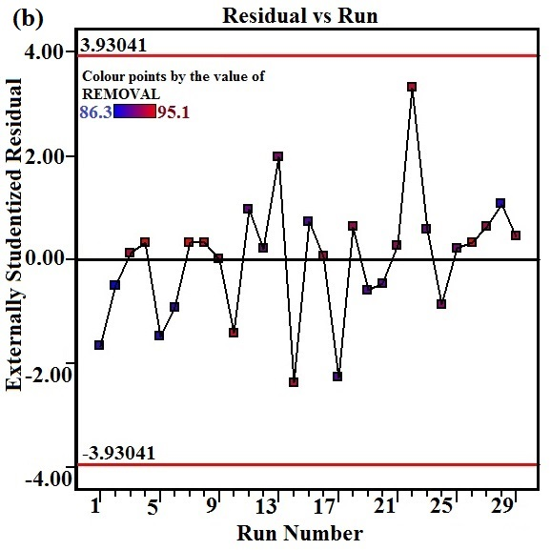
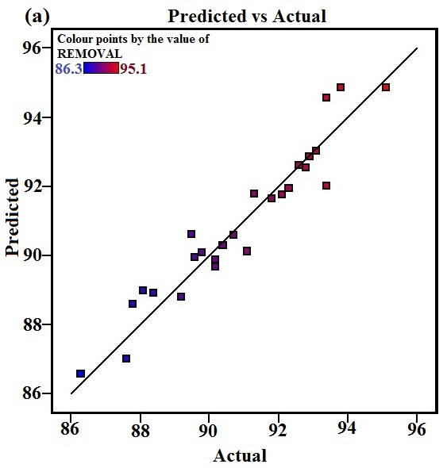

Fig. 1. RSM model graphs of a) Predicted vs Actual values b) Studentized residuals vs experimental run number on optimized parameters of As(V) removal

The Fig.1a graph, plotted between actual and predicted values for removal of As(v), indicated that the distribution of actual values were relatively close to the straight line,which, specifies the quadratic model necessity under the parameters studied. The plot between studentized residuals and run number, in Fig.1b, showed that the random distribution of residuals around ± 3.9 (limit is < ±4.00) was a good sign of well fitted experimental data with the model.²⁸

  - Effect of Process Variables on Removal of As(v)
The optimization process parameters and the interaction between the variables were studied by a plot of three-dimensional curves for the efficient adsorption of As(v).Fig. 2a, represents the effect of temperature and pH indicated that the adsorption reaches maximum at 35ºC on pH 6.5 beyond that desorption process start and continues due to complexation. Fig. 2b represents the correlation of temperature and reaction time having optimal adsorption efficiency of 95.1% was reached within 60 min at temperature of 35ºC, beyond that contact time (>60 min) and temperature (>35ºC), the adsorption rate decreased. The plot of temperature versus adsorbent dosage in Fig. 2c, shows that the degree of adsorption increases with increasing adsorbent dosage, upto 700mg on 35ºC, due to high surface availability, beyond 800mg dosage and 35ºC it has equilibrium and decreasing trend continues infers, that the process is controlled by temperature.²⁹ Fig. 2d, shows the effect of time and pH and the adsorption capacity was almost constant in the pH range 5 - 6, and then increases and reaches maximum at pH 6.5, which matches with the pKa value of chitosan.³⁰
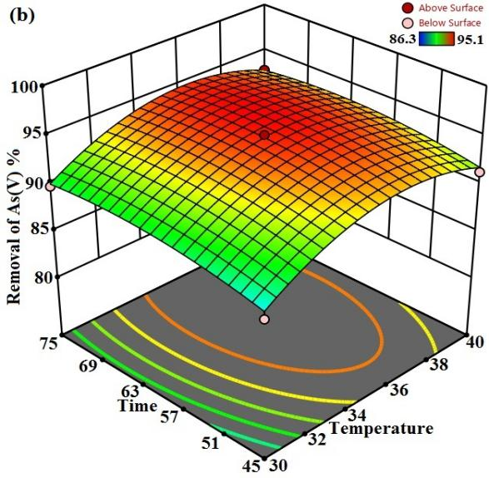
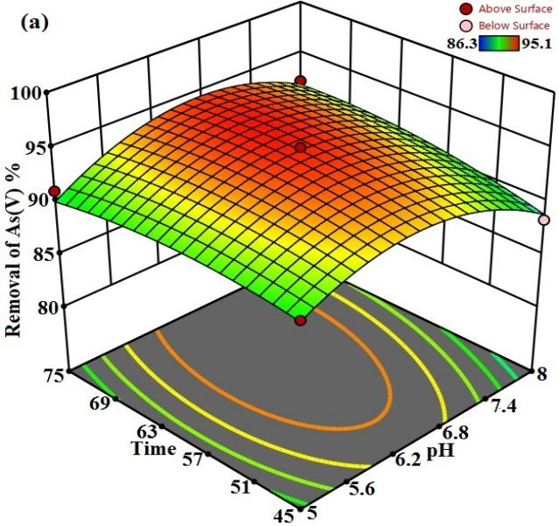

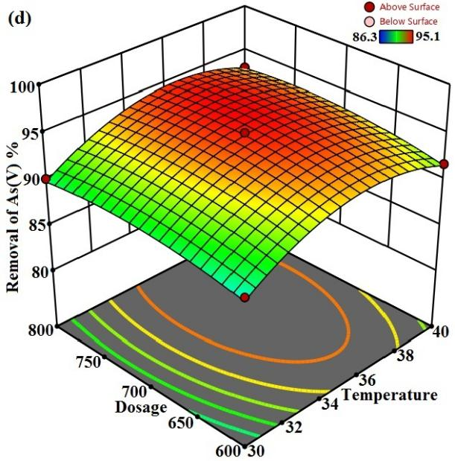
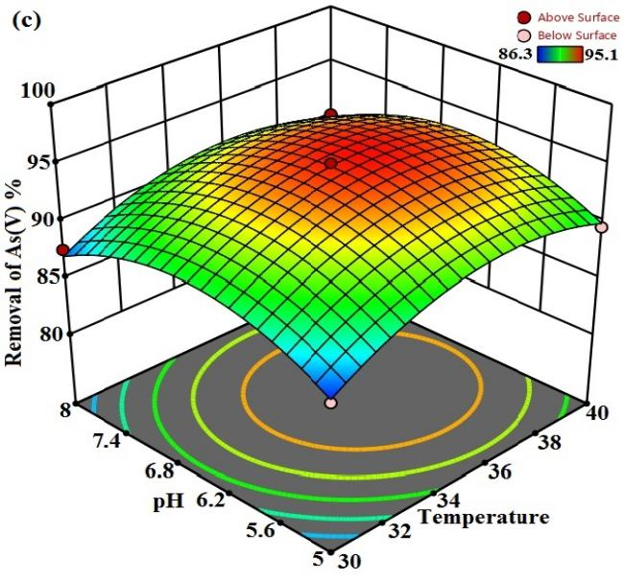

Fig. 2. 3D surface plot for multiple effects of a) time vs pH b) time vs temperature c) pH vs temperature and d) adsorbent dosage vs temperature on As(V) removal

From the above it was evident that the adsorption rate mainly depends on temperature and pH, while the contact time and adsorbent dosage had fringe effect only.The above fact is supported by the contour plot,³¹ in Fig. S1, between pH and temperature had a difference of minimum 0.5% between experimental and predicted removal efficiency shows that the adsorption is endothermic took place by the increasing diffusion rate and the growing rate of complexation between adsorbent and adsorbate.³²
  - Langmuir Isotherms
The isotherm models employed describes the sorption data, sorption mechanism, the surface properties and the affinity between sorbent and sorbate.³³The Langmuir isotherm model represents the monolayer sorption on an energetically uniform surface having maximum adsorption capacity, q_{m}=26.11-28.99mgg⁻¹, and higher regression coefficient, R²=0.9988 obtained from the relevant plots, Fig. 3a, and table V, suggesting that the surface of the sorbent was homogenous. The dimensionless factor ($R_{L}$=1/1+ b$C_{o}$) was calculated as <1, indicates favourable and monolayer adsorption process.The certainty of the isotherm were committed by the least RMSE and χ² values for Langmuir model than Freundlich model.
  - Freundlich Isotherm
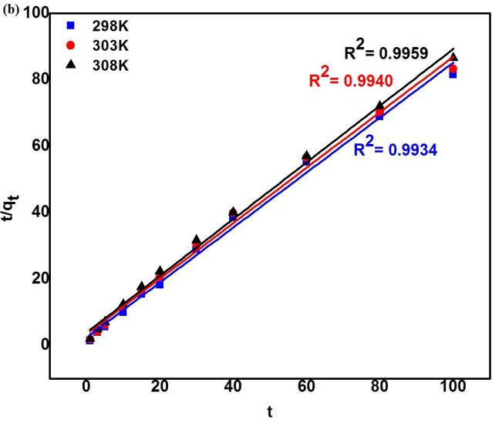
The isotherm describes the sorption on an energetically heterogeneous surface and the exponential distribution of active sites and their energies.³⁴ The value of n (adsorption intensity) obtained by the table 5, from the plot (Fig.S2) in the range 1-10 signifies the good performance of Fe₃O₄ doped CMC-EPI adsorbent towards As(V) adsorption.
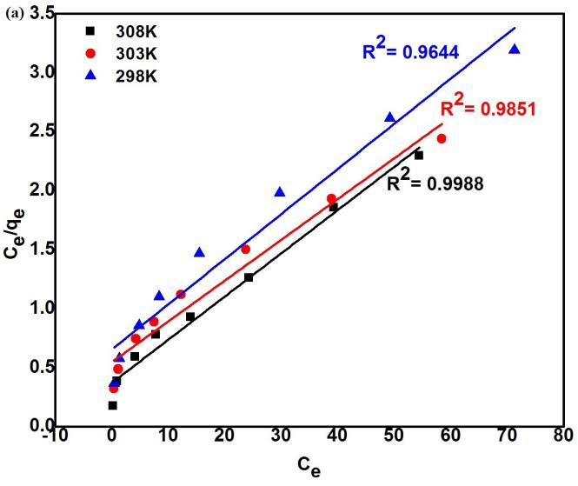
Fig. 3. a) Langmuir isotherm plot b) pseudo second order kinetics plot for the adsorption of As(V) ions at different temperatures

Table. 5. Isotherm parameters for As(v) adsorption onto the CMC-EPI/INC composite
Model | Parameters | Temperature (K)
Model | Parameters | 298 | 303 | 308
Langmuir | $$q_{m({mg.g}^{−1})}$$ | 26.11 | 27.38 | 28.99
Langmuir | $$k_{l(L.{mg}^{−1})}$$ | 0.0594 | 0.0668 | 0.0941
Langmuir | $$R^{2}$$ | 0.9644 | 0.9851 | 0.9988
Langmuir | $$R_{L}$$ | 0.6274 | 0.5995 | 0.5152
Langmuir | $$RMSE$$ | 0.3852 | 0.3526 | 0.2978
Langmuir | $$χ^{2}$$ | 0.2943 | 0.2896 | 0.1781
Freundlich | $$k_{f({mg.g}^{−1})}$$ | 1.4027 | 1.4276 | 1.5327
Freundlich | η | 1.9592 | 1.6489 | 1.8221
Freundlich | $$R^{2}$$ | 0.9623 | 0.9821 | 0.9898
Freundlich | $$RMSE$$ | 2.9651 | 3.1475 | 3.2541
Freundlich | $$χ^{2}$$ | 5.9621 | 5.6254 | 4.9632

  - Residual Mean Square Error (RMSE) and Chi-square (χ²) statistical test
To represent the errors in the isotherm curves the RMSE and Chi-square (χ²) statistical analysis is employed.
RMSE = $\frac{1}{n−2 }\sum_{i=1}^{n}{({qe}_{exp−}{qe}_{cal})^{2}}$ (6)
${qe}_{\exp{ ,}}{qe}_{cal}$ and n are the experimental, calculated values and number of observations respectively.³⁵The χ² test confirms the suitability of a particular isotherm model given by the equation,³⁶
χ² = $\sum{\frac{(qe,\exp{− qe,cal)^{2}}}{qe,cal}}$ (7)
The RMSE and χ² value would be less if the adsorption data correlated concurs with experimental values. By which, from Table V, the adsorption suitability more correlate with the Langmuir model than other models.

  - Kinetic Study
The kinetics,³⁷ effective adsorption capacity, initial adsorption rate and the rate constant of As(v) adsorption without any parameter in advance were evaluated using the pseudo First order and Second order equation.³⁸ The linear form of pseudo-first-order Lagergren equation and pseudo-second-order equation is given as equation 8 and 9
log (q_{e}- q_{t}) = log q_{e} – $\frac{kt}{2.303}$ (8)
$\frac{t}{qt}$ = $\frac{1}{k_{2}{qe}^{2}}$ + $\frac{t}{qe}$ (9)
The initial adsorption rate, h (mg/(g min)), as $t→0,$ can be defined as:
h =$k_{2{qe}^{2}}$ (10)
The kinetic parameters were obtained through the Pseudo first order plot (Fig.S3), and second order plot (Fig.3b) shows higher regression coefficient value of 0.996, (Table 6) for the second order model, exposed its applicability in fitting the experimental kinetic data. From the Table VI, it shows that the h value of As(V) adsorption at 35ºC was higher than at 25ºC.
Temp  (K) | $$q_{\begin{aligned}e,exp \\ {mg}/g\end{aligned}}$$ | Pseudo first order |  |  | Pseudo Second order |  |  |  | Intra particle diffusion
Temp  (K) | $$q_{\begin{aligned}e,exp \\ {mg}/g\end{aligned}}$$ | $$q_{\begin{aligned}e,cal \\ {mg}/g\end{aligned}}$$ | $${ k}_{1}$$  ($\min^{−1}$) | $$R^{2}$$ | $$h_{(mg.g\min^{−1)}}$$ | $$q_{\begin{aligned}e,cal \\ {mg}/g\end{aligned}}$$ | $${ k}_{1}$$  ($\min^{−1}$) | $$R^{2}$$ | $$k_{id}$$  ${(mg}/{{g.min}^{1/2}}$)  )
298 | 1.1954 | 1.1698 | 0.0193 | 0.9805 | 0.1957 | 1.0169 | 0.2326 | 0.993 | 0.0448
303 | 1.2015 | 1.1985 | 0.0218 | 0.9873 | 0.2142 | 1.1278 | 0.2432 | 0.994 | 0.0422
308 | 1.2235 | 1.0356 | 0.0246 | 0.9925 | 0.2583 | 1.1705 | 0.1885 | 0.996 | 0.0400
Table. 6. Kinetic parameters for As(v) adsorption onto the CMC-EPI/INC composite

  - Intraparticle diffusion
The Weber-Morris model for intraparticle diffusion explored the nature of the ‘rate-controlling step, which is given by the equation as,³⁹
$q_{id}$ = $k_{id}t^{0.5}$ + c (11)
Where $k_{id}$ is the intraparticle diffusion rate constant ((${mg}/g\min^{0.5}$)). From the plots $q_{e}$versus $t^{0.5}$, Fig. S4, the relationship is not linear and follows rate-limiting step. The first sharper portion being rapid external surface adsorption, the second portion being gradual adsorption and the final phase being final equilibrium stage due to the low concentration of As(V) in the solution phase as well as less number of available adsorption sites.

  - Adsorption thermodynamics
The thermodynamic parameters were utilized to elucidate the feasibility of adsorption.⁴⁰ The Van’t Hoff plot,Fig. 4 ($\ln{K_{c} }$against 1/T$)$ relates the parameters as
$lnK_{c}$ = $\frac{−∆H}{RT}$ + $\frac{∆S}{R}$ (12)
∆G = -$RT$ $lnK_{c}$ (13)
Where $K_{c}$ is the equilibrium constant, T the absolute temperature (K), and R is the universal gas constant (8.314J.mol⁻¹). The calculated values of the energy parameters ∆G, ∆H, and ∆S are given in the Table 7. The negative ∆G values observed at various temperatures suggested the feasibility and spontaneous adsorption process. The positive nature and the value of ∆H= 7.9835${kJ.mol}^{−1}$(< 80${kJ.mol}^{−1}$) suggesting that the reaction follows endothermic physisorption. The positive value of ∆S reflects the affinity and some structural changes in adsorbent and adsorbate during adsorption process.⁴¹
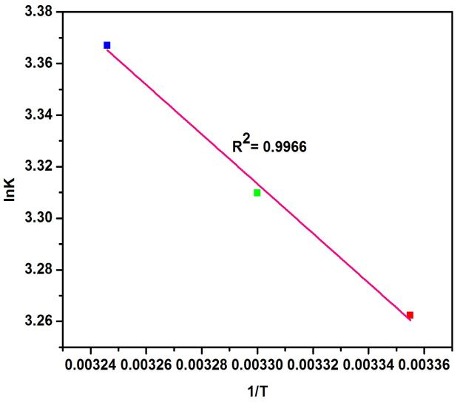
Table. 7. Thermodynamic parameters for As(v)
adsorption
Van’t Hoff plot
Temp | ∆G  ${(kJ}/{mol}$) | ∆H  ${(kJ}/{mol}$) | ∆S  $$(J/{{mol}/k})$$
289K | -8.0787 | 7.9835 | 0.0539
303K | -8.3482
308K | -8.6177

Fig. 4. Van’t Hoff plot at different temperatures

  - Desorption experiments
Desorption studies carried out with 0.1M NaOH, in a batch reactor. The desorption result
(Table SI), revealed that after four cycles around 81-87% of loaded As(v) were found to be
desorbed during desorption cycles. The desorption ratio was calculated by:
$R\left(\%\right)=\frac{C_{2}}{C_{0}−C_{1}}×100\%$ (14)
Where C₀, C₁, and C₂ are the initial, equilibrium concentration of adsorbed and desorbed solution in mg/l respectively.

- Conclusions
The removal of As(V) were successfully carried out in this study by the prepared novel hybrid crosslinked magnetite enhanced carboxymethylchitosan biosorbent. The optimization results of main variables by Box-Behnken Design of RSM model (R² = 0.9406) shows the process were good in agreement with arsenic adsorption. The maximum sorption capacity for As(V) was calculated to be 28.99 mg.g⁻¹ from the Langmuir isotherm, correlate with low RMSE and chi square value, and follows pseudo-second-order kinetics. Thermodynamic studies revealed the process is spontaneous, endothermic and physisorption in nature. Interfering ions had minimal effects on adsorption. The adsorbent was successfully recycled for four cycles and efficiently treated with As (V) contaminated wastewater. Thus, it could be concluded that the CMC-EPI/INC biosorbent would be a prospective candidate for arsenic filtering units, due to its biocongenial nature.

Acknowledgment
The authors also would like to thank Department of Chemistry, IIT Madras and Center for Environment, CLRI Chennai for providing the analytical instrumentation facility. One of the authors Dr.G.Prabha would like to thank University Grant Commission (UGC), Government of India, for providing the fund under the scheme of UGC – Dr. D.S. Kothari Postdoctoral Fellowship (Award No:F.4-2/2006(BSR)/CH/18-19/0110).

Conflict of interest
As the author(s), we declare that there is no conflict of interest regarding the publication of this article.

- References
- A.K. Sharma , J.C. Tjell J.C, J.J. Sloth, P.E. Holm, Appl. Geochem,(2014),41:11–33.
DOI: 10.1016/j.apgeochem.2013.11.012.
- S. Fendorf, H.A.Michael, A.Geen, Science Mag, (2010), 328 (5928), 1123-1127.
DOI: 10.1126/science.1172974
- P. L. Smedley, D.G.Kinniburgh, Appl. Geochem, (2002), 17, 517-568.
DOI: 10.1016/S0883-2927(02)00018-5
- W. E. Morton, D.A.Dunette, Arsenic in the Environment, Part II, Wiley and sons,New York
(1994), 17-34. DOI:10.1002/jat.2550150320
- Drinking water Quality Information, World Health Organization,Vol 2,WHO,Geneva
(1984), 940-949. DOI:10.1002/food.19860300121
- V.M Boddu, K. Abburi, J.L.Talbott, E.D. Smith, R.Haasch, Water. Res, (2008), 42, 633–642.
DOI:10.1016/j.watres.2007.08.014
- A. Dabrowski, Z. Hubicki, P. Podkościelny, E. Robens, Chemosphere, (2004), 56(2),
91–106. DOI:10.1007/s10450-006-0375-1
- T. F. Lin, J. K. Wu, Water Res, (2001), 35(8), 2049-2057.
DOI: 10.1016/S0043- 1354(00)00467-X
- H. Genc-Fuhrman, J. C. Tjell, D. McConhie, J. Colloid Interface Sci, (2004),27(2) 313-320.
DOI:10.1016/j.jcis.2003.10.011
10. F. Fu, Q.Wang, J. Envn Mgmt, (2011), 92(3), 407–418.DOI:10.1016/j.jenvman.2010.11.011
11. R. S. Juang, F. C. Wu, R. L.Tseng, Water Res, (1999), 33(10), 2403-2409.
DOI: 10.1016/s0043-1354 (98)00469-2
- P. Pillewan, S. Mukherjee, T. Roychowdhury, S. Das, A. Bansiwal, S. Rayalu,
J.Hazard. Mater, (2011), 186 (1), 367-375. DOI:10.1016/j.jhazmat.2010.11.008
- M.Bilal, Z. Jing, Y. Zhao, H. M. Iqbal, Biocatal. Agric. Biotechnol, (2019), 19,
101174 -101184. DOI:10.1016/j.bcab.2019.101174
- Y.Gutha, Y. Zhang, W. Zhang, X. Jiao, Int. J. Biol. Macromol, (2017), 97, 85-98.
DOI: 10.1016/j.ijbiomac.2017.01.004
- F. Marrakchi, W. A. Khanday, M. Asif, B. H. Hameed, Int. J. Biol. Macrol, (2016), 93(pt A),
1231-1239. DOI:10.1016/j.ijbiomac.2016.09.069
- K. P. Raven, A. Jain, R. H. Leoppert, Environ. Sci. Technol, (1998), 32(3), 344-349.
DOI: 10.1021/es970421p
- V. Fierro, G.Muniz, M. L. Ballinas, J. Hazard. Mater, (2009),168(1),430-437.
DOI: 10.1016/j.jhazmat.2009.02.055
- H. Genc-Fuhrman, J. C. Tjell, D. McConchie, Environ.Sci.Technol, (2004), 38(8),
2428-2439. DOI: 10.1021/es035207h
19. T. S. Anirudhan, L. Divya, J. Parvathy, Journal of Chemical Technology & Biotechnology, (2013), 88(5), 878–886. DOI:10.1002/jctb.3916
20. R. S.Vieira, M. M. Beppu, Coll.Surf. A, (2006), 279(1-3),196-207.
DOI:10.1016/j.colsurfa.2006.01.026
- E. Guibal, T.Vincent, R. Navarro, J. Mater. Sci, (2014), 49, 5505-5518.
DOI: 10.1007/s10853-014-8301-5
- Y. Haldorai, T. Rengaraj,Y. S. Huh, Y. K. Han, Mater.Sci.and Eng B,(2015),136921,01-10.
DOI: 10.1016/j.mseb.2015.01.006
- A. T Mohammad, A.S. Abdulhameed, A.H. Jawad, Int.J. Macromol, (2019), 129,98-109.
DOI: 10.1016/j.ijbiomac.2019.02.025
- K.Manzoor, M. Ahmad, S. Ahad, S. Ikram, RSC Adv, (2019), 9, 7890-7902.
DOI: 10.1039/c9ra00356h
- M. Monier, D. A. Abdel-Latif, Int. J. Biol. Macromol, (2017), 105(1), 777-787.
DOI: 10.1016/j.ijbiomac.2017.07.098
- J. L. Wang, C. Chen, Biotechnol Adv, (2009), 27, 195-226.
DOI: 10.1016/j.biotechadv.2008.11.002
- E. Guibal, Purif. Technol, (2004), 38(1),43-74. DOI: 10.1016/j.seppur.2003.10.004
- N.Ayawei, A. T. Ekubo, D. Wankasi, E. D. Dikio, Oriental. J. of Chem, (2015), 5(03),56-70.
DOI: 10.13005/ojc/310307
- S. Sharma, M. Bharathi, and N. Rajesh, Chemical Eng. J, (2015), 59, 457-466.
DOI: 10.1016/j.cej.2014.08.002
- C. Chia-Pin, L. Ming-Chao, L. Chung-Min, J. of Hazard. Mater, (2009), 171(1-3),859-864.
DOI: 10.1016/j.jhazmat.2009.06.086
- M. S. Rana, M. A. Halim, H. Waliul, H. Kamrul, M. K. Hossain, Biotechnol, (2009), 8(1),
160-166. DOI : 10.3923/biotech.2009.160.165
- H. Guo H,Y. Li, K. Zhao, J. of Hazard Mater, (2010), 176(1-3),174-180.
DOI: 10.1016/j.jhazmat.2009.11.009
- C. Yuwei, W. Jianlong, Chemical Eng. J, (2011), 168(1), 286-292.
DOI: 10.1016/j.cej.2011.01.006
34. G. E. J. Poinern, D. Parsonage, B. Touma B, M. K. Issa Ghosh, E. Paling, P. Singh, Inter. J. of Eng Sci. and Technol, (2010), 2(8), 13-24. DOI: 10.4314/ijest.v2i8.63776
35. A. S. Krishna Kumar, C. Uday Kumar, R. Vidhya, N. Rajesh, Inter. J. of Biological macromol, (2014), 66,135-143. DOI:10.1016/j.ijbiomac.2014.02.007
- G.Anjali, M. Yunus, S. Nalini, Chemosphere. (2012),86(2), 150-155.
DOI: 10.1016/j.chemosphere.2011.10.003
- B. Choudhary, D. Paul, J. Environ. Chem. Eng. (2018), 6(2), 2335-2343.
DOI: 10.1016/j.jece.2018.03.028
- K. Y. Foo, B. H. Hameed, Chem. Eng. J, (2010), 156(1), 2-10.
DOI: 10.1016/j. cej.2009.09.013
- W. J. Weber Jr, J. C. Morris, J. Saint. Eng Div, (1963), 89, 31-42.
DOI: 10.1073/pnas.85.14.5274
- W. Zhang, P. Singh, E. Paling, S. Delides, Mineral Eng, (2004), 17, 517-524.
DOI: 10.1016/j.mineng.2003.11.020
- H. M. Guo, D. Stuben, Z. Berner, Appl Geochem, (2007), 22(5), 1039-1051.
DOI: 10.1016/j.apgeochem.2007.01.004

