Statistical Optimization of As(V) Adsorption Parameters onto Epichlorohydrin/Fe₃O₄ crosslinked Chitosan derivative Nanocomposite using Box-Behnken Design

Vijayanand Nagarajan*¹, Raja Ganesan¹ , Srinivasan Govindan² , Prabha Govind³
*¹ Anna University,Faculty of Chemistry, Paavai Engineering College, Namakkal 637018, TN, INDIA
¹ Anna University,Faculty of Chemical Engineering, Paavai Engineering College, Namakkal 637018, TN,INDIA
² Anna University,Department of Applied Science and Technology, Alagappa College of Technology,Chennai 600005 INDIA
*Corresponding author:E-mail: vijayanandnagarajanpec@paavai.edu.in
Phone: +91 8344488356

SUPPLEMENTARY MATERIALS

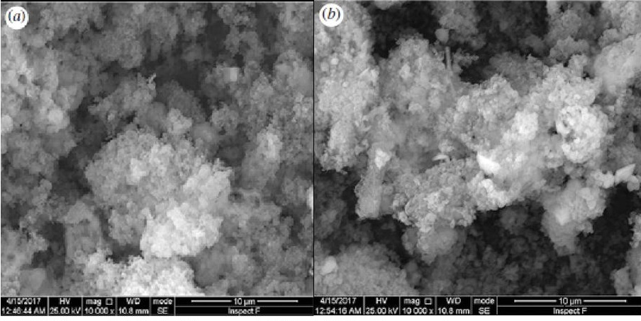

Fig. S1 SEM images of CMC-EPI/INC nanocomposite a) before and b) after As(V) adsorption

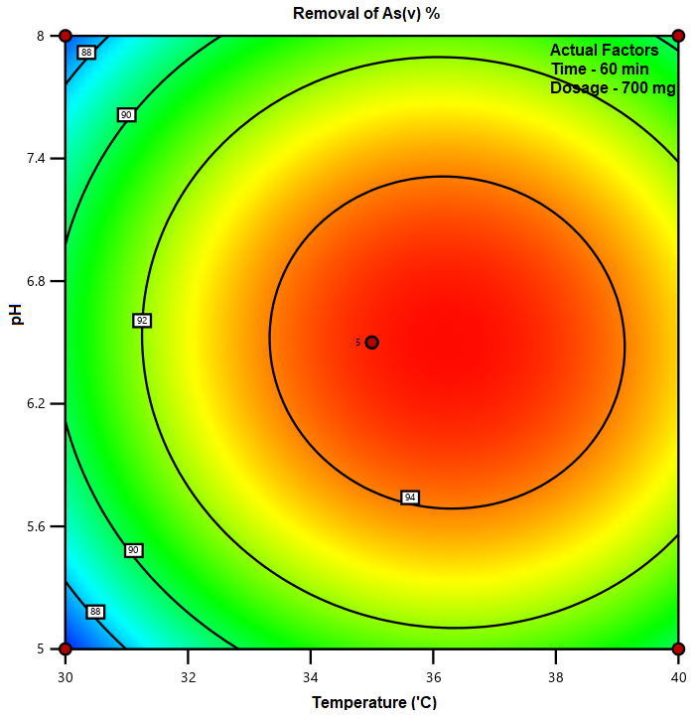

Fig. S2 Contour plot for multiple effects of pH vs temperature at 60 min of 700mg dosage for As(V) removal

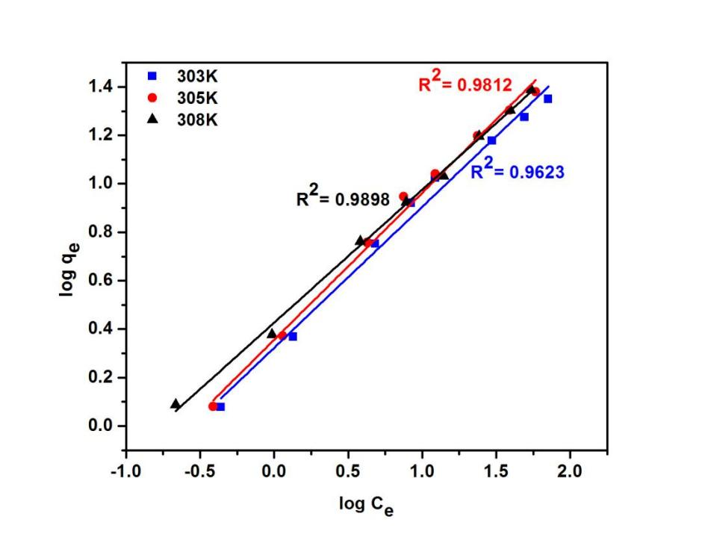

Fig. S3 Freundlich isotherm plot for the adsorption of As(V) ions at different temperatures

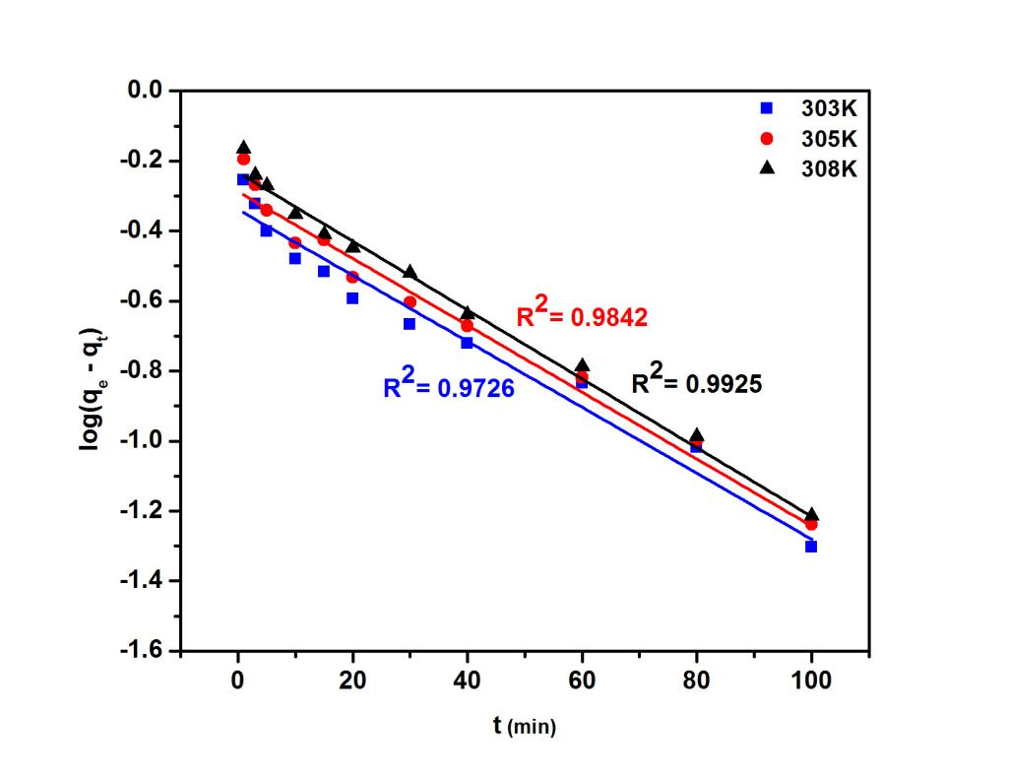

Fig. S4. pseudo first order kinetics plot for the adsorption of As(V) ions at different temperatures

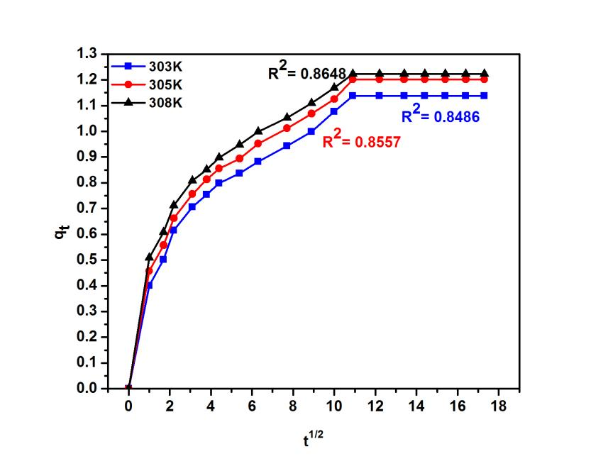

Fig. S5. Intra particle diffusion plot for the adsorption of As(V) ions at different temperatures

TABLE S1. Desorption cycles against the adsorption of As(V) ions with 0.1M NaOH

