Synthesis of the New 1-(7-methoxy-1-benzofuran-2-yl)-3-(4-methylphenyl) prop-2-en-1-one and Controlling of Spectroscopic, Optical and Conductivity Properties by Concentration
Demet Coskun ^{1,*}, Mehmet Fatih Coskun ¹, Bayram Gunduz ²
¹ Firat University, Department of Chemistry, 23200, Elazig, Turkey.
² Turgut Ozal University, Department of Engineering Basic Sciences, 44210, Malatya, Turkey.
dcoskun@firat.edu.tr , fcoskun@firat.edu.tr , bgunduz83@hotmail.com
Abstract
Chalcone derivatives have an important place in science due to their different applications from their semiconductor properties to their biological properties. In this work 1-(7-methoxy-1-benzofuran-2-yl)-3-(4-methylphenyl)prop-2-en-1-one (2) has been prepared by condensation of 1-(7-methoxy-1-benzofuran-2-yl) ethanone with 4-methylbenzaldehyde in basic medium. The chemical structure of compound 2 was confirmed by elemental analysis, FT-IR, ¹H NMR and ¹³C-NMR. UV spectroscopic characteristics, absorption band edges, optical band gaps, refractive indices, environmental behaviors and conductivity properties of compound 2 solutions for different concentrations were investigated in detail. With the concentration, we examined how the spectroscopic, optical and conductivity properties of compound 2 have changed and can be controlled.
Keywords: Benzofuran, chalcone, absorption band edge, optical band gap, refractive index, environmental behavior and conductivity properties.
1. Introduction
Benzofurans and their derivatives are used in the science of materials due to their significant fluorescence, absorption and quantum values,¹ electrochemical behavior, thermal stability,² blue-light emitting,³ layered organic light-emitting diodes (OLEDs)⁴ and organic electroluminescence (OEL)⁵ properties. Studies in recent years have indicated that benzofuran and its derivatives are good electron transport and perforated injection materials.⁶ Benzofurans exhibit significant optical properties due to the possibility of π - π * transitions.⁷ They are also in the semiconductor class. This is due to delocalization and intermolecular charge transfer.⁸⁻¹⁰ Conjugated organic molecules are very important in the second harmonic production due to their many delocalized π-electrons and provide easy charge transfer to first order polarization (β) nonlinear optical (NLO) applications.^{11,12} Chalcones are a class of flavonoids with significant biological activity.¹³⁻¹⁵ Chalcones are also important because of their optical applications such as second harmonic generating materials in nonlinear optics and their photophysical properties,¹⁶⁻¹⁹ holographic recording materials,²⁰ fluorescent probes for sensing of metal ions²¹ photo refractive polymers²², and micro environment in micelles.²³ The simplest chalcone structure is formed by two benzene rings that are connected by α, α-conjugated enol-keto groups.²⁴ Conjugated double bonds between benzene are responsible for nonlinear optical properties.²⁵ The spectroscopic and photophysical properties of chalcone compounds can be easily changed by conjugation. Many researchers have revealed different types of transmitter and receiver groups to increase nonlinear optical coefficients. In recent years, chalcone compounds containing phenyl groups have been reported to be important materials to create a donor-accepting regulation for high SHG.²⁶ Therefore, it is important to study the NLO properties and molecular structures of new chalcone derivatives. Previously, benzofuran substituted chalcones in which the electrone releasing groups are attached to the phenyl ring showed improved electro-optical properties. For this reason, in this study, we have selected benzofuran substituted chalcone derivative (2) comprising of methyl group. New chalcone derivative 2 was prepared using the reaction of 1-(7-methoxy-1-benzofuran-2-yl) ethanone with 4-methylbenzaldehyde in methanolic NaOH.
The aim of this study is to examine the effect of concentration on the spectroscopic, optical and conductivity properties and to investigate the important parameters for material science with device performance of compound 2. These aims were accomplished with great success in this study.
2. Experimental
All chemicals for compound synthesis were of analytical grade and were purchased from commercial sources. It was used without purification. Reactions were monitored by thin layer chromatography (TLC) using silica gel 60 plates. Buchi RE 11 rotary evaporator was used for solvent evaporation. A differential scanning calorimeter (Shimadzu DSC-50) was used for melting point measurement. A Leco CHNS-932 device was used for element analysis. For NMR spectra, a Bruker AC 400 (400MHz for ¹H NMR and 100MHz for ¹³C NMR) was obtained with deuterium dimethylsulfoxide (DMSO d₆) at 25 ° C. Chemical shift values were recorded in parts per million (ppm). FT-Infrared (FT-IR) spectra was recorded as KBr pellet on a Perkin-Elmer Spectrum One FTIR spectrometer. 1-(7-methoxy-1-benzofuran-2-yl) ethanone (1) was synthesized as described before.²⁷
General Procedure for synthesis of chalcone 2
4-methylbenzaldehyde (1 mmol) and 1- (7-methoxy-1-benzofuran-2-yl) ethanone (1 mmol) into MeOH (5 mL) cooled to 0-5 ° C It was added and mixed. Then 3 mL of aqueous NaOH (1 mol / L) was added and stirred for 3 hours at room temperature. The solution was poured onto the water-ice mixture and precipitated. The precipitated solid was washed with dilute HCl and water, dried and crystallized in ethanol.
Characterization techniques
A differential scanning calorimeter (Shimadzu DSC-50) was used for melting point measurement. A Leco CHNS-932 device was used for element analysis. For NMR spectra, a Bruker AC 400 (400MHz for 1H NMR and 100MHz for 13C NMR) was obtained with deuterium dimethylsulfoxide (DMSO d6) at 25 ° C. Chemical shift values were recorded in parts per million (ppm). FT-Infrared (FT-IR) spectra was recorded as KBr pellet on a Perkin-Elmer Spectrum One FTIR spectrometer.
1-(7-methoxy-1-benzofuran-2-yl)-3-(4-methylphenyl)prop-2-en-1-one (2)
Yield: 80%, mp 103-104 ºC. IR spectrum, ʋ, cm⁻¹: 3140-3001 (arom. C-H), 2966-2842 (aliph. C-H), 1653 (C=O), 1593 (C=C). ¹H NMR spectrum, δ, ppm: 8.29 s (1H, 3-H), 7.81-7.79 m (4H, α,β-H, 12,14-H), 7.41 d (1H, J=8.0 Hz, 4-H), 7.33-7.29 m (3H, 11,15-H, 5-H), 7.15 d (1H, J=8.0 Hz, 6-H), 3.98 s (3H, OCH₃), 2.36 s (3H, R₂=CH₃). ¹³C NMR spectrum, δC, ppm: 178.94, 153.77, 145.95, 145.27, 144.08, 141.66, 132.09, 131.07, 130.21, 129.52, 125.37, 121.19, 115.74, 115.58, 110.61, 56.36, 21.61. Found, %: C 78.10; H 5.45. C₁₉H₁₆O₃. Calculated, %: C 78.08; H 5.48.
Optical measurements of compound 2 solutions
The solutions of the compound 2 in the chloroform solvent for 6.0, 4.0, 0.7 and 0.2 mM concentrations were precisely prepared. Using a digital vortex mixer (Four E's Scientific CO., Ltd.), of the compound 2 was also better dissolved for chloroform. This process is very important in the solution technique for the most sensitive and accurate optical measurements. We recorded the optical measurements of the compound 2 solutions for related concentrations with an UV-1800 Spectrophotometer (Shimadzu model) at room temperature.
3. Results And Discussion
Synthesis and characterization
First, 1- (7-methoxy-1-benzofuran-2-yl) ethanone was synthesized from the reaction of 1-chloroacetone and 3-methoxy salicylaldehyde.²⁷ Benzofuran substituted chalcone derivative 2 was synthesized as shown in Fig-4. The most common method used for the synthesis of chalcone is the base catalyzed Claisen-Schmidt reaction, which includes condensation of a benzaldehyde derivative with an acetophenone derivative in ethanol or methanol with NaOH catalyst. In the characterization of Compound 2, FTIR, elemental analysis and NMR spectroscopy techniques were used.
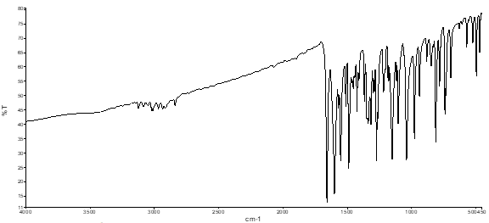
Fig. 1 FT-IR spectrum of compound 2.
Fig. 2 ¹H-NMR (DMSO-d₆) spectrum of compound 2.
Fig. 3 ¹³C-NMR (DMSO-d₆) spectrum of compound 2.
In the FT-IR spectrum, C = O stretching vibration of 1- (7-methoxy-1-benzofuran-2-yl) ethanol was observed at 1664 cm-1. Also, C=O stretching vibration in chalcone structure was observed at 1653 cm⁻¹. The reason for the shifting of the C = O tensile vibration of chalcone to low wave numbers is the delocalization of π-electrons between the a and β carbons. This reduces the order of C = O bonds. After all, it increases the order of bonding between carbonyl carbon and a carbon atom. Another characteristic peak of the chalcone compound is the C = C stretching vibration at 1593 cm -1. The most characteristic signals in ¹H-NMR spectra of the benzofuran substituted chalcone was observed at 8.29 ppm (3-H belong to benzofuran ring) and at 7.81-7,79 ppm (α and β hydrogens of chalcone moiety) with acoupling constants about 15 Hz which characterized the trans-configuration. The β-H signal is in a lower area than α-H. due to resonance of π-electrons between α and β carbons with carbonyl group. In the 13C-NMR spectrum, carbonyl carbon was observed at about 178 ppm. The spectra FT-IR, ¹H-NMR and ¹³C-NMR are given in Fig. 1, Fig. 2 and Fig.3.

Fig. 4 General synthesis of compounds (1) and (2). Reagants and conditions (i). K₂CO₃, acetone, reflax; (ii). NaOH, MeOH, r.t.

UV spectroscopic characteristics and absorption band edges of compound 2 solutions
Absorbance (A) is the amount of light absorbed by a solution (a sample). In other words, absorbance is a process of light that interacts with matter. Traditionally, absorbance measurements are carried out in a cuvette. We obtained UV spectra of the compound 2 solutions for 6.0, 4.0, 0.7 and 0.2 mM concentrations. Fig. 5 indicates the absorbance spectra of the compound 2 solutions for different concentrations. In higher molarities, it is normal that the absorbance curves do not appear completely. In higher molarities, it is normal that the absorbance curves do not appear completely. All absorbance curves of solutions below certain concentrations can be observed. As seen in Fig. 5, all absorption curves are observed for 0.7 and 0.2 mM. The maximum absorbance peak for 0.7 and 0.2 mM is observed at 347 v4 345 nm, respectively. The compound 2 has a single peak and its absorbance decreases as the concentration is reduced.

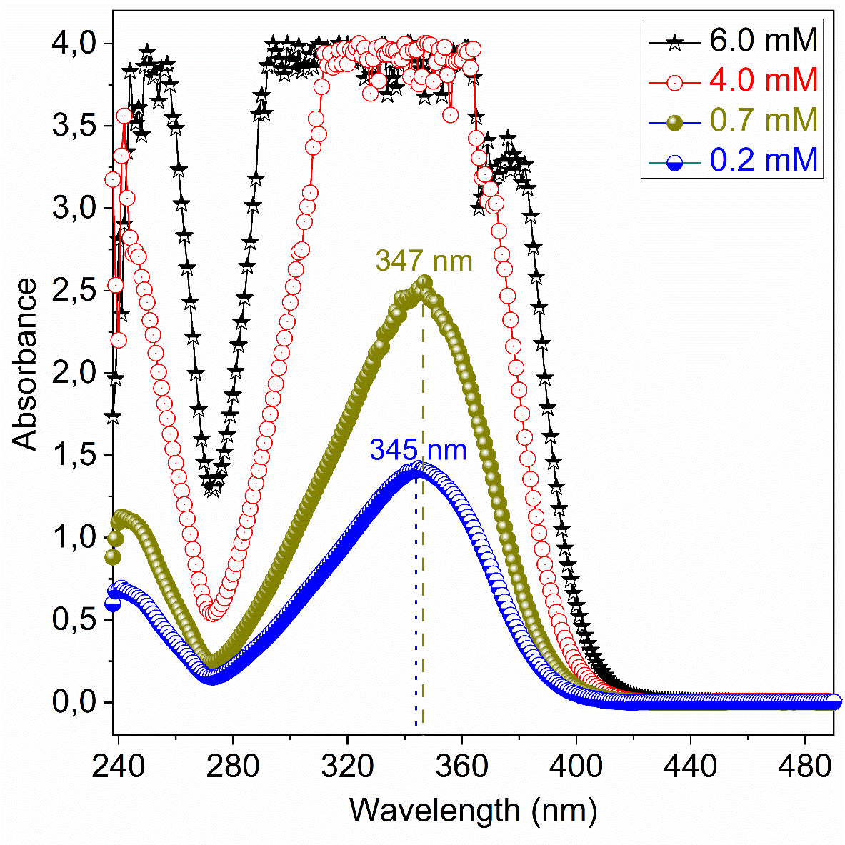
Fig. 5 The absorbance spectra of the compound 2 solutions for 6.0, 4.0, 0.7 and 0.2 mM concentrations.

Transmittance (T) is defined as light passing through an object that is not reflected or absorbed. It is relatively easy to determine the permeability levels of an object. Transmittance is the transmitted part of incoming light. The transmittance spectra of the compound 2 solutions for 6.0, 4.0, 0.7 and 0.2 mM are shown in Fig. 6a. As can be seen in Figure 6a, all transmittance displays a peak at 273 nm and increase sharply in the range of about 350-420 nm. Transmittance increases with decreased concentration.
When examining the UV spectroscopic properties of a material, it is important to consider the absorbance band edge (E_{Abe}) of the material. Because this parameter is a specific parameter of the related material, it gives very important information about the absorption and the behavior of the material in the environment. Therefore, we investigated the absorbance band edges of the compound 2 for different concentrations and we obtained the E_{Abe} values from the maximum peaks using the dT/dλ curves vs. wavelength (λ) as seen in Fig. 6b. While the concentration increased from 0.2 to 6.0 mM, the absorbance band edge of the compound 2 decreased from 3.002 to 2.877 eV. It is expected that the absorbance band edge decreased with increasing concentration as can be seen in the insert of Fig. 6b. This result indicates that the absorbance band edge of the compound 2 can be controlled by concentration. Solutions with lower absorbance band edge are a desirable and preferred feature for metal-semiconductor based structures.
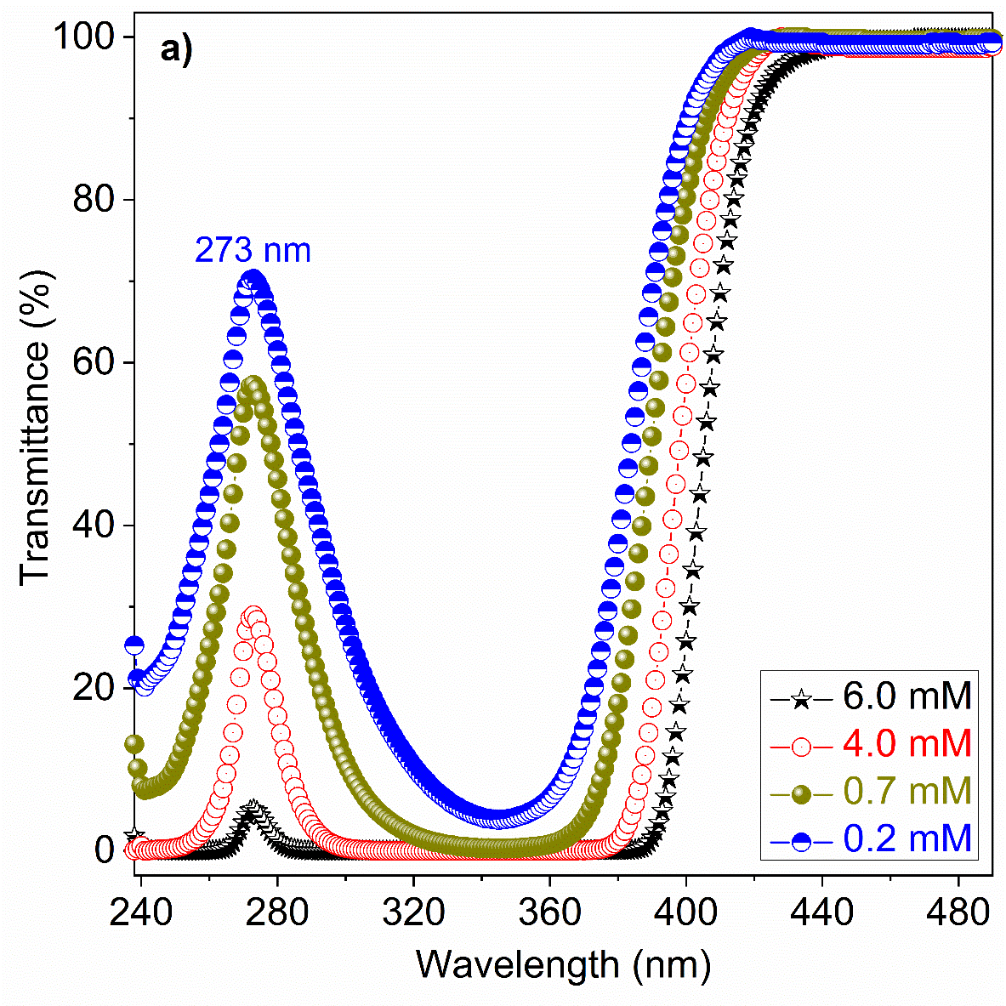
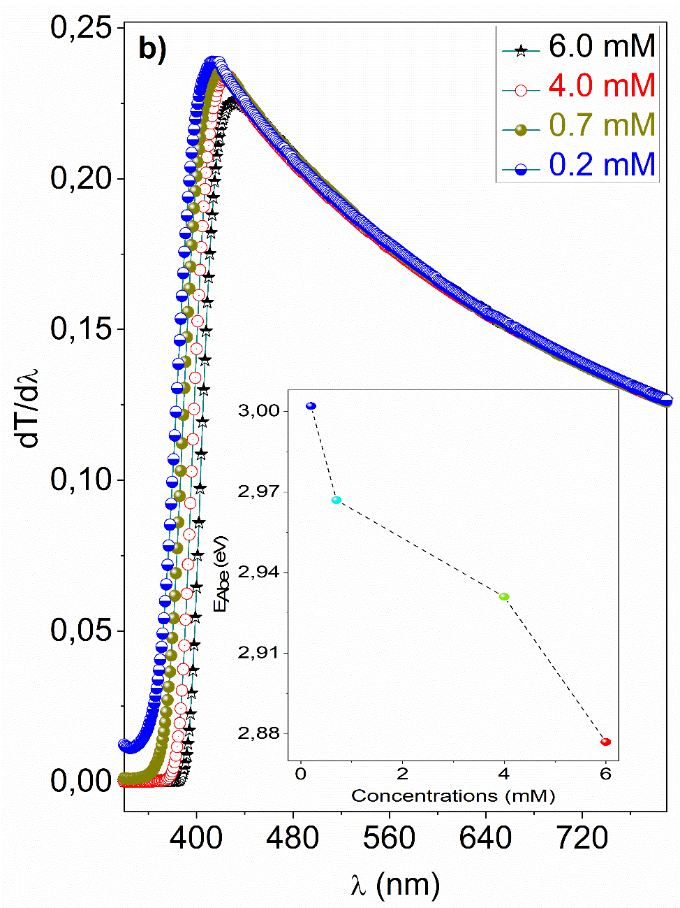
Fig. 6 The a) transmittance spectra b) dT/dλ curves vs. wavelength (λ) of the compound 2 solutions for 6.0, 4.0, 0.7 and 0.2 mM.

Controlling of optical band gap of compound 2 solutions
When it comes to optical properties, one of the first parameters that come to mind is the optical band gap (E_{g}) parameter. This parameter is very important for the determination of material and device performance. The E_{g} can be estimated from Tauc model²⁸ given by

(1)

where α is absorption coefficient, and E are the photon energy, A is a constant and m determines type of the optical transitions. We found m as ½, which corresponds to allowed direct optical band gap (E_{gd}). Therefore, the curves vs. E of the compound 2 solutions for 6.0, 4.0, 0.7 and 0.2 mM were plotted as seen in Fig. 7a. By extrapolating the linear plot to , the E_{gd} values of the compound 2 for different concentrations were obtained. As seen in Fig. 7b, the direct optical band gap of the compound 2 varies from 3.046 to 2.926 eV. That is, as the concentration increases, the optical band gap decreases. Materials with the lowest optical band gap are preferred for many electronic, optical and photonic devices. Because the lowest band gaps weaken the mobility barrier of the carrier.

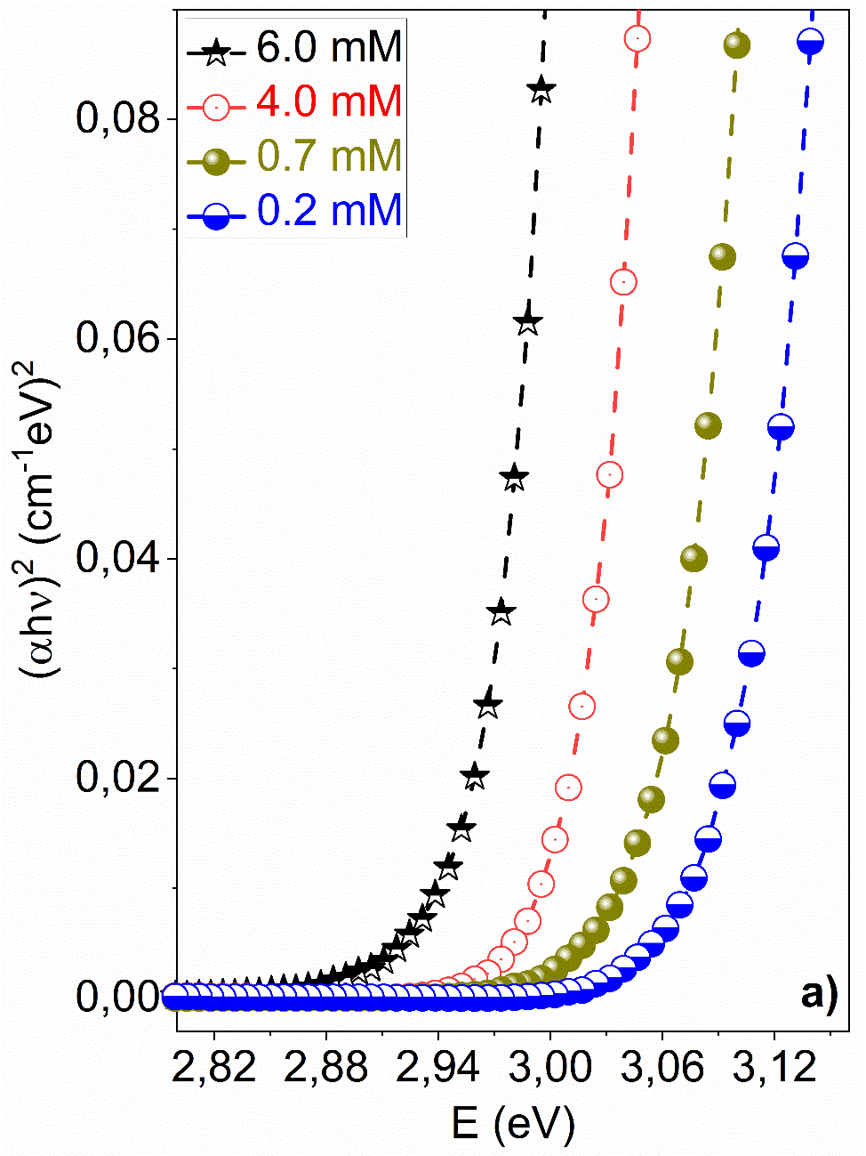
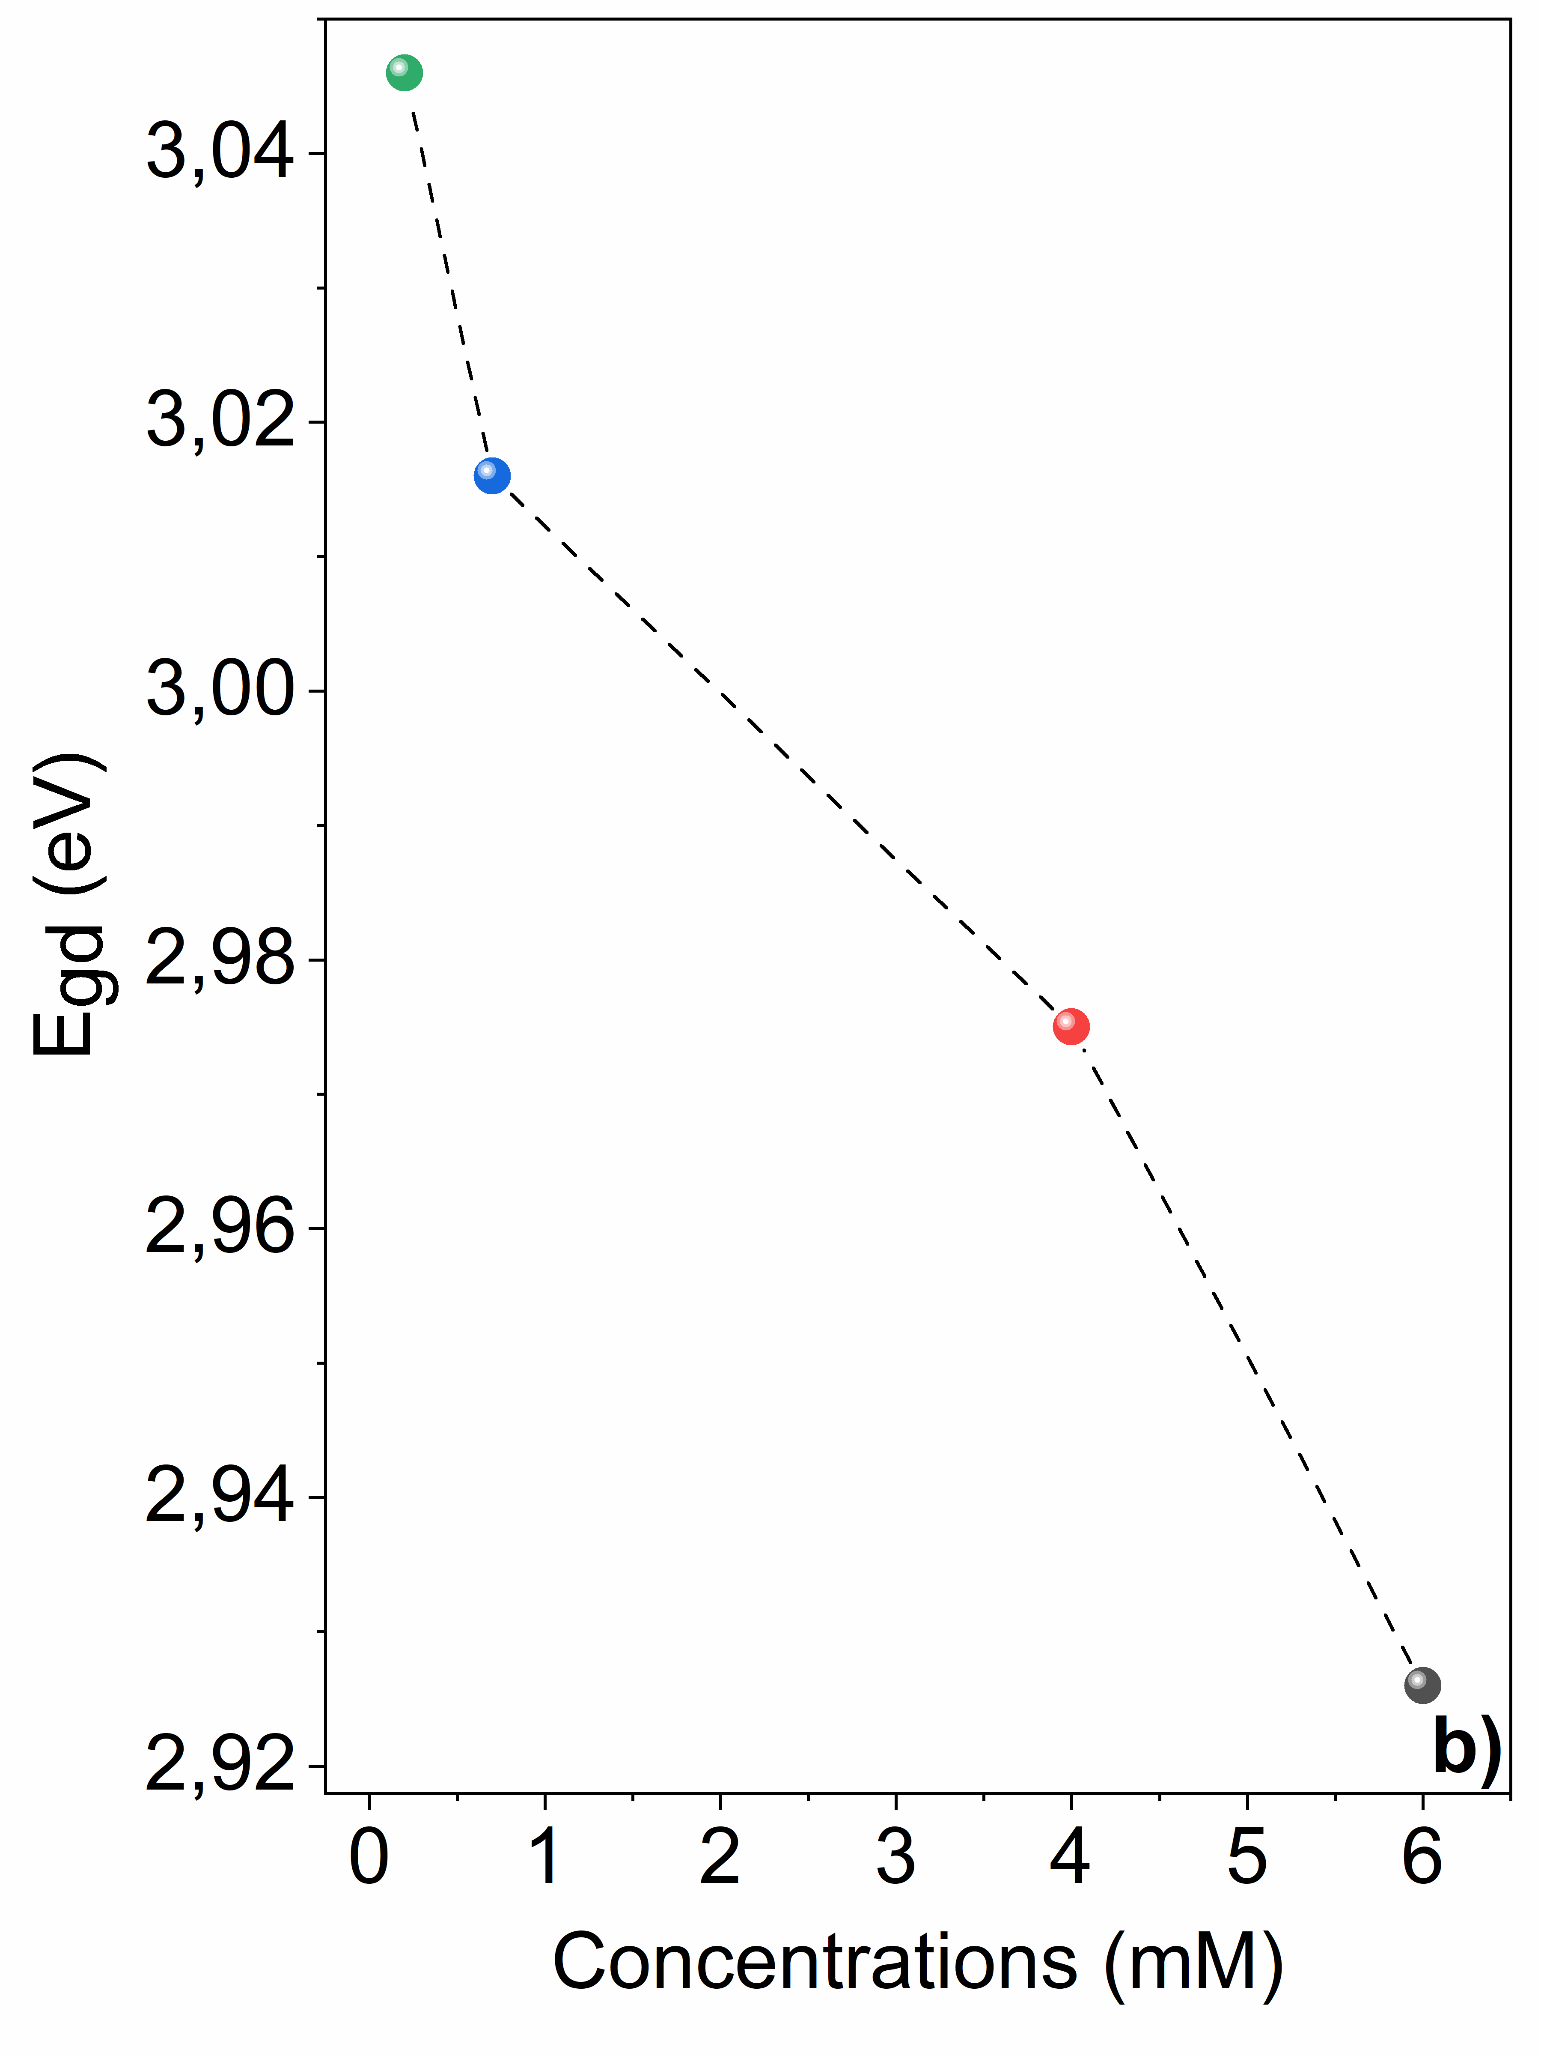
Fig. 7 The a) curves vs. E b) E_{gd} curves vs. concentrations of the compound 2 solutions.

Controlling of refractive index of compound 2 solutions
Another parameter that comes to mind when talking about optical properties is the refractive index (n). The refractive index is a measure of the bending of a ray of light as it passes from one medium to another. The n can be explained with reflectance (R) and is calculated from following equation,^{29,30}
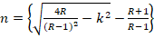 (2)
where k=αλ/4π. The refractive indices of the compound 2 solutions for 6.0, 4.0, 0.7 and 0.2 mM were calculated from Eq. (2). The n curves of the compound 2 solutions for different concentrations are shown in Fig. 8a. Fig. As seen in 8a, the refractive index increases with increasing angular frequency. This behavior is known as normal dispersion behavior. In addition, it is observed that the index of refraction increases with increasing concentration. This indicates that the refractive index can vary and can be controlled with different concentrations.
There are many relations such as Herve-Vandamme, Kumar-Singh, Moss, Ravindra and Reddy^{31,32} to obtain the refractive indices based on optical band gaps. The refractive indices of the compound 2 solutions for 6.0, 4.0, 0.7 and 0.2 mM were obtained. The n curves vs. concentrations of the compound 2 for related relations are shown in Fig. 8b. The refractive indices obtained from Reddy relation are the highest, while the refractive indices obtained from Ravindra relation are the lowest. Also, the index of refraction increases with increasing concentration for all correlations as seen in Fig. 8b.
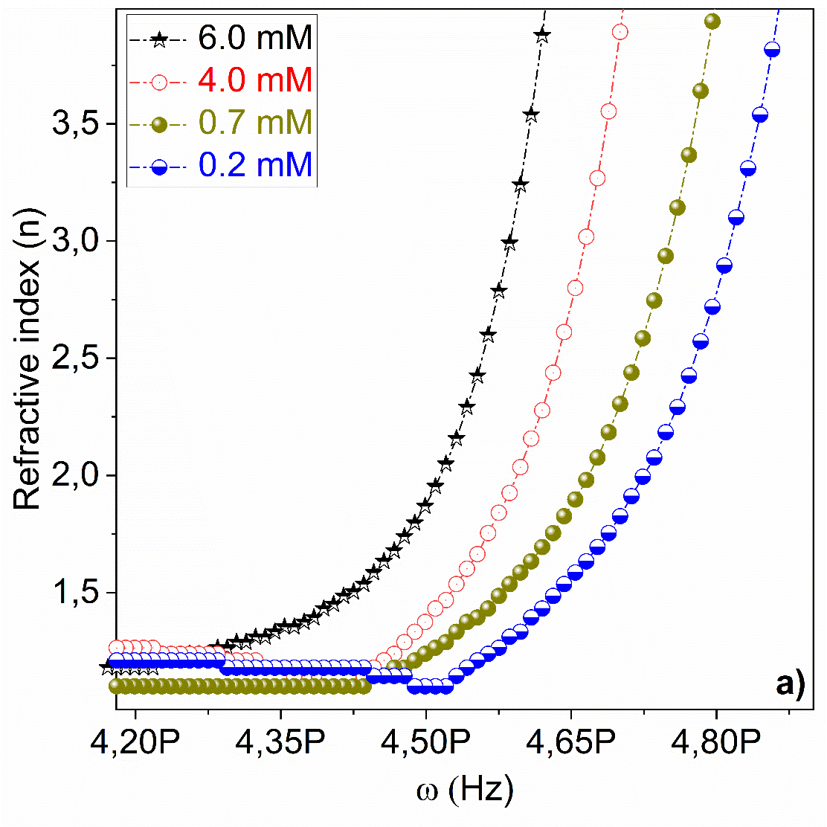
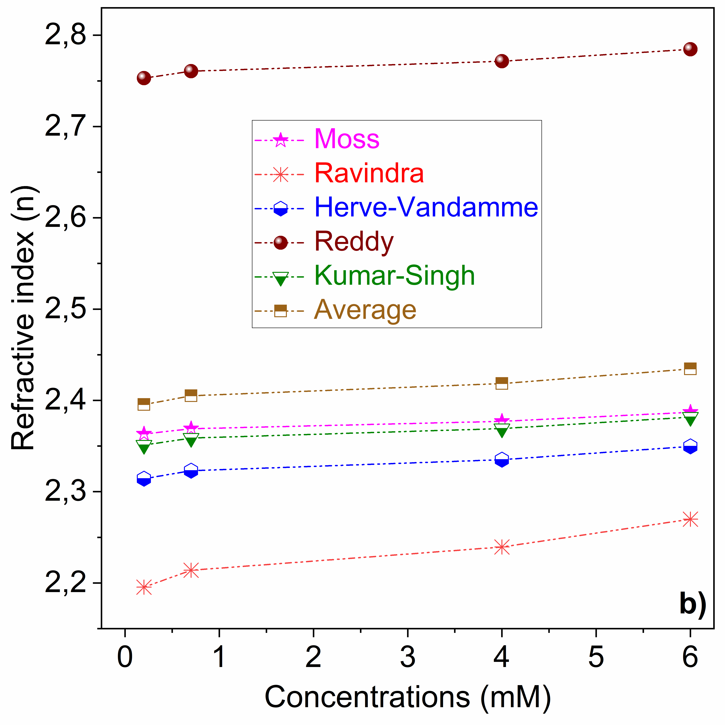
Fig. 8 The a) curves vs. angular frequency (ω) b) curves vs. concentrations of the compound 2 solutions.

Environmental behavior of compound 2 solutions
The behavior of a material in different environments, in other words, its interaction with light is very important for the science of materials and devices. Incidence angle (Φ1) and refraction angle (Φ2) play an important role in investigating the behavior of the material in an environment. The Φ₁ is given by the following equation,^{29,33}
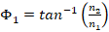 (3)
We calculated the incidence angle of the compound 2 solutions for 6.0, 4.0, 0.7 and 0.2 mM from Eq. (3). The Φ₁ plots vs. E of the compound 2 for related concentrations are shown in Fig. 9. These curves give the variation of the angle of incidence of the compound 2 according to the wavelength. In other words, it shows at which wavelengths the angles of incidence are decreasing and increasing. Also, as concentration increases, angles of incidence also increase.
The Φ₂ is given by,
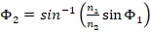 (4)
The refraction angles of the compound 2 solutions for 6.0, 4.0, 0.7 and 0.2 mM were calculated from Eq. (4). Fig. 9 indicates the Φ₂ plots vs. E of the compound 2 for these concentrations. As expected, the angles of refraction are smaller than the angles of incidence. The angle of refraction varies with varying wavelengths. On the other hand, as the concentration increases, the angle of refraction decreases.
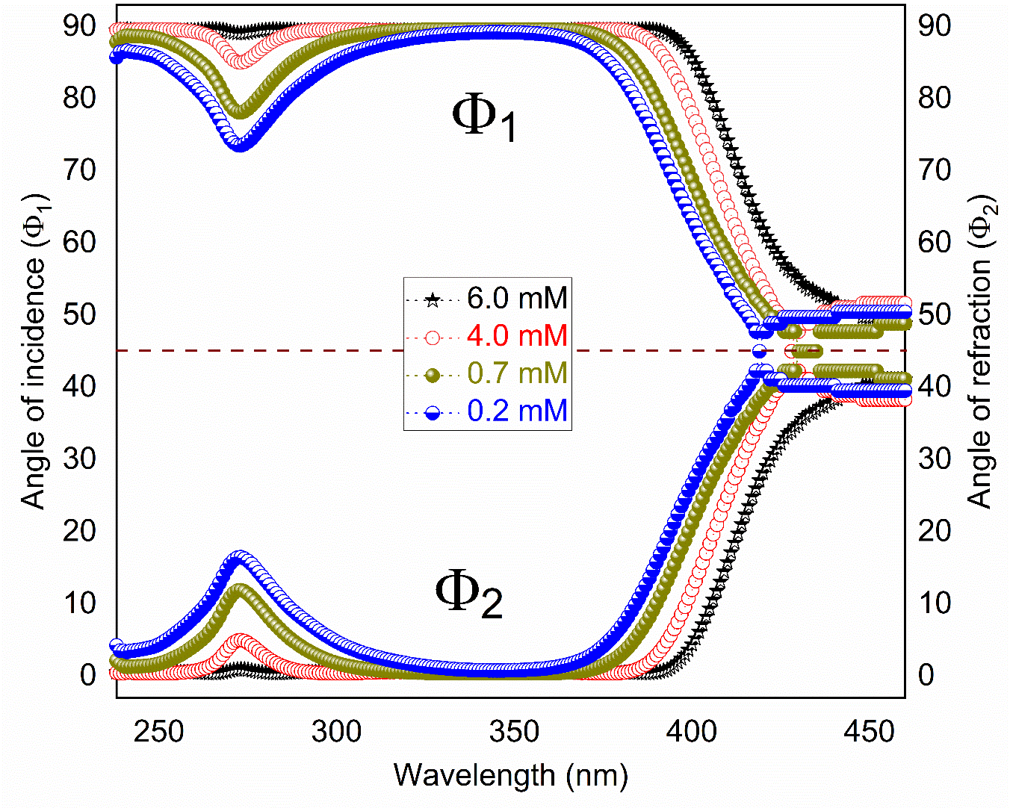
Fig. 9 The incidence angle (Φ1) and refraction angle (Φ2) plots vs. E of the compound 2 for various concentrations.

Conductivity properties of compound 2 solutions
Conductivity plays an important role in materials science and device performance. Optical and electrical components of conductivity make a great contribution to electronic and optical applications. The optical conductance (σ_{opt}) and electrical conductance (σ_{elec}) properties can be explained by,³⁴ respectively.
(5)
where c is the velocity of light. σ_{elec} is given as;
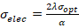 (6)
The σ_{opt} and σ_{elect} values of solutions of the compound 2 for 6.0, 4.0, 0.7 and 0.2 mM were calculated from Eqs. (5) and (6), respectively. The optical and electrical conductance curves vs. ω are shown in Fig. 10(a,b), respectively. As seen in Fig. 10a, the compound 2 displays peaks at about 5.5 PHz at low concentrations, while the compound 2 displays pits at about 6.9 PHz at higher concentrations. The optical conductance values are order of 10¹¹ S. On the other hand, the electrical conductance values are order of 10³ S. As can be seen, both optical conductivity and electrical conductivity vary significantly with varying concentration and angular frequency.
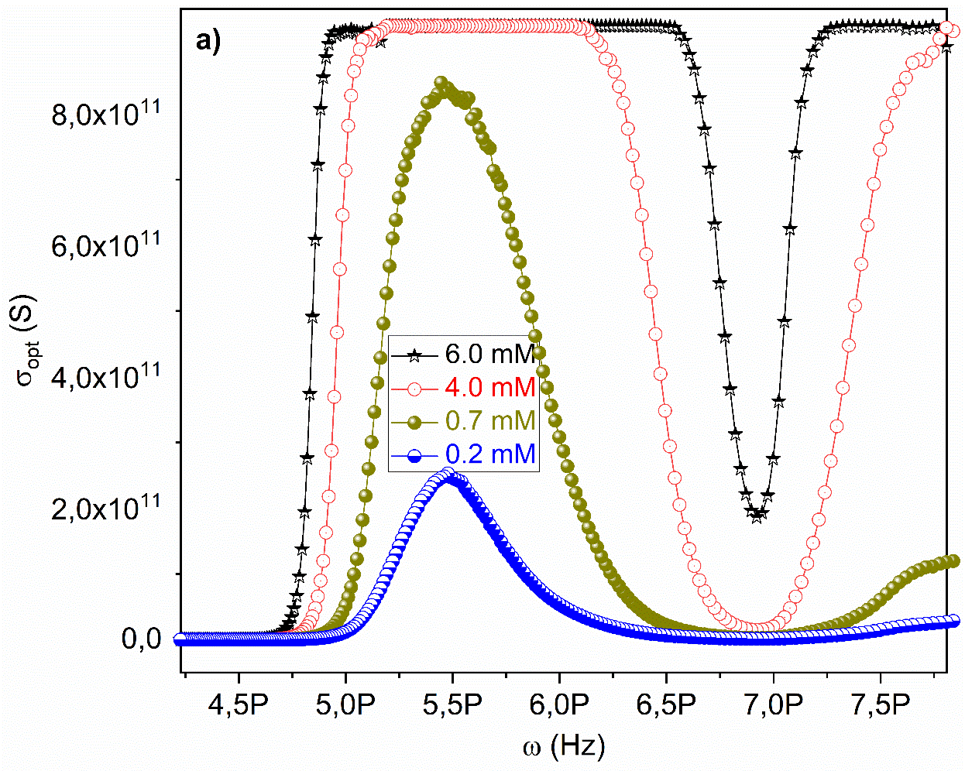
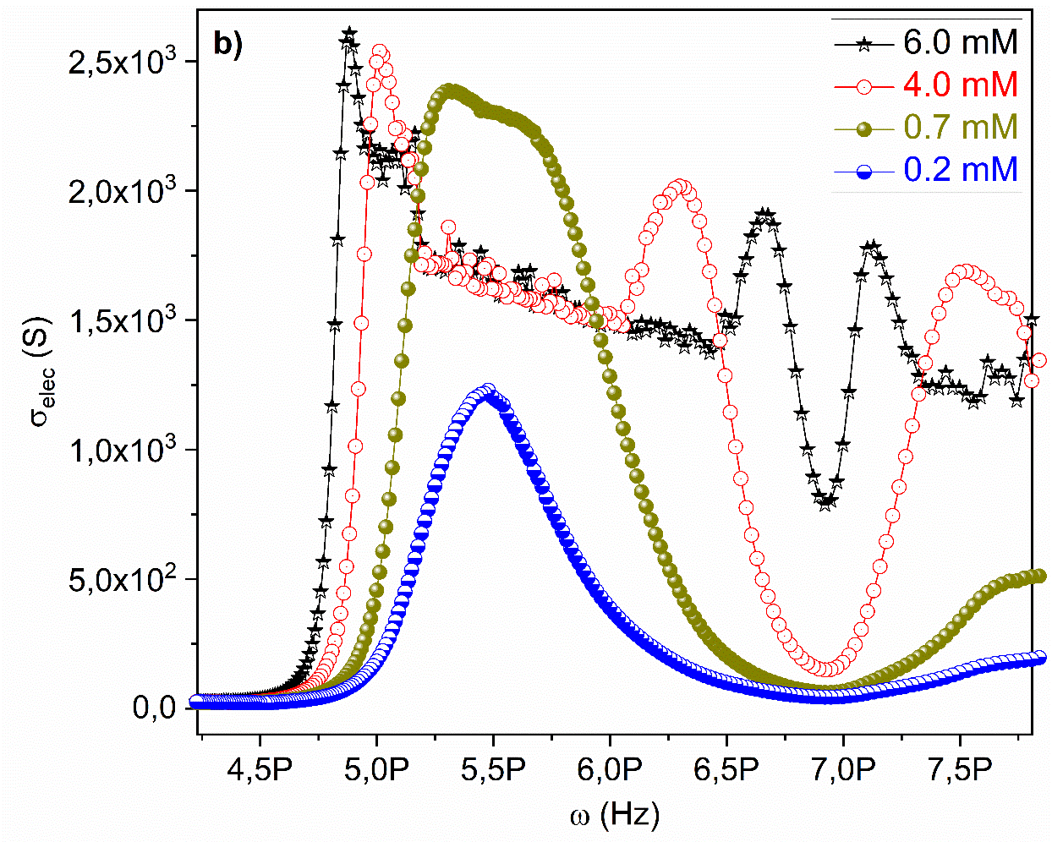
Fig. 10 The a) σ_{opt} and b) σ_{elec} curves vs. ω of the compound 2 solutions for 6.0, 4.0, 0.7 and 0.2 mM.
4. Conclusions
We examined the effect of concentration on the spectroscopic, optical and conductivity properties and investigated the important parameters of the compound 2 for material science and device performance. The absorbance band edge of the compound 2 decreased from 3.002 to 2.877 eV, while the direct optical band gap of the compound 2 varies from 3.046 to 2.926 eV. The refractive index can vary and can be controlled with different concentrations. Both optical conductivity and electrical conductivity vary significantly with varying concentration and angular frequency. According to the data obtained, the compound 2 contains promising properties for semiconductor and conjugated polymer technology and applications.
Acknowledgements
The authors thank Firat University for financial support of this work.
5. References
1. J. X. Yang, X. L. Wang, Tusong, L. H. Xu, Dyes Pigm. 2005, 67, 27-33. DOI:10.1016/j.dyepig.2004.09.017
2. J. K. Xu, G. M. Nie, S. S. Zhang, X. J. Han, S. Z. Pu, L. Shen, Q. Xiao, Europ. Poly. J. 2005, 41, 1654-1661. DOI:10.1016/j.eurpolymj.2005.01.014
3. A. R. Hwu, K. S. Chuang, S. H. Chuang, S. C. Tsay, Org. Lett. 2005, 7, 1545-1548. DOI:10.1021/ol050196d
4. H. Tsuji, C. Mitsui, L. Ilies, Y. Sato, B. Nakamura, J. Am.. Chem. Soc., 2007, 129, 11902-11903. DOI:10.1021/ja074365w
5. S. Anderson, P. N. Taylor, G. L. B. Verschoor, Chem. Eur. J. 2004, 10, 518-527. DOI:10.1002/chem.200305284
6. S. Glenis, M. Benz, E. Legoff, J. L. Schindler, C. R. Kannewurf, M. G. Kanatzidis, J. Am. Chem. Soc. 1993, 115, 12519-12525. DOI:10.1021/ja00079a035
7. Y. Y. Li, A. M. Ren, J. K. Feng, L. Yang, C. C. Sun, Opt. Mater. 2007, 29, 1571-1578. DOI:10.1016/j.optmat.2006.05.012
8. T. A. Fayed, Chem. Phys. 2006, 324, 631-638. DOI:10.1016/j.chemphys.2005.11.039
9. E. Sucre-Rosales, R. Fernandes-Teran, N. Urdaneta, I. E. Hernandez, L. Echevarria, Chem. Phys. 2020, 537, 110854. DOI:10.1016/j.chemphys.2020.110854
10. M. Koca, F. Dagdelen, Y. Aydogdu, Mater. Lett. 2004, 58, 2901-2905. DOI:10.1016/j.matlet.2004.05.016
11. M. Shkir, S. Muhammad, S. AlFaify, A. Irfan, P. S. Patil, M. Arora, H. Algarni, J. P. Zhang, RSC Adv. 2015, 5, 87320-87332. DOI:10.1039/c5ra13494c
12. C. Valverde, S. A. D. E. Castro, G. R. Vaz, J. L. D. Ferreira, B. Baseia, F. A. P. Osorio, Acta Chim. Slov. 2018, 65, 739-749. DOI: 10.17344/acsi.2018.4462
13. K. Kiran, M. Sarasija, B. A. Rao, V. Namratha, D. Ashok, A. S. Rao, Russ. J. Gen. Chem. 2001, 89, 1859-1866. DOI:10.1134/S1070363219090214
14. N. Yayli, O. Ucuncu, E. Aydin, Y. Gok, A. Yasar, C. Baltaci, N. Yildirim, M. Kucuk, J. Photochem. Photobiol. A: Chem. 2005, 169, 229-234. DOI:10.1016/j.jphotochem.2004.06.015
15. D. Coskun, M. Erkisa, E. Ulukaya, M. F. Coskun, F. Ari, Eur J. Med. Chem. 2007, 136, 212-222. DOI:10.1016/j.ejmech.2017.05.017
16. N. I. Rtishchev, G. I. Nosova, N. A. Solovskaya, V. A. Luk’yashina, E. F. Galaktionova, V. V. Kudryavtsev, Russ. J. Gen. Chem. 2001, 71, 1272-1281. DOI:10.1023/A:1013237415295
17. J. Zyss, I. Ledoux, M. Bertault, E. Toupet, Chem. Phys. 1991, 150, 125-135. DOI:10.1016/0301-0104(91)90062-X
18. S. R. Maidur, J. R. Jahagirdar, P. S. Patil, T. S. Chai, C. K. Quah, Opt. Materi. 2018, 75, 580-594. DOI:10.1016/j.optmat.2017.11.008
19. P. S. Patil, M. Shkir, S. R. Maidur, S. AlFaify, M. Arora, S. V. Rao, H. Abbas, V. Ganesh, Opt. Materi. 2017, 72, 427-435. DOI:10.1016/j.optmat.2017.06.038
20. W. C. Li, S. P. Deng, Y. G. Liu, L. S. Yao, X. H. Lu, L. Xuan, Acta Poly. Sini. 2011, 7, 758-765. DOI:10.3724/SP.J.1105.2011.10223
21. K. Rurack, J. L. Bricks, G. Reck, R. Radeglia, U. Resch-Genger, J. Phys. Chem. A. 2000, 104, 3087-3109. DOI:10.1021/jp994269k
22. S. J. Sun, G. Schwarz, R. H. Kricheldorf, T. C. Chang, J. Polym. Sci. A: Polym. Chem. 1999, 37, 1125-1133. DOI:10.1002/(SICI)1099-0518(19990415)37:8<1125::AID-POLA9>3.0.CO;2-J
23. M. Shannigrahi, S. Bagchi, Spectrochim. Acta Part A Mol. Biomol. Spect. 2005, 61, 2131-2138. DOI:10.1016/j.saa.2004.08.012
24. L. Kamath, K. B. Manjunatha, S. Shettigar, G. Umesh, B. Narayana, S. Samshuddin, B. K. Sarojini, Opt. Laser Tech. 2014, 56, 425-429. DOI:10.1016/j.optlastec.2013.09.025
25. Gunter, P.: Nonlinear Optical Effects and Materials, Springer, Berlin, 2000.
26. B. Ganapayya, A. Jayarama, R. Sankolli, V. R. Hathwar, S. M. Dharmaprakash, J. Mol. Struct. 2012, 1007, 175-178. DOI:10.1016/j.molstruc.2011.10.042
27. D. Coskun, B. Gunduz, M. F. Coskun, J. Mol. Struct. 2019, 1178, 261-267. DOI:10.1016/j.molstruc.2018.10.043
28. J. Tauc, A. Menth, J. Non-Cry. Solids. 1972, 8, 569-585. DOI:10.1016/0022-3093(72)90194-9
29. B. Gunduz, Poly. Bull. 2015, 72, 3241-3267. DOI:10.1007/s00289-015-1464-7
30. B. Gunduz, Opt. Mat. 2013, 36, 425-436. DOI:10.1016/j.optmat.2013.10.005
31. S. K. Tripathy, Opt. Mater. 2015, 46, 240-246. DOI:10.1016/j.optmat.2015.04.026
32. M. Cabuk, B. Gunduz, App. Surf. Sci. 2017, 424, 345-351. DOI:10.1016/j.apsusc.2017.03.010
33. F. Abeles, Opt. properties of solids. North-Holland Publishing Company, Amsterdam, 1972.
34. M. M. Abd El-Raheem, J. Phys. Conden. Matt. 2007, 19, 216209-216215. DOI:10.1088/0953-8984/19/21/216209

