Supplementary Information for
Dehydrogenation of 1-Phenylethanol Catalyzed by Nickel(II)diphosphine Complexes

Fig S1: ³¹P{¹H} NMR spectrum of the complex [1,2-bis(diphenylphosphino)ethane]dichloronickel(II) (C4)

Fig S2: ³¹P{¹H} NMR spectrum of C4 after treating with 1-phenyl ethanol.

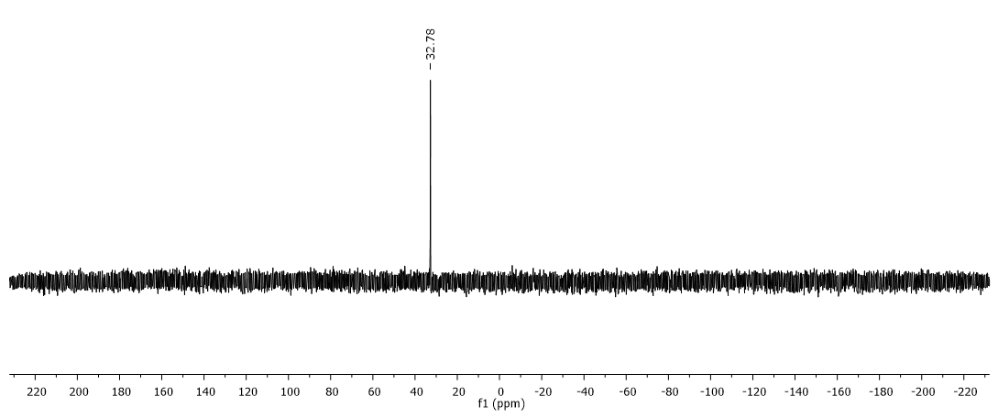

Fig S3: ³¹P{¹H} NMR spectrum of catalytic mixture (within 5 min)

Fig S4: ³¹P{¹H} NMR spectrum of catalytic mixture (after 24h)

