Medicinal plants extracts impact on oxidative stress in mice brain: the effects of corn silk, parsley, and bearberry
Marijana VRANJEŠ¹, Dubravka ŠTAJNER², Dejan VRANJEŠ¹, Bojana BLAGOJEVIĆ^{2*}, Ksenija PAVLOVIĆ³, Dubravka MILANOV⁴, Boris M. POPOVIĆ²
¹ Emergency Centre, Clinical Centre of Vojvodina, Hajduk Veljkova 1, 21000 Novi Sad, Serbia
² Chemistry and Biochemistry Laboratory, Department of Field and Vegetable Crops, Faculty of Agriculture, University of Novi Sad, Trg Dositeja Obradovića 8, 21000 Novi Sad, Serbia
³ Department of Chemistry, Biochemistry and Environmental Protection, Faculty of Sciences, University of Novi Sad, Trg Dositeja Obradovića 3, 21000 Novi Sad, Serbia
⁴ Scientific Veterinary Institute “Novi Sad”, Rumenački put 20, 21113 Novi Sad, Serbia

*Corresponding author: Bojana Blagojević, Faculty of Agriculture, University of Novi Sad, Trg Dositeja Obradovića 8, 21000 Novi Sad, Serbia, bojana.blagojevic@polj.uns.ac.rs, telephone: +381214853272
Abstract: This study was performed to examine the effects of medicinal plant extracts of corn silk (Stigma maydis), parsley leaf (Petroselinum crispum folium), and bearberry leaf (Uvae ursi folium) on antioxidant status of the brain of experimental animals (mice). Biological properties of these plants are insufficiently investigated and the aim was to explore their possible antioxidant effects that can alleviate oxidative damage of the brain tissue. Corn silk extract showed positive effect on activities of antioxidant enzymes in mice brain tissue. Parsley extract induced the increase in glutathione content and decrease of lipid peroxidation. Bearberry leaf extract induced catalase activity and decrease of hydroxyl radical content, while malonyldialdehide accumulation was maintained at the control level. Results obtained in this study support the use of corn silk, parsley and bearberry leaves as natural non-toxic antioxidant sources in the prevention and treatment of brain tissue damages and different diseases caused by oxidative stress.

Keywords: corn silk; parsley; bearberry; brain; oxidative stress; antioxidants
- Introduction
Oxidative stress is one of the biggest threats to brain cells because of their large oxygen consumption.¹ Brain oxidative stress can be monitored primarily by superoxide and hydroxyl radical, hydrogen peroxide, other reactive oxygen species (ROS) and lipid peroxidation (LP) products.² Moreover, brain damages caused by free radicals can lead to serious neurological disorders such as stroke, dementia, Alzheimer’s disease.³ Traumatic brain injuries (TBI) are followed by increased reactive species production and LP process that can further cause severe damages and fatal consequences.⁴ Human clinical trials still did not result in efficient neuroprotective therapies for TBI and this disorder is among the most severe health problems and causes of death worldwide.⁵
When nerve injury occures, the first minutes and hours are critical because of the activation of numerous sources of superoxide anion radical (O₂^{•-}). The brain, like the other organs in aerobic organisms, has potent defenses against superoxide, including enzymatic antioxidants such as superoxide dismutase (SOD), catalase (CAT), guaiacol peroxidase (GPx), glutathione peroxidase (GSH-Px) and reduced glutathione as nonenzymatic antioxidant (GSH).⁶ By reduction of oxidative stress, they play important roles in neurotoxicity and neurological disorders.⁷
Over the last time period, the accent is given to the drugs with antioxidant properties, designed to scavenge reactive species responsible for LP induction and its neurotoxic effects.⁴ Natural products can enhance antioxidant defense activities and minimize different tissue oxidative damages.^{8,9} It was shown that high dietary intake of some vitamins, carotenoids and flavonoids from food and medicinal plants can reduce the risk of Alzheimer’s disease and exhibit a protective effect on neural tissue.¹⁰
Although the bioactive potential of corn silk (Stigma maydis), parsley leaf (Petroselinum crispum folium) and bearberry leaf (Uvae ursi folium) is insufficiently tested, these medicinal plants showed the antioxidative and protective roles in treatment and prevention of many diseases, especially renal diseases, nephritis, kidney stones, chronic cystitis, for weakened kidneys, liver or pancreas.¹¹⁻¹³ The aim of this study was to explore their protective antioxidative and free radical scavenging effects that could prevent oxidative damage of the mice brain tissue.
- Experimental
  - Chemicals and reagents
Folin-Ciocalteau’s reagent, guaiacol (2-methoxyphenol), NBT (Nitro Blue Tetrazolium), DPPH (2,2-diphenyl-1-picrylhydrazyl), TPTZ (2,4,6-tripyridyl-triazine), TBA (2-thiobarbituric acid), iron(III) chloride and potassium dihydrogen phosphate, methanol (HPLC gradient grade) and standard substances were obtained from Sigma-Aldrich (Beograd, Serbia). All other reagents and chemicals were of analytical grade.
  - Plant extracts preparation
Corn silk (Stigma maydis), parsley leaf (Petroselinum crispum folium) and bearberry leaf (Uvae ursi folium) originated from Serbia and were bought commercially (Dr. Josif Pančić Institute). Dried plant material was ground into a fine powder and macerated in 96% ethanol (1:20, w/v) for 72 h in the dark. Ethanol was evaporated under reduced pressure at 40 ˚C. The yields (Y) of obtained extracts were 6.12%, 8.28% and 34.93% for corn silk, parsley leaves and bearberry leaves, respectively. Dry residues were redissolved in water to obtain 5% (w/v) extracts.
  - Experimental animals
Three months old male mice (Mus musculus, NMRI strain), weighing 31-46 g, were housed at the Department of Pharmacology, Toxicology and Clinical Pharmacology, Medical Faculty, University of Novi Sad, Serbia. Animals were handled in accordance with the European Union principles established for research on animal models (EU Directive 2010/63/EU) and Serbian national guideline (No. 41/09). Animals were bred at controlled temperature (21 ± 1 ºC) and humidity (55% ± 1.5%), with 12 h day/12 h night cycle. They were fed standard laboratory mice feed, produced by the Veterinary Institute in Zemun, Serbia. During the treatment, every animal was kept in a separate metabolic plexiglas cage. Ten animals were regarded as one group. The first group served as control and had ad libitum access to water and feed. Instead of water, animals in the other three groups were given appropriate plant extract: corn silk, parsley and bearberry leaf extract, respectively. After 28 days of the treatment, animals were sacrificed under urethane anesthesia. Brain tissue was removed and homogenized.
  - Preparation of brain homogenate
According to the method of Vranješ et al.¹³, after washing the brain tissue in saline solution, it was homogenized in 1.15% potassium chloride solution and 0.05 M potassium phosphate buffer solution (pH 7.4) to yield 10% homogenate (w/v). The mixture was ultrasonicated for 15 minutes and then centrifuged 5 minutes at 4000 × g and 4 °C. Supernatants were kept at −20 °C until analyses. Samples prepared as described were used for all assays except for DPPH scavenger activity. For this test one gram of brain tissue was homogenized with 10 mL of ethanol and extract was used for the radical scavenging determination.
  - Assessment of prooxidant / antioxidant activity
The activity of the enzyme superoxide dismutase (SOD) was estimated by the ability of the extract to inhibit photosensitive reduction of nitro blue tetrazolium chloride (NBT) reagent.¹⁴ The quantity of the enzyme needed for 50% inhibition of the NBT formation is expressed as one Unit (U). Final results were calculated as U per milligram of protein. Catalase (CAT) activity was determined by measuring the reduction of absorbance at 240 nm, as a consequence of the degradation of H₂O₂.¹⁵ Guaiacol peroxidase (GPx) activity was determined by transformation of guaiacol to tetraguaiacol,¹⁶ while the activity of glutathione peroxidase (GSH-Px) was assessed using cumene hydroperoxide and reduced glutathione (GSH) as substrates.¹⁷ Soluble protein content was set by the method of Bradford.¹⁸ The intensity of lipid peroxidation (LP) was expressed as the amount of malonyldialdehyde (MDA), which is one of the final products of lipid membrane degradation.¹⁹ Hydroxyl radical quantity was measured by the inhibition of deoxyribose degradation²⁰ and the quantity of GSH with Ellman reagent.²¹
Antioxidant capacity was determined by free radical scavenging capacity and FRAP (Ferric Reducing Antioxidant Power) test.
Free radical scavenging capacity was determined using DPPH (1,1-diphenyl-2-picrylhydrasyl) radical.²² Scavenging capacity was calculated by Eq 1:
Inhibition (%) = (A_{control} – A_{sample})/A_{control} × 100% (1)
The concentration of the homogenate that inhibits 50% of the DPPH radical is defined as IC₅₀ value.
FRAP test was performed according to the method of Benzie and Strain (1999),²³ measuring the total antioxidant potential of the sample through the reduction of ferric ions (Fe³⁺) to ferrous ions (Fe²⁺). Results were expressed as FRAP units. FRAP unit is equal to the concentration of 100 μmol/L Fe²⁺.
  - Plant extracts polyphenol characterization by HPLC-PDA method
Separation and identification of polyphenol compounds were performed using the reversed phase high preasure liquid chromatography (RP-HPLC) with a photodiode array (PDA) detector. The spectra were acquired in the range 190–600 nm and chromatograms were plotted at 280 (hydroxybenzoic acids), 320 (hydroxycinnamic acids), 350 (flavonoids). The results were expressed as μg of the polyphenol compound per mL of the extract. For the flavonoid derivatives calibration curve of corresponding flavonoid glucoside was used for calculation and derivatives of hydroxycinnamic acids were calculated as corresponding aglycones.²⁴
  - Statistical analysis
All determinations were performed in triplicate. Data were expressed as mean ± standard error (SE). Values are given as means for ten mice. For statistical evaluation of data Statistica 12 software (StatSoft Inc., USA) was used. Statistical significance of differences between means was tested by Duncan’s multiple range test (p < 0.05).
- Results and discussion
The results of the antioxidant enzymes SOD and CAT activities in mice brain tissue are presented in Figure 1a and 1b, respectively. The only favorable and the highest SOD activity was observed after corn silk treatment (2.78 U/mg protein). SOD isoenzymes play an important role in cerebral ischemia, particularly in reperfusion injury when brain cells are resupplied with oxygen that leads to overproduction of ROS and LP process. Therefore, altering SOD activity can reduce neurotoxicity.²⁵ Bearberry extract treatment elevated CAT activity (1.17 U/mg protein), but more effective was the influence of corn silk extract (1.92 U/mg protein).
Figure 1. The activity of antioxidant enzymes SOD (a), CAT (b), GPx (c) and GSH-Px (d) in mice brain after the plant extract treatment.
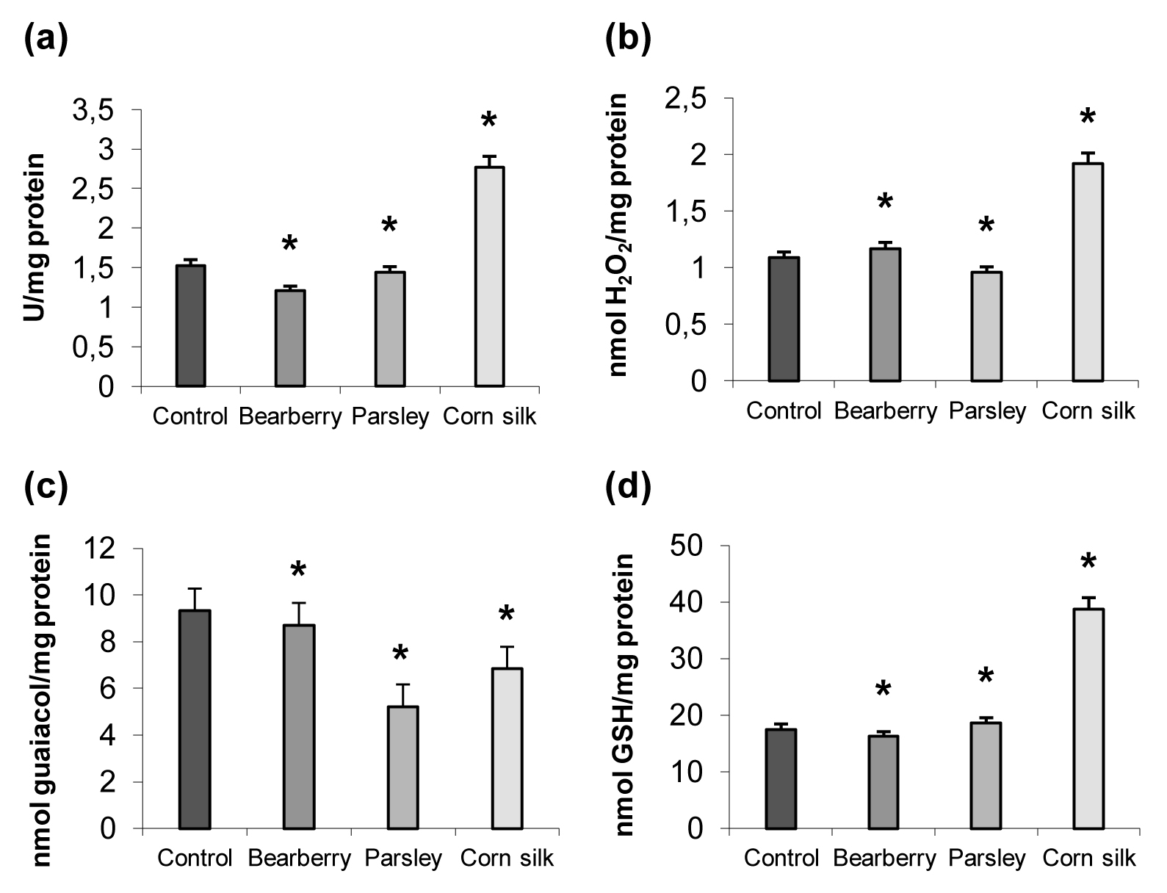
*Marked values significantly differ from control according to the Duncan’s multiple range test results (p < 0.05).
The results presented in Figure 1c show that GPx activity in mice brain tissue decreased under the influence of all studied plant extracts. The lowest enzyme activity was obtained after the parsley extract intake (5.22 nmol guaiacol/mg protein). In comparison to the control and to the other examined extracts, corn silk extract significantly enhanced the activity of GSH-Px (38.78 nmol GSH/mg protein, Figure 1d). Mice GSH-Px activity is very important for the detoxification of H₂O₂ in brain cells in physiological conditions. It was proved that if GSH-Px is inhibited, CAT compensates its activity and vice versa, but in metabolic stress, it is important that all scavenging mechanisms are active²⁶, which was achieved by corn silk extrat in our experiment.
Figure 2. The soluble protein content (a) and reduced gluthatione content (GSH; b) in mice brain after the plant extract treatment.
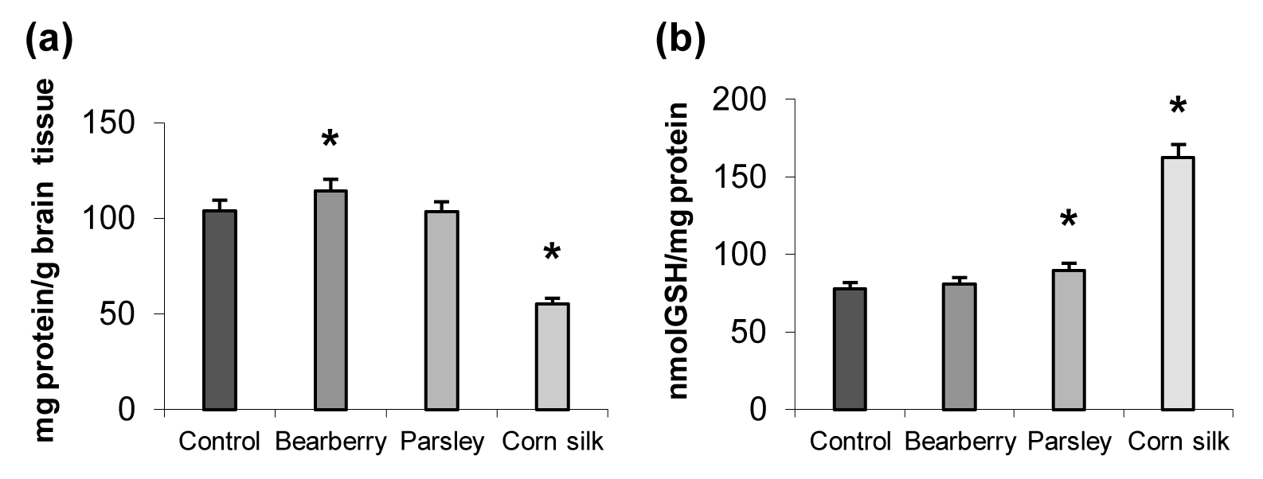
*Marked values significantly differ from control according to the Duncan’s multiple range test results (p < 0.05).
The effect of investigated medicinal plant extracts on soluble protein and GSH content in mice brain is shown in the Figure 2a and 2b. In comparison with the control (104.0 mg/g), protein content was significantly decreased after corn silk treatment (55.21 mg/g), while after bearberry extract treatment it was elevated (114.41 mg/g).
In mice brains treated with corn silk and parsley (162.53 and 89.59 nmol GSH/mg protein) quantities of GSH were above the control value (77.65 nmol GSH/mg protein, Figure 2b). The increase of GSH quantity is favorable for oxidative stress protection because of its role in peroxide detoxification, as it is the substrate of the GSH-Px enzyme. Also, as an endogenous molecular antioxidant, it is important for neutralizing other reactive species. Thus, GSH is very important for intracellular redox status maintenance.²⁷
Table 1 shows DPPH free radical scavenging activity and the ability of ferric ion reduction (FRAP test) of the brain tissue of treated animals. Radical scavenging capacity was improved under the bearberry and parsley leaf treatment, while the effect of corn silk extract was at the control level. FRAP values were improved after treatments with all examined medicinal plant extracts.
Table 1. DPPH radical scavenging capacity and ferric reducing antioxidant power (FRAP) of brain cells after the plant extract treatment
Sample | DPPH (IC₅₀, mg/mL) | FRAP units
Control | 31.40 a | 33.30 a
Bearberry | 27.13 b | 36.23 b
Parsley | 29.52 ab | 36.41 b
Corn silk | 30.86 a | 36.52 b
Values with the different letters are significantly different according to Duncan’s multiple range test results (p < 0.05).
DPPH and FRAP tests are used for overall antioxidant potential assessment. Concerning the damages induced by free radicals and other highly reactive species, the increase of the antioxidant power of the cells is crucial to prevent different diseases.²⁸ Our results show that there are no big differences among the effects of examined plants and that all of them induced slightly better antioxidant status of brain cells in comparison to the control. It could be possibly achieved by the promoted activity of endogenous antioxidants or by the action of polyphenol compounds present in the extracts. Plants rich in flavonoid compounds, like plants examined in our study (Table 1), promote DPPH free radical scavenging activity.²⁹
The effects of medicinal plant extracts on •OH quantities and level of LP in mice brains are shown in Figure 3.
Figure 3. Hydroxyl radical quantity (a) and level of lipid peroxidation (b) in mice brain after the plant extract treatment.
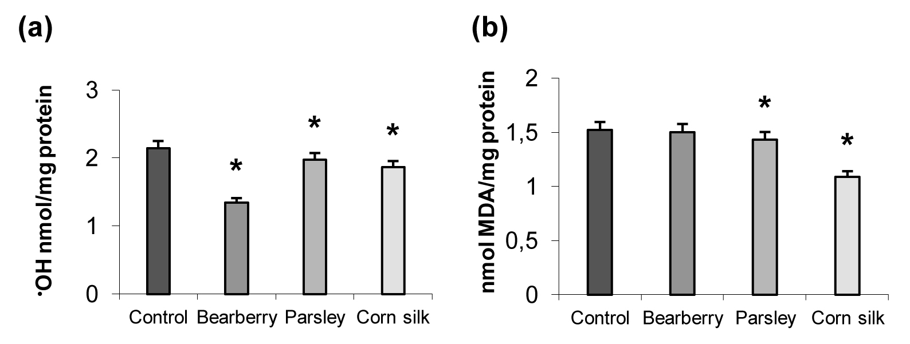
*Marked values significantly differ from control according to the Duncan’s multiple range test results (p < 0.05).
A significant decrease in •OH accumulation was observed in the brain tissue of mice drinking all three herb extracts (Figure 3a). Hydroxyl radical is one of the most harmful reactive species because of its high reactivity, small size and easy transport through cell compartments. It attacks proteins, DNA, lipids and carbohydrates leading to their dysfunctions and severe tissue damages. Since it initiates LP, any decrease of •OH content is very important for brain cells, because lipids are responsible for normal structure and function of neural membranes (Adibhatla and Hatcher, 2007).
The LP in brain cells of mice drinking medicinal plant extracts was at the lower level than in the control group of animals. Accumulation of MDA, the product of LP, was significantly reduced under the influence of corn silk and parsley extract (1.09 and 1.43 nmol MDA/mg protein, Figure 3b). Brain cells are rich in polyunsaturated fatty acids, which are very susceptible to LP, so the decrease of LP is very important, also because many neurological disorders, like Alzheimer’s, Parkinson’s, Huntington disease, schizophrenia, and many CNS traumas, involve dysfunction of lipid metabolism.³⁰
Polyphenol profile of medicinal plant extracts investigated in this study is presented in Table 2.
Table 2. Polyphenol compounds content in plant extracts.
 | Bearberry leaves | Parsley leaves | Corn silk
Polyphenol compound | μg/mL extract | μg/mL extract | μg/mL extract
Gallic acid | 162.99 | 4.14 | 3.16
Protocatechuic acid | - | 2.69 | 1.20
Catechin | - | 51.60 | -
p-Hydroxybenzoic | - | 0.42 | 0.69
Vanilic acid | - | - | 1.63
Syringic acid | 20.02 | - | -
p-Coumaric acid derivative | - | - | 0.75
p-Coumaric acid | - | 7.53 | 1.47
Ferulic acid derivative | - | - | 2.40
Ferulic acid | - | - | 5.94
Quercetin derivatives | 208.74 | - | -
Quercetin | 4.16 | - | -
Kaempferol derivatives | - | 211.80 | -
Apigenin 7-glucoside | - | 491.97 | -
Apigenin derivative | - | 192.44 | -
Apigenin | - | 0.22 | -
Luteolin 7-glucoside | - | - | 31.93
Luteolin derivatives | - | - | 584.07
Luteolin | - | - | 35.34
TOTAL | 395.91 | 962.80 | 668.58

The polyphenol profile and content varies among the extracts, but all of them are pointed out with high flavonoid content, although flavonoid subgroups differ. Parsley and corn silk are rich in flavones. Apigenin derivatives predominate in parsley, while in corn silk extract the most dominant are luteolin derivatives. Flavonols, in particular, quercetin derivatives, are present in bearberry leaf extract, and kaempferol derivatives are present in the parsley leaf extract. These results are similar to those obtained from the other authors.³¹⁻³³
Polyphenols are generally known for their strong antioxidant activities.³⁴ Our results suggest that luteolin derivatives from corn silk extract may be responsible for the very potent reducing capacity of corn silk extract and protection against LP. Polyphenol compounds could also contribute to lower •OH accumulation in the brains of animals that were subjected to the treatments.

- Conclusion
The intake of corn silk, parsley leaf and bearberry leaf extracts affected the metabolism of mice brain tissue. Corn silk showed a significant positive effect on activities of antioxidant enzymes SOD, CAT, and GSH-Px. The quantity of GSH was the highest under the influence of corn silk extract, while the accumulation of •OH and MDA was the lowest, suggesting its protective effect against LP. Parsley leaf extract induced the increase in GSH content and the decrease in •OH and MDA accumulation. Bearberry leaf extract induced CAT activity and the decrease in the accumulation of •OH, while MDA accumulation was maintained at the control level. All three plant extracts were rich in polyphenol compounds, especially in flavonoids, which could contribute to beneficial effects. Our results support the use of these medicinal plants as natural non-toxic antioxidants in the prevention of oxidative stress provoked damages of brain tissue, but further investigations are required to clarify their mechanisms of action.

Acknowledgment: This research was funded by the Ministry of Education, Science and Technological Development, Republic of Serbia, Contract No. 451-03-9/2021-14/200117
Conflicts of Interest: The authors declare that they have no conflict of interest.

References
- L. M. Haces, T. L. Montiel, L. Massieu, Neurosci. J. 2010, 165, 28–38. DOI: 10.1016/j.neuroscience.2009.10.003
- G. P. Marrazzo, P. Bosco, F. La Delia, Neurosci. Lett. 2011, 504: 252–256. DOI: 10.1016/j.pmpp.2008.04.002
- M. Bains, E. D. Hall, Biochim. Biophys. Acta, Mol. Basis Dis. 2012, 1822: 675–684. DOI: 10.1016/j.bbadis.2011.10.017
- T. S. Anthonymuthu, E. M. Kenny, H. Bayır, Brain. Res. 2016,1640(Pt A), 57-7. DOI: 10.1016/j.brainres.2016.02.006
- A. Kumar, D. J. Loane, Brain. Behav. Immun. 2012, 26, 1191–1201. DOI: 10.1016/j.bbi.2012.06.008
- L. B. Ceretta, G. Z. Réus, H. M. Abelaira, K. F. Ribeiro, G. Zappellini, F. F. Felisbino, A. V. Steckert, F. Dal-Pizzol, J. Quevedo, J. Diabetes. Res. 2012, Article ID 302682, DOI: 10.1155/2012/302682
- J. C. Hanish Singh, V. Alagarsamy, S. Sathesh Kumar, Y. Narsimha Reddy, Willd. Phytother. Res. 2011, 25, 1061–1067. DOI: 10.1016/j.jep.2011.08.048
- D. Štajner, B. M. Popović, J. Čanadanović-Brunet, S. Ðilas, G. Ćetković, LWT-Food Sci. Technol. 2014, 55, 408-413. DOI: 10.1016/j.lwt.2013.08.025
- D. Štajner, B. M. Popović, D. Čalić, M. Štajner, Sci. World. J. 2014, 7 pages, DOI:10.1155/2014/767392 –b.
- M. J. Engelhart, M. I. Geerlings, A. Ruitenberg, J. C. van Swieten, A. Hofman, J. C. Witteman, M. M. Breteler, JAMA, 2002, 287(24): 3223-3229. DOI: 10.1001/jama.287.24.3223
- B. Hua, H. Chunx, X. Miaomiao, L. Xin, L. Rui, Plant Food Hum. Nutr. 2010, 65(3), 271‐276. DOI: 10.1007/s11130-010-0172-6
- H. J. W. Aw, M. Hanate, S. Takahashi, K. Saito, H. Tanaka, M. Tomita, M. Hisanori Kato, J. Funct. Foods. 2014, 11, 438-448. DOI:
- H. Jia, W. Aw, M. Hanate, S. Takahashi, K. Saito, H. Tanaka, M. Tomita, H. Kato, J. Funct. Foods. 2014, 11, 438-448. DOI: 10.1016/j.jff.2014.09.018
- M. Vranješ, B. M. Popović, D. Štajner, V. Ivetić, A. Mandić, D. Vranješ, J. Funct. Foods. 2016, 21, 272–282. DOI: 10.1016/j.jff.2015.12.016
- S. Mandal, A. Mitra, N. Mallick, Physiol. Mol. Plant Path. 2008, 72, 56-61. DOI: 10.1016/j.pmpp.2008.04.002
- T. Iwase , A. Tajima, S. Sugimoto, K. Okuda, I. Hironaka, Y. Kamata, K. Takada, Y. Mizunoe, Sci. Rep. 2013, 3, 3081. DOI: 10.1038/srep03081
- I. Morkunas, J. Gmerek, J. Plant. Physiol. 2007, 164, 185-194. DOI: 10.1016/j.jplph.2005.11.005
- D. T. Y. Chiu, F. H.Stults, A. L Tappel, Biochim. Biophys. Acta. 1976, 445, 558-606. DOI: 10.1016/0005-2744(76)90110-8
- M. M. Bradford, Anal. Biochem. 1976, 72, 248-253. DOI: 10.1016/0003-2697(76)90527-3
- J. K. Moon, T. Shibamoto, Antioxidant assays for plant and food components. J. Agric. Food Chem. 2009, 57, 1655–1666. DOI: 10.1021/jf803537k
- K. H. Cheesman, A. Beavis, H. Esterbaurer, Hydroxyl radical induced iron catalyzed degradation of 2-deoxyribose. Biochem. J. 1988, 232, 649-653. DOI:10.1042/bj2520649
- I. Sedlak, R. H. Lindsay, Anal. Biochem. 1968, 16, 259-205.
- N. Abe, T. Murata, A. Hirota, Biosci. Biotechnol. Biochem. 1998, 62, 661-662. DOI: 10.1271/bbb.62.661
- I. F. F. Benzie, J. J. Strain, Methods. Enzymol. 1999, 299, 15-27. DOI: 10.1016/S0076-6879(99)99005-5
- B. Popović, B. Blagojević, R. Ždero Pavlović, N. Mićić, S. Bijelić, S. Bogdanović, A. T. Serra, Food Chem. 2020, 302:125373. DOI: 10.1016/j.foodchem.2019.125373
- S. Fukui, T. Ookawara, H. Nawashiro, K. Suzuki, K. Shima. Free Rad. Biol. Med. 2002, 32, 289-298. DOI: 10.1016/S0891-5849(01)00804-8
- P. Klivenyi, O. A. Andreassen, R. J. Ferrante, N. Dedeoglu, G. Mueller, E. Lancelot, M. K. Bogdanov, J. K. Andersen, D. Jiang, M. F. Beal, J. Neurosci. 2000, 20, 1‐7. DOI: 10.1523/JNEUROSCI.20-01-00001.2000
- F. Favilli, T. Iantomasi, M. Marraccini, M. Stio, B. Lunghi, C. Treves, M. T. Vincenzini, Neurobiol. Aging 1994, 15(4), 429-433. DOI: 10.1016/0197-4580(94)90074-4
- I. Álvarez-González, F. Fernando Garcia-Melo, V. R. Vásquez-Garzón, A. E. Saúl Villa-Treviño, O. Madrigal-Santillán, J. A. Morales-González, J. A. Mendoza-Peres, E. Madrigal-Bujaidar, Evid. Based Complement. Alternat. Med. 2014, Article ID 379890, 8 pages. DOI: 10.1155/2014/379890
- I. Baranowska, S. Bajkacz, Food Chem. 2018, 256, 333-341. DOI: 10.1016/j.foodchem.2018.02.138
- R. M. Adibhatla, J. F. Hatcher, Future Lipidol. 2007, 2(4), 403–422. DOI: 10.2217/17460875.2.4.403
- A. Plazonić, F. Bucar, Ž. Maleš, A. Mornar, B. Nigović, N. Kujundžić. Molecules 2009, 14, 2466–2490. DOI: 10.3390/molecules14072466
- J. Tian, H. Chen, S. Chen, L. Xing, Y. Wang, J. Wang. Food Funct. 2013, 10, 1526–1534. DOI: 10.1039/C3FO60171D
- N. A. Mohd Azman, M. G. Gallego, F. Segovia, S. Sureena Abdullah, S. M. Shaarani, M. P. Almajano Pablos, Antioxidants 2016, 5(11), 11. DOI: 10.3390/antiox5020011
- A. Scalbert, I. T. Johnson, M. Saltmarsh, Am. J. Clin. Nutr. 2005, 81, 215S-217S. DOI: 10.1093/ajcn/81.1.215S

