QSAR Studies and Structure Property/Activity Relationships Applied In Pyrazine Derivatives

Fatima Soualmia^{1,2}, Salah Belaidi²*,NoureddineTchouar
¹, Touhami Lanez³and Samia Boudergua ^{1,4}

¹ Laboratoire Génie des Procédés et Environnement (GPE), Faculté de chimie, Université des sciences et technologies d'Oran (USTO) BP 1503 Oran 31000, Algérie
²University of Biskra, Group of Computational and Medicinal Chemistry, LMCE Laboratory, BP 145 Biskra 07000, Algeria
³University of El-Oued,Faculty of Sciences and Technology, VTRS Laboratory, B.P.789, 39000, El-Oued, Algeria
⁴University of KhemisMiliana, Faculty of Sciences and Technology, 44225, Ain Defla, Algeria
* Corresponding author, E-mail: s.belaidi@univ-biskra.dz.

Abstract:

Electronic structure, effect of the substitution, structure physicochemical property/activity relationships and drug-likeness applied in pyrazine derivatives, has been studied at ab initio (HF, MP2) and B3LYP/DFT (density functional theory) levels. In the present paper, the calculated values, i.e., NBO (natural bond orbitals) charges, bond lengths, dipole moments, electron affinities, heats of formation and quantitative structure-activity relationships (QSAR) properties. For the QSAR studies, we used multiple linear regression and artificial neural network statistical modeling. The results show high correlation between experimental and predicted activity values, indicating the validation and the good quality of the derived QSAR models. In addition, statistical analysis reveals that ANN technique with (9-4-1) architecture is more significant than MLR model.

Keywords: pyrazine, DFT, QSAR, MLR, ANN.

- INTRODUCTION

Pyrazine is a heterocyclic compound containing two nitrogen atoms in its aromatic ring with molecular formula C₄H₄N₂.¹ Pyrazine is a symmetrical molecule with point group D_{2h}.
Pyrazine is less basic in nature than pyridine, pyridazine and pyrimidine. Tetramethyl pyrazine (also known as ligustrazine) is reported to scavenge superoxide anion and decrease nitric oxide production in human polymorph nuclear leukocytes, and is a component of some herbs in traditional Chinese medicine. Some of the pyrazine derivative contains various pharmacological effects: anti-cancer, antidepressant and anxiolytic, tuberculosis, Anti-diabetic drug and pulmonary hypertension and cardiac valve.²⁻⁷
Quantum chemistry methods play an important role in obtaining molecular structures and predicting various properties. To obtain highly accurate geometries and physical properties for molecules that are built from electronegative elements, expensive Ab initio/MP2 electron correlation methods are required.⁸ Density functional theory methods⁹⁻¹⁴ offer an alternative use of inexpensive computational methods which could handle relatively large molecules.¹⁵⁻²⁰
Quantitative structure-activity relationships (QSAR) ²¹⁻²⁵ are attempts to correlate molecular structure, or properties derived from molecular structure, with a particular kind of chemical or biochemical activity. The kind of activity is a function of the interest of the user. QSAR is widely used in pharmaceutical, environmental and agricultural chemistry in the search for particular properties. The molecular properties used in the correlations relate as directly as possible to the key physical or chemical processes taking place in the target activity.²⁶
In this work, it is planned to illuminate theoretical determination of the optimized molecular geometries, MESP, NBO charges and of pyrazine compound. In addition, we calculated important quantities such as HOMO–LUMO energy gap. ²⁷
The Lipinski’s ‘Rule of Five’²⁸ as well as other parameters has been shown to be useful tools to aid in choosing oral drug candidates. Drug-likeness is described to encode the balance among the molecular properties of a compound that influences its pharmacodynamics, pharmacokinetics and ADME (absorption, distribution, metabolism and excretion) in human body like a drug .²⁹
These parameters allow estimating oral absorption or membrane permeability, which occurs when evaluated molecules obey the Lipinski’s rule-of-five. Other parameters that included are number of rotatable bonds, molecular volume, molecular polar surface area and the in vitro plasma protein binding.
The present paper deals with a specific organization form of molecular matter. Other forms are given for example in the References.³⁰⁻³⁴
Many different chemometric methods, such as multiple linear regression (MLR),³⁵ partial least squares regression (PLS),³⁶ different types of artificial neural networks (ANN),³⁷⁻⁴⁰ genetic algorithms (GA) ⁴¹ and support vector machine (SVM) can be employed to deduce correlation models between the molecular structure and properties. At present, we derive a quantitative structure-activity relationship (QSAR) model using multiple linear regression (MLR) as well as artificial neural network (ANN) methods for the series of pyrazine derivatives.
- MATERIALS AND METHODS

All calculations were performed using HyperChem 8.0.6 software ⁴² and Gaussian 09 program package ⁴³, Marvin Sketch 6.2.1 software ⁴⁴, Molinspiration online database ⁴⁵ and JMP 8.0.2 software. ⁴⁶
The geometries of pyrazine and their methyl, ethyl, bromo, fluoro derivatives were fully optimized with ab initio/HF, MP2 and DFT/B3LYP methods, using both basis set 6-311G ++(d,p) and cc-pVDZ integrated in Gaussian 09 program package. The calculation of QSAR properties is performed through the module QSAR properties (HyperChem version 8.0.6), allows several properties commonly used in QSAR studies to be calculated.
Molinspiration, web based software was used to obtain parameter such as TPSA (topological polar surface area), nrotb (number of rotatable bonds) and drug likeness.
Multiple Linear Regression MLR analysis and artificial neural networks ANN were carried out using the software JMP 8.0.2.
The calculated results have been reported in the present work.
- RESULTS AND DISCUSSION

  - Geometric and electronic structure of pyrazine
The optimized geometrical parameters of pyrazine with ab initio/HF, ab initio/MP2 and DFT method using 6-311G ++ (d, p) and cc-pVDZ basis set. Results concerning bond length values for pyrazine are listed in (Table 1), bond angles are listed in (Table 2) with the experimental results ⁴⁷ and charge densities are listed in (Table 3) are in accordance with numbering scheme given in (Fig. 1).
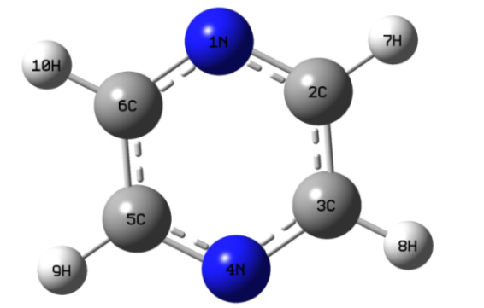
Fig. 1. 3D conformation of pyrazine (GaussView 5.0.8).
The efficiency of DFT/B3LYP method with cc-pVDZ basis set may be scrutinized by comparison with the results obtained by more elaborate calculation such as ab initio/HF and MP2 method. A very good agreement between predicted geometries (bond lengths and bond angles) and corresponding experimental data was obtained especially through the DFT/B3LYP results.
From that, we can say that the DFT method is more appropriate for further study on pyrazine ring. Charge densities calculated by DFT/B3LYP are almost similar to ab initio/HF and MP2 methods. The geometry of the pyrazine is symmetric and planar; as all the dihedral angles are either nearly 0° or 180°, which make this conformation more stable. The total atomic charges of pyrazine are obtained from NBO charges with DFT/B3LYP and ab initio/HF and MP2 methods with cc-pVDZ basis set are listed in Table 3. The atoms N have negative charges which leads to electrophilic attack, the atom C and H have positive charge which lead to preferential site to nucleophilic attack.
The molecular electrostatic potential surface (MESP) is a plot of electrostatic potential mapped on to the constant electron density surface. In majority of the MESP the maximum negative region which preferred the site for electrophilic attack is indicated in as red color, while the maximum positive region which preferred the site for nucleophilic attack is symptoms indicated in blue color.⁴⁸ MESP has been found to be a very useful tool in the investigation of the correlation between the molecular structure and the physiochemical property relationship of molecules including biomolecules and drugs.⁴⁹⁻⁵³
The MESP surface and contour map of pyrazine (Fig. 2) show the three regions characterized by red color (negative electrostatic potential) around the tow cyclic nitrogen atoms which explain the ability for an electrophilic attack on these positions, also by blue color (positive electrostatic potential) around the four hydrogen atoms which explain that these regions are susceptible for a nucleophilic attack. The green color situated in the middle between the red and blue regions explain the neutral electrostatic potential surface.
-3.906e-2 3.906e-2
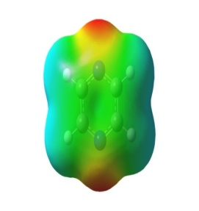 | 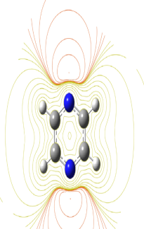
Fig. 2. 3D MESP surface map and 2D MESP contour map for pyrazine (Gauss view 5).
Table 1.Calculated bond lengths (angstrom) of pyrazine molecule.
Distance | EXP⁴⁷ | DFT/B3LYP |  | Ab initio/HF |  | Ab initio/MP2
Distance | EXP⁴⁷ | 6-311G ++ (d, p) | cc-pVDZ | 6-311G ++ (d, p) | cc-pVDZ | 6-311G ++ (d, p) | cc-pVDZ
C-N | 1.338 | 1.335 | 1.339 | 1.317 | 1.320 | 1.343 | 1.349
C-C | 1.397 | 1.394 | 1.398 | 1.386 | 1.388 | 1.399 | 1.405
C-H | 1.083 | 1.086 | 1.095 | 1.075 | 1.082 | 1.087 | 1.096

Table 2. Angles in degree of pyrazine molecule.
Angle | EXP⁴⁷ | DFT/B3LYP |  | Ab initio/HF |  |  | Ab initio/MP2
Angle | EXP⁴⁷ | 6-311G++(d, p) | cc-PVDZ |  | 6-311G++ (d, p) | cc-pVDZ | 6-311G++(d, p) | cc-pVDZ
CCH | 120.0 | 120.0 | 120.8 |  | 120.8 | 120.8 | 120.7 | 120.6
CNC | 115.7 | 116.1 | 115.6 |  | 116.6 | 116.3 | 115.2 | 114.6

Table 3. NBO charges of pyrazine molecule.
Pyrazine  Atoms | DFT/B3LYP  cc-pVDZ | Ab initio/HF  cc-pVDZ | Ab initio/MP2  cc-pVDZ
C | 0.013 | 0.044 | 0.033
N | -0.456 | -0.492 | -0.487
H | 0.215 | 0.202 | 0.210

  - Substitution effect on pyrazine structure
Calculated values of two studied series indicated that in the first series methyl and ethyl groups with effects of electron donors, in the second series bromo and fluoro groups with effects of electron acceptors in position C2 and C3 in the same series are given in (Table 4) and (Table 5), heat of formation, dipole moment (µ) and HOMO (Highest Occupied Molecular Orbital) and LUMO (Lowest Unoccupied Molecular Orbital) energies of pyrazine systems are presented in (Fig. 3), NBO charges of pyrazine derivatives are reported in (Table 6) for the first series and in (Table7) for the second series. This calculation is performed with DFT/B3LYP method using cc-pVDZ basis set.

Series 1 | Series 2
(A1) R1 = H , R2 = H | (B1) R1 = H ,R2=H
(A2) R1 = CH₃, R2 = H | (B2) R1 = Br, R2=H
(A3) R1 = CH₃, R2 = CH₃ | (B3) R1 = Br, R2=Br
(A4) R1 = C₂H₅, R2=H | (B4) R1 = F, R2=H
(A5) R1 = C₂H₅, R2=C₂H₅ | (B5) R1 = F, R2=F
Fig. 3. Pyrazine system (Marvin sketch15.8.31).
For each addition of methyl, ethyl and fluoro, the heat of formation decreases approximately 6, 12 or 39 (kcal∙mol⁻¹) respectively but the addition of the bromo group leads the increase of the heat of formation with 6 (kcal∙mol⁻¹) approximately.
The Frontier orbitals, highest occupied molecular orbital (HOMO) and lowest unoccupied molecular orbital (LUMO) are important factors in quantum chemistry ⁵⁴ as these determine the way the molecule interacts with other species. The frontier reactivity and kinetic stability of the molecule. A molecule with a small frontier orbital gap is more polarizable and is generally associated with a high chemical reactivity, low kinetic stability and is also termed as soft molecule.⁵⁵

Table 4. Energies of pyrazine and methyl, ethyl-substituted pyrazine.
 |  | ΔH_{f}  [kcal/mol]  ol) | HOMO  [au] | LUMO  [au] | ΔE  [au] | µ  [Debye]
A1 | Pyrazine | 44.09 | -0.252 | -0.055 | 0.197 | 0.00
A2 | 2-methyl pyrazine | 37.05 | -0.247 | -0.051 | 0.196 | 0.59
A3 | 2,3-di-methyl pyrazine | 31.78 | -0.243 | -0.044 | 0.199 | 0.80
A4 | 2-ethyl pyrazine | 30.97 | -0.247 | -0.051 | 0.195 | 0.59
A5 | 2,3-di-ethyl pyrazine | 20.48 | -0.242 | -0.045 | 0.196 | 0.69

Table 5. Energies of pyrazine and fluoro, bromo-substituted pyrazine.
 |  | ΔH_{f}  [kcal/mol] | HOMO  [au] | LUMO  [au] | ΔE  [au] | µ  [Debye]
B1 | Pyrazine | 44.09 | -0.253 | -0.055 | 0.197 | 0.00
B2 | 2-bromopyrazine | 49.73 | -0.269 | -0.068 | 0.201 | 1.50
B3 | 2,3-dibromopyrazine | 55.88 | -0.268 | -0.075 | 0.192 | 2.05
B4 | 2-fluoro pyrazine | 04.15 | -0.272 | -0.065 | 0.207 | 1.33
B5 | 2,3-di-fluoropyrazine | -33.52 | -0.280 | -0.069 | 0.211 | 2.24

It was found that electron donors of compound A4 (2-ethyl pyrazine) has the lowest energy gap HOMO-LUMO (0.1958) for the first series and compound B3 (2,3-dibromopyrazine) has the lowest energy gap (0.1927) for the second series (Fig. 4).
From HSAB (Hard Soft Acid and Base) principle the lowest energetic gap allows an easy flow of electrons which makes the molecule soft and more reactive ,⁵⁶ which means that A4 and B3 compounds are the most reactive in the two series of pyrazine derivatives. For each addition of alkyl substituted the HOMO and LUMO increases respectively but the addition of the fluoro, bromo substituted leads the decrease of the LUMO an exception increase of the bromo substituted and decrease of the fluoro substituted of the HOMO. The carbon C2 has the most important positive charge (0.206) in the compound A4 (2-ethyl pyrazine) for the first series, also for compound B3 (2,3-dibromopyrazine) for the second series, the most important positive charges are in carbon C2 (0.102) and C3 (0.102) as shown in (Table 5), these positions C2 and C3 with the important positive charges lead to preferential sites of nucleophilic attack. The compound B3 is predicted to be the most reactive with smaller HOMO-LUMO energy gap and with sites of nucleophilic attack, more stable with the maximum value in the heat of formation.
The contour plots of the π like frontier orbital for the ground state of the compound B3 are shown in (Fig. 4).
From the plots, we can observe that the HOMO is a π bonding molecular orbital developed on C5 and C6 atoms, and the LUMO is a π* anti-bonding molecular orbital developed on the N1 and C2. These further demonstrate the existence of the delocalization of the conjugated π-electron system in 2,3-dibromopyrazine molecule. Dipole moment equal to zero which confirms the symmetry group D_{2h} of pyrazine. The compound B5 (2,3-di-fluoropyrazine) also shows a high dipole moment value (2.2435 Debye).

Table 6. NBO charges of pyrazine series 1.
 | A1 | A2 | A3 | A4 | A5
N1 | -0.456 | -0.472 | -0.471 | -0.476 | -0.476
N4 | -0.456 | -0.452 | -0.473 | -0.452 | -0.472
C2 | 0.013 | 0.204 | 0.215 | 0.206 | 0.216
C3 | 0.013 | 0.016 | 0.208 | 0.020 | 0.213
C5 | 0.013 | 0.003 | 0.010 | 0.004 | 0.013
C6 | 0.013 | 0.022 | 0.012 | 0.023 | 0.015
C-methyl- 2 | - | -0.665 | -0.669 | - | -
C-methyl -3 | - | - | -0.673 | - | -
C¹-ethyl- 2 | - | - | - | -0.458 | -0.459
C²-ethyl -2 | - | - | - | -0.628 | -0.627
C¹-ethyl -3 | - | - | - | - | -0.461
C²-ethyl-3 | - | - | - | - | -0.627

Table 7. NBO charges of pyrazine series 2.
 | B1 | B2 | B3 | B4 | B5
N1 | -0.456 | - 0.458 | -0.446 | -0.497 | -0.485
N4 | -0.456 | -0.441 | -0.446 | -0.441 | -0.485
C2 | 0.013 | 0.112 | 0.102 | 0.634 | 0.586
C3 | 0.013 | 0.018 | 0.102 | -0.040 | 0.586
C5 | 0.013 | 0.006 | 0.018 | -0.008 | 0.002
C6 | 0.013 | 0.024 | 0.018 | 0.024 | 0.002
Brome-2 | - | 0.064 | 0.100 | - | -
Brome-3 | - | - | 0.100 | - | -
Fluor- 2 | - | - | - | -0.338 | -0.327
Fluor -3 | - | - | - | - | -0.327
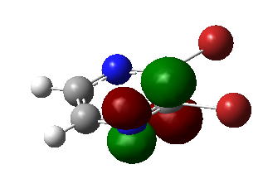
LUMO
∆E=0.192 au
LUMO
∆E=0.192 au

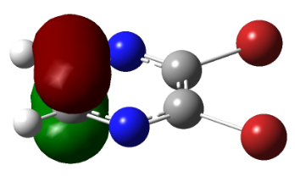
HOMO
Fig. 4. π like frontier orbitals of the compound B3.

  - Structure activity/property relationship for pyrazine derivatives
For the series of pyrazine derivatives (Fig. 8) we have studied seven physicochemical properties with respect to their anti-proliferative activity against the BGC823 (human gastric cell). ⁵⁷ The properties involved are: Surface area grid (SAG), molar volume (V), hydration energy (HE), partition coefficient octanol/water (log P), molar refractivity (MR), polarizability (Pol) and molecular weight (MW).
Table 8. QSAR properties of pyrazine derivatives.
Compounds | MW  [amu] | SAG  [A°²] | V  [A°³] | Pol  [A°³] | MR  [A°³] | LogP | HE  [kcal/mol]
1 | 288.30 | 466.47 | 770.17 | 28.82 | 79.14 | 1.94 | -12.54
2 | 304.75 | 474.61 | 791.62 | 30.84 | 83.73 | 2.32 | -12.63
3 | 349.20 | 485.20 | 810.26 | 31.54 | 86.54 | 2.60 | -12.58
4 | 304.75 | 498.29 | 809.75 | 30.84 | 83.73 | 2.32 | -13.29
5 | 349.20 | 505.96 | 828.55 | 31.54 | 86.54 | 2.6 | -13.24
6 | 320.81 | 512.80 | 828.87 | 33.20 | 90.17 | 2.67 | -11.30
7 | 304.36 | 486.18 | 800.84 | 31.18 | 85.58 | 2.29 | -11.39
8 | 320.81 | 498.70 | 822.05 | 33.20 | 90.17 | 2.67 | -12.25
9 | 424.32 | 628.79 | 1054.66 | 41.91 | 118.37 | 3.13 | -11.55
10 | 363.41 | 543.20 | 948.38 | 39.20 | 110.97 | 2.48 | -11.54
11 | 379.87 | 550.54 | 984.28 | 41.21 | 115.56 | 2.86 | -10.69
12 | 424.32 | 554.53 | 997.06 | 41.91 | 118.37 | 3.13 | -10.63
13 | 379.87 | 562.49 | 980.74 | 41.21 | 115.56 | 2.86 | -11.45
14 | 363.41 | 543.20 | 948.38 | 39.20 | 110.97 | 2.48 | -11.54
15 | 270.31 | 475.71 | 769.23 | 28.91 | 79.01 | 2.55 | -13.67
16 | 286.37 | 490.32 | 789.01 | 31.27 | 85.45 | 2.89 | -12.89
17 | 349.20 | 517.21 | 832.69 | 31.54 | 86.54 | 2.60 | -14.62
18 | 306.29 | 476.68 | 771.74 | 28.73 | 79.26 | 1.34 | -13.64

The results obtained using HyperChem 8.0.8 software are shown in Table 8. For example, Fig. 5 shows the favored conformation in 3D of the compound 1.

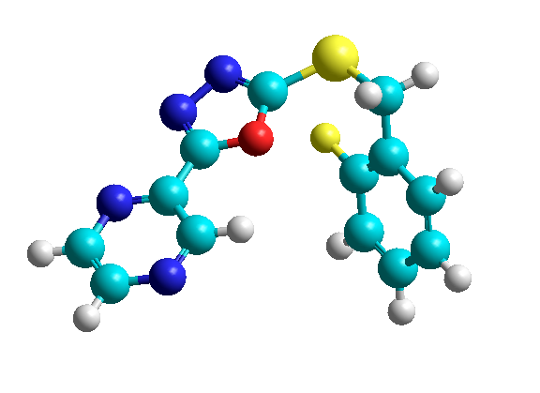

Fig. 5. 3D Conformation of compound 1 (HyperChem 8.03).
Molar refractivity and polarizability relatively increase with the size and the molecular weight of the studied pyrazine derivatives (Table 8 and fig.6). This result is in agreement with the formula of Lorentz-Lorenz, which gives a relationship between polarizability, molar refractivity and the molecular size.
From the results obtained in Table 8 and figure 6, we observed that polarizability data and molecular refractivity are generally proportional to the size and the molecular weight of pyrazine derivatives. This explains the congruity of our results with Lorentz-Lorenz expression, for instance compound number 9 and compound 12 shows the same maximum values of polarizability (41.91 (Å³)) and refractivity (118.37(Å³)). These compounds have also high values of Molecular weight (424.32 uma), and a slight difference in surfaces and volumes.

Fig.6. Graphical representation of physicochemical properties.

Hydration energy in absolute value, the most important is that of the compound 17 (14.62 kcal∙mol⁻¹) and the smallest value is that of the compound 12 (10.63 kcal∙mol⁻¹). Indeed, in the biological environments the polar molecules are surrounded by water molecules. They are established hydrogen bonds between them.
Hydrophobic groups in pyrazine derivatives induce a decrease of hydration energy.
However, the lipophilie increase proportionally with the hydrophobic features of substituent. As seen in Table 8, the compound 17 is expected to have highest hydrophilicity, Whereas compound number 12 will be most lipophilic. This implies that these compounds will have poor permeability across cell membrane.
We noticed that compounds 17 possess seven (HBA) hydrogen bond acceptors and no (HBD) hydrogen bond donors, the presence of hydrophilic groups in this compound results in an increase of the hydration energy. This property explains the ability of these compounds, not only fixing to the receptor, but also activating it. Hydration energy measures the degree of agonist character of a potential drug molecule.
Almost (log P) of studied molecules have optimal values. For good oral bioavailability, the log P must be greater than zero and less than 3 (0 < log P < 3). For very high values of log P, the drug has low solubility and for very low values of log P; the drug has difficulty penetrating the lipid membranes. Thus the compound 17 has important hydratation energy and the optimal value of log P, the small value of molecular weight leading to a better distribution and solubility in fabrics, a good oral bioavaibility and permeability in cellular membranes respectively (Fig. 7).
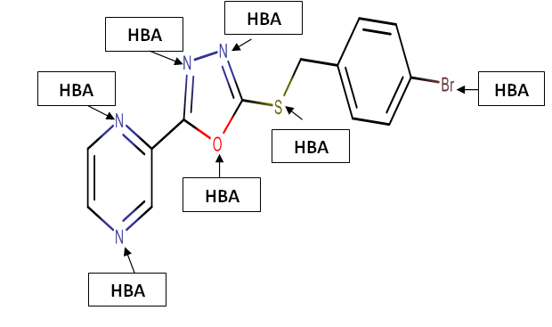

Fig. 7. Acceptor sites of proton for compound 17.

  - Virtual screening and Drug-likeness applied in pyrazine Derivatives
We have applied rules of thumb and calculated metrics of eighteen derivatives of pyrazine (Fig. 8) taken from literature with their anti-proliferative activity against the BGC823.⁵⁷
The properties involved are: octanol/water partition coefficient (log P), molecular weight (MW), hydrogen bond donors (HBD), hydrogen bond acceptors (HBA), number of rotatable bonds (NRB), polar surface area (TPSA). All the results have been calculated using HyperChem 8.0.8 and Marvin Sketch 6.2.1 software, which are listed respectively in Table 9, we have studied Lipinski and Veber rules to identify “drug-like” compounds: ^{58,59}
(1) There are less than 5 H-bond donors (expressed as the sum of OHs and NHs).
(2) The molecular weight is under 500 DA.
(3) The logP is under 5.
(4) There are less than 10 H-bond acceptors (expressed as the sum of Ns and Os).
(5) Rotatable bonds are under 10.
(6) TPSA is under 140 Å ²

Table 9. Pharmacological activities and properties involved in MPO methods for drug-likeness of pyrazine derivatives.
N° | pIC50_{BGC823} ⁵⁷ | Lipinski’s rule |  |  |  | Veber rules
N° | pIC50_{BGC823} ⁵⁷ | logP  <5 | MW  [amu]  <500 | HBA  <10 | HBD  <5 | NRB  <10 | TPSA[A°²]  <140
1 | 4.74 | 1.94 | 288.30 | 5 | 0 | 4 | 64.71
2 | 4.56 | 2.32 | 304.75 | 5 | 0 | 4 | 64.71
3 | 4.76 | 2.60 | 349.20 | 5 | 0 | 4 | 64.71
4 | 4.8 | 2.32 | 304.75 | 5 | 0 | 4 | 64.71
5 | 4.94 | 2.6 | 349.20 | 5 | 0 | 4 | 64.71
6 | 4.87 | 2.67 | 320.81 | 4 | 0 | 4 | 51.57
7 | 4.73 | 2.29 | 304.36 | 4 | 0 | 4 | 51.57
8 | 4.69 | 2.67 | 320.81 | 4 | 0 | 4 | 51.57
9 | 4.70 | 3.13 | 424.32 | 5 | 0 | 5 | 56.50
10 | 4.53 | 2.48 | 363.41 | 4 | 0 | 4 | 51.57
11 | 4.46 | 2.86 | 379.87 | 5 | 0 | 5 | 56.50
12 | 4.44 | 3.13 | 424.32 | 5 | 0 | 5 | 56.50
13 | 4.69 | 2.86 | 379.87 | 5 | 0 | 5 | 56.50
14 | 4.57 | 2.48 | 363.41 | 5 | 0 | 5 | 56.50
15 | 4.60 | 2.55 | 270.31 | 5 | 0 | 4 | 64.71
16 | 4.67 | 2.89 | 286.37 | 4 | 0 | 4 | 51.57
17 | 4.59 | 2.60 | 349.20 | 5 | 0 | 4 | 64.71
18 | 4.48 | 1.34 | 306.29 | 5 | 0 | 4 | 64.71

All the compounds of the series have the MW under 500 DA, thus they can easily pass through cell membrane and the better the absorption will be.
There are less than 10 H-bond acceptors and 0 H-bond donor, the fat solubility will be high and therefore the drug will be able to penetrate the cell membrane to reach the inside of the cell. If two of these rules are unsatisfied, the compound will have problem in absorption and Permeability.⁶⁰
TPSA of pyrazine derivatives were found in the range of 52.325 - 65.217 and is well below the 140 Å², indicating that these compounds should have good cellular plasmatic membrane permeability. All the screened compounds were flexible, especially; compounds 9 and 11-14 which have 5 rotatable bonds (table 9).
1 | 2 | 3 | 4
5 | 6 | 7 | 8
9 | 10 | 11 | 12
13 | 14 | 15 | 16
 | 17 | 18
Fig. 8. Structural comparaison of pyrazine derivatives.

  - Quantitative Structure-Activity Relationships Studies (QSAR) of pyrazine Derivatives
When chemical or physical properties and molecular structures are derived from numbers, it is often possible to propose mathematical relations connecting them, which allow making quantitative predictions. The obtained mathematical expressions can then be used as a predictive means of the biological response for similar structures. They are widely used in the pharmaceutical industry to identify promising compounds, especially at early stages of drug
discovery .⁶¹
Relationships between the physicochemical properties of chemical substances and their biological activities can be derived using QSAR (Quantitative Structure-Activity Relationships) concept. These models can also be used to predict the activities of new chemical entities and for their design .⁶² therefore, the biological activity is quantitatively expressed as the concentration of substance necessary to obtain a certain biological response. For that purpose, multiple linear regression, MLR, and artificial neural networks (ANNs) are used. The accuracy of such models is mainly evaluated by the correlation coefficient R².⁶³ The MLR and ANN models were generated using the software JMP 8.0.2.
The equilibrium geometries and the highest occupied molecular orbital energy (E_{HOMO}) and lowest unoccupied molecular orbital energy (E_{LUMO}) and dipole moment (µ) of pyrazine derivatives were determined at the B3LYP/cc-pVDZ level of theory. We list in table 10 of the supplementary material the Cartesian coordinates of the optimized pyrazine derivatives equilibrium structures. Then, the QSAR properties module from Hyper Chem 8.08 was used to calculate: molar weight (MW), surface area (SAG), volume (V),molar refractivity (MR), polarizability (Pol), octanol-water partition coefficient (log P) and hydration energy (HE).
Table 10.Values of molecular descriptors.
N° | pIC50_{BGC823}⁵⁷ | V  [A°³] | HE  [kcal/mol] | Log P | MR  [A°³] | SAG  [A°²] | MW  [amu] | Pol  [A°³] | E_{HOMO}  [au] | E_{LUMO}  [au] | µ  [Debye]
1 | 4.740 | 770.170 | -12.540 | 1.940 | 79.140 | 466.470 | 288.300 | 28.820 | -0.239 | -0.079 | 0.886
2 | 4.560 | 791.620 | -12.630 | 2.320 | 83.730 | 474.610 | 304.750 | 30.840 | -0.249 | -0.081 | 5.144
3 | 4.760 | 810.260 | -12.580 | 2.600 | 86.540 | 485.200 | 349.200 | 31.540 | -0.240 | -0.080 | 0.887
4 | 4.800 | 809.750 | -13.290 | 2.320 | 83.730 | 498.290 | 304.750 | 30.840 | -0.243 | -0.081 | 1.269
5 | 4.940 | 828.550 | -13.240 | 2.600 | 86.540 | 505.960 | 349.200 | 31.540 | -0.247 | -0.082 | 1.498
6* | 4.870 | 828.870 | -11.300 | 2.670 | 90.170 | 512.800 | 320.810 | 33.200 | -0.236 | -0.086 | 2.564
7 | 4.730 | 800.840 | -11.390 | 2.290 | 85.580 | 486.180 | 304.360 | 31.180 | -0.234 | -0.084 | 5.024
8 | 4.690 | 822.050 | -12.250 | 2.670 | 90.170 | 498.700 | 320.810 | 33.200 | -0.235 | -0.086 | 5.023
9* | 4.700 | 1054.660 | -11.550 | 3.130 | 118.370 | 628.790 | 424.320 | 41.910 | -0.223 | -0.065 | 4.262
10 | 4.530 | 948.380 | -11.540 | 2.480 | 110.970 | 543.200 | 363.410 | 39.200 | -0.223 | -0.064 | 4.275
11* | 4.460 | 984.280 | -10.690 | 2.860 | 115.560 | 550.540 | 379.870 | 41.210 | -0.220 | -0.063 | 4.963
12 | 4.440 | 997.060 | -10.630 | 3.130 | 118.370 | 554.530 | 424.320 | 41.910 | -0.220 | -0.063 | 4.949
13 | 4.690 | 980.740 | -11.450 | 2.860 | 115.560 | 562.490 | 379.870 | 41.210 | -0.224 | -0.067 | 4.190
14 | 4.570 | 948.380 | -11.540 | 2.480 | 110.970 | 543.200 | 363.410 | 39.200 | -0.223 | -0.064 | 4.275
15 | 4.600 | 769.230 | -13.670 | 2.550 | 79.010 | 475.710 | 270.310 | 28.910 | -0.240 | -0.081 | 4.278
16 | 4.670 | 789.010 | -12.890 | 2.890 | 85.450 | 490.320 | 286.370 | 31.270 | -0.233 | -0.083 | 1.449
17 | 4.590 | 832.690 | -14.620 | 2.600 | 86.540 | 517.210 | 349.200 | 31.540 | -0.241 | -0.081 | 4.127
18 | 4.480 | 771.740 | 13.640 | 1.340 | 79.260 | 476.680 | 306.290 | 28.730 | -0.243 | -0.084 | 4.472
* denotes the selected compounds for external validation (test set).

3.5.1. Multiple linear regression (MLR)
Despite being the oldest, MLR still remains one of the most popular approaches to build QSAR models. This is due to its simple practicaluse, ease of interpretation and transparency. Indeed, the key algorithm is available and accurate predictions can be provided. ⁶⁴ The values of the calculated descriptors are those listed in Table 10. Data were randomly divided into two groups: a training set (internal validation) and a testing set (external validation) at a ratio of 80:20. Correlation matrix between parameters was performed on all nine descriptors. Nevertheless, the analysis revealed six independent descriptors for the development of the model. The significant correlation analysis between biological activity and descriptors is represented by the following equation:

pIC50_{BGC823}=-6.878+0.0115 V-0.0134HE+0.1763MR-0.0087SAG-0.004355MAG- 0.5185Pol-15.46E_{HOMO}-66.309 E_{LUMO}-0.067 µ (1)

Where, pIC50 is the response or dependent variable (V, HE, MR, SAG, MAG , Pol ,E_{HOMO}, E_{LUMO} and µ) are descriptors (features or independent variables). Within the regression, the coefficients in front of these descriptors are optimized.
The F value (F=11.84) has found to be statistically significant at 95% level, since all the calculated F value is higher as compared to tabulated values.
For validation of the model, we plot in Fig. 9 the experimental activities against the predicted values as determined by equation (1). We can observe that the predicted pIC50 values are in an acceptable agreement and regular distribution with experimental ones with correlation coefficient (R²) for the training set ($R_{inter}^{2}$=0.955) and test set ($R_{ext}^{2}$=0.930) indicate the significant correlation between different independent variables with anti-proliferative activity against the BGC823.
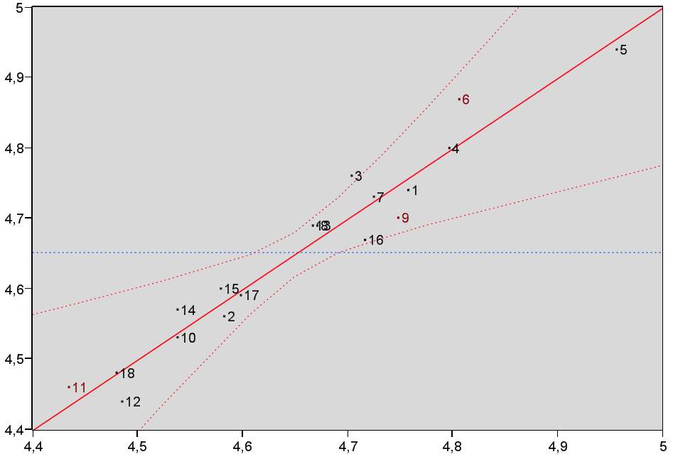
Exp. pIC50

Pred. pIC50
Fig.9. Correlation of experimental and predicted pIC50 as derived using MLR.

    - Artificial neural networks
ANN ^{65,66} is a popular nonlinear model, which is used to predict the biological activity (i.e. IC50) of the datasets of therapeutic molecules. It presents several benefits like better prediction, adaptation and generalization capacity beyond the studied sample, and better stability of the coefficients. It is employed in complex drug design, drug engineering and medicinal chemistry domains .⁶⁷ In this work, the neural network is a system of fully interconnected neurons arranged in three layers. The input layer is made of nine neurons, where each of them receive one of the nine descriptors selected from the correlation matrix of the model. The intermediate (hidden) layer is composed of four neurons that form the deep internal pattern that discovers the most significant correlations between predicted and experimental data. One neuron constitutes the output layer, which returns the value of pIC50 (Fig. 10).⁶⁸
Fig. 10. Structure of ANN.

As can be seen in Fig. 10, a good agreement between experimental data and predicted pIC50 issued from the ANN model is observed. Indeed, the statistical parameters for this model, reveal a correlation coefficient close to 1 ($R_{inter}^{2}$= 0.995), indicating that the ANN one is more reliable. Furthermore, the robustness of the model was further confirmed by the significant $R_{ext}^{2}$value of the test data set ($R_{ext}^{2}$= 0.920).
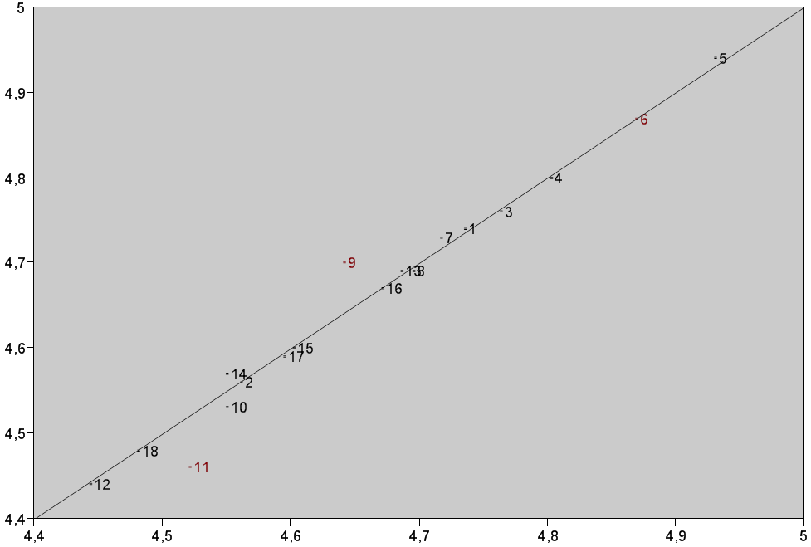
Pred. pIC50
Exp. pIC50

Fig.11. Correlation of experimental and predicted pIC50 as derived using ANN.

Table 11. Experimental and predicted pIC50 using MLR and ANN methods.
N° | Exp. pIC50(BGC823) | Pred. pIC50(BGC823)  MLR | Pred.pIC50(BGC823)  ANN
1 | 4.740 | 4.757 | 4.736
2 | 4.560 | 4.582 | 4.562
3 | 4.760 | 4.704 | 4.764
4 | 4.800 | 4.796 | 4.804
5 | 4.940 | 4.956 | 4.931
6* | 4.870 | 4.806 | 4.869
7 | 4.730 | 4.724 | 4.717
8 | 4.690 | 4.671 | 4.696
9* | 4.700 | 4.748 | 4.642
10 | 4.530 | 4.537 | 4.550
11* | 4.460 | 4.434 | 4.521
12 | 4.440 | 4.485 | 4.443
13 | 4.690 | 4.666 | 4.686
14 | 4.570 | 4.537 | 4.550
15 | 4.600 | 4.579 | 4.603
16 | 4.670 | 4.716 | 4.672
17 | 4.590 | 4.598 | 4.595
18 | 4.480 | 4.480 | 4.481
* denotes the compounds selected for external validation (test set).

4. CONCLUSION

The present work deals with the molecular properties of pyrazine. The HF, MP2 and DFT methods, the DFT method is more appropriate for further study on pyrazine ring. The geometry of the pyrazine is symmetric and planar, as all the dihedral angles are either nearly 0° or 180°, which make this conformation more stable. The compound B3(2,3-dibromo pyrazine) is predicted to be the most reactive with smaller HOMO–LUMO energy gap of all pyrazine systems, C2 and C3 positions are the most preferential site of nucleophilic attack .
Afterwards, we showed that both ANN and MLR methods provide similar QSAR model accuracy. As can be seen in Table 11, the ANN network has substantially better predictive capabilities compared to MLR, leading to pIC50 values closer to the experimental determinations. Nevertheless, both models remain satisfactory and exhibit a high predictive power, thus validating their use to explore and propose new molecules as anti-proliferative activity against the BGC823.

REFERENCES
- V. M. Baldwin , S.D. Arikkatt, T.J. Sindhu, M. Chanran, A.R. Bhat, K. Krishnakumar , World J. Pharm. Sci.2014, 3, 1124-1132.
- D.L. Trump, H. Payne, K. Miller, J.S. de Bono,J. Stephenson ,H. Burris, F. Nathan, M. Taboada ,T. Morris ,A. Hubner, J. of Prostate ,2011, 71 , 1264-1275.DOI: 10.1002/pros.21342.
- C.P. Meher, A.M. Rao, Md. Omar , Asian J. Pharm. Sci. & Res.2013, 3, 52-56.
- L.E. Schechter , Q. Lin , D.L. Smith, G. Zhang , Q. Shan, B. Platt, M.R. Brandt, L.A. Dawson , D. Cole,R. Bernotas ,A. Robichaud ,S. Rosenzweig-Lipson ,C.E. Beyer ,Int. J. Neuropsychopharmacol.2008, 33 , 1323-1335. DOI: 10.1038/sj.npp.1301503.
- S. Spaia ,I. Magoula , G. Tsapas ,G. Vayonas , Perit. Dial. Int.2002,20, 47-52. DOI:10.1177/089686080002000109.
- K. Whalen, “Pharmacology ”,6th edition, University of Florida, College of Pharmacy Gainesville, Gainesville, Florida,USA ,2014.
- S. Rosenzweig-Lipson, J. Zhang,H. Mazandarani ,L. H. Boyd , A. sabb,J. Sabalski,G. Stack,G. Welmaker,J. E. Barrett,J. Dunlop , Brain Res.2006, 1073-1074, 240-251. DOI :10.1016/j.brainres.2005.12.052.
- W.J. Hehre: Practical Strategies for Electronic Structure Calculations, Wave functions, Irvine, California,USA ,1995.
- I. H. Nazlı, D. B. Celepci, G. Yakali, D. Topkaya, M. Aygün, S. Alp, Acta Chim. Slov. 2018, 65, 86–96. DOI: 10.17344/acsi.2017.3613.
- F. Odame, Acta Chim. Slov. 2018, 65, 328–332, DOI: 10.17344/acsi.2017.4001.
- S. Belaidi ,R. Mazri ,H. Belaidi ,T. Lanez ,D. Bouzidi ,Asian J. Chem.2015, 25, 9241-9245. DOI :10.14233/ajchem.2013.15199.
- Z. Haddadi,H. Meghezzi, A. Amar,A. Boucekkine, J. Theor. Comput. Chem.2019, 31, 595-601. DOI: 10.1142/S0219633619500019.
- A. K. Sachan ,S. K. Pathak ,S. Chand ,R. Srivastava, O. Prasad, S. Belaidi ,L. Sinha, Spectrochim. Acta A Mol. Biomol. Spectrosc.2014, 132,568-581. DOI:10.1016/j.saa.2014.05.011.
- S. Belaidi , Z. Almi ,D. Bouzidi , J. Comput. Theor. Nanosci.2014,11, 2481-2488. DOI: 10.1166/jctn.2014.3665.
- C. M. Chang, H. L. Tseng, A. F. Jalbout, A. de Leon, J. Comput. Theor. Nanosci.2013, 10, 527-533.DOI:10.1166/jctn.2013.2730.

T. L. Jensen ,J. Moxnes , E. Unneberg , J. Comput. Theor. Nanosci.2013, 10, 464-469. DOI: 10.1166/jctn.2013.2720.
- M. Ibrahim ,H. Elhaes, Rev. Theor.Sci.2013,1, 368-376. DOI:10.1166/rits.2013.1012.
- E. C. Anota ,H. H. Cocoletzi ,M. Castro, J. Comput. Theor. Nanosci.2013, 10,2542-2546. DOI:10.1166/jctn.2013.3244.

F. Bazooyar ,M. Taherzadeh ,C. Niklasson ,K. Bolton , J. Comput. Theor. Nanosci.2013, 10, 2639-2646. DOI: 10.1166/jctn.2013.3263.
- E.R. Davidson : Quantum Theory of Matter,Chem.Rev. ,guest editor, department of chemistry ,Indiana university,India, 1991,91, 649. DOI:10.1021/cr00005a600.
- S. Belaidi ,H. Belaidi ,D. Bouzidi , J. Comput. Theor. Nanosci.2015, 12,1737-1745. DOI:10.1166/jctn.2015.3952.
- B. Souyei, A. Hadj Seyd, F. Zaiz,A. Rebiai, Acta Chim. Slov. 2019, 66, 315–325, DOI: 10.17344/acsi.2018.4793.
- R. A. Gupta,A. K. Gupta, S. G. Kaskhedikar , Acta Chim. Slov. 2009, 56, 977–984.
- E. Zerroug,S. Belaidi,I. Benbrahim,S. Leena, J. King Saud Univ. Sci.2019, 31, 595-601.

DOI: 10.1016/j.jksus.2018.03.024.
- F. Soualmia, S. Belaidi, N. Tchouar, T. Lanez, J. Fundam. Appl. Sci. 2020, 12, 392-415. DOI: 10.4314/jfas.v12i1S.28.
- Y.C. Martin: Quantitative Drug Design, Marcel Dekker, New York, USA,1978.
- I. Almi,S. Belaidi,E. Zerroug, M. Alloui, R. G. Ben Said, R. Linguerri, M. Hochlaf, J. Mol. Struct.2020, 1211,128015. DOI: 10.1016/j.molstruc.2020.128015.
- C.A. Lipinski, V. Lombardo, B.W. Dominy, P. J. Feeney, Adv. Drug Deliv. Rev. 2001, 46, 3–26.DOI: 10.1016/s0169-409x(00)00129-0.
- E. L. Pankratov ,E. A. Bulaeva, Rev. Theor. Sci.2013,1, 58-82. DOI:10.1166/rits.2013.1004.
- Q. Zhao , Rev. Theor. Sci. 2013, 1, 83-101. DOI: 10.1166/rits.2013.1005.
- A. Khrennikov , Rev. Theor. Sci.2013, 1, 34-57. DOI: 10.1166/rits.2013.1003.
- V. Paitya ,K. P. Ghatak , Rev. Theor. Sci.2013, 1,165- 305. DOI: 10.1166/rits.2013.1008.
- D. Fiscaletti , Rev. Theor. Sci.2013,1, 103-144. DOI:10.1166/rits.2013.1006.
- D. M. Segall, J. Curr.Pharm.Des.2012, 18,1292-1310. DOI: 10.2174/138161212799436430.
- R. Darnag, B. Minaoui, M. Fakir, Arab. J. Chem.2017, 10,600-608. DOI:10.1016/j.arabjc.2012.10.021.
- P. Xuan, Y. Zhang, T.J. Tzeng, X.F. Wan, F. Luo, Glycobiology ,2012, 22,554-560. DOI: 10.1093/glycob/cwr163.
- S. Kothiwale, C. Borza, A. Pozzi, J. Meiler, Molecules.2017, 22 ,1576-1586. DOI: 10.3390/molecules22091576.
- Z. Hajimahdi, A. Ranjbar, A.A. Suratgar, A. Zarghi, Iran. J. Pharm. Res. 2014, 14, 69-74.
- M. Ghamri , D. Harkati , S. Belaidi, S. Boudergua , R. Ben Said , R. Linguerri , G. Chambaud , M. Hochlaf, Spectrochim. Acta A Mol. Biomol. Spectrosc.2020,242,118724, DOI: 10.1016/j.saa.2020.118724.
- S. Boudergua , M. Alloui, S. Belaidi , M. Mogren Al Mogren,U. A. Abd Ellatif Ibrahim, M. Hochlaf, J. Mol. Struct.2019,1189,307-314. DOI:10.1016/j.molstruc.2019.04.004.
- E. Pourbasheer, S. Vahdani, D. Malekzadeh, R. Aalizadeh, A. Ebadi, Iran. J. Pharm. Res.2017, 16 , 966-980.
- HyperChem (Molecular Modeling System) Hypercube, Inc., 1115 NW, 4th Street, Gainesville, FL 32601, USA(2008).
- Gaussian 09, M.J. Frisch , G.W. Trucks, H.B. Schlegel , G.E. Scuseria , M.A. Robb , J.R. Cheeseman , G. Scalmani , V. Barone, B. Mennucci , G.A. Petersson, H. Nakatsuji , M. Caricato , X. Li, H.P. Hratchian , A.F. Izmaylov, J. Bloino , G. Zheng, J.L. Sonnenberg , M. Hada , M. Ehara , K. Toyota, R. Fukuda , J. Hasegawa , M. Ishida , T. Nakajima , Y. Honda ,Y. Kitao ,H. Nakai , T. Vreven , J.A. Montgomery , J.E. Peralta , F. Ogliaro, M. Bearpark , J.J. Heyd, E. Brothers , K.N. Kudin , V.N. Staroverov, T. Keith , R. Kobayashi , J. Normand , K. Raghavachari , A. Rendell , J.C. Burant, S.S. Iyengar, J. Tomasi, M. Cossi , N. Rega , J.M. Millam , M. Klene , J.E. Knox , J.B. Cross ,V. Bakken , C. Adamo , J. Jaramillo, R. Gomperts, R.E. Stratmann, O. Yazyev, A.J. Austin , G.A. Cammi R., Pomelli C., Ochterski J.W., Martin R.L., Morokuma K., Zakrzewski V.G., Voth , P. Salvador , J.J. Dannenberg , S. Dapprich, A.D. Daniels , O. Farkas , J.B. Foresman , J.V. Ortiz , J. Cioslowski , D.J. Fox, Gaussian Inc., Wallingford, CT(2010).
- MarvinSketch15.8.31, Chemaxon (http://www.chemaxon.com) (2015).
- Database,(http://www.molinspiration.com).
- JMP 8.0.2, SAS Institute Inc., (2009).
- M. Kanno , Y. Ito, N. Shimakura , S. Koseki , H. Kono , Y. Fujimura , J. Phys. Chem.- Chem.Phys.2015 ,17 , 2012-2024. DOI: 10.1039/C4CP04807E.

P. Govindasamy , S. Gunasekaran , J. Mol. Struct.2015,1081 ,96-109. DOI :10.1016/j.molstruc.2014.10.011.

J. S. Murray , K. Sen, Molecular Electrostatic Potentials,1st Edition ,Concepts and Applications, Elsevier, Amsterdam , Holland,1996.

I. Alkorta , J.J. Perez , Int. J. Quantum Chem.1996,57, 123-135.DOI:10.1002/(SICI)1097-461X(1996)57:1<123::AID-QUA14>3.0.CO;2-9.

E. Scrocco ,J. Tomasi , Adv. Quantum Chem.1978,11, 115–193.DOI: 10.1016/S0065-3276(08)60236-1.

F.J. Luque , M. Orozco , P.K. Bhadane , S. R. J. Gadre, J. Phys. Chem.1993, 97,9380-9384.DOI :10.1021/j100139a021.

J. Sponer,P. Hobza , J. Quantum Chem.1996, 57, 959-970. DOI:10.1002/(SICI)1097-461X(1996)57:5<959::AID-QUA16>3.0.CO;2-S.
- J.M. Seminario , Recent Developments and Applications of Modern Density Functional Theory, Elsevier, Amsterdam, Holland, 1996.
- I. Fleming: Frontier orbitals and organic chemical reactions, Wiley, New York,USA,1976.
- G.L. Miessler, D.A. Tarr : Inorganic Chemistry, 2nd edition, Prentice-Hall Upper Saddle River, New Jersey, USA ,1999.

Y.B. Zhang , X.L. Wang , W. Liu, Y.S. Yang , J.F. Tang , H.L. Zhu, Bioorg. Med. Chem.2012, 20, 6356-6365. DOI: 10.1016/j.bmc.2012.08.059 .

C.A. Lipinski, F. Lombardo, B.W. Dominy, P. J. Feeney, J. Adv. Drug Deliv. Rev.2012 , 64, 4-17. DOI: 10.1016/j.addr.2012.09.019.
- D.F. Veber, S.R. Johnson, H. Y. Cheng, B.R. Smith, K.W. Ward, K.D. Kopple, J. Med. Chem.2002, 45, 2615–2623.DOI:10.1021/jm020017n.
- M. Aurélien, Ph.D. Dissertation, Orleans University ,France,2006.
- F. Soualmia, S. Belaidi, H. Belaidi, N. Tchouar, Z. Almi, J. Bionanosci. 2017, 11, 584-591. DOI:10.1166/jbns.2017.1476.
- B. Jhanwarb, V. Sharmaa, R.K. Singla, B. Shrivastava, Pharmacologyonline.2011, 1, 306-344.
- R. Darnag, B. Minaoui, M. Fakir, Arab. J. Chem.2017, 10,600-608. DOI:10.1016/j.arabjc.2012.10.021.
- K. Roy, S. Kar, R.N. Das, A Primer on QSAR/QSPR Modeling: Fundamental Concepts, Springer, New York, USA,2015.
- S. Erić, M. Kalinić, A. Popović, M. Zloh, I. Kuzmanovski, Int. J. Pharm. 2012,437 ,232–241. DOI: 10.1016/j.ijpharm.2012.08.022
- R. Lowe, H.Y. Mussa, J.B. Mitchell, R.C. Glen, J. Chem. Inf. Model.2011, 51,1539–1544. DOI :10.1021/ci200128w.
- C. Feng, S. Vijaykumar, Clin. Exp. Pharmacol.2012, 2,2–3.DOI:10.4172/2161-1459.1000e113.
- B.D. Ripley, Pattern Recognition and Neural Networks, Cambridge University Press,
NY United States,USA, 1996.

