Table S1. Study target with CMAs and CPPs
QTPP |  |  |  | CMAs | CPPs
TPP | Target | TPQP | MoA | Materials | Parameters
Formulation type | NS | - Particle size and PDI | Malvern Zetasizer | Poloxamer 188 (mg) | Number of cycles  Time of milling (h)
Formulation type | NS | - Particle shape and morphology | SEM | Poloxamer 188 (mg) | Number of cycles  Time of milling (h)
Oral bioavailability | Enhancement of oral bioavailability | - Saturation solubility | Orbital shaker | Tween 80  (% v/v) | Number of cycles  Time of milling (h)
Oral bioavailability | Enhancement of oral bioavailability | - In-vitro drug release | USP apparatus type II | Tween 80  (% v/v) | Number of cycles  Time of milling (h)
Oral bioavailability | Enhancement of oral bioavailability | - In-vivo studies | an indirect method for the assessment of drug in rat plasma | Tween 80  (% v/v) | Number of cycles  Time of milling (h)
* TPQP: Target Product Quality Profile; TPP: Target Product Profile; CMA: Critical Material Attribute; QTPP: Quality Target Product Profile; CPP= Critical Processing Parameter; SEM: Scanning Electron Microscopy; USP: United States Pharmacopeia; PCS: Photon Correlation Spectroscopy; PDI: Polydispersity Index.

Table S2. Risk assessment using failure mode effects analysis approach
Risk factor | Particle size | Polydispersity index | Zeta potential | Drug content | Solubility | Dissolution | Bioavailability
Speed of Homogenizer (Preliminary Stage) (Rpm) | High | High | Medium | Low | Medium | Medium | Medium
Time of Homogenizer (Preliminary Stage) (Min.) | Medium | Medium | Low | Low | Low | Low | Low
Homogenization Pressure (Bars * 1000) | High | High | High | Low | Medium | Medium | Medium
Number of Cycles | High | High | High | Medium | High | High | High
Concentration of Poloxamer 188 (Mg) | Low | Low | High | Low | Medium | Medium | Medium
Concentration of Sodium Lauryl Sulphate (Mg) | Low | Low | High | Low | Medium | Medium | Medium
Concentration of Tween 80 (mL) | Low | Low | High | Low | Medium | Medium | Medium
Concentration of Methotrexate (mg) | Low | Low | Low | High | Medium | Medium | Medium
Temperature of HPH | Low | Low | Low | Low | Low | Low | Low
Molecular weight of Cryoprotectant | Low | Low | Low | Low | Low | Low | Low
Concentration of Cryoprotectant | Low | Low | Low | Low | Low | Low | Low
pH of solution | Low | Low | Low | Low | Low | Low | Low
Volume of Feed | Low | Low | Low | Low | Low | Low | Low
Type of stabilizers | Low | Low | Low | Low | Low | Low | Low

Table S3. Risk assessment using failure mode effects analysis approach
Score | Severity (S) | Regularity of occurrence (R) | Detectability (D)
1 | Minor | Very unlikely | Normally not detected
2 | Moderate | Occasional | Likely detected
3 | Major | Regular | Regularly detected

Table S4. Different levels of risk to rank CMPs and CPPs
CPPs/ CMPs | Failure mode  (critical event) | Effect on CAAs(justification of failure mode) | S | R | D | RPN (S*R*D)
Speed of Homogenizer (Preliminary Stage) (Rpm) | Very low and very high | Low speed- particles size will not be reduced  High speed- reduction in particle size | 3 | 3 | 3 | 27
Time of Homogenizer (Preliminary Stage) (Min.) | Lesser and Higher | Lesser-higher particle size as attrition is for lesser period.  Higher- particle size reduced | 3 | 3 | 3 | 27
Homogenization Pressure (Bars * 1000) | Lower and higher | It will affect the stability of drug particles in formulation. | 2 | 2 | 2 | 8
Number of Cycles | More and Less | As cycles increases there is more chances of particle size reduction | 3 | 3 | 3 | 27
Concentration of Poloxamer 188 (Mg) | Low and High | May affect the stability of drug particles in formulation | 2 | 2 | 2 | 8
Concentration of Sodium Lauryl Sulphate (Mg) | Low and High | May affect the stability of drug particles in formulation | 2 | 2 | 2 | 8
Concentration of Tween 80 (mL) | Low and High | May affect the stability of drug particles in formulation | 2 | 2 | 2 | 8
Concentration of Methotrexate (mg) | Low and High | Therapeutic activity and toxicity may Hamper | 2 | 2 | 2 | 8
Temperature of HPH | Low and High | May affect the nature of drug | 1 | 1 | 1 | 1
Molecular weight of Cryoprotectant | Monosaccharide or disaccharide | Affects bumping of solution | 0 | 0 | 0 | 0
Concentration of Cryoprotectant | Low and High | Cake formation | 0 | 0 | 0 | 0
pH of solution | Acidic or basic | Affects the pH of final preparation | 1 | 0 | 0 | 0
Volume of Feed | More and Less | Loss of content | 0 | 0 | 0 | 0
Type of stabilizers | Grades | No effect | 0 | 0 | 0 | 0

Table S5: Suspending concentrations and particle size of MTX in different stabilizer systems for MTX-NS
Stabilizers* | Concentration of MTX**  (µg/ml) | Particle size (nm) ** | Stabilizers* | Concentration of MTX**  (µg/ml) | Particle size  (nm) **
Tween 80 | 119.14±0.14 | 301.65±1.45 | SL/SDS | 111.32±0.24 | 564.98±3.45
Sodium lauryl sulphate (SLS) | 112.83±0.21 | 349.09±2.18 | SLS/ Poloxamer 407 | 117.72±0.18 | 387.09±3.42
Poloxamer 188 | 126.09±0.31 | 293.46±3.32 | Poloxamer 407/ Tween 80 | 119.23±0.12 | 345.67±2.54
Poloxamer 407 | 101.81±0.24 | 312.45±2.34 | Tween 80/ Carbomer 940 | 51.82±0.21 | 573.45±2.98
HPMC-K5 | 109.59±0.17 | 765.90±1.44 | Tween 80/ SLS | 101.44±0.24 | 535.07±2.70
Soya lecithin (SL) | 41.84±0.19 | 352.77±2.56 | SDS/ Poloxamer 407 | 95.04±0.54 | 376.88±2.54
Cremophor EL- 40 | 103.25±0.32 | 675.43±2.43 | Tween 80 / HPMC-K5 | 105.15±0.65 | 389.56±3.44
Sodium deoxycholate (SDS) | 88.28±0.28 | 673.09±2.78 | Tween 80/ SDS | 54.93±0.24 | 409.99±2.33
Carbomer 940 | 69.97±0.27 | 456.98±3.45 | Tween 80/ SL | 56.17±0.45 | 456.98±3.01
PVP K30 | 98.87±0.18 | 345.65±3.54 | Poloxamer 407/ SL | 41.48±0.74 | 378.01±3.21
PEG 6000 | 110.59±0.16 | 345.09±2.54 | SLS/soya lecithin/ PEG 6000 | 110.63±0.23 | 421.98±2.45
Span 80 | 85.87±0.22 | 665.98±2.43 | Tween 80/SLS/ Poloxamer 188 | 198.88±0.31 | 372.89±2.43
Poloxamer 188/ SLS | 51.94±0.11 | 435.98±2.87 | Soya lecithin /Poloxamer 407/ SLS | 99.43±0.22 | 332.45±1.03
Tween 80/  Poloxamer 188 | 115.21±0.27 | 389.09±3.33 | Tween 80/ SLS/ SL | 104.23±0.28 | 406.09±2.09
* All the above ratios of different types of stabilizers in a single system are represented in 1:1 (w/w) or 1:1:1 (w/w/w), except that the ratio of Carbomer and Tween 80 was 1:0.5 (w/w). ** Results presented as means ± SD (n = 3).

Table S6. Results of Quadratic model for regression analysis of response variables Y1, and Y2
Quadratic model | R² | Adjusted R² | Predicted R² | SD | % CV
Y1 | 0.7225 | 0.4728 | -1.2310 | 12.77 | 4.69
Y2 | 0.5943 | 0.2292 | -2.0628 | 1.07 | 1.22
The optimized CPPs and CMAs with residual values of CQAs are summarized in Table 2.

Table S7. Residual values of CQAs of optimized formulations
Response parameters | CMAs/CPPs |  |  | CQAs
Response parameters | Concentration of Tween 80  (% v/v) | Concentration of Poloxamer 188  (mg) | Number of cycles | Particle size  (nm) | Drug content  (%)
Software-predicted results | 0.10 | 75 | 25 | 259.71 | 87.35
Actual obtained results | 0.10 | 76 | 25 | 260±0.25 | 88.65±0.24
Residual values (%) | - | - | - | -1.27 | -1.47

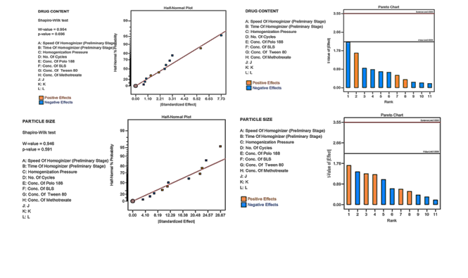
Figure S1: The half-normal plot and Pareto charts showing the significant process and formulation variables on drug content, entrapment efficiency, and particle size

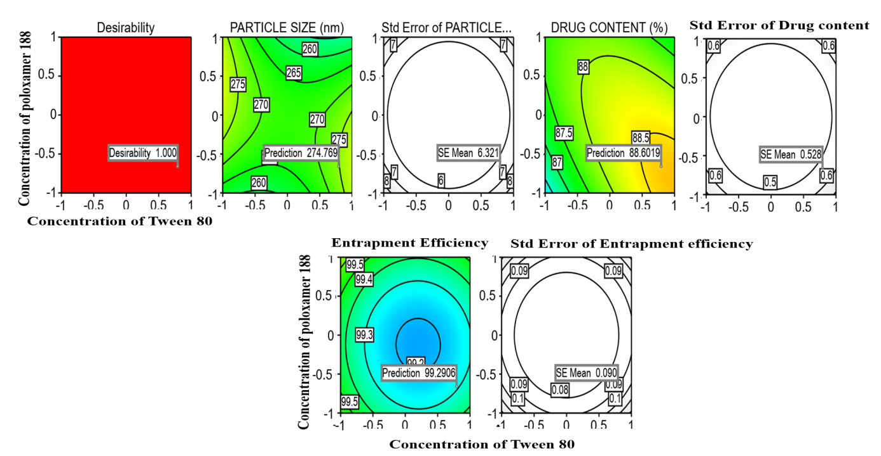
Figure S2. Contour plot showing the desirability value and predicted values obtained from the AB model term.

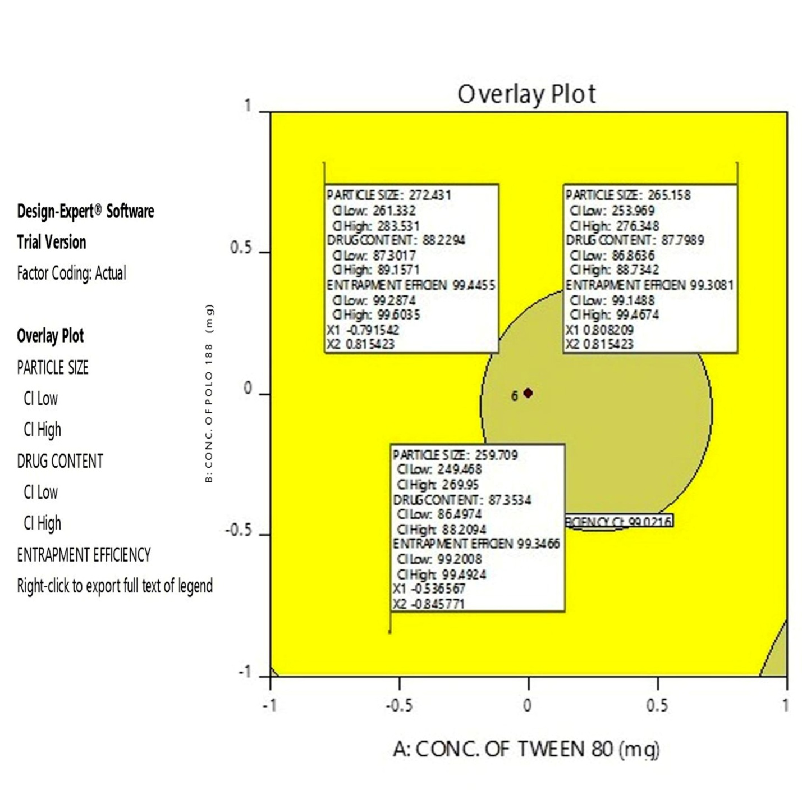
Figure S3. Overlay plot proposed by the DOE software displaying design space in yellow color along with the compositions of selected optimized formulations with the responses

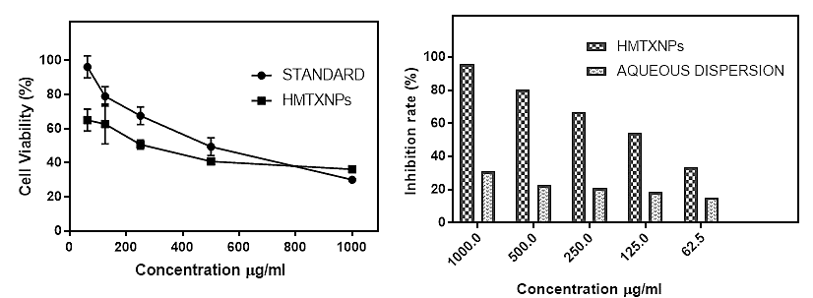
Figure S4. Cytotoxicity of MTX-NS and MTX-AQD after 48 h of incubation (n=3, mean± standard deviation)

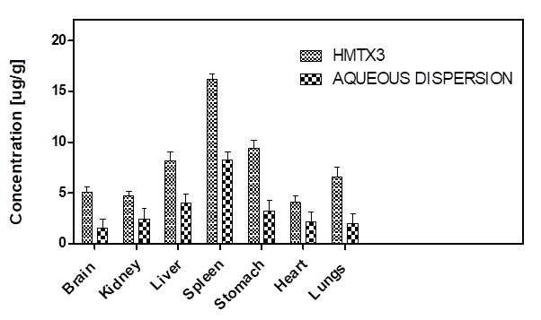
Figure S5. Biodistribution of MTX-NS and MTX-AQD after oral administration in rats brain, kidney, liver, spleen, stomach, heart, lungs

