COD removal of binary mixture of dyes by heterogeneous Fenton oxidation: Kinetics, product identification and toxicity assessment

John Elisa Kumar¹, Tsungom Mulai ¹, Wanshanlang Kharmawphlang¹, Rajeshwar Nath Sharan², Mihir Kumar Sahoo^{1*}
¹Centre for Advanced Studies in Chemistry, Department of Chemistry, North-Eastern Hill University, Shillong– 793 022, India
²Radiation & Molecular Biology Unit, Department of Biochemistry, North-Eastern Hill University, Shillong– 793 022, India

*Corresponding author: Tel.: +91-364-2722632; Cell: +91-9436706767;
Fax: +91-364-2551634
E-mail id: mksahoo@nehu.ac.in; mihirs2107@gmail.com

Abstract

COD removal of mixture of two azo dyes, Acid blue 29 and Ponceau xylidine was studied by heterogeneous Fenton and Fenton-type processes using hydrogen peroxide (HP) and sodium persulphate (SPS) as oxidants and nano and micro-${Fe}_{2}O_{3 }$particles as catalysts. The nano-${Fe}_{2}O_{3 }$particles were characterized using various analytical techniques, viz. FT-IR, TEM, EDX, powder XRD and VSM. Effect of pH, catalyst load, nature of oxidant, and particle size of catalysts on the COD removal efficiency (${COD}_{eff}$) was established. Although nano-${Fe}_{2}O_{3 }$/HP system was found to be most effective, satisfactory result was obtained till 2nd cycle. The mechanisms of formation of different ions and the intermediate products were proposed and the variation of ${COD}_{eff}$ with residual HP on was established. It was established that the COD removal and consumption of HP proceed through an initial slow followed by a fast process, each following pseudo first order kinetics. Based on our result of toxicity assay using V. fischeri and E. coli, we recommend that the nature of recipient water body for wastewater disposal should be primarily considered before choosing either of the two toxicity assays.

Keywords: Binary mixture of dyes; Heterogeneous Fenton processes; COD removal kinetics; Identification of ions and products; Toxicity assessment using Escherichia coli and Vibrio fischeri

1. Introduction

The wastewater generated by the textile industry usually contain higher concentration of Chemical Oxygen Demand (COD), Biochemical Oxygen Demand (BOD), alkalinity and Colour¹ which should be removed before being released into the water bodies. Advance Oxidation Processes (AOPs), which involve in situ generation of hydroxyl radicals have been able to achieve the above goals to a great extent.²⁻⁴ The oldest AOPs, which involve the activation of HP and SPS to generate of hydroxyl and sulphate radicals⁵⁻⁷ using ${Fe}^{2+}$ as catalyst, are popularly known as Fenton (${Fe}^{2+}$/HP) and Fenton-type process (${Fe}^{2+}$/SPS) (Eqs. (1) and (2)). Apart from simple operation, high efficiency and requirement of no electrical energy, the other important advantage of ${Fe}^{2+}$/HP process is that only a catalytic amount of ${Fe}^{2+}$ is required as it is regenerated from the ${Fe}^{3+}$ ion in a process called Fenton-like reaction (Eq. (3)).⁸
${Fe}^{2+}+H_{2}O_{2}+ H^{+}→{Fe}^{3+}+H_{2}O+{HO}^{•}$ (1)
${Fe}^{2+}$ + $S_{2}O_{8}^{2-}$ → ${Fe}^{3+}$ + S$O_{4}^{•-}$ + S$O_{4}^{2-}$ (2)
${Fe}^{3+}+H_{2}O_{2}→{Fe}^{2+}+{HO}_{2}^{•}+H^{+}$ (3)
However, these advantages have been masked by its narrow operational pH range and the generation of sludge at the end of the process.^{5,9} So, a search for a low cost and stable catalyst, which can be easily separated from the reaction medium and can run in successive cycles, thereby reducing the cost of operation, was felt necessary by the environmental chemists. A heterogeneous catalyst has been shown to meet the above mentioned requirements and therefore, can be used in Fenton process, the heterogeneous Fenton process. Among the various heterogeneous catalysts, zero-valent iron nano-particles,^{10,11} and iron oxide minerals¹²⁻¹⁵ have been widely used for environmental remediation processes. Iron is fixed in the structure of heterogeneous catalyst and activates the oxidant (Eq. (4)) over a broad range of pH values depending on the point of zero charge (PZC) of the catalyst.¹⁶ The advantage of heterogeneous over homogeneous Fenton process is that the catalyst can be separated from the solution by an external magnet.
$≡{Fe}_{surf}^{2+}+H_{2}O_{2}+ H^{+}→ ≡{Fe}_{surf}^{3+}+H_{2}O+{HO}^{•}$ (4)
The objective of the present work is to investigate the colour and ${COD}_{eff}$ of binary mixture of dyes, viz. Acid Blue 29 (AB) and Ponceau Xylidine (PX), by heterogeneous Fenton and Fenton-type processes using two types of iron oxide particles as catalysts: nano-${Fe}_{2}O_{3 }$(synthesised, average particle size 26-35 nm) and micro-${Fe}_{2}O_{3 }$particles (commercially available, < 5 µm) and two different oxidants, i.e. HP and SPS. AB and PX were selected as the model dye pollutants because of their extensive use in textile industries for dyeing wool, cotton, silk, polyester and rayon etc. and to a less extent in paint, ink, plastic and leather industries. Moreover, both the dyes are recalcitrant in nature. Although the literature is rich in reports on degradation of individual dyes by different AOPs, that for mixture of dyes is scanty even though textile industries invariably use mixture of dyes. Since the activation of HP and SPS depends on the specific surface area of the catalyst, we proposed to investigate the ability of iron (III) oxide nano-particles (n-${Fe}_{2}O_{3}$) and micro-${Fe}_{2}O_{3 }$(m-${Fe}_{2}O_{3}$) particles to decompose HP and SPS and produce hydroxyl and sulphate radicals. The influence of catalyst loading, HP dosage, as well as pH on the efficiency of the process was also considered in the study. As it is known that HP interference results in the over estimation of COD values,¹⁷ we have calculated the actual COD values at optimum parameters by eliminating the interference due to HP. The COD values presented in the text are inclusive of the HP factor (represented as m-COD) unless otherwise stated. Nevertheless, the result gives a qualitative idea about the COD value, which would obviously be higher than the value obtained after eliminating the HP factor. The COD removal kinetics was also determined. Different ions and end products formed in the process were analysed by Ion chromatography. The degradation mechanism of mixture of dyes based on end product analysis and supported by literature data has been proposed.
Determination of toxicity of treated samples is an integral part of any wastewater treatment process. Two methods are used by researchers to assess the toxicity of treated wastewater solutions. One is by monitoring the growth inhibition assay (reduction of colony forming unit) of Escherichia coli (E. coli) and the other is by measuring inhibition of luminescence (light loss) in marine bacterium Vibrio fischeri (V. fischeri) when exposed to a given test sample.^{7,18-21} The bacterium, V. fischeri emits light as a natural part of their metabolism. When exposed to a toxic chemical, a disruption of the respiratory process of the bacteria and hence reduction in the emitted light intensity is observed. We have compared the results of toxicity assessments of the samples by these two methods at different stages of treatment.

2. Materials and Methods
2.1 Chemicals and materials

The diazo dye, Acid Blue 29 (Synonym: Amacid Navy Blue B; Cetil Black M; Fabracid Navy S-BL; Mordant Blue 82; C.I. number: 20460; molecular formula:$C_{22}H_{14}N_{6}{Na}_{2}O_{9}S_{2}$; molecular weight: 616.49 (${g mol}^{-1}$); $λ_{max}$ = 602 nm; pH of the dye solution in water: 6.7) and the anionic diazo dye, Ponceau Xylidine (Synonym: 1-(2,4-xylylazo)-2-naphthol-3,6-disulphonicacid, disodiumsalt; C.I. number: 16150; molecular formula:$C_{18}H_{14}N_{2}{Na}_{2}O_{7}S_{2}$; molecular weight: 480.42 (${g mol}^{-1}$); $λ_{max}$ = 504 nm; pH of the dye solution in water: 6.2) were procured from Sigma Aldrich (Germany). The molecular structures of AB 29 and PX are shown Fig. 1.
Figure 1. Structures of Acid blue 29 (a) and Ponceau xylidine (b).

The other chemicals viz. sulphuric acid ($H_{2}SO_{4}$, GR), sodium hydroxide (NaOH, GR), hydrogen peroxide ($H_{2}O_{2}$, 30% w/w, purified), Sodium peroxodisulphate (${Na}_{2 }S_{2}O_{8}$, for analysis), iron (II) sulphate (${FeSO}_{4}. 7 H_{2}O$, GR), Iron (II) Chloride anhydrous (${FeCl}_{2}$, purified), Iron (III) Chloride tetra hydrate (${FeCl}_{3}.{4H}_{2}O$), Hydrochloric Acid (HCl, min 35% GR), Nitric Acid (${HNO}_{3},$ min 65% GR), Methanol (${CH}_{3}OH, GR$) were obtained from Merck. Ethanol (Absolute, 99.9%) was obtained from Changshu Yangyuan Chemical china. Iron (III) oxide power (< 5µm), i.e. m-${Fe}_{2}O_{3}$ used as one of the catalysts in the heterogeneous process was supplied by Sigma-Aldrich. Solution 1’ (mercuric sulphate and sulphuric acid) and ‘Solution 2’ for low range COD (silver sulphate, chromic acid, sulphuric acid and demineralised water) required for the determination of COD was supplied by HACH, USA. The chemicals used for ion chromatographic analysis were sodium hydroxide (NaOH, 50-52% in water, Sigma), methane sulphonic acid (${CH}_{3}{SO}_{3}H$, HIMEDIA), acetonitrile (${CH}_{3}CN,$ HPLC grade, HIMEDIA), ammonium acetate ($CH_{3}COONH_{4}$, Merck, Emparta ACS). All the chemicals were used as received without further purification. Luria Bertani (LB) agar, LB broth and ampicillin used in detoxification experiment were acquired from Himedia, India. The lyophilized luminescent bacteria, V. fischeri used for toxicity assessment was supplied by Modern Water Inc, USA.

2.2 Synthesis of ${Fe}_{2}O_{3}$ nano-particles

Iron (III) oxide nano-particles (n-${Fe}_{2}O_{3}$) were synthesised by chemical co-precipitation of Fe(II) and Fe(III) ions as described earlier.²² Briefly, 3.1 g of ${FeCl}_{2}.4H_{2}O$ and 5.2 g of ${FeCl}_{3}$ (molar ratio of 1:2) were successively added to 25 ml of deionized water acidified with 0.85 mL of 12.1 N HCl with constant stirring. The resulting solution was added drop wise to 250 mL of 1.5 M NaOH solution under vigorous stirring when an instant black precipitate was observed. The paramagnetic character of the particles was checked in situ by placing a magnet near the precipitate. The precipitate was filtered in a vacuum pump after continuous stirring for 6 hrs, washed with deionized water until neutral pH was achieved. Finally, the precipitate was washed with ethanol, dried and stored after grinded. The black precipitate turned light brown after drying due to calcination.

2.3 Characterization of n-${Fe}_{2}O_{3}$

The surface functional groups of the prepared n-${Fe}_{2}O_{3}$ particles were qualitatively identified using FTIR spectrum (Bruker, Model: Alpha II). The morphology of the synthesized n-${Fe}_{2}O_{3}$ was determined by transmission electron microscopy (TEM) with an instrument (JEOL, JEM-2100) operating at 200 kV. The purity of n-${Fe}_{2}O_{3}$ was confirmed by energy dispersive X-rays (EDX) analysis. The EDX was analysed using the TEM instrument. To check the crystallinity, powder X-ray diffraction (XRD) patterns of the dried n-${Fe}_{2}O_{3}$ were recorded in reflection mode using a high resolution diffractometer (GNR Analytical Instrument, Explorer, Italy) with CuKα radiation ($λ$ = 1.54 Å) within the 2θ values ranging from 20–8$0^{0}$ with a step size of ${0.05}^{0}$ and step time of 2 min. The operating voltage and current are 40 kV and 35 mA, respectively. The vibrating sample magnetometry (VSM) analysis was performed using Vibrating Sample Magnetometer (Lakeshore, 7410 series) to confirm the paramagnetic nature of the prepared nano-particles.

2.4 Adsorption experiment

100 ml of mixture of dyes ([AB] = [PX] = 0.15 mM) was taken in a 250 ml RB. The pH was adjusted to 3 by adding 5 mM $H_{2}{SO}_{4}$ followed by the addition of n-${Fe}_{2}O_{3 }$so as to make the concentration of nano-particles 400 mg/L. The content was stirred for different time intervals. The concentration of each component of the dye solution, after a certain reaction period, was measured after centrifuging for 5 min at 4800 rpm and separating from the nano-particles. The concentration was measured by following Beer-Lambert law. It was observed that the concentration of each component of the dye solution remains constant from 60 min onwards. So, it was decided to carry out the adsorption experiment for 90 min before the start of the experiment to ensure complete adsorption and establishment of equilibrium.

2.5 Heterogeneous Fenton Procedure

Stock solutions of AB and PX of desired concentration were prepared separately by dissolving in required amount of Millipore water (Elix3 Century, Millipore India, Bangalore). Equal volume of both the dyes (15 ml each) were taken in a volumetric flask and the volume was adjusted to 100 ml. The concentrations of both the dyes in the mixture were calculated to be 0.15 mM each. The content in the volumetric flask was transferred to 250 ml round bottom flask (RB). After adjusting the pH to desired value, 4.0 g/L n-${Fe}_{2}O_{3}$were added to the mixture. The mixture was stirred for 90 min when complete equilibrium was established. The equilibrium point was established by measuring the concentration of the dyes from time to time until no change in concentration was observed. The reaction was started by adding 0.5 ml of HP of desired concentration after equilibration was achieved. The mixture after centrifuging for 6 min at 4800 rpm after desired reaction period was used for decolorisation and COD removal studies.
All reactions were carried out in the presence of air and at room temperature (varying between 19 and 25 $℃$). The body and the mouth of the RB were wrapped with aluminium foil to prevent passage of light. Two holes were pierced through aluminium foil covering the mouth to allow free passage of air. It may be mentioned that the temperature was not controlled during course of the experiments. Each RB was designated to be sacrificed for analysis after a predetermined time interval. The initial pH of the solution was adjusted to the desired value with $H_{2}SO_{4}$ (the strength varying between 0.05-0.35N depending on the pH required) or $NaOH$ (the strength varying between 0.025-0.125N depending on the pH required) using a digital pH meter (Eutech instrument pH-Tutor). All solutions used in this study were freshly prepared except the dye solution, which was stored at $4^{ o}C$ and used within three days.

2.6 Analytical Methods
Since the colour of the solution is due to the contribution of both the dyes, i.e. AB and PX, the decolorisation studies were carried out by measuring the absorbance at 539 nm (for PX) and 604 nm (AB 29) with the help of a UV-vis spectrophotometer (HACH, USA; DR 6000). The procedure for the determination of COD was supplied by HACH, USA [2]. In short, 2 ml of a given sample mixed with 0.25 ml of ‘Solution 1’ and 2.8 ml of ‘Solution 2’ (low range) was first digested in a COD digester (HACH, USA; DRB 200) at 150 $℃$ for 2 hrs. The digested sample after cooling to room temperature was analysed at 420 nm with the help of a UV-vis spectrophotometer (HACH, USA; DR 6000) for measurement of COD of the samples.
Decolorisation and ${COD}_{eff}$ are calculated according to the following equations:
$$Decolorisation (\%) =\frac{A_{0}-A_{t}}{A_{0}}×100 \%$$
$${COD}_{eff}= \frac{{COD}_{0}- {COD}_{t}}{{COD}_{0}} ×100\%$$
Where, $A_{0}$, and ${COD}_{0}$ are the initial absorbance and COD respectively and $A_{t}$, and ${COD}_{t}$ are absorbance, and COD at time ‘t’ respectively.
The COD value for the samples containing $H_{2}O_{2}$ was corrected quantitatively using Eq. (5), as proposed by Kang et al.¹⁷ The degradation rate constant in terms of COD removal was determined according to the pseudo-first-order rate laws (Eq. (6)).
$COD (mg/L) = {COD}_{m}-(0.4706 . \left[H_{2}O_{2}\right]-4.06 × {10}^{ -5}. [H_{2}O_{2}]^{2})$ (5)

Where ${COD}_{m}$ is the measured COD (mg/L)

$-ln{(COD}/{{COD}_{0})}= k_{COD}$.t (6)

Where, ${COD}_{0}$ is the initial COD at time t=0 and COD is its value at any time t (min). The first order rate constant ($k_{COD}$) for COD removal is the slope of the straight line obtained by plotting $-ln{(COD}/{{COD}_{0})}$ vs. time. The kinetics of HP consumption was determined by replacing COD with HP and ${COD}_{0}$ with ${HP}_{0}$ in Eq. (6), where ${HP}_{0}$ the initial [HP] at time t=0 and HP is its value at any time t (min).
Anions, cations, organic acids, phenols and concentration of residual HP were analysed using Ion Chromatography System (ICS) supplied by Thermo Scientific, USA (Dionex, ICS-1100). For anions and organic acids, IonPac AS11 analytical column (4 x 250 mm) with a suitable guard column and an automatic electrolytic suppressor (AERS 500, 4 mm) was used. The current of the suppressor was maintained at 30 mA for anions and 38 mA for organic acids. The mobile phase was NaOH (12 mM for anion and 15 mM for organic acids) with a flow rate of 1 ml $\min^{-1}$. Cations were analysed using IonPac CS17 analytical column (4 x 250 mm) with a suitable guard column and an automatic electrolytic suppressor (CERS 300, 4 mm) with a current of 15 mA. The mobile phase was 5 mM MSA with a flow rate of 1 ml $\min^{-1}$. Concentration of residual HP was analysed using CarboPac PA20 analytical column (3 x 150 mm) with a suitable guard column and an electro chemical detector (ED 50A). The mobile phase was 50 mM NaOH with a flow rate of 0.5 ml $\min^{-1}$. Phenols were analysed using a VWD variable wavelength absorbance UV-vis detector (cell path length: 10mm; cell volume: 11 µL). The wavelengths selected for the purpose were 270 nm and 320 nm. The mobile phase was 0.1 M ammonium acetate solution with a flow rate of 1 ml $\min^{-1}$. It was prepared by mixing appropriate amount of ammonium acetate to a mixture of water and acetonitrile (1:1). All the experiments were repeated at least three times and the error was always found to be within ± 5%. The data presented in the text and figures were analysed by standard deviation using ‘Origin 7’ (Microcal Inc.) and has been rounded up to significant values.
The iron content of the catalysts was determined by ICP-OES (ICP-OES: Model No. iCap 7600 Duo, Thermo Fisher). The sample preparation involves solubilising 0.02 g of the catalyst in 5 mL conc. HN$O_{3}$ by heating and evaporating to less than 1 ml. After solubilisation, the samples were diluted to 100 mL with distilled water and submitted for analysis by ICP-OES.²³

2.7 Toxicity assessment of the treated solutions
We have adopted two methods for the toxicity assessment of the treated solutions. The first method is based on the on E. coli growth inhibition (metabolic inhibition) bioassay.^{7,18} The procedure involves dissolving 40 g of LB agar in 1000 ml of water followed by autoclaving for 30 min. Upon cooling down to about 40 ºC, Ampicillin (1 µL for each ml of LB agar solution) was added, mixed, and aliquots of approximately 10 ml of the medium was poured into sterilized Petri plates. LB broth (25 g) was separately dissolved in 1000 ml of water, aliquoted (9 ml) in 100 ml conical flasks and sterilized by autoclaving for 30 min. To the sterilized LB broth, 10 µL of ampicillin, 100 µL of the E. coli culture inoculum and 1 ml of the dye or other test solution were added and the cultures were grown at 37 ºC overnight in a rotary shaker. The following day, the mid-log phase culture was diluted 10,000 times and 10 µL of the diluted culture was spread over the LB agar plates prepared earlier. The plates were incubated for 16 h in a 37 $℃$ incubator as described earlier.²⁴ Colony forming units (CFUs) formed in each plate was counted after 16 hrs. All the experiments were performed under sterilized conditions. The relative toxicity, measured as a reduction in CFU, of the treated solutions presented in the study were with respect to the control.
In the other method, the toxicity was measured using Microtox FX test system (Modern Water Inc, USA). This method is based on the principles suggested by ISO (2007).²⁵ The relative toxicity of each sample was measured by using 81.9% screening test, the procedure of which was supplied by Modern Water Inc, USA. The optical density (OD) of the samples were checked to ensure that the absorbance is not greater than 1.0 at 490 nm. A pre-dilution is required to get it below 1.0 in order to avoid the interference of colour with the readings. The test was conducted at 15-22 $℃$ by adding osmotic adjusting solution (OAS) containing 22% NaCl to the samples to allow normal cellular activity of V. fischeri and emission of luminescence. The pH of the samples in the present case varies between 2.6 to 5.9 and therefore, were adjusted to ≈6 by using 5N NaOH (for fine adjustment 0.5N NaOH was used) before adding OAS. The samples were centrifuged at 4500 rpm for 3 min to remove the precipitate formed after the adjustment of pH. Microtox SOLO reagent (V. fischeri bacterium) were reconstituted by adding 300 µL Microtox diluent (3.5% NaCl) and were incubated for 15 min followed by the addition of samples containing OAS. The inhibition of luminescence or light loss (%) by the bacterium was analyzed by the Microtox FX photometer. The light loss (%) was used as a measure of the relative toxicity of the samples.

3. Results and discussion
3.1 Characterization of n-${Fe}_{2}O_{3}$ catalyst

The size and characteristics of the synthesised nano-particles were determined by FTIR, TEM, EDS, powder XRD and VSM. The FTIR spectrum of the prepared n-${Fe}_{2}O_{3}$ particles is shown in Fig. 2. The peak at 604 ${cm}^{-1}$ in the spectrum is assigned to Fe-O stretching band indicating the presence of ${Fe}_{2}O_{3}$ and that at 3446 ${cm}^{-1}$ to the characteristic stretching vibrations of $-OH$ moieties, probably belonging to the adsorbed water molecules on the surface during the preparation process of the catalyst. Besides, the peak at 1647 ${cm}^{-1}$ may be assigned to vibrations due to $H-OH$ bending at 𝛾-${Fe}_{2}O_{3}$ surface.²⁶⁻²⁸ The weight (%) of iron and oxygen on the surface of n-${Fe}_{2}O_{3}$ as analysed by EDX was found to be 83.71 and 16.29% respectively (Fig. 3). As there are no peaks other than those corresponding to Fe and O atoms in the EDX data, it may be concluded that the synthesised particles are pure and contains no impurity. The morphology of the nano-particles (TEM image), particle size distribution, powder XRD and VSM are shown in Fig. 4 It is observed that the shape of the particles is spherical. The size of the particles as calculated using image j software was found to vary from 5-65 nm and the average particle size lies within 26-35 nm. In order to confirm the nature of the nano-particles, powder XRD and VSM studies were carried out. The XRD diffractogram of nano-particles shows diffraction peaks at angles 2θ = 30.22°, 35.64°, 43.25°, 53.75°, 57.45°, 62.98° which correspond to the 220, 311, 400, 422, 511, 440 planes of ${Fe}_{2}O_{3}$ NPs.¹⁸ No other peak corresponding to any impurity was detected. Based on the XRD pattern and on the Joint Committee on Powder Diffraction Standards (JCPDS) data, it may be concluded that the synthesised ${Fe}_{2}O_{3}$ particles are 𝛾-${Fe}_{2}O_{3}$.²⁸ The VSM analysis suggested that the synthesised nano-catalyst possess super paramagnetic property with a saturation magnetization of 57.05 emu/g.

Figure 2. FTIR spectrum of n-${Fe}_{2}O_{3}$ particles.

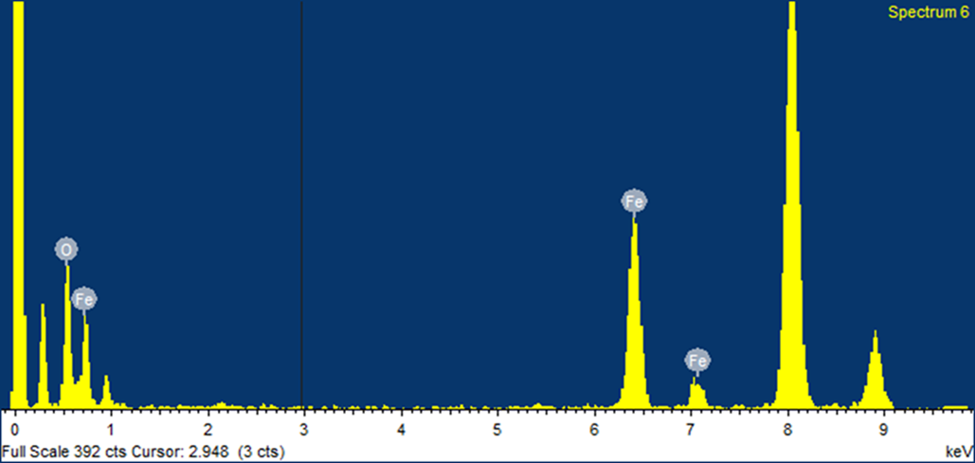

Figure 3. EDX analysis of n-${Fe}_{2}O_{3}$ particles.
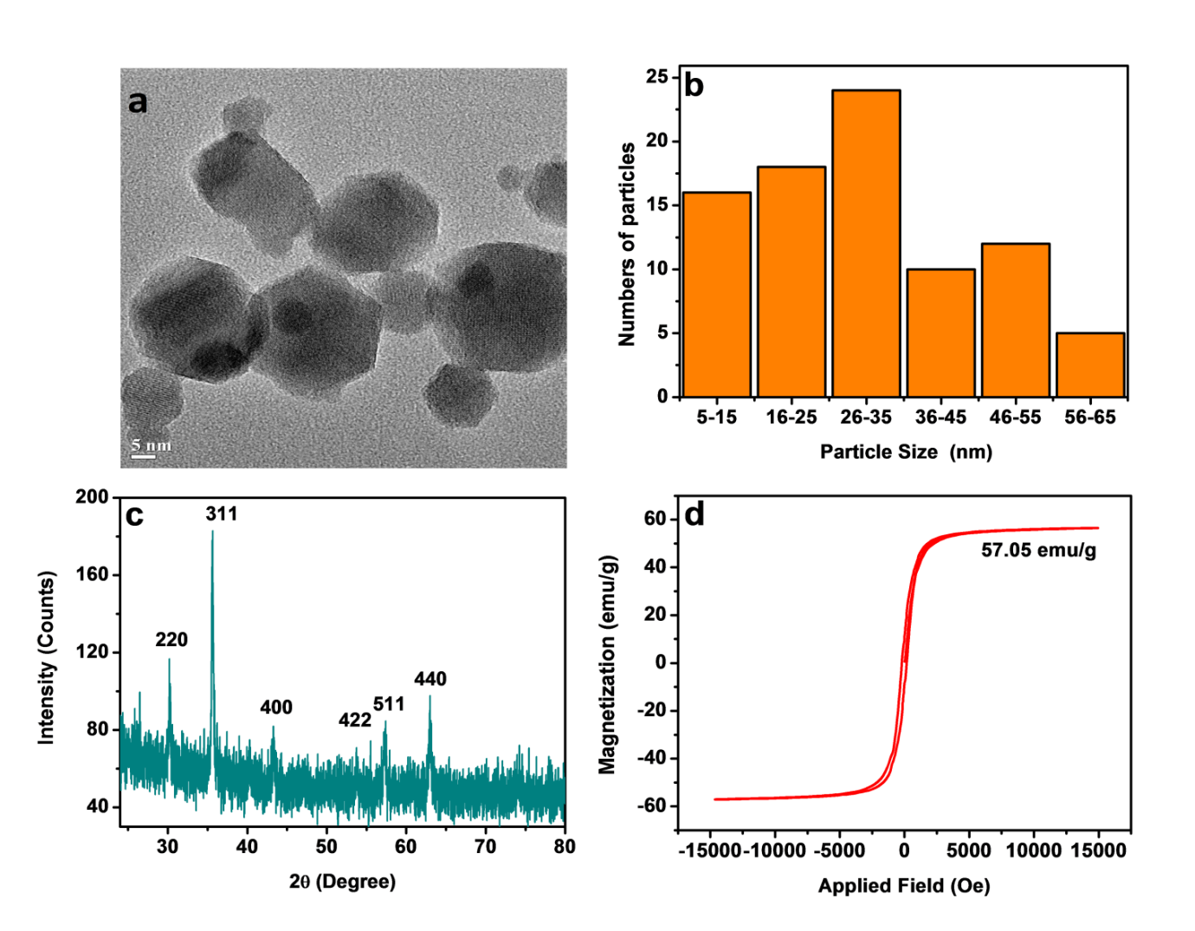
Figure 4. Characterisation of n-${Fe}_{2}O_{3}$ particles: a. TEM image; b. Particle size distribution; c. XRD diffractogram; d. Magnetization curve.

3.2 Optimization of operational parameters for n-${Fe}_{2}O_{3 }/HP$system

The optimization of catalyst load was initially done on the basis of decolorisation efficiency. The concentration of the nano-particles were increased from 0.1 to 1.0 g/L keeping other parameters constant: [HP] = 7.0 mM; [AB] = [PX] = 0.15 mM; pH= 3; treatment period= 90 min. It was observed that decolorisation remained practically constant (95.0 and 91.4% for AB and PX respectively) from 0.4 g/L onwards.
The effect of pH on decolorisation at the optimum load of the nano-particles (0.4 g/L) was also considered and found that it was highest at pH 3 (95.0 and 91.4% for AB and PX respectively) and no decolorisation was observed at pH ≥ 5.9 (the natural pH of the mixture of dyes). Decolorisation study at high acidic media, e.g. pH 1 was not undertaken considering the large amount of acid that is required to get the desired pH. Further at pH 1, HP is protonated to generate a stable oxonium ion, $H_{3}O_{2}^{+}$ (Eq. (7)) which is expected to reduce the activation of HP with ${Fe}^{2+}$ and restrict the regeneration of ${Fe}^{2+}$ as per Eq. (3), thereby decreasing the generation of hydroxyl radicals and hence ${COD}_{eff}$.^{29,30} The higher efficiency at pH 3 may be due to the higher oxidation potential of ${HO}^{•}$ radicals, leaching of more iron species into the solution and formation of catalyst-pollutant inner sphere complexes, which promotes the reaction.³¹⁻³³ The higher decolorisation efficiency at lower pH and least at higher pH may also be attributed to the surface properties of the catalyst. As it is known that degradation in heterogeneous catalysis takes place at the surface of the catalyst and therefore, the adsorption of the target molecule on the surface of the catalyst plays an important role in the degradation process. The adsorption depends on the charge on the target molecule and surface of the catalyst. The point of zero charge (PZC) of a catalyst is the pH at which the surface is neutral. Therefore, the surface is acidic at pH < PZC and basic at pH > PZC. Since, AB and PX are anionic dyes, they are attracted towards the surface at pH < PZC. In case of n-${Fe}_{2}O_{3}$, the PZC lies in between 6.0-6.8³⁴ and therefore AB and PX are attracted towards the surface at pH < 6, i.e. in acidic pH.¹⁶ Since there is no adsorption of the dyes on the catalyst at pH > 6, no decolorisation was observed at pH ≥ 5.9. The reduced decolorisation at higher pH may also be attributed to the oxidation of NaOH by HP (Eq. (8)).³⁵
$H_{2}O_{2}+ H^{+}→ H_{3}O_{2}^{+}$ (7)
$2NaOH+H_{2}O_{2}+6H_{2}O→{Na}_{2}O_{2}•8H_{2}O$ (8)
The optimization of HP was done by varying its concentration from 5.0 to 9.0 mM. The decolorisation with respect to both the components of the dye solution was found to increase up to 7 mM, beyond which a decrease was observed. This is evident from the UV-vis spectra of the dye solution at different concentrations of HP keeping other parameters constant ([AB] = [PX] = 0.15 mM; pH =3; [n-${Fe}_{2}O_{3 }$] = 0.4 g/L) (Fig. 5). With increase in HP concentration, a decrease in absorption was observed till 7 mM, beyond which an increase was observed. This shows the adverse effect of higher concentration of HP on decolorisation. Thus, the optimum parameters for decolorisation in n-${Fe}_{2}O_{3 }/HP$system are: [AB] = [PX] = 0.15 mM; pH =3; [n-${Fe}_{2}O_{3 }$] = 0.4 g/L; [HP] = 7.0mM. The initial increase in decolorisation with HP is due to the higher generation of hydroxyl radicals and decrease at higher conc. is due to the self-scavenging of hydroxyl radicals as well as by HP (Eqs. (9) and (10)).³⁵ Apart from being less reactive than ${HO}^{•}$, the resulting hydroperoxyl radicals (${HO}_{2}^{•}$) further reduce the availability of ${HO}^{•}$ (Eq. (11)), a factor which is responsible for lower degree of decolorisation.³⁶
${HO}^{•}$ + ${HO}^{•}$ → $H_{2}O_{2}$ (9)
$H_{2}O_{2}$+ ${HO}^{•}$ → ${HO}_{2}^{•}$ + $H_{2}$O (10)
${HO}_{2}^{•}$ + ${HO}^{•}$ → $H_{2}$O + $O_{2}$ (11)
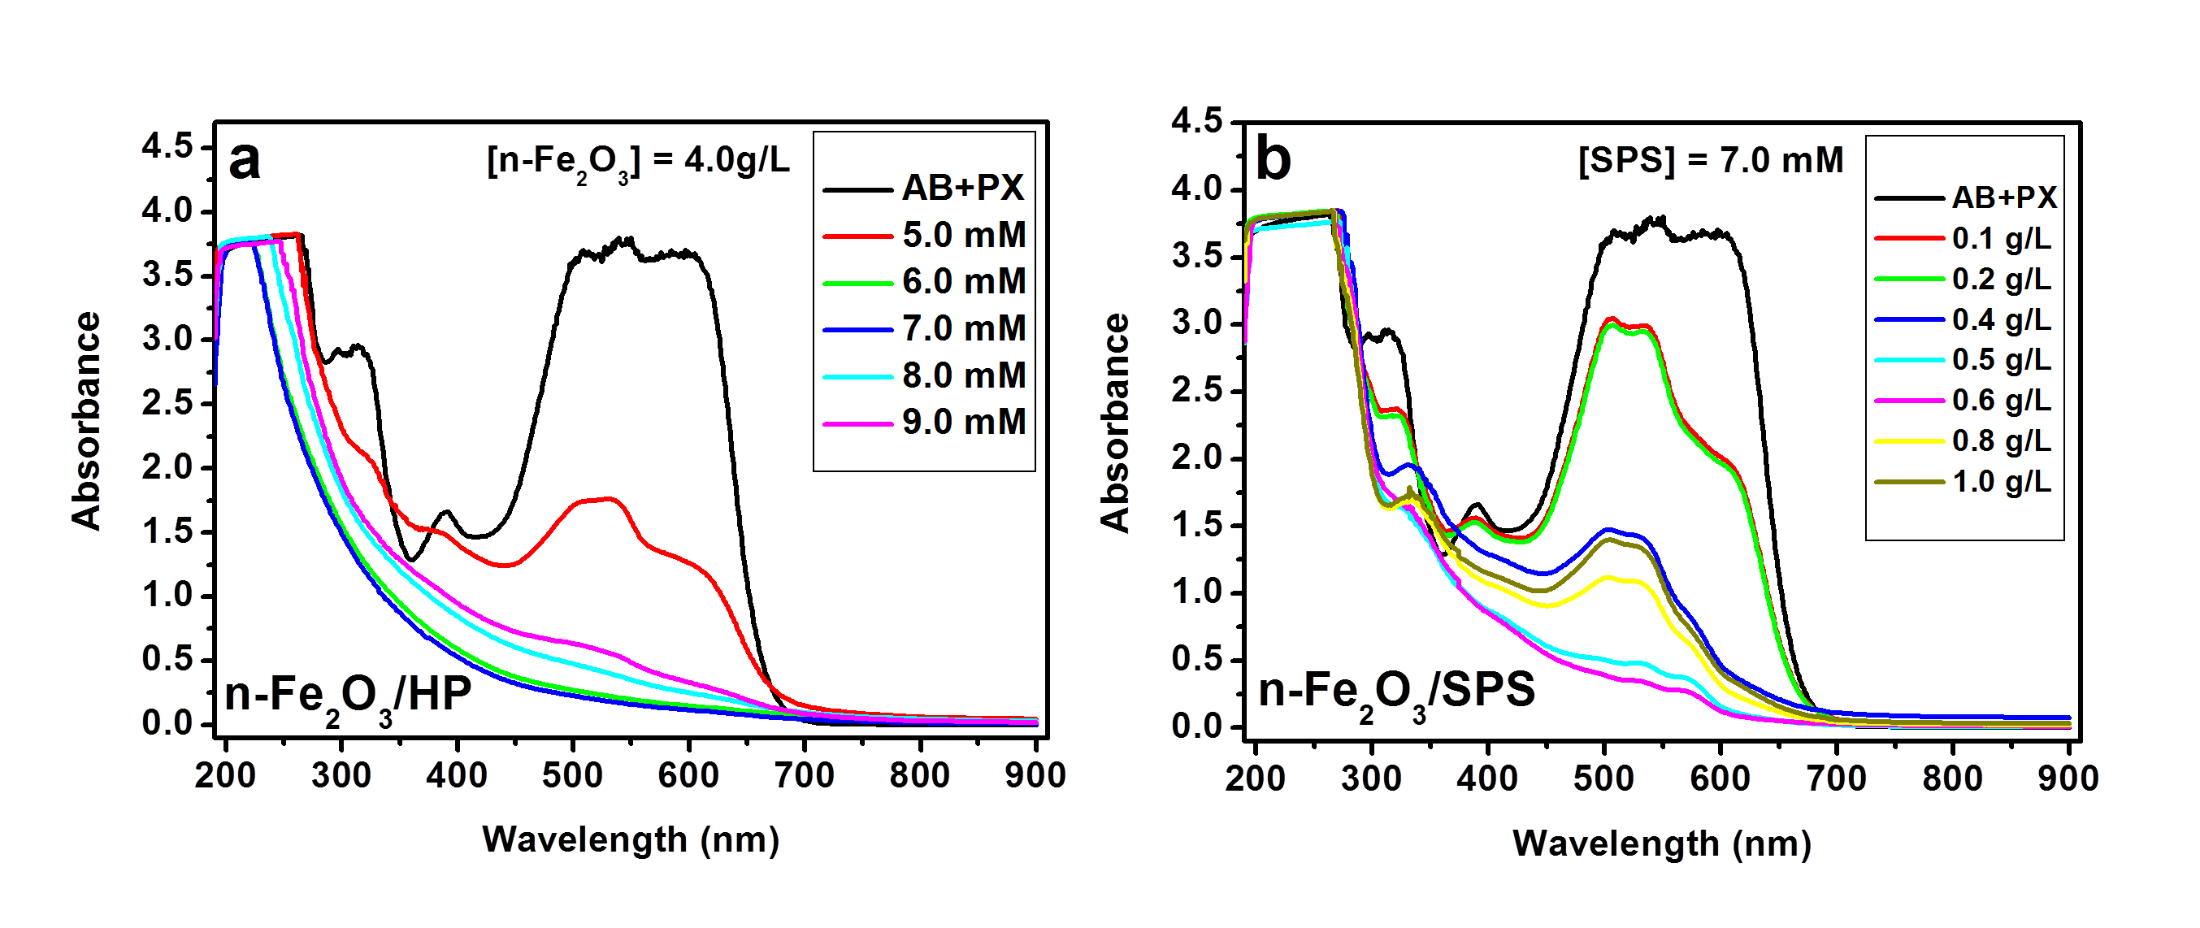
Figure 5. Effect of [HP] (a) and catalyst loading (b) on the absorption spectra: [AB] = [PX] = 0.15 mM; pH= 3; treatment period = 90 min; equilibrium period = 90 min.

3.3 Optimization of operational parameters for n-${Fe}_{2}O_{3 }/SPS$system

In order to optimise the parameters for decolorisation with n-${Fe}_{2}O_{3 }/SPS$ system, the optimum conc. of HP (7.0 mM) in n-${Fe}_{2}O_{3 }/HP$system was taken as the optimum conc. of SPS in order to have a better comparison between equimolar conc. of oxidants. To find the effect of catalyst loading, decolorisation studies were carried out at different concentrations of n-${Fe}_{2}O_{3 }$ ranging from 0.1 to 1.0 g/L. It was noticed that maximum decolorisation of was observed at 0.6 g/L with the absorbance for AB corresponding to $λ_{max}$ = 604 nm decreasing from 3.678 to 0.109 representing a decolorisation of 97.0% and that for PX corresponding to $λ_{max}$ = 539 nm decreasing from 3.801 to 0.325 representing a decolorisation of 91.4%. This is evident from the UV-vis spectra of the dye solution at different concentration of catalyst keeping other parameters constant (Fig. 5). With increase in catalyst concentration, a decrease in absorption was observed till 0.6 g/L, beyond which an increase was observed. This shows the adverse effect of higher concentration of catalyst on decolorisation.
The effect of pH on decolorisation was established by carrying out the reaction at pH 3.0, 5.9, 9.0 and 11.0. The decolorisation of PX component slowly decreases from 91.4% at pH 3 to 82.8% at pH 9. On the other hand, within the same pH range the decolorisation of AB component remained practically constant varying between 97.0 to 94.2%. On further increasing the pH to 11, a sharp decrease in decolorisation to and 25.6 and 3.0% respectively for AB and PX was observed. On the basis of above observations, the optimum parameters for decolorisation are: [AB] = [PX] = 0.15 mM; pH =3; [n-${Fe}_{2}O_{3 }$] = 0.6 g/L; [SPS] = 7.0 mM. A comparison of decolorisation in both the systems (HP and SPS) shows that both the systems have equal efficiency at their optimum parameters even though a higher concentration of catalyst is required for SPS system than for HP.

3.4 COD removal study at optimum parameters for n-${Fe}_{2}O_{3 }/HP$ and n-${Fe}_{2}O_{3 }/SPS$ systems

In order to find ${COD}_{eff}$ of both the systems at their respective optimal parameters, we have varied the treatment period up to 300 min. To our surprise, the ${COD}_{eff}$ was found to be very low (1.4 and 6.8% respectively for HP and SPS systems) at 300 min of reaction even though complete decolorisation was achieved under the present conditions. So, it was decided to increase the catalyst load further to see if there is any increase in ${COD}_{eff}$. The reaction with catalyst load varying from 1.0 to 6.0 g/L was carried out under optimum parameters, i.e. [HP] = 7.0 mM; treatment period = 300 min: [AB] = [PX] = 0.15 mM; pH= 3; equilibrium period = 90 min. Although complete decolorisation was obtained from 0.4 g/L onwards, an increase in m-${COD}_{eff}$ from 45.6% to 72.1% at 300 min was observed when the load was increased from 1.0 to 4.0 g/L. A slight decrease in the value was observed when the load was increased to 6.0 g/L (Fig. 6). Thus, 4.0 g/L was taken as the optimum concentration of n-${Fe}_{2}O_{3 }$throughout the study. This initial increase in m-${COD}_{eff}$ may be attributed to the acceleration of iron leaching and HP activation generating more ${HO}^{•}$ radicals due to an increase in the number of active sites on the catalyst surface area available for degradation and the decrease at higher catalyst concentration may be due to the agglomeration of nano-particles. Another reason may be due to the scavenging of ${HO}^{•}$ and ${HO}_{2}^{•}$ (from Eq. (10)) radicals on the oxide surface (Eqs. (12) – (14)).³⁷⁻⁴⁰ As already discussed earlier, the presence of HP in the solution results in the over estimation of COD and hence, there is a need to eliminate the interference due to HP.
$≡{Fe}_{surf}^{2+}$ + ${HO}^{•}$ → $≡{Fe}_{surf}^{3+}$ + ${HO}^{-}$ (12)
$≡{Fe}_{surf}^{2+}$ + ${HO}_{2}^{•}$ → $≡{Fe}_{surf}^{3+}$ + ${HOO}^{-}$ (13)
$≡{Fe}_{surf}^{3+}$ + ${HO}_{2}^{•}$ → $≡{Fe}_{surf}^{2+}$ + $H^{+}$ + $O_{2}$ (14)
Figure 6. Effect of catalyst load on the m-${COD}_{eff}$of mixture of dyes (AB+PX): [HP] = 7.0 mM; [AB] = [PX] = 0.15 mM; pH= 3; equilibrium period = 90 min; treatment period= 90 min.

With an aim to see the increase in m-${COD}_{eff}$ pattern with time, we have carried out the reaction from 10 to 360 min. Fig. 7 shows the effect of HP on the m-${COD}_{eff}$ of the process. It is thus apparent that presence of HP leads to a reduction of m-${COD}_{eff}$ values and therefore, our result is in good agreement with the findings of Kang et al.¹⁷ It is apparent from Fig. 7 that the COD removal process takes place in two stages – a slow induction period (1st stage) followed by a fast degradation process (2nd stage). During the induction period the ${COD}_{eff}$ practically remained constant and lasts up to 60 min of the reaction (31.3% in 10 min to 35.7% in 60 min) beyond which an increase was observed and the value reached to 83.8% in 360 min. This is also evident from the consumption of HP, which follows the same trend as ${COD}_{eff}$ (Inset of Fig. 7). On the other hand, complete decolorisation was achieved at 120 min of the reaction. From Table 1 it is evident that 67.2% of HP is consumed in 60 min with a corresponding ${COD}_{eff}$ of 35.7%. On the other hand, rest of the HP was consumed in the next 300 min for an additional 45.4% ${COD}_{eff}$. Thus, the HP consumption was rapid during the initial stage of the reaction up to 60 min, which was mostly utilized towards the decolorisation.
Previous studies have suggested that iron leaching from the surface of n-${Fe}_{2}O_{3 }$ into the solution forms the rate determining step of this reaction^{41,42} and therefore, the slow leaching of iron takes place in the first stage, i.e. induction period. It appears that during the induction period sufficient amount of ${HO}^{•}$ radicals are not formed through the activation of HP by n-${Fe}_{2}O_{3 }$. Further, part of the ${HO}^{•}$ radicals might be recombined or scavenged quickly in the presence of high conc. of HP (Eqs. (9)–(10)) and large active surface (Eq. (12)) and partly might be engaged to a great extent in breaking the N=N bond leading to decolorisation and to lesser extent in removing the dyes and intermediate products and hence COD. The second and fast process mostly involves the interaction of ${HO}^{•}$ radicals, generated through the activation of HP with dissolved iron (${Fe}^{2+}$) (Eq. (4)), with the dyes leading to their degradation. The ${HO}^{•}$ radicals generated during process are involved in the color and COD removal process by acting in two different ways: by attacking the $–N=N-$ chromophore or the carbon attached to the azo bond.^{43,44} In both the cases the dye molecules are fragmented causing colour and COD removal.
Heterogeneous Fenton-type reactions (n-${Fe}_{2}O_{3 }/SPS$) were carried out with 4.0 g/L of ${Fe}_{2}O_{3 }$in the presence of SPS as oxidant. To study the effect of equimolar concentration of oxidants, we have considered the concentration of SPS as 7.0 mM. The other parameters taken were same as with heterogeneous Fenton process, e.g. [AB] = [PX] = 0.15 mM; pH= 3, equilibrium period = 90 min. Under these operational parameters, ${COD}_{eff}$ was found to be only 28.5% in 360 min. (without correction due to interference of HP). The effect of pH was also studied on this system and it was observed that ${COD}_{eff}$ was highest at pH 3 and negligible at other pHs.
Figure 7. Effect of residual HP on ${COD}_{eff}$ of mixture of dyes (AB+PX). Inset: consumption of HP with time. [AB] = [PX] = 0.15 mM; [n-${Fe}_{2}O_{3 }$] = 4.0 g/L; [HP] = 7.0 mM; pH= 3; equilibrium period = 90 min.
Table 1. COD removal efficiency of mixture of dyes (AB+PX): [AB] = [PX] = 0.15 mM; [n-${Fe}_{2}O_{3 }$] = 4.0 g/L; [HP] = 7.0 mM; pH= 3; equilibrium period = 90 min; ${COD}_{0}$ = 147 mg/L.
Treatment period  (Min) | Decolorisation (%) |  | Consumption of [HP]  (%) | m-${COD}_{eff}$ (%) | ${COD}_{eff}$ (%)
Treatment period  (Min) | AB | PX | Consumption of [HP]  (%) | m-${COD}_{eff}$ (%) | ${COD}_{eff}$ (%)
10 | 71.6 | 65.3 | 64.0 | 4.1 | 31.3
30 | 83.6 | 77.6 | 64.0 | 6.1 | 33.2
60 | 97.9 | 96.9 | 67.2 | 10.9 | 35.7
120 | 100.0 | 100.0 | 76.3 | 29.3 | 45.1
180 | 100.0 | 100.0 | 87.3 | 47.4 | 58.8
240 | 100.0 | 100.0 | 95.4 | 55.7 | 74.9
300 | 100.0 | 100.0 | 98.9 | 72.1 | 83.1
360 | 100.0 | 100.0 | 99.8 | 78.2 | 83.8

m-${COD}_{eff}$ – COD removal efficiency in the presence of residual HP
${COD}_{eff}$ – COD removal efficiency in the absence of residual HP
3.5 Effect of particle size on ${COD}_{eff}$ of mixture of dyes

In order to establish the effect of particle size of ${Fe}_{2}O_{3 }$particles on the ${COD}_{eff}$, we have used particles with two different sizes. The effect of n-${Fe}_{2}O_{3 }$has already been described in earlier section. The other iron oxide used in this work is m-${Fe}_{2}O_{3 }$ particles with particle size <5 µm. The oxidants used in this reaction were HP and SPS. The same operational parameters as used in n-${Fe}_{2}O_{3 }/HP$ was employed in this reaction ([m-${Fe}_{2}O_{3 }$] = 4.0 g/L; [HP] = 7.0 mM; [AB] = [PX] = 0.15 mM; pH= 3; equilibrium period = 90 min). m-${COD}_{eff}$, with a value of 51% in 360 min in the presence of HP, was completely inhibited in the presence of SPS. It may be noted that under similar conditions, m-${COD}_{eff}$ was 78.2% in n-${Fe}_{2}O_{3 }/HP$ system. A comparison of the effectiveness of all the systems at their optimum parameters is shown in Fig. 8. It is apparent from the figure that SPS inhibits m-${COD}_{eff}$ in both the systems (n-${Fe}_{2}O_{3 }$ and m-${Fe}_{2}O_{3 }$), more so in m-${Fe}_{2}O_{3 }$ than n-${Fe}_{2}O_{3 }$. Hence, study with only n-${Fe}_{2}O_{3 }/HP$ system was considered further.

3.6 Reusability of n-${Fe}_{2}O_{3 }$in Heterogeneous Fenton Reaction
The economy of the heterogeneous Fenton process lies in the stability and reusability of the catalyst in multiple cycles. The catalysts after each cycle of reaction under optimum parameters were separated from the solution with the help of a vacuum pump. The particles were then washed with 500 ml water followed by 250 ml methanol repeatedly till the pH of the solution after washing was maintained at 7. At the end the particles were washed with 1000 ml water to make them free of methanol. The particles were dried in an oven for 8 hours, cooled at room temperature, grinded and stored for the next cycle of reaction. Four cycles of reaction was performed and the result is presented in Fig. 8. It is observed that the m-${COD}_{eff}$remains constant till the 2nd cycle after which a rapid decrease in the efficiency was observed and the value reached to 11.6% in 4th cycle. The lowering in efficiency from 3rd cycle onwards may be attributed diverse factors such as lower leaching of iron resulting in a lower contribution to homogeneous Fenton process, catalyst surface area reduction due to agglomeration, deactivation of active sites by adsorption of organic intermediates etc.^{33,37, 45} The nano-particles lose their colloidal stability due to dipole-dipole interaction causing them to agglomerate.⁴⁶ As seen in Fig. 9, the number of black spots increases in each cycle indicating the occurrence of agglomeration. As the number of agglomeration increases with treatment period, a decrease in the number of nano-particles and hence surface area is observed. This explains the decrease in m-${COD}_{eff}$ in successive cycles. Nevertheless, complete decolorisation was achieved in all the cycles. To verify the amount of iron leaching from n-${Fe}_{2}O_{3}$, the samples at the end of each of the four cycles were analysed by ICP-OES and was found to be 8.3, 41.1, 42.3, and 50.1% respectively.
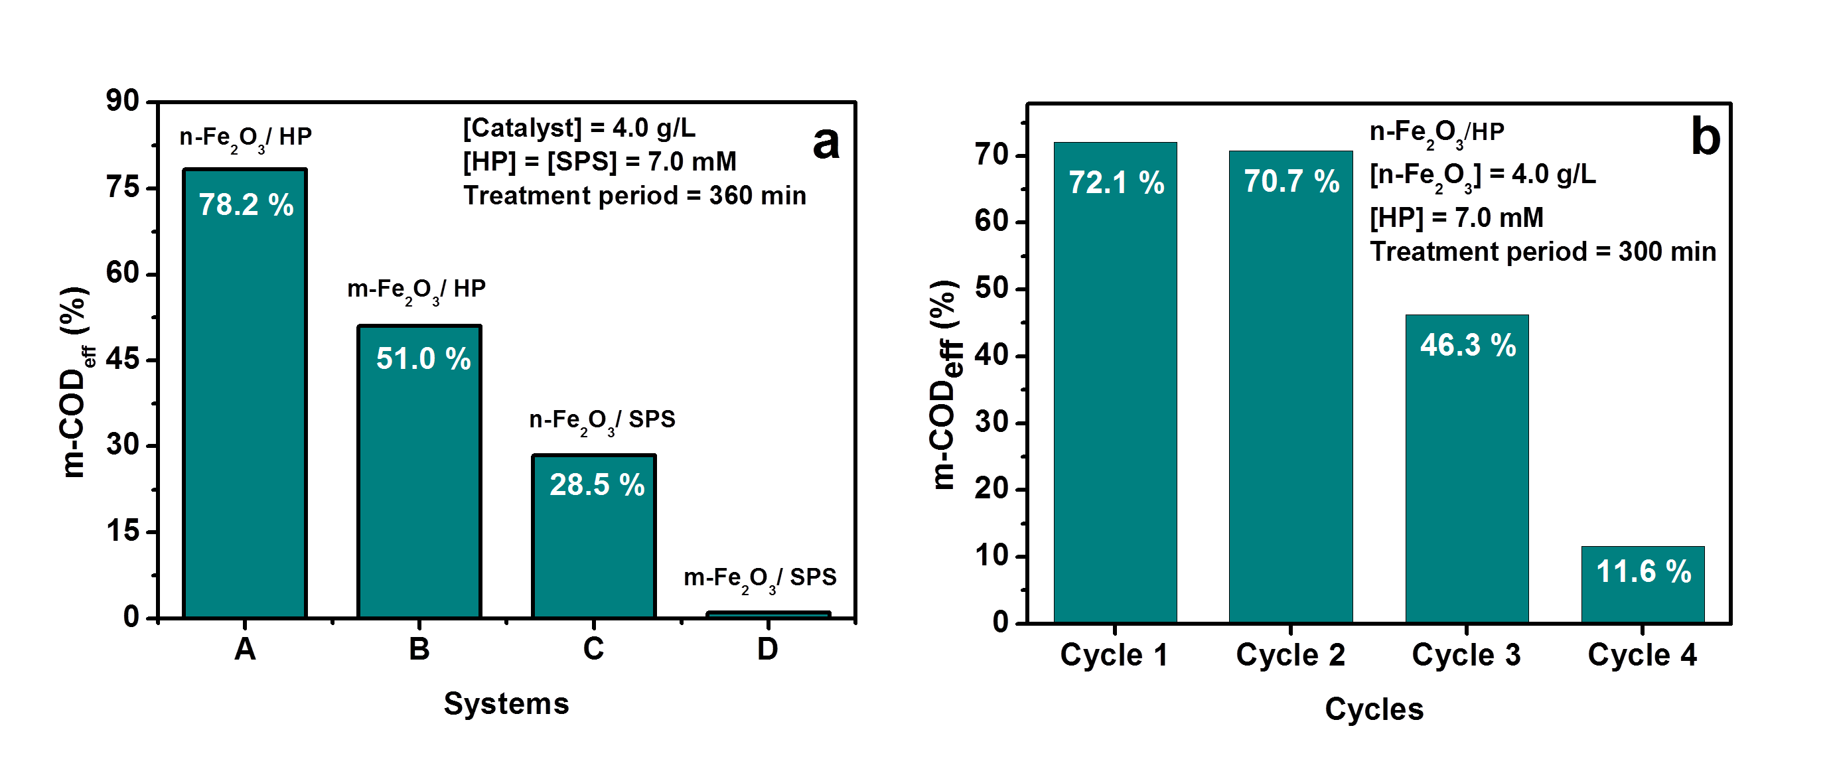
Figure 8. Effect of particle size of catalyst on m-${COD}_{eff}$ (a) and reusability of catalyst (b): [AB] = [PX] = 0.15 mM; equilibrium period = 90 min; pH= 3.
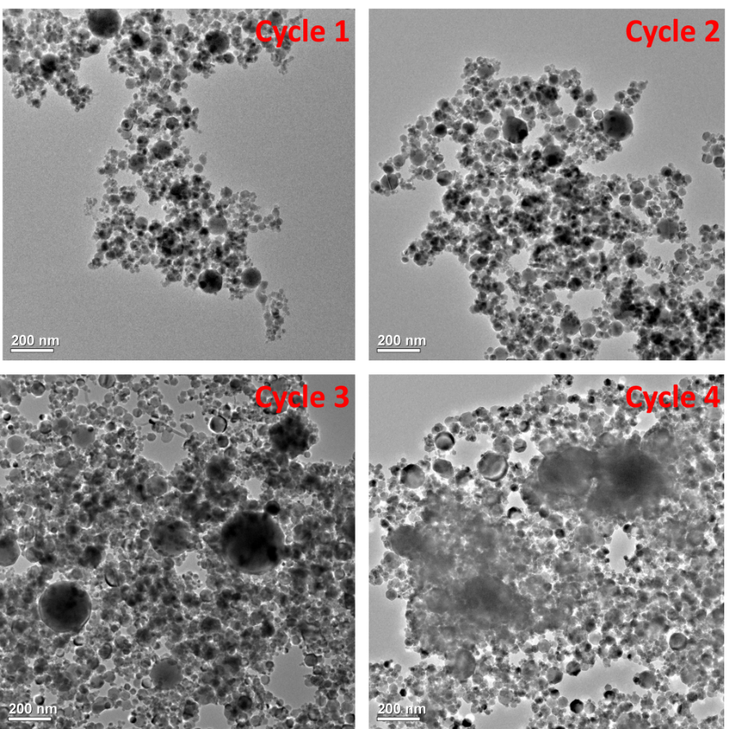
Figure 9. TEM images of n-${Fe}_{2}O_{3}$ particles after different cycles of treatment: [AB] = [PX] = 0.15 mM; [n-${Fe}_{2}O_{3}$] = 4.0 g/L; [HP] = 7.0 mM; treatment period = 300 min; pH = 3.

3.7 Kinetics of COD removal and HP consumption in n-${Fe}_{2}O_{3 }$/HP system
As discussed before, the COD removal process consists of a slow and a fast process. Both the processes have been shown to follow pseudo first order kinetics (Fig. 10). The slow process takes place within first 60 min of the reaction with a rate constant of 1.49 and 1.32 (${10}^{-3}\min^{-1}$) from 0-60 min with and without HP interference respectively and the corresponding values of the faster process from 120-300 min are 7.94 and 6.73 (${10}^{-3}\min^{-1}$) respectively (Table 2). Data beyond 300 min was not considered for kinetic study as no appreciable change in ${COD}_{eff}$ value was observed and the reaction appeared to have completed with ≈99% consumption of HP (Table 1 and Fig. 7 (inset)). The higher rate constant with HP interference in comparison to that without HP interference established the influence of HP on COD removal process. As discussed before, the HP used in the process was almost completely consumed in 300 min of the treatment. The kinetics of HP consumption and the rate constants during 0-60 and 120-300 min are given in Fig. 11 and Table 2 respectively.
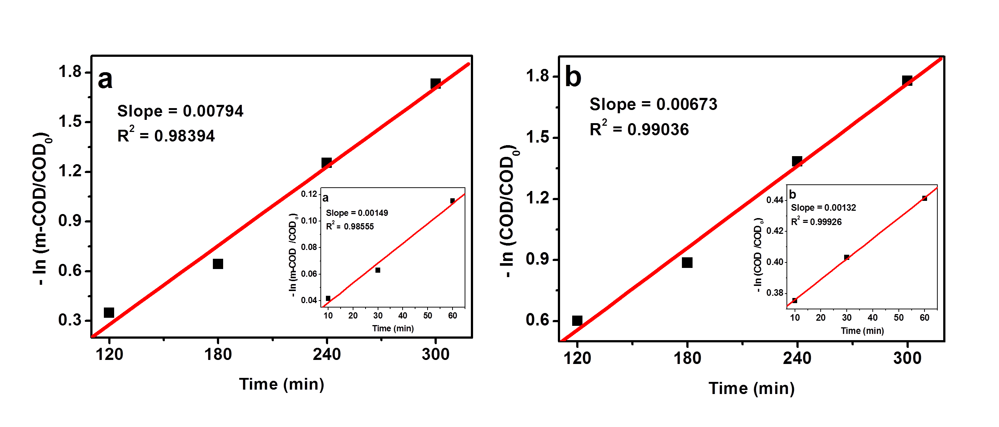
Figure 10. COD removal kinetics in n-${Fe}_{2}O_{3 }$/HP system: (a) with interference due to HP from 120 min to 300 min (inset: from 0-60 min); (b) Without interference due to HP from 120 to 300 min (inset: from 0-60 min).

Table 2. COD removal and HP consumption rate constants for mixture of dyes (AB+PX) by n-${Fe}_{2}O_{3}$ / HP system at different time intervals
Time scale | Rate constant (${10}^{-3}\min^{-1}$) |  | $$R^{2}$$
Time scale | COD removal rate constants
Time scale | HP interference | No HP interference | HP interference | No HP interference
0-60 (min) | 1.49 | 1.32 | 0.98555 | 0.99926
120-300 (min) | 7.94 | 6.73 | 0.98394 | 0.99036
Time scale | HP consumption rate constants
0 - 60 min | 1.96 |  | 0.8813
120 -300 min | 17.17 |  | 0.9684
Figure 11. Kinetics of HP consumption in n-${Fe}_{2}O_{3 }$/HP system from 120 min to 300 min. (Inset: from 05 min to 60 min)
3.8 Analysis of ions and intermediate products formed in n-${Fe}_{2}O_{3 }$/HP system
Different ions and intermediate products identified by ion chromatography during the degradation process are listed in Table 3. Both AB and PX have two sources of nitrogen: four azo nitrogen atoms on AB and two on PX, one on AB as -${NO}_{2}$ substituent. The formation of ${Na}^{+}$ as the dissociation product of both AB and PX and ${SO}_{4}^{2-}$, formed as a result of substitution of ${SO}_{3}^{-}$ group by ${HO}^{•}$, radicals has been identified.⁴⁷⁻⁴⁹ The aryl radical formed after the elimination of ${SO}_{4}^{2-}$ gets converted to hydroxyaromatic compounds on interacting with ${HO}^{•}$ radicals.⁵⁰ Apart from these ions, ${NH}_{4}^{+}$, ${NO}_{2}^{-}$ and ${NO}_{3}^{-}$ are identified in the process. The ${NH}_{4}^{+}$ ions are reported to have been formed from the azo bonds. In the first step azo bonds are attacked by ${HO}^{•}$ radicals and convert them into -${NH}_{2}$ groups, which accounts for the formation of aromatic amino derivatives. It may be noted that in the present case the azo group attached to nitrophenyl group of AB is electron deficient and hence the ${HO}^{•}$ radicals attack the other azo bond attached to unsubstituted phenyl group preferentially.⁵⁰ In the next step -${NH}_{2}$ groups undergo protonation and subsequent attack of ${HO}^{•}$ radicals at the nitrogen bearing carbon of the aromatic ring are converted into ${NH}_{4}^{+}$ ions.^{48,51}. This accounts for the formation of phenols. There is report that $N_{2}$ is generated by the attack of ${HO}^{•}$ radicals on the azo bond bearing carbon of the aromatic ring,⁴⁸ which accounts for an additional route to the formation of aromatic hydroxyl derivatives. The conversion of ${NH}_{4}^{+}$ to ${NO}_{2}^{-}$, ${NO}_{3}^{-}$ as a result of attack of ${HO}^{•}$ radicals was suggested by Reddy and Mahajani.⁵² All these sequence of events are presented in Scheme 1. The formation of ${CO}_{3}^{2-}$ ions indicates the partial, if not complete mineralisation of the dyes to carbon dioxide.
The different intermediate products identified during the process are phenol, 2- and 3-aminophenol (Table 3). A peak appeared at retention time (R.T) 2.95, but could not be identified using ion chromatography. Although we have been able to identify nitro aromatic compounds in other studies (data not published), the presence of these products couldn’t be established in this study. Besides these products, smaller aliphatic acids like formic acid, malonic acid, maleic acid and fumaric acid were also identified. The presence of these acids indicates that the dyes are not completely mineralised. As per another report, the attack of ${HO}^{•}$ radicals to azo bond takes place with ~60% probability leading to decolorisation. Successive attack on azo bond by ${HO}^{•}$ radicals leads to the formation of nitroso (Scheme 1) followed by nitro aromatic compounds.⁵³ The formation of aromatic amino compounds has been described earlier. Since complete decolorisation was achieved at 360 min with a ${COD}_{eff}$ of 83.8% by consuming 100% HP (Table 1), it may be concluded that the azo bonds have broken completely forming aromatic amines and other products (Scheme 1). Further attack of ${HO}^{•}$ radicals on nitro aromatic compounds leads to the formation of hydroxybenzenes, which ultimately generate the aliphatic acids through the formation of quinones.⁵⁴ The displaced $O_{2}N^{•}$radical in its term undergoes oxidation to form ${HNO}_{3}$.⁵⁵ The attack of ${HO}^{•}$ radicals onto the nitro group may also result in the formation of ${HNO}_{3}$,^{50,56} in addition to an aromatic radical, which on further interaction with ${HO}^{•}$ radicals generate aromatic hydroxyl derivatives (Scheme 1). The absence of nitro derivatives suggests that all the nitro groups are immediately substituted by ${HO}^{•}$ radicals as soon as they are formed and generate aromatic hydroxyl derivatives. It is observed that phenol is obtained at 120 min and 2- and 3-aminophenol at 60 min of the reaction. This is an indication that phenol is not formed from aminophenols, rather they are formed in different routes. Based on the above analysis and with support from literature data,^{53,57,58} a mechanism of degradation of mixture of dyes (AB+PX) has been proposed (Scheme 2).

Table 3. Ions and intermediate products identified by ion chromatography

Sr. No. | Ions |  | Intermediate products
Sr. No. | R.T (min) | Name | R. T (min) | Name
1 | 4.27 | $${Na}^{+}$$ | 1.54 | Formic acid
2 | 4.54 | $${NH}_{4}^{+}$$ | 2.63 | Malonic acid
3 | 2.12 | $${NO}_{2}^{-}$$ | 2.81 | Maleic acid
4 | 3.65 | $${NO}_{3}^{-}$$ | 3.37 | Fumaric acid
5 | 4.26 | $${CO}_{3}^{2-}$$ | 2.95 | Not identified
6 | 5.56 | $${SO}_{4}^{2-}$$ | 3.86 | 3- Amino phenol
7 | --- | --- | 4.57 | 2- Amino phenol
8 | --- | --- | 7.91 | Phenol

- Formation of ${SO}_{4}^{2-}$ and $C_{6}H_{5}OH$

- Formation of Phenol, ${NH}_{4}^{+}$ , ${NO}_{2}^{-}$, ${NO}_{3}^{-}$

- Conversion of azo bond to ${- NH}_{2}$, - N=O group and ${NO}_{2}$
- Conversion of –N=N- to phenolic group

- Formation of phenols and amines

Scheme 1. Mechanism of formation of different ions and products from azo compounds

Scheme 2. Mechanism of degradation of mixture of dyes (AB+PX)

3.9 Comparison of toxicity by CFU and light loss
The relative toxicity of the pure dye separately as well as their solutions after different treatment periods were measured in n- ${Fe}_{2}O_{3}$/HP systems as a function of CFU and light loss percentage. A comparison of the results by the two methods is presented in Fig. 12. It is clearly evident that different levels of relative toxicity were obtained when measured with V. fischeri and E.coli. As seen from the figure, the untreated dye solution was toxic in both test systems. A sharp decrease in relative toxicity with increasing treatment period was observed with former (V. fischeri based assay) than the later (E. coli based assay) method, where a gradual decrease was observed indicating that both assay systems possessed differential sensitivities towards the chemical toxicity. The V. fischeri based test measured by loss of emitted fluoresce or light was much more sensitive than the E. coli, based test measuring the reproductive ability expressed as CFU. Thus, the results in Fig. 12 suggest that depending on the need and circumstances, either of the two parameters may be applied to measure the extent of dye detoxification. While complete detoxification was apparently achieved in 360 min based on the loss of light assay utilizing V. fischeri test system, the later test system based on E. coli CFU measurements showed that the detoxification was not complete in 360 min and the solution still possessed about 37% relative toxicity. The different levels of sensitivity of the two test systems may be attributed to assay of different end points of biological parameters. Looking at the slopes of the two toxicity curves for loss of light and loss of CFU, one may postulate that E. coli, a fresh water bacterium, may be more resistant to the aromatic intermediates formed during the beginning of the reaction (Scheme 1) than V. fischeri, a marine bacterium, which could be more resistant to organic acids formed at the end of the reaction.²⁰
Thus, the selection of an assay or a test system for the measurement of toxicity should be decided based on the nature of microorganisms present in a given water body to which the treated wastewater has to be released. Thus, applying the measurement with V. fischeri could be preferred in marine environment and E. coli for fresh water bodies. Further, the cost involvement in both cases has to be taken care of while deciding the preferred method of assessment. While measurement by V. fischeri requires costly Microtox photometer and other reagents, that with E. coli requires simple and common chemicals & instruments. Thirdly, the time required for performing the test should also be a factor in the consideration. While it takes just about 20 min for the V. fischeri fluorescence loss assay, it takes up to 3 days for the E. coli CFU assay.

Fig. 12. CFU and light loss (%) in n- ${Fe}_{2}O_{3}$/ HP system: [AB] = [PX] = 0.15 mM; pH of treatment = 3; pH of E. coli growth = 7; [n-${Fe}_{2}O_{3}$] = 4.0 g/L; [HP] = 7.0 mM.

4. Conclusions
Colour and COD removal studies of mixture of two dyes (AB+X) were carried out by heterogeneous Fenton process using two different types of iron oxides: n-${Fe}_{2}O_{3 }$and m-${Fe}_{2}O_{3 }$ particles and two different oxidants (HP and SPS). n-${Fe}_{2}O_{3 }$ and HP were found to be efficient catalyst and oxidant respectively. Although, m-${Fe}_{2}O_{3 }$causes very low COD reduction in the presence of HP, it is completely inhibited in the presence of SPS. Decolorisation and therefore, COD removal was accelerated in acidic pH and inhibited at pH > 6 due to surface characteristics of the nano-particles. The over estimation of COD values due to interference of $H_{2}O_{2}$ has been verified and our results are in good agreement with the results reported earlier. The COD removal is a two-stage process, a slow induction period and a fast degradation process, each following pseudo first order kinetics. The rate constants for ${COD}_{eff}$ were found to be 1.32 (${10}^{-3}\min^{-1}$) and 6.73 (${10}^{-3}\min^{-1}$) during 0-60 and 120-300 min respectively after eliminating the interference due to HP and those for HP consumption during 0-60 and 120-300 min were found to be 1.96 and 17.17 (${10}^{-3}\min^{-1}$). The efficiency of the catalyst is decreased from 3rd cycle onwards due to various factors such as such as lower leaching of iron resulting in a lower contribution to homogeneous Fenton process, catalyst surface area reduction due to agglomeration, deactivation of active sites by adsorption of organic intermediates etc. Hence, more work is required to identify the causes of deactivation and find some regeneration measures and restore the catalyst efficiency. The different ions formed during the process were identified as ${Na}^{+}$, ${SO}_{3}^{2-}$, ${NH}_{4}^{+}$, ${NO}_{2}^{-}$ and ${NO}_{3}^{-}$ and the intermediate products as phenol, 2- and 3-aminophenol, formic acid, malonic acid, maleic acid and fumaric acid. Using two different bio-toxicity assays measured either by V. fischeri test system based on measurement of fluorescence or E. coli test system based on CFU measurement, we find differential expression of relative toxicities for the same solution. Therefore, based on the results of bio-toxicity assays, it appears that choice of assay system should be based on several considerations. They should include, the nature of recipient water bodies for wastewater disposal, as well as the time, fund and infrastructure at disposal for performing the tests, based on the inclusive considerations, either of the two toxicity assays may be chosen and applied.

Acknowledgements
The authors gratefully acknowledge use of facilities acquired through the DAE-BRNS grant (2013/36/50-BRNS/2485, dated 05.12.2013) to MKS; DST-FIST grant (SR/FST/CSI-194-2008) of the Department of Science and Technology, Govt. of India and UGC-SAP CAS-I grant (F.540/21/CAS/2013(SAP I)) of UGC to the Department of Chemistry, North-Eastern Hill University (NEHU), Shillong. The services provided by the Sophisticated Analytical Instrumentation Facility, NEHU for TEM, EDX and ICP-OES analysis and Department of Nanotechnology, NEHU for XRD measurements are duly acknowledged. It is further declared that this research did not receive any specific grant from funding agencies in the public, commercial, or not-for-profit sectors.

References
[1] A. Yadav, S. Mukherji, A. Garg, Ind. Eng. Chem. Res. 2013, 52, 10063-10071. DOI: 10.1021/ie400855b
[2] A. Eslami, M. Moradi, F. Ghanbari, F. Mehdipour, J. Environ. Health Sci. Eng. 2013, 11, 1-8. DOI: 10.1186/2052-336X-11-31
[3] I. Oller, S. Malato, J. A. Sánchez-Pérez, Sci. Total Environ. 2011, 409, 4141-4166. DOI: 10.1016/j.scitotenv.2010.08.061
[4] P. Ghosh, A. N. Samanta, S. Ray, Can. J. Chem. Eng. 2010, 88, 1021-1026. DOI: 10.1002/cjce.20353
[5] A. Durán, J. M. Monteagudo, I. S. Martén, F. J. Amunategui, D. A. Patterson, Chemosphere, 2017, 186, 177-184. DOI: 10.1016/j.chemosphere.2017.07.148
[6] X. –R. Xu, X. -Z. Li, Sep. Purif. Technol. 2010, 72, 105-111. DOI: 10.1016/j.seppur.2010.01.012
[7] M. K. Sahoo, J. E. Kumar, B. Sinha, M. Marbaniang, R. N. Sharan, Water Sci. Tech. 2018, 77, 2917-2928. DOI: 10.2166/wst.2018.290.
[8] F. Haber, J. Weiss, Proc. Roy. Soc. A, 1934, 147, 332-351. DOI: 10.1098/rspa.1934.0221.
[9] G. P. Anipsitakis, D. D. Dionysiou, Environ. Sci. Technol. 2004, 38, 3705-3712. DOI: 10.1021/es035121o
[10] I. Grčić, S. Papić, K. Žižek, N. Koprivanac, Chem. Eng. J. 2012, 195/196, 77-90. DOI: 10.1016/j.cej.2012.04.093
[11] L. Xu, J. Wang, J. Hazard. Mater. 2011, 186, 256-264. DOI: 10.1016/j.jhazmat.2010.10.116
[12] Y. Wang, Y. Gao, L. Chen, Catal. Today, 2015, 252, 107-112. DOI: 10.1016/j.cattod.2015.01.012
[13] M. C. Pereira, L. C. A. Oliveira, E. Murad, Clay Miner. 2012, 47, 285-302. DOI: 10.1180/claymin.2012.047.3.01
[14] S. P. Sun, A. T. Lemley, J. Mol. Catal. A: Chem. 2011, 349, 71-79. DOI: 10.1016/j.molcata.2011.08.022
[15] X. Xue, K. Hanna, N. Deng, J. Hazard. Mater. 2009, 166, 407-414. DOI: 10.1016/j.jhazmat.2008.11.089
[16] D. B. Hasan, S. R. Pouran, A. R. A. Aziz, S. M. Nashwan, W. M. A. W. Daud, M. G. Shaaban, J. Indust. Eng. Chem. 2015, 25, 186–191. DOI: 10.1016/j.jiec.2014.10.033
[17] Y. W. Kang, M. -J. Cho, K. –Y. Hwang, Water Res. 1999, 33, 1247-1251. DOI: 10.1016/S0043-1354(98)00315-7
[18] Y. Zhang, N. Zhang, T. Wang, H. Huang, Y. Chen, Z. Li, Z. Zou, Appl. Catal. B: Environ. 2019, 245, 410-419. DOI: 10.1016/j.apcatb.2019.01.003
[19] T. X. H. Le, T. V. Nguyen, Z. A. Yacouba, L. Zoungrana, F. Avril, E. Petit, J. Mendret, V. Bonniol, M. Bechelany, S. Lacour, G. Lesage, M. Cretin, Chemosphere, 2016, 161, 308-318. DOI: 10.1016/j.chemosphere.2016.06.108
[20] M. Munoz, Z. M. de Pedro, J. A. Casas, J. J. Rodriguez, Chem. Eng. J. 2012, 198-199, 275-281. DOI: 10.1016/j.cej.2012.05.097
[21] J. Bayo, J. M. Angosto, M. D. Gómez-López, J. Hazard. Mater. 2009, 172, 166-171. DOI: 10.1016/j.jhazmat.2009.06.157.
[22] R. Massart, IEEE Trans. Magn. 1981, 17, 1247-1248. DOI: 10.1109/TMAG.1981.1061188
[23] APHA, Standard methods for the examination of water and wastewater. 19th Ed. Wahington DC, New York, 1995.
[24] R. N. Sharan, H. Ryo, T. Nomura, Int. J. Radiat. Biol. 2007, 83, 89-97. DOI: 10.1080/09553000601121140
[25] A. Karczmarczyk, A. Celebanska, W. Nogala, V. Sashuk, O. Chernyaeva, M. Opallo, Electrochim. Acta, 2014, 117, 211-216. DOI: 10.1016/j.electacta.2013.11.049
[26] S. M. El‐Khouly, N. A. Fathy, Asia-Pac. J. Chem. Eng. 2018, 13, 1-11. DOI: 10.1002/apj.2184
[27] P. Djomgoue, D. Njopwouo, J. Surf. Eng. Mater. Adv. Technol. 2013, 3, 275-282. DOI: 10.4236/jsemat.2013.34037.
[28] C. Liang, H. Liu, J. Zhou, X. Peng, H. Zhang, J. Chem. 2015, 2015, 1-8. DOI: 10.1155/2015/791829
[29] H. Ramirez, F. M. Duarte, F. G. Martins, C. A. Costa, L. M. Madeira, Chem. Eng. J. 2009, 148, 394-404. DOI: 10.1016/j.cej.2008.09.012
[30] B. G. Kwon, D. S. Lee, N. Kang, J. Yoon, Water Res. 1999, 33, 2110-2118. DOI: 10.1016/S0043-1354(98)00428-X
[31] N. K. Daud, B. H. Hameed, J. Hazard. Mater. 2010, 176, 938-944. DOI: 10.1016/j.jhazmat.2009.11.130
[32] N. Masomboon, C. Ratanatamskul, M. C. Lu, Environ. Sci. Technol. 2009, 43, 8629-8634. DOI: 10.1021/es802274h
[33] S. X. Zhang, X. L. Zhao, H. Y. Niu, Y. L. Shi, Y. Q. Cai, G. Jiang, J. Hazard. Mater. 2009, 167, 560-566. DOI: 10.1016/j.jhazmat.2009.01.024
[34] H. Watanabe, J. Seto, Bull. Chem. Soc. Jpn. 1986, 59, 2683-2687. DOI: 10.1246/bcsj.59.2683
[35] G. V. Buxton, C. L. Greenstock, W. P. Helman, A. B. Ross, J. Phys. Chem. Ref. Data, 1988, 17, 513-886. DOI: 10.1063/1.555805
[36] S. R. Pouran, A. Bayrami, M. S. Shafeeyan, A. A. B. Raman, W. M. A. W. Daud, Acta Chim. Slov. 2018, 65, 166-171. DOI:10.17344/acsi.2017.3732
[37] F. Velichkova, C. Julcour-Lebigue, B. Koumanova, H. Delmas, J. Environ. Chem. Eng. 2013, 1, 1214–1222. DOI:10.1016/j.jece.2013.09.011
[38] K. Rusevova, F. D. Kopinke, A. Georgi, J. Hazard. Mater. 2012, 241/242, 433-440. DOI: 10.1016/j.jhazmat.2012.09.068
[39] D. N. Thi, H. P. Ngoc, H. D. Manh, T. N. Kim, J. Hazard. Mater. 2011, 185, 653-661. DOI: 10.1016/j.jhazmat.2010.09.068
[40] J. H. Ramirez, F. J. Maldonado-Hódar, A. F. Pérez-Cadenas, C. Moreno-Castilla, C. A. Costa, L. M. Madeira, Appl. Catal. B: Environ. 2007, 75, 312-323. DOI: 10.1016/j.apcatb.2007.05.003
[41] L. Xua, J. Wang, Appl. Catal. B: Environ. 2012, 123-124, 117-126. DOI: 10.1016/j.apcatb.2012.04.028
[42] T. R. Gordon, A. L. Marsh, Catal. Lett. 2009, 132, 349-354. DOI: 10.1007/s10562-009-0125-6
[43] S. Das, P. V. Kamat, S. Padmaja, V. Au, S. A. Madison, Free radical induced oxidation of the azo dye Acid Yellow 9, J. Chem. Soc. Perkin Trans. 1999, 2, 1219-1224. DOI: 10.1039/A809720H
[44] J. T. Spadaro, L. Isabelle, V. Renganathan, Environ. Sci. Technol. 1994, 28, 1389-1393. DOI: 10.1021/es00056a031
[45] J. Guo, M. Al-Dahhan, Appl. Catal. A, 2006, 299, 175-184. DOI: 10.1016/j.apcata.2005.10.039
[46] S. P. Yeap, J. Lim, B. S. Ooi, A. Ahmad, J. Nanopart Res. 2017, 368, 1-15. DOI: 10.1007/s11051-017-4065-6
[47] M. Karkmaz, E. Puzenat, C. Guillard, J. M. Herrmann, Appl. Catal. B: Environ. 2004, 51, 183-194. DOI:10.1016/j.apcatb.2004.02.009
[48] H. Lachheb, E. Puzenat, A. Houas, M. Ksibi, E. Elaloui, C. Guillard, J. Herrmann, Appl. Catal. B: Environ. 2002, 39, 75-90. DOI: 10.1016/S0926-3373(02)00078-4
[49] C. Galindo, P. Jacques, A. Kalt, J. Photochem. Photobiol. A: Chem. 2000, 130, 35-47. DOI: 10.1016/S1010-6030(99)00199-9
[50] M. A. Meetani, S. M. Hisaindee, F. Abdullah, S. S. Ashraf, M. A. Rauf, Chemosphere, 2010, 80, 422-427. DOI:10.1016/j.chemosphere.2010.04.065
[51] K. Sahel, N. Perol, H. Chermette, C. Bordes, Z. Derriche, C. Guillard, Appl. Catal. B-Environ. 2007, 77, 100-109. DOI: 10.1016/j.apcatb.2007.06.016
[52] G. R. Reddy, V. V. Mahajani, Ind. Eng. Chem. Res. 2005, 44, 7320–7328. DOI: 10.1021/ie050438d
[53] J. M. Joseph, H. Destaillats, H. –M. Hung, M. R. Hoffmann, J. Phys. Chem. A. 2000, 104, 301-307. DOI: 10.1021/jp992354m
[54] J. H. Fendler, G. L. Gasowski, J. Org. Chem. 1968, 33, 1865-1868. DOI: 10.1021/jo01269a035
[55] A. Kotronarou, G. Mills, M. R. Hoffmann, J. Phys. Chem. 1991, 95, 3630-3638. DOI: 10.1021/j100162a037
[56] M. Holčapek, K. Volná, D. Vaněrková, Dyes Pigm. 2007, 75, 156-165. DOI: 10.1016/j.dyepig.2006.05.040
[57] J. R. Steter, W. R. P. Barros, M. R. V. Lanza, A. J. Motheo, Chemosphere, 2014, 117, 200-207. DOI:10.1016/j.chemosphere.2014.06.085
[58] E. Neyens, J. Baeyens, J. Hazard. Mater. B, 2003, 98, 33-50. DOI: 10.1016/S0304-3894(02)00282-0

