Synthesis and dye release applications of glucose/fructose sensitive poly(ethylene glycol) methyl ether methacrylate nanoparticles with novel boronate ester bridge crosslinker

Electronic Supplementary Information (ESI)

Şeküre YILDIRIM¹, Hasan AKYILDIZ^{1,2}, Zeynep ÇETİNKAYA^{1,3}
¹Department of Metallurgical and Materials Engineering, Konya Technical University, Konya, Turkey
²Nanotechnology and Advanced Materials Development, Application, and Research Center, Konya Technical University, Konya, Turkey
³Advanced Technology Research and Application Center, Selçuk University, Konya, Turkey

Correspondence
Zeynep ÇETİNKAYA, zcetinkaya@ktun.edu.tr, + 90 332 205 1945

¹H-NMR spectrum of the crosslinker
Solid-state ¹H-NMR of CRX-3 was recorded on a Varian 400 MHz spectrometer with a 5 mm double-resonance probe, sample spinning rate of 8.0 kHz, contact time of 2 ms, and a pulse delay of 5 s. A detailed spectrum is provided in Fig. S1. The following numbering scheme was used to determine the sample; 400 MHz, DMSO-d6, ppm, δ= 8.79-8.67 (Ar-OH), 8.07 (B-OH), 7.25-723 (d), 7.18-7.16 (c), 6.60 (b), 6.36-6.28 (f,e,g), 5.92 (a2), 5.88-5,85 (i), 5.04-5.00 (a1), 4.99-4.95 (j), 3.18-3.17 (h).
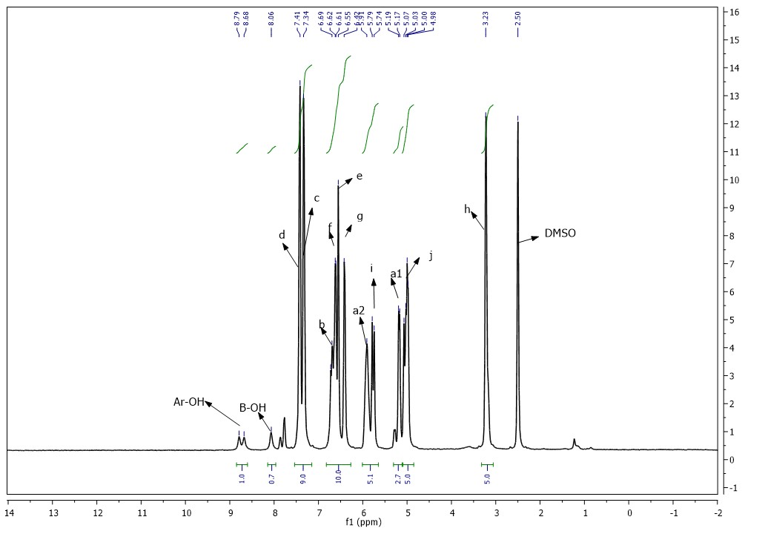

Figure S1. ¹H-NMR spectrum of CRX-3
Calculation of the CRX-3 yield from the ¹H-NMR spectra
¹H-NMR spectra of the precursors used in this study exhibited very high intensity peaks for (-OH) groups in Ar-OH, (δ= 8.79-8.67 ppm) and in B-OH, (δ= 8.07 ppm) for 4-allylcatechol molecule and 4-vinylphenyl boronic acid, respectively. On the other hand, these peaks were almost disappeared with the formation of the crosslinker and only very low intensity peaks (split peaks for Ar-OH and a single peak for B-OH) observed from the ¹H-NMR spectra of the crosslinker. The change in the intensity of these peaks after the reaction can be attributed to the consuming of the precursors and formation of the crosslinker with boronate ester bridges. Therefore, an integration for the area of H peaks in ¹H-NMR spectra can be used as a good approximation for the conversion or yield efficiency of the product from the corresponding precursors. According to the integration calculations which is carried out using the MestraNova software, the reduction of H peaks of Ar-OH groups in 4-allylcatechol molecule and B-OH groups in 4-vinylphenyl boronic acid is more than 80% which also suggests that the product was obtained with a yield of more than 80%.

