Synthesis and dye release applications of glucose/fructose sensitive poly(ethylene glycol) methyl ether methacrylate nanoparticles with novel boronate ester bridge crosslinker

Şeküre YILDIRIM¹, Hasan AKYILDIZ^{1,2}, Zeynep ÇETİNKAYA^{1,3}
¹Department of Metallurgical and Materials Engineering, Konya Technical University, Konya, Turkey
²Nanotechnology and Advanced Materials Development, Application, and Research Center, Konya Technical University, Konya, Turkey
³Advanced Technology Research and Application Center, Selçuk University, Konya, Turkey

Correspondence
Zeynep ÇETİNKAYA, zcetinkaya@ktun.edu.tr, + 90 332 205 1945

Abstract

In this study, it is aimed to develop glucose/fructose sensitive poly(ethylene glycol) methyl ether methacrylate (PEGMA) nanoparticles which can be employed in controlled drug delivery applications. For this purpose, a boric acid based crosslinker was synthesized using 4-vinylphenylboronic acid and its formation was confirmed by ¹H-NMR and FT-IR analyses. Sugar-sensitive polymeric nanoparticles were then achieved using this crosslinker and PEGMA monomer in one step and surfactant free emulsion polymerization technique. The nanoparticles produced were characterized by SEM, DLS, and TEM in terms of size and morphology. In order to determine the sensitivity of the nanoparticles to sugar molecules, first Rhodamine B dye (as a model drug) loading experiments was performed. The nanoparticles were then subjected to glucose/fructose rich media and dye release was monitored as a function of time using UV-Vis spectrophotometry. The results of the current study have revealed that the PEGMA nanoparticles are more sensitive to fructose (~39% release) compared to glucose (~25% release) at pH 7.4 and 37 °C.

Keywords: Controlled drug release, fructose sensitivity, phenylboronic acid, smart polymers, crosslinker

Introduction
Smart polymers are a group of materials which can modify some of their physical/chemical properties upon exposure to external stimuli such as temperature,^{1,2} pH,^{3,4} light^{5,6}, and magnetic/electric field.⁷⁻⁹ They may also show response to variety of organic compounds. Examples of these compounds include carbohydrates, enzymes, acids, and sugar molecules.¹⁰ Due to this unique behavior, these polymers are highly promising in various innovative applications including biomedical and bioengineering studies.¹¹ Among these applications, non-invasive biosensors have attracted great attention. Because the level of glucose or fructose molecules in the metabolism can be detected without disturbing the patient by the use of these biosensors.¹²
Glucose-sensitive biosensors can be classified into three types according to their chemical make-up and sensing mechanism.¹³ These are known as glucose-oxidase, protein, and phenyl-boronic acid (PBA) based systems. Glucose-oxidase sensors operate via the enzymatic oxidation of glucose molecules, whereas glucose-binding proteins are functioning through the binding of glucose molecules with glycol polymer-lectin complexes. These compounds are natural biological proteins which makes them intolerant to several environmental factors such as high temperature and pH. Further, the instability of these materials limits their widely use as glucose-sensitive systems. On the contrary, PBA is known to be the synthetic derivative of boronic acid with good stability and easy preparation.^{12,14} Boronic acid can bind to diol and polyol species of saccharides with high affinity through reversible boronate ester formation.^{1,12,15} For example, cis-1,2 and cis-1,3 diols of the sugar molecules can link reversibly with boronic acid. The details of this binding mechanism was well established in literature.¹¹
Phenyl-boronic acid compounds exhibit an equilibrium between the charged and uncharged forms in aqueous media.¹⁶ These two forms of PBA can react with the cis-1,2 diols of sugar molecules. While the uncharged PBA is hydrophobic in nature, the complex of this form of PBA with glucose is not stable in aqueous media due to hydrolysis. On the other hand, the complex of charged PBA-glucose can form hydrophilic phenylborate which is highly stable. Moreover, this reaction can shift the equilibrium towards hydrophilic state¹⁷ which in principle increases the swelling ratio of the polymer network. This provides an opportunity to use polymeric nanoparticles (NPs) as sugar sensitive systems in glucose or fructose containing environments for controlled insulin release.¹⁰ However, PBA-based glucose sensitive systems cannot function effectively at physiological pH due to the high pKa value (⁓9) of this compound.¹⁸ This is due to low ionization of phenylboronic acid at pH=7.4 which decrease the solubility of polymer in water and also its affinity to glucose. Among the proposed methods to reduce the pKa of PBA, using of alkaline solutions was suggested as a promising route which increase the binding between the boronic acid and sugar molecules.^{11,19,20}
Up to now, many forms of phenyl-boronic acid based system, such as hydrogels,²¹ multi-layered films,²² nanofibers,²³ and nanoparticles²⁴ have been studied for insulin release applications. Chen et al., reported that a polymer network can be obtained by crosslinking the boronate ester of two separate polymers which contain boronic acid functional groups and diols.¹⁹ With a similar approach, it has been shown that polymeric NPs can be synthesized using a polymer containing PEG-based boronic acid and another polymer containing diol groups.²⁰ Further, the NPs synthesized with the surfactant free emulsion polymerization method were reported to exhibit smooth surface and high stability.^{11,25} In addition, these samples were successfully employed in drug delivery and glucose/fructose sensing applications. However, only a few studies have been reported in literature which focuses on the synthesis of a crosslinker with boronate ester bridge and using the surfactant free polymerization method in the production of stimuli responsive polymeric NPs.^{3,19,20}
Here, we have produced PEGMA NPs which are sensitive to glucose/fructose molecules similar to those reviewed above but using a novel crosslinker containing boronate ester bonds for the first time. The PEGMA NPs was achieved using this novel crosslinker in one step and surfactant free emulsion polymerization method. These particles were loaded with a model drug (Rhodamine B dye) during the polymerization reaction and the amount of dye release was monitored carefully upon exposing the nanoparticles to glucose or fructose rich media and interpreted as the sensitivity level of the particles to sugar molecules.
- Experimental
4-vinylphenyl boronic acid (PBA, 97%, Sigma Aldrich), 4-allylatechol (%95, Sigma Aldrich), toluene (99.8%, Sigma Aldrich), and sodium hydroxide (NaOH, 97%, Sigma Aldrich) were used in the synthesis of the novel crosslinker. Poly(ethylene glycol) methyl ether methacrylate (PEGMA, Mn= 300, 97%, Sigma Aldrich), acetone (99.8%, Sigma Aldrich) and 2,2'-azobis [2-methylpropinamide] dihydrochloride (AMPDH, 97%, Sigma Aldrich) were employed in the production of PEGMA NPs. Toluene and deionized water (18.2 mΩ) were used as catalyst and cleaning purposes, where necessary.
2.1. Synthesis of boranate ester bridge containing crosslinker
The crosslinker was synthesized according to Scheme 1 given below.²⁶ The samples were obtained by mixing 1 mmol (0.150 g) of 4-allylcatechol and 1 mmol (0.147 g) of 4-vinylphenyl boronic acid in 10 mL of toluene in a glass beaker equipped with a reflux system. The solution pH was adjusted to 8.2 using NaOH and continuously stirred at 450 rpm for 72 h at a temperature of 110 °C. After the reaction completed, the system was cooled down to room temperature and brown colored precipitates were collected and washed with fresh toluene for 3 times and then dried in a vacuum oven for 24 h at 75 °C. Hereafter, this novel boronate ester bridge containing crosslinker is referred as CRX-3.

Scheme 1. Schematic representation of boronate ester bridge containing crosslinker (CRX-3) synthesis

2.2. Synthesis of PEGMA nanoparticles using boronate ester bridge containing crosslinker
PEGMA nanoparticles were obtained by mixing poly(ethylene glycol) methyl ether methacrylate monomer (Mn=300) with various amounts of CRX-3, as summarized in Table 1. Scheme 2 shows the emulsion polymerization reaction between the two precursors. For the synthesis of the NPs; 300 µL of PEGMA monomer and proper amount of crosslinker were dissolved in 30 mL of acetone:water mixture (1:29, v:v). The amount of the crosslinker was calculated based on the mole % of the monomer. The reaction flask was first purged with ultrahigh purity N₂ gas for 30 min to remove any dissolved oxygen. Polymerization process was carried out in this flask which was placed in a water bath on a magnetic stirrer at 70 °C. 10 mg of AMPDH (free radical initiator) was added to the medium to initiate the polymerization reaction. The solution was stirred for 3 h at 400 rpm. After cooling to room temperature, pale orange color suspension was centrifuged at 7000 rpm for 10 min to collect the PEGMA NPs. Any unreacted monomer or reactant was then removed by rinsing the particles for 3 times with distilled water. Finally, the NPs were suspended in ultra-pure water for further use. The obtained samples were designated as P-NP-1, P-NP-2, P-NP-3, P-NP-4, and P-NP-5 depending on the amount of crosslinker used during the synthesis, see Table 1.
Table 1. Synthesis conditions for PEGMA NPs
Sample | PEGMA 300 (µL) | CRX-3  (%)ª | AMPDH (mg) | Acetone (mL) | DI water (mL)
P-NP-1 | 300 | 1 | 10 | 1 | 29
P-NP-2 | 300 | 3 | 10 | 1 | 29
P-NP-3 | 300 | 5 | 10 | 1 | 29
P-NP-4 | 300 | 7.5 | 10 | 1 | 29
P-NP-5 | 300 | 10 | 10 | 1 | 29
ª According to the mole of the monomer.

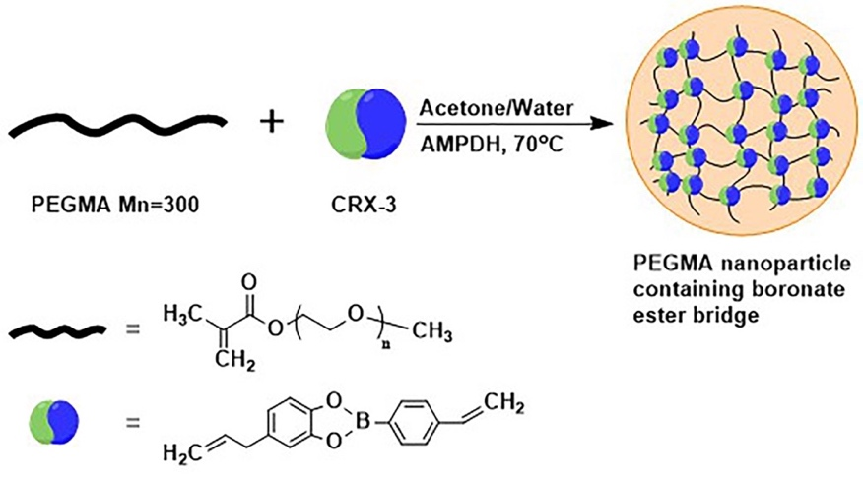
Scheme 2. Schematic representation of PEGMA NPs synthesis using poly(ethylene glycol) methyl ether methacrylate monomer (Mn=300) and boronate ester bridge containing crosslinker

  - Synthesis of dye loaded PEGMA NPs
In order to achieve dye loaded PEGMA NPs, 1 mg of Rhodamine B (in powder form) was added to the reactants at the initial stage of polymerization reaction. By doing this, the dissolved dye molecules were forced to be trapped in the polymer network during polymerization. After the reactions have completed, non-trapped dye molecules were removed by washing the NPs in phosphate buffered saline (PBS) solution for 3 times. Then, certain amount of PEGMA NPs were dispersed in 30 mL of PBS and poured into 3 separate vials with identical volumes i.e., 10 mL. 10 mg of fructose was added to the first vial, 10 mg of glucose was added to the second vial and the third vial left as it is, as the control sample. The vials were placed on a magnetic stirrer and heated to a constant temperature of 37°C. Finally, the absorbance data were recorded using a UV-Vis spectrophotometer after 0.5, 1, 2, 4, 6, 12, 24, and 48 h.

  - Sample Characterization
FT-IR spectrum of the crosslinker was obtained over the range of 4000 – 400 cm⁻¹ at a resolution of 4 cm⁻¹ using a Bruker VERTEX-70 spectroscopy. Solid-state ¹H-NMR spectrum was recorded on a Varian 400 MHz spectrometer with a 5 mm double- resonance probe, sample spinning rate of 8.0 kHz, contact time of 2 ms, and a pulse delay of 5 s to verify the formation of the material. The following numbering scheme was used to determine the sample; 400 MHz, DMSO-d6, ppm, δ= 8.79-8.67 (Ar-OH), 8.07 (B-OH), 7.25-723 (d), 7.18-7.16 (c), 6.60 (b), 6.36-6.28 (f,e,g), 5.92 (a2), 5.88-5,85 (i), 5.04-5.00 (a1), 4.99-4.95 (j), 3.18-3.17 (h). The conversion efficiency for the crosslinker was estimated using an integration on the reduction of H peaks in ¹H-NMR spectra of CRX-3 compared to the one belongs to the precursors. The calculations were performed using MestraNova software.
The morphology of PEGMA NPs was investigated in as-centrifuged state using SM Zeiss LS-10 scanning electron microscope (SEM). For transmission electron microscope (TEM) examinations, the nanoparticles were first washed with DI-water for 3 times to remove any unreacted species and then mixed with 2 mL of fresh DI-water to obtain a dispersion in an ultrasonic bath. This dispersion was then dropped on a carbon-coated copper grid and dried for an overnight at room temperature. A JEOL 2100F model TEM was used to determine the size and morphology of the synthesized NPs. The size of PEGMA NPs were further verified using Malvern ZetaSizer Nano ZS dynamic light scattering (DLS) system. The polydispersity index (PDI) and average hydrodynamic diameters (dH) of the NPs were measured after dispersing the NPs in 2 mL KCl solution (10 mM). The change in the absorbance of the samples during dye release were recorded via Biochrom Libra S22 UV-Vis spectrometer in the wavelength range of 450-650 nm.

- Results and Discussion
  - Structural and morphological evaluation of the prepared materials
The formation of CRX-3 crosslinker with boronate ester bridge was verified by conducting ¹H-NMR and FT-IR analyses of the samples. ¹H-NMR spectra of the synthesized crosslinker (Fig. 1a) and 4-allylcatechol (Fig. 1b) and the precursors of 4-vinylphenyl boronic acid (Fig. 1c) are presented together in Fig. 1, for comparison. As seen from this figure, the spectra of 4-vinylphenyl boronic acid and 4-allylcatechol exhibits (-OH) groups in Ar-OH, (δ= 8.79-8.67 ppm) and in B-OH, (δ= 8.07 ppm) peaks, respectively with high intensity. On the other hand, these peaks were almost disappeared in the spectrum of CRX-3. According to the integration calculations, the reduction of H peaks of Ar-OH groups in 4-allylcatechol molecule and B-OH groups in 4-vinylphenyl boronic acid is more than 80% which also suggests that the product was obtained with a yield of more than 80%. A detailed ¹H-NMR spectrum for the crosslinker (Fig. S1) and the integration steps can be followed from the supplementary information.
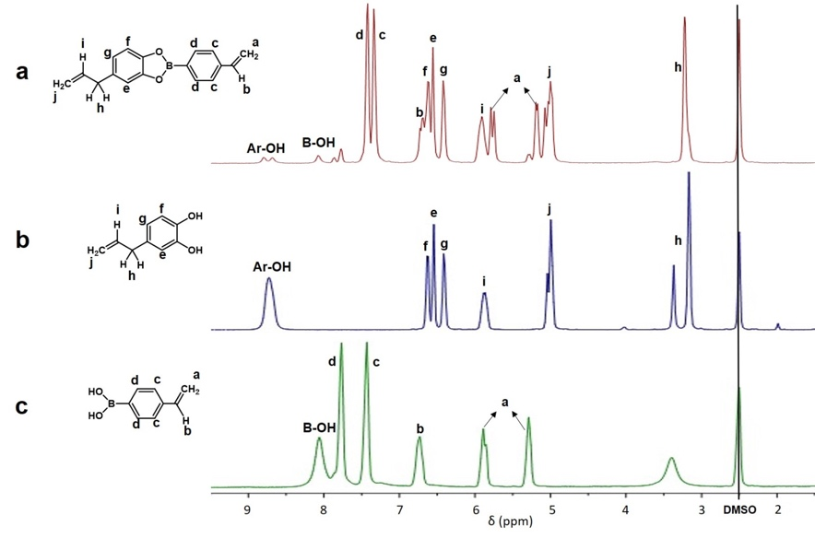
Fig. 1. ¹H-NMR spectrum of a) CRX-3 b) 4-allylcatechol c) 4-vinylphenyl boronic acid
The formation of the crosslinker was further verified by comparing the FT-IR spectra of CRX-3 and 4-vinylphenil boronic acid. The results are presented in Fig. 2. According to literature, bands at 1220 and 1250 cm⁻¹, 1000 -1090 cm⁻¹, and 500-750 cm⁻¹ can be assigned to C−O stretches,²⁷⁻³² B−C stretches,^{28,29,33-35} and out-of-plane vibrations,^{28,36} respectively in boronate esters. On the contrary, in some other studies, one can find that the assigned wavenumbers for C−O and B−C stretches were replaced, i.e., 1200 and 1270 cm⁻¹ for B-C streches^{37,38} and 1100 and 1200 cm⁻¹ for C-O stretches.^{37,39} In addition, bands around 1300 cm⁻¹ are mostly attributed to B-O stretches in boronate esters.⁴⁰ The spectrum for our sample displayed 2 sharp peaks in this region at 1330 cm⁻¹ and 1366 cm⁻¹. However, boronic acid have also been reported to exhibit vibrations here which makes the distinguish between the boranate ester and boronic acid disputable.⁴¹ As discussed above, peaks observed in the spectrum of the crosslinker at 1233 cm⁻¹ and 1050 cm⁻¹ are probably due to C−O and B-O stretches. The presence of these peaks was evaluated as the characteristic of boronate ester formation.²⁷ Further, the vibrational mode seen at 662.8 cm⁻¹ also designate that the boronic acid was consumed during the reaction in order to form the boronate ester bridge containing crosslinker.⁴¹ These findings shows that the 4-allylcatechol and 4-vinylphenyl boronic acid precursors almost reacted successfully to form the crosslinker under the experimental conditions applied for the current study.
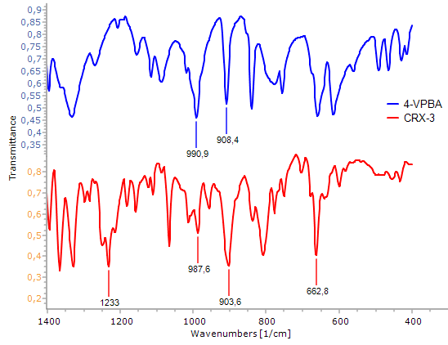
Fig. 2. FT-IR spectrum of 4-vinylphenyl boronic acid (4-VPBA, top) and CRX-3 (bottom).

As discussed in the experimental section, PEGMA NPs were obtained by mixing constant amount of PEGMA 300 monomers and different amount of CRX-3 (1, 3, 5, 7.5, and 10% mole of the monomer) in the presence of AMPDH. Further, the emulsion polymerization process yielded PEGMA including suspensions and the polymer content of these suspensions was collected by centrifugation. Morphological examination of these as-collected samples was carried out via SEM analysis. Figure 3 (a and b) demonstrates SEM images of as-centrifuged P-NP-3 sample. In fact, the product consists of uneven shaped and large sized (20-30 µm) individual agglomerates. Figure 3a shows only a portion of the surface of a random agglomerate. As it is clear from this image, under the experimental conditions applied, the polymerization reaction ended-up with the formation of spherical shaped PEGMA (indicated by red arrows) embedded in an un-reacted matrix. Fig. 3b provides a closer view of the surface belongs to one of these PEGMA spheres. It is obvious that these large spheres are made-up of much smaller particles. As this image refer to unwashed state, it is not easy to determine the size and size distribution of the nanoparticles using this SEM micrograph. Yet, it can be stated that these nanoparticles exhibit a distinct spherical morphology, and the diameter of the largest particles can reach up to ⁓194 nm.

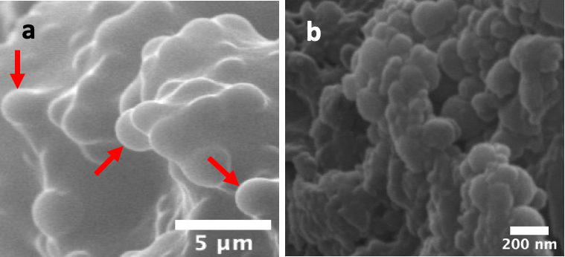
Fig. 3. SEM images of P-NP-3 sample in as-centrifuged state a) general view of the surface of a large sized agglomerate, b) high magnification surface image of denoted spheres in (a).

The size and morphology of cleaned PEGMA NPs were investigated using DLS and TEM techniques. The average hydrodynamic diameter and polydispersity index of the NPs were extracted from DLS measurements. The results are demonstrated in Fig 4. The numerical values can be followed from Table 2. As seen from this figure and table, no data are presented for P-NP-1 and P-NP-2 samples. This indicates that PEGMA NPs formation could not be achieved when the amount of the crosslinker used was 1 or 3 % mole of monomer, probably due to insufficient linking. On the other hand, in case of CRX-3 additions at 5, 7.5, and 10 % mole of monomer, PEGMA NPs were successfully obtained. The values given in Table 2 states that the dH and PDI of the NPs are directly proportional to the amount of crosslinker used during synthesis. In consistent with the SEM examinations given above, the dH value of P-NP-3 sample was measured as 184.4 nm. In addition, dH values of 267.5 nm for 7.5% mole and 318 nm for 10% mole of monomer crosslinker additions were identified. Further, PDI values were obtained as 0.274, 0.336, and 0.393 for P-NP-3, P-NP-4, and P-NP-5, respectively.
Fig. 4. Polydispersity index and average hydrodynamic diameter values of the synthesized PEGMA NPs as a function of the amount of CRX-3 used during synthesis

These findings show that the amount of CRX-3 used during synthesis is a significant parameter such that the formation of NPs directly depends on the amount of crosslinker present in the reaction environment. Further, the amount of the crosslinker not only affects the size but also the size distribution of the PEGMA NPs. In a similar study, the acetone/water ratio was reported as an another important parameter in terms of controlling the average hydrodynamic diameter of PMMA (Poly Methyl Methacrylate) NPs.¹¹ It was stated that increasing the fraction of acetone in the solvent could be used as an effective way to reduce the size of the NPs. On the other hand, for the current study, a constant value of acetone to water ratio (1/29) was used for all experiments. Further, increasing the amount of acetone in the solvent mixture led to the formation of strong agglomerates which are not dispersible by washing/ultrasonic treatments. Therefore, the observed difference in the diameter of the NPs here can be ascribed to the change in the amount of CRX-3 used during the synthesis reactions.
As the size of the particles dictate a specific value for the surface area of the samples and further the reaction with sugar molecules was expected to proceed from boronate ester bridges exposed to the surface; the synthesis condition which provides the lowest hydrodynamic diameter for the particles was selected for further investigation. As seen from Fig. 4 and Table 2, the P-NP-3 (synthesized by using CRX-3 at an amount of 5% mole of monomer) sample exhibited the lowest size with dH value of 184.4 nm. In addition, the PDI (0.274) of this sample is the lowest among others which indicates that the synthesized particles exhibit acceptable narrow size distribution.

Table 2. Average hydrodynamic diameters and polydipersity index of the synthesized PEGMA NPs
Sample | dH (nm)ª | PDI^{b}
P-NP-1 | - | -
P-NP-2 | - | -
P-NP-3 | 184.4 | 0.274
P-NP-4 | 267.5 | 0.336
P-NP-5 | 318 | 0.393
ª Average hydrodynamic diameter.
^{b} Multi-distribution indicator, unitless.

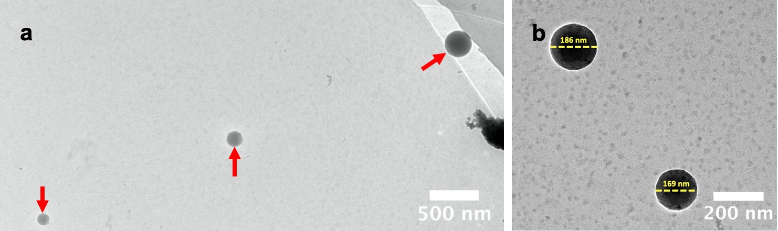
Fig. 5. Low resolution TEM images of P-NP-3 sample, a) an array of particles with different sizes b) a single PEGMA nanoparticle

Figure 5 (a and b) shows the low resolution TEM images of the P-NP-3 sample. As it is clear from these images, the PEGMA NPs are highly dispersed after the cleaning procedure and exhibits almost perfectly spherical morphology. Fig. 5a illustrates an array of PEGMA NPs on holey carbon coated Cu grid with various sizes. In addition, two random spherical PEGMA nanoparticle with similar diameters can be seen in Fig 4b. According to the measurements conducted using TEM images, the NPs have sizes in the range of 90 to 186 nm. This finding agrees with the SEM and DLS measurements given above. These observations reveal that the PEGMA NPs were successfully formed by the surfactant free emulsion polymerization reaction using the boranate ester bridge containing crosslinker and exhibit a narrow size distribution and particle size below 200 nm.

  - Dye loading and sugar sensitivity experiments

Rhodamine B dye with specific absorbance in the visible region (λ_{max} = 554 nm) was used as a model drug in this study. Scheme 3a summarizes the dye loading process into the network of a PEGMA nanoparticle. In addition, the proposed mechanism of the dye release is presented schematically in Scheme 3b. According to this mechanism, in case of the presence of sugar molecules in the environment, the trapped dye is expected to be released due to the high sensitivity of CRX-3 to these external molecules. While the sugar molecules can bind to boronic acid, this simply breaks the boronate ester bridge between the monomers. Thus, this reaction will collapse the network of the polymer. Therefore, the amount of the liberated dye to the surrounding can be considered as a measure of drug released by the NPs.

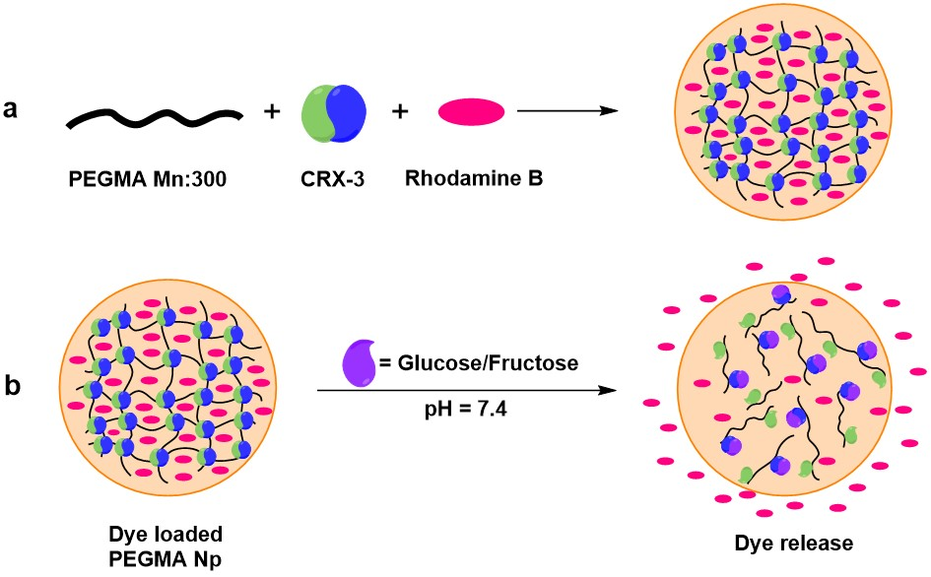
Scheme 3. Schematic representation of a) dye loading into PEGMA NPs, b) dye release in the presence of glucose/fructose
Figure 6a shows the absorbance spectra of P-NP-3 sample (1.25 x 10⁻² g) dispersed in PBS, PBS + glucose, and PBS + fructose environments. These spectra were recorded after 2 h of the dispersion process. Absorbance behavior of the pure PEGMA NPs (synthesized without dye loading) in the range of 450 to 650 nm was also presented for comparison. As seen, pure nanoparticles were displayed no absorbance in this region. Therefore, any measured absorbance for other cases can be considered as due to the Rhodamine B dye molecules released from the network of the NPs depending on the surrounding media. According to the measured values after 2 h, the lowest amount of dye was released in PBS environment, which also means that the nanoparticles are releasing a certain amount of dye (16.7 %) even in sugar free environment. In case of PBS with 10 mg/mL glucose, the released amount of dye (18.2 %) was only slightly increased compared to PBS environment, which suggests that the nanoparticles with boronate ester bridge containing crosslinker is only partially sensitive to glucose molecules. On the other hand, in case of PBS + 10 mg/mL fructose environment, the amount of the released dye increased substantially and reached to 24.5 % after 120 min.
Figure 6b demonstrates time dependent increase of dye concentration in PBS+10 mg/mL fructose medium for a total holding duration of 48 h. As seen from the spectra, the absorbance increases continuously as a function of time which means the quantity of the liberated dye is increasing in the environment with time. After 48 h, a total of 39 % dye release was achieved. The left inset image in this figure shows the deep pink color of the solution because of Rhodamine B dye released to the environment in the presence of fructose after 48 h by the P-NP-3 sample. In addition, the right inset image presents this PEGMA NPs collected from the pink colored solution, which indicates that the particles can be separated from the solution via a simple centrifugation.
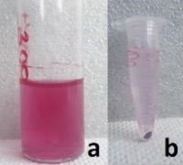
Fig. 6. Absorbance spectra of P-NP-3 sample after 2 h in a) PBS, PBS+10 mg/mL glucose and PBS+10 mg/mL fructose environments, b) time dependent increase of dye release in PBS+10 mg/mL Fructose environment (insets in (b) shows the digital images of the solution because of released Rhodamine B dye by the NPs (left) and the collected NPs with centrifuging (right))
The details and the cumulative release of the dye (after 48 h) by the P-NP-3 sample dispersed in PBS, PBS + glucose, and PBS + fructose environments are presented in a comparative base in Fig 7. The figure reveals that the dye release by the NPs reached a constant value of ⁓25 % in PBS or PBS + glucose within the first 6 h. After this period, the recorded amount of dye lost by the network was ascended only slightly. On the other hand, in PBS + fructose medium, dye release by the NPs increased rapidly up to 28.52 % in 6 h. After this point, the concentration of Rhodamine B gradually continued to increase in the solution, but a decline in the slope of the curve is obvious. At the end of 48 h, a total amount of the released dye was recorded as 39 %. As these dispersions were prepared by dividing a single and homogenous 30 mL PBS-PEGMA NPs dispersion into three identical vials for dye release experiments (see section 2.3), the amount of NPs in each vial and the amount of initially trapped dye by these NPs can be assumed similar for each condition. As other parameters such as temperature, pH, time, etc. were all kept constant, the total amount of released dye for each case can be correlate to the presence of PBS, glucose or fructose in these environments. The highest amount of dye was released in fructose environment. Therefore, it can be stated that the boranate ester bridge network is much more sensitive to external fructose molecules compared to glucose molecules.

Fig. 7. Time dependent Rhodamine B dye release % of P-NP-3 sample dispersed in different environments

In a recent study, Wu et. al., discussed on an amphiphilic boronic acid glucose sensor, where the hydrophobic group in glucose and hydrophilic boronic acid attached to each other with a dynamic covalent linkage, preferably an imine bond.⁴² According to the proposed mechanism, the presence of glucose can induce aggregation of simple boronic acids due to its ability to crosslink the two boronic acid molecules.⁴³ On the other hand, experiments with fructose showed no sign of turbidity in the solutions which indicate little or no amphiphile aggregation.⁴² Therefore, they stated that the binding of glucose may lead to formation of “Gemini-type” amphiphiles, which have a higher ability of aggregation compared to “single-tail” amphiphiles formed with boronic acid and fructose. Based on the dye release values for the current experiments, it is believed that the boranate ester bridge in the network has opened in the presence of glucose, but due to a similar mechanism discussed above or a competition between the network disintegration and amphiphile aggregation, the dye release by the particles was inhibited. On the contrary, fructose molecules probably have disintegrated the network to form a single tail amphiphiles, which allowed to the liberation of the trapped dye in the network. As a result, more dye released to the environment for fructose containing experiment. Of course, this speculation has need to be verified by further experiments, which will be considered in future studies. In addition, it is clear from the earlier studies that the affinity of samples to external molecules and the amount of the model drug released by the particles may scatter widely depending on various parameters, such as temperature,^{1,2} time,⁴⁴ pH,^{3,4} glucose/fructose concentration,^{10,45} and etc. On the other hand, the current study has aimed to propose a simple preparation route for the polymeric nanoparticles using a novel crosslinker. Therefore, the pH, polymeric particle dosage or sugar molecule concentration were kept constant in all experiments. And the amount of the dye liberated by the samples were measured as a function of time only. This also imply that the dye release performance of the nanoparticles can be improved by applying the optimized conditions.

- Conclusions
In this study, PEGMA NPs were synthesized successfully in one step with surfactant free emulsion polymerization method using a novel boronate ester bridge containing crosslinker. The characterizations have revealed perfectly spherical morphology for the NPs. Further, the study has shown the tunability of the process in terms of achievable NPs sizes. It was observed that PEGMA NPs could be synthesized in various sizes depending on the amount of the crosslinker added to the polymerization reaction. The NPs with the narrower size distribution and average diameter were then examined for controlled drug release application using their sensitivity against glucose or fructose molecules. The experiments have shown that the affinity of PEGMA NPs with boronate ester bonds was 56% higher to fructose compared to glucose molecules. Finally, this study demonstrated that it is possible to synthesize a variety of polymeric nanoparticles with improved sensing ability by designing a suitable crosslinker.
Acknowledgement
Support for this work is provided by the Scientific Research Foundation (BAP) of Selçuk University (Project Number 191019020) which authors gratefully acknowledge.
REFERENCES
1. A. S. Wadajkar, Z. Bhavsar, C. Y. Ko, B. Koppolu, W. Cui, L. Tang, K. T. Nguyen, Acta Biomater. 2012, 8, 2996-3004.
2. J. Zhang, H. Chen, L. Xu, Y. Gu, J. Control Release 2008, 131, 34-40.
3. A. S. I. Kamba, M.; Ibrahim, T. A. T.; Zakaria, Z. A. , Biomed. Res. Int. 2013.
4. B. H. Tan, K. C. Tam, Y. C. Lam, C. B. Tan, Langmuir 2004, 20, 11380-11386.
5. M. F. Bedard, B. G. De Geest, A. G. Skirtach, H. Mohwald, G. B. Sukhorukov, Adv. Colloid Interface Sci. 2010, 158, 2-14.
6. K. C. Hribar, M. H. Lee, D. Lee, J. A. Burdick, ACS Nano 2011, 5, 2948-56.
7. A. Baeza, E. Guisasola, E. Ruiz-Hernández, M. Vallet-Regí, Chem. Mater. 2012, 24, 517-524.
8. S. Kirchberg, M. Rudolph, G. Ziegmann, U. A. Peuker, J. Nanomater. 2012.
9. M. Zrínyi, Colloid Polym. Sci. 2000, 278, 98-103.
10. G. Springsteen, B. Wang, Tetrahedron 2002, 58, 5291-5300.
11. H. Sakalak, M. Ulasan, E. Yavuz, S. Camli, M. Yavuz, J. Nanoparticle Res. 2014, 16.
12. T. Elshaarani, H. Yu, L. Wang, A. Zain ul, R. S. Ullah, M. Haroon, R. U. Khan, S. Fahad, A. Khan, A. Nazir, M. Usman, K.-u.-R. Naveed, J. Mater. Chem. B 2018, 6, 3831-3854.
13. L. Zhao, C. Xiao, L. wang, G. Gai, J. Ding, Chem. Comm. 2016, 52, 7633-7652.
14. G. Springsteen, B. Wang, Chem. Comm. 2001, 1608-1609.
15. C. Cannizzo, S. Amigoni-Gerbier, C. Larpent, Polymer 2005, 46, 1269-1276.
16. K. Kataoka, H. Miyazaki, M. Bunya, T. Okano, Y. Sakurai, J. Am. Chem. Soc. 1998, 120, 12694-12695.
17. A. P. Vogt, V. Trouillet, A. M. Greiner, M. Kaupp, U. Geckle, L. Barner, T. Hofe, C. Barner-Kowollik, Macromol. Rapid Commun. 2012, 33, 1108-1113.
18. S. Kitano, I. Hisamitsu, Y. Koyama, K. Kataoka, T. Okano, Y. Sakurai, Advan. Technol. 1991, 2, 261-264.
19. W. Chen, Y. Cheng, B. Wang, Angew. Chem. Int. Ed. Engl. 2012, 51, 5293-5295.
20. Y. Li, W. Xiao, K. Xiao, L. Berti, J. Luo, H. P. Tseng, G. Fung, K. S. Lam, Angew. Chem. Int. Ed. Engl. 2012, 51, 2864-2869.
21. A. Kikuchi, K. Suzuki, O. Okabayashi, H. Hoshino, K. Kataoka, Y. Sakurai, T. Okano, Anal. Chem. 1996, 68, 823-828.
22. M. Seno, K. Yoshida, K. Sato, J. Anzai, Mater. Sci. Eng. C Mater. Biol. Appl. 2016, 62, 474-479.
23. Y. Zhang, F. Wang, S. Y. Qian, Z. X. Liu, Q. Wang, Y. Y. Gu, Z. L. Wu, Z. G. Jing, C. S. Sun, W. Peng, Sensors 2017, 17.
24. A. Matuszewska, M. Uchman, A. Adamczyk-Wozniak, A. Sporzynski, S. Pispas, L. Kovacik, M. Stepanek, Biomacromolecules 2015, 16, 3731-3739.
25. Y. Guangzhi, L. Yang, J. Runping, X. Risheng, W. Xia, L. Licheng, Y. Junhe, J. Appl. Polym. Sci. 2009, 112, 410-415.
26. S. Pasa, PhD Thesis. Dicle University, Diyarbakır, 2014.
27. M. K. Smith, B. H. Northrop, Chem. Mater. 2014, 26, 3781-3795.
28. A. P. Côte, A. I. Benin, N. W. Ockwig, M. O ́ ’Keeffe, A. J. Matzger, O. M. Yaghi, Science 2005, 310, 1166−1170.
29. H. M. El-Kaderi, J. R. Hunt, J. L. Mendoza-Cortes, A. P. Côte, R. E. Taylor, M. O’Keeffe, O. M. Yaghi, Science 2007, 316, 268−272.
30. X. Ding, J. Guo, X. Feng, Y. Honshihito, J. Guo, S. Seki, P. Maitarad, A. Saeki, S. Nagase, D. Jiang, Angew. Chem., Int. Ed. 2011, 50, 1289−1293.
31. X. Feng, L. L. Liu, Y. Honsho, A. Saeki, S. Seki, S. Irle, Y. P. Dong, A. Nagai, D. L. Jiang, Angew. Chem., Int. Ed. 2012, 51, 2618−2622.
32. M. Dogru, M. Handloser, F. Auras, T. Kunz, D. Medina, A. Hartschuh, P. Knochel, T. Bein, Angew. Chem., Int. Ed. 2013, 52, 2920−2924.
33. X. Feng, L. Chen, Y. Honsho, O. Saengsawang, L. Liu, L. Wang, A. Saeki, S. Irle, S. Seki, Y. Dong, D. Jiang, Adv. Mater. 2012, 24, 3026-3031.
34. E. L. Spitler, W. R. Dichtel, Nat. Chem. 2010, 2, 672-677.
35. J.-T. Yu, Z. Chen, J. Sun, Z.-T. Huang, Q.-Y. Zheng, J. Mater. Chem. 2012, 22, 5369-5373.
36. R. W. Tilford, S. J. Mugavero, 3rd, P. J. Pellechia, J. J. Lavigne, Adv. Mater. 2008, 20, 2741-2746.
37. Z. Kahveci, T. Islamoglu, G. A. Shar, R. Ding, H. M. El-Kaderi, Cryst. Eng. Comm. 2013, 15, 1524-1527.
38. S. Jin, K. Furukawa, M. Addicoat, L. Chen, S. Takashi, S. Irle, T. Nakamura, D. Jiang, Chem. Sci. 2013, 4, 4505−4511.
39. X. Feng, Y. Dong, D. Jiang, Cryst. Eng. Comm. 2013, 15, 1508-1511.
40. J. W. Colson, W. R. Dichtel, Nat. Chem. 2013, 5, 453-65.
41. B. M. Rambo, J. J. Lavigne, Chem. Mater. 2007, 19, 3732-3739.
42. S. Camli, F. Buyukserin, O. Balci, G. Budak, J. Colloid Interface Sci. 2010, 344.
43. Y. Tsuchido, Y. Sakai, K. Aimu, T. Hashimoto, K. Akiyoshi, T. Hayashita, New J. Chem. 2015, 39, 2620-2626.
44. X. Huang, S. Li, J. S. Schultz, Q. Wang, Q. Lin, Sensors Actuat. B-Chem. 2009, 140, 603-609.
45. A. Ori, S. Shinkai, J. Chem. Soc. Chem. Comm. 1995, 1771-1772.

