Understanding of Symmetry: Measuring the Contribution of Virtual and Concrete Models for Students with Different Spatial Abilities
Thayban Thayban¹, Habiddin Habiddin^{1,2}*, Yudhi Utomo¹ and Muarifin Muarifin³
¹Graduate Program, Department of Chemistry, Faculty of Mathematics and Natural Sciences, Universitas Negeri Malang - Indonesia
²PUI PT Disruptive Learning Innovation (DLI), Universitas Negeri Malang - Indonesia
³Faculty of Sport Science, Universitas Negeri Malang - Indonesia
*Corresponding Email: Habiddin_wuni@um.ac.id
Abstract
Virtual and concrete models have been of interest in chemistry teaching to improve students' understanding of a three-dimensional representation of chemical concepts such as symmetry. This study aims to determine the effectiveness of using concrete and virtual models on students' understanding of symmetry. Students' understanding was also explored in light of their spatial ability. The study was conducted using a quasi-experimental design with 62 students as participants. Two different instruments, spatial ability and understanding of symmetry tests, were employed for data collection. Data analysis was performed using the Pearson product-moment correlation and two-way variance analysis test. The results showed the virtual model's contribution to improving students' understanding of symmetry is higher than that of the concrete model for both students with a high spatial ability (HSA) and low spatial ability (LSA). Also, the better students' spatial ability, the better their understanding of molecular symmetry.
Keywords
Virtual Model, Concrete Model, Molecular Symmetry, Spatial Ability
INTRODUCTION
Molecular symmetry is an essential topic that is generally provided for university students taking an inorganic chemistry course. Symmetry governing the physical and spectroscopic properties of molecules provides clues regarding electronic and molecular structure as well as the way of reaction carried out.¹ The topic is also essential in other chemistry branches, such as predicting optical activity in organic chemistry.² Recognising and understanding three-dimensional representations is a paramount ability to understand chemical concepts, particularly symmetry. Having good visual-spatial thinking skill is highly required to build a robust understanding of symmetry.³ Also, students should visualise and predict three dimensions of unfamiliar motion.⁴ The sound understanding of symmetry and 3D orientation of chemical compound and reaction contributes to students' success in learning other chemical concepts.⁵ It is the building blocks for understanding modern molecular chemistry.⁶ Difficulty in understanding symmetry contributes to the barrier to understand other chemical concepts.⁷ These statements confirm that a good understanding of symmetry is essential for chemistry students. Visualising a two-dimensional object to a three-dimensional object requires several thinking tasks. Firstly, the interpretation and understanding of different charts must be done correctly before translating them into three-dimensional forms.^{8–11} Secondly, converting abstract objects into real objects.¹² However, the results of our preliminary observations showed that the vast majority of students could not predict the shapes of molecules and determine the angle of the molecular shape. These inabilities could be rooted in students' tendency to describe molecular shapes based solely on Lewis structures without considering molecules' position as three-dimensional objects.¹³ Also, the explanation of abstract concepts in textbooks is generally only based on two-dimensional visualisations,¹⁴ which distort mental models.
Recent studies ^{11,15–17} revealed that students still find it challenging to visualise two-dimensional forms implying an insufficient spatial ability. This insufficient ability could be rooted in difficulty identifying the rotation axis position relative to the object based on the visualisation of objects before and after rotation and difficulty visualising an object's appearance after rotation and reflection operations.¹⁸ Students' ability to build mental visualisation of molecular shapes can be improved by optimising their representational competence.^{10,19,20} This ability can be improved by applying a virtual model-assisted learning strategy or concrete model.^{10,20,21} Virtual or concrete model-assisted learning provides Visio-spatial information better than without using a model.¹⁰ Research comparing the effectiveness of using virtual and concrete models in chemistry has been carried out.^{8,10,22} The results found different outcomes. Fjeld²² found that the concrete model demonstrated better support to students' achievement than a virtual model.
On the other hand, Abraham et al.⁸ and Stull & Hegarty¹⁰ found an insignificant difference between the two models. The difference in cognitive construct when using the two models could be a complementary aspect for each other. Fjeld²² revealed that the virtual model requires more cognitive tasks than the concrete model. Therefore, combining the two models is reasonable exercises.¹⁰
Several approaches have been applied in teaching symmetry as well as overcoming students' unscientific understanding of the topic including hands-on symmetry project,²³ three-dimensional (3D) models,^{24–26} virtual laboratories,³ common daily objects,²⁷ and drawing 2D projection.²⁸ A study focusing on the difference between using concrete and virtual model is limited. Therefore, this study aimed to explore how concrete and virtual media affect the students' understanding of symmetry and how students' spatial ability influences it. The result of this study will provide a vital perspective to be applied in the teaching of symmetry. The virtual model in this study is an online multimedia application provided by the website, https://symotter.org/. Meanwhile, the concrete models were created by students representing the molecular geometries.
METHODOLOGY
Research Design & Participants
This study employed a quasi-experimental design and involved two classes/groups (with 31 students for each) of third-year students at the Chemistry Department, Universitas Negeri Gorontalo taking chemical bonding. In this university, symmetry is one of the topics discussed in the chemical bonding course. The convenience sampling technique was applied because the study was carried out in a natural setting in which the authors were not allowed to randomise the classes.
Procedure
This study was carried out according to the following procedure. Before the treatment, the two groups were given a preliminary test to determine whether they posed an equal academic ability. The test covered the geometry molecule topic, a prerequisite topic before embarking on the symmetry class. Homogeneity test using the Levene's Test (P> 0.05) showed that the prior academic ability between the two groups was equal. Students' spatial ability was also measured using an adapted instrument, Purdue Spatial Visualization Test (PVST), developed by Guay.²⁹ Next, a guided inquiry teaching approach was implemented for the two groups. The virtual model was applied as symmetry learning media for one class (we named it virtual class), and the concrete model was applied for another class (we name it concrete class). The teaching of molecular symmetry to both groups was carried out in three meetings with 120 minutes for each. After completing all three meetings, students' understanding of molecular symmetry was measured using a short answer test with 18 questions. The instrument is named Students' Understanding of Molecular Symmetry Test (SUMST).
Learning Media and Instrument
Virtual Model
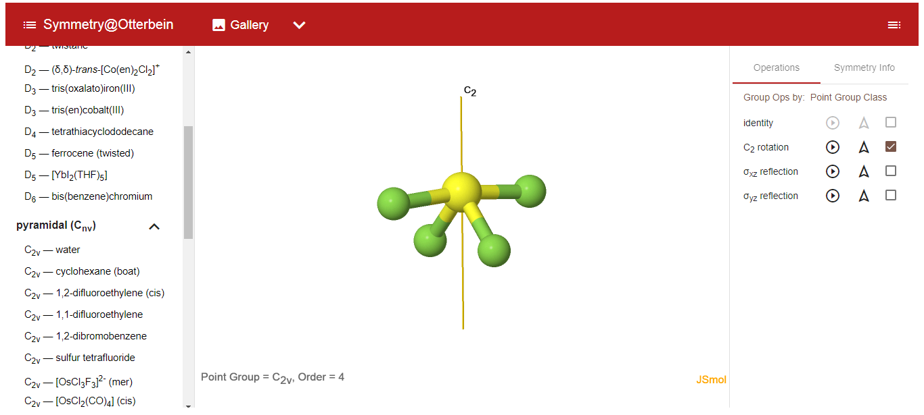
The virtual model was applied as the learning media to facilitate students' understanding of symmetry for a virtual class. The virtual models are available on the website of https://symotter.org/. The website (Symmetry @ Otterbein) offers three features like the following. (1) Symmetry Tutorial provides an interactive point group that can guide the user through all elements and operations of symmetry with interactive displays and animations. (2) Symmetry Gallery is a collection of more than hundreds of unique molecules with interactive views of all elements of symmetry and animation of symmetry operations. The molecules are arranged by groups of points, so the user can select samples to show a particular element of symmetry. (3) Symmetry Challenge provides a detailed flow chart of the process of determining the point group of each molecule. Figure 1 below depicts a virtual model of molecular symmetry available on the website.
Figure 1. Example of the virtual model presented in the teaching of virtual class

Concrete Model
The concrete model was applied as the learning media to facilitate students' understanding of symmetry for concrete class. The concrete models were produced by utilising daily materials such as pencil eraser and needles. Students were required to create the concrete model to build their understanding of the symmetry operation unconsciously. The molecular shape design was arranged to form an angle following the experimental molecule's angle and affect the symmetry operation.
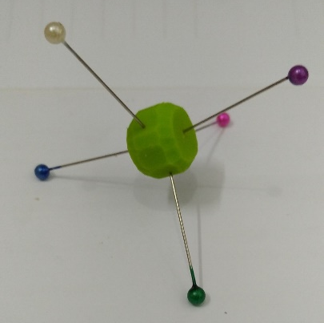
Figure 2. Example of a concrete model produced in the teaching of concrete class

Spatial Ability Test
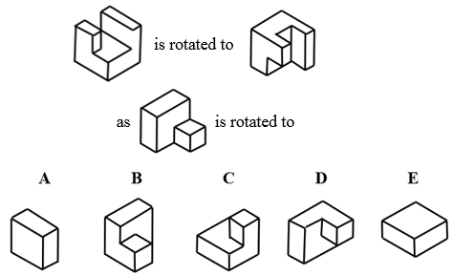
The PSVT applied to measure students' spatial ability was in a multiple-choice question and 30 items. The example of a question is provided in Figure 3 below. The spatial ability test instrument has high category reliability with a value of 0.95.
Figure 3. Example of a question in the PSVT

Students' Understanding of Molecular Symmetry Test (SUMST)
Students' understanding of molecular symmetry after teaching using virtual and concrete models was measured using the Students' Understanding of Molecular Symmetry Test (SUMST). The SUMST was in the form of a short answer question and represented all symmetrical operations that exist in the molecule in depth. The test instrument consisted of 18 items with a Cronbach Alpha coefficient of 0.905 falling in the very high category.
Data Analysis
Students' Spatial Ability
The level of students' spatial ability is categorised based on the spatial ability test score. Students who obtained scores above the average are included in students with high category spatial abilities (HAS). In contrast, students who obtained scores below the average are included in students with low category spatial abilities (LSA).
Students' spatial ability and understanding of symmetry
The correlation between students' spatial ability and students' understanding of symmetry was measured using Pearson product-moment correlation. Before the correlation test performed, the prerequisite tests, including the normality test and the homogeneity test, were applied. The normality test using the Kolmogorov-Smirnov test ( One-Sample KS ) obtained P>0.05, which means that the data is normally distributed. The homogeneity test using Levene's Test obtained P>0.05, which means the data is homogeneous.
The effectiveness of virtual and concrete models on students 'understanding of symmetry
Two-way analysis of variance (ANOVA) was used to determine (1) the difference in the effectiveness of using virtual and concrete models on students 'understanding of molecular symmetry with different spatial abilities and (2) the interaction between virtual models and concrete models on students' spatial abilities in learning molecular symmetry.
Ethics approval
Ethical approval has been obtained from Universitas Negeri Malang and Universitas Negeri Gorontalo.
RESULTS AND DISCUSSION
Student Spatial Ability Level
Students' spatial abilities were classified into three categories, including spatial visualisation (SV), spatial relation (SR) and spatial orientation (SO). All three categories were identified using the related type of spatial questions. Ten questions represented each category. The example portrayed in Figure 3 above is a type of SV question. The description of students' spatial ability level is presented in Table 1.
Table 1. Students' Spatial Ability Test Results
Spatial ability category | Number of Students (%)
Spatial ability category | High | Low
SV | 77.4 | 22.6%
SR | 58.1 | 41.9%
SO | 75.8 | 24.2%

The table described that the number of students with high spatial level ability is always higher than that of each category with low spatial ability. The previous study ³⁰ supports this finding that spatial abilities develop well at 11-16.
Spatial Abilities, Virtual & Concrete models, and Understanding of Molecular Symmetry
Students' responses to the SUMST instrument representing their understanding of molecular symmetry for virtual and concrete models with high and low spatial ability levels are presented in Table 2.
Table 2. Students' Responses to the SUMST and spatial ability level
Spatial ability level | Students' score to the SUMST
Spatial ability level | Students with Virtual Model (SVM) | Students with Concrete Model (SCM)
High | X = 66.20 | X = 51.9
High | N = 17 | N = 19
High | SD = 13.83 | SD = 18.93
Low | X = 44.34 | X = 36.80
Low | N = 14 | N = 12
Low | SD = 21.05 | SD = 21.5
The table shows that the virtual model provided a better contribution to the students' understanding of symmetry for high spatial ability (HSA) and low spatial ability (LSA) students. This finding is in accordance with the previous research.^{10,21,31} The better performances of SVM students were demonstrated in several aspects. Students with the virtual model (SVM) demonstrated better performance than students with the concrete model (SCM) in predicting molecular shape, especially in determining the bond angles. The availability and accuracy of information regarding bond angle a molecular geometry cause students to become accustomed to predicting molecular shape by including bond angles, making it easier for students to identify molecular symmetry operations. This familiarity leads to better cognitive training and the improvement of cognitive abilities.³²
Below is the different level of students' responses in predicting the shape of the PFCl₄ molecule for the two groups. SVM students understood that the angle of Cl_{eq}-P-Cl_{eq} (eq= equatorial) would be distorted and <120⁰ due to the difference in electronegativity between the Cl atom and the F atom, which is in the axial position. Meanwhile, SCM students assumed that the difference in electronegativity would not affect the angle of the molecule = 120⁰ (Figure 4). Such error in determining the bond angle will lead to an incorrect choice in determining the rotation and reflection operations.³³
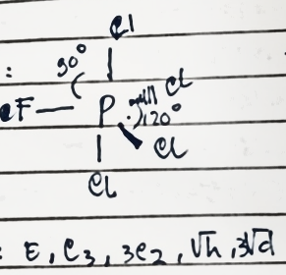

Figure 4. Example of an incorrect answer of SCM students regarding PFCl₄ molecule

SVM students also identified the rotation operations through the actual rotation axis than SCM did. The limited possibilities in manipulating the movement of molecular shapes for SVM strengthen students' long-term memory retention. In contrast, the concrete model provides plenty of possibilities for SCM students to do movement manipulations of molecular shape leading to overload memory remembering these movements. The limited possibilities help students remember every detail of three-dimensional objects' movement.³¹ The two groups demonstrated the different responses in determining the rotational operations of the SeF₆ molecule. SVM students identified that SeF₆ molecule exhibit C₄, C₃, and C₂ of axes rotations. Meanwhile, SCM students assumed that the molecule only exhibits C₃ and C₂ axes rotation.
SVM students also more succeeded in identifying reflection operations in the mirror plane than SCM students. The virtual model's availability of mirror plane features (vertical, horizontal, and diagonal mirror planes) supported a better understanding of SVM students when studying the mirror plane's reflection operation. In identifying the reflection operation on the mirror plane of the POF₃ molecule, SVM understood that the molecule has a vertical mirror plane at the F atom's corners. Meanwhile, SCM students assumed that the molecule has a horizontal and diagonal mirror plane.
The difference in students' understanding between SVM and ACM students is also described based on each topic's correct answer (Table 3). SVM students obtained a higher average score than SCM students. This fact emphasises that the virtual model is adequate for teaching chemistry concepts involving three-dimensional objects, ³⁴ such as molecular geometry and molecular symmetry, particularly for high spatial ability.
Table 3. The comparison of Correct Answers between SVM and SCM students
No. | Sub-topic | Correct Answers (%)
No. | Sub-topic | Virtual Model | Concrete Model
1 | Predict molecular shape | 68 | 67
2 | Identify the rotation operation via the actual axis of rotation | 53 | 50
3 | Identify the major axes | 45 | 41
4 | Identify the reflection operation on the mirror plane | 33 | 31
5 | Identify any inversion operations through the centre of symmetry | 49 | 45
6 | Identify the rotation operation via the pseudo rotation axis | 35 | 35
7 | Predict the polarity of molecules based on the symmetry operations they have | 33 | 29
8 | Predict the conservation of molecules based on the symmetry operations they have | 46 | 43

The phenomena discussed above provide strong evidence of different students' understanding due to the use of virtual and concrete models in teaching molecular symmetry. Two-way ANOVA also confirmed the difference with the F values of 5.059. The virtual model is more effective than the concrete model in increasing student' understanding of molecular symmetry. The test also found that there is no interaction between learning media and spatial skills (F (1.62) = 0.484; P> .05).
The Relationship between Spatial Abilities and Understanding Molecular Symmetry
Table 2 above also shows a contribution of students' spatial ability towards their success in understanding molecular symmetry. In particular, students with high spatial ability (HSA) demonstrated a better understanding of molecular symmetry than low spatial ability (LSA) students, as uncovered in the previous studies.^{3,35} HSA students could use spatial visualisation, spatial orientation, and spatial relation, strengthening their understanding of molecular symmetry operations such as rotation, reflection, inversion, and pseudo rotation operations. In determining the reflection operation on the AsH₃ molecule, LSA students believed that the molecule has four mirror planes, including one horizontal mirror plane and three dihedral mirror planes. This error resulted from a low understanding of the spatial visualisation aspect, leading to the difficulty of translating the bold visual notation code and dotted line notation in molecular structures.¹¹
In term of the ability of spatial relations, holding this ability contributed to students' competence in manipulating representative three-dimensional objects in space.¹⁴ LSA students believed that the SO₂F₂ molecule has a C₃ rotation operation (Figure 5). This error could be the result of an inability to determine the geometry of the molecule.
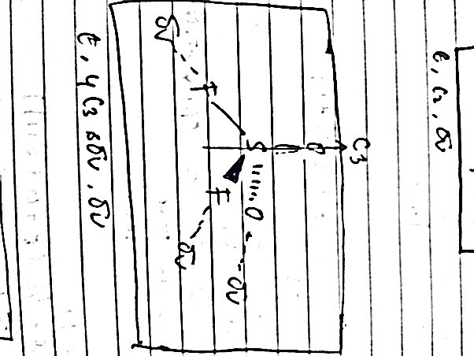
Figure 5. Example of LSA students' error in determining the rotation operation of SO₂F₂ molecule

The different responses between the two groups were also found when determining the rotation operation on the SeF₆ molecule. Robust knowledge in spatial orientation will lead students to determine the molecular rotation operations on different axes 36 correctly. SLA students believed that SeF₆ molecules only have the C₄ rotation operation as the main axis due to their inability to imagine the appearance of the SeF ₆ molecule from various viewpoints, which allows determining the existence of other rotation operations.
In terms of combining spatial visualisation, spatial orientation, and spatial relations abilities, the discrepancy between the two groups' responses was determined by determining the rotation operation via the pseudo axis (Sn) of the CCl₄ molecule. LSA students were unable to show a pseudo-axis rotation operation on the CCl₄ molecule. Students' mistakes were shown in several ways. Firstly, they can perform rotation operations correctly but cannot for reflection operations. Secondly, they performed rotation and reflection operations correctly but could not determine the new molecule's position from a different point of view.
The findings above show that students' spatial ability correlates to their understanding of molecular symmetry both for HAS and LAS students. The better students' spatial ability, the better they understand the topic of molecular symmetry. This correlation was also confirmed by the statistical test result using Person product-moment correlation with an r-value of +0.395.
CONCLUSION
This study confirms that the virtual model provides a better contribution toward students' understanding of molecular symmetry. Also, students' spatial ability affects students' understanding of the topic. Students' understanding of molecular symmetry increase with the increase of their spatial ability. This study implies that employing a virtual model in the teaching of molecular symmetry is a fruitful approach. Improving students' spatial ability is essential to be a solid milestone in learning chemistry concepts involving three-dimensional objects such as molecular geometry and molecular symmetry.
ACKNOWLEDGEMENTS
We thank Prof. Effendy, PhD, for his tremendous and valuable supports in doing this study.
REFERENCE
1. P. Atkins, T. Overton, J. Rourke, M. Weller and F. Armstrong, Inorganic Chemistry, Oxford University Press, Oxford, 4th edn., 2006.
2. S. F. A. Kettle, J. Chem. Educ., 2009, 86, 634.
3. K. Achuthan, V. K. Kolil and S. Diwakar, Educ. Inf. Technol., 2018, 23, 2499–2515.
4. B. K. Niece, J. Chem. Educ., 2019, 96, 2059–2062.
5. S. E. McKay and S. R. Boone, J. Chem. Educ., 2001, 78, 1487.
6. A. Korkmaz and W. S. Harwood, J. Sci. Educ. Technol., 2004, 13, 243–253.
7. J. D. Dunitz, Proc. Natl. Acad. Sci., 1996, 93, 14260 LP – 14266.
8. M. Abraham, V. Varghese and H. Tang, J. Chem. Educ., 2010, 87, 1425–1429.
9. S. Padalkar and M. Hegarty, J. Educ. Psychol., 2015, 107, 451–467.
10. A. T. Stull and M. Hegarty, J. Educ. Psychol., 2016, 108, 509–527.
11. H. K. Wu and P. Shah, Sci. Educ., 2004, 88, 465–492.
12. J. T. Olimpo, B. C. Kumi, R. Wroblewski and B. L. Dixon, Chem. Educ. Res. Pract., 2015, 16, 143–153.
13. C. Furió, M. L. Calatayud, S. L. Bárcenas and O. M. Padilla, Sci. Educ., 2000, 84, 545–565.
14. I. Tuvi-Arad and P. Gorsky, Chem. Educ. Res. Pract., 2007, 8, 61–72.
15. M. Stieff, Learn. Instr., 2007, 17, 219–234.
16. M. Stieff and S. Raje, Spat. Cogn. Comput., 2010, 10, 53–81.
17. M. Harle and M. Towns, J. Chem. Educ., 2011, 88, 351–360.
18. H. Tuckey and M. Selvaratnam, Stud. Sci. Educ., 1993, 21, 99–121.
19. Kozma and J. Russell, J. Res. Sci. Teach., 1997, 34, 949–968.
20. M. Stieff, R. C. Bateman and D. H. Uttal, in Visualization in science education, ed. J. K. Gilbert, Springer Netherlands, Dordrecht, 2005, pp. 93–120.
21. A. T. Stull, T. Barrett and M. Hegarty, Comput. Human Behav., 2013, 29, 2546–2556.
22. M. Fjeld, J. Fredriksson, M. Ejdestig, F. Duca, K. Bötschi, B. Voegtli and P. Juchli, in Proceedings of the SIGCHI Conference on Human Factors in Computing Systems, Association for Computing Machinery, New York, NY, USA, 2007, pp. 805–808.
23. K. Fuchigami, M. Schrandt and G. L. Miessler, J. Chem. Educ., 2016, 93, 1081–1084.
24. A. V Savchenkov, J. Chem. Educ., 2020, 97, 1682–1687.
25. E. B. Flint, J. Chem. Educ., 2011, 88, 907–909.
26. V. F. Scalfani and T. P. Vaid, J. Chem. Educ., 2014, 91, 1174–1180.
27. P. Jittam, P. Ruenwongsa and B. Panijpan, Biosci. Educ., 2008, 12, 1–8.
28. L. Chen, H. Sun and C. Lai, J. Chem. Educ., 2015, 92, 1422–1425.
29. R. Guay, Purdue Spatial Visualization Test, Purdue Research Foundation, West Lafayette, Indiana, 1976.
30. H.-D. Barke and T. Engida, Chem. Educ. Res. Pract., 2001, 2, 227–239.
31. T. J. Barrett, A. T. Stull, T. M. Hsu and M. Hegarty, Comput. Educ., 2015, 81, 69–81.
32. S. M. Jaeggi, J. Karbach and T. Strobach, J. Cogn. Enhanc., 2017, 1, 353–357.
33. Effendy, Molekul, Struktur, dan Sifat-sifatnya, Indonesian Academic Publishing, Malang, 2017.
34. A. T. Stull, M. Gainer, S. Padalkar and M. Hegarty, J. Chem. Educ., 2016, 93, 994–1001.
35. I. Tuvi-Arad and R. Blonder, Chem. Educ. Res. Pract., 2010, 11, 48–58.

