Glucose Decorated Silica-Molybdate Complex: A Novel Catalyst for the Facile Synthesis of Pyrano[2,3-d]-pyrimidines Derivatives

Arezoo Pourkazemi, Negin Asaadi, Mahnaz Farahi,* Ali Zarnegaryan and Bahador Karami
Department of Chemistry, Yasouj University, P. O. Box 353, Yasouj 75918-74831, Iran
*Corresponding author: E-mail: farahimb@yu.ac.ir

Abstract
This article describes the preparation and identification of SiO₂@Glu/Si(OEt)₂(CH₂)₃N=Mo[Mo₅O₁₈] as a new acid-base bifunctional (both Lewis acidic and Lewis basic sites) heterogeneous catalyst. Firstly, aminopropyl triethoxysilane was reacted by hexamolybdate anions followed by treatment with glucose to produce Glu/Si(OEt)₂(CH₂)₃N=Mo[Mo₅O₁₈]. Next, nano-silica was modified by the prepared glucose/molybdate complex to obtain SiO₂@Glu/Si(OEt)₂(CH₂)₃N=Mo[Mo₅O₁₈]. The designed catalyst was characterized using FT-IR, EDX, XRD, FE-SEM and TGA analyses. Its catalytic efficiency was examined for the preparation of pyrano[2,3-d]pyrimidine derivatives via the reaction between aldehyde, malononitrile and barbituric acid. Desirable products have been produced in the presence of 0.004 g of the prepared catalyst in high to excellent yields.

Keywords: Silica nanoparticle; glucose; hexamolybdate anions; pyrano[2,3-d]pyrimidine; nanocatalyst

- Introduction
Catalysis includes the varieties of homogeneous, heterogeneous and biological catalysis. Homogeneous catalysts offer many vital advantages over their heterogeneous counterparts. For example, as a result of the high solubility of homogeneous catalysts, all their catalytic sites are accessible. Also, they often show high chemoselectivity, regioselectivity, and/or enantioselectivity in organic transformations.¹ Despite these benefits, most homogeneous catalysts have not been commercialized owing to one main disadvantage compared with heterogeneous catalysts: the difficult separation from the reaction mixture and solvent. The commonly used separation method needs high temperatures while most homogeneous catalysts are thermally sensitive, usually decomposing below 150°C.² The attempts to solve the problem were made by immobilizing of the catalysts on various supports, such as carbon, silica, metal oxide, polymer, and nanocomposites.¹ Over the past century, development of recoverable supported catalysts with high efficacy has been the subject of numerous investigations. Immobilized catalysts possess main benefits such as ease of handling, low solubility, the possibility of recovery and low toxicity.³⁻⁸ In the case of heterogeneous supported catalysis, the catalytic capability of materials mostly depends on their microscopic structure which directly impacts the activity, selectivity and thermal or chemical stability of the catalyst.⁹ Nanomaterials have been broadly used as solid support material for the preparation of many heterogeneous catalytic systems to address several economic and green chemistry subjects.¹⁰ Among them, nano SiO₂ owing to its unique properties such as controllable particle size and nontoxicity has been extremely used. Nano SiO₂ has a high surface area to volume ratio and porous structure therefore providing the potential for great chemical reactivity.¹¹ Moreover, nano silica has been applied in various fields, such as biomedicine, filler, catalysis, and drug delivery systems. The size and uniformity of nano-silica particles have main influence on their quality; so, SiO₂ nanoparticles with narrow and monodisperse size distribution are under increasing demands.¹²⁻¹⁴ Compared to the reported methods for preparation of nano-SiO₂, the Stöber process is considered the most effective method for preparing monodisperse silica spheres. This method provides a flexible chemical route producing materials that are highly pure, chemically reactive, and well disperse.¹⁵
A lot of attention to nanoparticles is due to their exceptional properties including ease of availability, chemical inertness, high surface area to volume ratio, high activity and selectivity, thermal stability and low toxicity. Also, nano sized systems intensely increase the contact between reactants and catalyst. Actually, they open new perspectives for the mild catalysis of important reactions with lower environmental impact. Nanoparticles are different from their bulk counterparts and show special properties. According to the mentioned benefits, they have been developed as suitable replacements for conventional heterogeneous catalysts.¹⁶
Recently, inorganic/organic hybrid materials have been widely used in organic reactions as catalysts, because they are well-matched with various processes of eco-friendly chemical transformations.¹⁷ This quickly growing field is producing several exciting new materials with novel properties. They gather together typical advantages of organic components like flexibility, low density, toughness, and formability, with the ones displayed by typical inorganic materials like hardness, chemical resistance, strength, optical properties among others.¹⁸ The properties of these materials are not only the sum of the individual contributions of both phases, but the role of the internal interfaces could be important. Organic/inorganic grafted materials have appeared as a superseded material to design unique products and formed a new field of academic studies.
When the idea of monomolecular bifunctional catalyst for helpful catalysis was first presented in 2003, both homogeneous and heterogeneous catalysts with molecular design and their usage in organic reactions have become the focus of attention.¹⁹ In this regard, polyoxometalates (POMs) are an important class of nanosized polynuclear clusters with substantial physical and chemical properties which are based on transition metals in their highest oxidation states and oxygen bridges.²⁰ Polyoxometalate clusters, known to have huge sizes and exciting properties for medicine and nonlinear optics, are a prominent class of linkers to prepare interpenetrating networks. Directly applying POM clusters as linkers promises to be an appealing route to design new entangled network structures. The chief properties of polyoxometalates and variation of the structures of polyoxometalates endow them with strong potential for applications in different areas of chemical processing.²¹ Despite of the benefits mentioned, the solubility and non-recoverability of POMs in various media, limit their applications in some procedures. The immobilization of these clusters on solid supports such as silica and magnetic nanoparticles could be an important way to overcome this problem. Hexamolybdates are a group of POMs that have been used in several inorganic and organic reactions due to their thermal stability and radiation resistant. Lindqvist hexamolybdate cluster, [Mo₆O₁₉]²⁻, as a unique class of metal oxide clusters, is an ideal building block for constructing the organic–inorganic hybrid assemblies.^{22,23}
The carbon-based materials have attracted much attention from researchers because they are eco-friendly, cheap and non-toxic. Numerous studies have been performed on these materials as catalyst support such as carbon nanotubes, carbon-polymer composites, mesoporous carbons, graphitized carbons, nitride graphitized carbons, carbides and carbon aerogels. In this regard, cellulose has been used as catalyst support due to their uniform shape, stability in aqueous solution, good mechanical strength, high specific surface area, biocompatibility and biodegradability. The development of cellulose-based composites with metal oxides such as silica, titanium dioxide, zinc oxide and iron oxides are of great interest for various high-technology applications.²⁴⁻²⁶ As a consequence of the polyhydroxy structure, glucose as the most important monosaccharide has been used as a green catalyst and provided excellent catalytic activity in chemical reactions such as epoxidation and enantioselective Michael addition. Also, it has played the role of a green medium for undertaking reactions. Lately, glucose‐coated Fe₃O₄ nanoparticles have been prepared and applied as a heterogeneous catalyst for the synthesis of pyrazole derivatives.²⁷
Nowadays, several chemists have paid much attention to the development of novel approaches for the preparation of nitrogen-containing heterocycles which play vital roles in our life. They are part of many natural products, fine chemicals and biologically active pharmaceuticals that are really important for enhancing the quality of life.²⁸ Pyrano [2,3-d]pyrimidine derivatives represent a “privileged” structural motif well distributed in naturally occurring compounds with a wide spectrum of important biological properties. Recently, a series of synthetic pyrano[2,3-d]pyrimidines has been evaluated to own effective anticancer, antibacterial, antifungal, and antirheumatic properties.²⁹ Also, they show anti-inflammatory,³⁰ anti-HIV,³¹ cytotoxic,³² antimicrobial,³³ antimalarial and antihyperglycemic properties.³⁴ It is worthwhile to mention that many drug molecules bearing the pyrano pyrimidine moiety are in use in the treatment of various ailments, such as bronchitis, hepatoprotective, and cardiotonic.³³
With the increasing public concern over environmental degradation and future resources, it is of great importance for chemists to come up with new approaches that are less hazardous to human health and environment. So, in connection with our previous research on the new heterogeneous catalysts,³⁵⁻⁴¹ we decided to introduce SiO₂@Glu/Si(OEt)₂(CH₂)₃N=Mo[Mo₅O₁₈] nanocatalyst whose catalytic activity in the one-pot synthesis of pyrano[2,3-d]pyrimidines has been investigated.

- Results and discussion
The desired catalyst has been synthesized in a straightforward manner as shown in Scheme 1. In order to prepare SiO₂@Glu/Si(OEt)₂(CH₂)₃NH₂ grafted [Mo₆O₁₉]²⁻ composite (3), 3-aminopropyltriethoxysilane was reacted with tetrabutylammonium hexamolybdate and then glucose to obtain Glu/Si(OEt)₂(CH₂)₃N=Mo[Mo₅O₁₈] (2). Also, SiO₂ nanoparticles are synthesized by the Stöber method.¹⁵ Finally, the OH groups on silica surface can be grafted with Glu/Si(OEt)₂(CH₂)₃N=Mo[Mo₅O₁₈] to achieve the desired nanocatalyst 3. The chemical and structural properties of the catalyst were investigated using FT-IR, EDX, XRD, FE-SEM and TGA analyses.
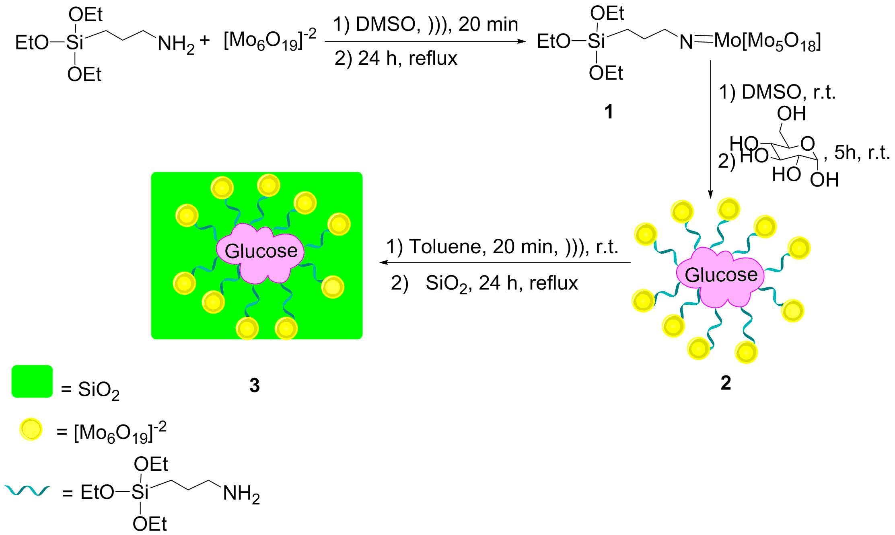
Scheme 1. Schematic representation for the synthesis of SiO₂@Glu/Si(OEt)₂(CH₂)₃N=Mo[Mo₅O₁₈] (3).

The identification and determination of organic functional groups were carried out using FT-IR spectroscopy. Fig. 1 shows the infrared spectra of glucose, SiO₂, SiO₂@Glu/Si(OEt)₂(CH₂)₃N=Mo[Mo₅O₁₈] and [n-Bu₄N]₂[Mo₆O₁₉]. In Fig. 1a, the peaks at 3662 and 3385 cm⁻¹ are corresponded to the OH groups. Also, the peak appeared at 2939 and 1458 cm⁻¹ are related to the stretching of CH and symmetric bending stretching of CH₂, respectively. The bands at 1160 cm⁻¹ (antisymmetric bridge C–O–C stretching), 1116 cm⁻¹, and 1052 cm⁻¹ (skeletal vibrations involving C–O stretching) can be assigned.¹⁸ Fig. 1b shows the bands at 1080, 948 and 797 cm⁻¹ that are due to Si–O stretching, Si-OH stretching, and Si–O–Si symmetric stretching, respectively.¹⁵ In Fig. 1c, absorption peaks at 2934 and 2840 cm⁻¹ are corresponded to alkyl chains C–H vibrations.³⁵ Furthermore, the bands at 953, 804 and 798 cm⁻¹ are attributed to N=Mo, Mo-O, and Mo-O-Mo, which confirms the presence of [Mo₆O₁₈]⁻² ions in the structure of the synthesized nanocatalyst.²²
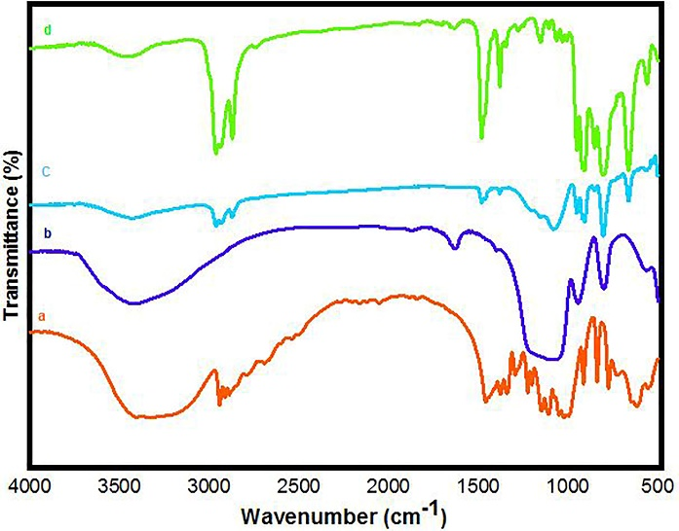
Fig. 1. FT-IR spectra of a) glucose, b) SiO₂, c) SiO₂@Glu/Si(OEt)₂(CH₂)₃N=Mo[Mo₅O₁₈] and d) [n-Bu₄N]₂[Mo₆O₁₉].

The XRD patterns of SiO₂@Glu/Si(OEt)₂(CH₂)₃N=Mo[Mo₅O₁₈] and SiO₂ are shown in Fig. 2 which was used to investigate the crystallographic features of the prepared catalyst. It is evident that the reflection peaks in the 2θ range of 0-70° are detected. In Fig. 2a, the wide peak the in range of 2θ 20°-32° is consistent with an amorphous silica phase.³⁶ The presence of sharp peaks proves the special status of the nanocatalyst structure. In Fig. 2b, the XRD pattern indicated that the amorphous structure of SiO₂ particles was retained. The confirming peak showing the presence of the molybdate group has appeared in the range of 2θ = 20°-30° which can be attributed to the amorphous molybdate supported on the composite.^{35,39}

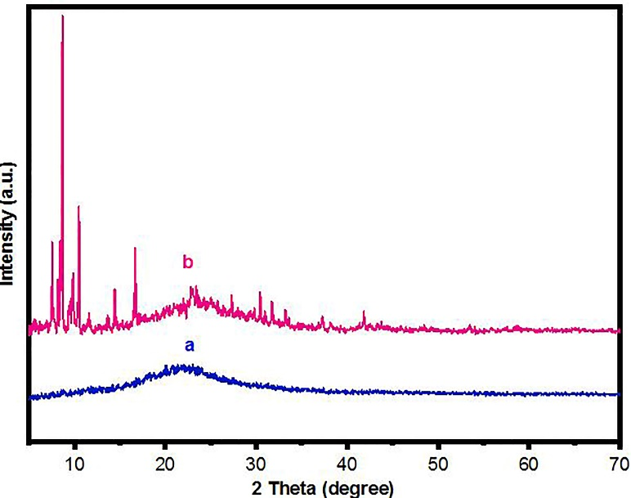
Fig. 2. The XRD pattern of a) SiO₂ and b) SiO₂@Glu/Si(OEt)₂(CH₂)₃N=Mo[Mo₅O₁₈] nanocatalyst.

Energy-dispersive X-ray spectroscopy (EDS) was selected to provide the necessary information on elemental structure of the catalyst. According to the Fig. 3, the EDS pattern clearly indicated the existence expected the elemental composition of C, N, O, Si, and Mo in the nanocatalyst structure.
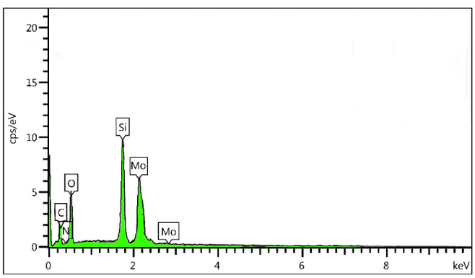
Fig. 3. EDS analysis of SiO₂@Glu/Si(OEt)₂(CH₂)₃N=Mo[Mo₅O₁₈].

The surface morphology and particle size distribution of the prepared nanocatalyst were observed by the FE-SEM and the corresponding image is shown in Fig. 4. Results show a uniform and regular spherical of particles with an average diameter range is 22-42 nm.
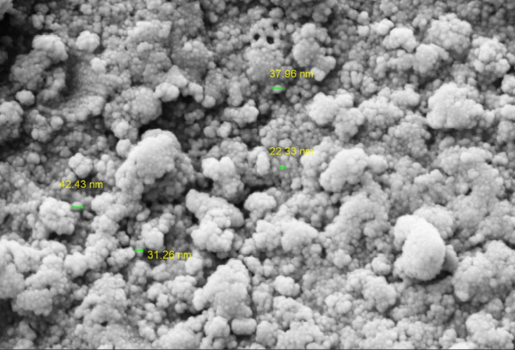
Fig. 4. FE-SEM analysis of SiO₂@Glu/Si(OEt)₂(CH₂)₃N=Mo[Mo₅O₁₈].

The results of the thermal stability of nanocatalyst 3, using thermal gravimetric analysis (TG) from 0 to 900 C, are shown in Fig. 5. The results show that initial weight loss at a temperature 120 °C (about 12 %) is related to the removal of H₂O and other organic solvents that remained from the extraction process. The second weight loss observed at 220-320 °C (about 5%) corresponds to the removal of organic moieties located on the catalyst’s surface. The greatest weight loss at a temperature range of 500-550 °C (about 12.5%) is related to removal of propylamine groups appended to the catalyst framework.²²
Fig. 5. TG analysis of SiO₂@Glu/Si(OEt)₂(CH₂)₃N=Mo[Mo₅O₁₈].

After characterization, to investigate the catalytic activity and efficiency of the newly designed catalyst, it was applied as a catalyst for the synthesis of pyrano [2,3-d]- pyrimidines 7 via the three-component reactions of aryl aldehydes 4, malononitrile 5 and barbituric acid 6 under solvent-free conditions (Scheme 2).
Scheme 1. Preparation of pyrano[2,3-d]pyrimidines 7 in the presence of SiO₂@Glu/Si(OEt)₂(CH₂)₃N=Mo[Mo₅O₁₈] nanocatalyst.

To find the optimal reaction conditions, a three-component reaction between benzaldehyde, malononitrile and 1,3-dimethylbarbituric acid was selected as a model reaction, and the effect of different parameters, such as temperature, catalyst loading and solvent was evaluated. The reaction did not progress well in the absence of the catalyst after a long reaction time. The model reaction was performed at 25, 60, 80 and 100 °C in the presence of 0.002 g of catalyst 3. The study showed the reaction to be affected by temperature, and the best result was observed at 80 °C. Next, the effect of catalyst amount was studied. Next, we found that with increasing the catalyst amount from 0.002 to 0.004 g, the yield is increased and a higher amount of catalyst has not good effect on the reaction progress. Furthermore, the model reaction was performed by 0.004 g of SiO₂@Glu/Si(OEt)₂(CH₂)₃N=Mo[Mo₅O₁₈] in some solvents such as methanol, ethanol, acetonitrile and toluene. As can be seen, considerable acceleration is mostly observed in reactions performed at solvent-free conditions. According to these results, use of SiO₂@Glu/Si(OEt)₂(CH₂)₃N=Mo[Mo₅O₁₈] (0.004 g) as catalyst under solvent-free conditions at 80 °C would be the best of choice (Table 1).

Table 1. Screening different parameters in the synthesis of 7a catalyzed by nanocatalyst 3.ª
Entry | Catalyst loading (g) | Solvent | Temp. (°C) | Yield^{b} (%)
1 | 0.002 | - | 25 | 20
2 | 0.002 | - | 60 | 45
3 | 0.002 | - | 80 | 60
4 | 0.002 | - | 100 | 50
5 | 0.004 | - | 80 | 90
6 | 0.006 | - | 80 | 85
7 | 0.008 | - | 80 | 80
8 | 0.004 | MeOH | Reflux | 60
9 | 0.004 | EtOH | Reflux | 70
10 | 0.004 | CH₃CN | Reflux | 75
11 | 0.004 | Toluene | Reflux | 65
ª Reaction conditions: benzaldehyde (1 mmol), malononitrile (1 mmol), 1,3-dimethylbarbituric acid (1 mmol), time: 20 min. ^{b} Isolated yields.

After optimization of the reaction conditions, the reaction of various aromatic aldehydes, malononitrile and barbituric acid derivatives in the presence of catalyst 3 was studied under optimal conditions which showed the successful generation of the corresponding pyrano[2,3-d]-pyrimidines (Table 2). Both aldehydes bearing electron-releasing groups and bearing electron-withdrawing was produced with good to excellent yields.

Table 2. Preparation of pyrano[2,3-d]-pyrimidines by SiO₂@Glu/Si(OEt)₂(CH₂)₃N=Mo[Mo₅O₁₈].
Entry | R | Aldehyde | Tim (min) | Yieldª (%) | Mp (Lit) (°C)
7a | H | C₆H₅CHO | 30 | 90 | 212-214 (212-213)⁴²
7b | H | 2,4-Cl C₆H₃CHO | 15 | 93 | 242-244 (242-243)⁴²
7c | H | 3-NO₂ C₆H₄CHO | 20 | 95 | 260-262 (262-263)⁴³
7d | H | 4-NO₂ C₆H₄CHO | 20 | 93 | 237-239 (237-238)⁴³
7e | H | 3-Br C₆H₄CHO | 25 | 95 | 280-282 (279-280)⁴³
7f | H | 4-Br C₆H₄CHO | 20 | 90 | 228-230 (227-229)⁴³
7g | H | 4-OCH₃ C₆H₄CHO | 25 | 95 | 280-282 (281-282)⁴³
7h | H | 4-Cl C₆H₄ CHO | 15 | 90 | 238-240 (239-240)⁴⁴
7i | CH₃ | C₆H₅CHO | 20 | 95 | 228-230 (228-229)⁴⁴
7j | CH₃ | 2-Cl C₆H₄ CHO | 15 | 89 | 248-250 (250-251)⁴⁴
7k | CH₃ | 4-OCH₃ C₆H₄CHO | 30 | 95 | 224-225 (225-227)⁴⁴
7l | CH₃ | 4-Cl C₆H₄CHO | 10 | 95 | 238-240 (239-241)⁴⁴
7m | CH₃ | 3-NO₂ C₆H₄CHO | 20 | 93 | 212-214 (212-213)⁴⁴
7n | CH₃ | 4-NO₂ C₆H₄CHO | 20 | 95 | 230-232 (231-232)⁴⁴
7o | CH₃ | 3-Br C₆H₄CHO | 15 | 93 | 218-220 (218-219)⁴⁴
7p | CH₃ | 4-CH₃ C₆H₄CHO | 20 | 90 | 230-232 (229-230)⁴⁴
7q | CH₃ | 2,4-Cl₂ C₆H₃CHO | 10 | 95 | 211-213 (211-212)³⁰
7r | CH₃ | 1-Naphthaldehyde | 40 | 93 | 360 (360-361)⁴⁴
7s | CH₃ | Biphenyl-4-carboxaldehyde | 30 | 95 | 275-277^{b}
7t | CH₃ | Terephthalaldehyde | 20 | 95 | 240-242^{b}
ª Isolated yields. ^{b} Novel product.

The suggested mechanism of the formation of pyrano[2,3-d]pyrimidines 7 is shown in Scheme 3. Based on the proposed mechanism, firstly, adduct 8 is obtained using the condensation of aromatic aldehydes and malononitrile in the presence of the catalyst. Next, Michael-type addition of barbituric acid to this intermediate creates 9. The intramolecular cyclization of 9 gives adduct 10 which rearranges into the pyrano [2,3-d]pyrimidinones 7.
Scheme 3. The suggested mechanism for the synthesis of pyrano[2,3-d]pyrimidinones catalyzed by nanocatalyst 3.

To investigate any leaching of [Mo₆O₁₉]²⁻ from SiO₂@Glu/Si(OEt)₂(CH₂)₃N=Mo[Mo₅O₁₈], we have performed an in situ filtration technique. When the model reaction progress reached 50% warm EtOAc (5 mL) was added, and the catalyst isolation was carried out by simple filtration. After removing the solvent, the catalyst-free residue continued the process under the conditions which before were optimized. As we expected, the progress of the reaction stopped, which confirms that no leaching of the supported catalytic centers has happened under optimized conditions. Also, the reusability of SiO₂@Glu/Si(OEt)₂(CH₂)₃N=Mo[Mo₅O₁₈] was also investigated in the model reaction. After completion of the reaction, EtOAc (5 mL) was added to the mixture and the catalyst was filtered, washed with EtOH (10 mL) and deionized water (10 mL), followed by drying at 100 °C. Applying the recovered catalyst for ten successive runs in the model reaction generated the product, having a negligible reduction in yield (Fig. 6). These experiments indicates high stability and durability of this nanocatalyst under the applied conditions. To test the stability of the catalyst structure, the recycled nano catalyst was examined by FT-IR spectra. The FT-IR spectra of the freshly prepared catalyst and the recovered catalyst are shown Fig. 7 which confirms the chemical stability of catalyst 3.
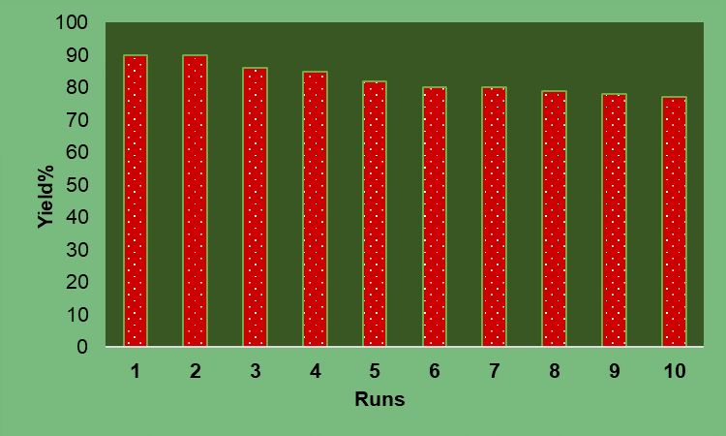
Fig. 6. Reuses efficiency of SiO₂@Glu/Si(OEt)₂(CH₂)₃N=Mo[Mo₅O₁₈] nanocatalyst.

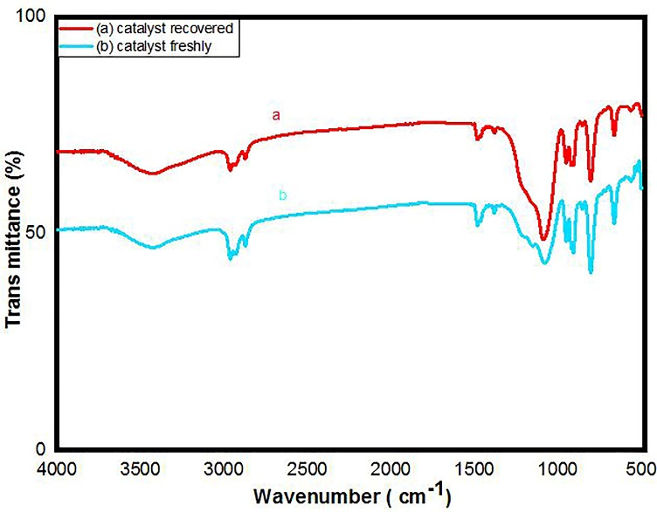
Fig. 7. FT-IR spectra for the comparison of fresh catalyst and recovered catalyst.

- Experimental
All chemical materials were bought from Merck and Aldrich corporations. The supervision of reaction progress and purity of the compounds was done exploit TLC represented with silica gel SIL G/UV254 plates. Melting points were reviewed by electrothermal KSB1N equipment and are correct. The IR spectra of all synthesized compounds recorded in the matrix of KBr with a Model JASCO FT-IR/680 plus spectrometer. ¹H NMR spectra were reported in DMSO-d₆ as a solvent on a Bruker Avance Ultra Shield 400 MHz instrument spectrometer and ¹³C NMR spectra were registered at 100 MHz. A scanning electron microscope (FE-SEM) was applied to measure the size of particles and the shape of the catalyst. X-ray diffraction (XRD) patterns were acquired by using a Philips X Pert Pro X diffractometer performed with Ni-filtered Cu-Ka radiation. Energy dispersive spectroscopy (EDS) was recorded using the TESCAN Vega model instrument.

Preparation of the Glu/Si(OEt)₂(CH₂)₃N=Mo[Mo₅O₁₈]
Firstly, the tetrabutylammonium hexamolybdate ([n-Bu₄N]₂ [Mo₆O₁₉]) was prepared according to the reported procedure.²⁰ The tetrabutylammonium hexamolybdate (0.4 g) and DMSO (20 mL) were added to a round-bottom flask (50 mL), and dispersed for time 20 mine. Then, 3-aminopropyl triethoxysilane (2.5 mL) was added drop-wise to the mixture and stirred under reflux condition for 24 h under argon atmosphere. Subsequently, dissolved glucose (o.26 g) in dry DMSO (5 mL) and H₂SO₄ (98%, 0.33 mL) were added. The mixture was stirred for 5 h at room-temperature. Finally, the obtained product (compound 2) was washed with ethanol and distilled and dried at 80 °C.

Protocol for the synthesis of nano-SiO₂
Tetraethyl orthosilicate (TEOS) (6.2 mL) was added to ethanol (100 mL) and ammonium hydroxide (6.5 mL) and the mixture was stirred for 15 h at room temperature. Then, the mixture was filtered by centrifuge (4000 rpm, 30 min) and the obtained white powder was washed three times with ethanol, and dried at 60 °C for 12 h.¹⁵

Preparation of the SiO₂@Glu/Si(OEt)₂(CH₂)₃N=Mo[Mo₅O₁₈]
In order to immobilize Glu/Si(OEt)₂(CH₂)₃N=Mo[Mo₅O₁₈] on the surface of SiO₂, the prepared SiO₂ nanoparticles (1.0 g) were dispersed in dry toluene (30 mL) by ultrasonication for 20 min. Subsequently, compound 2 (0.5 g) was added and the mixture was refluxed for 24 h under argon atmosphere. Then, prepared SiO₂@Glu/Si(OEt)₂(CH₂)₃N=Mo[Mo₅O₁₈] was filtered and washed several times with ethanol followed by water. Ultimately, the brown powder was dried under the vacuum at 80 °C for 24 h.

General procedure for the synthesis of pyrano[2,3-d]-pyrimidines derivatives 7
SiO₂@Glu/Si(OEt)₂(CH₂)₃N=Mo[Mo₅O₁₈] (0.004) was added to the mixture of arylaldehyde (1 mmol), malononitrile (1 mmol) and barbituric acid (1 mmol at 80 °C under solvent-free conditions. The progression of the reaction was monitored by TLC. After completion of the reaction, ethyl acetate was added and the catalyst was separated by filtration. To further purification of the product, obtained powder was recrystallized from EtOH.

Spectral data
7-Amino-5-(2,4-dichlorophenyl)-1,3-dimethyl-2,4-dioxo-1,3,4,5-tetrahydro-2H-pyrano[2,3-d]pyrimidine-6-carbonitrile (7q). White solid; mp: 211-213 °C; IR (KBr) (v_{max}, cm^{–1}) = 3394, 3313, 3212, 3081, 2962, 2194, 1708, 1689, 1643, 1494, 1384, 1230, 1184, 1099, 1049, 844, 582, 755. ¹H NMR (400 MHz, DMSO-d₆): δ = 3.09 (s, 3H), 3.39 (s, 3H), 4.88 (s, 1H), 6.93-7.55 (m, 5H) ppm. ¹³C NMR (100 MHz, DMSO-d₆): δ = 28.09, 29.63, 33.70, 57.19, 88.07, 118.86, 128.12, 129.01, 132.11, 132.44, 133.67, 140.85, 150.44, 151.05, 158.22, 160.78 ppm.
5-([1,1'-Biphenyl]-4-yl)-7-amino-1,3-dimethyl-2,4-dioxo-1,3,4,5-tetrahydro-2H-pyrano[2,3-d]pyrimidine-6-carbonitrile (7s). White solid; mp: 275-277 °C; IR (KBr) (v_{max}, cm^{–1}) = 3432, 3300, 3177, 3074, 2984, 2190, 1736, 1684, 1634, 1486, 1386, 1227, 1186, 1040, 1007, 850, 744, 751, 698, 571, 550. ¹H NMR (400 MHz, DMSO-d₆): δ = 2.11 (s, 3H), 2.54 (s, 3H), 4.40 (s, 1H), 6.93-7.67 (m, 11H) ppm. ¹³C NMR (100 MHz, DMSO-d₆): δ = 28.17, 29.62, 36.70, 58.99, 81.25, 119.56, 127.39, 127.56, 127.56, 127.78, 128.02, 128.44, 129.37, 129.40, 129.59, 129.67, 138.72, 139.29, 140.47, 150.48, 158.20, 161.00, 161.27 ppm.
7-Amino-5-(4-formylphenyl)-1,3-dimethyl-2,4-dioxo-1,3,4,5-tetrahydro-2H-pyrano[2,3-d]pyrimidine-6-carbonitrile (7t). White solid; mp: 240-242 °C; IR (KBr) (v_{max}, cm^{–1}) = 3380, 3316, 3192, 3074, 2984, 2195, 1708, 1685, 1638, 1487, 1386, 1226, 1185, 1040, 1115, 847, 751, 698, 571. ¹H NMR (400 MHz, DMSO-d₆): δ = 3.116 (s, 3H), 3.386 (s, 3H), 4.403 (s, 1H), 7.341-7.672 (m,6H), 9.146, (s, 1H) ppm. ¹³C NMR (100 MHz, DMSO-d₆): δ = 28.25, 29.63, 36.70, 58.99, 81.25, 128.03, 128.44, 129.37, 129.67, 130.79, 131.81, 140.47, 150.49, 158.20, 161.01, 161.28 ppm.

- Conclusions
In this paper, for the first time, we have introduced SiO₂@Glu/Si(OEt)₂(CH₂)₃N=Mo[Mo₅O₁₈] as a green and recyclable SiO₂-based nanocatalyst. The efficiency of this catalyst was evaluated in the synthesis of pyrano[2,3-d]pyrimidinone derivatives. This new catalytic system demonstrated the advantages of environmentally benign character, easily separation, non-toxicity, mild reaction conditions, short reaction times as well as good reusability.

Acknowledgements
The authors would acknowledge the Yasouj University Research Council for trifle support of this research.

- References
- K. Zheng, C. Shen, J. Qiao, J. Tong, J. Jin, P. Zhang, Catalysts 2018, 8, 443-454.
- D. J. Cole-Hamilton, Science 2003, 299, 1702-1706.
- S. X. Fei, B. Han, L. Li, P. Mei, T. Zhu, M. Yang, H. Chen, Int. J. Hydrogen Energy 2017, 42, 25942-25950.
- C. Dai, Y. Li, C. Ning, W. Zhang, X. Wang, C. Zhang, Appl. Catal. A Gen. 2017, 545, 97-103.
- W. Shi, J. Yu, Z. Jiang, Q. Shao, W. Su, Beilstein J. Org. Chem. 2017, 13, 1661-1668.
- M. Celebi, M. Yurderi, A. Bulut, M. Kaya, M. Zahmakiran, Appl. Catal. B Environ. 2016, 180, 53-64.
- T. Hattori, A. Tsubone, Y. Sawama, Y. Monguchi, H. Sajiki, Catalysts 2015, 5, 18-25.
- S. Zhang, Y. R. Lee, H. J. Jeon, W. S. Ahn, Y. M. Chung, Mater. Lett. 2018, 215, 211-213.
- B. Karami, M. Kiani, S. J. Hosseini, M. Bahrami, New J. Chem. 2015, 39, 8576-8581.
- J. E. Gholtash, M. Farahi, B. Karami, M. Abdollahi, Acta Chim. Slov. 2020, 67, 866-875.
- Y. Guo, J. Tang, Z. Wang, Y.-M. Kang, Y. Bando, Y. Yamauchi, Nano Eng. 2018, 47, 494-502.
- P. R. Monich, F. V. Berti, L. M. Porto, B. Henriques, A. P. N. de Oliveira, M. C. Fredel, J. C. Souza, Mater. Sci. Eng. C Mater. Biol. Appl. 2017, 79, 354-362.
- D. W. Lee, B. R. Yoo, J. Ind. Eng. Chem. 2016, 38, 1-12.
- R. S. Dubey, Y. B. R. D. Rajesh, M. A. More, Mater. Today: Proc. 2015, 2, 3575-3579.
- X. Jiang, X. Tang, L. Tang, B. Zhang, H. Mao, Ceram. Int. 2019, 45, 7673-7680.
- L. Zare Fekri, A. R. Darya-Laal, Polycycl. Arom. Comp. 2020, 40, 1539-1556.
- C. Sanchez, B. Julián, P. Belleville, M. Popall, J. Mater. Chem. 2015, 15, 3559-3592.
- H. S. Barud, R. M. N. Assunção, M. A. U. Martines, J. Dexpert-Ghys, R. F. C. Marques, Y. Messaddeq, S. J. L. Ribeiro, J. Sol-Gel Sci. Technol. 2008, 46, 363-367.
- F. Xue, Y. Dong, P. Hu, Y. Deng, Y. Wei, RSC Adv. 2015, 5, 73684-73691.
- A. Zarnegaryan, M. Moghadam, S. Tangestaninejad, V. Mirkhani, I. Mohammadpoor-Baltork, Polyhedron 2016, 115, 61-66.
- Z. Shi, X. Gu, J. Peng, X. Yu, E. Wang, Eur. J. Inorg. Chem. 2006, 3, 385-388.
- S. Kargar, D. Elhamifar, A. Zarnegaryan, J. Phys. Chem. Solids 2020, 146, 109601-109612.
- M. Neysi, A. Zarnegaryan, D. Elhamifar, New J. Chem. 2019, 43, 12283-12291.
- N. Veronovski, M. Sfiligoj-Smole, J. L. Viota, Text. Res. J. 2010, 80, 55-62.
- U. M. Garusinghe, S. Varanasi, G. Garnier, W. Batchelor, Cellulose 2017, 24, 2511-2521.
- U. J. Kim, S. Kimura, M. Wada, Carbohydr. Polym. 2019, 222, 114975-114980.
- N. Esfandiary, A. Nakisa, K. Azizi, J. Azarnia, I. Radfar, A. Heydari, Appl. Organomet. Chem. 2017 31, 3641-3649.
- D. Azarifar, R. Nejat-Yami, F. Sameri, Z. Akrami, Lett. Org. Chem. 2012, 9, 435-439.
- G. Brahmachari, B. Banerjee, ACS Sustain. Chem. Eng. 2014, 2, 2802-2812.
- A. Khazaei, A. Ranjbaran, F. Abbasi, M. Khazaei, A. R. Moosavi-Zare, RSC Adv. 2015, 5, 13643-13647.
- M. Nogueras, J. Cobo, M. L. Quijano, M. Melguizo, A. Sánchez, M. Melgarejo, Nucleosides Nucleotides Nucleic Acids 1994, 13, 447-457.
- E. M. Grivsky, S. Lee, C. W. Sigel, D. S. Duch, C. A. Nichol, J. Med. Chem. 1980, 23, 327-329.
- J. Davoll, J. Clarke, E. F. Elslager, J. Med. Chem. 1972, 15, 837-839.
- M. Bararjanian, S. Balalaie, B. Movassag, A. M. Amani, J. Iran. Chem. Soc. 2009, 6, 436-442.
- F. Khosravian, B. Karami, M. Farahi, New J. Chem. 2017, 41, 11584-11590.
- M. Farahi, B. Karami, R. Keshavarz, F. Khosravian, RSC Adv. 2017, 7, 46644-46650.
- S. Akrami, B. Karami, M. Farahi, RSC Adv. 2017, 7, 34315-34320.
- B. Karami, M. Farahi, S. Akrami, D. Elhamifar, New J. Chem. Chem. 2018, 42, 12811-12816.
- H. M. Tanuraghaj, M. Farahi, Monatsh. Chem. 2019, 150, 1841-1847.
- H. M. Tanuraghaj, M. Farahi, RSC Adv. 2018, 8, 27818-27824.
- J. E. Gholtash, M. Farahi, RSC Adv. 2018, 8, 40962-40967.
- E. Mollashahi, M. Nikraftar, J. Saudi Chem. Soc. 2018, 22, 42-48.
- T. S. Jin, L. B. Liu, Y. Zhao, T. S. Li, J. Chem. Res. 2005, 3, 162-163.
- M. A. Zolfigol, R. Ayazi-Nasrabadi, S. Baghery, Appl. Organomet. Chem. 2016, 30, 273-281.

