Quantification of hydroperoxides by gas chromatography with flame ionisation detection

Damjan J. Pavlica, Črtomir Podlipnik, Matevž Pompe
Faculty of Chemistry and Chemical Technology, University of Ljubljana, Ljubljana, 1001, Slovenia
Correspondence to: Matevž Pompe (Matevz.Pompe@fkkt.uni-lj.si)
Abstract.
Hydroperoxides are of great importance in the fields of atmospheric and biological chemistry. However, there are several analytical challenges in their analysis: unknown and usually low UV absorption coefficients, high reactivity, thermal instability, and a lack of available reference standards. To overcome these limitations, we propose a GC-FID approach involving pre-column silylation and quantification via the effective carbon number approach. Four hydroperoxides of α-pinene were synthesized in the liquid phase with singlet oxygen and identified using literature data on isomer yield distribution, MS spectra, estimated boiling temperatures of each isomer (retention time), their thermal stability and derivatisation rate. The developed procedure was used for the determination of hydroperoxides in bottled and autooxidised turpentine. We anticipate that this method could also be applied in atmospheric chemistry, where the reactivity of singlet oxygen could help explain the high formation rates of secondary organic aerosols.

Keywords: hydroperoxides, α-pinene, photooxidation, singlet oxygen, gas chromatography

1 Introduction
Organic hydroperoxides are used industrially as radical initiators, bleaching agents, and disinfectants. They are formed in the process of oxidative ageing, which they simultaneously promote by radical chain reactions. In ethereal solvents, they can be stable at low concentrations but become explosive at higher concentrations. Degradation by peroxidation decomposes all organic matter and is hazardous to health because hydroperoxides are irritating to skin, eyes, and mucous membranes and are potent allergens.¹ In rats, they induce progressive oxidative damage and cell death when inhaled.²
Hydroperoxides (HPs) are formed in nature as primary oxidation products of volatile organic compounds, for example, α-pinene, which is emitted from coniferous trees. This compound is the most abundant monoterpene in the air and plays an essential role in the growth of atmospheric particles.³ It is present in essential oils and thus in various types of cosmetic and cleaning products. It is also the main component of turpentine, which is used as a paint thinner and as an ingredient in paints, polishes, adhesives, topical remedies and household chemicals. It has been found that 3.1% of the German population is allergic to turpentine.⁴ The most likely major haptens in turpentine are Δ3-carene hydroperoxide and oxidation products of α- and β-pinene.⁵
Despite the need to monitor and quantify HPs in various matrices, their analysis is complicated due to low UV absorption, thermal instability, catalyzed decomposition, and lack of available reference standards. Quantification is mainly performed by chemical assays, such as the iodometric⁶ or triphenylphosphine assay⁷ or assays with other reducing agents, followed by an analysis of the reaction products.⁸ However, these methods only provide information on the total amount of HPs present, and interference by other compounds cannot be excluded. For the monitoring and quantification of specific HPs, chromatographic and NMR methods can be used.
Some authors reported using gas chromatography (GC) methods without derivatisation, but only for HPs with low molecular masses.^{8,9} HPs with higher molecular masses are partially decomposed at high oven elution temperatures and therefore often derivatised to more thermostable species. Most methods involve silylation^{11,12} or reduction of HPs to alcohols with sodium sulfite,^{9,13} sodium borohydride,¹⁴ triphenylphosphine^{9,14} or trimethyl phosphine.¹⁵ Derivatisation to alcohols can be used if the resulting alcohols were not previously present in the sample.
High-pressure liquid chromatography (HPLC) for HP quantification is very convenient because separation occurs at lower temperatures. However, due to lack of chromophores, HPs must be detected by post-column reactions or by MS. Post-column reactions include a method using phosphine (the fluorescent product phosphine oxide is formed)¹⁶ or a chemiluminescence reaction using luminol.¹⁷ The preferred MS ionisation techniques for detecting terpene HPs are electrospray ionisation (ESI)^{18,19} and atmospheric pressure chemical ionisation (APCI).^{18,20} Post-column reactions are specific for the peroxy functional group, whereas in MS, specific fragment loss of 34 Da (loss of H₂O₂) is observed sporadically.²⁰ Identification of the peroxy functional group can be confirmed by dual injection, with and without iodometric sample pretreatment, which reduces HP species to alcohols.¹⁹
Quantification of α-pinene HPs is very demanding because reference standards are nonexistent. Additionally, HPs have limited stability, so reliable quantitative methods are needed to assess purity, such as GC-FID with predicted relative response factors or NMR.¹¹ Quantitative NMR spectrometry is a universal, non-destructive, absolute detection technique and provides a quantitative reference for other analytical methods. Analytes in the μM concentration range can be detected, with precision and accuracy of around 1%.²¹ The authenticity of individual spectra can be assessed by generating various one-dimensional and multidimensional experiments. The major hurdles are sensitivity, spectral overlap, dynamic range, selection of the internal standard, interpretation and processing of the spectra, and the use of expensive equipment and deuterated solvents. Therefore, when performing routine targeted analysis, optimized molecule-specific chromatographic methods are preferred. GC-FID has a dynamic range of 10⁷ and the analysis time depends only on the mixture composition and not on the concentration as in NMR. In our case, the separation of isomers took 30 minutes. In the absence of calibration standards, the relative concentrations of the organic peroxides can be estimated from the GC-FID peak intensities by peak area normalization approach, application of the effective carbon number (ECN) concept, or by some other algorithm based on the chemical structure of the analytes.²²
To date, only two HPs have been synthesised in the reaction of α-pinene with singlet oxygen.^{13,14} Electrophilic singlet oxygen (¹O₂) reacts with a double bond in the ene addition reactions, where allylic hydrogen is abstracted to give allyl-HPs in which the double bond has migrated. The reaction of singlet oxygen with α-pinene in this manner generates pinocarvyl-hydroperoxide and 4-hydroperoxy-4,6,6-trimethylbicyclo[3.1.1]hept-2-ene (Fig.1.). The ¹O₂ attack on the double bond occurs on the sterically less congested π face. The two methyl groups on the methylene bridge are distinctively anti-directing; therefore, the HPs resulting from the syn attack are formed only in trace amounts.^{14,23} Upon storage in solution, the OOH group can migrate to the other side of the double bond,²⁴ which has already been observed as the rearrangement of pinocarvyl-hydroperoxide to myrtenyl-hydroperoxide.⁹ In this work, we observe for the first time the rearrangement of 4-hydroperoxy-4,6,6-trimethylbicyclo[3.1.1]hept-2-ene (HP2) to verbenyl-hydroperoxide.
In the absence of isolated reference standards, the identification of separate peaks in the GC chromatogram was based on literature data on isomer yield distribution, MS spectra, estimated boiling temperatures of individual isomers (retention time), their thermal stability, and rate of derivatisation. Trimethylsilylation increased the thermostability and allowed us to validate linearity, selectivity and repeatability of the GC-FID method. The concept of the effective carbon number allowed determination without standards of known purity.

2 Experimental section

2.1 Chemicals, synthesis of HPs and air exposure procedure
For the synthesis of the HPs, we have used: α–pinene, >97% purity, Fluka (Buchs, Switzerland), methylene blue, Merck (Darmstadt, Germany) and HPLC grade acetonitrile, ≥99,9% purity, Fischer (Zürich, Switzerland).
HPs of α-pinene were synthesised by a modified photochemical procedure.^{13,14} Photooxidation of α-pinene was carried out in a flask at room temperature in acetonitrile using methylene blue as a sensitiser and a 60 W household daylight lamp as a light source. The flask was opened to allow oxygenation and mixed manually every 12 h for 14 days, followed by analysis by GC-MS and GC-FID. The structures of four resulting HPs of α-pinene are shown in Fig. 1.

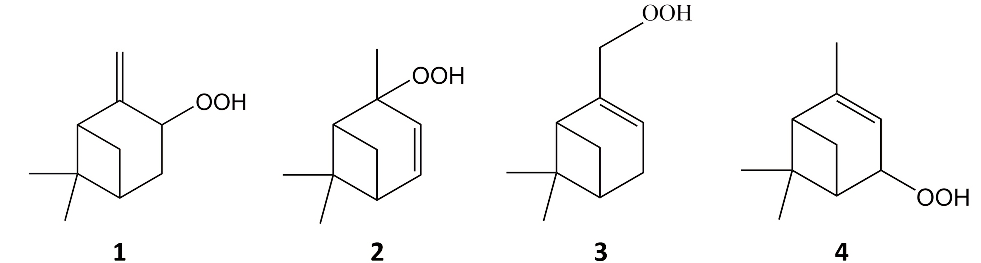

Figure 1. Structures of the hydroperoxides studied: pinocarvyl-hydroperoxide 1, 4-hydroperoxy-4,6,6-trimethylbicyclo[3.1.1]hept-2-ene 2, myrtenyl-hydroperoxide 3 and verbenyl-hydroperoxide 4.

Derivatisation reagent N-Methyl-N-(trimethylsilyl)trifluoroacetamide (MSTFA) was purchased from Fluka (Buchs, Switzerland), toluene from Sigma-Aldrich (Taufkirchen, Germany), cumene-hydroperoxide, 80% purity from Sigma-Aldrich (Taufkirchen, Germany), tetradecane of >99% purity from Merck (Schuchardt, Germany).
Turpentine was purchased from HGtrade (Ljubljana, Slovenia). A sample of turpentine was exposed to air in an Erlenmeyer flask at room temperature and under a 60-watt household daylight lamp. The neck of the flask was covered with aluminium foil to prevent contamination. The flask was stirred daily. After 20 days, the sample was derivatised, and the specific HPs were determined by GC-FID.

2.2 Derivatisation procedure
For the analysis of turpentine oil ≈ 200 mg of sample was weighed into a vial, then ≈ 200 mg internal standard solution (3 mg/g cumene-hydroperoxide in toluene) and ≈ 200 mg MSTFA (250 µL) were precisely weighted. The vial was closed, mixed by hand, and kept at room temperature for 2 h. 1 μL of the resulting solution was injected into the GC-FID.
For calibration, the following procedure was used: A stock solution of cumene-hydroperoxide at 2.5 mg/mL was prepared in acetonitrile and stored at 5°C, calibration solutions (0.6, 1, 6, 25, 50, 90 μg/mL) were further diluted in acetonitrile. From each calibration solution, an aliquot of 0.4 mL was transferred to a vial, to which 0.4 mL of internal standard tetradecane (40 mg/kg in toluene) and 0.4 mL of the derivatisation reagent MSTFA (50 mg/g in toluene) were added. The vial was closed, mixed by hand, and kept at room temperature for 2 h. 1 μL of the resulting solution was injected into the GC-FID. The derivatised HP solutions were found to be stable in the refrigerator for at least three days.

2.3 Instrumentation and analysis
The GC separation was performed on GC Trace 1300, Thermo Scientific (Waltham, USA), equipped with a Rxi–5Sil MS column from Restek (Bellefonte, USA), 30 m x 0.32 mm x 0.25 μm. The carrier gas was helium under a constant flow of 2 mL/min and a split ratio of 50:1. The injector and FID temperatures were 250 and 280 °C, respectively. The oven was held at 60 °C for 0.3 min; then the temperature was raised to 80 °C at a rate of 5 °C/min and held for 3 min, then the temperature was raised to 160 °C at a rate of 5 °C/min and to 275 °C at a rate of 40 °C/min and held for 4 min.
The GC-MS separation was performed on GC Trace 1310 and MS TSQ 9000 from Thermo Scientific (Waltham, USA). A Restek (Bellefonte, USA) 5-MS column with 0.25 μm film thickness (30 m x 0.25 mm i.d.) was used for separation. The temperature programme was translated from GC-FID with the help of EZGC, an online freely available method translator tool from Restek (Bellefonte, USA). The carrier gas was helium under a constant flow of 1.56 mL/min. The injector and transfer line temperatures were 250 and 280 °C, respectively. The oven was held at 60 °C for 0.1 min; then the temperature was raised to 80 °C at a rate of 5.6 °C/min and held for 2.95 min, then the temperature was raised to 160 °C at a rate of 5.1 °C/min and raised to 275 °C at a rate of 38.4 °C/min and held for 4.15 min. The temperature of the ion source was 270 °C.

2.4 Quantification
Due to the lack of commercially available standards for the HPs, we used the concept of effective carbon number (ECN) to calculate the response factors. The ECN is calculated using the contributions of different molecular structures with the error of predicting about 3% RSD.²⁵ Since there are no recommendations for calculating the ECN of trimethylsilyl peroxides, we treated these compounds as the corresponding trimethylsilyl oxides with ECN for the H-C-O-TMS group = 3.69. The relative mass response factors of silylated peroxides were calculated using the following equation:
$$f=\frac{M_{rx}}{M_{rr}}\frac{{ECN}_{r}}{{ECN}_{x}}$$
Where r = reference compound (cumene HP); x = uncalibrated compound and M_{r} = molecular mass.

3 Results and discussion

3.1 Qualitative analysis
Irradiation of α-pinene in acetonitrile solution with methylene blue as sensitizer resulted in four HPs. Initially, pinocarvyl-hydroperoxide and later 4-hydroperoxy-4,6,6-trimethylbicyclo[3.1.1]hept-2-ene were formed. When methylene blue was replaced by rose bengal, no change in the reaction products was observed. Furthermore, the same products were obtained by chemically prepared ¹O₂ in the reaction between NaOCl and H₂O₂, all confirming the involvement of ¹O₂ in the product formation. Continuing the synthesis, two more HPs were formed, probably not only by rearrangement reactions²⁴ but also by radical mechanisms,¹⁵ with H abstraction from α-pinene by peroxyl radicals and ³O₂ addition.
A typical chromatogram of the optimised separation of the four isomers is shown in Fig. 2. In the absence of standards, the assignment of separation order was based on literature data on isomer yield distribution and estimated boiling temperatures (retention time). The identification was later confirmed with MS spectra, thermal stability and rate of derivatisation. The most abundant HP in the reaction of ¹O₂ with α-pinene is HP1, with an absolute yield of 99%.¹⁴ It is reasonable to assume that the structural variations between the isomers do not affect their FID detector response; if so, the chromatogram's largest peak belongs to pinocarvyl-hydroperoxide (HP1). The remaining three isomers can be compared in order of elution because chromatographic retention time depends on chemical structure (size, shape, charge, and composition). For the isomers, the more branched the chain, the lower the boiling point tends to be. Therefore, the tertiary HP 4-hydroperoxy-4,6,6-trimethylbicyclo[3.1.1]hept-2-ene (HP2) elutes first, and the primary HP myrtenyl-hydroperoxide (HP3) elutes last. The remaining peak belongs to the verbenyl-hydroperoxide (HP4).

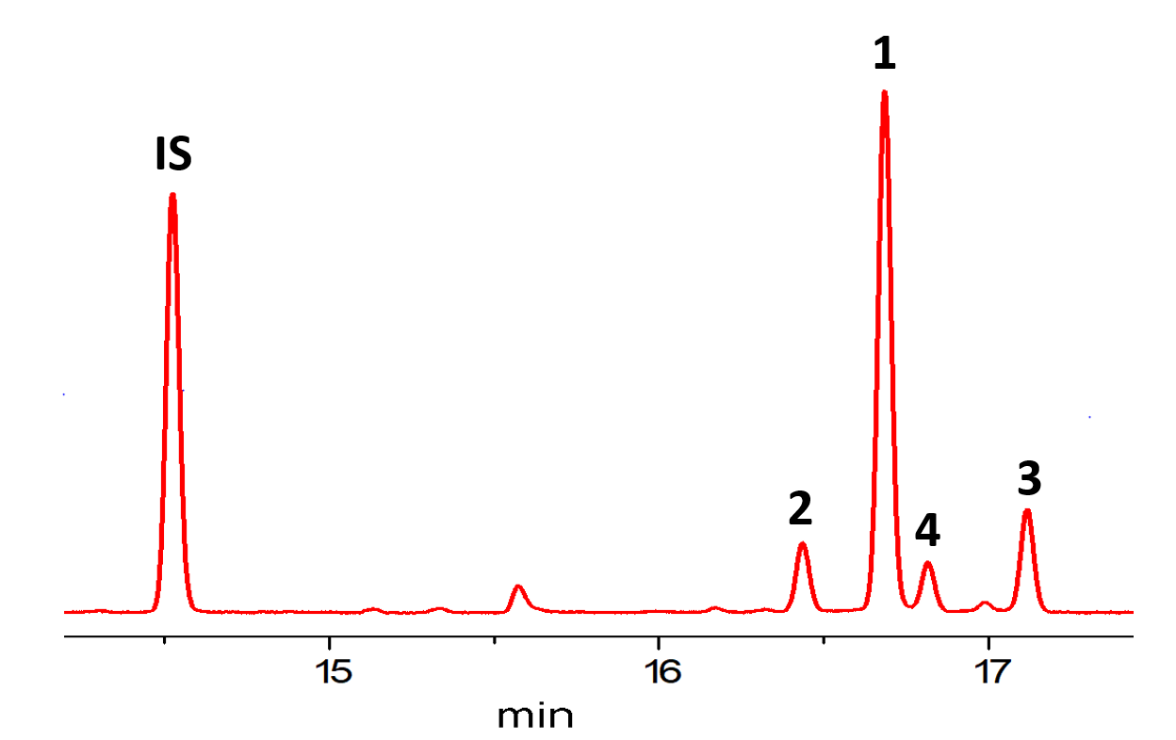
Figure 2. GC-FID chromatogram of four HP isomers obtained by photooxygenation of α-pinene: Cumene-hydroperoxide (IS), 4-hydroperoxy-4,6,6-trimethylbicyclo[3.1.1]hept-2-ene (2), pinocarvyl-hydroperoxide (1), verbenyl-hydroperoxide (4) and myrtenyl-hydroperoxide (3).

3.2 Derivatisation
Ideally, one would prefer to detect HPs directly, without derivatisation.⁹ To test this possibility, different injector temperatures were compared (from 70 °C to 250 °C), and significant decomposition of HPs was observed. Primary HPs are known to be the most thermolabile,¹² and indeed, 20% of HP3 was degraded with temperature. HP1 was the least decomposed at 10%. To test the effect of degradation on the column, the analysis was performed under a fast and slow temperature gradient. The HPs elute at about 130 °C, and at this temperature partial decomposition has already been observed in the injector. However, since the compounds spend most of their retention time dissolved in the liquid stationary phase, this could stabilize them. Therefore, we additionally tested the decomposition on the column with fast and slow temperature gradient. Under a fast temperature gradient, we quantified 3 to 9% more specific HPs, confirming the decomposition in the column. This rules out the possibility of avoiding thermal degradation by cool-on-column injection, so α-pinene HPs require derivatisation for quantitative determination.
Derivatisation to alcohols requires that the resulting alcohol was not previously present in the quantified product mixture or that its concentration was known beforehand. Essential oils of conifers and hence our sample, turpentine, contain some proportion of corresponding alcohols. Alcohols are also formed after the degradation of hydroperoxides. Neuenschwander et al.¹⁵ determined HPs via double injection, with and without reduction. The HP yield was quantified from the increase in alcohol content obtained, and no difference in yields was observed between split injection at 250 °C and cool-on-column injection at 50 °C. Since thermal degradation of HPs was observed in our experiments, they would be underestimated by this reduction method. We opted for silylation with MSTFA, in which the active hydrogens in the HPs are replaced by a TMS group. Silylation has a shortcoming: it cannot be applied to consumer product matrices with high water or alcohol content (e.g. eau de toilette, detergents).

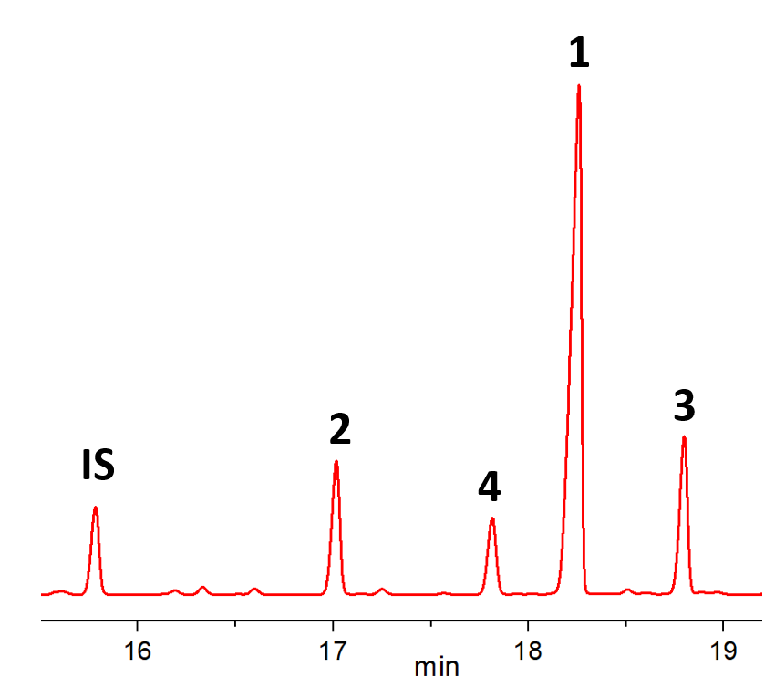
Figure 3. GC-FID chromatogram of TMS derivatives of α-pinene HPs obtained from the reaction of α-pinene with singlet oxygen: Cumene-hydroperoxide (IS, 15.8 min), 4-Hydroperoxy-4,6,6-trimethylbicyclo[3.1.1]hept-2-ene (2, 17.0 min), verbenyl-hydroperoxide (4, 17.8 min), pinocarvyl-hydroperoxide (1, 18.3 min) and myrtenyl-hydroperoxide (3, 18.8 min). Retention times are given in parentheses.

After derivatisation, the reversal of the elution order was observed for compounds HP1 and HP4. The positional isomers could be separated chromatographically with even better resolution than underivatised HPs (Fig. 3). The thermal stability of the TMS derivatives of HPs was studied under different injector temperatures, ranging from 70 °C to 270 °C. No adsorption on the column was observed at low temperatures, and no thermal decomposition was observed up to 250 °C. The repeatability of derivatisation at LOD (1 ppm, n=6) showed an RSD of 4.6%; thus, the method allows for accurate determination.
Since HPs decompose at higher temperatures, we derivatised HPs at room temperature. The reaction was considered complete when the responses for the TMS derivatives stopped increasing, and no peaks corresponding to unreacted HPs remained in the GC-FID chromatogram. Tertiary hydroperoxides (HP2 and IS) were derivatised in 25 min, primary HP (HP3) in 5 min, after only brief mixing. This can be explained by steric hindrance. We opted for a derivatization time of 2 h to give some extra time for samples with high concentrations of HPs.

3.3 EI fragmentation
Identification was made by classical mass spectra interpretation and by comparison with an authentic reference standard, 80% cumene-HP. The molecular ion m/z 240 is almost absent, and the fragmentation is extensive (Fig. 4). The extensive fragmentation into a large number of low-mass ions makes selected-reaction monitoring less profitable. On the other hand, however, the spectra are more informative and allow discrimination between the different positional isomers. Comparison of the mass spectra of derivatised and underivatised HPs confirmed the reversal of the elution order for HP1 and HP4 after derivatisation.
Common to all spectra is both a signal at m/z 135, due to the loss of the TMS-peroxy radical (-105 Da) and a specific ion series of terpenes with the molecular formula C_{n}H_{2n-5}: 65, 79, 93, 107, 121, and 135 (Fig. 4). The base peaks are typical hydrocarbon fragments: in HP2 spectra m/z 93 (C₇H₉⁺) and for HP3 and HP4 benzyl cation m/z 91. The base peak of HP1 is m/z 89, corresponding to [OSi(CH₃)₃]⁺. Other TMS fragments are also observed: m/z 73, corresponding to [Si(CH₃)₃]⁺ and m/z 105, corresponding to [OOSi(CH₃)₃]⁺. This is to be expected since most ionisation occurs at the silicon (ionisation potential 8.1 versus 13.6 eV for oxygen).^{10,12}

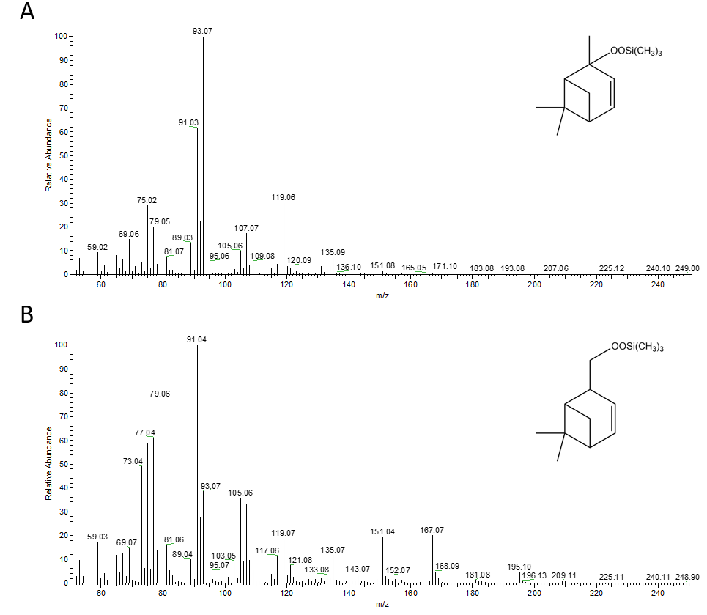
Figure 4. Mass spectra of the TMS derivative of the tertiary hydroperoxide (A) and primary hydroperoxide (B) showing different fragmentation patterns.

Even when there are similarities between isomers in their EI spectra, the ions' relative intensities vary considerably. The relative abundance of high-molecular-mass ions decreases in the order primary HP > secondary HPs > tertiary HP (Fig. 4). This trend can be explained by a greater distance of the ionized atoms from the strained bicyclic skeletal structure in primary HP and by fragmentation mechanisms. We propose an H-rearrangement mechanism for the stabilization of m/z 151, which would help explain its high abundance in primary HP (Fig. 4, B).

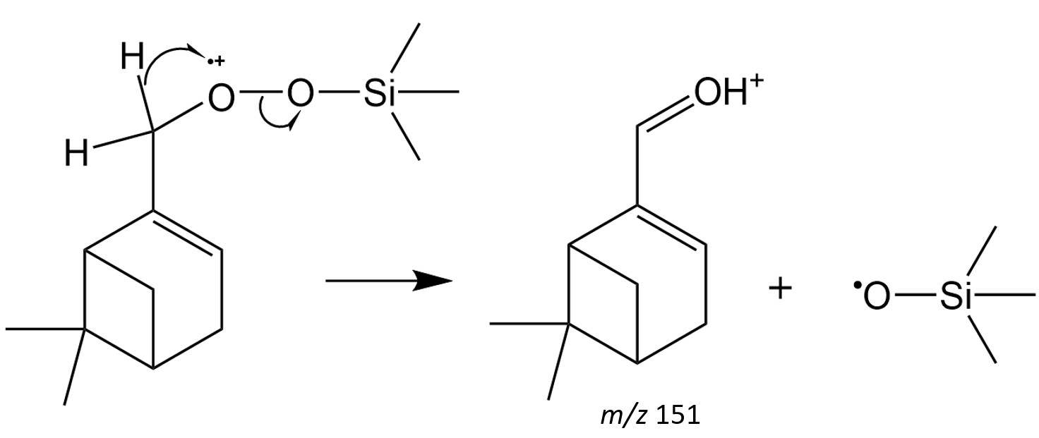
Figure 5. The mechanism for the formation of the fragment m/z 151, which is formed in higher amount in myrtenyl-hydroperoxide (HP3).

3.4 Method validation
A validation procedure was carried out i.e. linear regression range, precision and limit of quantification/detection were determined. Quantification was based on the peak area for cumene-HP relative to the peak area of the internal standard tetradecane. The linearity of the GC method was evaluated from 0.6 to 90 μg/mL of cumene-HP using five concentration levels, 0.6, 1, 6, 25, 50, 90 μg/mL. The R² value was greater than 0.999, LOD was 0.6 μg/mL, and LOQ was 1 μg/mL. The LOD was determined as the concentration giving a signal to noise ratio (S/N ratio) of at least 3, and LOQ as the lowest point of the calibration curve subject to linearity. Injection repeatability was evaluated using six injections of a standard solution, and the percentage of relative standard deviation (%RSD) in the peak area was 0.15%. Sample repeatability was evaluated by preparing six replicates of the same sample (with derivatisation for GC), and the %RSD in the peak area was 4.6%. The validation proved that the developed GC method was suitable for monitoring the α-pinene reaction with singlet oxygen. The selectivity of the method was verified by analysing turpentine samples, and all four HPs could be identified in autooxidised turpentine (Fig. 6).

3.5 Analysis of real samples
To investigate the applicability of the proposed method for the determination of HPs in real samples, turpentine was analysed before and after autoxidation. The sample of turpentine contained 72% α–pinene and 9% β-pinene. During exposure to air, HPs concentrations increased with time (Fig. 6). Turpentine autooxidation also increased the mixture's complexity; new peaks were formed as the hydroperoxides were degraded to secondary oxidation products, e.g. aldehydes, alcohols, epoxides. The concept of the effective carbon number allowed us to quantify the responses without standards of known purity. The calculated value of the relative mass response factor for α-pinene HP with IS cumene-peroxide was 0,987. Due to a poor evaluation of the chemical structure in the ECN calculation, a bias could enter the quantification. In our case, the ECN could be overestimated by about 2% because we used an aromatic internal standard and aliphatic analytes.²⁶
The method's selectivity was verified by analysing samples of turpentine and screening for peaks that might interfere with α-pinene HPs. HP3 coeluted with a compound with a normalised concentration of 150 ppm (chromatogram A in Fig. 6, the right part of the double peak). With increasing concentration after prolonged autooxidation, the concentration of HP3 increased (chromatogram B in Fig. 6). Therefore, in an oxidised turpentine sample, an overestimation of 2% HP3 is to be expected at a concentration of 7.57 mg HP3/g.

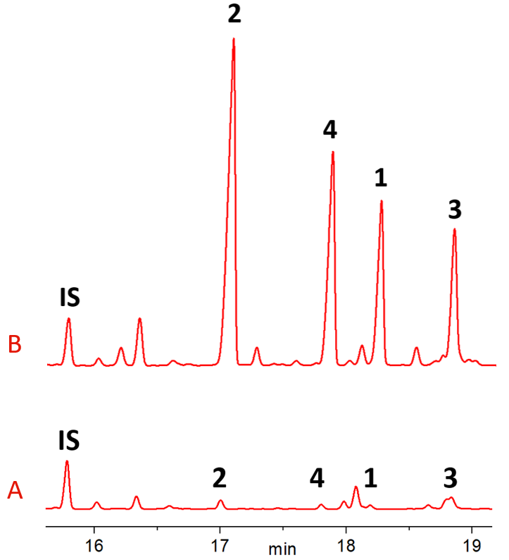

Figure 6. The chromatogram of turpentine before (A) and after 20 days of autooxidation (B).

Table 1. Concentrations of α-pinene hydroperoxides in turpentine before and after 20 days of air-exposure compared to concentrations of hydroperoxides synthesised photochemically with singlet oxygen (data in mg/g).

 | HP2 | HP4 | HP1 | HP3 | Σ
Turpentine | 0.416 | 0.207 | 0.186 | 0.626* | 1.44
oxidised turpentine | 21.7 | 12.5 | 8.84 | 7.57 | 50.6
photooxidised α-pinene | 3.55 | 2.14 | 17.6 | 4.17 | 27.4
*double peak

The turpentine sample data show a high presence of HPs. The total mass fraction of HPs in bottled turpentine was 0.1% and increased to 5.1% after 20 days of air exposure. The least stable primary hydroperoxide, HP3, was the least elevated, and the tertiary hydroperoxide HP2 had the highest yield. HP2 represents 43% of all radically sensitized HPs, and HP1 represents 64% of all HPs synthesized with singlet oxygen (Table 1). With this difference in yields, it would be possible to assess the importance of singlet oxygen as an atmospheric oxidant based on measurements of the concentrations of individual α-pinene HPs in the air.

4 Conclusions
The manuscript addresses the problem of quantifying reactive unstable organic species for which no standard reference material is available. We present the first GC-FID method for the quantification of all four α-pinene hydroperoxides formed in a reaction with α-pinene. The hydroperoxides were prepared by a simple photochemical synthesis in a laboratory flask. Pre-column silylation improved their stability, and the concept of effective carbon number allowed quantification despite the standards' poor stability. We believe that this new synthesis and analysis approach could be used for other unstable hydroperoxides as well.
The applicability of the proposed method was demonstrated on samples of bottled and oxidised turpentine. Each analysis was performed within 200 min with a quantification limit in the μg/mL range. After 20 days of air exposure, the mass fraction of hydroperoxides in turpentine increased 35-fold to 5.1%. This level is likely capable of causing oxidative damage to the skin and lungs.
For more complex matrices, such as hydroalcoholic products and atmospheric particles, an extraction step could be added. To further improve accuracy, isolation of individual α-pinene HPs and their purity determination by NMR would allow calibration and full validation of our GC-FID method. GC-MS or LC-MS could provide additional selectivity and better robustness, especially if isotope-labelled internal standards were available.
In addition to demonstrated importance of hydroperoxides in the analysis of essential oils, hydroperoxides of α-pinene are also important in atmospheric chemistry, where photoreactions of α-pinene with singlet oxygen could help explain high formation rates of secondary organic aerosols.^{3,27} The formation of hydroperoxides with singlet oxygen is, in contrast to the radical formation, independent of the NO_{x} concentration. As NO_{x} levels decrease due to emission control measures, photochemical HPs will become even more important for atmospheric chemistry.

Acknowledgements The study was carried out with financial support from the Slovenian Research Agency (P1-0153) and the World Federation of Scientists. The authors would like to thank Aleksandra Kuljanin and Dr. Ida Kraševec for advice and help during manuscript preparation.

References
1. A.-T. Karlberg, M. A. Bergström, A. Börje, K. Luthman, J. L. G. Nilsson, Chem. Res. Toxicol. 2008, 21, 53–69.
2. L. A. Morio, K. A. Hooper, J. Brittingham, T.-H. Li, R. E. Gordon, B. J. Turpin, D. L. Laskin, Toxicol. Appl. Pharmacol. 2001, 177, 188–199.
3. M. Ehn, J. A. Thornton, E. Kleist, M. Sipilä, H. Junninen, I. Pullinen, M. Springer, F. Rubach, R. Tillmann, B. Lee, F. Lopez-Hilfiker, S. Andres, I.-H. Acir, M. Rissanen, T. Jokinen, S. Schobesberger, J. Kangasluoma, J. Kontkanen, T. Nieminen, T. Kurtén, L. B. Nielsen, S. Jørgensen, H. G. Kjaergaard, M. Canagaratna, M. D. Maso, T. Berndt, T. Petäjä, A. Wahner, V.-M. Kerminen, M. Kulmala, D. R. Worsnop, J. Wildt, T. F. Mentel, Nature 2014, 506, 476–479.
4. R. Treudler, G. Richter, J. Geier, A. Schnuch, C. E. Orfanos, B. Tebbe, Contact Dermatitis 2000, 42, 68–73.
5. S. Hellerström, N. Thyresson, S.-G. Blohm, G. Widmark, J. Invest. Dermatol. 1955, 24, 217–224.
6. K. S. Docherty, W. Wu, Y. B. Lim, P. J. Ziemann, Environ. Sci. Technol. 2005, 39, 4049–4059.
7. T. Nakamura, H. Maeda, Lipids 1991, 26, 765–768.
8. G. L. Beutner, S. Ayers, T. Chen, S. W. Leung, H. C. Tai, Q. Wang, Org. Process Res. Dev. 2020, 24, 1321–1327.
9. W. F. Brill, J. Chem. Soc. Perkin Trans. 2 1984, 0, 621–627.
10. J. Polzer, K. Bächmann, J. Chromatogr. A 1993, 653, 283–291.
11. S. Leocata, S. Frank, Y. Wang, M. J. Calandra, A. Chaintreau, Flavour Fragr. J. 2016, 31, 329–335.
12. J. Rudbäck, A. Ramzy, A.-T. Karlberg, U. Nilsson, J. Sep. Sci. 2014, 37, 982–989.
13. G. O. Schenck, H. Eggert, W. Denk, Justus Liebigs Ann. Chem. 1953, 584, 177–198.
14. C. W. Jefford, A. F. Boschung, R. M. Moriarty, C. G. Rimbault, M. H. Laffer, Helv. Chim. Acta 1973, 56, 2649–2659.
15. U. Neuenschwander, F. Guignard, I. Hermans, ChemSusChem 2010, 3, 75–84.
16. K. Akasaka, H. Ohrui, J. Chromatogr. A 2000, 881, 159–170.
17. M. J. Calandra, J. Impellizzeri, Y. Wang, Flavour Fragr. J. 2015, 30, 121–130.
18. J. Nilsson, J. Carlberg, P. Abrahamsson, G. Hulthe, B.-A. Persson, A.-T. Karlberg, Rapid Commun. Mass Spectrom. 2008, 22, 3593–3598.
19. R. Zhao, C. M. Kenseth, Y. Huang, N. F. Dalleska, J. H. Seinfeld, Environ. Sci. Technol. 2018, 52, 2108–2117.
20. M.-C. Reinnig, J. Warnke, T. Hoffmann, Rapid Commun. Mass Spectrom. 2009, 23, 1735–1741.
21. S. K. Bharti, R. Roy, TrAC Trends Anal. Chem. 2012, 35, 5–26.
22. T. Cachet, H. Brevard, A. Chaintreau, J. Demyttenaere, L. French, K. Gassenmeier, D. Joulain, T. Koenig, H. Leijs, P. Liddle, G. Loesing, M. Marchant, Ph. Merle, K. Saito, C. Schippa, F. Sekiya, T. Smith, Flavour Fragr. J. 2016, 31, 191–194.
23. M. Prein, W. Adam, Angew. Chem. Int. Ed. Engl. 1996, 35, 477–494.
24. I. A. Yaremenko, V. A. Vil’, D. V. Demchuk, A. O. Terent’ev, Beilstein J. Org. Chem. 2016, 12, 1647–1748.
25. J. T. Scanlon, D. E. Willis, J. Chromatogr. Sci. 1985, 23, 333–340.
26. M. Kállai, J. Balla, Chromatographia 2002, 56, 357–360.
27. A. Manfrin, S. A. Nizkorodov, K. T. Malecha, G. J. Getzinger, K. McNeill, N. Borduas-Dedekind, Environ. Sci. Technol. 2019, 53, 8533-8562.

