Supplementary Information

Figure S1
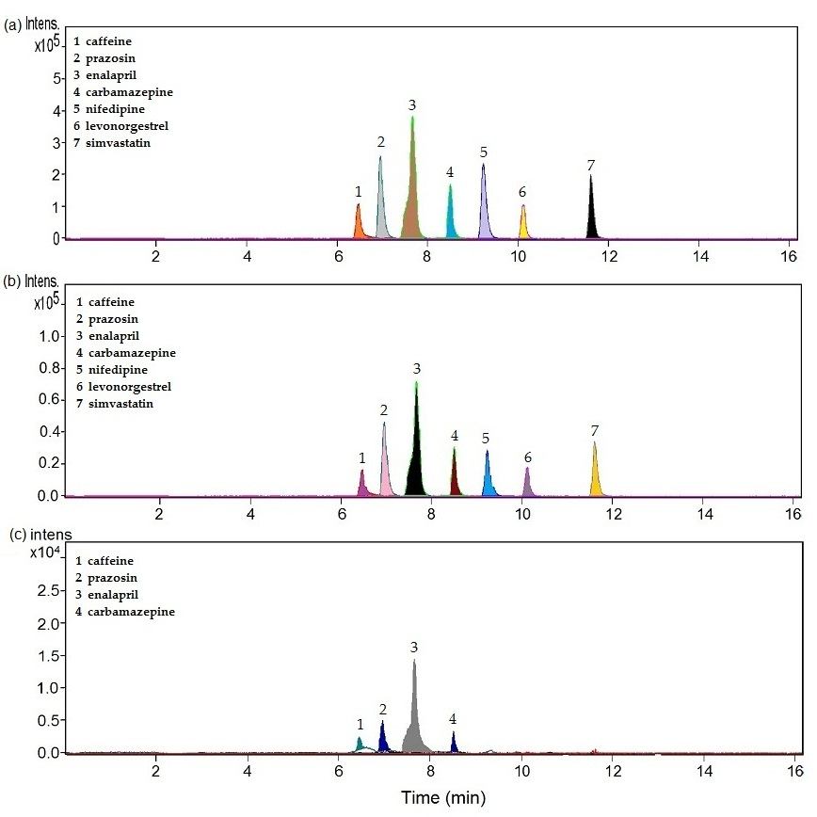

Figure S1. LC-TOF/MS chromatograms for all studied pharmaceuticals: (a) without NaCl, (b) 1 g/L NaCl and (c) 2 g/L NaCl at the following conditions: 5 mg/L, 50 min and 5 V.

Figure S2

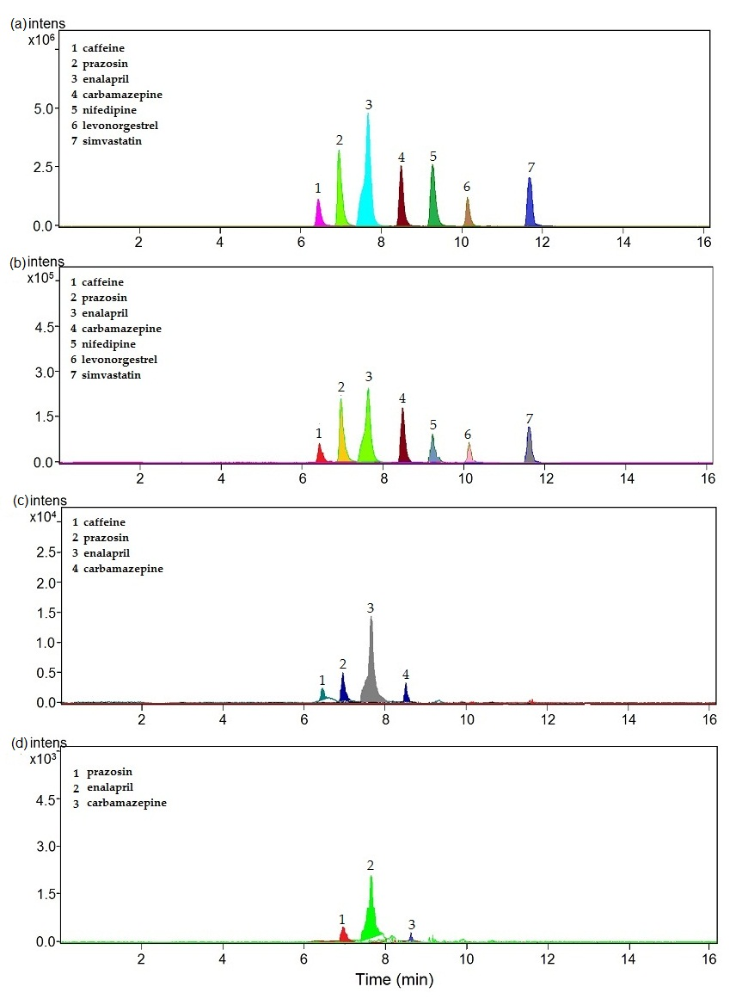

Figure S2. LC-TOF/MS chromatograms for all studied pharmaceuticals: (a) without NaCl, (b) applied voltage of 3 V, (c) applied voltage of 5 V and (d) applied voltage of 12 V at the following conditions: 5 mg/L, 50 min and 2 g/L NaCl.

