In vitro and In silico Evaluation of Structurally Diverse Benzyl pyrrolidin-3-ol Analogues as Apoptotic Agents via Caspase Activation.

Supplementary Data
Page no
Material and methods 2
General Synthetic procedure 2
Spectroscopic data of compounds (5a-5p) 2- 4
Biological assays and Biophysical methodology: 4- 6
In silico Methodology 7
Cytotoxicity data of synthesized compounds 5(a-p)
towards selected human cancer cell lines.(Table S1) 8

IC50 values of the compounds 5j and 5p. (Table S2) 9
Calculated K_{sv} and K_{q} values of 5j & 5p with BSA
at three temperatures (Table S3) 9

Cytotoxicity barchart of synthesized compounds 5(a-p) towards 9
selected human cancer cell lines. (Figure S2)

References 10

NMR Spectra of synthesized compounds 5(a-p) 11-25

Mass Spectra of synthesized compounds 5(a-p) 25-33

Materials and Methods
In an initial attempt, equimolar amounts of substrates were used under standard U-4CR conditions in methanol at room temperature, but no product formation took place. However, when attempted at higher temperatures (80⁰C), reaction afforded the Ugi product (5a) in 90% yield.
General procedure for Ugi-4 component reaction (5a-p): 1-(2-aminobenzyl)pyrrolidin-3-ol
1-(2-aminobenzyl)pyrrolidin-3-ol (0.096 g, 0.5 mmol), p-nitro benzaldehyde (0.0755 g, 0.5 mmol), benzoic acid (0.061 gm, 0.5 mmol) and tert-butyl isocyanide (169 μL, 1.5 mmol) were dissolved in MeOH (5 mL) and refluxed at 80 ⁰C. Reaction mixture was refluxed until 1-(2-aminobenzyl) pyrrolidin-3-ol completely disappeared on TLC. This followed concentrating reaction mixture over vacum evaporator. Ethylacetate was added to reaction system and extracted with saturated aqueous NaHCO₃ followed by brine solution. The organic layer was dried with Na₂SO₄ and residue was purified by column chromatography (CH₃OH:CH₂Cl₂ 1:20) to give compound 5a in 78% yield. Characterization was done by ¹H NMR and High-resolution electrospray ionisation mass spectrometry by comparing to accurate mass measurements and molecular formula.

Figure S1: Synthesis of 1-(2-aminobenzyl)pyrrolidin-3-ol derivatives using Ugi four component reaction

N-(2-(tert-butylamino)-1-(4-nitrophenyl)-2-oxoethyl)-N-(2-((3-hydroxypyrrolidin-1-yl)methyl)phenyl) benzamide (5a)
Yield = 78 %, 1H NMR (400 MHz, CDCl3) 8.08 – 8.25 (m, 2H), 7.70 – 7.51 (m, 3H), 7.46 – 7.28 (m, 3H), 7.24 – 7.10 (m, 5H), 6.32 – 6.05 (m, 1H), 4.75 – 4.50 (m, 1H), 3.51 – 3.27 (m, 2H), 3.19 – 2.95 (t, J = 12.0 Hz, 1H), 2.86 – 2.70 (m, 1H), 2.62 (d, J = 3.4 Hz, 1H), 2.37 – 2.24 (m, 2H), 2.12 – 1.88 (m, 1H), 1.32 (s, 9H); HR-ESI-MS (m/z) 531.2612 [M+H]+ (calcd for [C₃₀H₃₄N₄O₅+H]+ 531.2602).
N-(2-(tert-butylamino)-2-oxo-1-(4(trifluoromethoxy)phenyl)ethyl)-N-(2-((3-hydroxypyrrolidin-1-yl)methyl)phenyl)benzamide (5b)
Yield = 68 %, 1H NMR (400 MHz, CDCl3) δ 8.2 – 8.02 (m, 1H), 7.67 – 7.5 (m, 2H), 7.47 – 7.25 (m, 5H), 7.23 – 7.18 (m, 1H), 7.17 – 7.02 (m, 4H), 6.32 – 6.05 – 5.50 (m, 1H), 4.35 – 4.12 (m, 1H), 3.61 – 3.50 (m, 1H), 3.29 – 3.12 (m, 1H), 2.86 – 2.68 (m, 1H), 2.59 – 2.50 (m, 1H), 2.35 – 2.20 (m, 1H), 2.10 – 1.97 (m,1H), 1.92 – 1.81 (m, 1H), 1.78 – 1.57 (m, 1H) 1.32 – 1.10 (m, 9H);HR-ESI-MS (m/z) 570.2554 [M+H]+ (calcd for [C₃₁H₃₄F₃N₃O₄+H]+ 570.2574).
N-(1-(3-bromo-4-fluorophenyl)-2-(tert-butylamino)-2-oxoethyl)-N-(2-((3hydroxypyrrolidin-1-yl) methyl)phenyl) benzamide (5c)
Yield = 63 %, 1H NMR (400 MHz, CDCl3) δ 7.61 – 7.53 (m, 1H), 7.41 – 7.33 (m, 2H), 7.29 – 7.25(m, 2H), 7.24 – 7.18 (m, 2H), 7.17 – 7.08 (m, 2H), 7.07 –7.04 (m, 3H), 6.16 – 5.96 (m, 1H), 4.37 – 4.22 (m,1H), 3.55 – 3.35 (m, 1H), 3.28 –3.0 (m, 1H), 2.70 –2.65 (m, 1H), 2.51–2.48 (m, 1H), 2.44 – 2.32 (m, 1H), 2.19 – 2.00 (m, 2H), 1.71 – 1.62 (m, 1H), 1.36 (s, 9H); HR-ESI-MS (m/z) 582.1756 [M+H]+ (calcd. For [C₃₀H₃₃BrFN₃O₃+H]+ 582.1762).
N-(1-(3,5-bis(trifluoromethyl)phenyl)-2-(tert-butylamino)-2-oxoethyl)-N-(2-((3-hydroxypyrrolidin-1-yl)methyl) phenyl) benzamide (5d)
Yield = 60 %, 1H NMR (400 MHz, CDCl3) δ 7.61 (q, J = 9.6, 9.2 Hz, 3H), 7.36 – 7.30 (m, 3H), 7.28 – 7.24 (m, 1H), 7.21 (d, J = 7.8 Hz, 2H), 7.07 – 7.03 (m, 3H), 5.93-5.57 (m, 1H), 5.42-5.33 (m, 1H), 4.31 – 4.13 (m, 1H), 3.39 (t, J = 15.3 Hz, 1H), 3.28 – 3.06 (m, 2H), 2.61 (dd, J = 8.2, 4.0 Hz, 1H), 2.43 (d, J = 10.0 Hz, 1H), 2.40 – 2.38, (m, 1H), 2.20 – 1.98 (m, 2H), 1.64 (q, J = 7.5, 6.7 Hz, 1H), 1.37 (s, 9H); HRESI-MS (m/z) 622.3114 [M+H]+ (calcd for [C₃₂H₃₃F₆N₃O₃+H]+ 622.2499).
N-(2-(tert-butylamino)-2-oxo-1-(quinolin-2-yl)ethyl)-N-(2-((3-hydroxypyrrolidin-1 yl)methyl)phenyl)benzamide (5e)
Yield = 64 %, 1H NMR (400 MHz, CDCl3) δ δ 8.25 – 8.21 (m, 1H), 8.14 – 7.95 (m, 2H), 7.84 –7.66 (m, 3H), 7.57 –7.51 (m, 1H), 7.48 – 7.30 (m, 3H), 7.17 –7.0 (m, 5H), 6.51 – 6.04 (m, 1H), 4.66 - 4.07 (m, 1H), 3.52 – 3.25 (m, 2H), 3.29 – 3.12 (m, 1H), 3.10 – 2.97 (m, 1H), 2.62 – 2.55 (m, 2H), 2.31 (dq, J = 42.5, 6.9 Hz, 1H), 2.08 – 1.83 (m, 1H), 1.25 (s, 9H); HR-ESI-MS (m/z) 559.2711 [M+Na]+ (calcd for [C₃₃H₃₆N₄O₃+Na]+ 559.2680).
N-(2-(tert-butylamino)-2-oxo-1-(pyridin-2-yl)ethyl)-N-(2-((3-hydroxypyrrolidin-1 yl)methyl)phenyl)benzamide (5f)
Yield = 68 %, 1H NMR (400 MHz, CDCl3) δ 8.56 – 8.41 (m, 1H), 7.87 – 7.77 (m, 1H), 7.58 (d, J = 5.7 Hz, 2H), 7.47 – 7.29 (m, 3H), 7.21–7.17 (m, 2H), 7.15 (dt, J = 9.0, 4.2 Hz, 2H), 7.05 (d, J = 8.3 Hz, 2H), 6.21 (s, 1H, NH), 5.78 – 5.62 (m, 1H), 4.44 – 4.15 (m, 1H), 3.35 (d, J = 13.1 Hz, 1H), 3.25 (d, J = 13.5 Hz, 1H), 2.78 – 2.55 (m, 2H), 2.43 (dd, J = 14.1, 7.0 Hz, 1H), 2.10 (d, J = 4.3 Hz, 1H), 1.70 – 1.50 (m, 2H), 1.60 – 1.50 (m, 1H), 1.43 (s, 9H); HR-ESI-MS (m/z) 487.2707 [M+H]+ (calcd for [C₂₉H₃₄N₄O₃+H]+ 487.2704).
N-(2-(tert-butylamino)-2-oxo-1-(thiophen-2-yl)ethyl)-N-(2-((3-hydroxypyrrolidin-1 yl)methyl)phenyl)benzamide (5g)
Yield = 58 %, 1H NMR (400 MHz, CDCl3) 8.04 (d, J = 7.4 Hz, 1H), 7.62 (d, J = 6.6 Hz, 1H), 7.42 (dd, J= 8.6, 5.8 Hz, 1H), 7.35 (q, J = 6.6, 5.7 Hz, 2H), 7.31 – 7.16 (m, 5H), 7.11 (t, J = 7.8 Hz, 2H), 5.88 – 5.68 (m, 1H), 4.30 – 4.26 (m, 1H), 3.68 – 3.61 (m, 1H), 3.51 – 3.25 (m, 1H), 3.16 - 2.96 (m, 1H), 2.88 – 2.43 (m, 2H), 2.42 – 2.02 (m, 2H), 1.91 (m, 1H), 1.44 – 1.18 (m, 9H); HR-ESI-MS (m/z) 492.2297 [M+H]+(calcd for [C₂₈H₃₃N₃O₃S+H]+ 492.2315).
N-(2-(tert-butylamino)-2-oxo-1-(4-(trifluoromethoxy)phenyl) ethyl) -N-(2-((3-hydroxypyrrolidin-1-yl) methyl) phenyl) picolinamide (5h)
Yield = 56 %, 1H NMR (400 MHz, CDCl3) δ 8.62 – 8.25 (m, 1H), 8.08 – 7.81 (m, 1H), 7.80 – 7.74 (m, 1H), 7.60 (dd, J = 16.2, 8.3 Hz, 1H), 7.48 – 7.28 (d, J = 8.2 Hz, 2H), 7.25 – 7.19 (m, 2H), 7.18 – 6.98 (m, 4H), 6.25 – 6.0 (m, 1H), 4.29 – 4.11 (m, 1H), 3.77 – 3.25 (m, 2H), 2.77 – 2.50 (m, 2H), 2.50 – 2.20 (m, 2H), 2.19 – 1.98 (m, 1H), 1.78 – 1.59 (dd, J = 14.0, 7.4 Hz, 1H), 1.37 (s, 9H); HR-ESI-MS (m/z) 571.2529 [M+H]+ (calcd for [C₃₀H₃₄F₃N₄O₄+H]+ 571.2527).
2-bromo-N-(2-(tert-butylamino)-2-oxo-1-(4-(trifluoromethoxy) phenyl) ethyl)-N-(2-((3-hydroxypyrrolidin-1-yl)methyl) phenyl) nicotinamide (5i)
Yield = 70 %, 1H NMR (400 MHz, CDCl3) δ 8.72 – 8.53 (m, 1H), 8.50 (s, 1H), 7.88 – 7.75 (m, 1H), 7.57 (d, J = 8.3 Hz, 1H), 7.41– 7.34 (dd, J = 7.8, 5.2 Hz, 2H), 7.29 – 7.12 (m, 4H), 7.07 (d, J = 8.3 Hz, 1H), 6.16 (s, 1H, NH), 5.94 – 5.52 (m, 1H), 4.50 – 4.29 (m, 1H), 3.51 – 3.32 (m, 1H), 3.30 – 3.19 (m, 1H), 2.70 (dd, J = 8.6, 4.1 Hz, 1H), 2.51 (d, J = 8.7 Hz, 1H), 2.48 – 2.28 (m, 1H), 2.20 – 1.93 (m, 1H), 1.75 –1.61 (m, 1H), 1.48 – 1.25 (m, 9H); HR-ESI-MS (m/z) 651.1635 [M+H]+ (calcd for[C₃₀H₃₂BrF₃N₄O₄+H]+ 649.1632).
2-bromo-N-(2-(tert-butylamino)-2-oxo-1-(4-(trifluoromethoxy) phenyl) ethyl)-6-chloro-N-(2-(3-hydroxy pyrrolidin-1-yl)methyl) phenyl) benzamide (5j)
Yield = 62 %, 1H NMR (400 MHz, CDCl3) δ 7.88 (t, J = 11.9 Hz, 1H), 7.59 (dd, J = 8.4, 2.1 Hz, 3H), 7.33- 7.30 (m, 3H), 7.21 (m, 1H), 7.13 (d, J = 7.3 Hz, 1H), 7.05 (d, J = 8.4 Hz, 2H), 6.21 (s, 1H, NH), 5.78 – 5.70 (m, 1H), 4.29 – 4.17 (m, 1H), 3.35 (d, J = 12.8 Hz, 1H), 3.25 (d, J = 13.4 Hz, 1H), 2.70 – 2.57 (m, 1H), 2.56 – 2.28 (m, 2H), 2.22 – 1.92 (m, 2H), 1.65 (dd, J = 14.5, 6.6 Hz, 1H), 1.36 – 1.34 (s, 9H);HR-ESI-MS (m/z) 684.1290 [M+H]+ (calcd for [C₃₁H₃₂BrClF₃N₃O₄+H]+ 682.1290).
N-(2-(tert-butylamino)-2-oxo-1-(4-(trifluoromethoxy)phenyl)ethyl)-4-fluoro-N-(2-((3- hydroxypyrrolidin-1-yl)methyl)phenyl) benzamide (5k)
Yield = 72%, 1H NMR (400 MHz, CDCl3) 7.78 – 7.61 (m, 2H), 7.58 – 7.41 (m, 3H), 7.40 - 7.23 (m, 3H), 7.22 - 7.15 (m, 4H), 6.22 – 6.20 (m, 1H), 4.31– 4.25 (m, 1H), 3.52 – 3.28 (m, 2H), 3.25 – 2.87 (m, 1H),2.80 – 2.68 (m, 1H), 2.67 –2.66 (m, 1H), 2.65 – 2.21 (m, 2H), 2.18 – 1.75 (m, 2H), 1.17 – 1.31 (s, 9H); HR-ESI-MS (m/z) 504.2657 [M+H]+ (calcd for [C₃₀H₃₅FN₃O₃+H]+ 504.2650).
N-(2-(tert-butylamino)-2-oxo-1-(4-(trifluoromethoxy)phenyl)ethyl)-N-(2-((3-hydroxypyrrolidin-1-yl)methyl)phenyl) nicotinamide (5l)
Yield = 69%, 1H NMR (400 MHz, CDCl3) δ 8.90 – 8.50 (m, 1H), 8.50 – 8.24 (m, 1H), 7.75 - 7.52 (m,2H), 7.48 – 7.27 (m, 3H), 7.26 – 7.12 (m, 3H), 7.10 – 6.98 (d, J = 7.9 Hz, 2H), 6.25 – 6.01 (m, 1H, NH), 5.97– 5.8 (m, 1H), 4.25 – 4.23 (m, 2H), 3.50 - 3.31 (m, 1H), 3.30 – 3.11 (m, 1H), 2.61 (dd, J = 8.2, 4.0 Hz, 1H), 2.53 – 2.20 (m, 2H), 2.18 – 1.78 (m, 2H), 1.75 – 1.51 (m, 1H), 1.37 (s, 9H); HR-ESI-MS (m/z) 571.2521 [M+H]+ (calcd for [C₃₀H₃₃F₃N₄O₄+H]+ 571.2527).
Tert-butyl ((2S)-1-((2-(tert-butylamino)-2-oxo-1-(4-(trifluoromethoxy) phenyl) ethyl) (2- ((3-hydroxypyrrolidin-1-yl)methyl)phenyl)amino)-1-oxopropan-2-yl)Carbamate (5m)
Yield = 68%, 1H NMR (400 MHz, CDCl3) δ 7.65 –7.55 (m, 1H), 7.47- 7.24 (m, 5H), 7.23 – 7.19 (d, J = 4.1 Hz, 1H), 7.18 – 6.81 (m, 1H), 6.10 – 5.91 (m, 1H, NH), 5.88 – 5.75 (m, 1H), 5.59 - 5.48 (m, 1H), 4.39 – 4.17 (m, 1H), 3.79 – 3.50 (m, 1H), 3.48 – 3.33 (m, 1H), 3.32 – 3.20 (m, 1H), 3.10 – 2.81 (m, 1H), 2.80 – 2.68 (m, 1H), 2.62 – 2.58 (m, 1H), 2.54 – 2.32 (m, 1H), 2.20 – 1.99 (m, 1H), 1.79 – 1.54 (m, 1H), 1.47 (s,9H), 1.35 (s, 9H), 1.31- 1.19 (m, 3H); HR-ESI-MS (m/z) 637.3214 [M+H]+ (calcd for [C₃₂H₄₃F₃N₄O₆+H]+637.3207).
Methyl6-((2-(tert-butylamino)-2-oxo-1-(4-(trifluoromethoxy)phenyl)ethyl)(2-((3-hydroxy pyrrolidin-1-yl)methyl)phenyl)amino)-6-oxohexanoate(5n)
Yield = 55%, 1H NMR (400 MHz, CDCl3) δ 7.76 - 7.51 (m, 1H), 7.39 – 7.30 (d, J = 8.1 Hz, 2H), 7.30 –7.19 (m, 2H), 7.18 – 7.0 (m, 2H), 6.79 – 6.75 (m, 1H), 6.10 – 5.42 (s, 1H), 5.69 – 5.60 (m, 1H), 4.37 –4.26 (m, 1H), 4.22 – 4.10 (m, 3H), 3.78 – 3.51 (m, 1H), 3.18 – 2.75 (m, 2H), 2.75 – 2.58 (m, 1H), 2.49–2.28 (m, 3H), 2.27 – 2.15 (m, 2H), 2.12 – 1.80 (m, 2H), 1.80 – 1.74 (m, 1H), 1.75 – 1.51 (m,5H), 1.38(s,9H); HR-ESI-MS (m/z) 608.2920 [M+H]+ (calcd for [C₃₁H₄₀F₃N₃O₆+H]+ 608.2942).
Methyl 8-((2-(tert-butylamino)-2-oxo-1-(4-(trifluoromethoxy) phenyl)ethyl)(2-((3- hydroxypyrrolidin-1-yl)methyl)phenyl)amino)-8-oxooctanoate(5o)
Yield = 52%, 1H NMR (400 MHz, CDCl3) δ 7.68 – 7.48 (m, 1H), 7.57 (m, 4H), 7.17 – 7.0 (m, 2H), 6.80 –6.75 (m, 1H), 6.13 (d, 1H, NH), 6.04 – 5.80 (s, 1H), 5.60 – 5.54 (m, 1H), 4.38 (s, 1H), 4.19 - 4.03 (m,3H), 3.75 – 3.49 (m, 1H), 3.21 – 2.72 (m, 1H), 2.72 – 2.58 (m, 2H), 2.37 – 2.27 (m, 7H), 2.11– 1.92 (m,2H), 1.81 – 1.40 (m, 9H), 1.35 – 1.25 (m, 9H); HR-ESI-MS (m/z) 636.3261 [M+H]+ (calcd for[C₃₃H₄₄F₃N₃O₆+H]+636.3255).
N-(2-(tert-butylamino)-2-oxo-1-(4-(trifluoromethoxy)phenyl)ethyl)-N-(2-((3-hydroxypyrrolidin-1-yl)methyl)phenyl)-3,7-dimethyloct-6-enamide(5p)
Yield = 52%, 1H NMR (400 MHz, CDCl3) δ 7.44 – 7.33 (m, 2H), 7.28 – 7.32 (m, 4H), 7.18 - 7.05 (m,2H), 5.74 – 5.65 (m, 1H), 5.13 – 5.06 (m, 1H), 4.32 (t, J = 6.1 Hz, 1H), 3.69 – 3.38 (m, 1H), 3.05 – 2.78(m, 1H) 2.33 (dd, J = 14.6, 5.8 Hz, 1H), 2.32 – 2.12 (d, J = 8.3 Hz, 5H), 2.05 – 1.91 (m, 2H), 1.67 (s, 2H),1.65 (s, 2H), 1.60 (s, 3H), 1.54 (d, J = 8.6 Hz, 3H), 1.34 (s, 9H), 0.97 (d, J = 6.6 Hz, 3H). HR-ESI-MS(m/z)618.3515[M+H]+(calcd for[C₃₄H₄₆F₃N₃O₄+H]+618.3513).
Biological assay/protocols
Maintenance of cell lines:
Human epidermal cancer cell line A431, glioblastoma cell line T98G, breast cancer cell line T47D, prostate cancer cell line PC-3, colon cancer cell line HCT-116, leukemia cell line HL-60, lung cancer cell lines NCI-H322 and A-549 were purchased from ECACC(The European Collection of Authenticated Cell Cultures). The medium MEM, RPMI, DMEM and reagents: trypsin EDTA, Sulphordamine B (SRB), phosphate buffer saline (PBS), propidium iodide (PI), DNase-free RNase A, dimethyl sulfoxide (DMSO), 4,6-diamidino-2-phenylindole (DAPI),fetal bovine serum (FBS), sodium bicarbonate, streptomycin were purchased from Sigma Aldrich. The procured human cancer cell lines were maintained in RPMI-1640, MEM and DMEM medium containing 10 % FBS, 100 units penicillin/100 μg/mL streptomycin, in a CO₂ incubator (Thermocon Electron Corporation, USA) at 37 ⁰C with 95% humidity and 5 % CO₂.
Cell proliferation assay
The in vitro cytotoxicity of the synthesized compounds against chosen human cancer cell lines was determined by using SRB (sulphorhodamine B) assay.^{[1]} Cells were seeded at a density of 8 x10³ to15x10³ cells per 100μL in a well of 96 well tissue culture plates and incubated at 37 ⁰C under 5% CO₂ and 95% relative humidity for 24 h.The test compounds (100μL in each well) were addedat different concentrations and again incubated for 48h in CO₂ incubator. Cells were fixed with 50% w/v trichloroacetic acid by gently layering on the top of the wells. Subsequently, plates were incubated for 1h at 4 ºC. Thereafter, the plates were washed with distilled water three times and air dried. Cell growth was measured by adding SRB dye (0.4% w/v in 1% acetic acid, 100μL/well). The unbound dye was washed with 1% acetic acid 3 times and air dried. The dye was dissolved in tris-buffer (100μL/well, 0.01M, pH 10.4) and plates were kept on mechanical shaker for 10 min. The optical density (OD) was recorded at 540 nm with microplate reader (BioTek Synergy HT) and growth inhibition was calculated using theequation.
% 𝐆𝐫𝐨𝐰𝐭𝐡𝐢𝐧𝐡𝐢𝐛𝐢𝐭𝐢𝐨𝐧 = 𝟏𝟎𝟎 ― [(𝐭𝐞𝐬𝐭𝐬𝐚𝐦𝐩𝐥𝐞) – (𝐛𝐥𝐚𝐧𝐤)] x 100 [(𝐜𝐨𝐧𝐭𝐫𝐨𝐥) – 𝐎(𝐛𝐥𝐚𝐧𝐤)]
IC₅₀ was determined by using Prism, version 5.04, from Graph Pad Software (La Jolla, CA).
In vitro Proliferation Assay
HL-60 cells were seeded in 96 well microtiter plates at a density of 15 ×10³cells/well and treated with varying concentration of the test compounds for 48h. 20 μL of 2.5mg L⁻¹ of MTT dye was added to each well and incubated for 4 h before termination. Excess media was then blotted off and MTT purple formazan crystals were dissolved in 150 μL of DMSO. Optical density was measured at 570nm with microplate reader (BioTek Synergy HT). IC₅₀ was determined by using Prism, version 5.04, from GraphPad Software (La Jolla, CA). All in vitro experiments were repeated at least three times for consistent values.
Fluorescence microscopy
HL-60 cells were stained with DNA specific fluorescent nuclear dye 4'-6-diamidino-2-phenylindole (DAPI) to determine the nuclear morphological changes and analyzed under fluorescent microscope. Cells were treated with varying concentrations of 5j and 5p. After 24h incubation, cells were washed and resuspended in PBS. Smears of cells were made on glass slides, air dried, fixed in methanol for 20 min at -20 °C, again air dried and then stained in dark for 20 min with DAPI (1 μg mL⁻¹), then mounted using glycerol-PBS mixture (90:10) and analyzed under fluorescence microscope (Olympus) using UV filter at 40Xmagnification.

Cell cycle analysis
For cell cycle phase distribution analysis, HL-60 cells (5×10⁵) were seeded in a 6 well tissue culture plate and there after the cells were treated with different concentrations of 5j and 5p compounds for 24 h, washed with PBS and fixed in ice cold 70% ethanol at -20 ⁰C, overnight. Cells were then centrifuged and washed with PBS followed by the addition of RNase (100 μg/mL) at 37 °C for 45 min and stained with propidium iodide (PI) to determine the cell cycle phase distribution. DNA fluorescence was measured using flow cytometer FACS Aria (Becton Dickinson, USA) and resulting DNA distributions were analyzed for the proportions of cells in apoptosis, G1-phase, S- phase, and G2-M phases of the cell cycle.
Mitochondrial membrane potential
Mitochondrial membrane potential was measured using Rhodamine-123 staining and analyzed by flow cytometer.HL-60 cells (5×105) were treated with different concentrations of 5j and 5p for 24h. Before termination of experiment, cells were treated with RH-123 (200nM) for 1 hr, centrifuged and washed with PBS. Cells were re suspended in PBS and fluorescence intensity was analyzed by BD-FACS Aria flow cytometer with an excitation wavelength of 488 nm and emission wavelength of 525 nm in FITC channel.
Cell lysates preparation for western blots analysis
HL-60 cells (2 ×106) were treated with 5, 10 and 15 μM concentrations of 5j and 5p for 24 h. Cells were collected by centrifugation at 4 ⁰C, washed with PBS twice and processed for preparation of whole cell lysates. Cells were lysed with cold Cell lysis buffer (RIPA, Sigma with 50 mMNaF, 0.5 mM NaVO₄, 2 mM PMSF and 1% protease inhibitor cocktail) for 40 min. Cells were centrifuged at 12000×g for 15 min at 4 ⁰C and the supernatant was collected as whole cell lysates for western blot analysis.
Preparation of protein lysates, estimation and western blot analysis
After treatment with different concentrations of 5j and 5p, HL- 60 cells (3 ×10⁶) were harvested, washed with PBS and re suspended in lysis buffer containing RIPA and protease and phosphatase inhibitor cocktail. Cells were incubated for 45 min on ice with periodic vortexing and centrifuged at 14000xg for 15min. Supernatant was collected and stored at -20⁰C. The protein concentration was determined with Quanti Pro BCA assay kit according to manufacturer’s protocol using Bovine Serum Albumin (BSA) as standard. An equal concentration of protein was subjected to 10% SDS-PAGE and transferred to polyvinylidene difluoride membrane at 4⁰C. The membrane was blocked with 3% BSA in TBS-Tween 20 and probed with primary PARP-1, β-actin and horseradish peroxidase linked respective secondary antibodies.The signals were detected by using western chemiluminescent HRP substrate and exposed to X-ray film for analysis.
BSA binding experiments of 5j and 5p
Spectrophotometric measurements were carried on Shimadzu 1650 UV-visible spectrophotometer with thermostatic control. Fluorescence spectra were recorded using 1.0 cm quartz cells over Shimadzu 184 Spectrofluorimeter -5000(Japan) equipped with a xenon flash lamp and a thermostat bath. The absorption measurements of fixed BSA concentration(50 μM)was recordedin the range of 200–350 nm in presence of increasing concentration of lead compounds 5j and 5p (10-50 μL of 1mM). In fluorescence quenching experiments, BSA concentration was fixed at 50 μM to which10-60 μL of 1mM concentration of 5j and 5p was added. Fluorescence spectra were recorded at three different temperatures (298,303 and 308 K) in TrisHCl buffer solution (pH=7.4) in the range of 300–500 nm upon excitation at wavelength of λ 296 nm in each case.

In Silico studies:
Molecular docking
The lead molecules 5j and 5p were docked into the condensation site of Caspase-3 (PDB ID:3DEI) by using CDOCKER utilities within the Discovery Studio Client 18.1.0.^{[2]} Initially, a receptor description file was prepared and the binding cavity was defined around the co-crystallized isoquinoline-1,3,4-trione derivative (RXB). Re-docking of the RXB was furnished to validate the applicability of the docking protocol.Among the generated receptor-ligand conformations of 5j and 5p, the one with lowest CDOCKER energieswere analysed for the interactions accountable for biological activity. Subsequently, their stabilities were tested via molecular dynamics (MD) simulations in case of Caspase-3 and BSA.

Molecular dynamics simulations
MD simulations were performed to study the stability of lead compounds 5j and 5p in complex with the caspase-3 (PDB ID:3DEI) and BSA (PDB ID:4OR0) proteins. As the caspase-3 is active in dimer form (A and C chain), therefore, both the chains along with lead compounds were chosen for simulation whereas, due to identical nature of both the chains of BSA, only chain-A complexed with 5j and 5p was considered for the simulation overall a set of four-ligand complexes viz5j-caspase-3, 5p-caspase-3, 5jBSA and 5p-BSA were simulated for the duration of 50ns. An OPLS-2005 force field ^{[3]} based Maestro Desmond Interoperability tool ^{[4,5]} was used to carry out all the simulations. Initially, the protein complexes were solvated by using TIP3P water model ^{[6]} within a 10Å³ orthorhombic box. The systems were then neutralized by adding an appropriate number of Cl⁻ ions. During simulation run, the long-range electrostatic interactions and the non-bonded interactions (9Å cut-off) were evaluated by employing particle-mesh Ewald (PME) approximation ^{[7]} and MSHAKE algorithm ^{[8]} respectively. However, prior to the production run, the systems were relaxed by using a default six-step protocol as documented in the literature.^{[9-12]} Subsequently, the production run of 50ns was carried out on selected systems with NPT ensemble. The temperature of 300K was maintained by employing Nose-Hoover thermostat ^{[13]} and a pressure of 1.0 atmosphere was conserved by using Martyna-Tuckerman-Klein barostat.^{[14]} A multiple time step RESPA integrator^{[15]} was used to solve bonded short-range (2.0 fs), non-bonded short-range (2.0 fs) and non-bonded long-range (6.0 fs) interactions. The trajectories and energies were recorded at every 10.0ps and 1.2ps respectively. The parameters viz. root-mean-square-deviation (RMSD), rootmean-square-fluctuation (RMSF), protein-ligand interactions and contacts were evaluated to analyse stability of the lead compounds within the biological targets.

Table S1. Cytotoxicity profile of synthesized compounds 5(a-p) towards some human cancer cell lines.

Compound | Conc. (µM) | Glioblastoma T98G  (% inhibition) | Epidermal A431  (% inhibition) | Lung A549  (% inhibition) | Lung NCI-H322  (% inhibition) | Leukemia HL-60  (% inhibition)
5a | 10 | 17 | 18 | 5 | 18 | 22
 | 50 | 39 | 57 | 64 | 37 | 51
5b | 10 | 20 | 9 | 21 | 22 | 68
 | 50 | 100 | 100 | 100 | 95 | 100
5c | 10 | 0 | 0 | 10 | 0 | 0
 | 50 | 22 | 24 | 12 | 5 | 28
5d | 10 | 0 | 0 | 19 | 14 | 29
 | 50 | 33 | 30 | 28 | 41 | 49
5e | 10 | 0 | 1 | 0 | 25 | 3
 | 50 | 19 | 36 | 28 | 45 | 42
5f | 10 | 2 | 0 | 19 | 22 | 4
 | 50 | 26 | 42 | 22 | 25 | 30
5g | 10 | 0 | 0 | 10 | 0 | 0
 | 50 | 22 | 24 | 12 | 5 | 28
5f | 10 | 2 | 0 | 13 | 0 | 0
 | 50 | 29 | 18 | 30 | 28 | 28
5g | 10 | 0 | 0 | 7 | 0 | 2
 | 50 | 24 | 32 | 23 | 27 | 34
5h | 10 | 0 | 0 | 0 | 20 | 34
5i | 10 | 0 | 0 | 12 | 8 | 14
5j | 10 | 33 | 67 | 65 | 55 | 99
5k | 10 | 0 | 11 | 0 | 10 | 57
5l | 10 | 0 | 11 | 5 | 1 | 10
5m | 10 | 0 | 0 | 0 | 0 | 30
5n | 10 | 6 | 9 | 29 | 16 | 24
5o | 10 | 27 | 31 | 45 | 10 | 33
5p | 10 | 28 | 46 | 48 | 49 | 86
Erlotinib | 5 | 49 | 76 | - | 75 | -
Paclitaxel | 1 | - | - | 80 | - | -
Camptothecin | 1 | - | - | - | - | 88

Table S2. IC50 values of the compounds 5j and 5p.

Compound | Conc. (µM) | Epidermal A431 | Glioblastoma T98G | Lung A549 | Lung NCI-H322 | Leukemia HL-60
5j | 10 | 7 | 13 | 6.7 | 7.3 | 2.5
5p | 10 | 10.5 | 15.8 | 10.5 | 10.7 | 6.3

Table S3: Calculated K_{sv} and K_{q} values of 5j & 5p with BSA at three temperatures.
5j
Temp  (K) | K_{sv}×10⁴  (L mol⁻¹) | R² | Kq×10¹²  (L mol⁻¹ s⁻¹)
298 | 5.10 | 0.99 | 5.10
303 | 4.74 | 0.98 | 4.74
308 | 2.41 | 0.99 | 2.41
5p
298 | 6.77 | 0.98 | 6.77
303 | 3.99 | 0.99 | 3.99
308 | 3.91 | 0.99 | 3.91

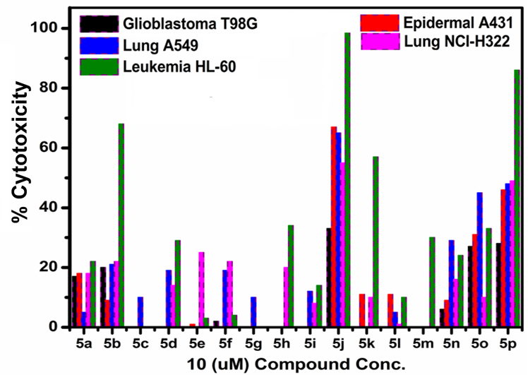

Figure S2. Cytoxicity profile of synthesized compounds 5(a-p) towards some human cancer cell lines.

References:
1. V.Vichai, K .Kirtikara, Nat. Protoc.2006, 1, 1112–1116.
2. Dassault Systèmes BIOVIA, Discovery Studio Client V 18.1, SanDiego:Dassault Systèmes, 2018.
3.W.L.Jorgensen,D.S.Maxwell, J.Tirado-Rives, J. Am. Chem. Soc.1996, 118,11225-11236.
4.K.J.Bowers,D.E.Chow,H.Xu,R.O.Dror,M.P.Eastwood,B.A.Gregersen,F.D.Sacerdoti,Scalable algorithms for molecular dynamics simulations on commodity clusters.SC2006 conference, proceedings of the ACM/IEEE.
5.D.E.Shaw Research. (2016). Maestro-Desmond Interoperability Tools,Desmond Molecular Dynamics System, New York, NY,. Schrödinger, New York, NY, 2016
6.W.L.Jorgensen,J.Chandrasekhar,J.D.Madura,R.W.Impey,M. L.Klein,J. Chem. Phys.1983, 79,926-935.
7.T.Darden,D.York,L.Pedersen,J.Chem.Phys.1993,98,10089-10092.
8.S. Lambrako, J. Boris,E.Oran,I.Chandrasekhar,M.Nagumo, J. Comp. Phys. 1989, 85, 473-486
9.M.Y.Lone, A.Manhas, M.Athar,P.C.Jha,J. Biomol. Struct. Dyn.2018,36, 2951-2965.
10. A.Manhas,M.Y.Lone,P.CJha,J. Mol. Graph. Model.2017,75, 413-423.
11. A.Manhas,M.Y.Lone, P.C.Jha, J. Biomol. Struct. Dyn.2019, 1-19.
12.A.Manhas,A.Patel,M.Y.Lone,P.K.Jha,P.C.Jha,J.Cell.Biochem.2018,119,8490-8500.
13.S.Nosé, J. Chem. Phys.1984,81, 511-519.
14.G.J.Martyna,D.J.Tobias, M.L.Klein,J. Chem. Phys.1994, 101, 4177-4189.
15.M.Tuckerman,B.J.Berne,G.J.Martyna,J.Chem.Phys.1992,97, 1990-2001.

NMR spectras:
¹H and ¹³C NMR spectra of 1-benzylpyrrolidin-3-ol:
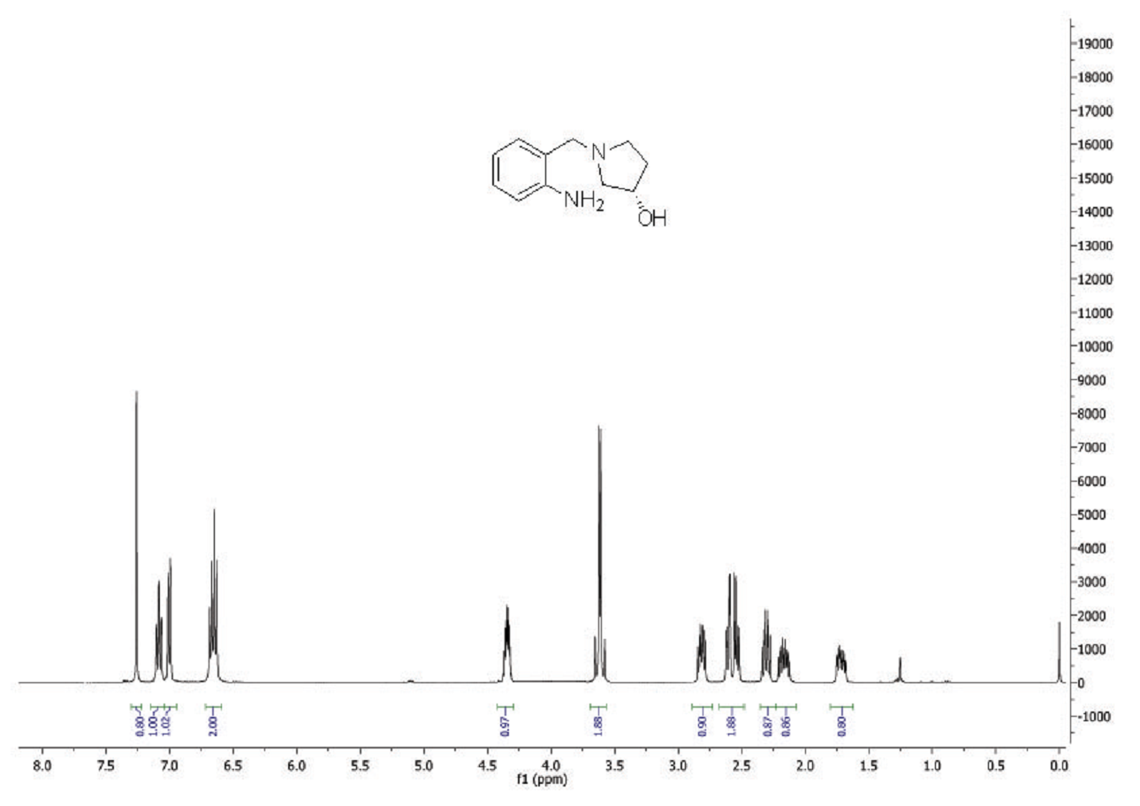
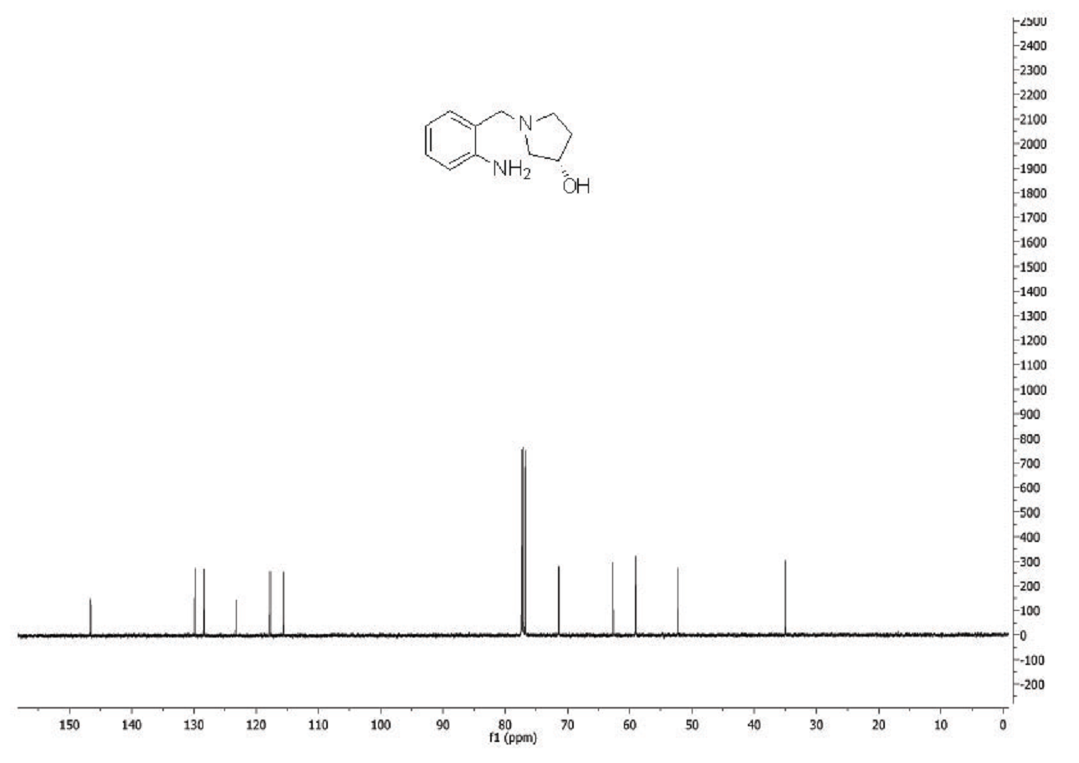
¹H spectra of compound 5a:
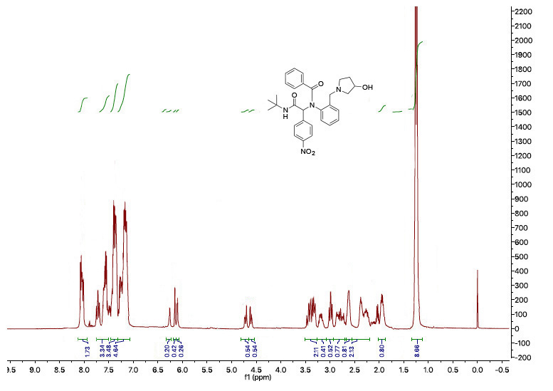
¹H spectra of compound 5b:
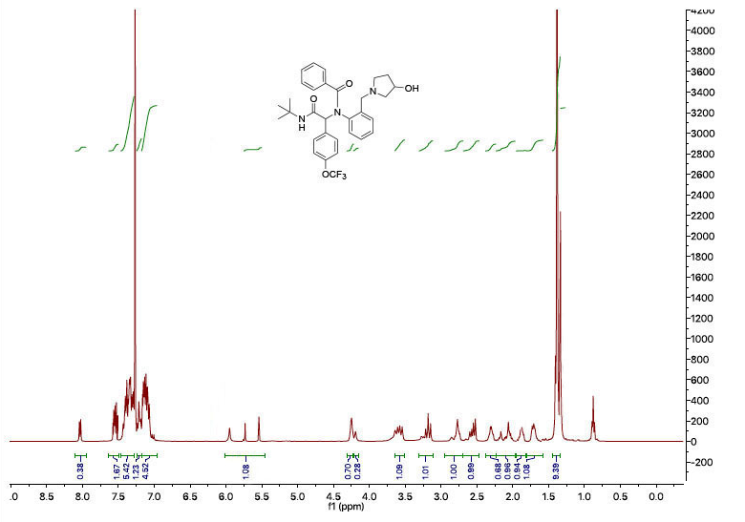
¹H spectra of compound 5c:
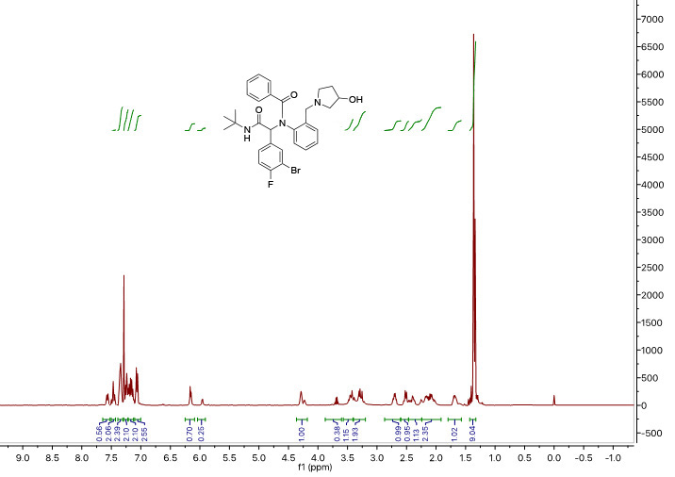
¹H spectra of compound 5d: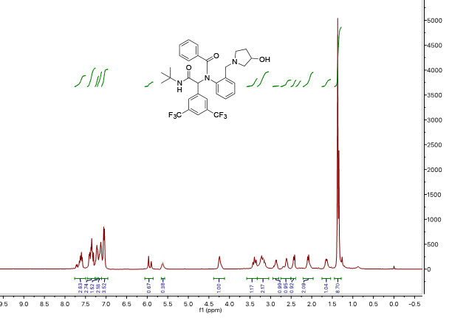
¹H spectra of compound 5e:

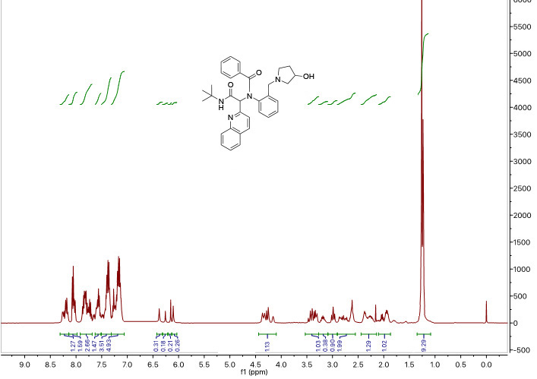
¹H spectra of compound 5f:
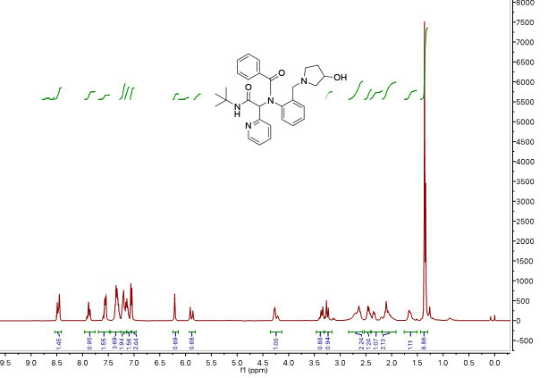
¹H spectra of compound 5g:
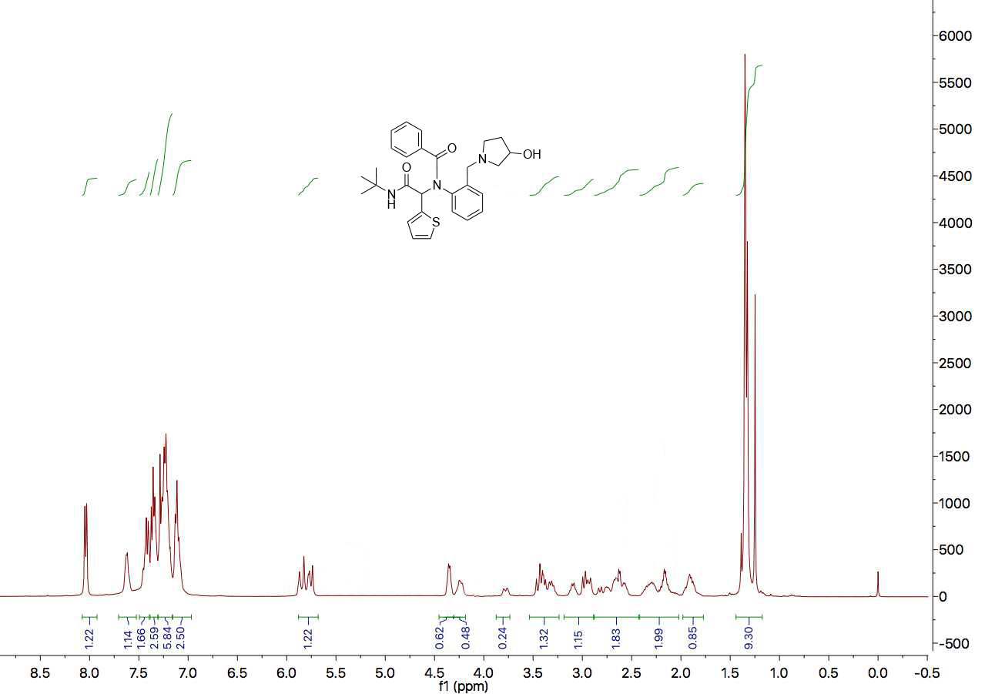
¹H spectra of compound 5h:
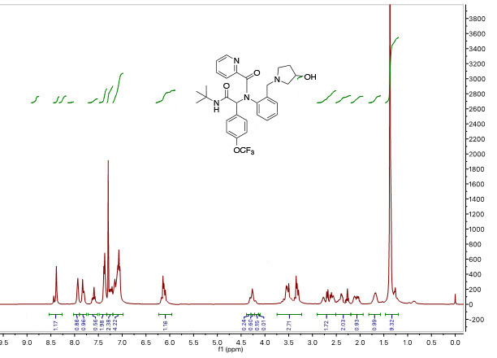
¹H spectra of compound 5i:
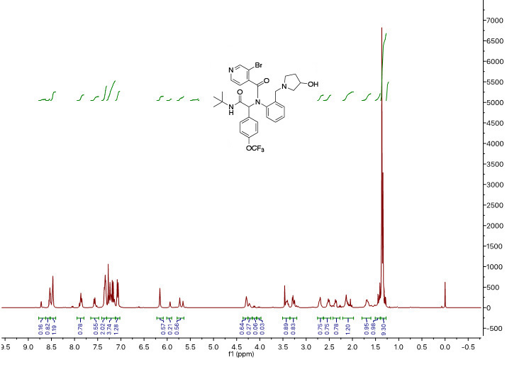

¹H spectra of compound 5j:
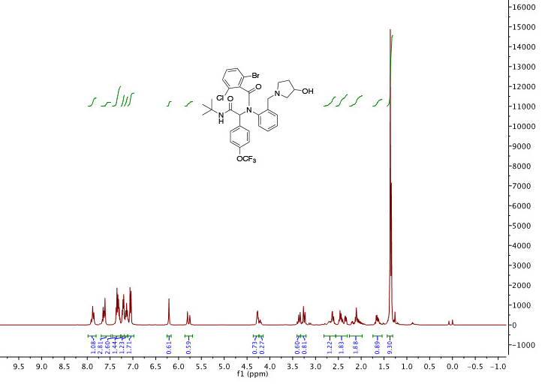
¹³C spectra of Compound 5j:
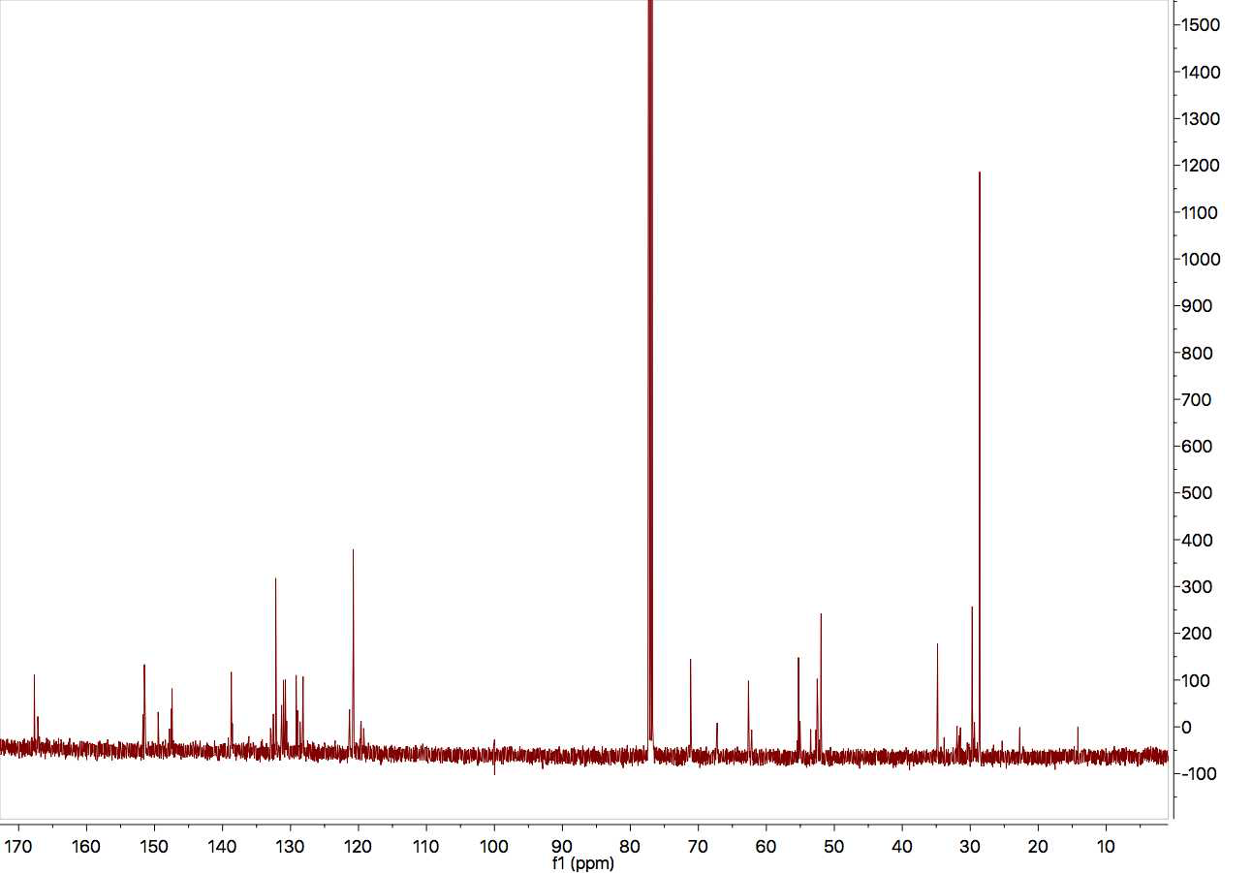
¹H spectra of compound 5k:
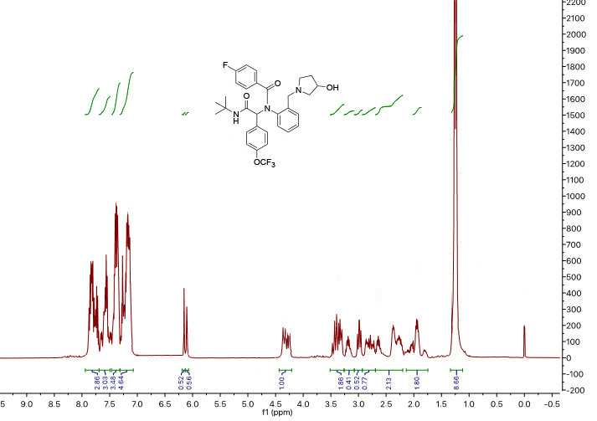
¹H spectra of compound 5l:
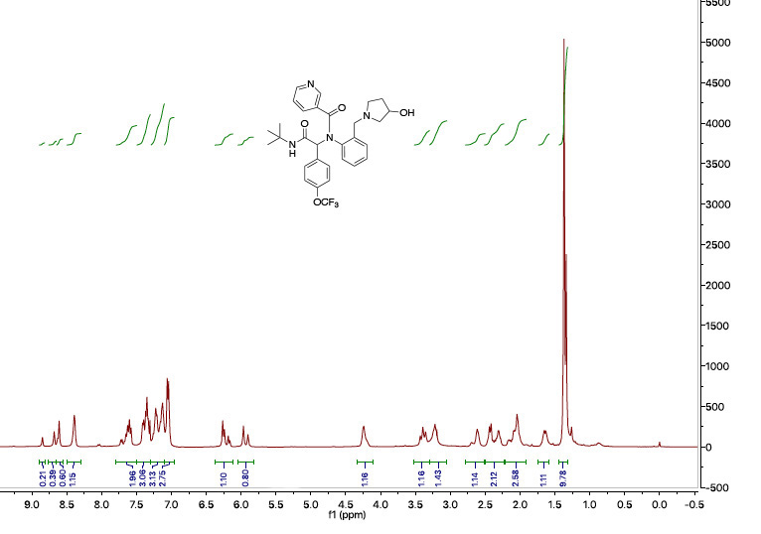
¹H spectra of compound 5m:
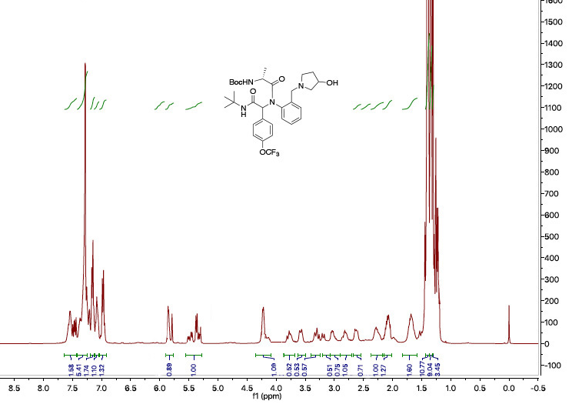
¹H spectra of compound 5n:
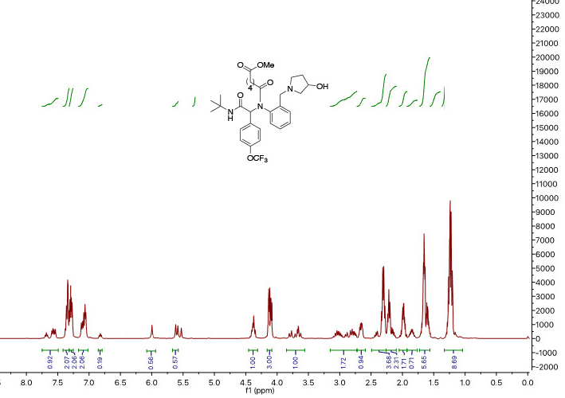
¹H spectra of compound 5o:
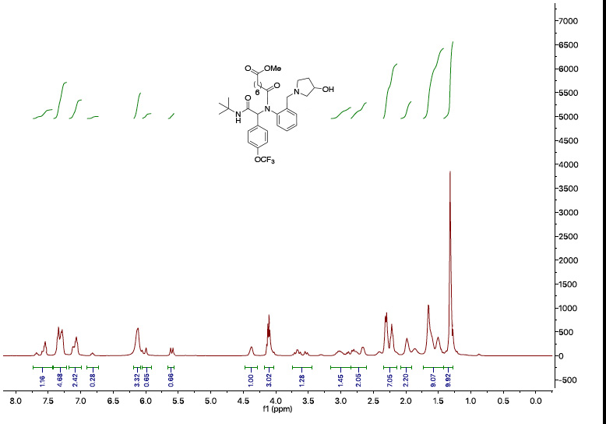

¹H spectra of compound 5p:
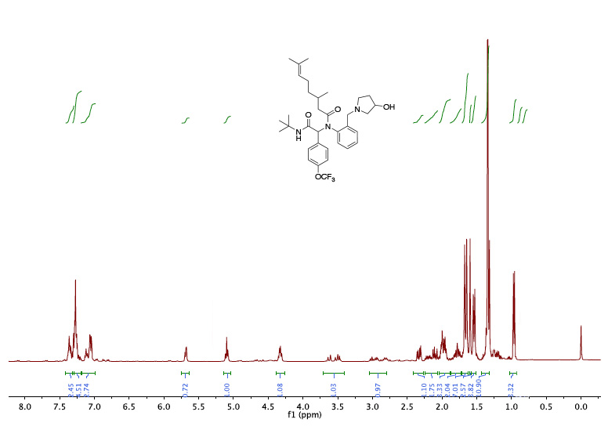
¹³C spectra of Compound 5p:
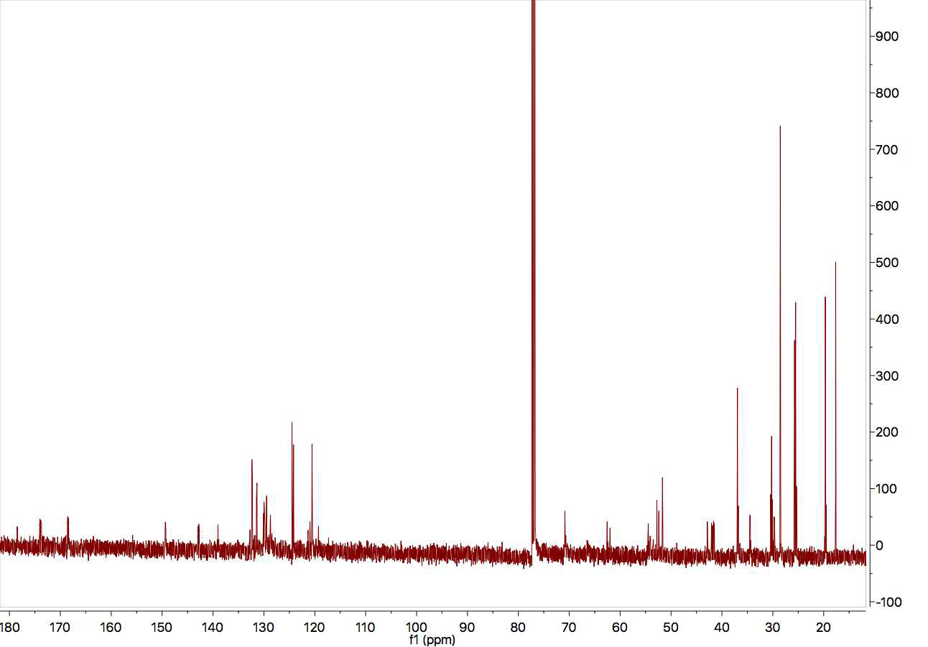
2.5.Massspectra of compound 5a:
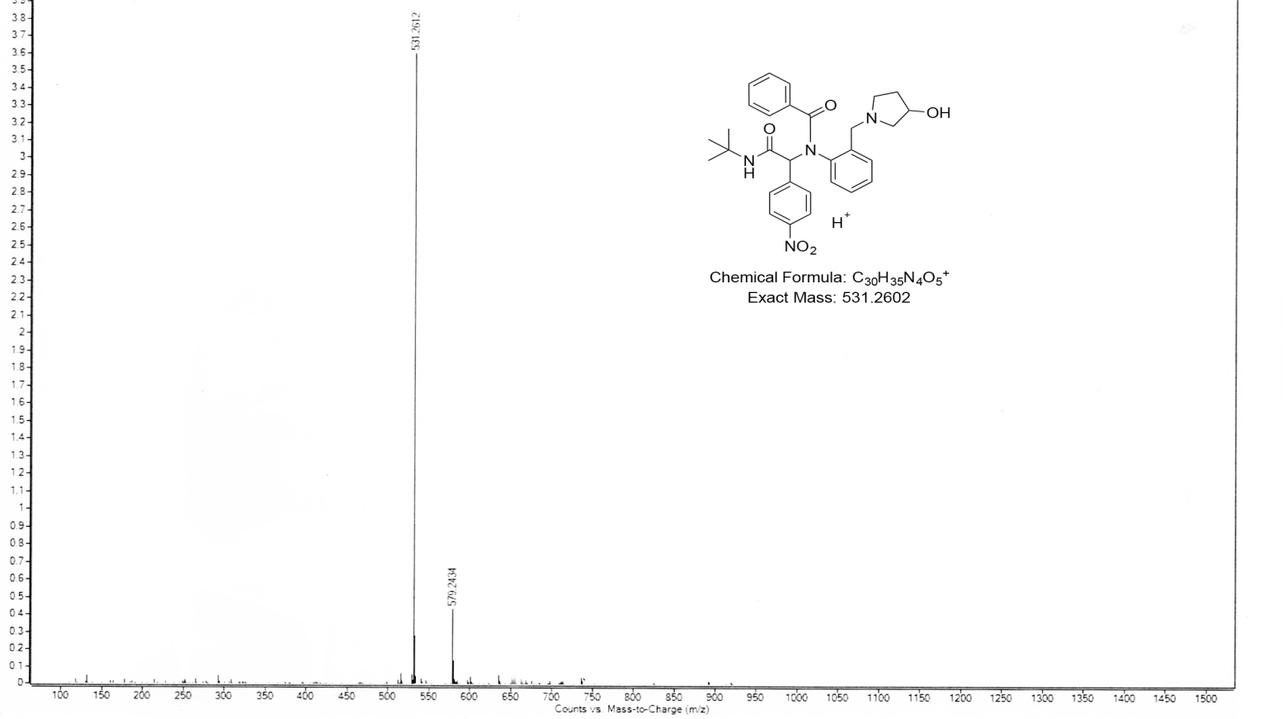
Mass spectra of compound 5b:
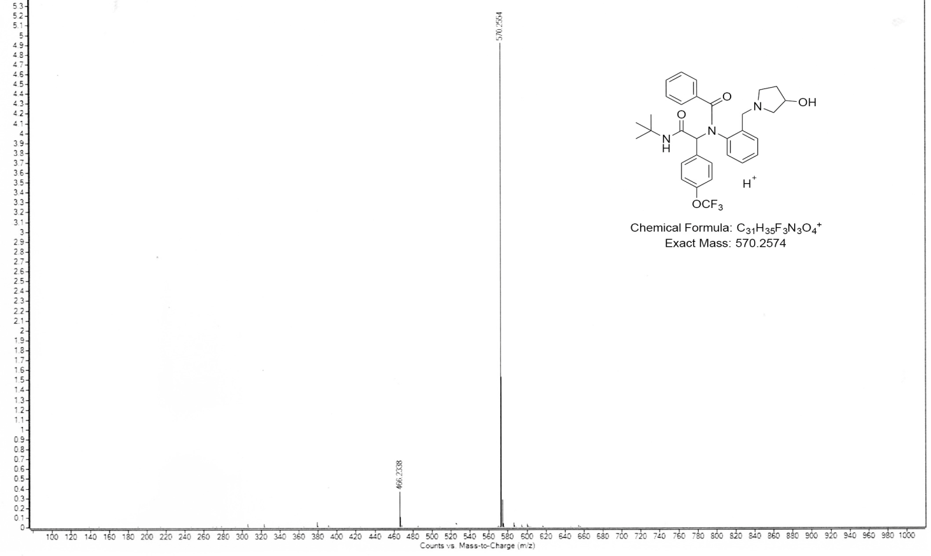

Mass spectra of compound 5c:
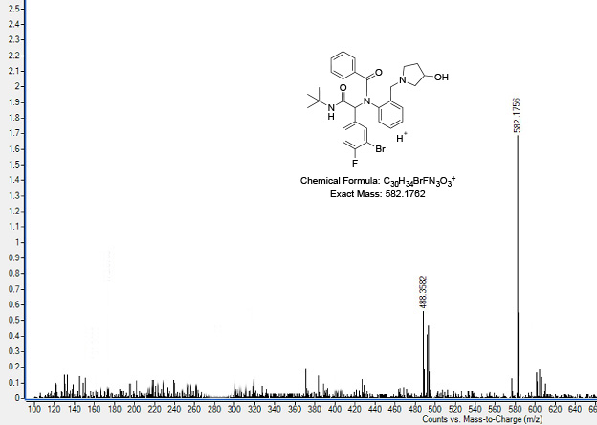
Mass spectra of compound 5d:
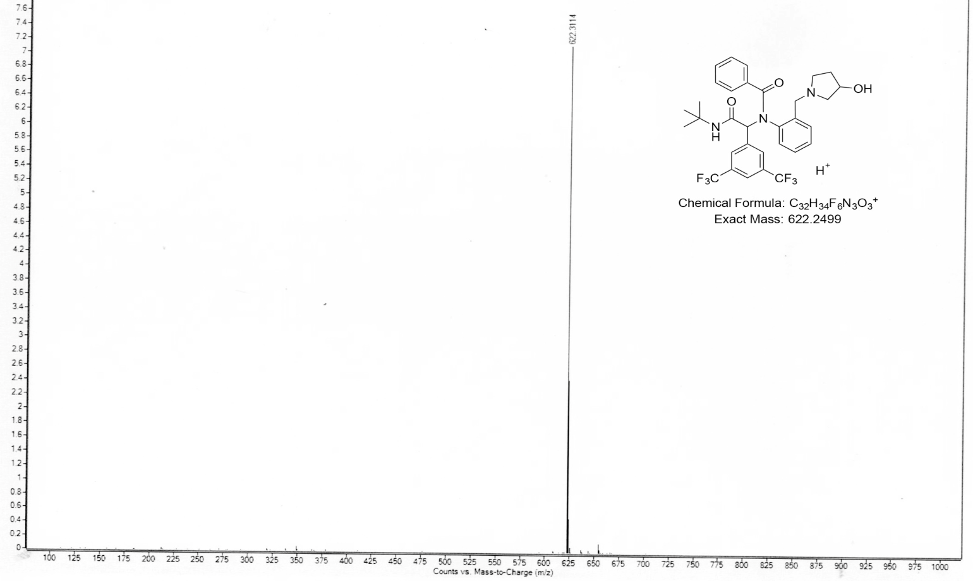
Mass spectra of compound 5e:
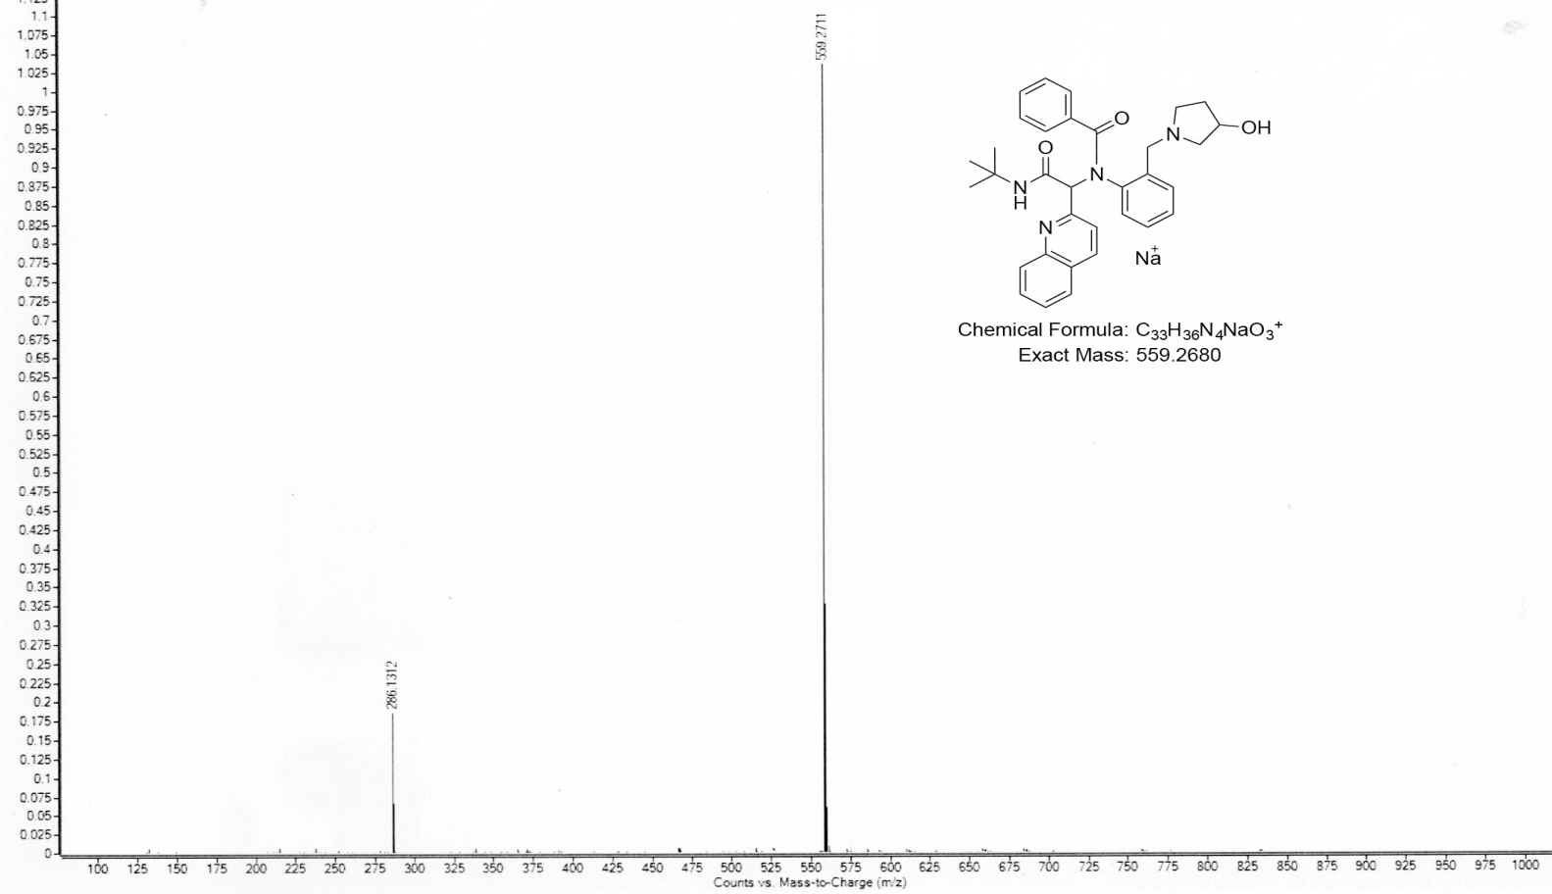
Mass spectra of compound 5f:
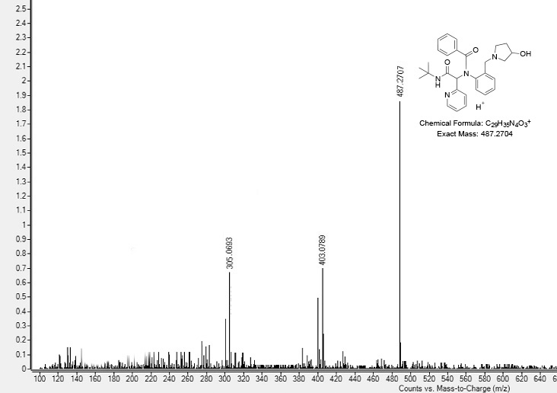
Mass spectra of compound 5g:
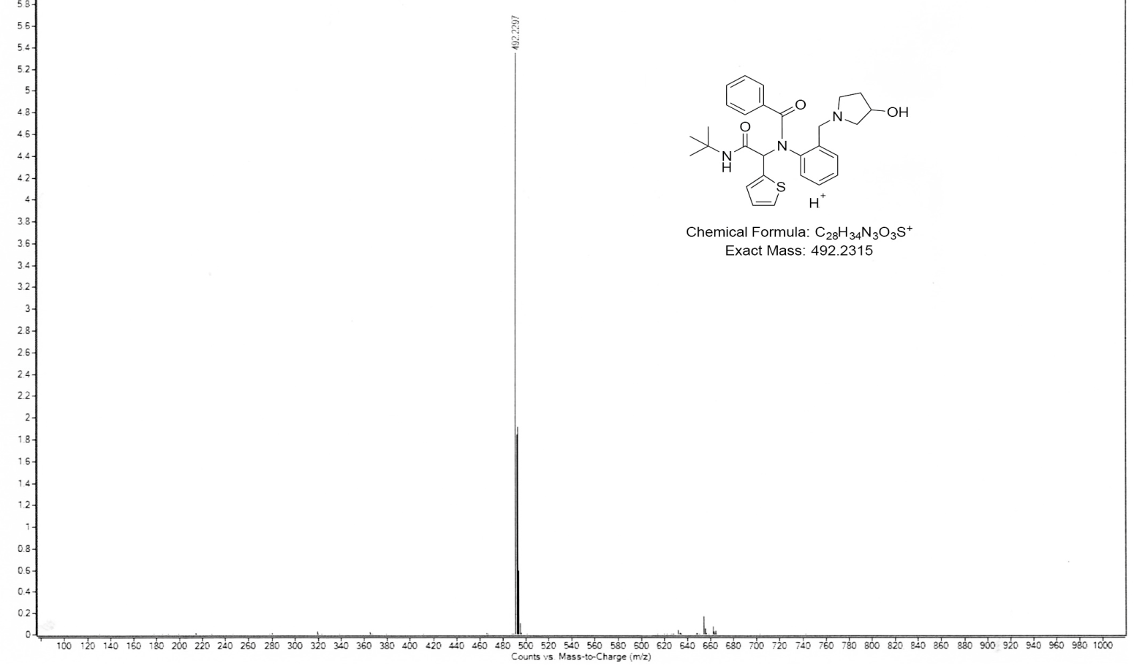
Mass spectra of compound 5h:
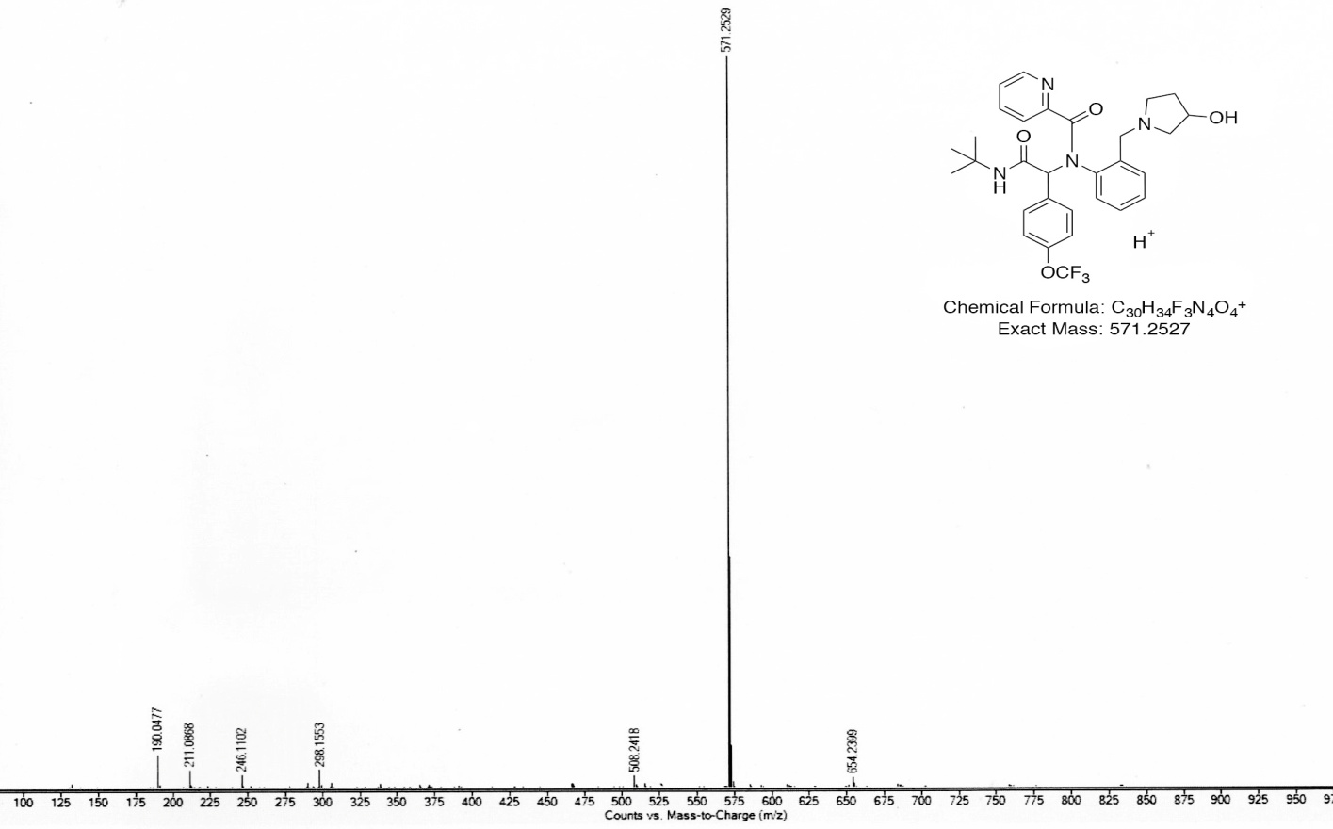

Mass spectra of compound 5i:
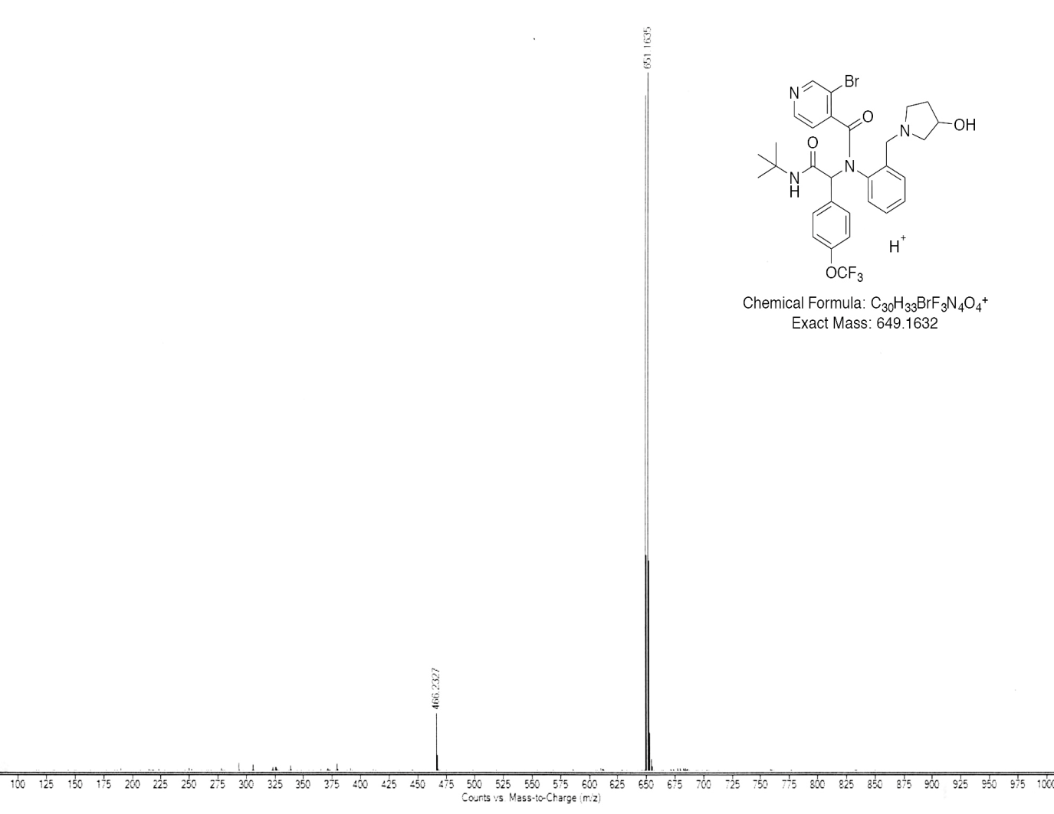
Mass spectra of compound 5j:
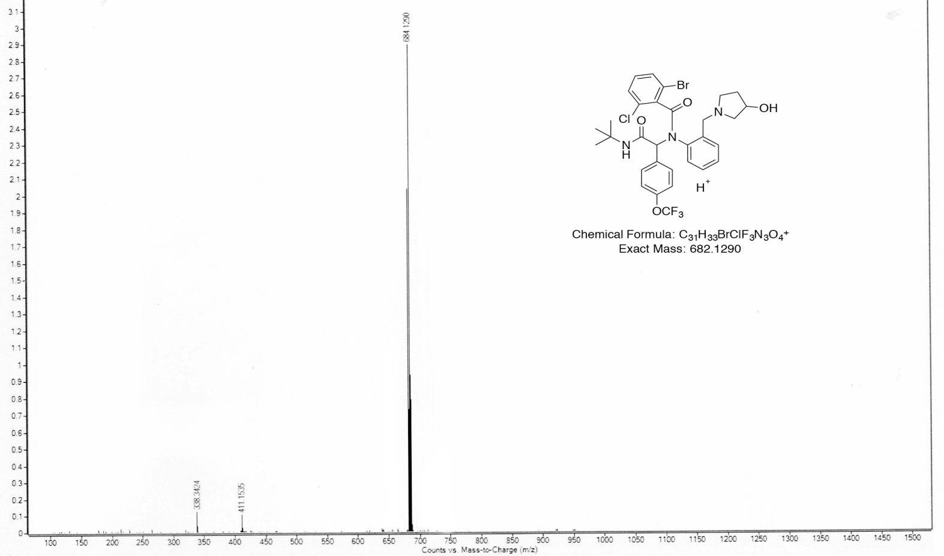
Mass spectra of compound 5k:
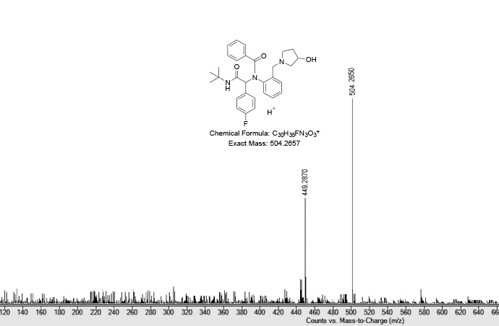
Mass spectra of compound 5l:
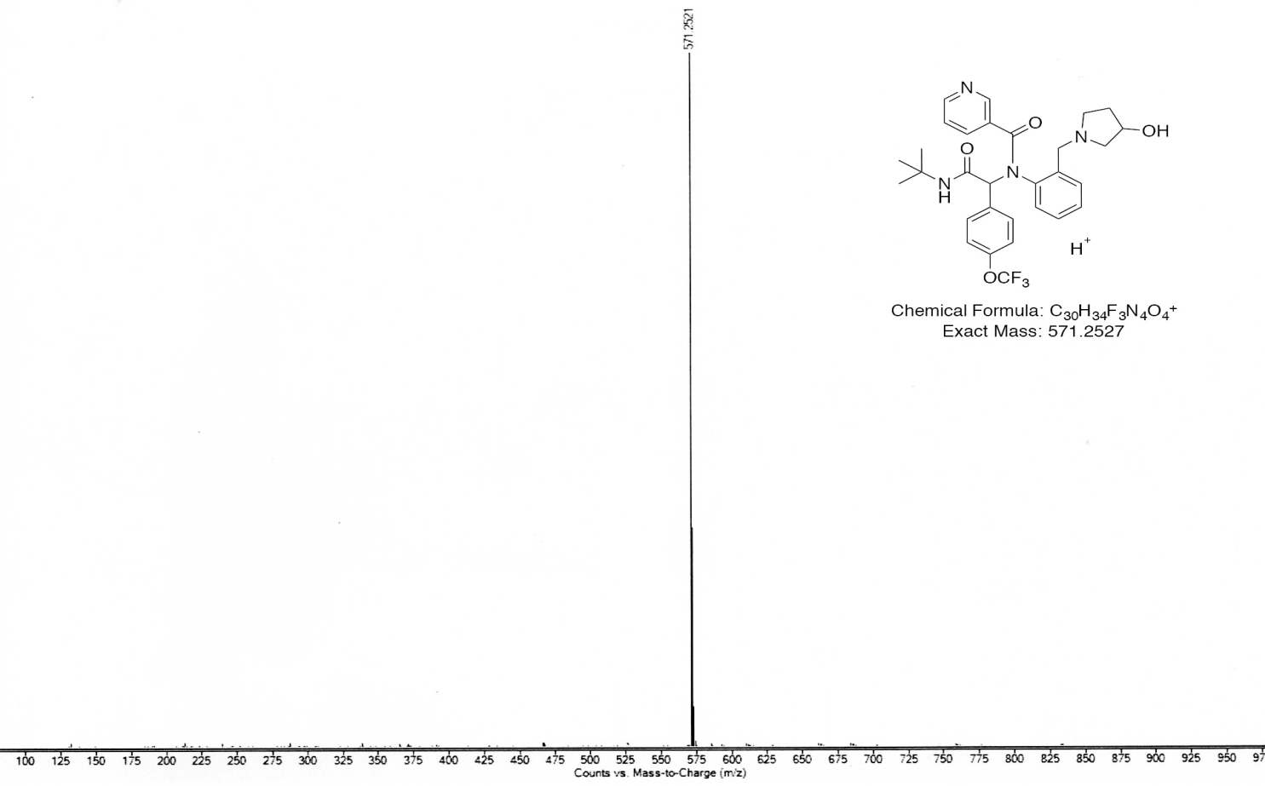
Mass spectra of compound 5m:
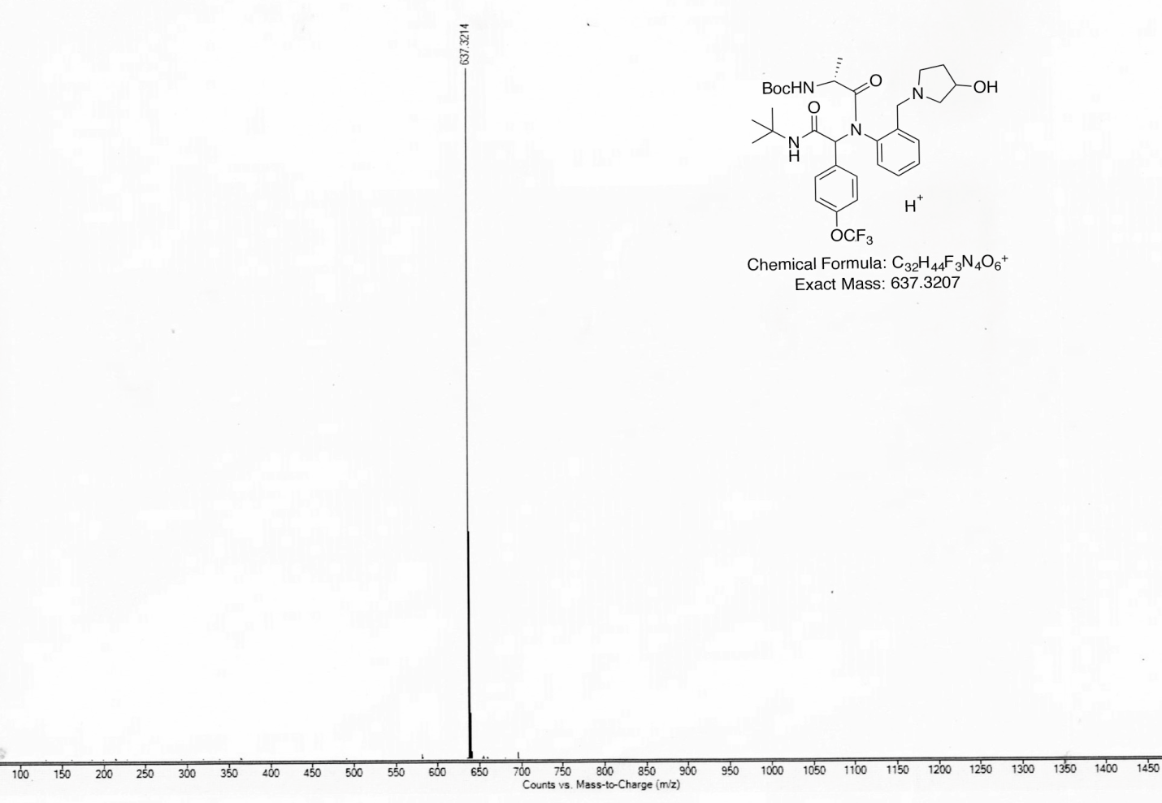
Mass spectra of compound 5n:
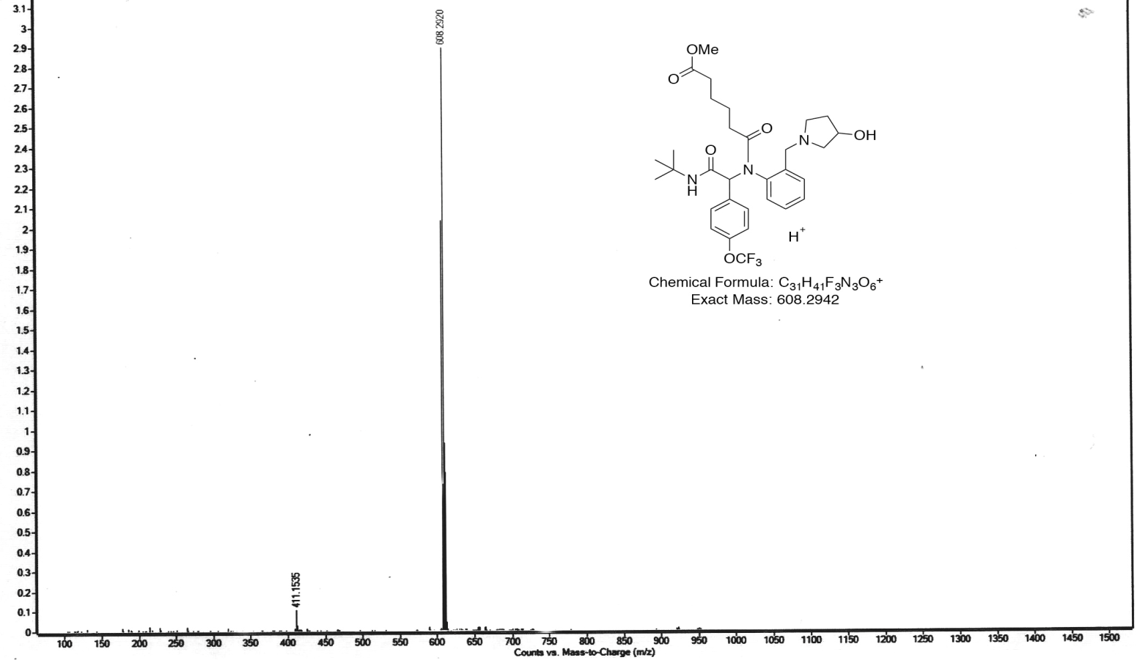
Mass spectra of compound 5o:
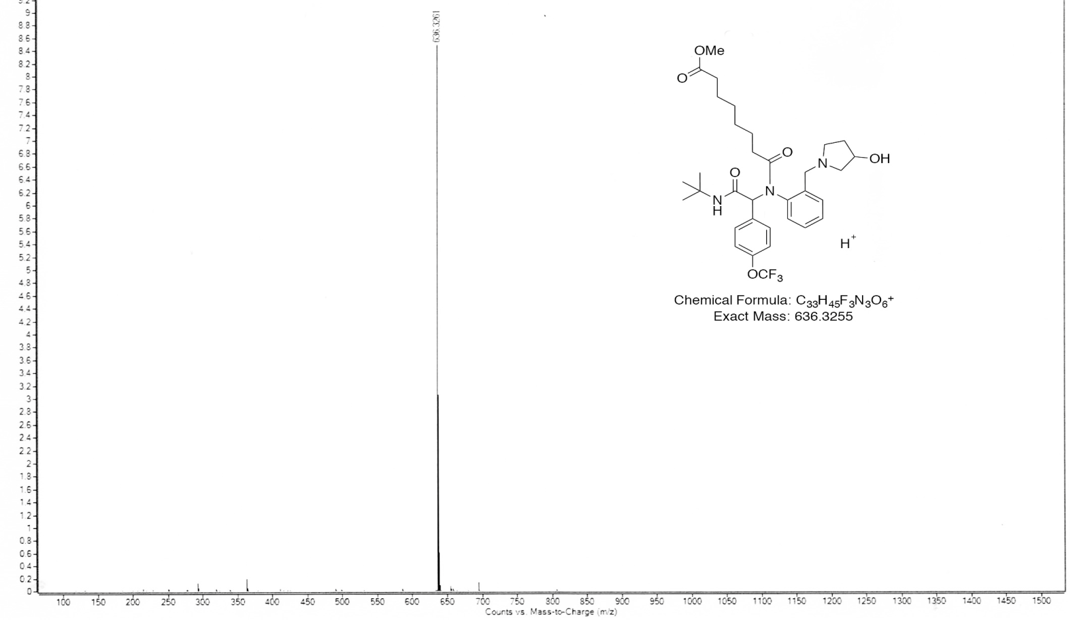
Mass spectra of compound 5p:
