SUPPORTING INFORMATION
The Synthesis of (2R)-Aziridine-2-carboxylic Acid Containing Dipeptides
S. Kuzmič,ª M. Hrast,ª R. Frlan^{a*}
ªUniversity of Ljubljana, Faculty of Pharmacy, The Chair of Pharmaceutical Chemistry, Aškerčeva 7, 1000 Ljubljana, Slovenia
*E-mail: rok.frlan@ffa.uni-lj.si; Tel.: +386 1 4769 674; Fax: +386-1-4258031
Table of contents
Figure S1: ¹H NMR spectra of methyl trityl-D-serinate (5). 3
Figure S2: ¹H NMR spectra of methyl (R)-1-tritylaziridine-2-carboxylate (6). 4
Figure S3: ¹³C NMR spectra of potassium (R)-1-tritylaziridine-2-carboxylate (7). 4
Figure S4: ¹H NMR spectra of methyl ((R)-1-tritylaziridine-2-carbonyl)-D-alaninate (8a). 5
Figure S5: ¹³C NMR spectra of methyl ((R)-1-tritylaziridine-2-carbonyl)-D-alaninate (8a). 5
Figure S6: ¹H NMR spectra of (R)-N-(3-(methylperoxy)propyl)-1-tritylaziridine-2-carboxamide (8b). 6
Figure S7: ¹³C NMR spectra of (R)-N-(3-(methylperoxy)propyl)-1-tritylaziridine-2-carboxamide (8b). 6
Figure S8: ¹H NMR spectra of methyl ((R)-1-tritylaziridine-2-carbonyl)-D-phenylalaninate (8c). 7
Figure S9: ¹³C NMR spectra of methyl ((R)-1-tritylaziridine-2-carbonyl)-D-phenylalaninate (8c). 7
Figure S10: ¹H NMR spectra of methyl dimethyl ((R)-1-tritylaziridine-2-carbonyl)-D-glutamate (8e). 8
Figure S11: ¹³C NMR spectra of methyl dimethyl ((R)-1-tritylaziridine-2-carbonyl)-D-glutamate (8e). 8
Figure S12: ¹H NMR spectra of methyl ((R)-aziridine-2-carbonyl)-D-alaninate (9a). 9
Figure S13: ¹³C NMR spectra of methyl ((R)-aziridine-2-carbonyl)-D-alaninate (9a). 9
Figure S14: ¹H NMR spectra of methyl (R)-3-(aziridine-2-carboxamido)propanoate (9b). 10
Figure S15: ¹³C NMR spectra of methyl (R)-3-(aziridine-2-carboxamido)propanoate (9b). 10
Figure S16: ¹H NMR spectra of methyl ((R)-aziridine-2-carbonyl)-D-phenylalaninate (9c). 11
Figure S17: ¹³C NMR spectra of methyl ((R)-aziridine-2-carbonyl)-D-phenylalaninate (9c). 11
Figure S18: ¹H NMR spectra of methyl ((R)-aziridine-2-carbonyl)-D-valinate (9d). 12
Figure S19: ¹³C NMR spectra of methyl ((R)-aziridine-2-carbonyl)-D-valinate (9d). 12
Figure S20: ¹H NMR spectra of dimethyl ((R)-aziridine-2-carbonyl)-D-glutamate (9e). 13
Figure S21: ¹³C NMR spectra of dimethyl ((R)-aziridine-2-carbonyl)-D-glutamate (9e) 13
Figure S22: ¹H NMR spectra of (R)-(aziridine-2-carbonyl)alanine(2a). 14
Figure S24: ¹H NMR spectra of ((R)-aziridine-2-carbonyl)-D-phenylalanine (2c). 15
Figure S25: ¹H NMR spectra of ((R)-aziridine-2-carbonyl)-D-valine (2d). 16
Figure S26: ¹³C NMR spectra of ((R)-aziridine-2-carbonyl)-D-valine (2d). 16
Figure S27: ¹H NMR spectra of benzyl (R)-1-((tert-butoxycarbonyl)-D-alanyl)aziridine-2-carboxylate (11). 17
Figure S28: ¹³C NMR spectra of benzyl (R)-1-((tert-butoxycarbonyl)-D-alanyl)aziridine-2-carboxylate (11). 17
Figure S29: ¹H NMR spectra of benzyl (R)-1-(((benzyloxy)carbonyl)-D-phenylalanyl)aziridine-2-carboxylate (13). 18

Figure S1: ¹H NMR spectra of methyl trityl-D-serinate (5).
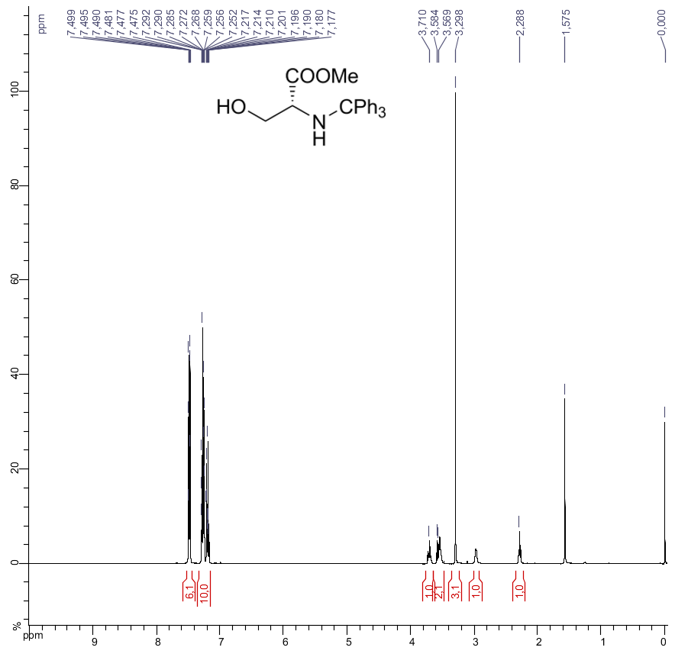

Figure S2: ¹H NMR spectra of methyl (R)-1-tritylaziridine-2-carboxylate (6).
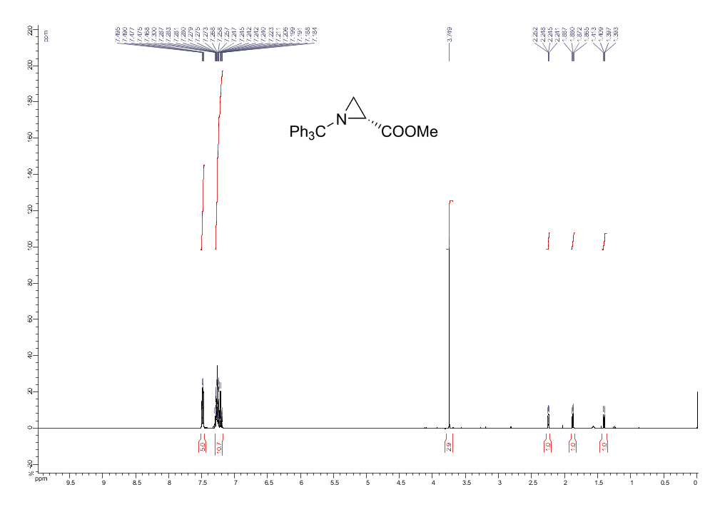

Figure S3: ¹³C NMR spectra of potassium (R)-1-tritylaziridine-2-carboxylate (7).
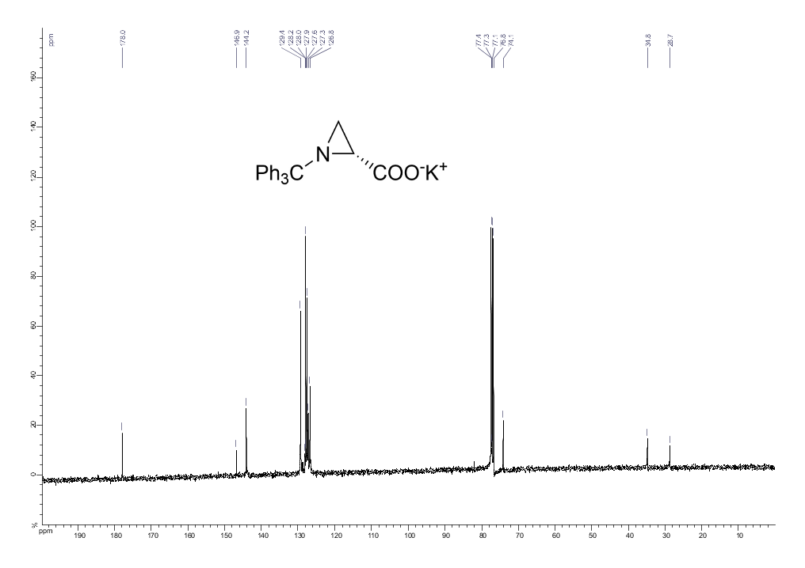

Figure S4: ¹H NMR spectra of methyl ((R)-1-tritylaziridine-2-carbonyl)-D-alaninate (8a).
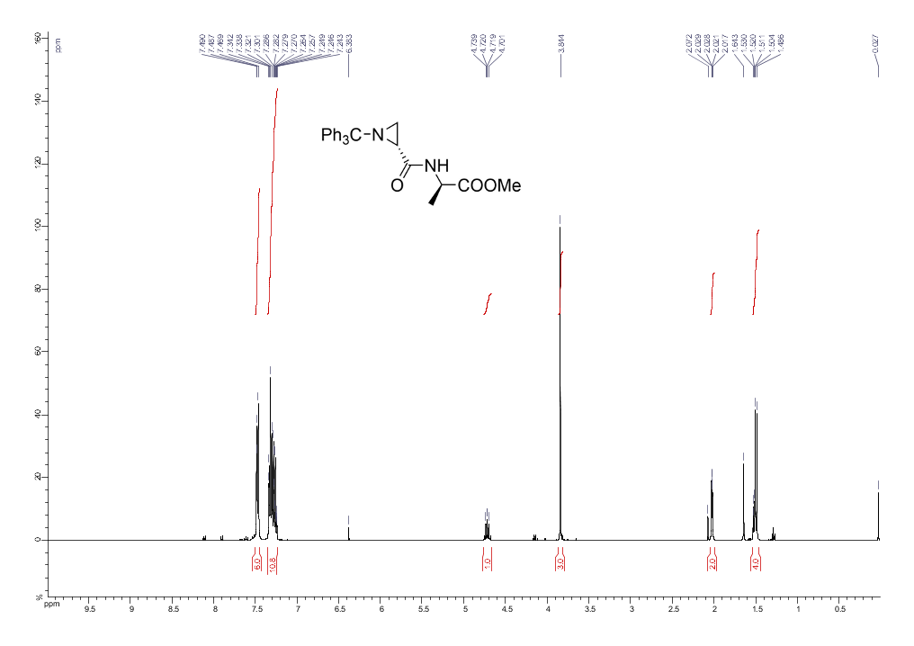

Figure S5: ¹³C NMR spectra of methyl ((R)-1-tritylaziridine-2-carbonyl)-D-alaninate (8a).
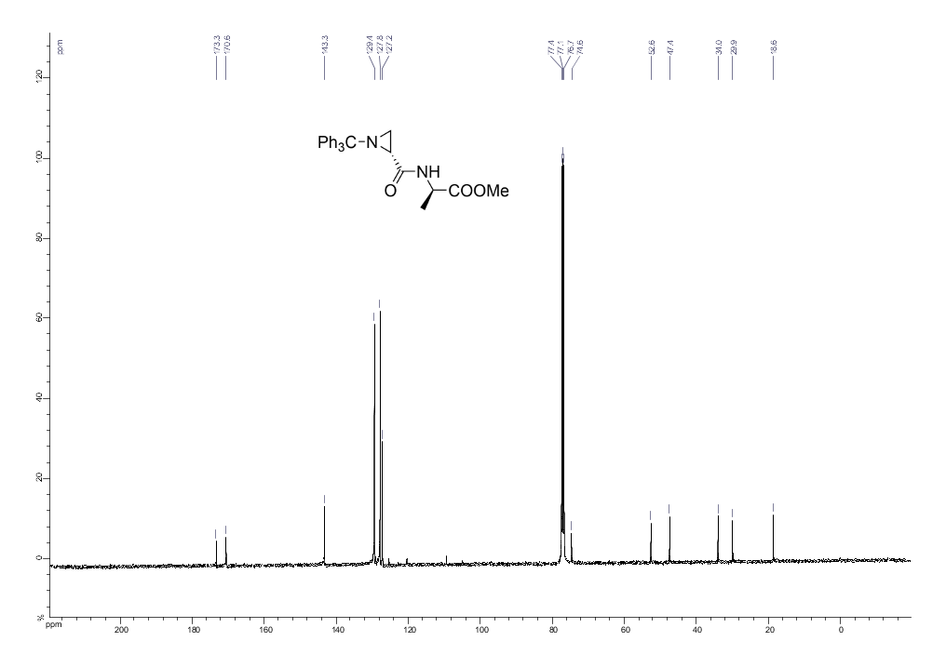

Figure S6: ¹H NMR spectra of (R)-N-(3-(methylperoxy)propyl)-1-tritylaziridine-2-carboxamide (8b).
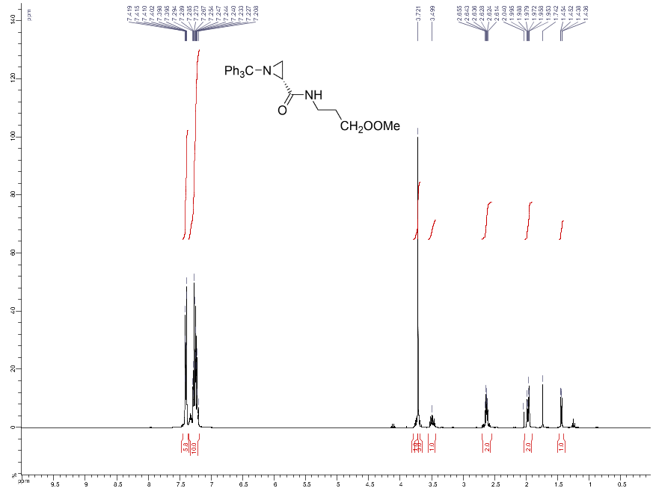
Figure S7: ¹³C NMR spectra of (R)-N-(3-(methylperoxy)propyl)-1-tritylaziridine-2-carboxamide (8b).
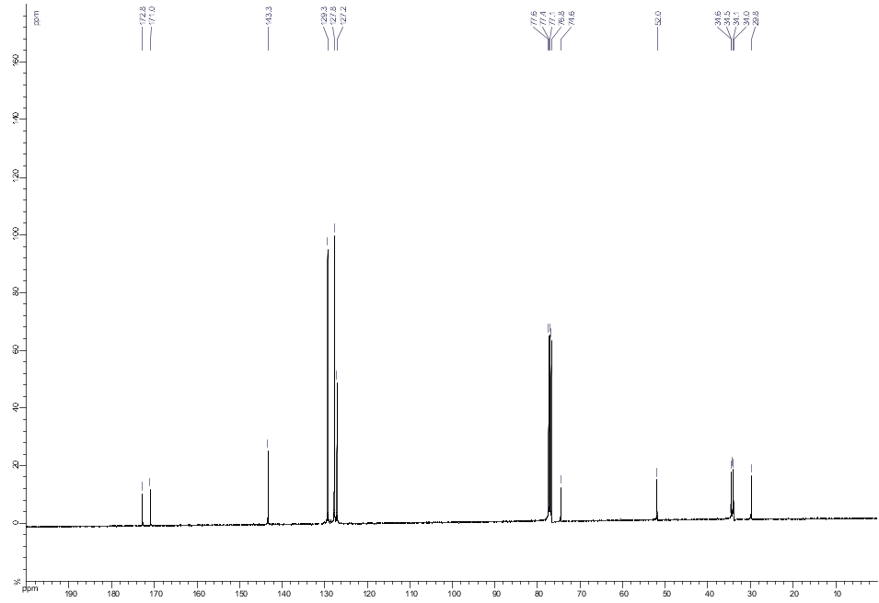

Figure S8: ¹H NMR spectra of methyl ((R)-1-tritylaziridine-2-carbonyl)-D-phenylalaninate (8c).
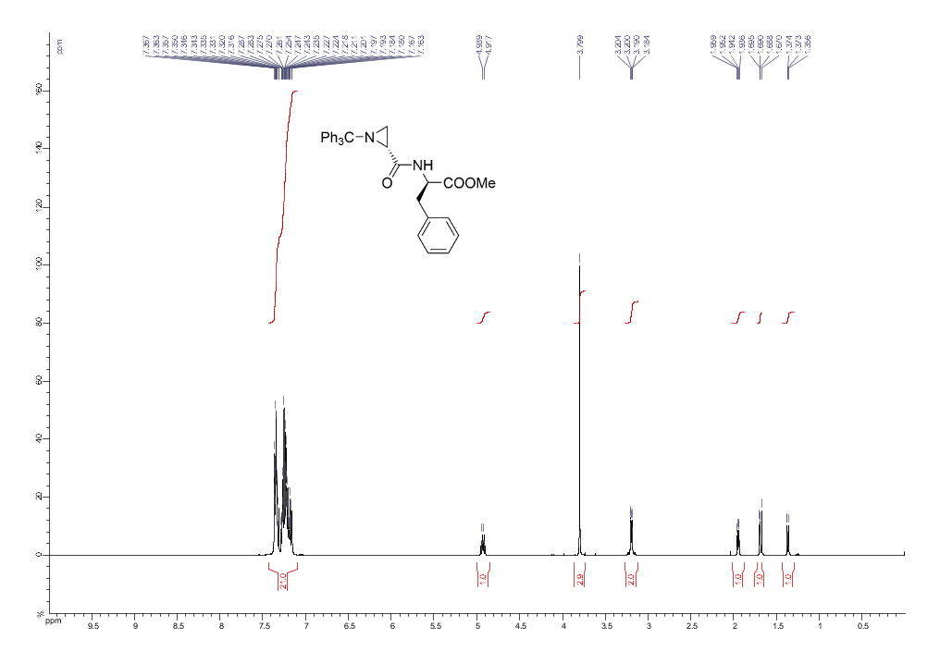Figure S9: ¹³C NMR spectra of methyl ((R)-1-tritylaziridine-2-carbonyl)-D-phenylalaninate (8c).
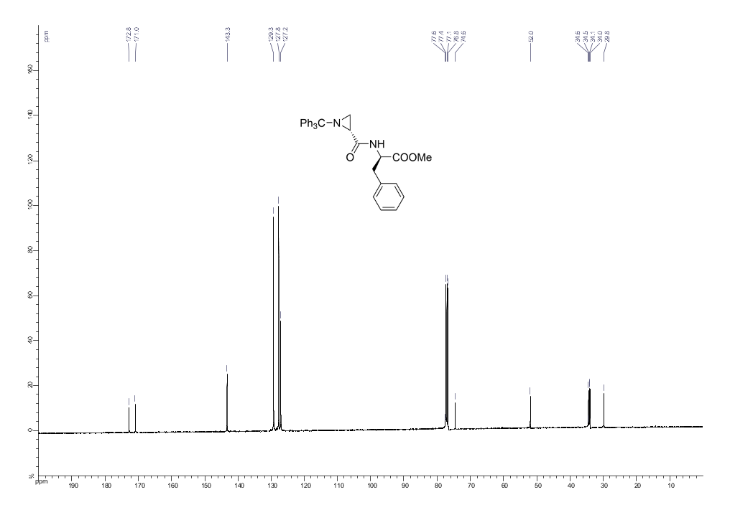

Figure S10: ¹H NMR spectra of methyl dimethyl ((R)-1-tritylaziridine-2-carbonyl)-D-glutamate (8e).
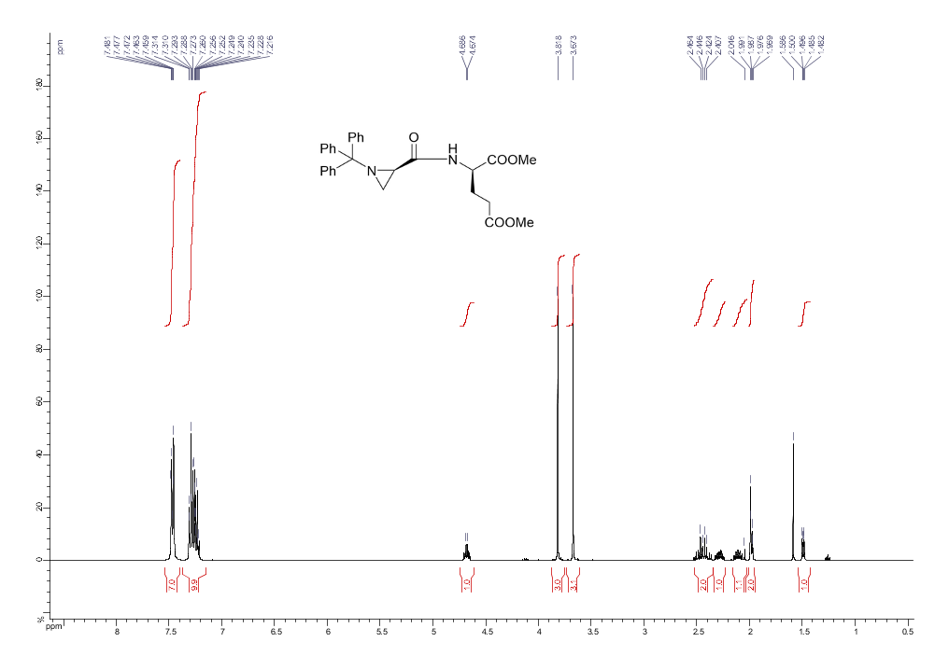Figure S11: ¹³C NMR spectra of methyl dimethyl ((R)-1-tritylaziridine-2-carbonyl)-D-glutamate (8e).
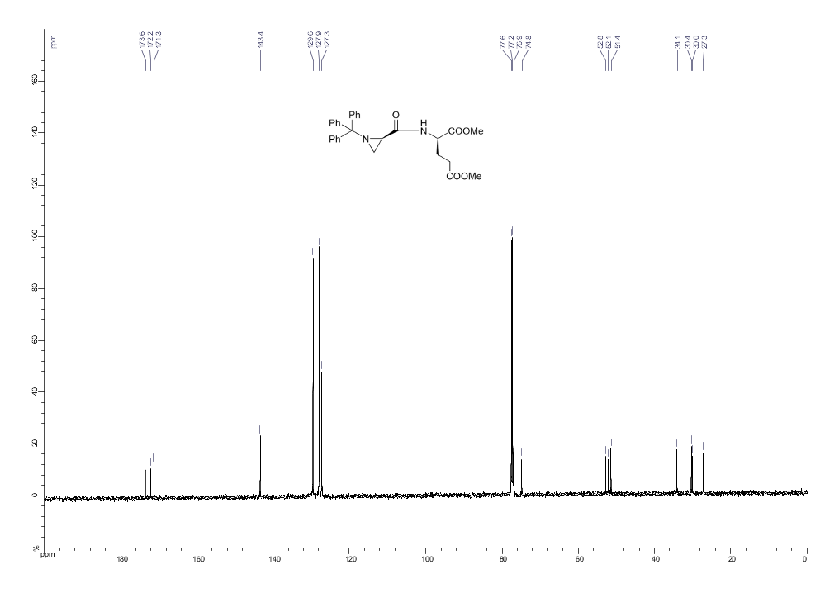

Figure S12: ¹H NMR spectra of methyl ((R)-aziridine-2-carbonyl)-D-alaninate (9a).
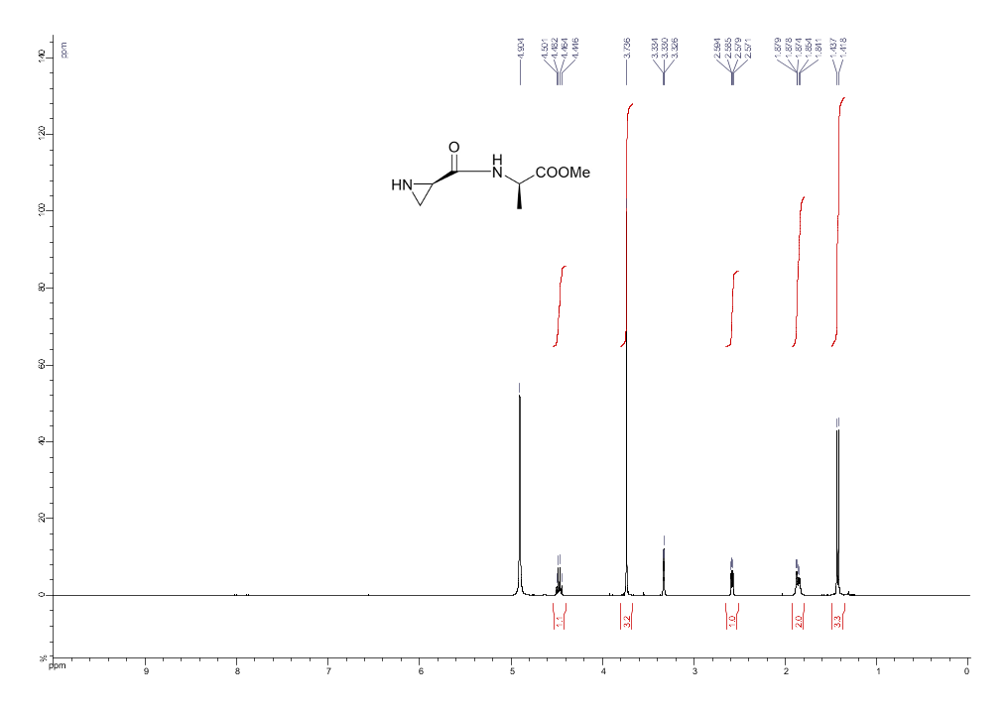

Figure S13: ¹³C NMR spectra of methyl ((R)-aziridine-2-carbonyl)-D-alaninate (9a).
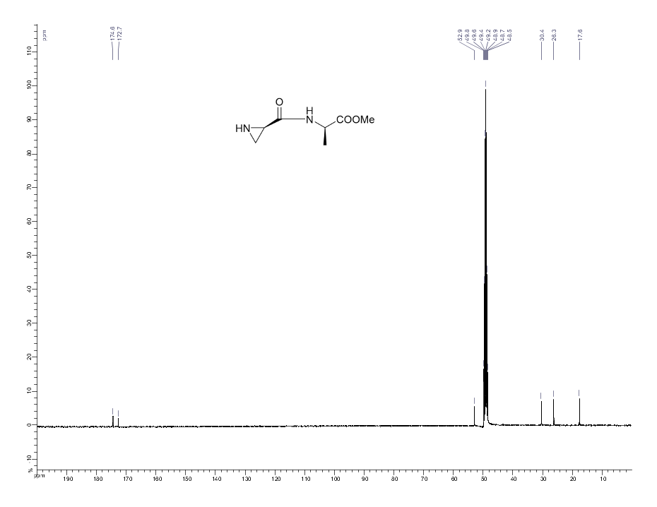

Figure S14: ¹H NMR spectra of methyl (R)-3-(aziridine-2-carboxamido)propanoate (9b).
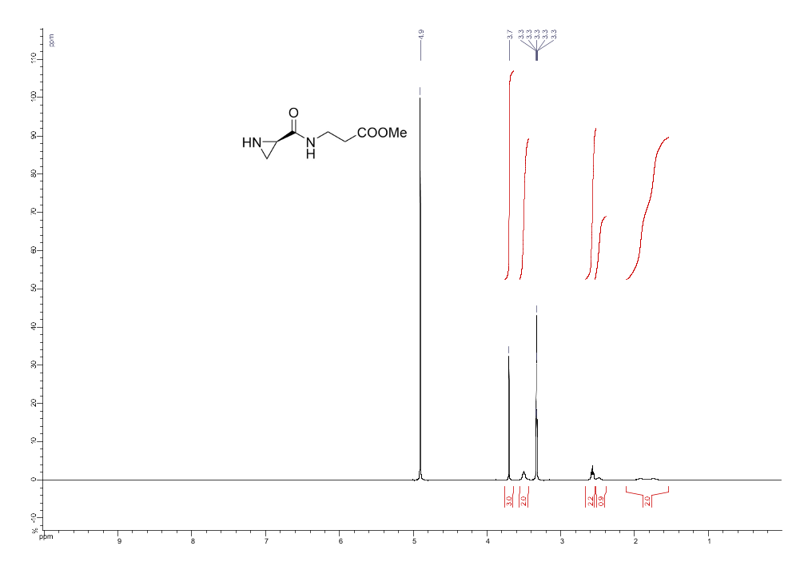

Figure S15: ¹³C NMR spectra of methyl (R)-3-(aziridine-2-carboxamido)propanoate (9b).

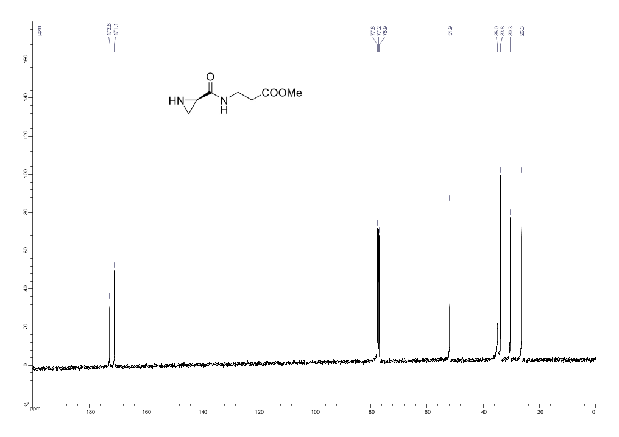

Figure S16: ¹H NMR spectra of methyl ((R)-aziridine-2-carbonyl)-D-phenylalaninate (9c).
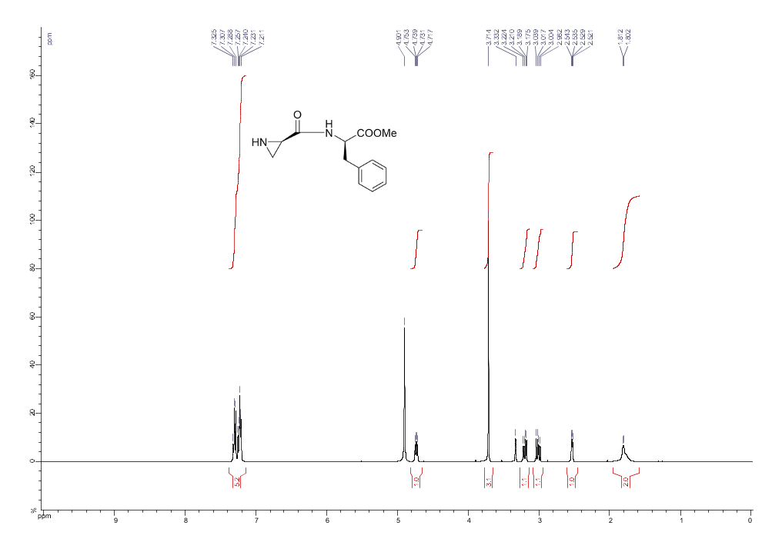

Figure S17: ¹³C NMR spectra of methyl ((R)-aziridine-2-carbonyl)-D-phenylalaninate (9c).

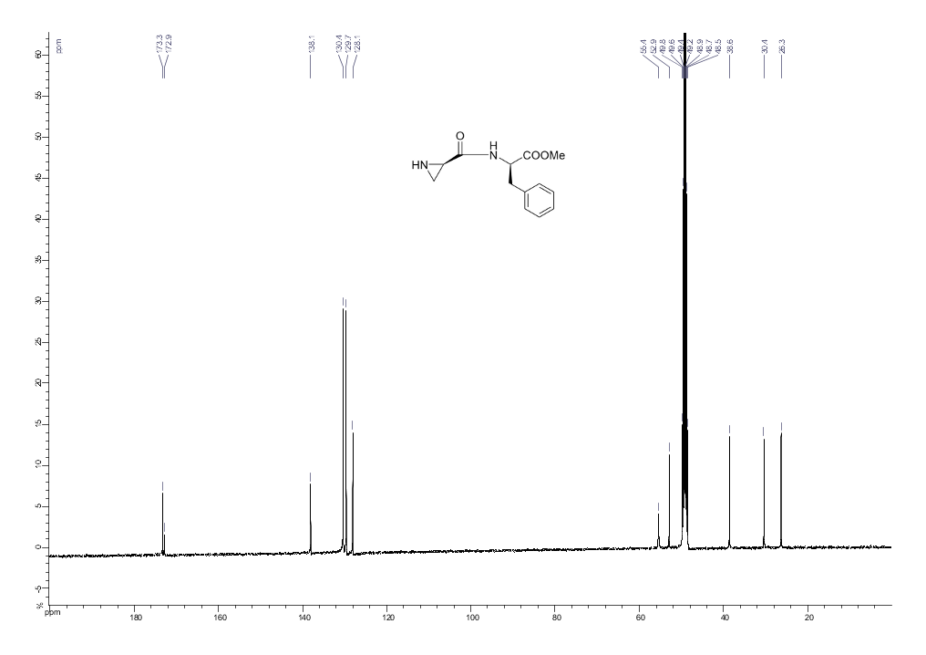

Figure S18: ¹H NMR spectra of methyl ((R)-aziridine-2-carbonyl)-D-valinate (9d).
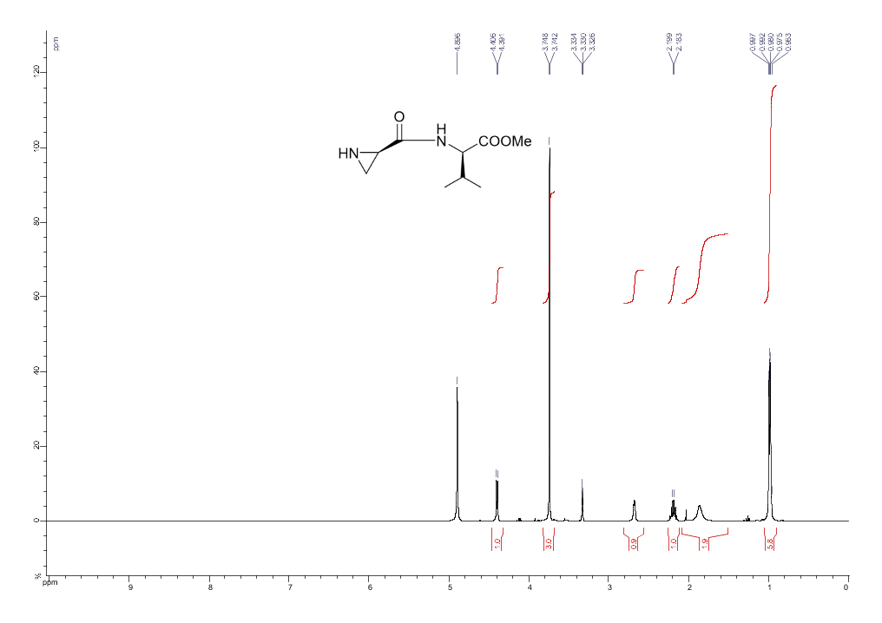

Figure S19: ¹³C NMR spectra of methyl ((R)-aziridine-2-carbonyl)-D-valinate (9d).

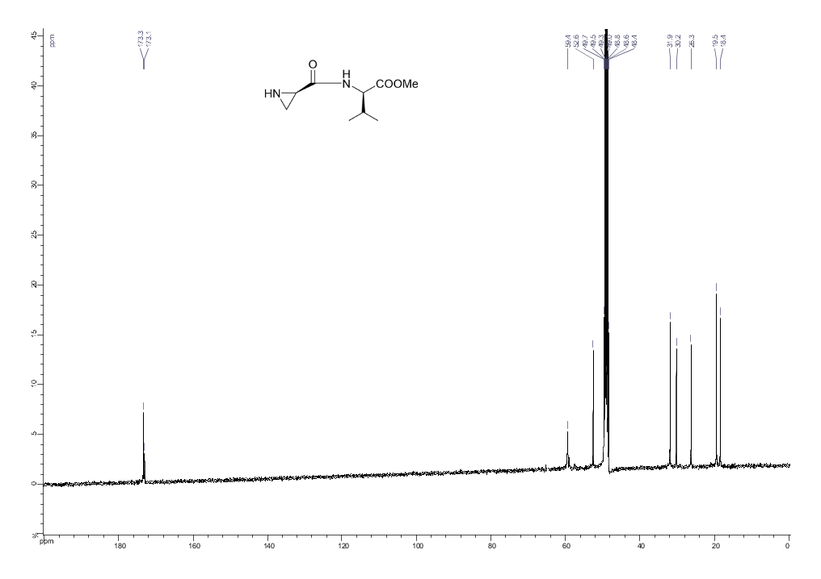

Figure S20: ¹H NMR spectra of dimethyl ((R)-aziridine-2-carbonyl)-D-glutamate (9e).
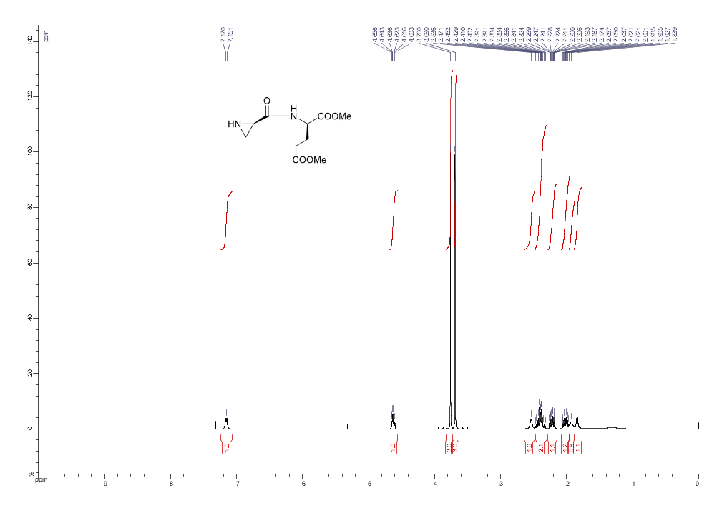

Figure S21: ¹³C NMR spectra of dimethyl ((R)-aziridine-2-carbonyl)-D-glutamate (9e)

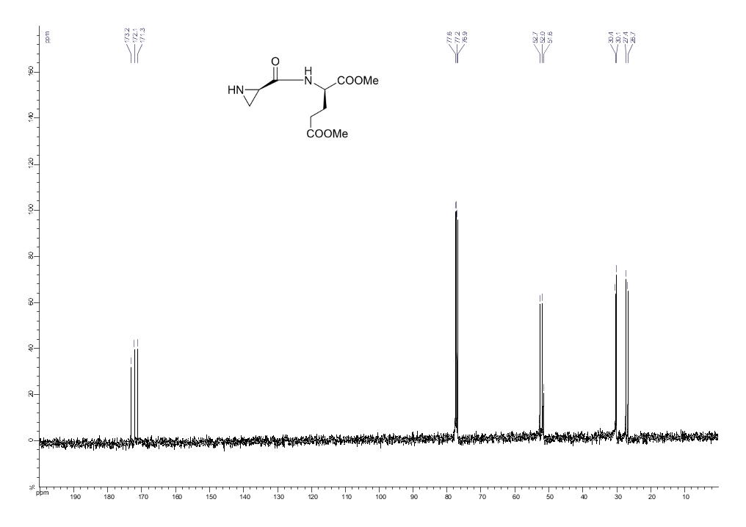

Figure S22: ¹H NMR spectra of (R)-(aziridine-2-carbonyl)alanine(2a).
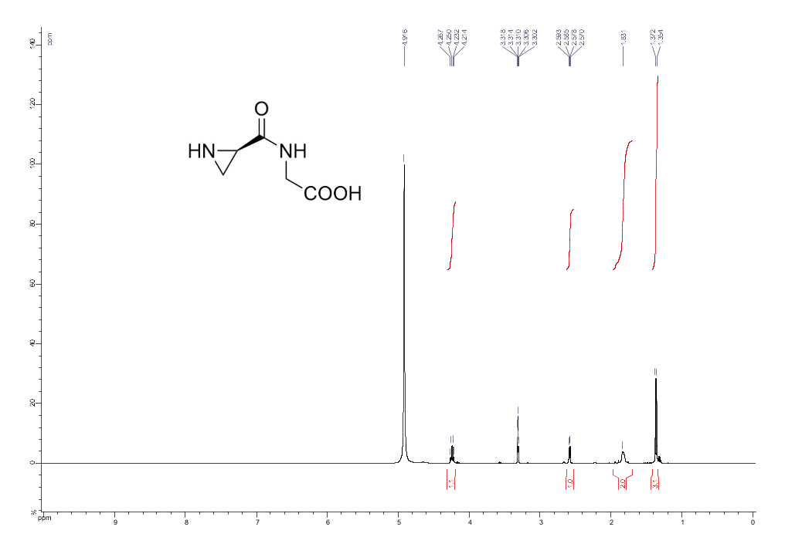
Figure S23: ¹³C NMR spectra of (R)-(aziridine-2-carbonyl)alanine(2a).
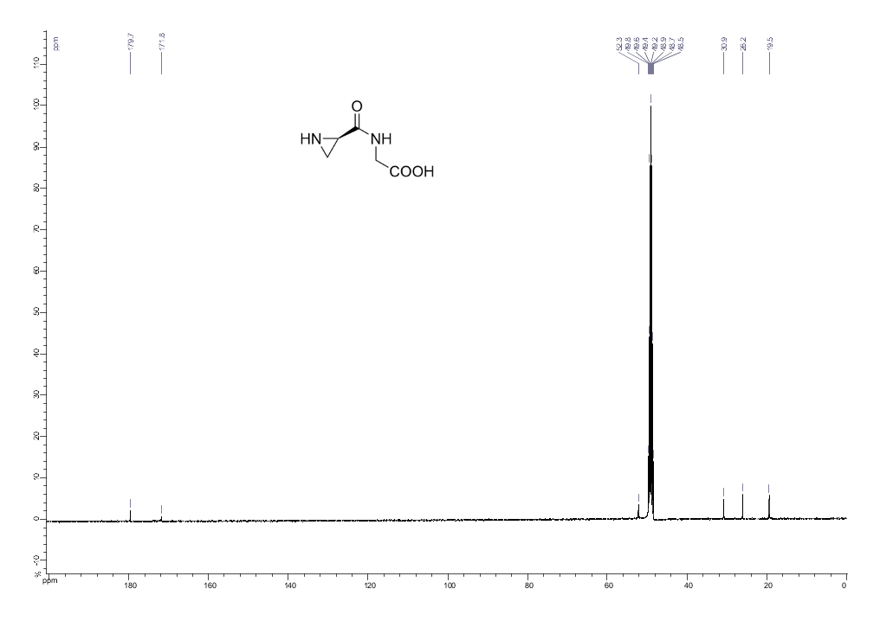

Figure S24: ¹H NMR spectra of ((R)-aziridine-2-carbonyl)-D-phenylalanine (2c).
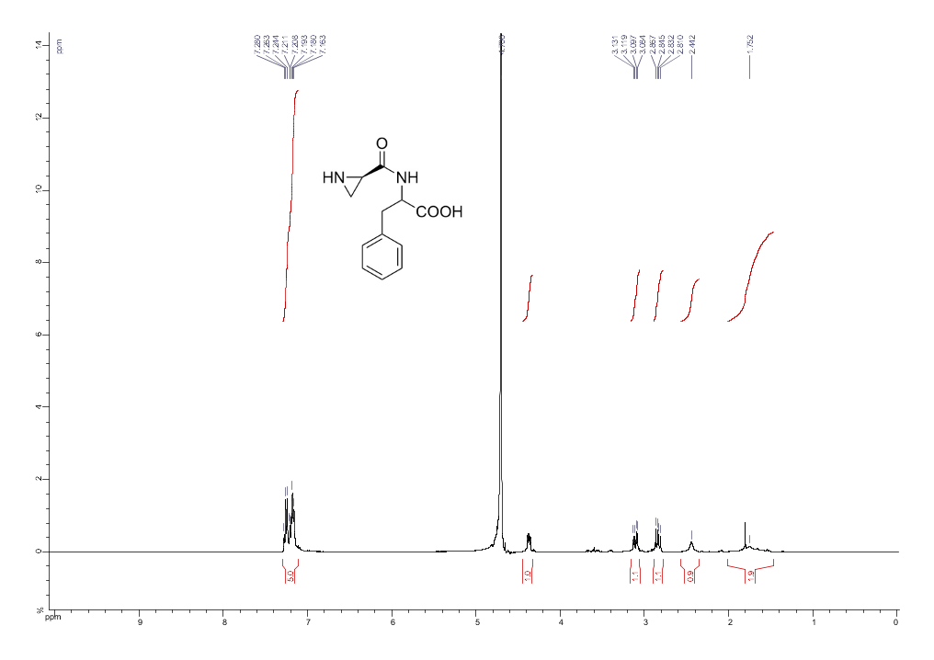

Figure S25: ¹H NMR spectra of ((R)-aziridine-2-carbonyl)-D-valine (2d).
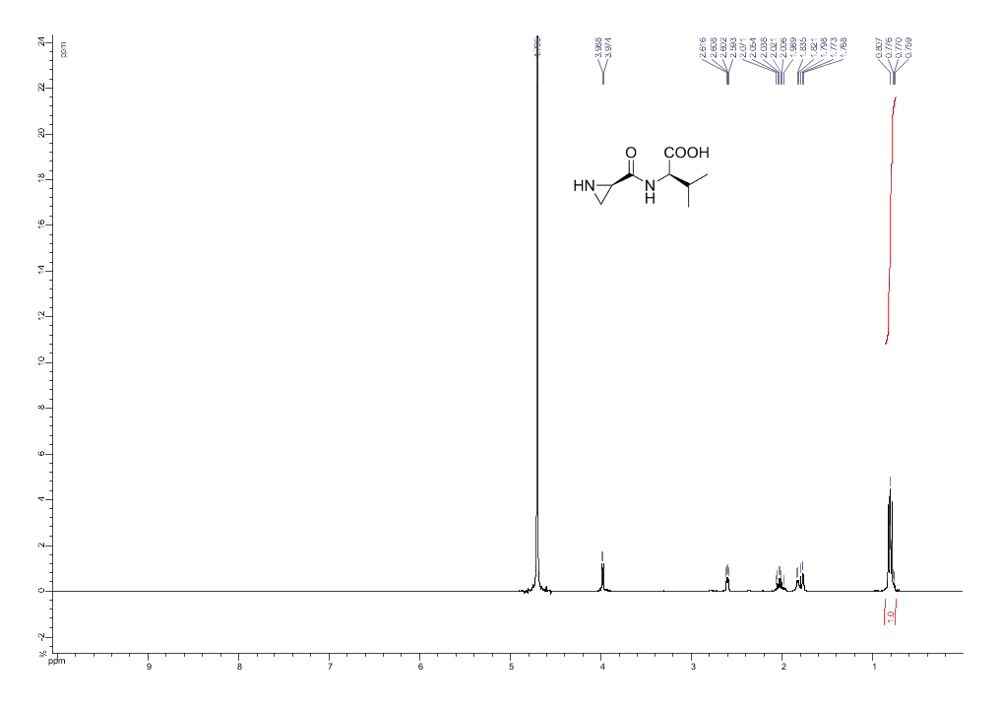

Figure S26: ¹³C NMR spectra of ((R)-aziridine-2-carbonyl)-D-valine (2d).
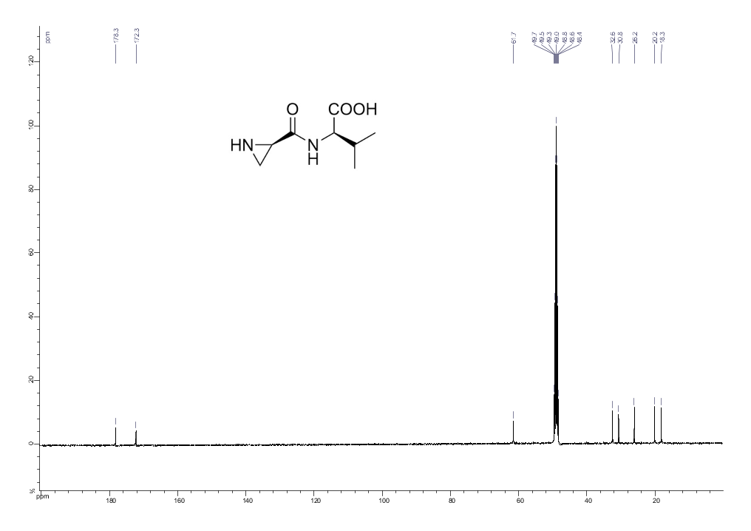

Figure S27: ¹H NMR spectra of benzyl (R)-1-((tert-butoxycarbonyl)-D-alanyl)aziridine-2-carboxylate (11).
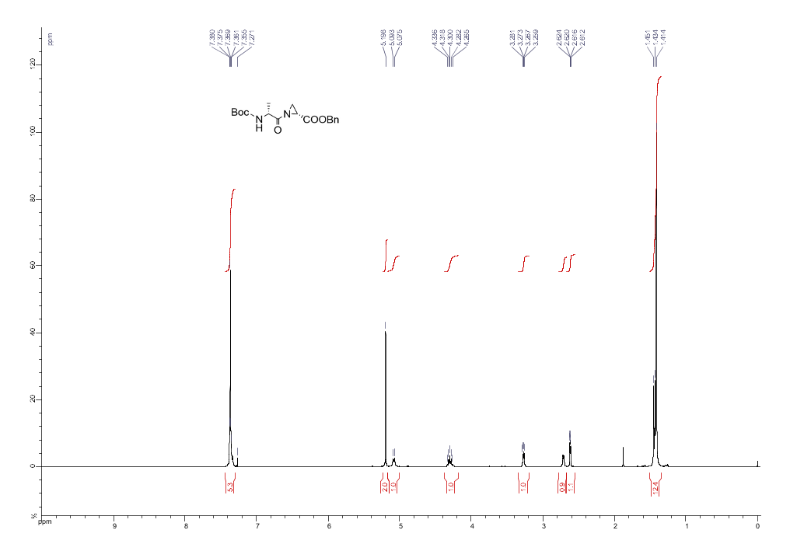

Figure S28: ¹³C NMR spectra of benzyl (R)-1-((tert-butoxycarbonyl)-D-alanyl)aziridine-2-carboxylate (11).
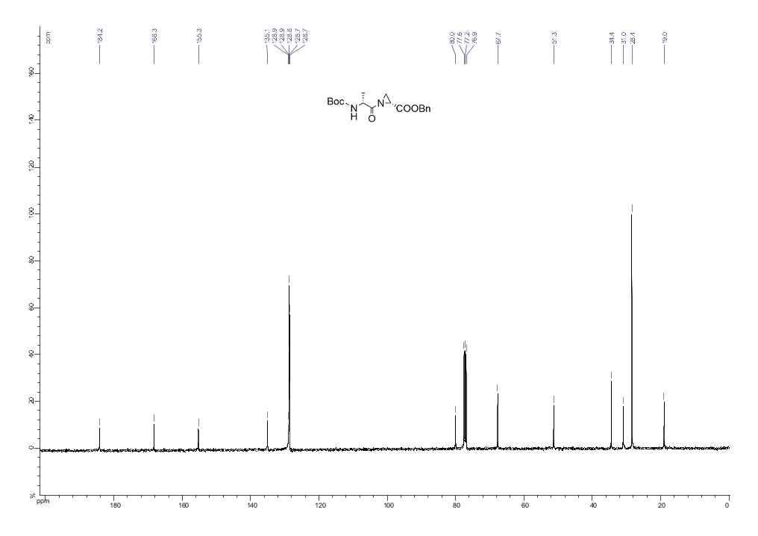

Figure S29: ¹H NMR spectra of benzyl (R)-1-(((benzyloxy)carbonyl)-D-phenylalanyl)aziridine-2-carboxylate (13).
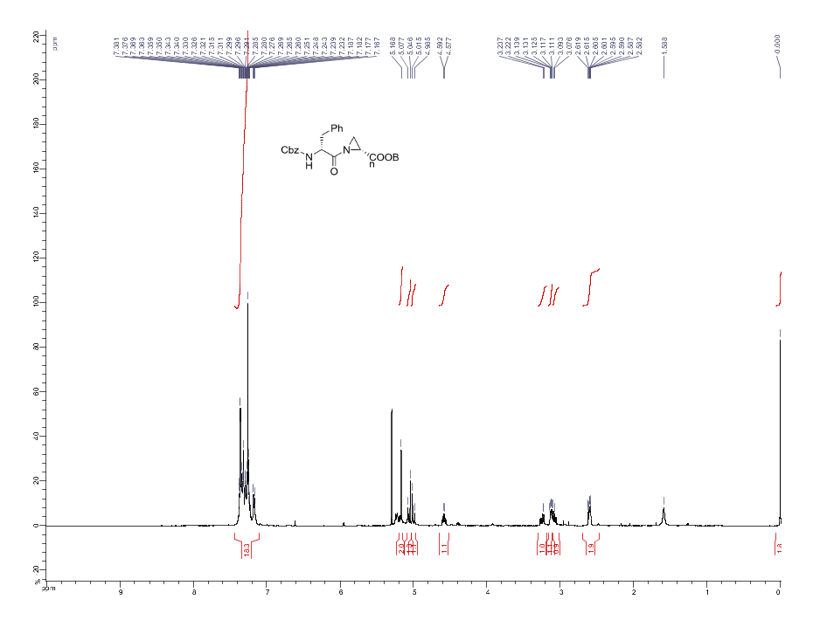
Figure S30: ¹³C NMR spectra of benzyl (R)-1-(((benzyloxy)carbonyl)-D-phenylalanyl)aziridine-2-carboxylate (13).
