New zinc coordination compound with simple salicylato and pyridine ligands: synthesis, crystal structure and Hirshfeld surface analysis
Nives Kitanovski and Marta Počkaj*
Faculty of Chemistry and Chemical Technology, University of Ljubljana, Večna pot 113, SI-1000 Ljubljana, Slovenia.
* Corresponding author: E-mail: marta.pockaj@fkkt.uni-lj.si.

Abstract
A novel mononuclear zinc coordination compound with formula [Zn(Hsal)₂(Py)₂] (H₂sal = salicylic acid, Py = pyridine) was prepared by a reaction between aqueous solutions of sodium salicylate and zinc sulfate(VI) in 1:1 molar ratio, to which pyridine was added dropwise. The obtained compound was characterized by elemental analysis, IR spectroscopy, and its crystal structure was determined by single-crystal X-ray diffraction method. X-ray structure analysis has shown that the central zinc ion is four-fold coordinated by two monodentate salicylato ligands and two pyridine molecules, forming a distorted tetrahedron. Since the asymmetric unit consists of two halves of coordination molecules, orthorhombic Ibca space group symmetry leads to two geometrically different coordination molecules. The comparison between the two is given in terms of interatomic distances and angles, and also in terms of differences in intermolecular interactions obtained as a result of Hirshfeld surface analysis.

Keywords: coordination chemistry; zinc; salicylic acid; crystal structure; Hirshfeld surface analysis.

1. Introduction
Although zinc is deemed to be a trace element in the human body, it is present in all organs, tissues and fluids, in total 2−4 grams. Its importance for the growth and existence of all living organisms has been known for more than hundred years.¹ The research on zinc coordination chemistry has been initiated in the early 1940s by the discovery of erythrocyte carbonic anhydrase which is involved in the transport of carbon dioxide in blood. Apart from being a part from enzymatic active sites of all six different enzyme classes with catalytic and regulatory functions (oxidoreductases, transferases, hydrolases, lyases, isomerases, and ligases), zinc also plays structural roles and as such contributes to the stability of proteins. With its d¹⁰ electron configuration, zinc is not subject to reduction or oxidation reactions. Furthermore, its crystal-field stabilization energy is zero, resulting in a remarkably adoptable coordination sphere which allows to accomodate a broad range of coordination numbers and geometries.² All of listed characteristics of zinc as a central ion in combination with various ligands lead to new compounds with interesting antimicrobial, optical, magnetic and other physical properties. ³⁻⁷
On the other hand, salicylic acid (H₂sal; Fig. 1) has been found in numerous plant species where it acts as a phytohormone necessary for plant growth and development. Its salts and esters, salicylates, are widely used in medicine. With their two functional groups, i.e. hydroxylic and carboxylic, salicylates are of great importance as ligands in coordination chemistry with their versatile coordination modes.⁸ For example, zinc acetylsalicylate with formula [Zn(acsal)₂(H₂O)₂] is used as anti-inflammatory agent.⁹
Despite the numerous researches in zinc chemistry, there are not as many reports on crystal structures containing the unsubstituted salicylato ligand and additional pyridine-like ligands as one might expect.¹⁰ Only four such crystal structures were reported till now¹¹⁻¹⁴ which might indicate considerable difficulties with the crystallization of mononuclear coordination compounds of the entitled class. However, we have managed to prepare the new zinc coordination compound with two salicylato and two additional pyridine ligands. In the present work, its synthesis and characterization, including the single crystal structure determination and Hirshfeld surface analysis, is described.
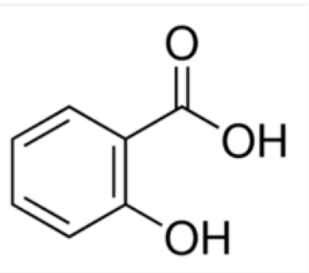
Fig. 1. Salicylic acid.

2. Experimental
2. 1. Materials and Physical Measurements
All reagents and chemicals were purchased from commercial sources and used without further purification.
CHN elemental analyses were performed with a PerkinElmer 2400 CHN Elemental Analyzer. The infrared spectra were measured on solid samples using a Perkin-Elmer Spectrum 100 series FT-IR spectrometer equipped with an ATR sampling accessory.

2. 2. Synthesis
To the solution of sodium salicylate, C₇H₅NaO₃, (178 mg, 1,12 mmol in 2 mL water) the solution of ZnSO₄ (300 mg, 1,08 mmol of ZnSO₄∙7H₂O in 5 mL water) was added. To the obtained colourless solution, pyridine was added dropwise (15 droplets, i.e. ~ 0.7 mL). The white solid, hydrated ZnSO₄, appeared immediately after the addition of pyridine. The reaction mixture including the fine white solid was left in an open Erlenmeyer flask at ambient temperature. The quantity of white solid decreased with time and after its disappearance, colourless single crystals suitable for the structural analysis grew out of the solution in 18 days. Yield: 50 mg (10%). Anal. Calcd. for C₂₄H₂₀N₂O₆Zn: C, 57.90%; H, 4.05%; N, 5.63%. Found: C, 56.89%; H, 4.14%; N, 6.08%. ν_{max}: 3077 (vw), 1632 (w, C=N from pyridine ring), 1601 (s, ν_{as}(OCO)), 1567 (s), 1541 (s), 1487 (s), 1468 (s), 1450 (s), 1394 (vs, ν_{s}(OCO)), 1319 (s), 1239 (s), 1220 (s), 1156 (s), 1098 (w), 1071 (w), 1044 (s), 1015 (w), 957 (w), 885 (s), 864 (s), 831 (s), 755 (w), 697 (vs), 670 (s), 638 (s).

2.3. X-Ray Crystallography
For X-ray structural analysis, single crystal of the title compound was dipped into silicon grease, mounted onto the tip of glass fibres and transferred to the goniometer head in the liquid nitrogen cryostream. Data were collected on a SuperNova diffractometer equipped with Atlas detector using CrysAlis software and monochromated Mo Kα radiation (0.71073 Å) at 150 K.¹⁵ The initial structural model was obtained via direct methods using the Superflip structure solution program.¹⁶ A full-matrix least-squares refinement on F² magnitudes with anisotropic displacement parameters for all nonhydrogen atoms using SHELXL-2018/3 was employed.¹⁷ All H atoms were initially located in difference Fourier maps; those residing on C-atoms were further treated as riding on their parent atoms with C(aromatic)−H distance of 0.95 Å. On the other hand, the hydrogens bonded to oxygen atoms (i.e. H3 and H6) were refined freely. Details on crystal data, data collection and structure refinement are given in Table 1. Figures depicting the structures were prepared with Mercury.¹⁸
Table 1. Crystal data, data collection and refinement.
Crystal data | 1
Formula | C₂₄H₂₀N₂O₆Zn
M_{r} | 497.79
Cell setting, space group | Orthorhombic, Ibca
a (Å) | 15.2247(5)
b (Å) | 15.5719(6)
c (Å) | 37.7204(17)
V (Å³) | 8942.7(6)
Z | 16
D_{x} (Mg m⁻³) | 1.479
μ (mm⁻¹) | 1.142
F(000) | 4096
Crystal form, colour | prism, colourless
Crystal size (mm) | 0.25 x 0.15 x 0.15
Data collection
T (K) | 150(2)
Radiation type, wavelength | Mo Kα, 0.71073 Å
Diffractometer | SuperNova, Dual, Cu at zero, Atlas
Data collection method | ω scan
Absorption correction | multi-scan
No. of measured, independent and observed reflections | 24914, 6220, 4140
Criterion for observed reflections | F² > 2.0 σ(F²)
R_{int} | 0.0373
θ range (°) | 2.858−30.396
h range | −1821
k range | −2021
l range | −3652
Refinement
Refinement method | full-matrix least-squares refinement on F²
R (on F_{obs}), wR (on F_{obs}), S | 0.0339, 0.0801, 1.025
No. of contributing reflections | 6220
No. of parameters | 307
No. of restraints | none
(Δ/σ)_{max}, (Δ/σ)_{ave} | <0.001, <0.001
Δρ_{max}, Δρ_{min} (eÅ⁻³) | 0.732, −0.733

2.4. Hirshfeld Surface Analysis
The Hirshfeld surface of the molecule is defined as a set of points in three-dimensional space where the contribution to the electron density of the molecule of interest is equal to the contribution from all other molecules.¹⁹ The Hirshfeld surface analyses were performed and fingerprint plots were drawn using Crystal Explorer, both based on the results of previous single crystal X-ray diffraction study.²⁰ The Hirshfeld surfaces were plotted over three quantities: a) d_{norm}, plotted in red-white-blue colour code, representing shorter/close to the sum of van der Waals radii/longer contacts between the molecules; b) shape index; the red colour represents concave and the blue convex regions; and c) curvedness. Furthermore, the 2D fingerprint plots, i.e. plots of d_{i} over d_{e} are provided to recognize and evaluate different intermolecular contacts in the crystal. d_{i} and d_{e} represent distances from the isosurface to the nearest atom inside or outside to the Hirshfeld surface, respectively.

3. Results and Discussion
3.1. Crystal structure
Single crystal X-ray structure determination has shown that the title compound crystallizes in orthorhombic Ibca space group (no. 73). The asymmetric unit depicted in Fig. 2 consists of two central zinc ions, each surrounded by a pyridine molecule and a salicylato ligand. The aforementioned space group symmetry leads to two similar but not completely identical coordination molecules with formula [Zn(Hsal)₂(Py)₂] (Fig. 3a), hereinafter referred to molecule1 (containing Zn1) and molecule2 (containing Zn2); their overlay is shown in Fig. 3b.
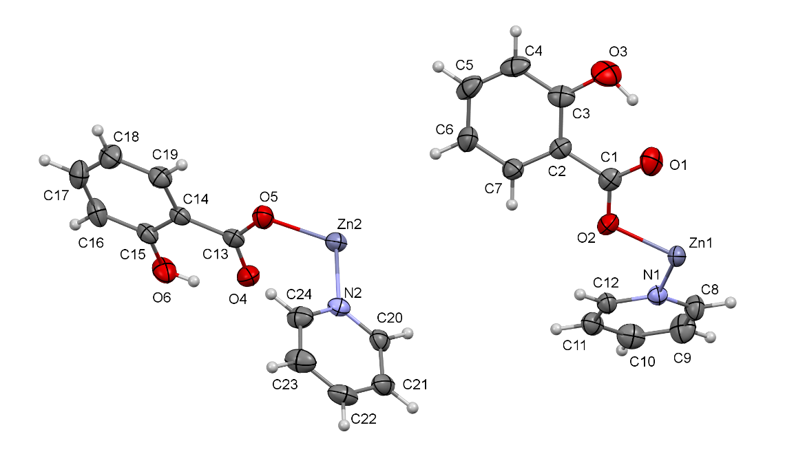
Fig. 2. Representation of asymmetric unit of the title compound. Hydrogen atoms are drawn as spheres of arbitrary radii and their labels are omitted for clarity.

Fig. 3. a) Two similar coordination molecules [Zn(Hsal)₂(Py)₂] in which hydrogen atoms are omitted for clarity. b) Overlay of the coordination molecules; molecule1 (i.e. containing Zn1) is black while the molecule2 (containing Zn2) is red.

In both symmetrical coordination molecules, a central Zn is positioned on a twofold axis running parallel to x (Zn1, Wyckoff site 8c) or y axis (Zn2, Wyckoff site 8d), respectively, and is surrounded by two pyridine molecules and two monodentately bound salicylato ligands via its deprotonated carboxylic oxygen. The obtained coordination number is four, and the values of τ₄' parameter^{21,22} of 0.70 for Zn1 and 0.74 for Zn2 confirm the distorted tetrahedra around both central ions. Data on selected bond lengths and angles around the central zinc ions are given in Table 2; values are in accordance with the previously reported Zn complexes with salicylato ligand and its derivatives.¹⁰

Table 2. Selected bond lengths and angles (Å, °) for 1.
Molecule1 |  | Molecule2
Zn1−O2 | 1.9502(13) | Zn2−O5 | 1.9533(14)
Zn1−N1 | 2.0256(15) | Zn2−N2 | 2.0405(16)
O2−Zn1−O2^{i} | 134.83(9) | O5−Zn2−O5^{ii} | 133.95(8)
N1−Zn1−N1^{i} | 119.61(9) | N2−Zn2−N2^{ii} | 111.42(9)
O2−Zn1−N1 | 97.83(6) | O5−Zn2−N2 | 105.38(6)
O2^{i}−Zn1−N1 | 104.48(6) | O5^{ii}−Zn2−N2 | 100.11(6)
Symmetry codes: (i) x, –y, –z + ½; (ii) –x+½, y, –z.

Although bond lengths and angles are quite similar in both molecules, there are some distinctions between them as already seen from their overlay (Fig. 3b). The angles between the meanplane defined by carboxylate group and the salicylate ring are similar, with values of 7.1(1)° in molecule1 and 6.4(1)° in molecule2, respectively. However, the angles between the meanplane of pyridine and salicylate rings differ significantly, with values 50.49(8)° in molecule1 and 82.21(6)° in molecule2, respectively. This difference is further reflected in the packing of the coordination molecules and also in slightly different hydrogen bonding schemes / close contacts of both molecules (Table 3). In molecule1 two intramolecular hydrogen bonds of O−H…O and C−H…O type are present. On the other hand, if considering the classical criterion for C−H…O hydrogen bonds, i.e. C-H…O angle > 110 ° and C…O distance < 3.22 Å, in molecule2 only the O−H…O interamolecular hydrogen bond appears, while there is no C−H…O hydrogen bond due to geometric differences in between the molecules. The corresponding distance between the same atoms in molecule2 is significantly larger than the sum of van der Waals radii (i.e. C24…O6, 3.440(3) Å).
Additional C−H…O contact can be found between two adjacent molecules1 (C11−H11∙∙∙O1) or two adjacent molecules2 (C20−H20∙∙∙O6), respectively, connecting the molecules with the same numerical label into chains that run parallel to a axis (Fig. 4). The C−H…O hydrogen bonds between molecule1 and molecule2 are slightly longer than is the sum of van der Waals radii (C5−H5…O6) but still connected the aforementioned chains into three-dimensional structure. The difference in hydrogen bonding schemes between both coordination molecules can be also revealed in fingerprint plots of both molecules (see Section 3.2).
Fig. 4. The packing of exchanging chains of hydrogen-bonded molecules1 (grey) and molecules2 (red) that run parallel to a direction. A view down b axis. The hydrogen bonds between molecules1 or molecules2 are given in green while those between molecule1 and molecule2 (C5−H5…O6) are depicted in blue.

Table 3. Hydrogen bond geometry in 1.
D−H∙∙∙A | D−H (Å) | H∙∙∙A (Å) | D∙∙∙A (Å) | D−H∙∙∙A (°) | Symmetry code of A | Comment
O3−H3∙∙∙O1 | 0.95(3) | 1.67(3) | 2.546(2) | 151(3) | - | (a)
C12−H12∙∙∙O2 | 0.95 | 2.60 | 3.111(2) | 114.2 | - | (a)
C11−H11∙∙∙O1 | 0.95 | 2.46 | 3.203(2) | 135.5 | −x+½, y+½, z | (c)
O6−H6∙∙∙O4 | 0.84(3) | 1.78(3) | 2.542(2) | 150(3) | - | (b)
C20−H20∙∙∙O6 | 0.95 | 2.57 | 3.027(2) | 109.6 | x, y−½, −z | (d)
C5−H5…O6 | 0.95 | 2.48 | 3.331(3) | 149 | x−½, −y+½, −z | (e)
(a) Intramolecular hydrogen bond in molecule1. (b) Intramolecular hydrogen bond in molecule2. (c) Intermolecular hydrogen bonds between two adjacent molecule1. (d) Intermolecular hydrogen bonds between two adjacent molecule2. (e) Intermolecular hydrogen bonds between adjacent molecule1 and molecule2.

3.2. Hirshfeld Surface Analysis
Hirshfeld surface (HS) analysis is an invaluable tool that enables us to understand and describe weak intermolecular interactions in the crystal structure that are crucial in the packing of molecules in crystals. By means of this method, the molecule is treated as a whole, opposing to the classical crystallographic analysis with which the molecule packing is studied by elucidating atom-to-atom or residue-to residue contacts. Fig. 5a represents Hirshfeld surface of molecule containing Zn1 (molecule1) mapped over d_{norm} in a range from −0.179 to +1.501 arbitrary units. The bright red spots ‘1’ and ‘2’ in the vicinity of hydrogen (H11) and oxygen (O1) indicate donors and acceptors of C−H…O interaction while the diminutive-red spot ‘3’ near hydroxylic oxygen (O3) claims its cooperation in a relatively weak C−H…O interaction.
HS mapped over shape index (Fig. 5b) clearly shows red hollows and blue bumps which in a close look from different perspectives can reveal the way the molecules (i. e. their Hirshfeld surfaces) touch each other. Together with HS mapped over curvedness (Fig. 5c), the absence of broad, flat regions can be observed and consequently there is no evidence of planar stacking arrangements of molecules1, e.g. π-π stacking.²³
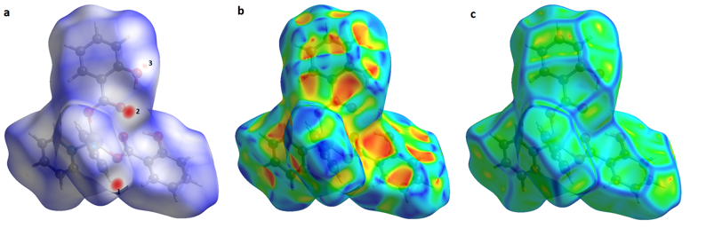Fig. 5. Hirshfeld surface of molecule 1 a) plotted over d_{norm} in the range from −0.179 to +1.501 arbitrary units; b) plotted over shape-index property (range from −1.000 to 1.000), and c) plotted over curvedness (range from −4.000 to 0.400).

To overcome the trouble of presenting 3D Hirshfeld surfaces in two dimensions, a quantitative 2D fingerprint plot of molecule1 is presented in Fig. 6. Only the dominant contributions to the Hirshfeld surface, i.e. H…H, C…H/H…C and O…H/H…O contacts which together contribute more than 92% to the total HS, are shown. Two symmetrical spikes at (d_{i} + d_{e}) ~ 2.3 Å represent C−H…O interactions observed as red spots of different intensities in Fig. 5a. All other features that should indicate other important short contacts such as π-π stacking are absent from 2D fingerprint plots of molecule1.
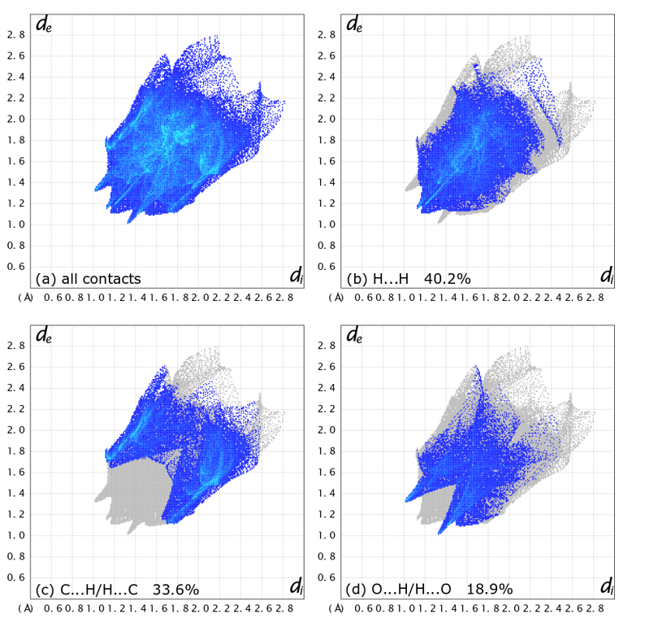Fig. 6. a) A full 2D fingerprint plots of molecule1, together with those delineated into b) H…H, c) C…H / H…C and d) O…H / H…O contacts.

Since the asymmetric unit consists of two halves of the coordination molecule and the HS analysis can reveal differences between the two symmetrically independent molecules, it was performed also on the molecule2. The HS mapped over d_{norm}, shape index and curvedness are shown in ESI (Fig. S1). The observations are very similar observations to those of molecule1. However, slight differences can be observed from 2D fingerprint plots (Fig. 7). The dominant contacts in molecule2 are the same as in molecule1, and also their contribution to the total HS is similar (>92%). However, the percentage contributions do differ slightly as a result of subtle geometry differences of both molecules (Fig. 8).

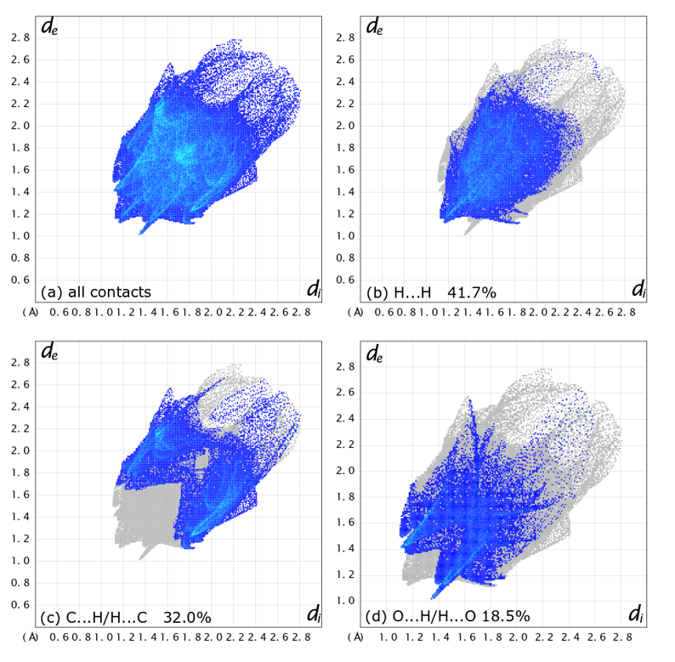Fig. 7. a) A full 2D fingerprint plots of molecule 2, together with those delineated into b) H…H, c) C…H / H…C and d) O…H / H…O contacts.

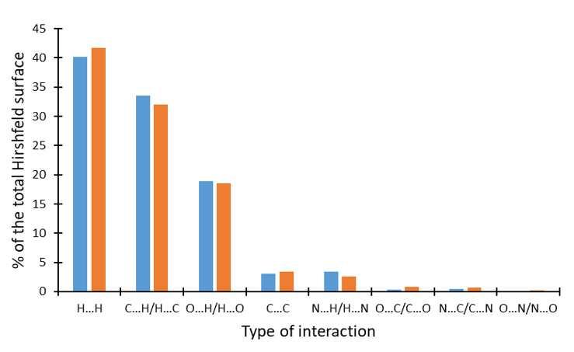
Fig. 8. The proportions of different interactions to the total Hirshfeld surface in molecule1 (blue) and molecule2 (orange columns).

4. Conclusions
Crystal structure of a new zinc coordination compound with salicylato and pyridine ligand, i.e. [Zn(Hsal)₂(Py)₂] was determined by single-crystal X-ray diffraction at 150 K, and it was further evaluated by Hirshfeld surface analysis. The central Zn(II) is four-coordinated in a shape of distorted tetrahedra. Since the asymmetric unit consists of two halves of coordination molecule, there are subtle differences between symmetrically independent coordination molecules. In both coordination molecules, H…H, C…H/H…C and O…H/H…O contacts contribute the most to molecular packing but the percentage of each of the aforementioned interactions to the total Hirshfeld surface differ as a consequence of slight geometrical differences between two coordination molecules.

5. Supplementary Information
CCDC 2014661 contains the supplementary crystallographic data. These data can be obtained free of charge from The Cambridge Crystallographic Data Centre via www.ccdc.cam.ac.uk/data_request/cif.

6. Acknowledgments
This work was financially supported by Slovenian research agency (grant P1-0175). The authors thank Eva Judež for the synthesis and EN-FIST Centre of Excellence for the use of SuperNova diffractometer.

7. References
1. M. J. Jackson in: C. F. Mills (Ed.): Zinc in human biology; Springer, London, UK, 1989, pp. 1−10.
2. J. Burgess, R. H. Prince: Zinc: Inorganic & Coordination Chemistry, in: Encyclopedia of Inorganic Chemistry, 2nd edition, John Wiley & Sons Ltd., 2006.
3. Y.-L. Sang, X.-S. Lin, W.-D. Sun, Acta Chim. Slov. 2020, 67, 581−585.
4. A. Erxleben, Coord. Chem. Rev. 2003, 246, 203−228.
5. X.-G. Yi, X.-N. Fang, J. Guo, J. Li, Z.-P. Xie, Acta Chim. Slov. 2020, 67, 507–515.
6. X. Meng, Y. Song, H. Hou, Y. Fan, G. Li, Y. Zhu, Yu Zhu, Inorg. Chem. 2003, 42, 1306−1315.
7. D. A. Shultz, S. H. Bodnar, Inorg. Chem. 1999, 38, 591−594.
8. K. Praveen, DSS Madhavi, A. Anil Kumar, Y. Kranthi Kumar, Int. j. eng. sci. invention res. dev. 2016, 5, 8−10.
9. P. Lemoine, B. Viossat, G. Morgant, F. T. Greenaway, A. Tomas, N.-H. Dung, J. R. J. Sorenson, J. Inorg. Biochem. 2002, 89, 18−28.
10. C. R. Groom, I. J. Bruno, M. P. Lightfoot, S. C. Ward, Acta Crystallogr. 2016, B72, 171−179.
11. H. Necefoglu, W. Clegg, A. J. Scott, Acta Crystallogr. 2001, E57, m462−m464.
12. T. Hokelek, H. Necefoglu, Anal. Sci. 2001, 17, 1241−1242.
13. D. Kose, A. Ay, O. Sahin, O. Buyukgungor, J. Iran. Chem. Soc. 2013, 9, 591−597.
14. Kun-Hua Lin, Fei-Fei Zhang, Zhe-Yin Yu, Shao Min, Acta Crystallogr. 2007, E63, m1930.
15. CrysAlisPRO, Oxford Diffraction /Agilent Technologies UK Ltd, Yarnton, England.
16. L. Palatinus, G. Chapuis, J. Appl. Cryst. 2007, 40, 786−790.
17. G. M. Sheldrick, Acta Crystallogr. 2015, C71, 3−8.
18. C. F. Macrae, P. R. Edgington, P. McCabe, E. Pidcock, G. P. Shields, R. Taylor, M. Towler, J. van de Streek, J. Appl. Crystallogr. 2006, 39, 453−457.
19. M. J. Turner, J. J. McKinnon, S. K. Wolff, D. J. Grimwood, P. R. Spackman, D. Jayatilaka, M. A. Spackman, CrystalExplorer17. University of Western Australia, 2017.
20. M. A. Spackman, D. Jayatilaka, CrystEngComm 2009, 11, 19−32.
21. A. Okuniewski, D. Rosiak, J. Chojnacki, B. Becker, Polyhedron 2015, 90, 47–57.
22. D. Rosiak, A. Okuniewski, J. Chojnacki, Polyhedron 2018, 146, 35–41.
23. S. L. Tan, M. M. Jotani, E. R. T. Tiekink, Acta Crystallogr. 2019, E75, 308–318.
Graphical contents
