SUPPORTING INFORMATION
SI 1. FT-IR spectrum of [Cd(IsoPht)(TEA)H₂O]·3H₂O complex, TEA ligand, and H₂IsoPht

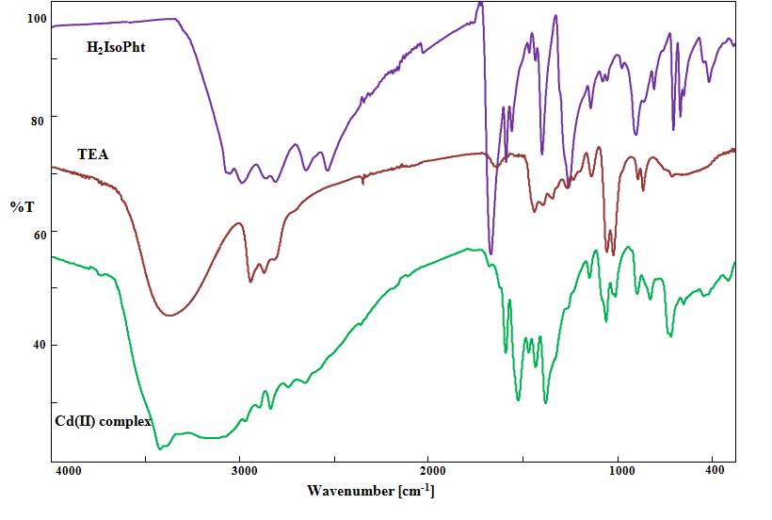
Figure S1. IR spectra of [Cd(IsoPht)(TEA)H₂O]·3H₂O complex, TEA ligand, and H₂IsoPht

