A Novel Mixed Ligand Cd(II) Isophthalate Complex with Triethanolamine: Crystal Structure, Fluorescence and Antimicrobial Activity

Zuhal YOLCU^{1*} Sinem YURTCAN² Meryem ÇITLAKOĞLU¹
¹Department of Chemistry, Faculty of Art and Science, Giresun University, Giresun, Turkey
²Giresun University Central Research Laboratory Application and Research Center
*Corresponding author: e-mail: zuhal.yolcu@giresun.edu.tr

Abstract
A novel mixed ligand complex [Cd(IsoPht)(TEA)H₂O]·3H₂O has been synthesized for the first time by using isophthalic acid (H₂IsoPht) and tetradentate triethanolamine (TEA) and characterized by X-ray single-crystal diffraction, FT-IR spectroscopy and thermogravimetric analysis (TGA). The title complex crystallized in the triclinic system with P-1 space group and distorted monocapped trigonal prismatic geometry. The Cd(II) atom is seven coordinated with bidentate Isopht, a TEA in the tetradentate mode, and an aqua ligand. The fluorescence properties of the Cd(II) complex and TEA ligand were investigated at room temperature. The present Cd(II) complex was also tested for its antimicrobial activity by in vitro agar diffusion method against some Gram-positive and Gram-negative bacteria and a fungus.

Keywords: Isophthalic acid, triethanolamine, X-ray single crystal, fluorescence property, antimicrobial activity.

1. Introduction
Triethanolamine (TEA) is a potential ligand that can interact with metal ions to form supramolecular complexes of different structures and many coordination compounds containing TEA ligands have been reported for the last two decades.¹⁻⁶ TEA is also used as a pH regulator in cosmetology, as a corrosion inhibitor in metal-cutting fluids, as a curing agent for epoxy and rubber polymers, in adhesives, antistatic agents, or as a pharmaceutical intermediate.⁷⁻⁹ Metal complexes containing TEA ligand can be (neutral or cationic) mono-bi- and polynuclear structures.¹⁰⁻¹¹ The TEA ligand generally acts as the tri- or tetradentate ligand, but metal complexes with mono- or bidentate TEA coordination modes are also known.¹²⁻¹³ Although TEA has no specific physiological effects except for its low antibacterial activity, as an auxiliary ligand TEA may increase the physiological effect of bioactive substances in mixed ligand metal complexes.^{10,14} There are preliminary pharmacological studies demonstrating that the transition metal complexes of TEA protect animals from ethanol and carbon monoxide poisoning and have immune-modulating and antiproliferative properties.¹⁵⁻¹⁷ In addition, the mixed ligand zinc complex containing TEA has been reported to have anti-angiogenic and anti-atherogenic effects.¹⁸
Coordination compounds may combine a metal ion, a biocompatible ligand, and some auxiliary ligands in the same molecule to form mixed-ligand coordination types to achieve the desired properties.¹⁹⁻²⁰ Apart from the TEA ligand, isophthalic acid (H₂IsoPht) has been selected as a good candidate for this purpose. H₂IsoPht has important advantages in the design of coordination compounds compared to other organic ligands. H₂IsoPht has two carboxyl groups that can lose one or two protons and form various coordination modes, act as a hydrogen bond acceptor and donor, and is a versatile and variable ligand as it can bind metal ions in different directions.²¹⁻²⁸ The synthesis of coordination compounds containing O and/or N-donor ligands is very significant and intriguing in the field of pharmacology due to the discovery of their antimicrobial properties. The biological activity of coordination compounds with O-donor ligand isophthalato (IsoPht) has been studied.²⁹⁻³² The antimicrobial activities of Zn-isopht complexes were displayed in vitro against some Gram-positive, some Gram-negative bacteria and fungus by Radovanović and co-workers, who showed the most potent inhibitory effect of [Zn(dipya)(isopht)]_{n} (dipya = 2,2’-dipyridylamine) against all the tested microorganisms.²⁹ Devereux and co-workers demonstrated the high antibacterial activity of Mn–phen–pht/isopht complexes against Candida albicans.³⁰ Cadmium coordination compounds containing O and/or N-donor ligands can show promising fluorescence properties.³³⁻³⁹
In this study, a novel mixed ligand Cd(II) complex containing TEA and isopht was synthesized to investigate its potential applications. The single-crystal X-ray structure, spectral and thermal properties of the complex were examined in detail. Also, the fluorescence and antimicrobial properties of the complex were investigated.
2. Experimental
2. 1. Materials and Instrumentations
Triethanolamine (TEA), IsoPhthalic acid (H₂IsoPht), and Cd(NO₃)₂.4H₂O were obtained from Sigma Aldrich Ltd. IR spectra were obtained with a FT/IR-100 type A Spectrophotometer using. Thermal degradation of Cd(II) complex was performed using a TA Instruments SII-EXTAR-6000 TG/DTA. Experiments were conducted from 30 to 900 °C, with a heating rate of 10 °C min⁻¹, under nitrogen atmosphere using platinum crucibles. Fluorescence spectra were measured on Agilent Cary Eclipse Fluorescence Spectrophotometer.
2. 2. Synthesis of [Cd(IsoPht)(TEA)H₂O]·3H₂O
5 mmol of Cd(NO₃)₂.4H₂O (1540 mg) was dissolved in 30 mL of water and then heated at
60-70 °C for 10 min on a magnetic stirrer. 10 mmol (1.33 mL )TEA was added and stirred for 10 min without further heating. Finally, the mixture 5 mmol (830 mg) of H₂IsoPht was added and stirred for 3 hours. After 4 weeks, colorless crystals were obtained.
2. 3. X-Ray Crystallography
The reflection intensities of the Cd(II) complex were collected at 296 K using Agilent SuperNova single-crystal diffractometer with Mo-Kα radiation (λ=0,71073 Å). The structure was solved using the program SHELXL-97 by direct methods, and all non-hydrogen atoms were refined with anisotropic displacement parameters by full-matrix least-squares methods based on F² using SHELXL-97.⁴⁰ The molecular graphics were prepared using OLEX² program.⁴¹ Detailed information about the crystal data and structure determination are summarized in Table 1. Selected experimental and calculated interatomic distances and bond angles are given in Table 2.
2. 4. Computational Protocol
Quantum chemical calculation of the complex was performed using Gaussian 09 program suits running under Windows.⁴² Ground state geometry optimization of the complex was performed by using Minnesota M062X hybrid density functional method with appropriate basis set combinations, 6-31g(d,p) for non-metal atoms and pseudo potential-included SDD for metal atom.
Table 1. Crystallographic data for [Cd(IsoPht)(TEA)H₂O]·3H₂O
Empirical formula | C₁₄H₂₇CdNO₁₁
Formula weight | 497.76
Temperature/K | 293(2)
Crystal system | Triclinic
Space group | PĪ
a/Å | 9.0749(3)
b/Å | 10.7120(3)
c/Å | 12.2025(5)
α/° | 66.944(3)
β/° | 72.272(3)
γ/° | 67.510(3)
Volume/Å³ | 991.61(7)
Z | 1
ρ_{calc}g/cm³ | 1.667
μ/mm⁻¹ | 1.157
F(000) | 508.0
Crystal size/mm³ | 0.13 × 0.15 × 0.17
Radiation | MoKα (λ = 0.71073)
2Θ range for data collection/° | 6.684 to 52.742
Reflections collected | 13143
Independent reflections | 4050 [R_{int}= 0.0400, R_{sigma}= 0.0352]
Data/restraints/parameters | 4050/3/258
F² | 1.067
Final R indexes [I>=2σ (I)] | R₁= 0.0325, wR₂= 0.0817
Final R indexes [all data] | R₁= 0.0325, wR₂= 0.0838
Largest diff. peak/hole / e Å⁻³ | 1.44/-0.78

2. 5. Antimicrobial Activity
In vitro antimicrobial screening test of the synthesized compound were carried out for antibacterial and antifungal activity. Antibacterial activity was tested against three bacterial strains; two gram-positive [Bacillus cereus (ATCC 10876), Staphylococcus aureus (ATCC 29213)] and one gram-negative [Escherichia coli (ATCC 25922)] and antifungal activity was tested against one fungal strain [Candida albicans (ATCC10231)]. The agar well diffusion method was used in these assays. After nutrient agar was sterilized in an autoclave at 121 °C for 15 min, it was transferred into sterile Petri plates. Then the agar medium solidified, 8 mm diameter wells were drilled with a sterile metallic applicator. 20 µL of the sample at different concentrations prepared in DMSO was poured into the wells. DMSO served as a negative control, Ampicillin and Fluconazole served as a positive control. The plates were incubated aerobically at 37 °C for 24 h. The diameters of inhibition zones were measured by using a zone reader and were given as millimeters. Evaluation of the inhibition zone was made by averaging the three test results.
3. Results and Discussion
3. 1. The Crystal Structure of [Cd(IsoPht)(TEA)H₂O]·3H₂O
X-ray single-crystal analysis reveals that complex crystallized in the triclinic system with space group PĪ. The complex has an interesting monomeric molecular structure which is rarely found for cadmium polycarboxylate complexes.³⁸ In the complex H₂IsoPht acts as a bidentate ligand by losing hydrogen atoms while the TEA ligand acts as a tetradentate ligand using all its donor atoms. The Cd1 atom is coordinated by six oxygen atoms and one nitrogen atom, two of which are from IsoPht ligand (O1 and O2), three oxygen atoms and one nitrogen atom from a TEA ligand (O5, O6, O7, and N1), together with one oxygen atom of aqua ligand, O8W. In crystallization, uncoordinated three water molecules are also part of the molecular structure (Figure 1). Thus, Cd(II) ions are in distorted monocapped trigonal prismatic geometry environments with CdO6N chromophores.
Figure 1. A view of the [Cd(IsoPht)(TEA)H₂O]·3H₂O compound showing the atom-labeling

The Cd1-O lengths are between 2.299 (2) and 2.400 (2) Å and Cd1-N bond is 2.434 (2) Å. In addition, the bond angles between the Cd1 and O atoms vary between 55.11º (7) and 170.62º (8) in Table 2. The bond values and angles of the complex are normal compared to those of the related complex.¹⁰ The crystal structure is further stabilized by multiply intermolecular hydrogen bonds. The uncoordinated water molecules play an important role in the supramolecular architecture. The hydrogen-bonding interactions, which are assembled into 2D layers parallel to by O-H···O weak hydrogen bonds (Table 3), formed where the TEA groups donate hydrogen atoms to the neighboring carboxylate and water oxygens (Figure 2). It is seen from Figure 2 that the hydrogen bonds between the TEA ligands and the carboxylate groups of IsoPht, giving rise to R₃² (8)and R₄⁴ (20) ring motives. The molecules located along the [010] direction (Figure 3(a)), are linked by π···π stacking [π···π d = 3.556 Å] (Figure 3(b)). An extensive network of hydrogen bonds, π··π stacking, and van der Walls interactions embed the complex in a three-dimensional lattice. Figure 4 shows the packing diagram of the complex along the [100] direction.

Table 2. Selected experimental and calculated coordination bonds and angles of [Cd(IsoPht)(TEA)H₂O]·3H₂O
Bond lengths (Å)
Bond | Exp. | Calc. | Bond | Exp. | Calc.
Cd1-O1 | 2.329(2) | 2.2216 | Cd1-O7 | 2.325(3) | 2.3801
Cd1-O2 | 2.399(2) | 2.2723 | Cd1-O6 | 2.353(2) | 2.5327
Cd1-O5 | 2.300(2) | 2.4193 | Cd1-O8 | 2.324(2) | 2.4119
Cd1-N1 | 2.434(2) | 2.4485
Bond angles (ᵒ)
Angle | Exp. | Calc. | Angle | Exp. | Calc.
O1-Cd1-O2 | 55.12(7) | 58.86 | O5-Cd1-O7 | 131.11(10) | 126.59
O1-Cd1-O6 | 86.17(9) | 92.92 | O7-Cd1-O2 | 80.08(8) | 103.19
O8-Cd1-O2 | 94.06(8) | 131.99 | O7- Cd1-O1 | 134.14(8) | 132.58
O8-Cd1-O1 | 88.16(9) | 87.74 | O7-Cd1-O6 | 103.78(11) | 123.19
O8- Cd1-O6 | 170.64(9) | 152.86 | O1-Cd1-N1 | 150.55 (8) | 152.40
O8-Cd1-O7 | 85.50(11) | 73.38 | O2-Cd1-N1 | 140.73 (7) | 127.47
O6-Cd1-O2 | 88.80(8) | 69.16 | O5-Cd1-N1 | 70.83 (8) | 74.03
O5-Cd1-O2 | 146.41(8) | 130.20 | O6-Cd1-N1 | 72,15 (8) | 69.51
O5-Cd1-O1 | 91.61(8) | 83.14 | O7-Cd1-N1 | 72.00 (8) | 74.64
O5-Cd1-O8 | 78.85(9) | 69.84 | O8-Cd1-N1 | 110.61(8) | 98.47
O5- Cd1-O6 | 93.86(10) | 83.29

Figure 2. Part of the crystal structure of [Cd(IsoPht)(TEA)H₂O]·3H₂O, showing the formation of R₃²(8), and R₄⁴(20) rings by the O-H∙∙∙O hydrogen bonds
Figure 3. ((a) 2-D supramolecular network along the [010] direction in [Cd(IsoPht)(TEA)H₂O]·3H₂O complex. (b) π···π interaction
Figure 4. Packing diagram of [Cd(IsoPht)(TEA)H₂O]·3H₂O complex along the [100] direction
Quantum chemical optimized geometry of the complex exhibited reasonable accordance with experimental X-ray geometry with a RMSE deviation of 0.622 Å. Superimpositions of the X-ray and calculated geometries of the complex are given in Figure 5. In general, there is a pleasant consistence between optimized and X-ray geometries according to the results and as expected, the general tendency of gas-phase optimizations in favour of somewhat extending the bond distances was introduced.
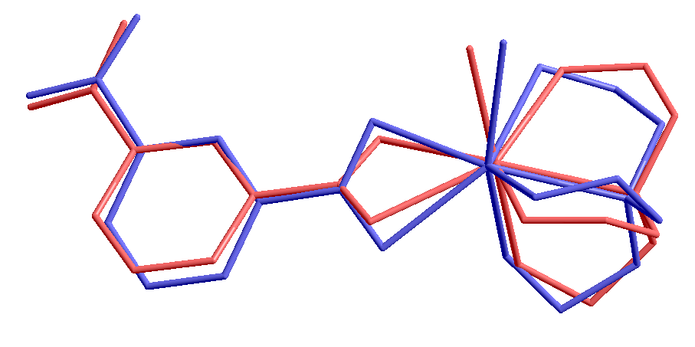
Figure 5. Superimposition of X-ray(red) and optimized(blue) geometries of [Cd(IsoPht)(TEA)H₂O]·3H₂O
Table 3. Hydrogen bond interactions for [Cd(IsoPht)(TEA)H₂O]·3H₂O
Hydrogen-bonds
D-H· · ·A | D-H | H···A | D···A | D-H···A
O8-H8-O9^{i} | 0.85 | 2.08(4) | 2.895(4) | 161.9
O8-H8-O11 | 0.85 | 1.98 | 2.818(4) | 167.2
O6-H6-O4^{ii} | 0.89(5) | 1.71(5) | 2.598(3) | 176(5)
O5-H5-O3^{iii} | 0.73(5) | 1.81(5) | 2.536(4) | 169(6)
O9-H9-O10 | 0.85 | 1.84 | 2.693(4) | 176.2
O9-H9-O8^{i} | 0.85 | 2.26 | 2.895(4) | 132.0
O10-H10-O1^{iv} | 0.85 | 2.01 | 2.808(3) | 156.1
O10-H10-O3^{i} | 0.85 | 1.91 | 2.743(4) | 165.0
O11-H11-O4^{iii} | 0.85 | 2.11 | 2.928(4) | 162.5
Symmetry transformations used to generate equivalent atoms: (i) x, 1-y, 1-z; (ii) x, 2-y, 1-z; (iii) 1-x, 2-y, 1-z; (iv) +z, -1 +y, +z

3. 2. FT-IR Study
The presence of strong FT-IR interactions between cadmium nitrate, TEA, and H₂Isopht molecules is confirmed by the FT-IR spectrum in the wavelength region of 4000–400 cm⁻¹ for the synthesized Cd(II)-complex (Figure 6). The broad FT-IR absorption band at 3429 cm⁻¹ is assigned to stretching vibrations of hydroxyl group (O–H) of uncoordinated water molecules. The FT-IR stretch band at 3155 cm⁻¹ belongs to the hydroxyl group (O–H) of the TEA ligand and has been observed to shift to a lower wavelength during complexation. The FT-IR bands identified at 3079 and 2844 cm⁻¹ are assigned to aromatic and aliphatic stretching vibrations of C–H group, respectively. The peaks corresponding to a strong asymmetric and a weak symmetric υ(C=O) stretching of the IsoPht ion were observed at lower frequencies in the
FT-IR spectrum of the complex. This situation demonstrates that the Isopht ligand coordinated to the Cd(II) metal ion via the oxygen atoms of the carboxylate group. The difference between the asymmetric and symmetric stretching υ(C=O) vibrations observed in the IR spectra of the complexes (∆υ), [∆υ = υ_{asym}(C=O) - υ_{sim}(C=O)] is used to determine the coordination type of the carboxylate group. The asymmetric υ_{asym}(C=O) and symmetric υ_{sym}(C=O) carboxylate stretching vibrations were observed at 1538 cm⁻¹ and 1390 cm⁻¹, respectively. A lower Δυ value (148 cm⁻¹) for the complex than the Na-IsoPht (169 cm⁻¹) indicated that the chelate coordination mode of the carboxyl group in the complex.⁴³⁻⁴⁴ The coordination mode of IsoPht ligand is also approved by the single-crystal X-ray structure examined. The peak at 1601 cm⁻¹ belongs to C=C bands in the complex. The band observed at 434 cm⁻¹ is due to the metal-oxygen (M–O) bond.⁴⁵

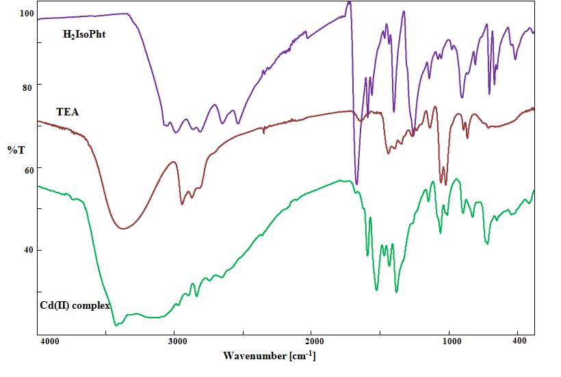
Figure 6. IR spectra of [Cd(IsoPht)(TEA)H₂O]·3H₂O complex, TEA ligand, and H₂IsoPht

3. 3. Thermal Analysis
Thermal stability and behavior of the Cd(II) complex were examined by simultaneous TG/DTG/DTA in nitrogen atmosphere. The TG-DTG and DTA curves of the complex are shown in Figure 7. The complex underwent complete degradation in two main stages. In the first stage, it is related to the removal of crystal water and aqua ligand at 44-118°C. This exhibits an endothermic peak at 89 °C in the DTA curve. The anhydrous complex stays stable up to 179°C. After this temperature, it can be suggested that the TEA and IsoPht ligands removed successively from the structure at 179-657 °C (DTG_{max}.: 378 °C). The final solid product of thermal decomposition is probably CdO with a total mass loss of 72.3% (calcd. 74.2 %).
Figure 7. TGA curves of [Cd(IsoPht)(TEA)H₂O]·3H₂O complex

3. 4. Fluorescence Properties
The fluorescent properties of the TEA ligand and Cd(II) complex have been examined at room temperature. The resulting emission spectrum is given in Figure 8. Due to the fluorescence quenching of carboxy groups of IsoPht (which are strong electron-attracting groups), this ligand shows very low fluorescence emission at room temperature.^{38,46} While the TEA ligand shows the emission peaks at 312 and 346 nm with the excitation at 270 nm, Cd(II) complex exhibits emission bands at 357 and 423 nm with the excitation at 270 nm. Compared with the emission of the TEA ligand, the emission peaks of the complex were observed to redshift (ca.45 nm and 77 nm). The solid-state fluorescence of the complex may be assigned to MLCT or LMCT transitions.⁴⁷

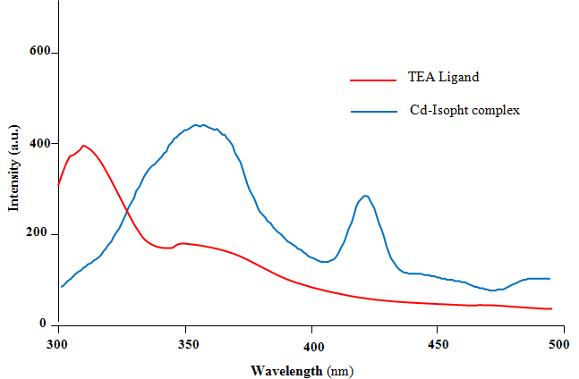
Figure 8. Fluorescence spectrum of [Cd(IsoPht)(TEA)H₂O]·3H₂O complex and TEA ligand in the solid-state (λ_{ex}= 270 nm).

3. 5. Antimicrobial Activity
The antimicrobial activity of the prepared [Cd(IsoPht)(TEA)H₂O]·3H₂O complex against three bacteria and one fungus was studied. Saturated solution and inhibition zones (mm) of the Cd(II) complex are given in Table 4. In the different concentrations of complex, various inhibition values were observed for B. cereus, S. aureus, E. coli, and C. albicans between 10-25 mm, 7-20 mm, 16-18 mm, and 8-15 mm respectively. It was shown more efficacy than positive control against all three bacterial zones, especially at concentrations of 40000 and 20000 ppm.
The antimicrobial activity of mixed ligand metal complex is determined by various factors such as the chelate effect, i.e. bidentate, tridentate or tetradentate ligands, the nature of ligand, the total charge of the complex, and metal ion located in the center.⁴⁸ In light of this information, it can be said that despite the weak antimicrobial activity of TEA alone, the complex formed by combining with Cd(II) ion shows stronger antimicrobial activity.

Table 4. Diameter of zones of inhibition (mm) of [Cd(IsoPht)(TEA)H₂O]·3H₂O complex
ppm | S.aureus | B.cereus | E.coli | C.albicans
40000 | 20 | 25 | 18 | 15
20000 | 20 | 25 | 16 | 15
10000 | 15 | 20 | 0 | 12
5000 | 13 | 16 | 0 | 8
2500 | 9 | 15 | 0 | 0
1250 | 7 | 15 | 0 | 0
625 | 0 | 14 | 0 | 0
312.5 | 0 | 10 | 0 | 0
ªDMSO | - | - | - | -
^{b}Ampicilin(10µg/mL) µ) | 18 | 20 | 15 | -
^{b}Flukonozol(25µg/mL) | - | - | - | 20
a: negative control; b: positive control

4. Conclusions
A novel mixed ligand [Cd(IsoPht)(TEA)H₂O]·3H₂O complex was synthesized and structurally characterized. The revealed X-ray structure clearly showed that the complex has a distorted monocapped trigonal prismatic geometry by binding to Cd(II) ion as TEA tetradentate and IsoPht bidentate. Thermal stability and behavior of the complex in the nitrogen atmosphere were investigated. The complex was completely degraded in two main stages. Fluorescence properties of cadmium complex having d¹⁰ electron configuration at room temperature were investigated. In the fluorescence spectrum, the red-shift of the peaks of the complex may be attributed to the LMCT or MLCT transitions. Also, the antimicrobial properties of the complex were investigated against three bacteria and one fungus. Data on the antimicrobial activity of the Cd(II) chelate complex formed by the tetradentate TEA and bidentate IsoPht ligands shows supported that it demonstrated an effective activity to inhibit the growth of all tested strains.

5. Supplementary Data
Crystallographic data have been deposited with the Cambridge Crystallographic Data Centre as supplementary publication No. CCDC 1977619. Copies of the data can be obtained, free of charge, on application to CCDC, 12 Union Road, Cambridge CB2 1EZ, UK (fax: +44-1223- 336033 or e-mail: deposit@ccdc.cam.ac.uk).
6. References
1. I Ucar, OZ Yesilel, A Bulut, H Icbudak, H Ölmez, C Kazak, Acta Cryst. 2004, 60, 392-394.
2. O Andac, Y Topcu, VT Yilmaz, K Guven, Acta Cryst. 2001, C57, 1381-1384.
3. JM Ashurov, Acta Cryst. 2016, 72, 526–529.
4. M Rubab, MN Akhtar, W Zierkiewicz, M Michalczyk, R Nadeem, M Shahid, MN Tahir, M Akram, MA Hanif, MA AlDamen, Res. Chem. Intermed. 2019, 45, 5649-5664.
5. Z Boulsourani, GD Geromichalos, K Repana, E Yiannaki, V Psycharis, CP Raptopoulou, D Hadjipavlou-Litina, E Pontiki, C Dendrinou-Samara, J. Inorg. Biochem. 2011, 105, 839-849.
6. Y Kondratenko, AA Zolotarev, I Ignatyev, V Ugolkov, T Kochina, Transition Met. Chem. 2020, 45, 71-81
7. T Esker, A DeBoo, Y Ishiwa, Ethanolamines. CEH Report, SRI Consulting, California, USA, 1999.
8. KH Beyer, WF Bergfeld, WO Berndt, RK Boutwell, WW Carlton, DK Hoffmann, AL Schroeder, J. Am. Coll. Toxicol. 1983, 2, 183-235.
9. JB Knaak, HW Leung, WT Stott, J Busch, J Bilsky, Rev. Environ. Contam. Toxicol. 1997, 149, 1-86.
10. JM Ashurov, AB Ibragimov, BT Ibragimov, Polyhedron. 2015, 102, 441-446.
11.VT Yilmaz, E Senel, Transit Metal Chem. 2004, 29, 336-342.
12. R Kumar, S Obrai, A Kaur, MS Hundal, H Meehnian, AK Jana, New J Chem. 2014, 38, 1186-1198.
13. GM Kapteijn, PJ Baesjou, PL Alsters, DM Grove, WJJ Smeets, H Kooijman, AL Spek, G Koten, Chem. Ber. 1997, 130, 34-44.
14. A Dicko, P Tardi, X Xie, L Mayer Int. J. Pharm. (Amsterdam, Neth.) 2007, 337, 219-228.
15. MG Voronkov, GA Kuznetsova, AY Fedorin, GG Yshkov, AV Mashanov, NA Malishkina, MM Rasulov, 2009. Pat. RF. No 2418580.
16. MG Voronkov, AY Fedorin, V Mashanov, NA Malishkina, GA Kuznetsova, GG Yshkov, Pat. RF. No 2425676, 2010.
17. OP Kolesnikova, AN Mirskova, SN Adamovich, RG Mirskov, OT Kudaeva, MG Voronkov, Dokl. Biol. Sci. 2009, 425, 556-560.
18. MM Rasulov, MG Voronkov, MK Nurbekov, MV Zvereva, AN Mirskova, SN Adamovich, RG Mirskov, Dokl. Biochem. Biophys. 2012, 444, 147-148.
19. T Hambley, Science. 2007, 318, 1392-1393.
20. T Storr, KH Thompson, C Orvig, Chem. Soc. Rev. 2006, 35, 534-544.
21. S Zhan, Y Sun, S Li, G Tang, Y Wang, Y Cui, Polyhedron. 2017, 121, 252-263.
22. X Shi, P Chen, Z Yin, T Li, M Wu, L Tian, Polyhedron. 2018, 141,87-93.
23. S-L Cai, L Lu, W-P Wu, J Wang, Y-C Sua, A-Q Ma, A Singh, A Kumar, Inorg. Chim. Acta 2019, 484, 291-296.
24. M Antonijević Nikolić, J Antić-Stanković, B Dražićc, S Tanasković, J. Mol. Struct. 2019, 1184, 41-48.
25. Z Lin, J Luo, M Hong, R Wang, L Han, R Cao, J. Solid State Chem. 2004, 177, 2794-2498.
26. Y Wang, L Wang, X Zhou, Y Li, J Li, J Mol. Struct. 2018, 1173, 612-619.
27. J Ge, J Cheng, P Wang, Q Liu, Y Dong, J. Mol. Struct. 2014, 1056-1057, 127-134.
28. W Song, X Cui, X Wang, L Liang, E Yang, X Zhao, Polyhedron. 2017, 127, 266-277.
29. L Radovanović, J Rogan, D Poleti, M Milutinović, MV Rodić, Polyhedron. 2016, 112, 18-26.
30. M Devereux, M McCann, V Leon, M Geraghty, V McKee, J Wikaira, Met.-Based Drugs 2000,7, 275-288.
31. M Geraghty, V Sheridan, M McCann, M Devereux, V McKee, Polyhedron 1999, 18, 2931-2939.
32. P Panchal, M Patel, Synth. React. Inorg. Met.-Org. Chem. 2004, 34, 1277-1289.
33.K Yue, S Zhao, R Zhao, Y Wang, Adv. Mater. Res. (Durnten-Zurich, Switz.) 2012, 399-401, 869-899.
34. X Cheng, X Zhu, H Kuai, Z. Naturforsch B J. Chem. Sci. 2013, 68, 1000-1006.
35. H Kuai, X Xu, X Cheng, L Feng, X Zhu, J. Coord. Chem. 2013, 66, 4304-4315.
36. G Pan, J Tang, X Yin, W Tian, Z Huang, Z. Naturforsch B J. Chem. Sci. 2013, 68, 1333-1339.
37. L Liu, S Zhang, Y Wang, X Guo, L Wu, B Wu, Inorg. Chim. Acta 2014, 423,176-183.
38. H Lin, F Sui, P Liu, X Wang, G Lin, Bull. Korean Chem. Soc. 2013, 34, 2138-2142.
39. X Yi, W Chen, J Huang, D Zhang, Y Wang, Acta Chim Slov. 2017, 64,1042-1047
40. GM. Sheldrick, SHELXL97, University of Gottingen, Germany 1997.
41. O Dolomanov, L Bourhis, R Gildea, J Howard, H Puschmann, J. Appl. Crystallogr. 2009, 42, 339-341.
42. A Revision, MJ Frisch, GW Trucks, HB Schlegel, GE Scuseria, MA Robb, JR Cheeseman, G Scalmani, V Barone, B Mennucci, GA Petersson, H Nakatsuji, M Caricato, X Li, HP Hratchian, AF Izmaylov, J Bloino, G Zheng, JL Sonnenberg, M Hada, M Ehara, K Toyota, R Fukuda, J Hasegawa, M Ishida, T Nakajima, Y Honda, O Kitao, H Nakai, T Vreven, JA Montgomery, Jr JE Peralta, F Ogliaro, M Bearpark, JJ Heyd, Brothers, KN Kudin, VN Staroverov, R Kobayashi, J Normand, K Raghavachari, A Rendell, JC Burant, SS Iyengar, J Tomasi, M Cossi, N Rega, JM Millam, M Klene, JE Knox, JB Cross, V Bakken, C Adamo, J Jaramillo, R Gomperts, RE Stratmann, O Yazyev, AJ Austin, R Cammi, C Pomelli, JW Ochterski, RL Martin, K Morokuma, VG Zakrzewski, GA Voth, P Salvador, JJ Dannenberg, S Dapprich, AD Daniels, Ö Farkas, JB Foresman, JV Ortiz, J Cioslowski, DJ Fox, Gaussian, Inc, C.T Wallingford, 2009 Gaussian 09.
43. GB Deacon, RJ Phillips, Coord. Chem. Rev. 1980, 33, 227-250.
44. K Nakamoto, Handbook of Vibrational Spectroscopy. 2006,1872-1892.
45. K Anandhan, R Thilak Kumar, Spectrochim. Acta, Part A. 2015, 149, 476-480.
46. X Shi, G Zhu, Q Fang, G Wu, G Tian, , R Wang, D Zhang, M Xue, S Qiu, Eur. J. Inorg. Chem. 2004, 1, 185-191.
47. G Sun, H Huang, X Tian, Y Song, Y Zhu, Z Yuan, W Xu, M Luo, S Liu, Feng X, F Luo, Cryst Eng Comm. 2012, 14, 6182-6189.
48. M Rizzotto Metal Complexes as Antimicrobial Agents. In: Bobbarala V (ed) A Search for Antibacterial Agents, IntechOpen, Rijeka, 2012, pp 73-86

