Supplementary information

- Bode plot of the big electrochemical cell with stainless steel working electrode

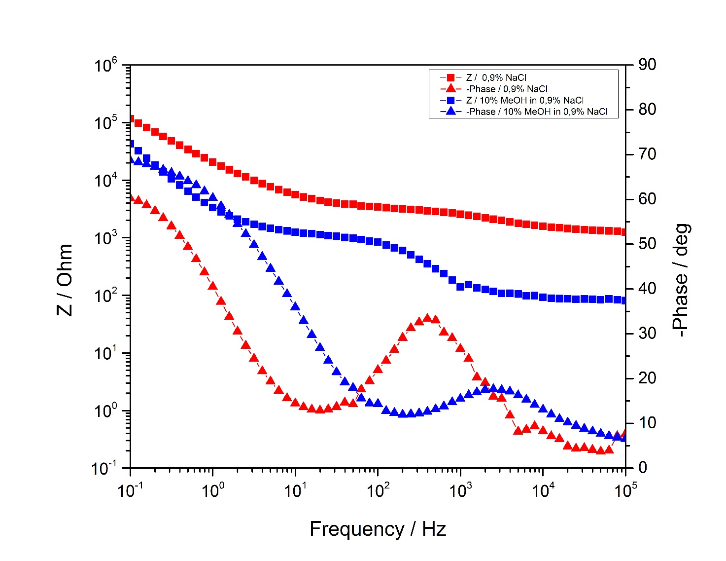
Figure 1S: Bode diagram of the big electrochemical cell with stainless steel working electrode. Red colored curves show the measurement where 0,9 % NaCl solution has been added to the system and the blue colored curves show the measurement where a 0,9 % NaCl solution with 10 % CH₃OH was added to the system. Squares represent impedance curve and triangles represent phase curve.
Figure 1S represents the Bode plot of the big electrochemical cell with stainless steel working electrode (WE). The Bode plot consist of two spectra simultaneously (impedance spectrum and phase spectrum), where the dependence of the impedance (Z) and the phase angle on frequency is represented. In the impedance spectrum, the activity on the working electrode is determined according to the slopes of the line, and in the phase spectrum the activity is determined according to a phase angle.
In the Bode diagram of big electrochemical cell (stainless steel working electrode) the solution resistance (R_{s}) with gradient of 0 in impedance spectrum , then the capacitance of the electric double layer (C_{dl}) with gradient of -1, which occurs at the phase boundary between electrode and electrolyte, charge transfer resistance with gradient of 0 (R_{ct}), which occurs due to the electrochemical reaction or charge transfer between the electrolyte and the metal, and the diffusion (Z_{w}) with gradient of -1/2 were detected. With the addition of 10% CH₃OH solution, a similar the solution resistance, lower capacitance of the electric double layer and more pronounced diffusion were observed.

- Bode plot of the small electrochemical cell with stainless steel working electrode
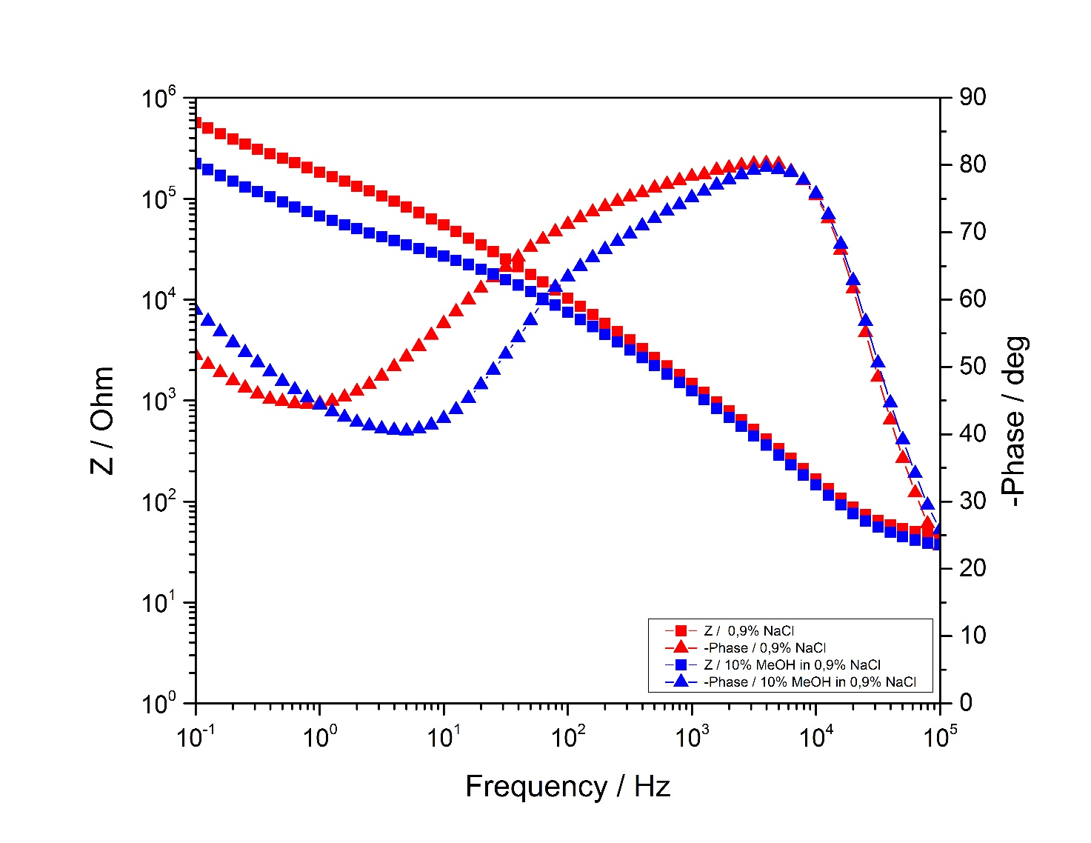
Figure 2S:Bode diagram of the small electrochemical cell with stainless steel working electrode. Red colored curves show the measurement where 0,9 % NaCl solution has been added to the system and the blue colored curves show the measurement where a 0,9 % NaCl solution Squares represent impedance curve and triangles represent phase curve.
Figure 2S represents the Bode plot of the small electrochemical cell with stainless steel working electrode (WE). In the impedance spectrum in the direction of frequency drop, the capacitance of the electric double layer (C_{dl}) and has a gradient of about -1 is represented. In the phase spectrum, the capacitance of the electric double layer (C_{dl}) is displayed as a negative phase angle of 80°. At lower frequencies, diffusion (Z_{w}) is observed, which is shown in the impedance spectrum with a gradient of -1/2 and in the phase spectrum with a negative phase angle of 45°.

- Bode plot of the big electrochemical cell with stainless steel covered with thin film of WO₃ working electrode
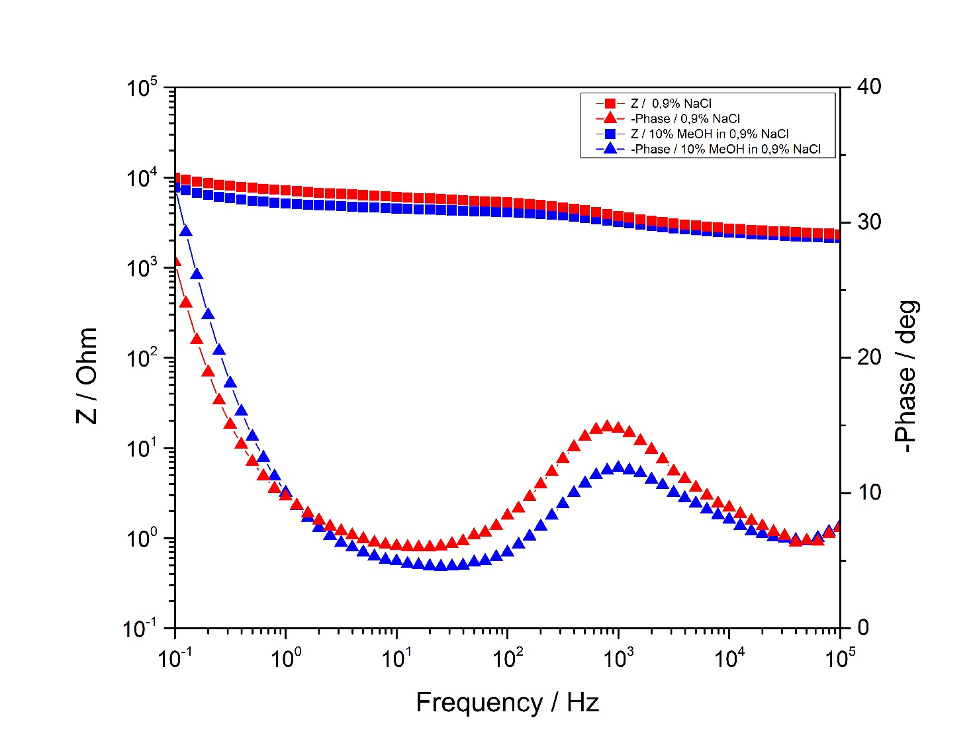
Figure 3S:Bode diagram of big electrochemical cell with stainless steel covered with WO₃ working electrode. Red colored curves show the measurement where 0,9 % NaCl solution has been added to the system and the blue colored curves show the measurement where a 0,9 % NaCl solution. Squares represent impedance curve and triangles represent phase curve.
In Figure 3S the Bode plot of the big electrochemical cell with stainless steel covered with thin layer of WO₃ is represented. The resistance and capacitance decreased with the addition of 10% CH₃OH solution. At higher frequency, the the solution resistance (R_{s}), the electron transfer resistance (R_{ct}) and the capacitance of the electric double layer (C_{dl}) formed at the phase boundary between the electrode are represented. At lower frequencies Warburg impedance (Z_{w}) is detected.

D. Bode plot of the small electrochemical cell with stainless steel covered with thin film of WO₃ working electrode

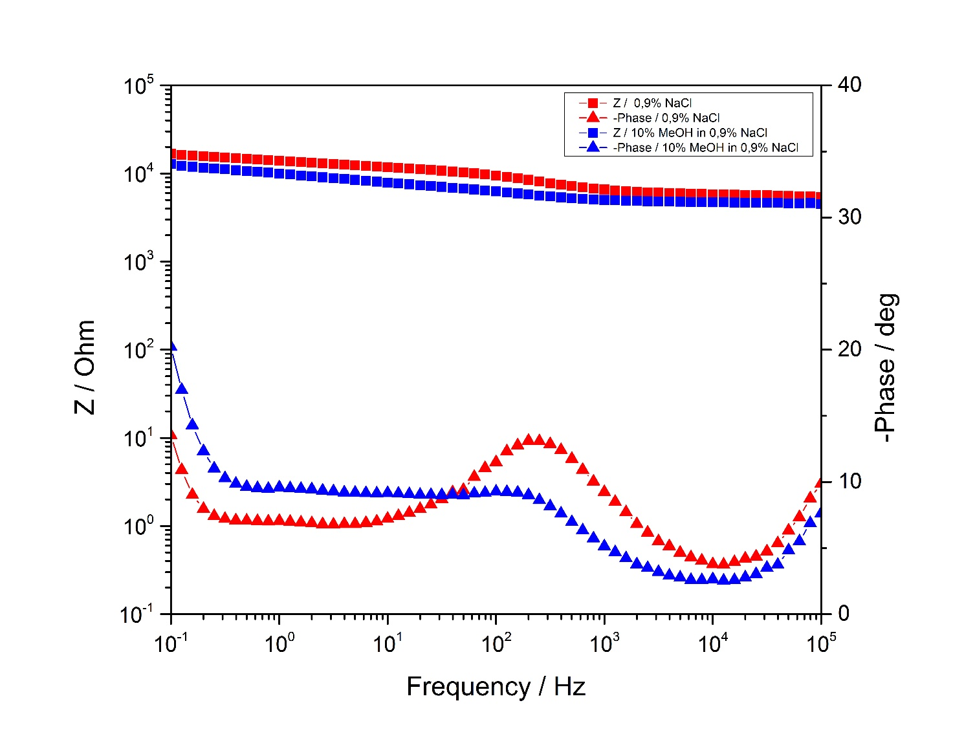
Figure 4S:Bode diagram of the small electrochemical cell with stainless steel covered with WO3 working electrode. Red colored curves show the measurement where 0,9 % NaCl solution has been added to the system and the blue colored curves show the measurement where a 0,9 % NaCl solution. Squares represent impedance curve and triangles represent phase curve.
In Figure 4S the Bode plot of the small electrochemical cell with stainless steel covered with thin layer of WO₃ is represented. In the Bode plot the solution resistance, then the capacitance of the electric double layer (C_{dl}) and the electron transfer resistance (R_{ct}), and diffusion as Warburg impedance (Z_{w}) are observed at higher frequencies with the addition of NaCl solution and with addition of CH₃OH solution. The electron transfer resistance is more pronounced with the addition of the NaCl solution than with the addition of the CH₃OH solution, and the electron transfer resistance is higher compared to electrodes that are not coated with the WO₃ layer.

E. Impedance spectrum, equivalent electric circuit and the fitting parameters of the large electrochemical cell with the stainless steel working electrode

- 0.9% NaCl
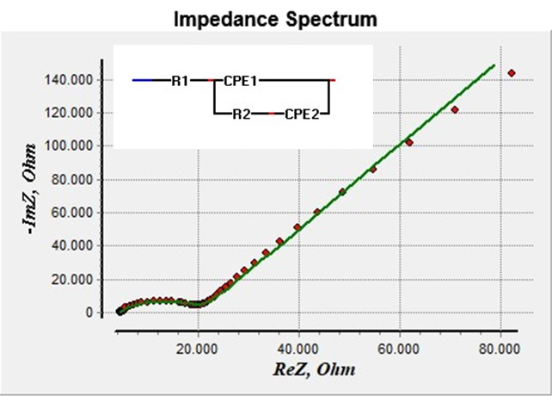
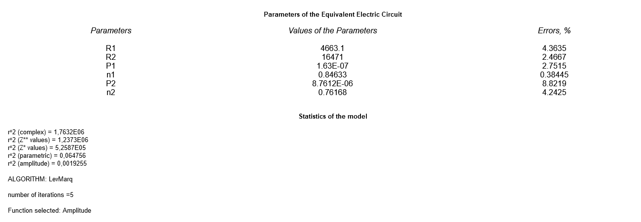
Figure 5S: Fitted impedance spectrum and the equivalent electric circuit of the large electrochemical cell with the stainless steel working electrode where NaCl was added to the system

- 10% CH₃OH in 0.9% NaCl
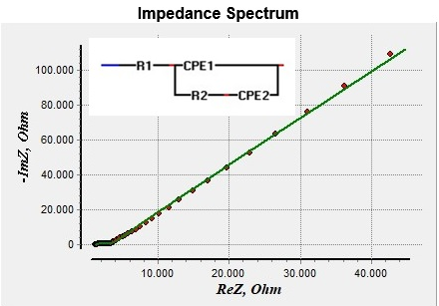
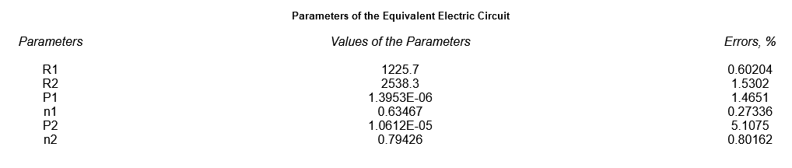
Figure 6S: Fitted impedance spectrum and the equivalent electric circuit of the large electrochemical cell with the stainless steel working electrode where methanol was added to the system
Impedance spectrums shown in Figure 5S and Figure 6S were fitted in EIS Spectrum Analyser with LevMarq algorithm. In Figure 5S, where 0.9% NaCl was added to the system, and Figure 6S, where 10% CH₃OH in 0.9% NaCl solution was added to the system, the equivalent electric circuits for the large electrochemical cell with the stainless steel working electrode are shown. R1 marks the solution resistance (R_{s}), R2 marks the charge transfer resistance (R_{ct}), P1 marks the double layer capacitance (C_{dl}), n1 is gradient of the P1 element and it describes the non-ideal capaticance. P2 marks the Warburg element with combination of non ideal capacitance and the n2 marks its gradient, which is usually for Warburg element 0.5 and for ideal capacitance 1. Parameters of the equivalent electric circuits, where 0.9% NaCl solution was added (Figure 5S) and where 10% CH₃0H in 0.9% NaCl (Figure 6S) was added, shows that the addition of 10% CH₃OH solution decreased the resistance and capacitance in comparison to addition of NaCl solution to the system, indicating that the electrode surface was released and, consequently, that CH₃OH caused the death of Saccharomyces cerevisiae cells.
F. Circuit fitting and the fitting parameters of the large electrochemical cell with the stainless steel covered with WO₃ working electrode
- 0.9% NaCl
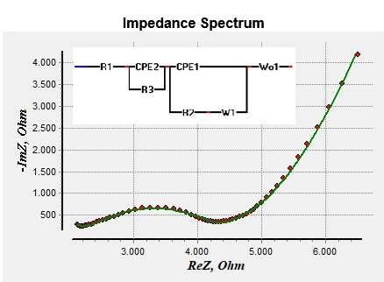
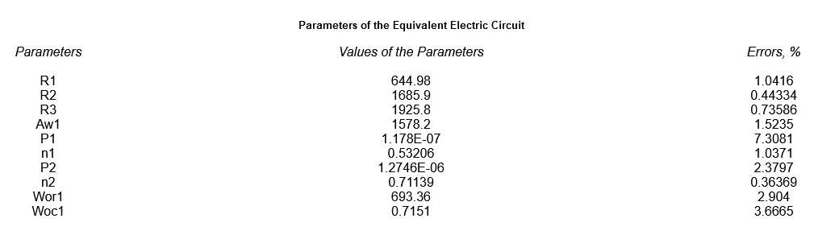
Figure 7S: Fitted impedance spectrum and the equivalent electric circuit of the large electrochemical cell with the stainless steel working electrode
- 10% CH₃OH in 0.9% NaCl
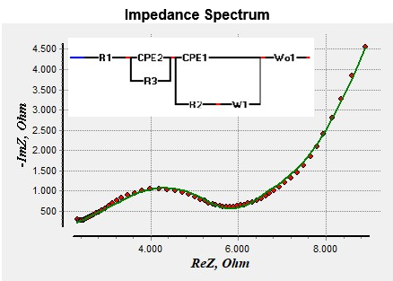
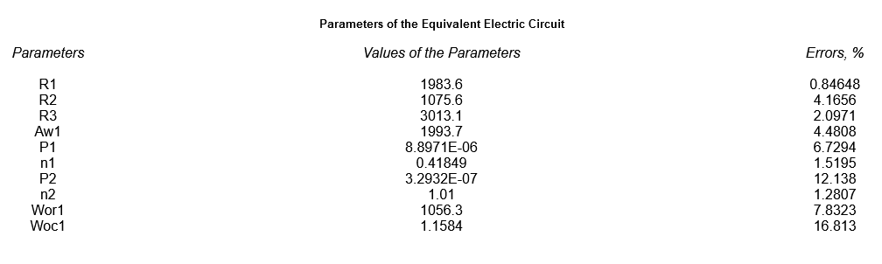
Figure 8S: Fitted impedance spectrum and the equivalent electric circuit of the large electrochemical cell with the stainless steel working electrode
Impedance spectrums shown in Figure 7S and Figure 8S were fitted in EIS Spectrum Analyser with LevMarq algorithm. In Figure 7S, where 0.9% NaCl was added to the system, and Figure 8S, where 10% CH₃OH in 0.9% NaCl solution was added to the system, the equivalent electric circuits for the large electrochemical cell with the stainless steel covered with WO₃ layer working electrode are shown. R1 marks the solution resistance (R_{s}), R2 and R3 mark the charge transfer resistance (R_{ct}), P1 and P2 mark the double layer capacitance (C_{dl}), n1 and n2 are gradients of the P1 element and P2 element, W1 marks the Warburg element and Wo1 marks the Warburg open diffusion, which occured because of the porous layer of the WO₃. Parameters of the equivalent electric circuits, where 0.9% NaCl solution was added (Figure 7S) and where 10% CH₃0H in 0.9% NaCl (Figure 8S) was added, shows that the addition of 10% CH₃OH solution decreased the resistance and capacitance in comparison to addition of NaCl solution to the system, indicating that the electrode surface was released and, consequently, that CH₃OH caused the death of Saccharomyces cerevisiae cells.

G. Graphs to estimate the LOD
1. Large electrochemical cell with the stainless steel working electrode (S1)
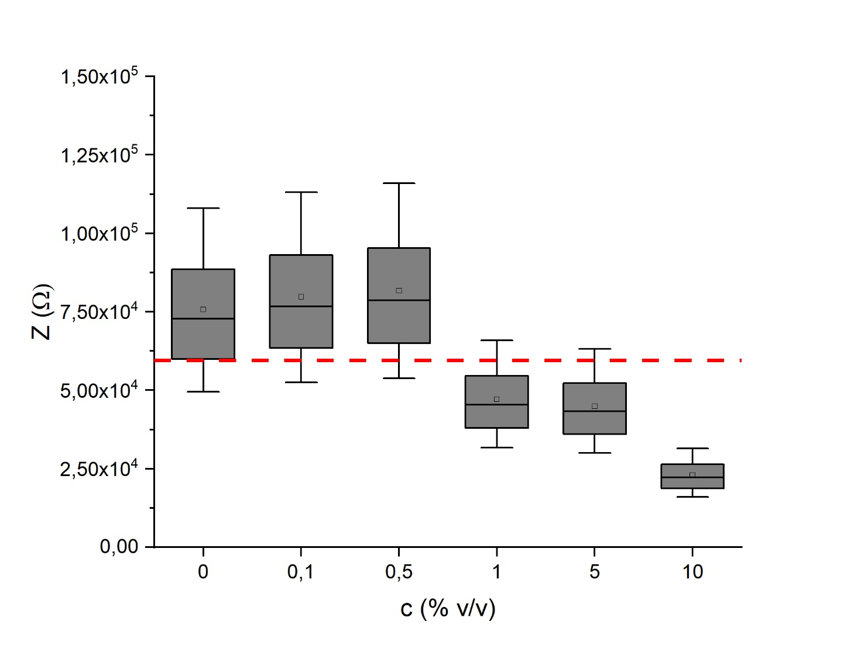
Figure 9S: Graph for estimate the LOD of the large electrochemical cell with the stainless steel working electrode (S1)

2. Small electrochemical cell with the stainless steel working electrode (S2)
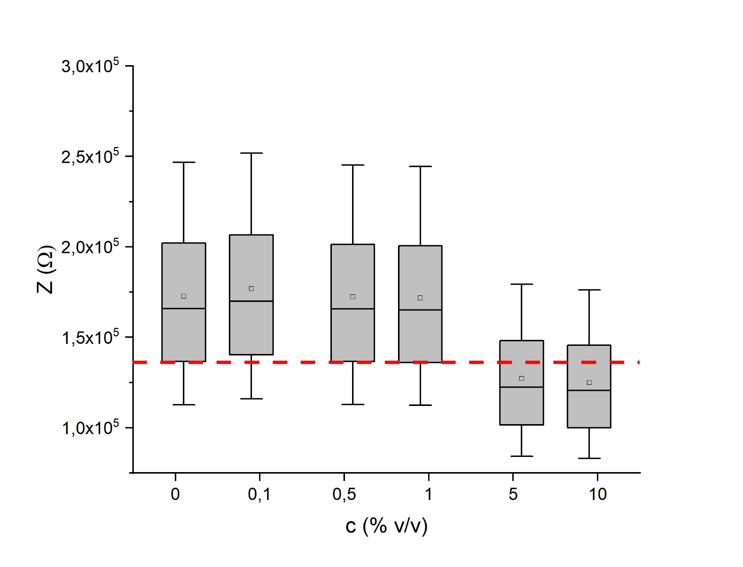
Figure 10S: Graph for estimate the LOD of the small electrochemical cell with the stainless steel working electrode (S2)

3. Large electrochemical cell with the stainless steel covered with WO₃ working electrode (W1)
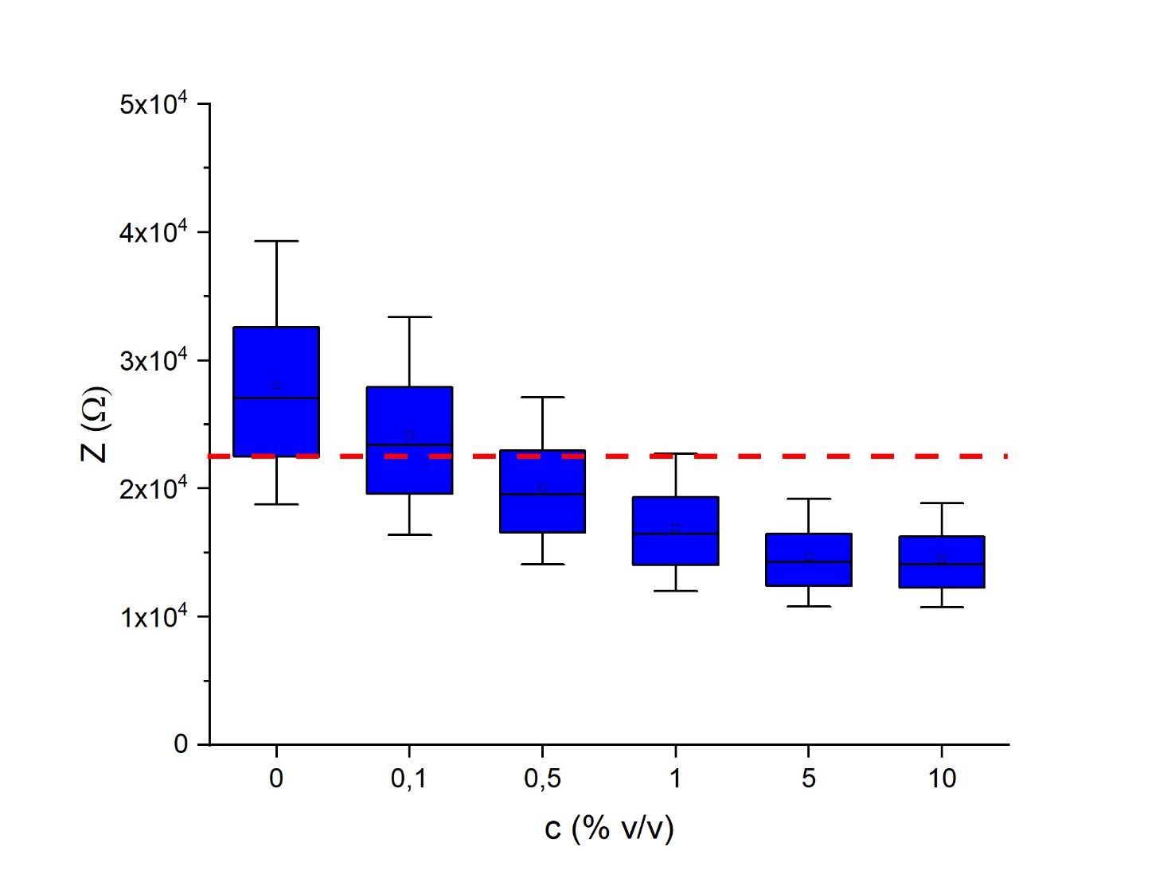
Figure 11S: Graph for estimate the LOD of the large electrochemical cell with the stainless steel covered with WO₃ working electrode (W1)

4. Small electrochemical cell with the stainless steel covered with WO₃ working electrode (W2)
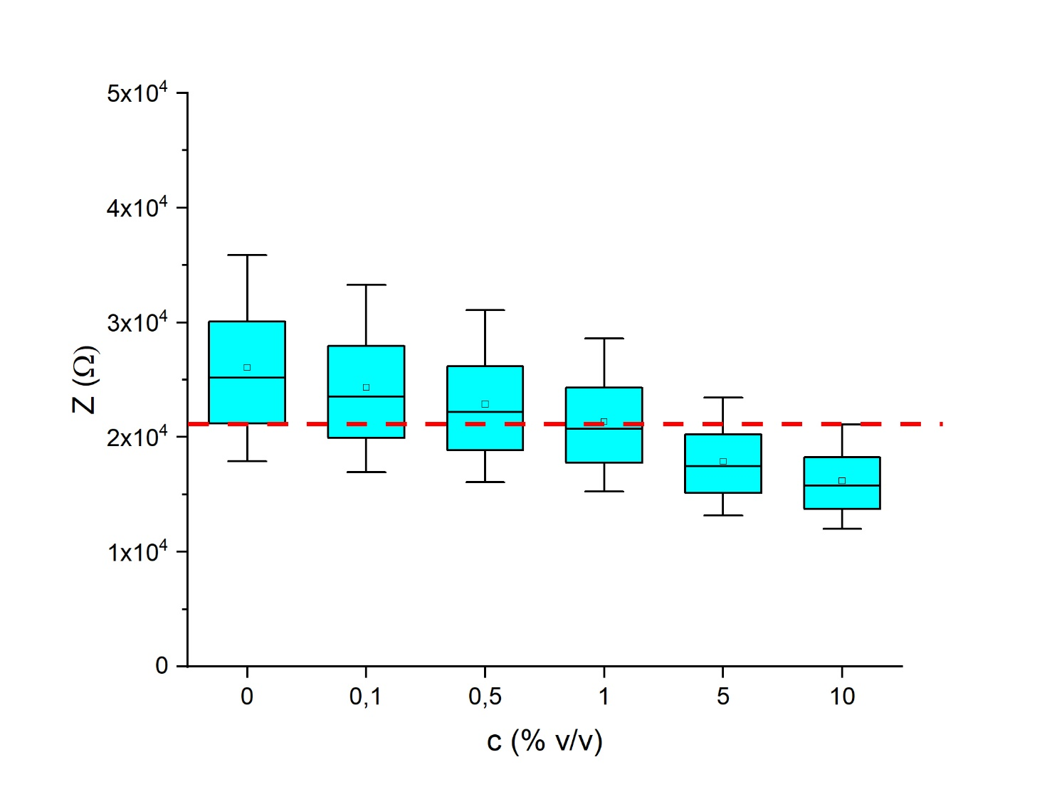
Figure 12S: Graph for estimate the LOD of the small electrochemical cell with the stainless steel covered with WO₃ working electrode (W2)
The LOD for stainless steel working electrode was estimated at about 5.0%v/v CH₃OH for small surface and 1.0%v/v CH₃OH for large surface. The LOD electrochemical cells with stainless steel covered with thin layer of WO₃ working electrode was determined as low as 1.0%v/v CH₃OH for small device and as low as 0.5%v/v CH₃OH for large device.

H. Nyquist diagrams of LOD estimate measurements
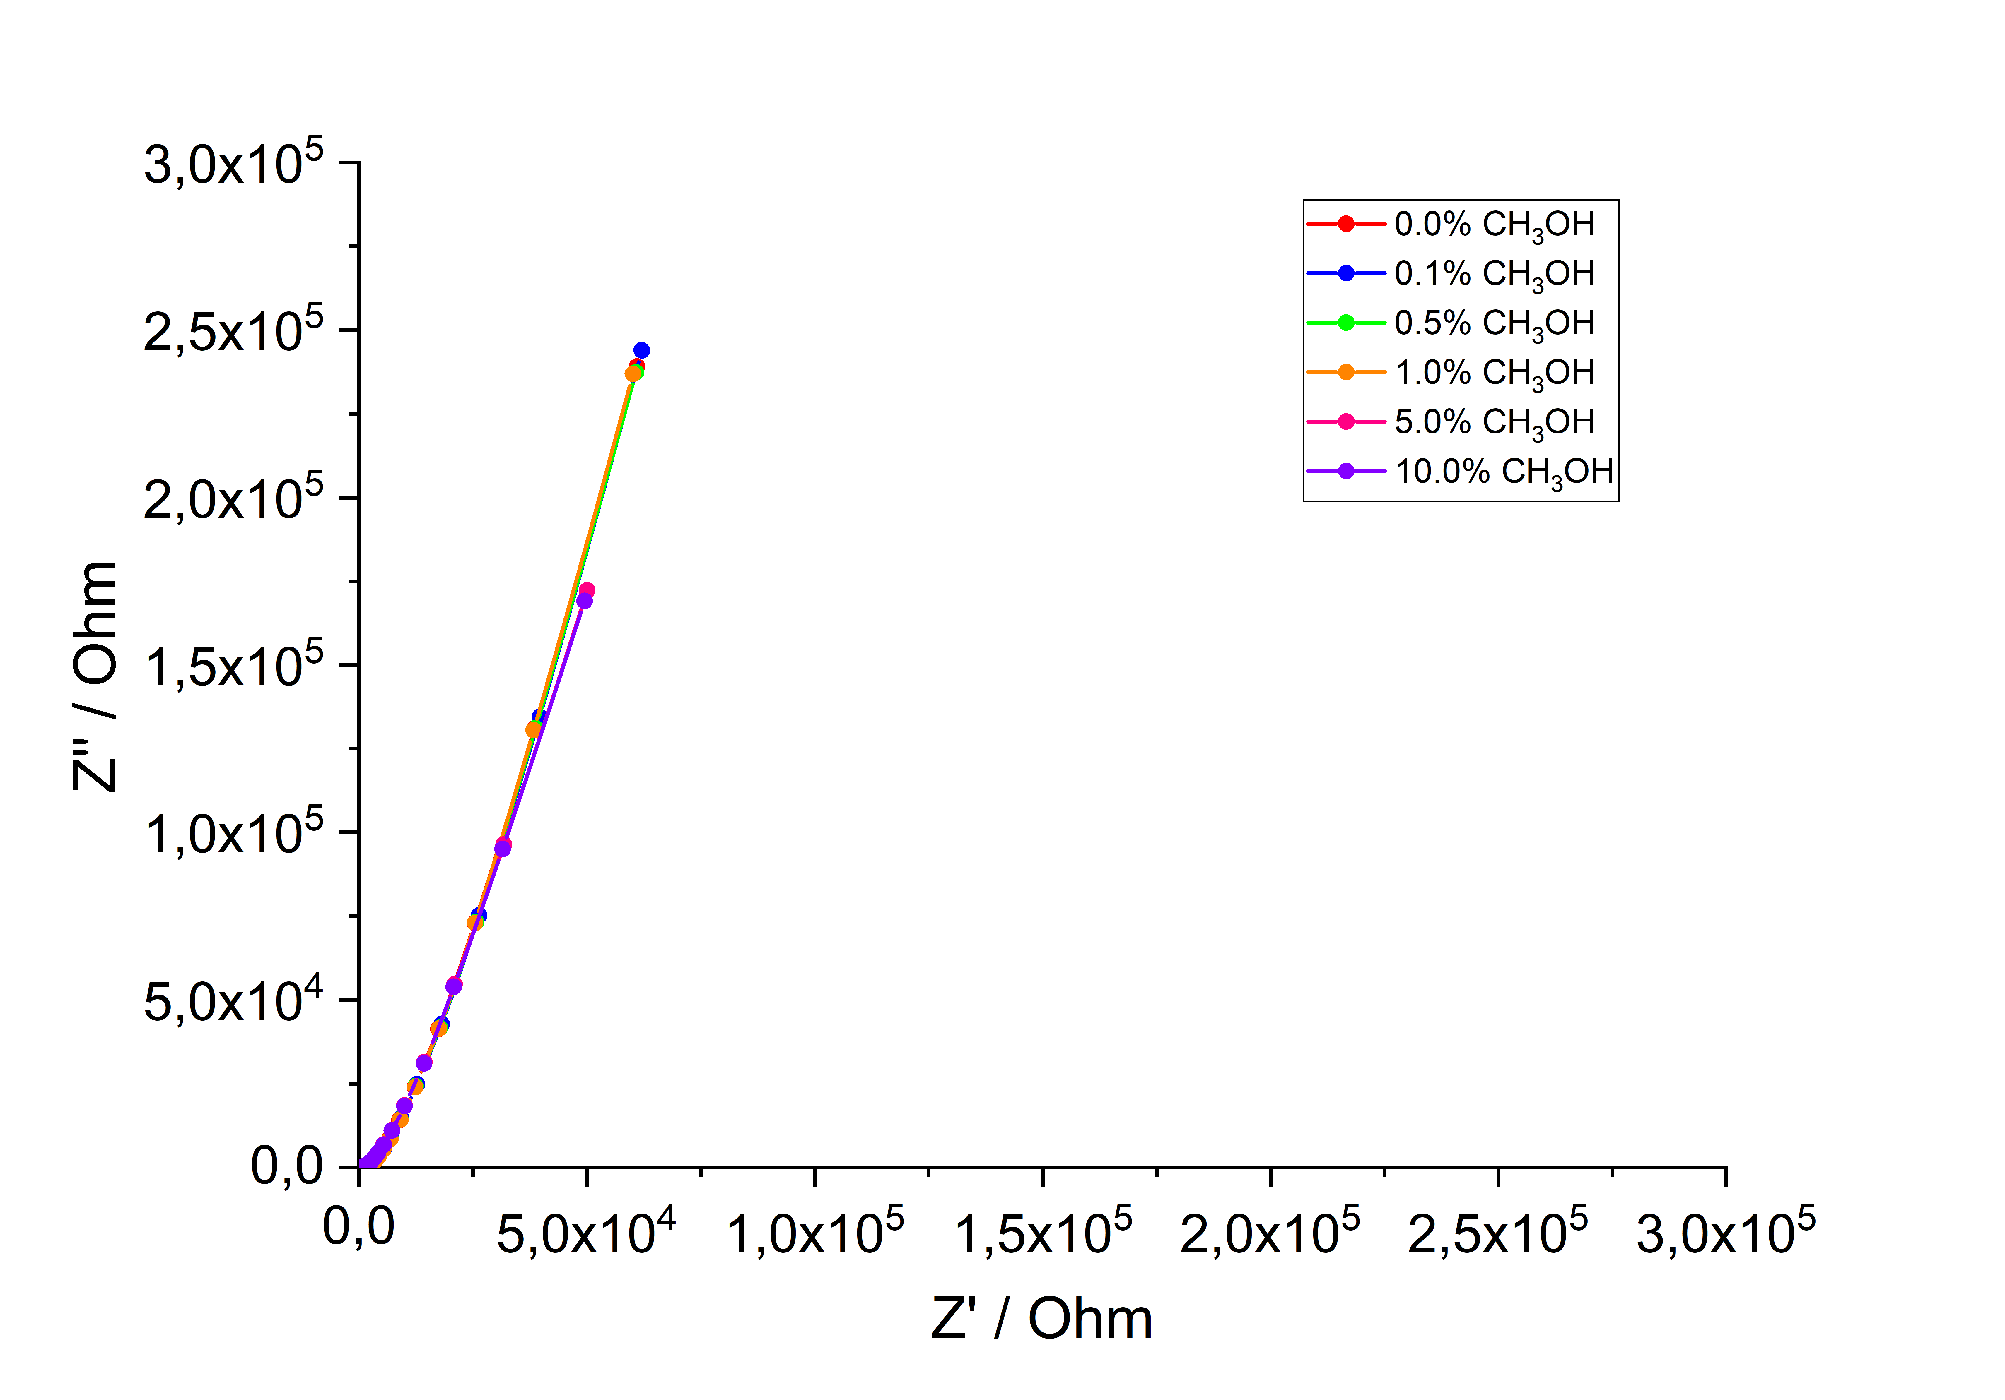
Figure 13S: Nyquist diagram for the large electrochemical cell with the stainless steel working electrode (S1).
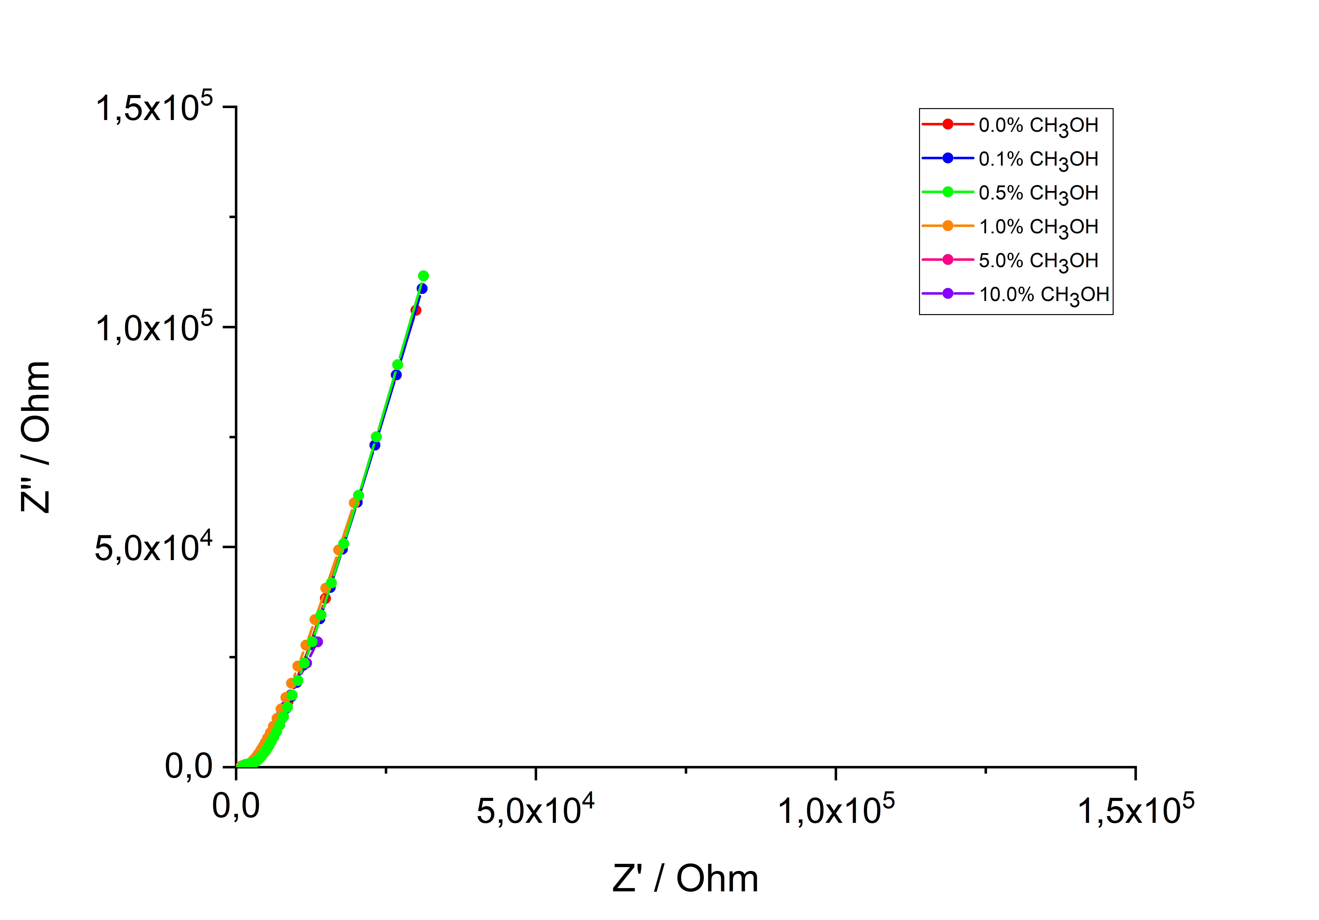
Figure 14S: Nyquist diagram for the small electrochemical cell with the stainless steel working electrode (S2)
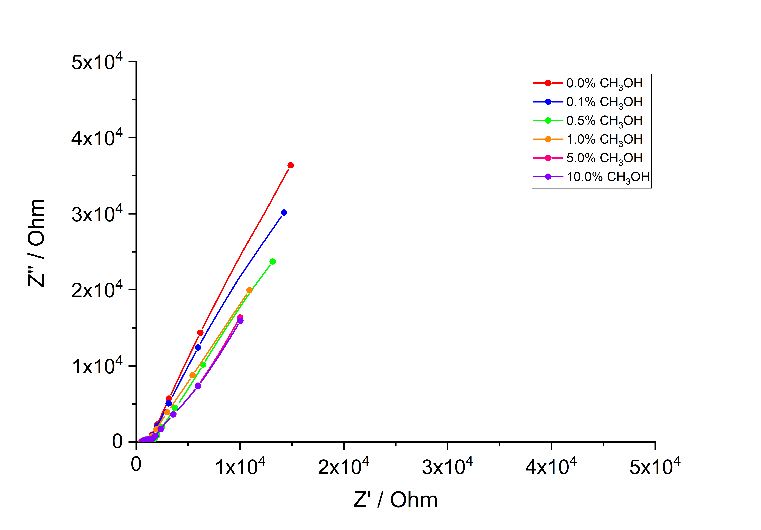
Figure 15S: Nyquist diagram for the large electrochemical cell with the stainless steel covered with WO₃ working electrode (W1)

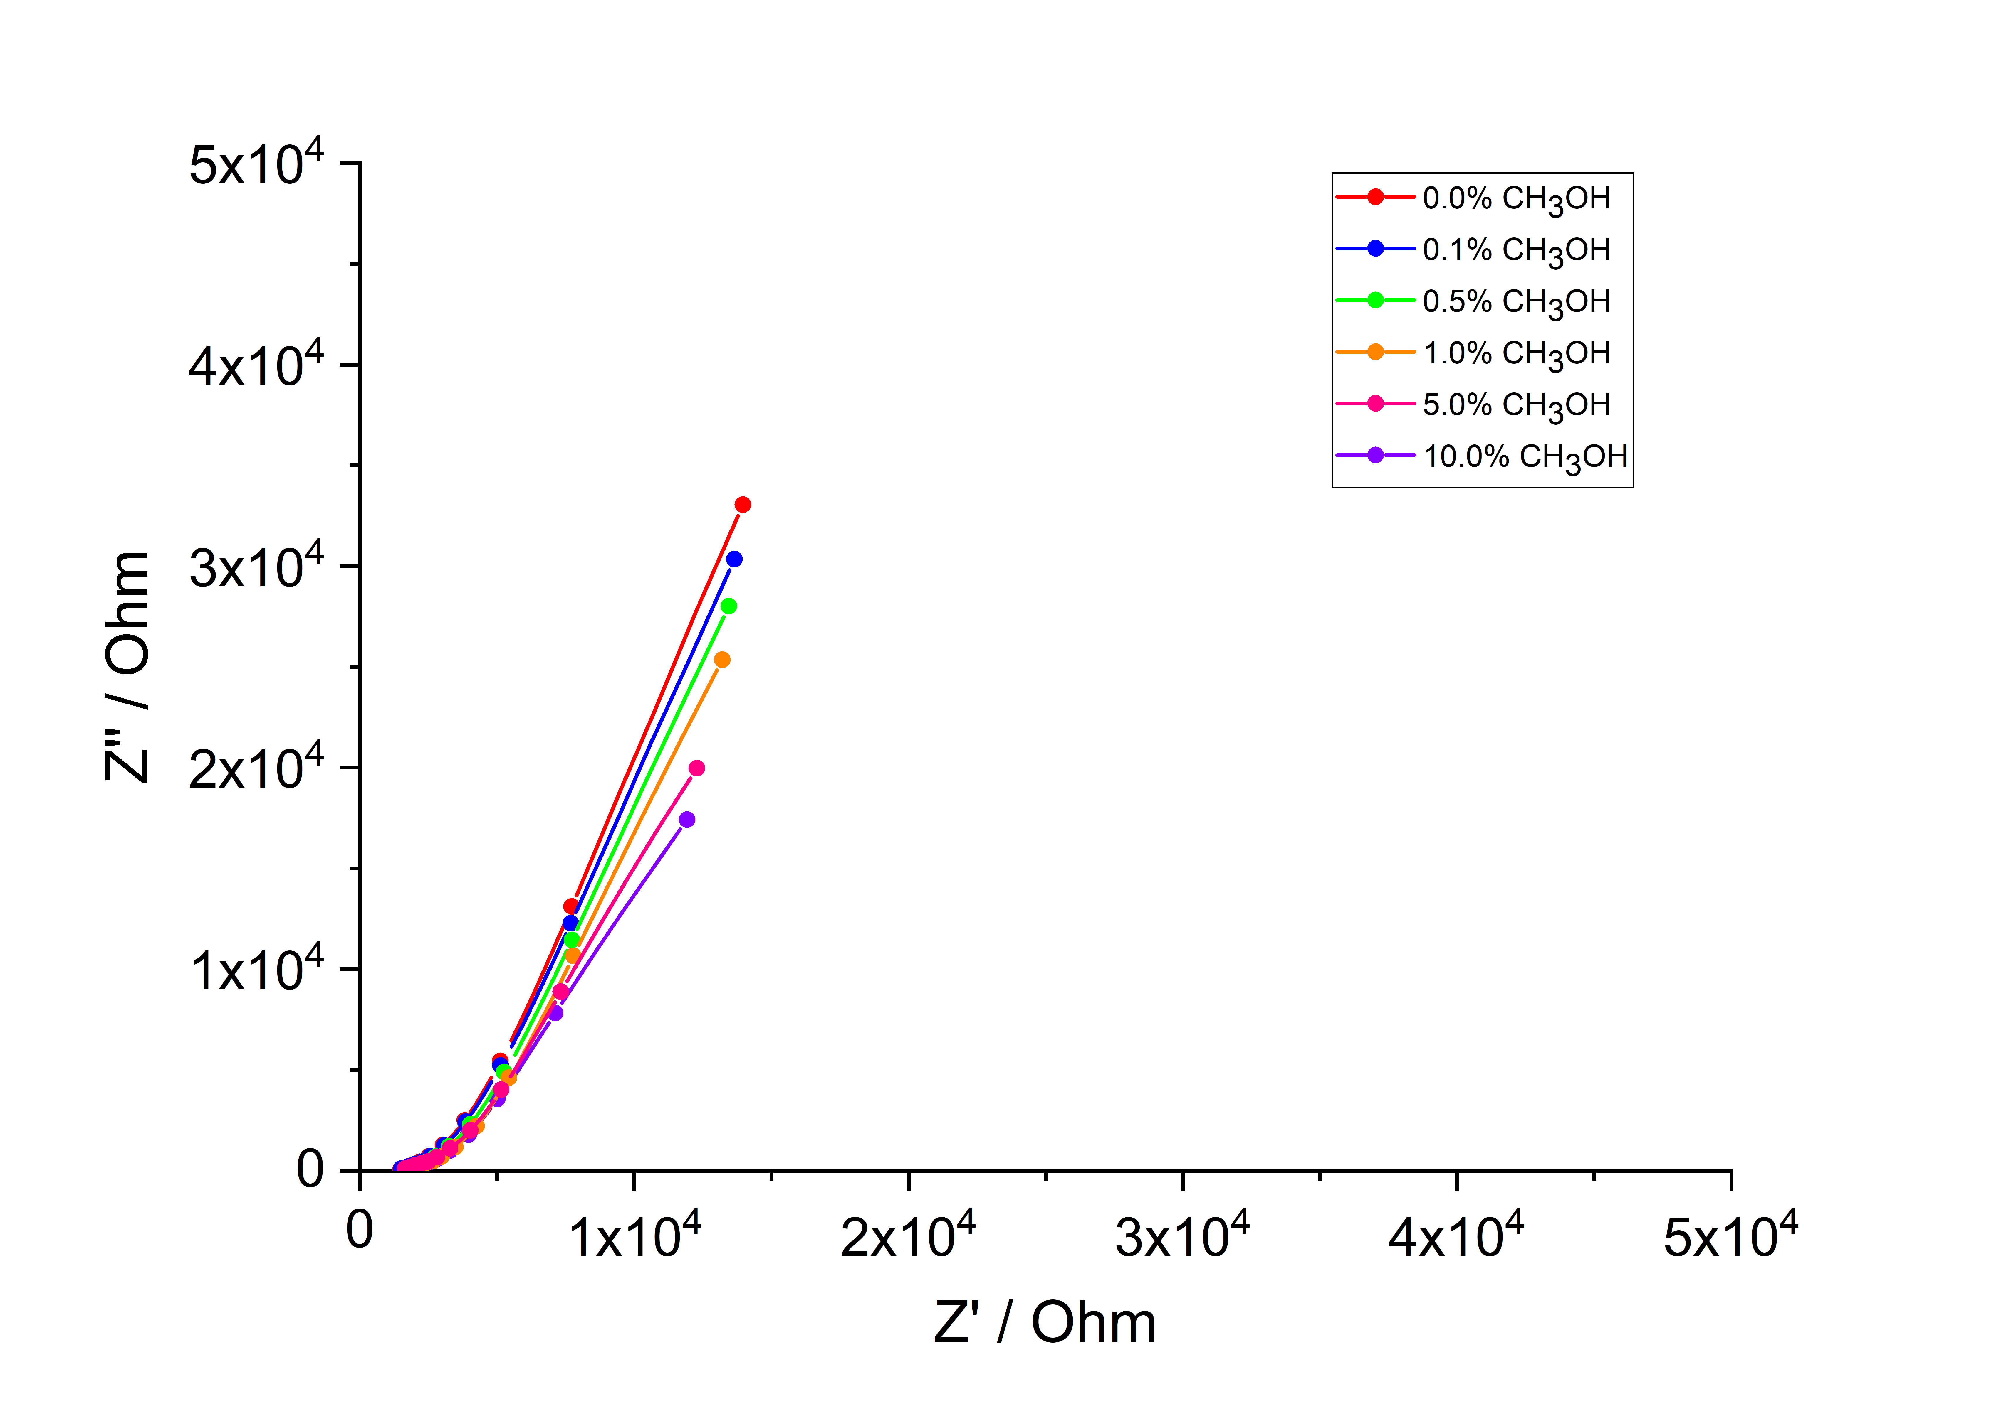
Figure 16S: Nyquist diagram for the small electrochemical cell with the stainless steel covered with WO₃ working electrode (W2)
Presented in paragraph H are the Nyquist diagrams for the LOD estimate measurements. It can be observed, that the detected differences between concentrations of CH₃OH are much less observable in case of stainless steel working electrode, where different concentrations can be usually distinguished only by points measured in low frequency region, with almost identical slopes. On the other hand, results obtained with biologically active component placed on WO₃ coated stainless steel electrodes show different slope along with different imedance (both Z' and Z'') values obtained in low frequency regions.

