Isolation of keratin from waste wool using hydrothermal processes
Aleksandra Verdnikª, Maja Čolnikª, Željko Knez^{a,b}, Mojca Škerget^{a*}

ª University of Maribor, Faculty of Chemistry and Chemical Engineering, Smetanova 17, 2000 Maribor, Slovenia

^{b} University of Maribor, Faculty of Medicine, Taborska ulica 8, 2000 Maribor, Slovenia

*Corresponding author: E-mail: mojca.skerget@um.si

»Presented at the 26th Annual Meeting of the Slovenian Chemical Society«.

Abstract
The subcritical water (SubCW) extractions of waste wool to produce keratin were performed at temperatures of 150 °C to 250 °C and at different reaction times between 5 min to 75 min. The resulting proteins in the obtained products were confirmed with Fourier-transform infrared spectroscopy (FTIR). The molecular weight of the protein extracts was determined by using two different methods: with a polyacrylamide gel electrophoresis in the presence of sodium dodecyl sulphate (SDS-PAGE) and by using a gel permeation chromatography. The results show, that by using SubCW, keratin can be isolated from waste wool in very high yields, much higher than by other chemical methods. Maximal yield was achieved at 180 °C and 60 min and it was 90.3%. The molecular weight distributions of extracted proteins, which were generated from waste wool were between 14 kDa and 4 kDa, what is comparable to the results obtained by other chemical methods.

Key words: waste wool, keratin, isolation, SubCW, gel permeation chromatography, SDS-PAGE electrophoresis.

Introduction
The growing concerns regarding the environmental pollution and the increasing demand for safe and sustainable materials are encouraging the search for green processing methods that would allow exploitation of natural resources and development of bio-based products. By-products of the textile and meat industries, such as wool, horns, hooves and feathers contain a large proportion of keratin.^{1,2} Keratin is a protein that has, due to its biodegradability and biocompatibility, recently become increasingly important.³ Wool is often used in textile industry due to its excellent mechanical properties. More than 2.5 million tons of wool is produced every year all over the world, where Australia, China, New Zeeland, Iran and Argentina represent five of the biggest producers of wool.⁴ The problem is that during the shearing and weaving processes as well as by processing in abattoirs also a considerable amount of wool waste is generated. Wool contains up to 95% of pure keratin, which is an important secondary product.⁵ Keratin has an extremely high potential to be used for the development of new products in the pharmaceutical, medical, cosmetic and biotechnology industries. Keratin from wool can be used for several forms of gels, microfibres, films, sponges, bulk materials, in wound healing, drug delivery, tissue engineering and medical devices.^{1,4,6,7}
For the extraction of keratin from natural by-products different methods were used: reduction, oxidation, microwave radiation, sulfitolysis, alkaline extraction, ionic liquids and use of enzymes.^{8,9} The disadvantage of these methods is that organic solvents and harmful chemicals are used, that could disrupt the structure of keratin and consequently have a negative influence on keratin properties. Organic solvents are expensive, toxic and non-renewable and pollute our environment.^{6,8,10}
Recently, SubCW has been increasingly used as a green medium for the extraction of value-added compounds from various materials, as it has many beneficial properties compared to other organic solvents.¹¹ SubCW is known as hot water under pressure with the critical point at 374 °C and 221 bar.^{12,13} Under these conditions, the ionic product, diffusivity and thermal conductivity of water increase.^{11,14–16} The advantages of the methods where SubCW is used as a medium are that they are performed rapidly and selectively without a catalyst,¹⁷ give high yields and high purity of products and water is easily removed from the decomposition products.^{18,19}
SubCW was used for hydrolysis of biomass waste (fish waste, chicken waste, hair and feathers), to produce amino acids.²⁰ Isolation of keratin from waste wool with SubCW has not yet been published. Until now, superheated water⁹ and steam explosion²¹ have been used for the isolation of keratin from wool and the yields of keratin were quite low (up to 30%).^{9,21}
The aim of this study was the development of SubCW isolation process of protein keratin from waste wool and to evaluate the performance of the process regarding the yield and molecular weight of the produced protein. The protein extracts were characterized with SDS-PAGE electrophoresis, gel permeation chromatography and FTIR analysis and new data about the molecular weight distribution of the keratin, isolated from wool with SubCW are presented.

Experimental

Materials
The waste wool of white traditional Slovenian sheep was kindly donated by local sheep farm. Trizma® base, sodium dodecyl sulfate, ammonium persulfate, glycine, methanol, 2-propanol, bovine serum albumin, trypsin, hydrochloric acid, dextran blue and Sephadex G-100 were supplied by Sigma-Aldrich. Coomassie brilliant blue G-250, sodium chloride, potassium chloride, disodium phosphate, potassium phosphate, monobasic, methylene blue and potassium chloride were supplied by Merck. Acetic acid was supplied by J.T.Baker. Lonza™ ProSieve™ protein marker was supplied by Fisher Scientific. 3X blue stained deposition buffer for SDS-PAGE electrophoresis and dithiothreitol were supplied by BioLabs Inc.

Isolation of keratin from waste wool with SubCW
The high pressure and high temperature batch reactor (series 4740 Stainless Steel, Parr Instruments, Moline, IL, USA) was filled with 2 g of raw wool and 40 mL of distilled water. The ratio of solvent to wool was 20 mL/g. The filled reactor was purged three times with an inert nitrogen gas (N₂) and the pressure in the reactor was set to 20 bar. The reactor was wrapped with a heating wire and glass wool in order to prevent heat losses. The reactions were carried out at different temperatures and different reaction times, as shown in Table 1. After the extraction, the reactor was rapidly cooled down.
Table 1: SubCW reaction conditions
Temperature | Reaction time
150 °C | 5 min, 15 min, 30 min, 60 min
180 °C | 5 min, 15 min, 30 min, 60 min, 75 min
200 °C | 5 min, 15 min, 30 min, 60 min
250 °C | 5 min, 15 min, 30 min, 60 min

The post reaction mixture was filtered by vacuum permeation and the products were collected in the forms of aqueous solution and solid residue.
A portion of the aqueous solution (2 mL) was evaporated using a rotary evaporator to determine the yield of extracted keratin. The yield of keratin was calculated by the equation 1, where the initial mass of wool (m_{wool}) and a percent of keratin (95%) in wool (w) were considered.

$η_{keratin}=\frac{m_{keratin}}{{w ∙m}_{wool}}∙100$ (1)

The remaining aqueous solution was stored in the freezer for further analysis.

Fourier transformed infrared spectroscopy (FTIR)
The presence of functional groups characteristic of the extracted keratin (amide A, amide I, amide II, amide III) was confirmed using the technique of attenuated total reflection of infrared spectroscopy by Fourier transform (ATR-FTIR) in the wavelength range of 4000 cm⁻¹ and 400 cm⁻¹. The data were analyzed with the high-performance IR solution software.⁹

Gel permeation chromatography
The molecular weight of extracted proteins was determined with gel permeation chromatography. For the preparation of stationary phase, 5% Sephadex G-100 gel was dissolved into deionized water and incubated at 95 °C for 5 h. Cooled Sephadex-G 100 was transferred into the glass separation column. 0.1 M phosphate buffered saline (PBS) at pH = 7.2 as the mobile phase were used.
The molecular weight determination of extracted proteins was done by comparing the ratio of V_{e}/V₀ for the sample protein and the V_{e}/V₀ of protein standards of known molecular weight, where V_{e} is the elution volume of standard protein and V₀ is the void volume.^{22,23} The V₀ of a glass separation column is based on the volume of effluent required for the elution of 0.2% blue dextran (large molecule). The calibration curve was prepared based on the standard proteins with already known molecular weights in the rage from 66000-360 Da. (Table 2).
The calibration curve of standards (equation 2) represents the dependence of the logarithm of the molecular weight (log M) on the ratio between the elution volume and the void volume of the column:
$log⁡(M)=\frac{V_{e}}{V_{0}}∙k+n$ (2)
where M is a molecular weight of keratin, V_{e} elution volume, V₀ void volume of column, k inclination of the curve and n section on the y axis.^{22,23}

Table 2: Molecular weights of standards
Standard protein | Molecular weight (Da)
bovine serum albumin (BSA) | 66 000
trypsin | 23 800
methylene blue | 360

Based on the equation 2 and elution volume of individual samples of isolated keratin the molecular weight of keratin was calculated.
In order to determine the elution volume of standards and samples, 1.4 mL of standards or sample solutions were loaded at the top of the column, the valve at the bottom was opened and the fractions of 1.5 mL were taken. The mobile phase (PBS buffer) was added at the top of the column throughout the experiment. The absorbance of the obtained fractions was measured by UV-Vis spectrophotometer at a wavelength of 280 nm.²³ The fraction with the highest absorbance represented the elution volume of an individual sample or standard.

SDS-PAGE electrophoresis
The molecular weight of the extracted keratin was determined by the SDS-PAGE gel electrophoresis. For the protein separation acrylamide/bisacrylamide (Acryl/Bis) separation gel with 1.5 M Tris-HCl buffer at pH 8.8 and 6% Acryl/Bis stacking gel with 0.5 M Tris HCl buffer at pH 6.8 were prepared. 20 µL of extracted keratin sample was added to 20 μL of loading buffer (mixture of SDS Blue Loading Buffer and dithiothreitol (DTT)). All prepared samples were incubated at 95 °C for 3-5 min and then centrifugated at 10,000 rpm for 2 min. Afterwards, 10 µL of sample and protein marker (mixture of highly purified proteins with molecular weights from 4.6 to 300 kDa) were pipetted from the bottom of the vial and transferred into the bottom of the gel wells. The electrophoresis was run at 150 V for 90 min with tris-glycine-SDS running buffer (pH 8.3).
After electrophoresis, the gels well were washed with deionized water and colored with Coomassie blue, methanol and acetic acid water mixture. Then, the gels were discolored with methanol, acetic acid water mixture. After that all gels were dried on the filter paper with a vacuum pump.
The gels were analysed by using ImageJ free software, which was based on the calibration curve of the protein marker, where the distances (d, in pixels) from the boundary between the entry and separation gel to the protein marker were measured. The calibration curve observes the dependence of log M on the distance (d).⁸

Results and discussion

Influence of temperature and reaction time on keratin yield

The yield of keratin in the reaction mixture is affected by temperature and reaction time as it is shown in Table 3. At the low temperature of 150 °C and at short reaction times from 5-30 min the yield of keratin was the lowest and it was only between 1% and 26%. As can be seen from Figure 1 at these conditions also the highest amount of wool residue was found. Rajabinejad et al.⁹ reported about similar yield of keratin (31%) obtained from wool with superheated water in a microwave at 170 °C and 30 min. In the present work however, by increasing the temperature to 180 °C, a much higher content of keratin in the liquid product was gained. The maximum yield of keratin (90.3%) was achieved at the temperature of 180 °C and reaction time of 60 min. Generally, the results show, that with increasing the temperature and prolonging the reaction time, the yield of keratin first increases and reaches a maximum and then it started to decrease. Namely, the high temperatures probably caused further decomposition of keratin to oligomers and free amino acids.⁹

Table 3: Yield of extracted keratin from waste wool with SubCW.

 | T = 150 °C | T = 180 °C | T = 200 °C | T = 250 °C
t (min) | ƞ_{keratin} (%) | ƞ_{keratin} (%) | ƞ_{keratin} (%) | ƞ_{keratin} (%)
5 | 1.7 | 23.8 | 73.0 | 73.3
15 | 5.4 | 57.9 | 81.1 | 75.3
30 | 16.1 | 71.4 | 87.6 | 80.5
60 | 25.6 | 90.3 | 86.0 | 63.2
75 | / | 73.6 | / | /

Furthermore, the differences in concentration of keratin in aqueous solutions obtained at different operating parameters are also visible by the color of the liquid product (Figure 1). The color of the aqueous solutions changed from a very pale yellow colored solutions obtained at the lowest and the highest temperatures (150 °C, 250 °C) to an intense yellow colored solution obtained at middle temperatures (180 °C and 200 °C) where the yield of keratin was near or at the maximum.
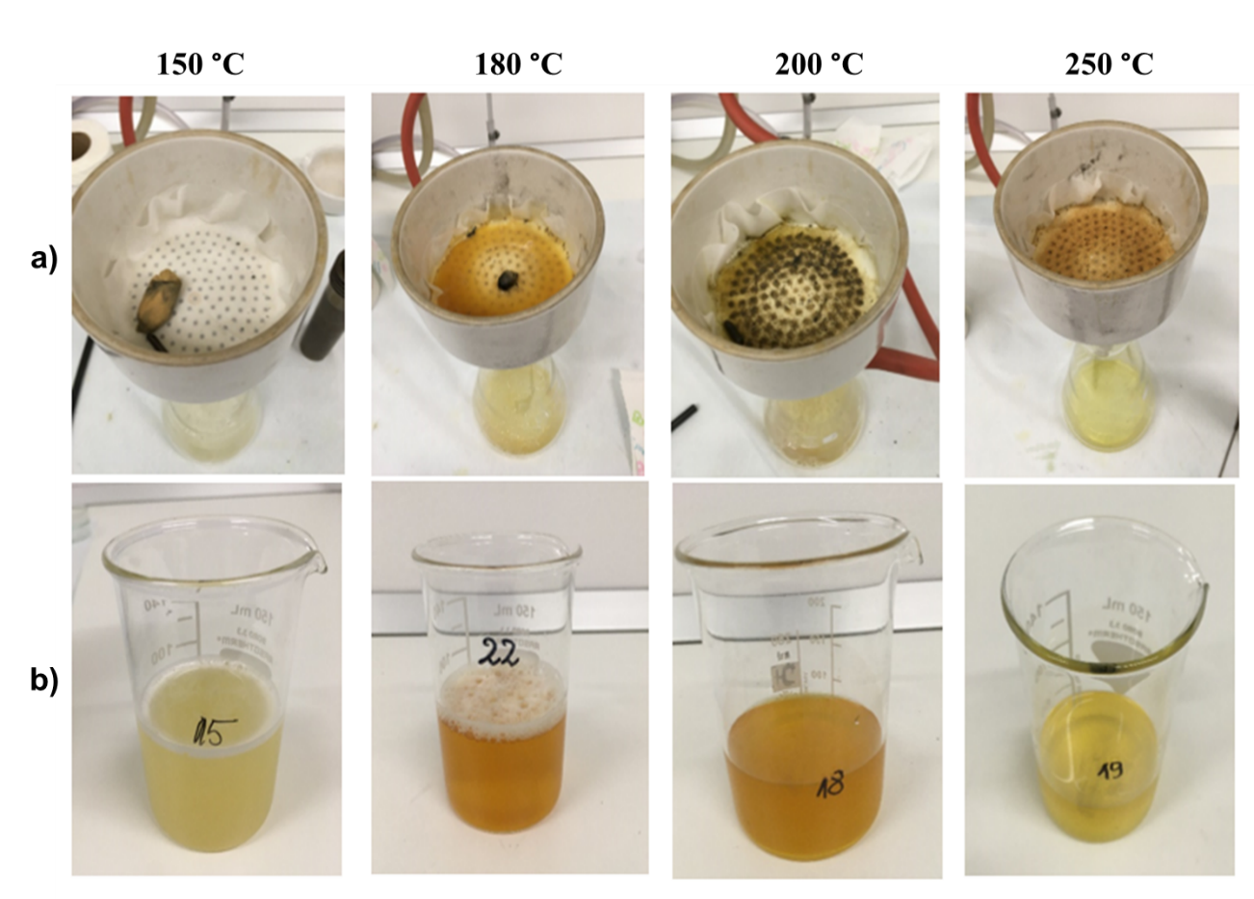
Figure 1: Reaction products at 150 °C, 180 °C, 200 °C and 250 °C at the reaction time (60 min); a) wool residues after filtration, b) liquid reaction product.

FTIR analysis of isolated keratin
In order to characterize the extracted keratin obtained from waste wool in SubCW at 180 °C and 60 min, FT-IR spectra were recorded. The infrared absorption spectra show characteristic absorption bands attributed to the peptide bonds.²⁴
In Figure 2, the major peaks represent peptide bonds characteristic for amides: amide A, amide I, amide II, amide III). Amide A peak at 3230 cm⁻¹ represents specific absorption bands for N-H bond while peak at 1635 cm⁻¹ (Amide I) is related to the C=O stretching vibration. Amide II (between 1480 cm⁻¹ and 1580 cm⁻¹) shows elongation of C-N bond and bending of N-H functional groups, while amide III at wavelength 1242 cm⁻¹ is a combination of N-H, C-N and C=O groups. Peaks that appear in the range between 2800 cm⁻¹ and 3000 cm⁻¹ are attributed to the vibrations of the CH, CH₂ and CH₃ functional groups.²⁴
Amide II

Amide I

Triple bands CH, CH₂, CH₃

Amide III

Amide A

Figure 2: FTIR spectrum of keratin isolated from waste wool with SubCW at temperature of 180 °C and a reaction time of 60 min.

Molecular weight of isolated keratin
The determination of the molecular weight of keratin with SDS-PAGE electrophoresis was done based on the calibration curve of protein standards (Figure 3) and by the elution of standards with known molecular weight (Figure 4) in Sephadex G-100 gel under the same conditions as the sample of extracted keratin (Figure 5).
The molecular weight distributions of the extracted proteins are shown in Table 4 and Figure 6. Figure 6 shows the SDS-PAGE electropherograms of wool proteins isolated by SubCW at different temperatures and reaction times.

Figure 3: Calibration curve of protein marker for determination of molecular weight of keratin with SDS-PAGE electrophoresis at temperature of 180 °C.

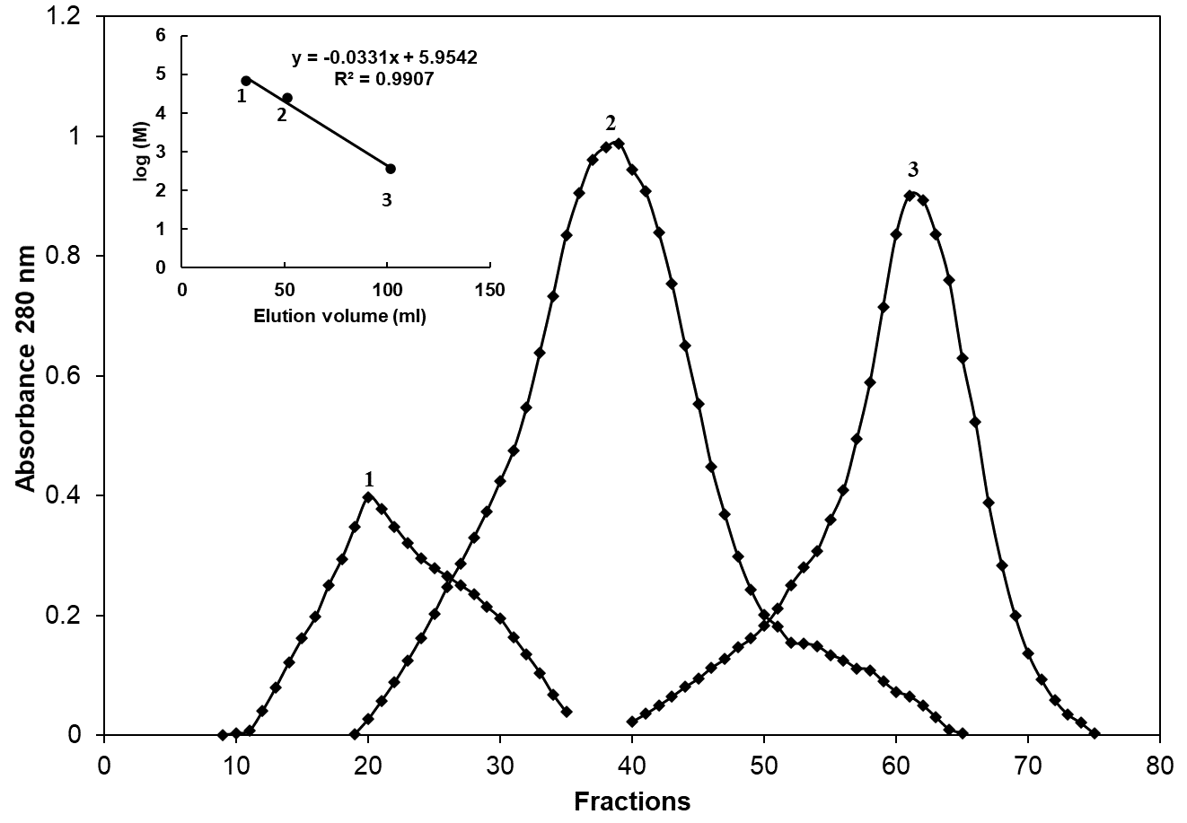
Figure 4: Gel permeation chromatography through Sephadex G-100 of standard proteins with known molecular weight: (1) BSA; (2) trypsin; (3) methylene blue.

Figure 5: Gel permeation chromatography through Sephadex G-100 of isolated keratin at temperature of 180 °C and time 60 min.

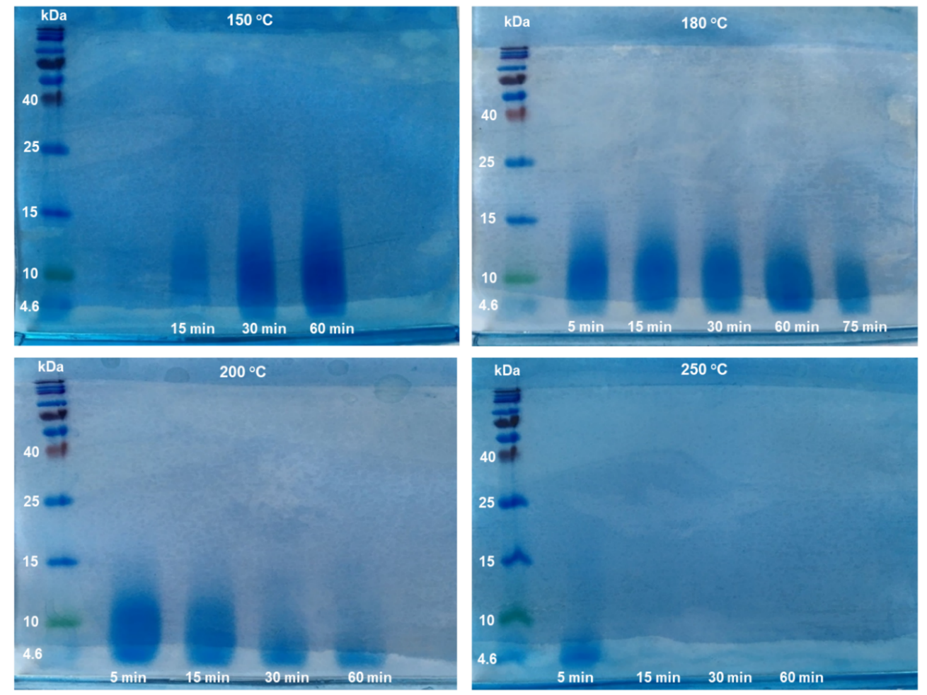
Figure 6: SDS-PAGE electrophoresis gels of isolated keratin.

Generally, the molecular weights of extracted proteins were quite low in all cases. A major protein fractions were in the range of 14 kDa and 4 kDa.

Table 4: Molecular weight of keratin.

Temperature (°C) | Reaction time (min) | Molecular weight of keratin (kDa)  (gel permeation chromatography) | Molecular weight of keratin (kDa)  (SDS-PAGE)
150 | 15 | 9.2 | 5–14.0
150 | 30 | 8.3 | 4.6–14.0
150 | 60 | 8.2 | 4.6–13.9
180 | 5 | 7.5 | 4.6–12.5
180 | 15 | 7.4 | 4.6–12.0
180 | 30 | 7.3 | 4.6–11.5
180 | 60 | 7.2 | 4.6–11.3
180 | 75 | 6.6 | 4.6–10.4
200 | 5 | 6.5 | 4.6–10.8
200 | 15 | 5.9 | 4.6–8.8
200 | 30 | 5.2 | 4.6–6.5
200 | 60 | 4.7 | 4.6–6.3
250 | 5 | 4.6 | 4.6–5.0
250 | 15 | 4.2 | /
250 | 30 | 4.1 | /
250 | 60 | 3.7 | /

Molecular weight distribution of isolated keratin at temperature of 150 °C and at time 5 min has not been determined, while the yield of keratin was only 1.7%.
Table 4 shows, that molecular weight of extracted proteins decreased with increasing the temperature and reaction time due to further degradation of long chain proteins to smaller molecules.
As can be seen from Figure 6, the clear major fraction band between 14-8 kDa appeared after the hydrolysis of waste wool at 150 °C for reaction time of 30 and 60 min. Similar strong bands can be observed for products obtained at 180 °C that indicate molecular weight between 13 kDa and 7 kDa for all reaction times, while molecular weights at a higher temperature of 200 °C are much lower, only between 10.8 kDa and 5 kDa. In the case of 250 °C the major protein fraction in the range from 5 to 4.6 kDa results only for 5 min of reaction time, while at longer reaction times no bands were observed in the studied gels, which is a consequence of their degradation to very low molecular weight oligopeptides.⁸ Low molecular weights of keratin indicated that structure of keratin was significantly affected with the high temperature of the SubCW treatment (cleavage of peptide bonds).
Based on the results it can be concluded that the optimal temperatures for isolation of keratin molecules of high molecular weights by using SubCW, would be 150 °C or 180 °C, because at these two temperatures molecular weights of keratin obtained were the highest and were in the range of 14 kDa to 4.6 kDa.

Comparison of molecular weights of keratin with the literature
The molecular weights of keratin and its yields obtained from wool with SubCW was compared with the molecular weights and yields of keratin derived from wool by different methods from the literature (Table 5).

Table 5: Keratin molecular weights determined by SDS-PAGE electrophoresis and its yields isolated in different ways.

Extraction method | Molecular weight of keratin (kDa) | Yield of keratin (%)
Oxidation²⁴ | > 40 | 6
Alkaline hydrolysis²⁴ | < 10 | 25
Superheated water⁹ | 14-3 | 31
Sulfitolysis²⁴ | 60-40 and 15-3.5 | 41
Ionic liquid²⁴ | 60-3.5 | 51
Reduction²⁴ | 55-40 and 10-3.5 | 53
H₂O₂⁸ | 36-6 | 54
SubCW | 14-4.0 | 90.3

Shavandi and co-workers²⁴ studied five different extraction methods of keratin from wool of merino ships. They used alkaline hydrolyses, reduction, oxidation, sulfitolysis and ionic liquid. For the reduction a solution of urea, sodium dodecyl sulphate and 2-mercaptoethanol was used, which gave the highest yield of keratin (53%). By using the ionic liquid, the yield of keratin was 51%. For sulfitolysis a solution of urea and sodium bisulfide was used and the yield of obtained keratin was 41%. Alkaline hydrolysis was done in the presence of 2% solution of sodium hydroxide, where only 25% of keratin was isolated. The oxidation reaction, where the 2% solution of acetic acid was used, the lowest yield of keratin (6%) was achieved. Keratin obtained by these various methods had different molecular weight and different physical-chemical properties.²⁴ In addition, keratin from wool and feathers was also extracted with different concentrations of hydrogen peroxide (H₂O₂), where the highest yield of keratin from wool was obtained with 1M H₂O₂ at pH=11 and it was 72.6%.⁸
All chemical methods for keratin isolation presented in Table 5, except the oxidation method, gave keratin with molecular weights in a similar range as SubCW, which is between 14 kDa and 4 kDa, however all the methods gave much lower yields as SubCW method, where the highest yield was 90.3%. This is an important advantage over other extraction methods, which use additional organic solvents and harmful chemicals, which pollute and cause negative effects on our environment. The use of SubCW for isolation of keratin from wool is a much greener alternative.

Conclusion
Keratin isolation from waste wool was performed in a high pressure and high temperature batch reactor with SubCW at temperatures of 150 °C - 250 °C and at different reaction time from 5 min to 75 min. At the lowest temperature of isolation (150 °C) the yields of keratin were very low (between 1% and 26%). The highest yield of keratin was achieved at 180 °C and at a reaction time of 60 min and it was 90.3%. At a temperature of 250 °C, the yield of keratin was lower than at a temperature 200 °C. The presence of keratin in reaction product was confirmed by FTIR spectroscopy. Molecular weights of extracted keratin were determined by gel permeation chromatography and SDS-PAGE electrophoresis. It was found that the molecular weight distribution of protein extracts was between 14 kDa and 4 kDa. The molecular weight of protein decreased with increasing temperature, due to degradation of long chain keratin to oligomers and amino acids. The optimum operating conditions for keratin isolation from waste wool with SubCW are temperature 180 °C and reaction time of 60 min where the yield of isolation was high and the molecular weight distribution of proteins was between 11.3 and 4.6 kDa.
The results of this study indicate that extraction of keratin from waste wool with SubCW represents an important alternative to the conventional extraction processes and provide an important basis for further development of keratin based bioactive materials.

Acknowledgements
Special thanks to the Slovenian Research Agency (ARRS) for financial support of research programme group P2-0046: Separation processes and production design.

References
1. A. Shavandi, T. H. Silva, A. A. Bekhit and A. E.-D. A. Bekhit, Biomater. Sci., 2017, 5, 1699–1735.
2. P. Staroń, M. Banach and Z. Kowalski, Chemik, 2011, 65, 1019–1026.
3. S. Sharma, A. Gupta, S. Sharma and A. Gupta, Braz. Arch. Biol. Technol., 2016, 59, 1–14.
4. P. Mokrejs, O. Krejci, P. Svoboda and V. Vasek, Rasayan J. Chem., 2011, 4, 728–735.
5. J. M. Cardamone, J. Mol. Struct., 2010, 969, 97–105.
6. S. Zheng, Y. Nie, S. Zhang, X. Zhang and L. Wang, ACS Sustainable Chem. Eng., 2015, 3, 2925–2932.
7. J. G. Rouse and M. E. Van Dyke, Materials (Basel), 2010, 3, 999–1014.
8. B. Fernández-d’Arlas, Eur. Polym. J., 2018, 103, 187–197.
9. H. Rajabinejad, M. Zoccola, A. Patrucco, A. Montarsolo, G. Rovero and C. Tonin, Text. Res. J., 2018, 88, 2415–2424.
10.G. Zhu, X. Zhu, Z. Xiao, R. Zhou, N. Feng and Y. Niu, Biomass Conv. Bioref., 2015, 5, 309–320.
11. I. Pavlovič, Ž. Knez and M. Škerget, J. Agric. Food Chem., 2013, 61, 8003–8025.
12. Ž. Knez, M. K. Hrnčič, M. Čolnik and M. Škerget, J. Supercrit. Fluids, 2018, 133, 591–602.
13. H. Qu, J.-H. Gong, X.-C. Tan, P.-Q. Yuan, Z.-M. Cheng and W.-K. Yuan, Chem. Eng. Sci., 2019, 195, 958–967.
14. F. Ondze, O. Boutin, J.-C. Ruiz, J.-H. Ferrasse and F. Charton, Chem. Eng. Sci., 2015, 123, 350–358.
15. X. Su, Y. Zhao, R. Zhang and J. Bi, Fuel Process. Technol., 2004, 85, 1249–1258.
16 . H. Zhang, X. Su, D. Sun, R. Zhang and J. Bi, J. Fuel Chem. Technol., 2007, 35, 487–491.
17. A. Cata, M. Miclau, I. Ienascu, D. Ursu, C. Tanasie and M. N. Stefanuta, Rev. Roum. Chim, 2015, 60, 579–585.
18. M. Ravber, Ž. Knez and M. Škerget, J. Supercrit. Fluids, 2015, 104, 145–152.
19. S. Jokić, T. Gagić, Ž. Knez, M. Banožić and M. Škerget, J. Supercrit. Fluids, 2019, 153, 104593.
20 . H. Cheng, X. Zhu, C. Zhu, J. Qian, N. Zhu, L. Zhao and J. Chen, Bioresour. Technol., 2008, 99, 3337–3341.
21. C. Tonin, M. Zoccola, A. Aluigi, A. Varesano, A. Montarsolo, C. Vineis and F. Zimbardi, Biomacromolecules, 2006, 7, 3499–3504.
22. K. C. Duong-Ly and S. B. Gabelli, Meth. Enzymol., 2014, 541, 105–114.
23. J. R. Whitaker, Anal. Chem., 1963, 35, 1950–1953.
24. A. Shavandi, A. E.-D. A. Bekhit, A. Carne and A. Bekhit, J. Bioact. Compat. Polym., 2017, 32, 163–177.

