Degradation of plasticized poly(vinyl chloride) waterproofing membranes used as a building material
Gregor Kravanja^{ab}*, Andrej Ivanič^{b}, Samo Lubej^{b}
ª University of Maribor; Faculty of Chemistry and Chemical Engineering; Laboratory of separation processes and product design; Smetanova ul. 17; 2000 Maribor; Slovenia
^{b} University of Maribor, Faculty of Civil Engineering, Transportation and Architecture, Smetanova 17, 2000 Maribor, Slovenia

Abstract
In the present work, both unused plasticized poly(vinyl chloride) membranes and membranes taken from a flat roof area were comprehensively analysed in a laboratory. First, tensile strength and elongation at breaking points were determined, followed by measurement of wettability. Secondly, morphological changes in microstructure, as well as thickness, were analysed using scanning electron microscopy (SEM). To study chemical changes in aged membranes, Fourier transform infrared spectroscopy (FTIR) analysis in the attenuated total reflection mode (ATR) was used. Finally, thermogravimetric analysis and differential scanning colometry (TGA-DSC) were performed simultaneously to study thermal degradation. The results show obvious changes in the mechanical, physical and chemical properties of membranes caused by plasticizer loss. Surface microstructure becomes stiffer, which leads to contractions and causes the prevalence of voids. In cross-sectional area, average thickness values decrease.
Keywords: degradation; waterproofing membranes; plasticized poly(vinyl chloride); SEM; FTIR; TGA-DCS
1. Introduction
Poly (vinyl chloride) (PVC) is formed by the polymerization of vinyl chloride monomers; it is one of the most commonly used thermoplastics in construction, automotive, electrical parts and packaging.¹ The properties of PVC can be significantly improved by adding plasticizers to make it more flexible and durable, which greatly expands its applications.^{2, 3}Plasticized PVC membranes are among the most commonly used waterproofing materials for roofing and geotechnical applications. However, practice shows that roofing membranes undergo chemical and physical changes when exposed to the combined effects of heat from solar radiation, near ultraviolet radiation, atmospheric oxidation, moisture and air pollution over long periods of time.⁴ As a result, plasticisers escape from the plasticised membranes through evaporation, leaching, and migration into other materials, causing significant changes in material flexibility, hardness, mass and elasticity.⁵
Despite extensive research in recent years in the field of testing of waterproofing membranes, there is still a shortage of specific studies on the durability, repairability and performance of such materials in roofing applications. The performance of plasticized PVC membranes has been evaluated by Dunn et al.⁶ who exposed the membranes to different climatic conditions for 4.5 years, and reported the loss of plasticizer in membranes, presumably due to evaporation. Similarly, Audouin et al.⁷ showed that increased temperature affects the migration of plasticizer from the membranes. They analysed the mass loss kinetics of plasticized PVC between 85 °C and 120 °C. Ito and Nagai⁸ investigated the influence of artificial ageing conditions on plasticized PVC. They found obvious changes in mechanical properties and microstructure through the thickness difference caused by plasticizer loss. Beer at al.⁹ investigated the long-term behaviour of plasticized PVC at different locations in Europe and North America. They confirmed reduced low-temperature flexibility and elongation at break points following plasticizer migration. Blanco et al. investigated the long-term behaviour of high-density polyethylene (HDPE), ethylene-propylene-diene monomer (EPDM) and plasticized PVC membranes, and reported that the shear strength of joints remained relatively unaffected by ageing despite the loss of plasticiser. Kositchaiyong et al.¹⁰ studied anti-fungal performance and mechanical-morphological properties of PVC and wood/PVC composites under the influence of soil and UV light, and concluded that UV weathering reduced the antifungal performance of the material from 81.4% to 28.3%. Recently, environmental and economic comparisons of the life cycle performance of bituminous, synthetic, liquid and cement-based membranes suitable for flat roofs were reviewed by Goncalves et al.¹¹. Paolini et al.¹² showed that damaged waterproofing membranes can significantly affect the energy consumption of a building: exposing the material to 2 years of ageing resulted in an average increase in energy consumption for air conditioning systems of 25%. As shown in our previous study, natural ageing under high humidity and thermal fluctuations can strongly influence the surface morphology and chemical composition of fibrous insulation material covered with plasticized PVC.¹³ A probable reason for the deterioration of the insulation was the damaged waterproofing PVC membrane. To ensure a fully functional and repair-free lifetime of a building, the degradation and durability estimation of covering water-repellent PVC-P membranes must be considered. The best way to test material performance is actual field experience.
The objectives of this study were to evaluate the basic properties of plasticized PVC membranes and to measure the level of degradation by comparing unused membranes and weathered (aged) membranes from a flat roofing area. To the best of the authors’ knowledge, no studies have been reported in the literature on commercially available Flagon SR plasticized PVC membranes reinforced with a polyester mesh that can be used for mechanically fixed roof systems above thermal insulation. First, the mechanical properties and wettability of these membranes were comprehensively evaluated. Secondly, morphological changes in the microstructure were evaluated to determine the thickness and prevalence of voids created by plasticizer loss. To justify plasticizer loss in material, chemical changes were identified and quantified. Finally, thermogravimetric tests were performed to determine the degree of thermal degradation.

2. Material and characterization methods
2.1 Samples from the case study
1.2 mm thin plasticized PVC membranes reinforced with polyester mesh (Flagon SR, Soprema, Italy) were obtained from the unvented roof of an industrial building located in Slovenia, Central Europe, which is characterized by a Cfb climate zone (Figure 1 a,b,c). Membranes are made of 51% pure PVC, 46% additives and 3% reinforcing material. The roof construction consisted of several layers: on top, a 1.2 mm thick plasticized PVC membrane; below, a 200 mm thick layer of thermal insulation with a density of 150 kg/m³, followed by a 0.3 mm thick vapor barrier and trapezoidal sheet metal cladding anchored in steel roof beams (Appendix 1). An inspection revealed that the waterproofing membranes were damaged at several points where the photovoltaic modules were installed; the damage was visible as star-shaped cracks (Figure 1. d).
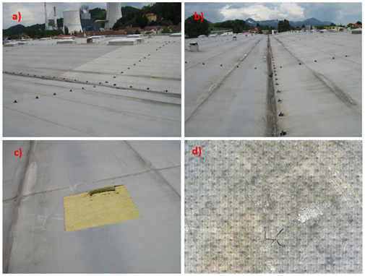
Figure 1. Plasticized PVC waterproofing membranes were taken from a flat industrial roof located in Slovenia, Central Europe (a, b) Extraction at sampling location 1 (c). Naturally aged and locally damaged plasticized PVC membrane (d).
Samples exposed to natural outdoor weathering were taken from a flat roof at various sampling locations, as shown in Appendix 2. Location 1 is an area with many visible star-shaped cracks on the surface of membranes. Location 2 is an area where a strong colour variation of the membranes was observed. Location 3 is a softening roofing area where a significant deterioration in the strength of the insulation has been observed. Plasticized PVC membranes were taken from each of these roofing areas, immediately wrapped in polyethylene, and transported to the laboratory for further analysis.
Plasticized PVC membranes are produced by caste spreading, whereby a spreading head applies a substrate of a liquid-viscosity raw material called "plastisol".¹⁴ The spreading and gelation process is repeated four times, creating a membrane of four differently formulated layers. Between the second and third layers an inner reinforcing layer of polyester mesh is inserted. This process creates a molecular bond between the layers, resulting in a homogeneous, elastic, single-layer membrane.
2.2 Mechanical testing
The mechanical performance of new, unused PVC membranes and aged membranes from the roof area was measured with a Zwick/Roell Z010 universal testing machine.¹⁵ The length of the samples was 200 mm. At an elongation of 1% and 2%, the secant modulus of elasticity was measured at a cross-heat speed of 1.25 mm/min. After exceeding a deformation of 2%, samples were measured with a test cross-head speed of 200 mm/min until they broke. All specimens were tested in longitudinal and transverse directions using the same test method under laboratory conditions T = 20 ± 2 °C, R_{H} = 50 ± 5 %.
2.3 Contact angle measurement
The wettability of plasticized membranes was assessed with an optimized experimental procedure. Droplets of adequate size were formed on a membrane with a micropipette. Measurements of the contact angle were filmed with a Basler Aca1300-200um digital camera equipped with a CCTV lens (Tamron, Japan), connected to a computer using the OpenDrop algorithm.¹⁶ To avoid optical aberrations and the fake reflections from other sources that can occur at the drop edge, the drop was lit from the opposite side with a diffusion light, which was achieved by placing a glass diffuser between the light source and the hanging drop. The undesired effect of drop oscillation was minimized by using an anti-vibration table.
2.4 Surface morphology and chemical characterization
The morphological changes in aged membrane microstructure were scanned using ESEM (Environmental Scanning Electron Microscopy) Quanta 200 3D (FEI Company, Hillsboro, OR). Chemical modifications were identified and quantified using Fourier Transform Infrared Spectroscopy (FTIR) analysis on a Bruker Tensor 27 DTGS spectrometer in attenuated total reflection (ATR) mode between 4000 and 450 cm⁻¹ with an average of 32 consecutive scans and a resolution of 4 cm⁻¹.
2.5. Low-temperature flexibility
A test of low-temperature resistance was carried out according to the SIST EN 495-5 standard.
2.6 Thermal degradation
Thermogravimetric analysis and thermal transition of material samples were carried out using a TGA/DSC (Differential Scanning Calorimetry) instrument (Mettler Toledo). Approximately 10 mg of the n material was placed in separate vials and heated in an N₂ atmosphere at a rate of 10 K/min from 298 K to 1273 K. Mass loss caused by the thermal change was measured as a consequence of water evaporation and combustion of membrane layers.

3. Results and discussion
New plasticized PVC membranes and membranes from the flat roof area, which are about 10 years old, were comprehensively analysed in a laboratory using various techniques.
3.1 Mechanical performance
The maximum tensile strength in MPa (σ) and the elongation at break in % (ε) were determined for samples after 10 years of use and the values were compared with those of new samples (Figures 2 and 3). At least three samples were tested from each sampling location. As can be seen in Figure 3, there is a small variation in tensile strength in the longitudinal direction of aged membranes. It appears that the polyester mesh is well encapsulated within the membrane matrix and has not degraded over time. In addition, there is a tendency for tensile strength to increase with age, as the membrane loses flexibility over time.⁹ On the other hand, the strength of aged membranes decreases in the transverse directions compared to the strength of a new membrane.
As shown in Table 1, aged membrane samples showed a shorter elongation at break than that of the new membrane. This indicates a loss of flexibility caused by natural aging under high humidity and thermal fluctuations. The deterioration in elastic properties is caused by the loss of plasticizers as a result of a long period of combined exposure to heat from solar radiation, near-ultraviolet radiation, atmospheric oxidation, humidity and air pollution.¹⁷ It was found that the influence of plasticizer content has a certain influence on elongation, but a mixed influence on the tensile strength of membranes reinforced with polyester mesh. Despite sufficient tensile strength, the wettability properties of these membranes were strongly influenced by age.
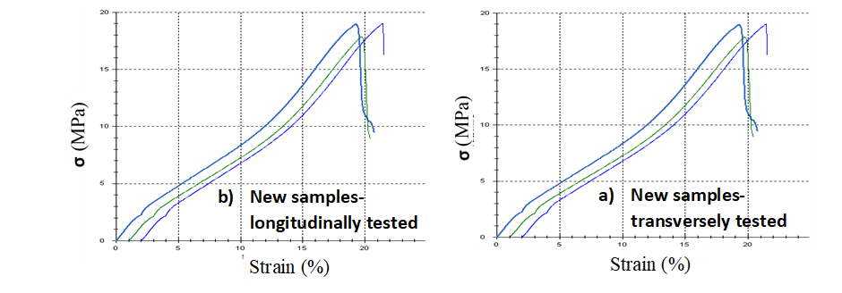
Figure 2. Tensile strength and elongation at break (load/strain curves) for new plasticized PVC membrane samples.
Figure 3. Tensile strength and elongation at break (load/strain curves) for aged and plasticized PVC membrane.
Table 1. Tensile strength and elongation at break.
Sample | σ (MPa) | ε (%) | σ (MPa) | ε (%)
 | longitudinally |  | transversely
New | 2.53 | 22.36 | 2.14 | 20.01  20.51
 | 2.60 | 44.54 | 2.13 | 20.01  20.51
 | 2.55 | 22.16 | 2.20 | 19.28
Location 1 | 5.74 | 19.34 | 4.98 | 17.48
 | 5.93  5.89 | 18.79  16.76 | 5.09  4.73 | 17.16  16.83
Location 2 | 5.08 | 18.36 | 3.86 | 17.21
 | 4.61 | 17.31 | 4.04 | 15.49
 | 5.53 | 18.39 | 4.01 | 16.51
Location 3 | 4.75 | 19.96 | 3.93 | 18.96
 | 4.80  5.06 | 19.99  19.96 | 3.87  3.99 | 17.73  16.29
3.2 Contact angle and wettability
The surface wettability of the membranes was confirmed by measuring the contact angles. The transition from spreading to splashing for all the water-membrane combinations was then mapped by varying the impact speed. As can be seen from Table 2, the contact angles of new plasticized PVC membranes remain almost constant within 180s. In contrast, the contact angle for aged membranes is significantly reduced from 56.1°±2.5° at 10s to 16.5°±4.5° at 30s and becomes zero after a few minutes (Table 3). Despite the good mechanical performance, the water repellency of these membranes is strongly impaired. Increasing the hydrophilicity of the aged membrane increases the unwanted water permeability and can cause damage in other roof layers.¹⁸
Table 2. Contact angles vs time of the new plasticized PVC membrane.
CA | 69.4°±1.1° | 68.2°±1.5° | 66.5°±0.8° | 65.11°±0.5°
 | 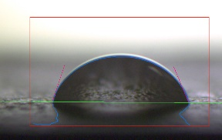 | 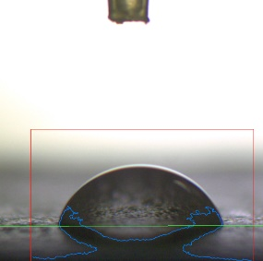 | 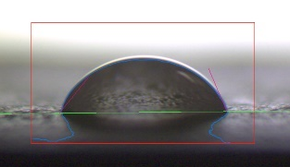 | 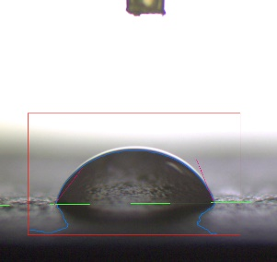
t (s) | 10 s | 30 s | 120 s | 180 s

Table 3. Contacts angle vs time of natural aged and damaged plasticized PVC (sampling location 1).
CA | 56.1°±2.5° | 16.5°±4.5° | / | /
 | 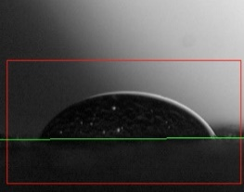 | 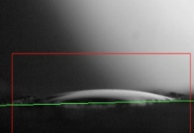 | 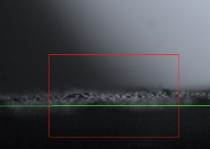 | 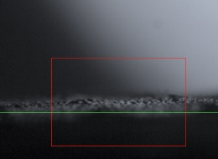
t (s) | 10 s | 30 s | 120 s | 180 s

3.3 Surface morphology
As mentioned above, the distribution and loss of plasticizer in the membrane can play an important role in tensile strength and elongation at break as well as in wettability properties. Change in surface of membranes that may result in the loss of plasticizer was also demonstrated by observation of micrographs from scanning electron microscopes (SEM).
3.3.1 Microstructure
Microphotographs of new and aged membranes taken by SEM show significant differences between them. As shown in Figure 4, new membranes have a smooth surface, without cracks. Locally, only the grains of filler can be observed. In contrast, aged membranes that have been exposed to natural weathering show irritated surfaces with many cracks, agglomerates and craters as a result of plasticizer loss. The material becomes stiffer, which leads to contractions and causes the prevalence of voids (Figure 5). It is assumed that the rearrangement and aggregation of molecular chains are the main mechanisms of membrane degradation.¹⁹
Figure 4. Microstructure of new membranes’ upper layer (a, c) and lower layer (b, d).
Figure 5. The microstructure of aged membranes extracted from different sampling locations: 1 (a, b), 2 (c, d), and 3 (e, f). The surface is more heterogeneous, with many craters, cracks, agglomerates, and voids.
3.3.2 Thickness evaluation
Cross-sectional microphotographs with thickness evaluation of both unused plasticized PVC membranes and membranes from flat roofed areas are presented in Figure 6 and Table 4. It can be seen that the thickness of the clear upper layer of the aged membranes is decreased. As can be seen in Figure 6, there is also a visible difference in cross-sectional area between new and aged membranes. The average thickness values decrease from 1.18 mm to 1.09 mm. Changes in material thickness might be because of the reduction of plasticizer content. To justify plasticizer loss in material, chemical changes were identified and quantified using ATR/FTIR analysis.
Table 4. Thickness of the clear upper layer of new and aged membranes.
Samples | First (mm) | Second (mm) | Third (mm) | Average value (mm)
Location 1 | 1.18 | 1.19 | 1.16 | 1.17
Location 2 | 1.11 | 1.13 | 1.09 | 1.11
Location 3 | 1.11 | 1.07 | 1.09 | 1.09
New | 1.18 | 1.20 | 1.15 | 1.18

Figure 6. Microphotographs in cross section with thickness evaluation for new membrane (a) and aged membranes (a, b, c).
3.4. ATR/FTIR analysis
FTIR spectra were obtained to investigate the chemical changes of aged membranes exposed to natural weathering influences such as solar radiation, near-ultraviolet radiation, atmospheric oxidation and moisture (Figure 7). In FTIR, the spectra appearance of several characteristic bands can be seen. In particular, the C=O stretching vibration of the ester function from plasticizer is detected at 1722.43 cm⁻¹ and is less intense in the aged membrane. Similarly, the C-O stretching vibration detected at 1072.42 cm⁻¹, 1122.57 cm⁻¹ and 1257.59 cm⁻¹ decreased in the aged membrane. In an open environment, the intensity of C=O and C-O stretching vibration decreases because of radiation and oxidation ²⁰. The very weak vibration bands at 1580 cm⁻¹and 1600 cm⁻¹ are associated with the stretching of the C=C bonds of the aromatic ring. C-H stretching mode can be observed at 2928.01 cm⁻¹, shifted to 2954.65 cm⁻¹, trans C-H wagging mode at 960.55 cm^{−1,} and is C-H wagging mode at 609.15 cm⁻¹ ²¹. These data are consistent with changes in the membrane morphology and elongation properties.
Figure 7. FTIR spectra for new plasticized membranes (black line) and old membranes (red line) operating in attenuated total reflection (ATR) mode.
3.5 Low-temperature flexibility
Low-temperature flexibility is a very important membrane property, especially during the application phase. Cracks were observed in all aged membranes. Normally, the flexibility of the membranes decreased significantly with surroundings temperature.⁹ It was also possible to see into the polyester reinforcement in the upper layer of the membrane (Figure 8).

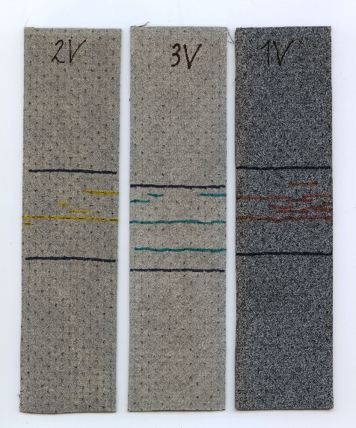
Figure 8. Cracks were observed along the upper layer of aged membranes after exposure to -25C for 2 h.
3.6 TGA-DSC analysis
Figure 9 shows the thermogravimetric and thermal transition analysis of a new membrane and an aged membrane at a temperature range from 298 K to 1273 K. The thermogravimetric analysis (TGA) shows that in both curves, the weight loss was caused by heating. A two-step decomposition process was recorded on both membranes, with a higher degree of mass loss in the first step, showing losses of 62.81% for the new membrane and 56.13% for the aged membrane compared to the initial mass, resulting in a total mass loss of about 80% in both samples. This could be because some of the plasticizers in the old membrane may have already been depleted before the analysis was performed. Membranes have relative thermal stability below 393 K and start to lose mass above 473 K. Both membranes exhibit a glass transition temperature (Tg), characterized as an endothermic deviation from the baseline, which is more clearly visible in a new sample. The Tg peaks were 591.18 K and 592.11 K for new and aged membranes, respectively. The negative heat flux shows that energy was released by the combustion of PVC, plasticizers and polyester mesh. In this step, dehydrochlorination takes place, producing HCl and polyene molecules.²² Increase in heat flux at approx. 898 K might correspond to exothermal transformation caused by crystallization of the samples. HCl is released from the melt and the polyene molecules undergo rearrangement through cross-linking from alkyl aromatic hydrocarbons and char residues.²³

Figure 9. Results of the TGA-DSC analysis between new and aged membranes.

4. Conclusions
The results of the measurements reaffirmed the sensitivity of plasticized PVC membranes reinforced with polyester mesh used for mechanically fixed unvented roof systems over thermal insulation. During 10 years of use, plasticized PVC gradually degraded, and its primary physical, chemical and mechanical properties changed. The main conclusions are:
- there is a tendency for tensile strength to increase with age. It appears that the polyester mesh is well encapsulated within the membrane matrix,
- aged membrane samples exhibited shorter elongation at break than new ones (longitudinally up to 25%, transversely up to 5%). This indicates a loss of flexibility caused by natural aging under high humidity and thermal fluctuations,
- wettability properties of examined membranes were highly affected with age,
- the surface of aged membranes is more heterogeneous that that of new ones, containing many craters, cracks, agglomerates, and voids. Similarly, the thickness of the clear upper layer of the aged membranes decreased as a result of the migration of plasticizer content. The average thickness values decrease from 1.18 mm to 1.09 mm,
- FTIR analysis confirmed the chemical changes in aged membranes. The intensity of C=O and C-O stretching vibration decreased compared to that of the new membrane.
- when low-temperature flexibility tests were performed, cracks were observed along the upper layer of the membrane inside the polyester mesh,
- on both membranes, a two-step decomposition process was recorded. Membranes exhibit a glass transition temperature (T_{g}) at 591.18 K and 592.11 K for new and aged membranes, respectively.
To reduce degradation and increase the durability of PVC membranes, new durable additives and plasticizers that are resistant to heat from solar radiation, near-ultraviolet radiation, atmospheric oxidation and moisture should be used. In future studies, we will use time-temperature superposition models to assess the effect of aging on waterproofing membranes.
Acknowledgments
The authors would like to acknowledge the Slovenian Research Agency (ARRS) for partly financing this research within the frame of program P2-0046.
Conflicts of Interest
The authors declare no conflict of interest.
References
- Y. Ma, S. Liao, Q. Li, Q. Guan, P. Jia and Y. Zhou, React Funct Polym. 2020, 147, 637-642.
- Z. Kormosh, I. Hunka and Y. Bazel, Acta Chim. Slov. 2008, 55. 261–267.
- M. Shamsipur, S. Sahari, M. Payehghadr and K. Alizadeh, Acta Chim. Slov.2011, 58. 555– 562.
- M. Zagorodnikova, V. Yartsev and V. Rupyshev, Adv. Mater. Technol. 2019. 2, 41-47.
- M. Londschien and M. Bonnet, J. Appl. Polym. Sci. 2018, 135, 46689.
- P. Dunn, D. Oldfield and R. Stacewicz, J. Appl. Polym. Sci. 1970, 14, 2107-2116.
- L. Audouin, B. Dalle, G. Metzger and J. Verdu, J. Appl. Polym. Sci. 1992, 45, 2091-2096.
- M. Ito and K. Nagai, Polym. Degrad. Stab. 2007, 92, 260-270.
- H. Beer, A. Delgado, R. Paroli and S. Graveline: 10DBMC International Conference On 10. Durability of Building Materials and Components LYON, International AG, Industriestrasse, Lyon, France 2005, 1-7.
- A. Kositchaiyong, V. Rosarpitak, H. Hamada and N. Sombatsompop, Int. Biodeterior. Biodegradation 2014, 91, 128-137.
- M. Gonçalves, J. D. Silvestre, J. de Brito and R. Gomes, J. Build. Eng. 2019, 24, 100710.
- R. Paolini, M. Zinzi, T. Poli, E. Carnielo and A. G. Mainini, Energy Build. 2014, 84, 333-343.
- A. Ivanič, G. Kravanja, W. Kidess, R. Rudolf and S. Lubej, Materials 2020, 13, 2392.
- K. Franklin and W. G. McDonald, U.S. Patent Number 12/691,405. date of patent July 21, 2011.
- P. Jelušič and S. Kravanja, Constr Build Mater. 2018, 174, 456-465.
- J. D. Berry, M. J. Neeson, R. R. Dagastine, D. Y. C. Chan and R. F. Tabor, J. Colloid Interface Sci. 2015, 454, 226-237.
- M. Lenartowicz, B. Swinarew, A. Swinarew and G. Rymarz, Int. J. Polym. Anal. Charact. 2014, 19, 611-624.
- A. Behboudi, Y. Jafarzadeh and R. Yegani, Chem. Eng. Res. Des. 2016, 114, 96-107.
- Y. Fu and J. R. Lakowicz, Nature 2011, 472, 178-179.
- A. Royaux, I. Fabre-Francke, N. Balcar, G. Barabant, C. Bollard, B. Lavédrine and S. Cantin, Polym. Degrad. Stab. 2017, 137, 109-121.
- S. Ramesh, K. H. Leen, K. Kumutha and A. K. Arof, Spectrochim. Acta A Mol. Biomol. Spectrosc. 2007, 66, 1237-1242.
- A. Marongiu, T. Faravelli, G. Bozzano, M. Dente and E. Ranzi, J Anal Appl Pyrolysis. 2003, 70, 519-553.
- H. Bockhorn, A. Hornung and U. Hornung, J Anal Appl Pyrolysis. 1999, 50, 77-101.

