Hydrogen Bonds of Bis(1H-benzimidazole-κN³)cadmium(II) Dibenzoate (Cd(Bzim)₂(BA)₂): In Hirshfeld Surface Analysis and AIM Perspective
Jia-Jun Wang,^{1,2} Li-Nan Dun,^{1,2} Bao-Sheng Zhang,^{1,2}
Zhong-Hui Wang,³ He Wang,^{1,2} Chuan-Bi Li,^{1,2,*} Wei Liang^{1,2,*}
¹ (Key Laboratory of Preparation and Application of Environmental Friendly Materials,
Ministry of Education, Jilin Normal University, Changchun 130103, China)
² (Chemistry Department of Jilin Normal University, Siping 136000, China)
³(Sulfuric Acid Plant, Jilin Petrochemical Company Acrylonitrile Factory, Jilin 132021, China)
Corresponding author: E-mail: li_c_b@163.com (Chuan-Bi Li);
E-mail: 16433576@qq.com (Wei Liang)
Received:

Abstract
The coordination complex bis(1H-benzimidazole-κN³)cadmium(II) dibenzoate ((C₂₈H₂₂CdN₄O₄), 1) has been synthesized, and characterized by single crystal diffraction analysis, the result reveals the cadmium center is six coordinated and formed an distorted octahedron coordinated geometry. The Hisfeld analysis shows that in the d_{norm}-surface of (1), there are dark red spots near the hydrogen-bonds acceptor and donor atoms, while intermolecular interactions result in faint-red spots. The AIM analysis were performed, there existence of a BCP in each N(C)–H∙∙∙O hydrogen bond, the bond paths also can be seen, the |V(b)|/G(b)<1 and the H(b)>0, the interaction is indicative of being a closed shell. The IR and TG results are consistent with the X-ray diffraction structure.

Keywords: Cd Complex, Crystal Structure, IR, TG, Hirshfeld Surface Analysis, AIM Analysis

1. Introduction
Crystal engineering based on coordination complexes¹ have been fast developing in the last few years owing to their potential applications such as absorption,² catalysis,³ luminescence,⁴ etc. The coordination complexes have already been applied in peoples’ all aspects of life. Even they can be used in the field of removing the highly toxic heavy metal ions.⁵
The Hydrogen Bonds are critical in life science⁶ and chemistry.⁷ The Hirshfeld surface analysis⁸ and the Atom in Molecule (AIM) theory⁹ are two powerful weapons to research hydrogen bonds from different perspectives. The Hirshfeld sufaces analysis are able to be utilized to identify a type and region of intermolecular interactions (including hydrogen bonds), the Hirshfeld surface analyses comprising d_{norm}- and shape index surfaces, and 2D fingerprint plots (FP). While the AIM theory enable us to analyze the properties of hydrogen bonds. In AIM view, the main concept is based on the bond critical point (BCP), there are the evidence of hydrogen bond is the existence of a bond path and a BCP between the donor hydrogen and the acceptor. People also developed the criteria for the assessment of the existence of hydrogen bonds.¹⁰
In this article, we synthesized a new benzimidazole coordinated cadmium (II) dibenzoate ((C₂₈H₂₂CdN₄O₄), (Cd(Bzim)₂(BA)₂, 1, benzimidazole = Bzim, benzoate = BA ) through the low temperature hydrothermal method, obtained the crystal structure, calculated the molecular orbitals, carried out the Hirshfeld analysis and the AIM analysis, we mainly focused on the analysis of the hydrogen bonds.

2. Experiments
Cd(Ac)₂·2H₂O (0.235 g, 1 mmol), benzimidazole (Bzim, 0.236 g, 2 mmol), benzoic acid (BA, 0.244g, 2 mmol) and 15 mL water were mixed with stirring followed by adjusting the pH value to 6.5 with an aqueous solution of NaOH. Then the mixture was sealed in a 25 mL Teflon-lined stainless-steel reactor and heated at 100 ℃ for 96 h to give dark yellow crystals of the title complex (1) after cooling. The C, H and N contents were determined by elemental analysis: Calcd. (%) for C₂₈H₂₂CdN₄O₄: C, 56.86; H, 3.72; N, 9.48; Found (%): C, 56.79; H, 3.81; N, 9.53. IR (cm⁻¹): 3315(w), 3236(w), 1680(s), 1653(s), 1477(s), 1430(s),1346(w), 877(w), 787(m), 449(m).

3. Structure Determination and Physical Measurements
A colorless block crystal for 1 with dimensions of 0.23mm × 0.20mm × 0.18mm was chosen for X-ray diffraction analysis. Crystal structure measurement was performed on a Bruker SMART APEX II CCD diffractometer equipped with a graphite-monochromatic MoKα (λ = 0.71073 Å) radiation by using an ω scan mode at 293(2) K. Absorption corrections were applied with a multi-scan mode.¹¹ A total of 37905 reflections were obtained in the range of 1.86 ≤ θ ≤ 28.30º, of which 6760 were independent (R_{int} = 0.1203) and 2823 observed reflections with I > 2σ(I) were employed for structure determination and refinement. The structure was solved by direct methods with SHELXS¹² and refined by full-matrix least-squares techniques using SHELXL-2018¹³ within WINGX.¹⁴ All non-hydrogen atoms were refined anisotropically. All H atoms on C atoms were positioned geometrically and refined as riding, with C–H = 0.93 and U_{iso}(H) = 1.2U_{eq}(C). The final R = 0.0411, wR = 0.0572 (w = 1/σ²(F_{o}²)+(0.0265P)²+0.0000P] where P = (F_{o}² + 2F_{c}²)/3), (Δ/σ)_{max} = 0.001, S = 0.992, (Δρ)_{max} = 0.659 and (Δρ)_{min} = –0.372 e/Å³. The Molecular graphics was prepared using program Diamond 3.2.¹⁵ Other reagents were of analytical grade.

4. Results and Discusion
4.1. Structure Description
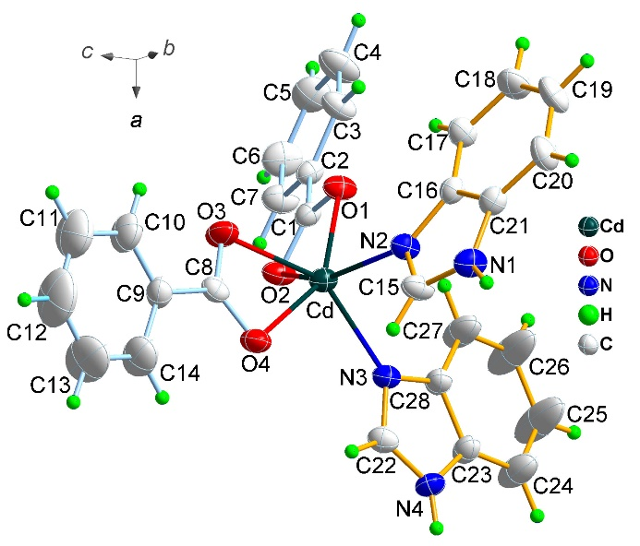
Fig. 1 Molecular Structure of Cd(Bzim)₂(BA)₂ (1, Ellipsoid Probability 30 %).

Table 1 Summary of data collection and structure refinement for (1).
CCDC | 780823 | Formula | C₂₈H₂₂CdN₄O₄
Formula weight | 590.89 | Crystal description | Yellow block
Crystal system | Orthorhombic | Crystal size/mm | 0.23×0.20×0.18
Space group | Pbca | a/Å | 14.0359(6)
V/Å³ | 5441.4(5) | b/Å | 17.7081(8)
Z | 8 | c/Å | 21.8928(12)
α, b, γ/deg | 90 | F(000) | 2384
ρ_{calc}/g cm⁻³ | 1.443 | T/K | 293(2)
θ range /deg | 1.86 to 28.30 | Radiation (λ/Å) | Mo K (0.71073)
Reflections collected / unique | 37904/6759 | Completeness (θ 28.30) | 100 %
R_{(int)} | 0.1203 | Goodness of fit | 0.971
Data/restraints/parameters | 6759 / 0 / 334 | R, ωR (I > 2σ (I)) | 0.0411, 0.0572
R, ωR (all data) | 0.1336, 0.0672 | Peak and hole/ e.A⁻³ | 0.670, -0.400
A perspective view of complex (1), with the atomic numbering scheme, is shown in Fig. 1. Complex (1) crystallizes in the space group Pbca (Table 1). The structure of (1) is an independent structure unit which consists of a cadmium, two benzimidazole molecules (Bzim) and two benzoic acid ions. The cadmium center is six coordinated and connected four oxygen from two benzoic acids and two nitrogen atoms from two Bzims. Each Bzim coordinated one Cd center in κN³ coordinate mode, and each benzoic acid ions also connected one Cd center in the chelating mode. So (1) can be deemed as the bis(1H-benzimidazole-κN³)cadmium(II) dibenzoate, and formed an distorted octahedron geometry.
Table 2 Selected Bond Length and Angles for (1).
Bond Length/Angle | Å/º | Bond Angle | º | Bond Angle | º
Cd-N(3) | 2.258(3) | N(3)-Cd-O(1) | 112.92(10) | O(1)-Cd-O(4) | 151.39(10)
Cd-O(3) | 2.367(3) | N(3)-Cd-N(2) | 92.37(10) | N(2)-Cd-O(4) | 91.57(10)
Cd-O(1) | 2.263(2) | O(1)-Cd-N(2) | 96.80(10) | O(3)-Cd-O(4) | 54.82(9)
Cd-O(4) | 2.375(3) | N(3)-Cd-O(3) | 147.27(10) | N(3)-Cd-O(2) | 88.65(9)
Cd-N(2) | 2.279(3) | O(1)-Cd-O(3) | 96.86(9) | O(1)-Cd-O(2) | 54.60(8)
Cd-O(2) | 2.490(2) | N(2)-Cd-O(3) | 97.48(10) | N(2)-Cd-O(2) | 148.68(10)
O(4)-Cd-O(2) | 119.61(8) | N(3)-Cd-O(4) | 93.93(10) | O(3)-Cd-O(2) | 98.43(9)

The Cd-N distances are 2.2258 and 2.279 Å (Table 2), which are not only shorter than the average Cd-N_{imidazole} distance (2.302 Å),¹⁶ but also shorter than the Cd-N_{N-Alkylimidazoles} (2.358 Å).¹⁷ The Cd–O distances is in the range of 2.263-2.490 Å, these distances are slightly longer than the Cd-O distances of the acetate (O₂CMe in chelating mode, 2.303-2.544 Å).^{18, 19}

Table 3 Short Ring-Interactions with Cg-Cg Distances < 4.0 Å, α < 20.000º and β < 60.0º. And the Analysis of C-H∙∙∙Cg(π-Ring) Interactions (H∙∙∙Cg < 3.0 Å. γ < 30.0 º) for Complex (1).
Cg(I) | Cg(J)^{[ARU]} | Cg-Cg | Transformed J-Plane |  |  |  | α | β | γ | CgI_Perp | CgJ_Perp | Slippage
Cg(I) | Cg(J)^{[ARU]} | Cg-Cg | P | Q | R | S
Cg(1) | Cg(2)^{[a]} | 3.677(2) | -0.3331 | 0.1920 | -0.9231 | -2.0825 | 3.0(2) | 17.7 | 18.6 | -3.4856(16) | -3.5029(18) | 1.117
Cg(2) | Cg(3)^{[b]} | 3.968(2) | -0.3801 | -0.1808 | -0.9071 | -2.6796 | 2.9(2) | 25.3 | 28.2 | -3.4958(18) | -3.5865(17) | 1.698
Cg(2) | Cg(4)^{[b]} | 3.700(2) | -0.3815 | -0.1845 | -0.9058 | -2.6637 | 2.97(17) | 16.8 | 19.2 | -3.4943(18) | -3.5427(13) | 1.067
C(I)-H(I) | Cg(J)^{[ARU]} | C∙∙∙Cg | P | Q | R | S | H-Perp |  | γ | C-H..Cg | H..Cg | C-H,π
C20-H(20) | Cg(5)^{[c]} | 3.487(4) | 0.1487 | 0.9649 | 0.2164 | 12.3496 | -2.57 |  | 1.17 | 169 | 2.57 | 78
C20-H(20) | Cg(6)^{[c]} | 3.634(4) | 0.1585 | 0.9575 | 0.2409 | 12.4764 | -2.56 |  | 23.75 | 150 | 2.80 | 77
The Representations and Definitions:
Cg(I) = Plane number I (= ring number in () above)
Cg(J) = Center of gravity of ring J (Plane number above)
α = Dihedral Angle between Planes I and J (º)
β = Angle Cg(I)-->Cg(J) or Cg(I)-->Me vector and normal to plane I (º)
γ = Angle Cg(I)-->Cg(J) vector and normal to plane J (º)
or Angle between Cg-H vector and ring J normal
Cg-Cg = Distance between ring Centroids (Å)
CgI_Perp = Perpendicular distance of Cg(I) on ring J (Å)
CgJ_Perp = Perpendicular distance of Cg(J) on ring I (Å)
Slippage = Distance between Cg(I) and Perpendicular Projection of Cg
H-Perp = Perpendicular distance of H to ring plane J
C-H∙∙∙Cg = C-H-Cg angle (º)
C∙∙∙Cg = Distance of C to Cg (Å)
C-H, π = Angle of the C-H bond with the π-plane (i.e.' Perpendicular = 90º, Parallel = 0º)
5-Membered Ring (1) N1 --> C15 --> N2 --> C16 --> C21 -->
6-Membered Ring (2) C2 --> C3 --> C4 --> C5 --> C6 --> C7 -->
6-Membered Ring (3) C16 --> C17 --> C18 --> C19 --> C20 --> C21 -->
9-Membered Ring (4) N1 --> C15 --> N2 --> C16 --> C17 --> C18 --> C19 --> C20 --> C21
5-Membered Ring (5) N3 --> C22 --> N4 --> C23 --> C28 -->
9-Membered Ring (6) N3 --> C22 --> N4 --> C23 --> C24 --> C25 --> C26 --> C27 --> C28 -->
Symmetry Codes for the Asymmetric Residual Unit (ARU).
[a] = -x, 1/2+y, 1/2-z
[b] = -x, -1/2+y, 1/2-z
[c] = 1/2-x, 1/2+y, z

In crystal lattice, there are π···π and C-H···π interactions (Table 3). The distances between the center of gravity of the π rings (Cg···Cg distance) range is from 3.68 to 3.97 Å, and the distances between C atom and Cg of the π rings (C···Cg distance) range is 3.49 and 3.63 Å. There are also exist the N-H···O and C-H···O²⁰ hydrogen bonds in crystal (Table 4), the N···O distances are 2.75 and 2.80 Å, while the C···O distances are 3.21and 3.35 Å. The D-H∙∙∙A angle of N-H∙∙∙O (161, 176 º) is larger than the angle of C-H∙∙∙O (134, 157 º). For the importance of the hydrogen bonds in life and crystallography, we will research it from Hirshfeld sufaces analysis and the AIM theory perspective.
Table 4 Hydrogen Bonds with d(D∙∙∙A) < 3.4 Å for Complex (1).
Donor-H | Acceptor^{[ARU]} | D-H | H∙∙∙A | D∙∙∙A | D-H∙∙∙A
N1-H1 | O2^{[i]} | 0.86 | 1.94 | 2.803(4) | 176
N4-H4 | O3^{[ii]} | 0.86 | 1.92 | 2.748(4) | 161
C3-H3 | O4^{[iii]} | 0.93 | 2.47 | 3.350(4) | 157
C22-H22 | O1^{[ii]} | 0.93 | 2.49 | 3.211(5) | 134
Symmetry Codes for the Asymmetric Residual Unit (ARU):
[i] = 1/2-x, 1/2+y, z; [ii] = 1/2+x, y, 1/2-z; [iii] = -1/2+x, y, 1/2-z

4.2 IR Spectrum
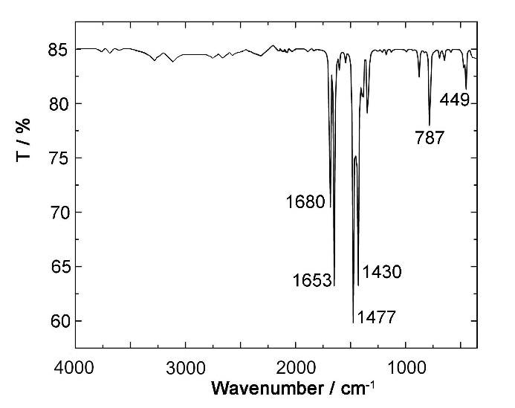
Fig. 2 The IR Spectrum of Cd(Bzim)₂(BA)₂.
In the IR spectrum (shown in Fig. 2), there are no very strong band at around 3300 cm⁻¹, it demonstrates there not exists the -OH group in the title complex. The strong absorption peak at 1680²¹and 1653 cm⁻¹ (C=O asymmetry stretching vibration of carboxylate of BA) in complex 1, the peak at 1477 cm⁻¹ indicates that there are the C=C vibration of the benzene stretch (of the BA and Bzim). The strong peak at 1430 cm⁻¹ corresponds to the symmetry stretching vibrations of carboxylate C-O and C-N, while the peaks at 787, and 449 cm⁻¹ may due to the scissor vibration of the carboxylate and benzene ring of BA, and the BA’s C=C stretching vibration, respectively.

4.3. Hirshfeld Surface Analysis
In the last few years the analysis of molecular crystal structures using tools based on Hirshfeld surfaces has rapidly gained in popularity, and they were carried out and plotted using CrystalExplorer 17.5.^{8, 22-24} In the Hirshfeld surface analysis comprising d_{norm}- and shape index-surfaces, and 2D fingerprint plots (FP).
In d_{norm}-surface for (1), hydrogen-bonds result in dark red spots near the hydrogen-bonds acceptor and donor atoms while intermolecular interactions result in faint-red spots. Further, the presence of patterns of red- and blue triangles on the same region of the shape-index surfaces is a characteristic of π∙∙∙π stacking. The d_{norm}- and shape index-surfaces of (1) are shown in Fig. 2.
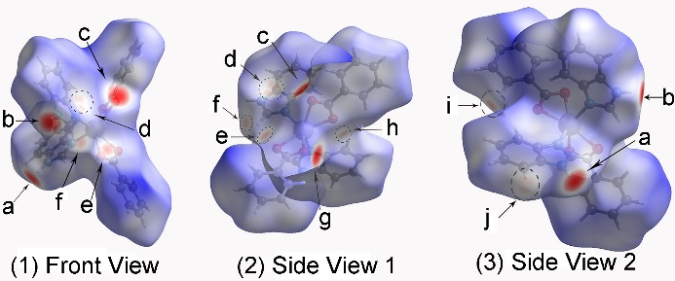
Fig. 3 The d_{norm} Surfaces Mapped on Hirshfeld Surface for (1).
The N-H∙∙∙O hydrogen-bonds in title complex (1) can be seen in the d_{norm}-surfaces as bright-red spots marked as a, b, c and g (the spots located near the atom each correspondence are: a → N1, b → N4, c →O2, g →O3) in Fig. 3, so that the a, b, c and g spots are due to N1–H1∙∙∙O2 and N4–H4∙∙∙O3 hydrogen bonds.
The weak C–H∙∙∙O hydrogen bond interactions (including intramolecular and intermolecular hydrogen bonds) in (1) are also demonstrated in the d_{norm}-surface as faint-red color spots (Fig.3) and signed as e, f, h, i. (that is, each correspondence are: e → O4, f → C22, h → O1, i → C3). The faint-red spots above the centre of the benzimidazole ring in the d_{norm}-surface of (1) (Fig. 3), all marked as d, arise from the C20–H(20)∙∙∙π(Cg(5)) and C20–H(20)∙∙∙π(Cg(6)) interaction, they are observed in crystal structure. The offset π∙∙∙π interactions observed in the crystal of (1) are identified by distinctive patterns of red- and blue-triangles across the respective phenyl rings on the shape-index surface plots of the molecule (see the circle in Fig. 4).
Fig. 4 The Shape-Index-Surfaces Mapped on Hirshfeld Surface for (1).
The quantitative analysis of the intermolecular interactions apparent in the crystal of (1) was attempted by observing the 2D FP’s (Fig. 5). The H∙∙∙O intermolecular interactions in (1), appeared as two distinct long sharp spikes in the FP, at d_{i} + d_{e} ≈ 1.75 Å which is roughly close to the observed N1H1∙∙∙O2 and N4H4∙∙∙O3 distance of 1.92, 1.94 Å (Table 4). In one molecule, these two spikes appear at (d_{i}, d_{e}) ≈ (0.70 Å, 1.05 Å) and (d_{e}, d_{i}) ≈ (0.70 Å, 1.05 Å, Fig. 4 d), and the spikes appear in the same manner.
The C–H∙∙∙π interactions in 1 appear as pair of blunt spikes at (d_{e}, d_{i}) ≈ (1.78 Å, 1.0 Å) and (d_{e}, d_{i}) ≈ (1.0 Å, 1.78 Å) in the FP of (1), occurring at d_{i} + d_{e} ≈ 2.78 Å, it appear as the spikes at d_{i} + d_{e} distances are close to the H∙∙∙π(Cg) distances in crystal (2.57, 2.80 Å, Table 3), so they are due to the C–H∙∙∙π interactions in Fig.4 (c). The C-H∙∙∙π interactions in (1) (Table 3) are also supported by the ‘two wings’ characters²⁵⁻²⁷, the wings are sites at the upper left and the bottom right. For the C∙∙∙C close contacts (Fig. 5 (e)) with the shortest d_{i} + d_{e} (distances ≈ 1.73 + 1.73 = 3.46 Å) is roughly accord with the C∙∙∙C distances 3.68–3.97 Å in Table 3. It corresponds to the π∙∙∙π stacking interactions.
Fig. 5 2D Fingerprint Plots for (1). d_{i} is the closest internal distance from a given point on the Hirshfeld surface and d_{e} is the closest external contacts, (a) is the full image of fingerprint plots.
The relative contributions of the intermolecular interactions to the Hirshfeld surface for (1) was calculated (see the upper bar diagram in Fig. 5). The greatest contribution (47.2 %) is from H∙∙∙H contacts in (1), followed by H∙∙∙C/C∙∙∙H contacts (which is stands for the C-H∙∙∙π intermolecular interactions, 27.4%), then is the H∙∙∙O/O∙∙∙H contacts (the C-H∙∙∙O or N-H∙∙∙O hydrogen bond interactions 14.0%), the contribution from the H∙∙∙N/N∙∙∙H contacts is in (1) 4.2%, other contacts is 1.1 %.

4.4. Atom in Molecules Analysis
The topology analysis proposed by Bader was initially used for researching electron density in "atoms in molecules" (AIM) theory.^{9, 28,29} In this theory, it is based on the parameters at a bond critical point (BCP), Popelier [10] believed that the hydrogen bond’s electron density at the BCP (ρ_{BCP}) should be in the scope of 0.002–0.035 a.u. and the electron density Laplacian value (∇²ρ_{BCP}) should be confined in the region from 0.024 to 0.139 a.u.

Fig. 6 The abridged general view of hydrogen bonds BCP (pink ball) from the three coordinated unit model of complex (1).

In this study, for investigating the hydrogen bonds of the complex (1), we select three coordination units of (1) and form the model (it contain three molecules), in which it can exhibit the hydrogen bonds and the π∙∙∙π interactions from the crystal information file (cif, see supporting information) and calculate the single point to get the fchk file (see supporting information) from Gaussian 09 program³⁰ at ωB97XD³¹/GenECP (6-31+G** basis set for C, H, O, N and Lanl2dz³² basis set for Cd), finally, use the Multiwfn program³³ to study the topological properties of the hydrogen bonds in title complex (The Multiwfn produced CPs.pdb, Path.pdb and CPprop.txt are also in supporting information).

Table 5 The Electron Density (ρ_{BCP}), the Laplacian of Electron Density (∇²ρ_{BCP}), and the Eigenvalues of Hessian at BCP (λ₁, λ₂ and λ₃)ª of Complex (1). Computed at ωB97XD/GenECP Level (6-31+G(d) for C, H, O, N and LanL2DZ for Cd).
Interactions | ρ_{BCP} | ∇²ρ_{BCP} | λ₁ | λ₂ | λ₃
N1-H1∙∙∙O2 | 0.0324 | 0.1091 | -0.0458 | -0.0456 | 0.2006
N4-H4∙∙∙O3 | 0.0254 | 0.0950 | -0.0320 | -0.0326 | 0.1596
C3-H3∙∙∙O4 | 0.0093 | 0.0322 | -0.0086 | -0.0092 | 0.0500
C22-H22∙∙∙O1 | 0.0091 | 0.0343 | -0.0087 | -0.0080 | 0.0510
a The unit is atom unit.

The abridged general view of Fig. 6 shows the existence of a BCP in each N–H∙∙∙O and each C–H∙∙∙O hydrogen bond. The bond paths associated with the hydrogen bonds can be seen in Fig. 5 (and also be seen in Fig. S1 in the supporting information). The BCP electron density of the hydrogen bonds is listed in Table 5. The ρ_{BCP} value (from 0.009 to 0.032 a.u.) for the N–H∙∙∙O and C–H∙∙∙O hydrogen bonds are all in the suggested interval of 0.002–0.035 a.u.³⁴ for the hydrogen bond. The two negative Hessian matrix eigenvalues of electron density, λ₁ and λ₂, can measure the scope of contraction of ρ_{BCP} which perpendicular to the bond toward the critical point, while the positive λ₃ eigenvalue weighs the extent of contraction parallel to the bond and from the BCP toward each of the adjacent nuclei. The sum of eigenvalues λ₁, λ₂, and λ₃ is ∇²ρ_{BCP}. In addition, the numeric value of ∇²ρ_{BCP} (0.0322–0.1091 a.u.) for N(C)–H∙∙∙O interactions are in the recommend region of 0.024–0.139 a.u. for hydrogen bonds. Bader et al. deemed that for the closed-shell interactions (which including the ionic bonds, hydrogen bonds, and van der Waals interactions) the ∇²ρ_{BCP} value is positive.^{9, 29, 35-40} On the basis of Table 5, the N–H∙∙∙O and C–H∙∙∙O hydrogen bonds are remain with the typical closed-shell interactions. Clearly, the topological properties of the hydrogen bonds studied are closed-shell interactions.

Table 6 The Local Properties at BCP in the Complex: the Potential Energy Density, V(b); the Lagrangian Kinetic Energy Density, G(b); and the Total Energy Density H(b)ª of Complex (1). The Calculations at ωB97XD/GenECP Level (6-31+G(d) for C, H, O, N and LanL2DZ for Cd).
Interactions | V(b) | G(b) | H(b) | |V(b)|/G(b)
N1-H1∙∙∙O2 | -0.02476 | 0.02602 | 0.00126 | 0.92158
N4-H4∙∙∙O3 | -0.02100 | 0.02237 | 0.00137 | 0.93876
C3-H3∙∙∙O4 | -0.00655 | 0.00731 | 0.00075 | 0.89603
C22-H22∙∙∙O1 | -0.00622 | 0.00740 | 0.00116 | 0.84054
a The unit is atom unit.

As it is known that when |V(b)| > G(b) and H(b) is negative, the interaction is the character of being shared, but when the G(b) > |V(b)| and H(b) is positive, which is closed shell. ⁴¹ And the research⁴² found that bonded interactions are sorted stemming from the |V(b)|/G(b) ratio, the ratio |V(b)|/G(b) < 1, the bonded interaction is taken for the closed shell, as shared when |V(b)|/G(b) > 2, and it is passed for intermediate when the ratio is in the interval of 1.0 and 2.0. As it is depicted in Table 6, the Lagrangian kinetic energy density is only slightly larger than the potential energy density for all the (N)C–H∙∙∙O interactions. It brings about the total energy density H(b) is drawn near to 0 and the |V(b)|/G(b) ratio is a little less than 1.0. Consequently, the N(C)–H∙∙∙O interactions are mainly the closed shell for the model of complex (1). This conclusion is agreement with the ∇²ρ_{BCP} > 0.

4.5. Thermogravimetic Analysis
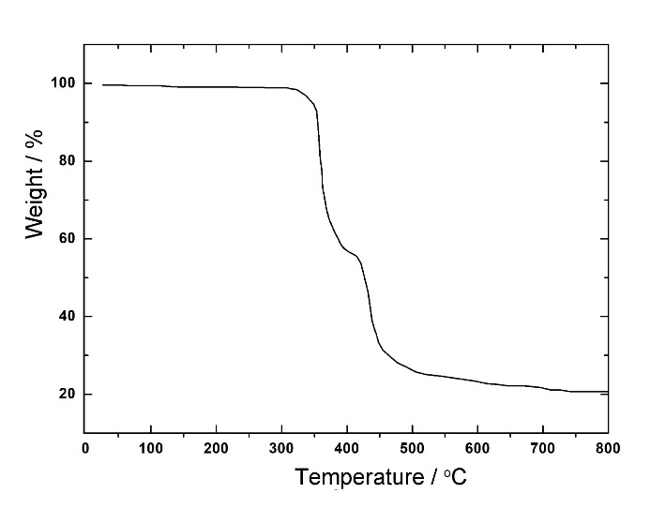
Fig. 7 The TG Analysis of complex 1.
The TG of the title complex at the heating rate of 10 ºC/min in nitrogen atmosphere are shown in Fig. 7, there are two weight loss steps. The first weight loss stage mainly takes place from 301 to 393 ºC, it may be related to the removal of the coordinated benzoic acid anion (found: 41.14 %; calcd: 40.99 %); The second weight loss step mainly takes place from 405 to 636 ºC, it corresponds to the release of the coordinated benzimidazole molecules (Bzim) (found: 36.3 %, calcd.: 40.99 %). After 650 ºC, nearly no weight loss is observed and the residue weight of 20.59 %, which suggests it to be the cobalt oxides (CdO, calcd.: 21.73 %).

5. Conclusion
The coordination complex Bis(1H-benzimidazole-κN3)cadmium(II) Dibenzoate (1) has been synthesized, the crystal structures were characterized by the single crystal diffraction analysis. The Hisfeld analysis were performed. And the AIM analysis were also investigated. The structure analysis reveals that the cadmium center is six coordinated and formed an distorted octahedron coordinated geometry, and the complex’s formular: Cd(Bzim)₂(C₆H₅COO)₂. The Hisfeld analysis shows that in the d_{norm}-surface for (1), there are dark red spots near the hydrogen-bond acceptor and donor atoms, while intermolecular interactions result in faint-red spots, the offset π∙∙∙π interactions observed are identified by distinctive patterns of red- and blue-triangles across the respective phenyl rings on the shape-index surface plots of (1), and the 2D Fingerprint Plots were also investigated. The AIM anylisis shows that there existence of a BCP in each N–H∙∙∙O and each C–H∙∙∙O hydrogen bond, the bond paths associated with the hydrogen bonds can be seen, and the |V(b)|/G(b) < 1.0 and the H(b) > 0, these results manifested that the interaction is a closed shell system. The IR spectrum indicated there are strong absorption peak at 1680 and 1653 cm⁻¹ (C=O asymmetry stretching vibration) in complex 1. The TG plot shown that there are two weight loss steps (corresponding to BA and Bzim), the residue may be the cobalt oxides (CdO). This work has a certain scientific significance for the research of hydrogen bonds.

6. Acknowledgments
Supported by the Project of the Education Department of Jilin Province, China (No. JJKH20180777KJ) and the Science and Technology Development Projects of Siping City (No. 2017057).

7. References
1. S. R. Batten, N. R. Champness, X. M. Chen, J. Garcia-Martinez, S. Kitagawa, L. Öhrström, M. O’Keeffe, M. P. Suh, J. Reedijk, Pure Appl. Chem., 2013, 85, 1715–1724. DOI: 10.1351/PAC-REC-12-11-20
2. P. García-Holley, B. Schweitzer, T. Islamoglu , Y. Y. Liu, L. Lin, S. Rodriguez, M. H. Weston, J. T. Hupp, D. A. Gómez-Gualdrón, T. Yildirim, O. K. Farha, ACS Energy Lett. 2018, 3, 748–754. DOI: 10.1021/acsenergylett.8b00154
3. H. Kaur, M. Venkateswarulu, S. Kumar, V. Krishnana, R. R. Koner, Dalton Trans., 2018, 47, 1488–1497. DOI: 10.1039/C7DT04057A
4. Y. Rachuri, B. Parmar, E. Suresh, Cryst. Growth Des. 2018, 18, 3062–3072. DOI: 10.1021/acs.cgd. 8b00204
5. H. R. Wang, W. Meng, J. Wu, J. Ding, H. W. Hou, Y. T. Fan, Coord. Chem. Rev. 2016, 307, 130–146. DOI: 10.1016/j.ccr.2015.05.009
6. G. A. Jeffrey, W. Saenger, Hydrogen Bonding in Biological Structures. Springer, 1991.pp 169–464.
7. K. Choi, A. D. Hamilton, Coord. Chem. Rev. 2003, 240, 101–110. DOI: 10.1016/s0010-8545(02)00305-3
8. S. K. Seth, D. Sarkar, A. D. Jana, T. Kar, Cryst. Growth Des. 2011, 11, 4837–4849. DOI: 10.1021/cg2006343
9. R. F. W. Bader, T. S. Slee, D. Cremer, E. Kraka, J. Am. Chem. Soc., 1983, 105, 5061–5068. DOI: 10.1021/ja00353a035
10. P. L. A. Popelier, J. Phys. Chem. A, 1998, 102, 1873–1878. DOI: 10.1021/jp9805048
11. T. Higashi, Program for Absorption Correction. Rigaku Corporation, Tokyo, Japan, 1995.
12. G. M. Sheldrick, Acta Cryst. 2008, A64, 112-122. DOI: 10.1107/S0108767307043930
13. G. M. Sheldrick, Acta Cryst. (2015). C71, 3-8. DOI: 10.1107/S2053229614024218
14. L. J. Farrugia, J. Appl. Cryst. 2012, 45, 849–854. DOI: 10.1107/S0021889812029111
15. H. Putz, K. Brandenburg, Diamond - Crystal and Molecular Structure Visualization Crystal Impact - Brandenburg GbR, Kreuzherrenstr. 102, 53227 Bonn, Germany, http://www.crystalimpact.com/diamond
16. A. G. Orpen, L. Brammer, F. H. Allen, O. Kennard, D. G. Watson, R. Taylor, J. Chem. Soc. Dalton Trans. 1989, S1–S83. DOI: 10.1039/DT98900000S1
17. E. A. H. Griffith, N. G. Charles, E. L. Amma, Acta Cryst., Sect. B, 1982, 38, 942–944. DOI: 10.1107/S0567740882004518
18. V. I. Bondar, V. G. Rau, Struchkov, T. Yu, V. M. Akimov, A. K. Molodkin, V. V. Ilyukhin, N. V. Belov, Crystal Structrue of Cd(CH₃COO)₂∙2CSN₂H₄. Dokl. Akad. Nauk SSSR., 1980, 250, 852–854. http://www.mathnet.ru/php/archive.phtml?wshow=paper&jrnid=dan&paperid=43342&option_lang=eng
19. W. Harrison, J. Trotter, J. Chem. Soc. Dalton Trans., 1972, 956–960. DOI: 10.1039/DT9720000956
20. Th. Steiner, Cryst. Rev. 1996, 6, 1–57. DOI: 10.1080/08893110310001621772
21. Z.-Y. Li, X.-T. Geng, J. Wang, Y. ZH AO, H. Wu, J.-B. Yan, Y.-Y. Wang, B. Sun, Spectrosc. Spect. Anal. 2009, 29, 2904–2908. DOI: 10.3964/j.issn.1000-0593(2009)11-2904-05
22. S. K. Saikat, N. K. Das, K. Aich, D. Sen, H. K. Fun, S. Goswami, J. Mol. Struct. 2013, 1048, 157–165. DOI: 10.1016/j.molstruc.2013.05.015
23. M. A. Spackman, D. Jayatilaka. Cryst. Eng. Comm., 2009, 11, 19–32. DOI: 10.1039/B818330A
24. M. J. Turner, J. J. McKinnon, S. K. Wolff, D. J. Grimwood, P. R. Spackman, D. Jayatilaka and M. A. Spackman, CrystalExplorer17, University of Western Australia. 2017. http://hirshfeldsurface.net
25. M. A. Spackman, P. G. Byrom, Chem. Phys. Lett. 1997, 267, 215–220. DOI: 10.1016/S0009-2614(97)00100-0
26. J. J. McKinnon, A. S. Mitchell, M.A. Spackman, Chem. Eur. J. 1998, 4, 2136–2141. DOI: 10.1002/(SICI)1521-3765(19981102)4:11<2136::AID-CHEM2136>3.0.CO;2-G
27. J. J. McKinnon, M. A. Spackman, A. S. Mitchell, Acta Crystallogr., Sect. B 2004, 60, 627–668. DOI:
10.1107/S0108768104020300
28. R. F. W. Bader, Acc. Chem. Res., 1985, 18, 9–15. DOI: 10.1021/ar00109a003
29. R. F. W. Bader, Chem. Rev., 1991, 91, 893–928. DOI: 10.1021/cr00005a013
30. M. J. Frisch, G. W. Trucks, H. B. Schlegel, G. E. Scuseria, M. A. Robb, J. R. Cheeseman, G. Scalmani, V. Barone, B. Mennucci, and D. J. Fox, et.al. Gaussian 09, Revision D.01, Gaussian, Inc., Wallingford CT, 2009.
31. J. D. Chai, M. Head-Gordon, Phys. Chem. Chem. Phys., 2008, 10, 6615–6620. DOI: 10.1039/B810189B
32. P. J. Hay, W. R. Wadt, J. Chem. Phys. 1985, 82, 270–283. DOI: 10.1063/1.448799
33. T. Lu, F. W. Chen, J. Comp. Chem. 2012, 33, 580–592. DOI: 10.1002/jcc.22885
34. U. Koch, P. Popelier, J. Phys. Chem. 1995, 99, 9747–9754. DOI: 10.1021/j100024a016
35. R. F. W. Bader, J. Phys. Chem. A, 1998, 102, 7314–7323. DOI: 10.1021/jp981794v
36. F. Biegler-König, R. F. W. Bader, T.H. Tang, J. Comput. Chem. 1982, 3, 317–328. DOI: 10.1002/jcc.540030306
37. T. H. Tang, R. F.W. Bader, P. MacDougall, Inorg. Chem. 1985, 24, 2047–2053. DOI: 10.1021/ic00207a018
38. F. Biegler-König, J. Schonbohm, D. Bayles, J. Comput. Chem. 2001, 22, 545–559. DOI: 10.1002/1096-987X(20010415)22:5<545::AID-JCC1027>3.0.CO;2-Y
39. F. Biegler-König, J. Schonbohm, J. Comput. Chem. 2002, 23, 1489–1494. DOI: 10.1002/jcc.10085
40. R. F. W. Bader, Atoms in Molecules–A Quantum Theory, Oxford University Press, New York, 1990, pp. 290–315.
41. D. Cremer, E. Kraka, Angew. Chem. 1984, 23, 627–628. DOI: 10.1002/anie.198406271
42. E. Espinosa, I. Alkorta, J. Elguero,, E. Molins, J. Chem. Phys. 2002, 117, 5529–5542. DOI: 10.1063/1.1501133

