A Catalysis, Kinetic and Mechanistical Studies for the Transformation of Ethylene Glycol by Alumina and Silica Gel under Autogenous Pressure and Solvent-free Conditions

Taoufik Rohand¹*, Kiyoshi Tanemura²

¹Laboratory of Analytical and molecular Chemistry, Faculty Polydisciplinaire of Safi, Route Sidi Bouzid BP 4162, 46000 Safi, University Cadi ayyad Marrakech, Morocco.
²Chemical Laboratory, School of Life Dentistry at Niigata, Nippon Dental University, Hamaura-cho, Niigata 951-8580, Japan
*Corresponding author E-mail: Taoufik.Rohand@uca.ac.ma

Abstract
A kinetic and mechanistical studies of the new pathway for competitive transformation of ethylene glycol by alumina and silica gel have been described. Commercial alumina Al com, synthetic alumina Al syn, commercial silica gel Si com and synthetic silica gel Si syn were used for the transformation of ethylene glycol to a mixture of diethylene glycol, 1,4-dioxane and 2-methyl-1,3-dioxolane via acetaldehyde by heating at 150 °C under autogenous pressure without solvent. The results show that the yield of these three products strongly depends on the nature of the used catalyst and the reaction time.

Keywords: Dioxolanes, Ethylene glycol, Dimerization, Acetalization, Environmental, Kinetic

1. Introduction

In recent years, the use of silica gel as a catalyst in environmentally friendly conditions became an interesting topic for investigation in organic chemistry reactions. In the same way, the use of pollutant and harmful organic solvents has been replaced by solvent-free reactions which became very advantageous alternatives.¹⁻³ However, protic acids are well-known to suffer from a number of shortcomings, including their corrosive and noxious nature.^{4,5} The recent move towards green chemistry has seen silica gel and alumina gradually replacing mineral acids in the synthesis of organic compounds.Indeed, these non-polluting heterogeneous catalysts possess numerous advantages such as ready availability, efficient recycling, low cost and ease of separation from crude reaction mixtures by simple filtration.⁶⁻⁸For example, the condensation of epoxystyrene with benzylmethylamine, the cyclization of enones, the vinylogous Michael double additions, the transformation of 1-amino-2-ketoesters and of 4-amino-3,4-dihydro-2H-1,4-thiazines have all been carried out in the presence of silica gel.⁹⁻¹¹ Alumina also catalyses the oxidation of alcohols to ketones by trichloroacetic acid, the dehydration of alcohols to alkenes, the synthesis of isoxazolines and of 1,2-aminoalcohols.¹²⁻²⁰ Ethylene glycol is frequently used in organic synthesis to protect aldehydes and ketones, enabling other functional groups in the molecule toundergo chemoselective transformations. These acetalization and ketalization reactions are typically carried out in ecologically harmful organic solvent, in the presence of noxious protic acids at various temperatures, and typically, at atmospheric pressure.²¹⁻²³
In this work, we have continued our investigation on the use of silica gel in chemical reactions,¹²⁻¹⁷ so we have been led to advance a new method of the synthesis of 2-methyl-1,3-dioxolane (5) by the conversion of ethylene glycol on solid catalysts such as silica gel and alumina while meeting the requirements of green chemistry.

2. Experimental

2.1. General

NMR spectra were recorded on a Bruker AC spectrometer (300 MHz ¹H and 75 MHz ¹³C) in CDCl₃ solution. The chemical shift (δ) of the signals described is expressed in ppm relative to TMS taken as internal reference. The following abbreviations are used: s: singlet, d: doublet, t: triplet, m: multiplet, l: large. The coupling constants (J) are expressed in Hz. The reagents are from Aldrich. The silica gel is commercial type Merck 60 (70-230 mesh) and alumina is an Aldrich commercial product. In all experiments, ethylene glycol 1 present in the crude reaction product was removed by adding water to the crude reaction mixture. After the treatment, the mixture of carbonyl compounds 4 and dioxolane 5 was recovered. The yields of products 5 were estimated from the ¹H and ¹³C NMR spectra of the crude reaction mixtures in order to avoid their decomposition during chromatographic purification, as reported in the other work.²⁴ Compounds 2, 3 and 5 were identified by comparing their ¹H and ¹³C NMR spectra with authentic samples marketed by Aldrich.

2.2. Synthesis of Dioxolane 5 using Sulfuric Acid

Procedure at atmospheric pressure: ethylene glycol 1 (7.67 g, 124 mmol) and H₂SO₄ (4% by mass) were placed in a flask (50 mL) equipped with a reflux condenser and then heated at 196 °C for 3 h. After cooling, 20 mL of water was added to the crude mixture to remove residual ethylene glycol. The aqueous solution was extracted with ether (3 × 50 mL). The organic phases were combined and then dried over MgSO₄. After filtration and evaporation of the ether in vacuo, the mixture of 2 and 3 was recovered. The yields of products 2 and 3 are displayed in Table 1.
Procedure under pressure: ethylene glycol 1 (7.67 g, 124 mmol) and H₂SO₄ (4% by mass) were placed in an autoclave (100 mL). The sealed reactor was heated at 150 °C for 3 hours or for 24 hours. After cooling, the residue was treated in the same manner as described above. The yields of products 2 and 3 are listed in Table 1.

2.3. Synthesis of 1,3-dioxolanes by Silica Gel

Procedure at atmospheric pressure: ethylene glycol 1 (7.67 g, 124 mmol) and 0.1 g of silica gel were placed in a flask (50 mL) equipped with a reflux condenser and the whole was heated at 196 °C for 120 h. After cooling and separating the silica gel by filtration, the residue was treated in the same manner as described above. Diethylene glycol 2 was obtained in a yield of 1% (Table 1).
Procedure under pressure: ethylene glycol 1 (7.67 g, 124 mmol) and 0.1 g of silica gel were placed in an autoclave (100 mL). The sealed reactor was heated to 150 °C for various amounts of time. After cooling and separating the silica gel by filtration, the residue was treated in the same manner as described above. The yields of products 2 and 5 are listed in Table 1.

2.4. Reaction under Atmospheric Pressure

In a single-layer ground-glass flask equipped with an ascending refrigerant and a magnetic stirrer, ethylene glycol 1 (6.9 mL, 7.68 g, 0.124 mmol) was introduced to which 0.307 g (1.3% by mass) of concentrated sulfuric acid was added. The mixture was heated under reflux at 150 °C for 1 hour and 3 hours and under atmospheric pressure. After cooling to room temperature, 20 mL of water was added to the reaction crude to remove ethylene glycol 1. The aqueous phase was extracted by ether (3 ×20 mL) and then the organic phase was dried on MgSO₄. After filtration and evaporation of the solvent under a vacuum, the mixture of diethylene glycol 2 and dioxane 3was recovered.

2.5. Autogenous Pressure Reaction

Ethylene glycol 1 (6.9 mL, 7.68 g, 0.124 mmol) and concentrated sulfuric acid (0.307 g, 1.3% by weight) were placed in a sealed autoclave and the mixture was heated to 150 °C under autogenous pressure for varying times. After cooling the reactor to room temperature, 20 mL of water was added to the filtrate to remove the remaining ethylene glycol 1 in the reaction mixture. The aqueous phase was extracted by ether (3 ×20 mL) and then the organic phase was dried on MgSO₄. After filtration and evaporation of the solvent under a vacuum, the mixture of diethylene glycol 2 and dioxane 3 was recovered.

2.6. Preparation of Synthetic Silica

Synthetic silica Si syn was obtained by precipitating the silica from a sodium silicate solution of concentration [Si] = 1.667 mol·L⁻¹ by adding, drop by drop and with agitation, 2M HCl until a pH of 4 was reached. Si syn silica was recovered after successive washing to remove sodium chloride and drying at a temperature of 100 °C for a few hours. Sodium silicate was obtained by alkaline fusion of extra-silica sand, originating from the Safi region in Morocco, with sodium carbonate with a SiO₂/Na₂O ratio of 1.

2.7. Preparation of Synthetic Silica

The procedure followed is similar to the method described by Noor Abdulateef Ghulam.²⁵

2.8. Reaction of Catalysts on Ethylene Glycol 1

Ethylene glycol 1 (7.68 g, 124 mmol) and the catalyst (0.1 g, 1.3% by weight) were placed in a sealed autoclave and heated to 150 °C under autogenous pressure for varying times. After cooling the reactor to room temperature, the catalyst was separated by filtration. 20 mL of water was added to the filtrate to remove the remaining ethylene glycol 1 in the reaction mixture. The aqueous phase was extracted by ether (3 ×20 mL) and then the organic phase was dried on MgSO₄. After filtration and evaporation of the solvent under a vacuum, a mixture of diethylene glycol 2, dioxane 3 and dioxolane 5 was recovered.

3. Results and Discussion

It is known that distillation of ethylene glycol (1) in the presence of sulfuric acid in small proportions (4% by mass) leads to three products.²⁶⁻²⁸ 1,4-Dioxane (3) is the majority product of this reaction while diethylene glycol (2), acetaldehyde (4) and dioxolane 5 are obtained in low yields (Scheme 1).
Scheme 1.
From our part, we have shown in this work that the heating of this same mixture at high temperatures for 2 h and under different pressures and with three different acids noted formic acid, acetic acid and sulfuric acid, allows the formation of diethylene glycol 2 as the majority product (Table 1, entries 1,3 and 5). It is noted that the prolongation of the duration of the heating of this reaction mixture from 2 hours to 2 days considerably increased the yield of dimer 2 while keeping dioxane 3 as a minor product of this reaction, whereas acetaldehyde 4 and dioxolane 5 were not obtained (Table 1, entries 2, 4 and 6). However, the best results were obtained using sulfuric acid as a catalyst.

Table 1.Conversion of ethylene glycol 1in homogenous acid medium
Entry | Pressure | Temp (°C) | Catalyst | Time | GlobalYield (%)
1 | P atm | 150 | HCOOH | 2 h | 5
2 | P atg | 150 | HCOOH | 2 days | 12
3 | P atm | 150 | CH₃COOH | 5 h | 9
4 | P atg | 150 | CH₃COOH | 2 days | 28
5 | P atm | 150 | H₂SO₄ | 5 h | 41
6 | P atg | 150 | H₂SO₄ | 24 h | 93

These unexpected results then motivated us to generalize this type of conversion by using imported and commercial solid catalysts, such as Silica gel Si com (Aldrich) and a local catalyst such as inexpensive synthetic Moroccan silica Si syn and easy to prepare from sand originating from the sea side of Safi in Morocco while the alumina is commercial Al com (Aldrich) (Table 2), also alumina Al syn was synthesised following the standard procedure made by Ghulam.²⁵ It is interesting to note that these three heterogeneous solid catalysts exhibit Brönsted and Lewis acidic sites at their active surfaces.
The cation exchange capacities (CEC) then make it possible to classify in decreasing the order of reactivity with respect to ethylene glycol 1: Si syn > Si com > Al com > Al syn.
Thus, heating the ethylene glycol 1 in an autoclave at a constant temperature of 150 °C for 24 hours under autogenous pressure and in the presence of these solid catalysts promotes the formation of the three products; dioxolane 5 is the major product of this reaction while diethylene glycol 2 and dioxane 3 are obtained in low yields (Table 2). The difference in the results reported in Tables 1 and 2 shows that the conversion of ethylene glycol 1 proceeds in a different way from the homogeneous to the heterogeneous medium. It is interesting to note that sulfuric acid (4% wt.) promotes the selective formation of dimer 2 while silica and alumina catalysts (1.3% wt.) selectively transform glycol 1 into dioxolane 5 (Fig. 1).
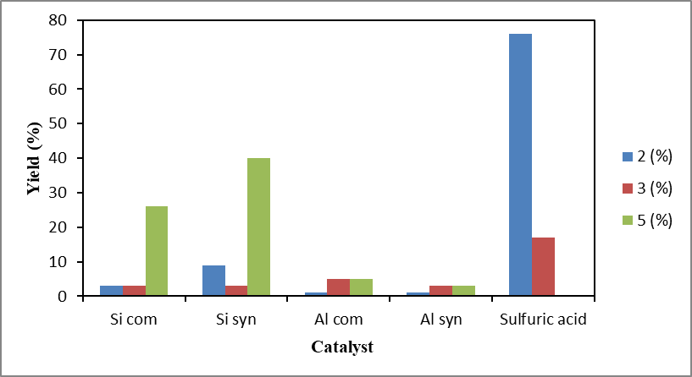
Figure 1.Evaluation of the yield of products 2, 3 and 5 in the presence of H₂SO₄ (4% wt.) and of catalysts based on silica gel and alumina (1.3% wt.)

We can then conclude that the homogeneous medium accelerates the dimerization of glycol 1 to diol 2, which cyclising to dioxane 3 while the heterogeneous medium promotes the dehydration of diol 1 to acetaldehyde 4, which in turn will be trapped by a second molecule of ethylene glycol 1 in excess to lead to dioxolane 5 (Scheme 2).
Scheme 2
From the results recorded above, we have found that commercial catalysts such as Si com silica gel and Al com alumina are not very active against ethylene glycol 1 (Table 2, entries 1 and 3), while synthetic Si syn silica being a Moroccan catalyst promotes the formation of dioxolane 5 with a very good yield (Table 2, entry 2). In addition, Si syn synthetic silica proved to be the best catalyst in this series with an overall reaction efficiency of 51% (Fig. 2).

3.1. Kinetic Study

In order to better understand the transformation of ethylene glycol 1 in a heterogeneous environment, we conducted a kinetic study by means of catalysts Al com, Si com and Si syn, except Al syn due to the low efficiency at 150 °C under autogenous pressure and for variable times. Analysis of the appearance of the curves shown in Figs. 3-6 indicates that the conversion of ethylene glycol 1 to diethylene glycol 2, dioxane 3 and dioxolane 5 depends closely on the nature of the used catalyst and the duration of the reaction. The formation of secondary products by the action of these three catalysts is a perceptible result.
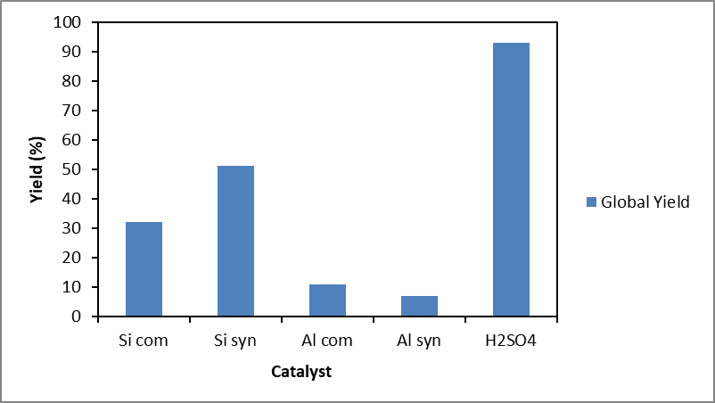
Figure2. Evaluationof the overall yield in the presence of H₂SO₄ (4% wt.) and catalysts based on silica gel and alumina (1.3% wt.)
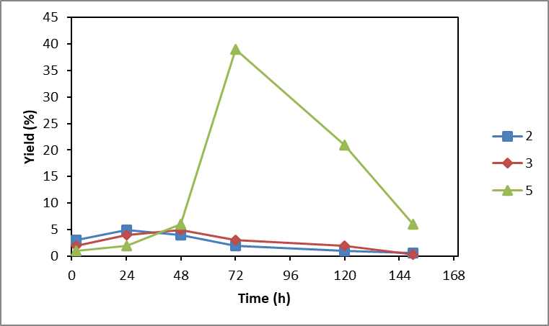
Figure3.Evaluation of products 2, 3 and 5 formed in the presence of commercial alumina Al com

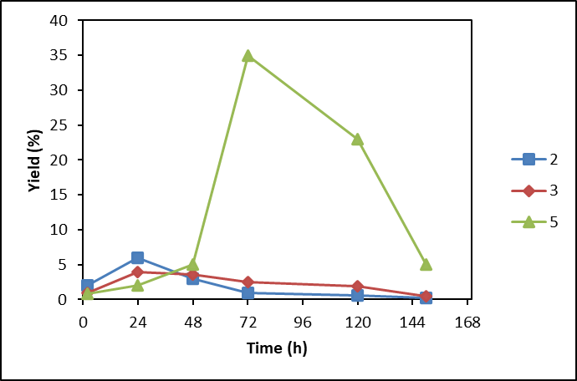
Figure4. Evaluation of products 2, 3 and 5 formed in the presence of synthetic alumina Al syn

Indeed, we have noticed that dimerization products 2 and 3 are obtained in low yields not exceeding 7% regardless of the nature of the used catalyst and the reaction time.

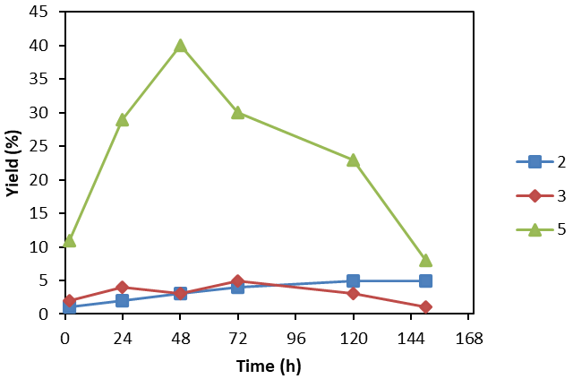
Figure5.Evaluation of products 2, 3 and 5 formed in the presence of commercial silica Si com

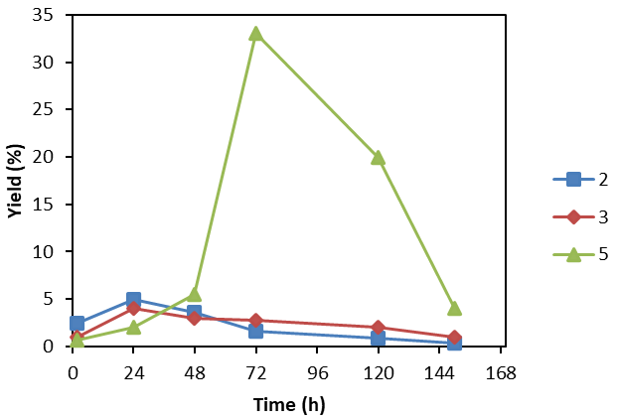
Figure6. Evaluationof products 2, 3 and 5 formed in the presence of synthetic silica Si syn

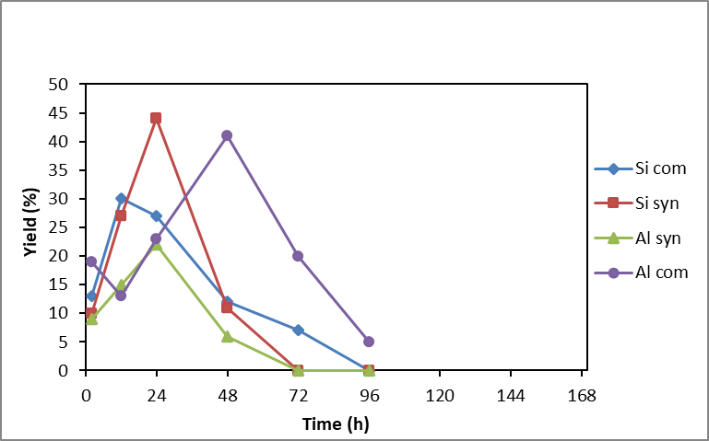
Figure7. Evaluation of dioxolane 5 according to the nature of the catalyst and the reaction time

We have also noticed that compound 5 is the main product of these reactions; it is obtained with a yield of 38% in the presence of alumina Al com after 48 hours of the reaction, 29% in the presence of silica Si com gel after 24 hours of the reaction and 40% when using synthetic silica Si syn after 48 hours of the reaction (Fig. 7).
We also found that the overall efficiency of the transformation of ethylene glycol 1 into products 2, 3 and 5 reached a maximum of 34% in the presence of alumina Al com after 72 hours of the reaction, 22% in the presence of silica Si com gel after 24 hours of the reaction and 44% in the presence of synthetic silica Si syn after 48 hours of the reaction (Fig. 8).
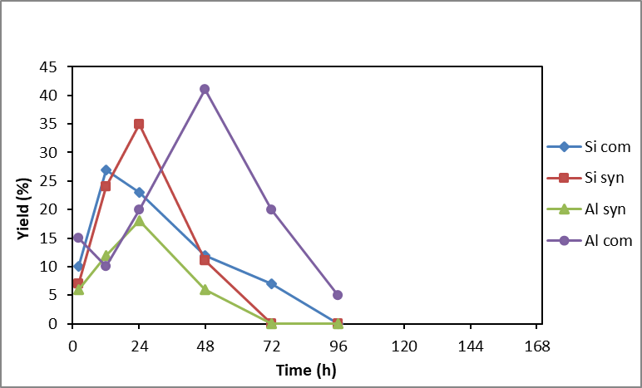
Figure8.Evaluation of the overall efficiency according to the nature of the catalyst used

It is interesting to note that the speed of the dimerization reaction is less important than that of the acetalization reaction (Figs.9-12). Synthetic Moroccan silica Si syn therefore represents the promising catalyst because it promotes the yield of dimerization (11%) and acetalization (40%) products after 48 hours of reaction (Fig. 12). We can thus conclude that Moroccan synthetic silica Si syn represents the promising catalyst because it favours the highest yield for a relatively long reaction time.
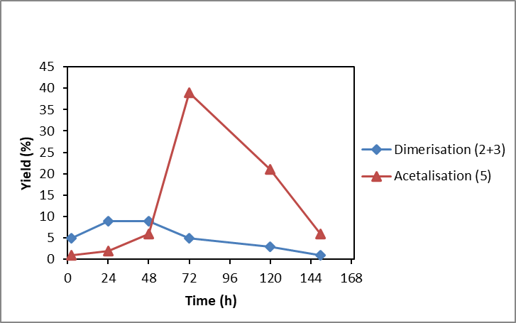
Figure9. Evaluation of dimerisation and cyclisation products in function of time and in the presence of commercial alumina Al com

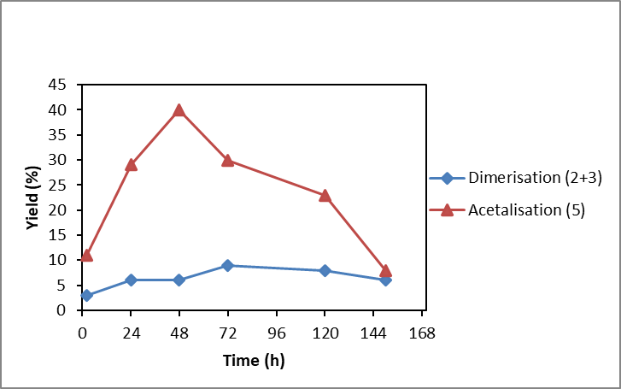
Figure10.Evaluationof dimerisation and cyclisation products formed in presence of commercial silica Si com

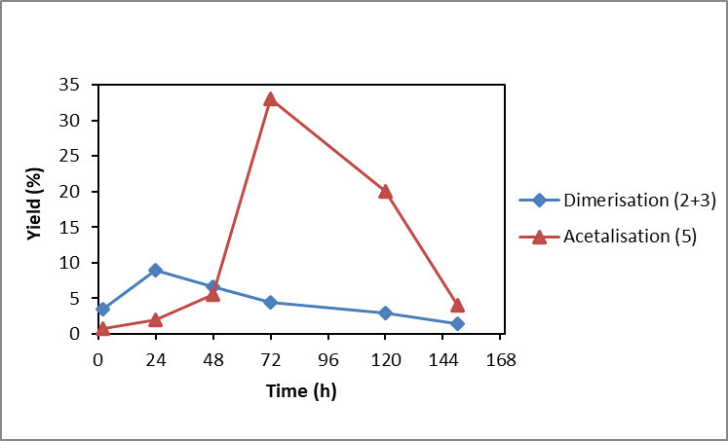
Figure11.Evaluation of dimerisation and cyclisation products formed in presence of synthetic silica Si syn
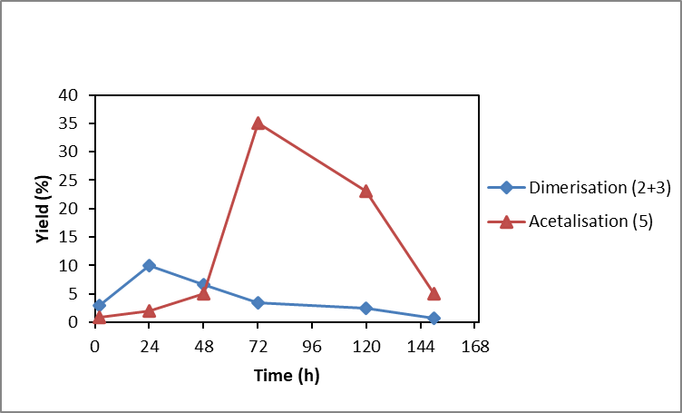
Figure12.Evaluation of dimerisation and cyclisation products formed in presence of synthetic alumina Al syn

3.2. Spectroscopic Study

Indeed, we noted that in the case of ethylene glycol 1 and dioxane 3, the C1 and C2 carbon atoms have the same atomic charges and the same for the oxygen atoms O1 and O2 (Table 3).
In the cases of diethylene glycol 2, acetaldehyde 4 and dioxolane 5 carbon atoms, C1, C2 and C3 do not have the same atomic charge values, identical for oxygen atoms O1 and O2 (Table 3). In addition, the lengths of the C-C, C-O and C-H bonds are closely related to the structure of the molecule under study (Table 3).
Finally, the nature of the atoms and the structure of the molecules have a significant effect on the dihedral angles of compounds 1-5(Table 3).
Similarly, during the heating of ethylene glycol 1, two major intermediates were formed in situ oxirane and acetaldehyde, which evolved differently to lead to products 2-5. The theoretical calculation of the NBO loads of these intermediates shows that the reaction evolves in the directions of formation of dioxolane 5 from acetaldehyde 4, since the atomic carbon load of the C=O group of acetaldehyde4 (0.452) is higher than that of the carbons (-0.080) of oxirane.
The addition of ethylene glycol 1 introduced in excess is then more favoured on the most electrophilic carbon of acetaldehyde despite two oxirane carbons (Scheme 3).
On the other hand, the comparative spectroscopic study of ¹H NMR (Table 3) and ¹³C NMR reveals that the differences in the chemical shifts of ¹H and ¹³C NMR spectra of compounds 1-5 are closely dependent on their electronic and steric effects.

Table 3.Some physical characteristics of ethylene glycol 1 and its derivatives 2-5

3.3. Plausible mechanism

These interesting results then led us to propose an ionic mechanism to explain the formation of the mixture of three products 2, 3 and 5 from ethylene glycol 1(Scheme 3). The first step in the conversion of ethylene glycol 1 to dioxolane 5 is the reaction of 1,2-diol 1 with the Brönsted sites located on the active surface of the three catalysts Al com, Si com and Si syn to lead first, after the removal of water from the oxonium ion A, to primary carbocation B. In this case, there are three possibilities: a first one where this primary carbocation B undergoes directly the nucleophilic attack of ethylene glycol 1 in excess to lead to diethylene glycol 2 via oxonium ion C. The dehydration of this dimer 2 initiated by heating in an acid medium leads to oxoniumion E which releases a water molecule and forms the second primary carbocation F. The intramolecular cyclisation of intermediate F gives dioxane 3 (Scheme 3, route a). The second possibility is that primary carbocation Bcyclises into protonated oxirane D which undergoes the nucleophilic addition of reagent 1 on methylenic carbon to lead to diethylene glycol 2 via oxonium ion C (Scheme 3, route b). Finally, the third way shows that this carbocation B undergoes a Wagner-Meerwein rearrangement, transforming it into a more stable secondary carbocation G. The acetaldehyde 4 formed in situ will in turn be trapped by diol 1 to lead to the oxonium ion H which converts into oxonium ions I and K. Dehydration of the latter K leads to a tertiary carbocation which is cyclised by an intramolecular O-alkylation to dioxolane 5 (Scheme 3, route c).

Scheme 3

We can then conclude that the spectral analysis confirms the experimental results well and that compound 5 is the main product of the conversion of ethylene glycol 1 and also the most thermodynamically stable product, which confirms its proportions in the obtained mixture. It should be noted that the other two products 2 and 3 are less stable and therefore have low proportions in the same mixture. In addition, we can note that in situ intermediates such as oxirane and acetaldehyde 4 are indeed the kinetic products in the conversion reaction of ethylene glycol 1 (Table 3).

4. Conclusions

In this work, we presented a new way of synthesising 2-methyl-1,3-dioxolane 5using solid catalysts that meet the demands of environmental and green chemistry. From the obtained results, we have showed that the yields of diethylene glycol 2, dioxane 3 and dioxolane 5 depends on the cation exchange capacity of alumina, silica gel and especially synthetic Moroccan silica. The rate of the acetalization reaction of acetaldehyde 4 formed in situ is more important than that of the dimerization reaction of ethylene glycol 1. In addition, synthetic silica is very effective in transforming ethylene glycol 1 to dioxolane 5.

Acknowledgments
Prof. Dr. Taoufik Rohand thanks the University Cadi Ayyad and specially the Faculty Polydisciplinaire of Safi for the financial support to the LACM laboratory. Dr. Kiyoshi Tanemura thanks Nippon Dental University for the financial support to the Chemical Laboratory.

Supporting Materials
The characterization data for all new product associated with this paper are presented as supplementary information.

References

1. B. Hatano, S. Toyota, F. Toda, Green Chem., 2001, 3, 140–142.
DOI:10.1039/B102447G
2. A. Sakakura, Y. Koshikari, K. Ishihara, Tetrahedron Lett., 2008, 49, 5017–5020.
DOI:10.1016/j.tetlet.2008.06.058
3. F. Toda, T. Suzuki, S. Higa, J. Chem. Soc. - Perkin Trans. 1, 1998, 3521–3522.
DOI:10.1039/A805884I
4. K. R. Prasad, P. Anbarasan, Tetrahedron Asymmetry, 2007, 18, 1419–1427.
DOI:10.1016/j.tetasy.2007.05.014
5. H. K. Patney, Tetrahedron Lett., 1991, 32, 2259–2260.
DOI:10.1016/S0040-4039(00)79696-1
6. K. Wilson, J. H. Clark, Pure Appl. Chem., 2000, 72, 1313–1319.
DOI:10.1351/pac200072071313
7. B. Pério, M. J. Dozias, P. Jacquault, J. Hamelin, Tetrahedron Lett., 1997, 38, 7867–7870.
DOI:10.1016/S0040-4039(97)10149-6
8. J. F. Knifton, Appl. Catal. A, Gen., 1995, 130, 79–88.
DOI:10.1016/0926-860X(95)00090-9
9. M. Onaka, M. Kawai, Y. Izumi, Chem. Lett., 1985, 14, 779–782.
DOI:10.1246/cl.1985.779
10. D. Schinzer, M. Kalesse, Synlett, 1989,1, 34–35.
DOI:10.1055/s-1989-34704
11. S.Manfredini, D.Simoni, V.Zanirato, A.Casolari, Tetrahedron Lett., 1988, 29, 3997–4000.
DOI:10.1016/S0040-4039(00)80403-7
12. T. Rohand, J. Savary, I. E. Markó, Monatshefte fur Chemie, 2018, 149, 1429–1436.
DOI:10.1007/s00706-018-2198-7
13. K. Tanemura, T. Suzuki, Tetrahedron Lett., 2018, 59, 392–396.
DOI:10.1016/j.tetlet.2017.12.050
14. K. Tanemura, Tetrahedron Lett., 2018, 59, 4293–4298.
DOI:10.1016/j.tetlet.2018.10.043
15. K. Tanemura, Tetrahedron Lett., 2019, 60, 1924–1928.
DOI:10.1016/j.tetlet.2019.06.030
16. K. Tanemura, T. Suzuki, Chem. Lett., 2015, 44, 797–799.
DOI:10.1246/cl.150166
17. K. Tanemura, T. Rohand, Tetrahedron Lett., 2020, 61, 152142.
DOI:10.1016/j.tetlet.2020.152142
18. A. Costa, J. Chem. Educ., 1982, 59, 1066.
DOI:10.1021/ed059p1066
19. K. Bougrin, A. Loupy, M. Soufiaoui, Tetrahedron, 1998, 54, 8055–8064.
DOI:10.1016/S0040-4020(98)00431-1
20. B. Syassi, K. Bougrin, M. Soufiaoui, Tetrahedron Lett., 1997, 38, 8855–8858.
DOI:10.1016/S0040-4039(97)10392-6
21. K. Petter,C.Vollhardt, N. E.Schore: Traité de Chimie Organique, 4ème Edit, De Boeck&Larcier, Bruxelles, Bruxelles, 2004, p 760
22. M. B.Smith: Organic Synthesis, McGraw-Hill, Inc, New York,1994, p 652
23. T. W.Green, P. G. M.Wuts: Protective Groups in Organic Synthesis, WieleyIntersciences, New York,1999, p 308
24. B. Joy, S. Ghosh, P. Padmaja, M. Lalithambika, Catal. Commun., 2005, 6, 573–577.
DOI:10.1016/j.catcom.2005.04.021
25. N. A. Ghulam, M. N. Abbas, D. E. Sachit, Indian Chem. Eng., 2020, 62, 301–313.
DOI:10.1080/00194506.2019.1677512
26. S. D. Barton, W. D. Ollis: Comprehensive Organic Chemistry, The Synthesis and Reactions of Organic Compounds, Pergamon Press. Ltd, Paris, 1979, p 881
27. R. C. Elderfield: Heterocyclic Compounds, Six Membered Heterocycles Containing Two Heteroatoms and Their Benzo Derivatives, John Wiley & Sons, Inc. New York, London, Chapman & Hall, 1957, p3
28. R. Grignard,J. Colonge: Précis de ChimieOrganique, 4èmeEdit, Masson etCie,1958, p344

