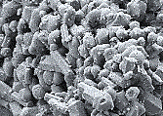
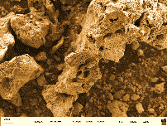

100
200
300
400
500
600
700
800
900
1000
25
30
40
50
60
70
80
90
100
T2H005
Temperature/°C
Mass/%
inflection point temperature
heating rate
dehydration
decomposition
T2H010
T2H020
T2H050
T2H100
T1H005
T1H010
T1H020
T1H050
T1H100

