Ultrasmall monodisperse NiO nanocrystals as a heterogeneous catalyst for the A3-coupling reaction toward propargylamines
Mohsen Moradian ^{1,}*, Masoome Nazar Abi ²
¹ Department of Organic Chemistry, Faculty of Chemistry, University of Kashan, Kashan, 87317, I.R. Iran Fax: 03155912397; Tel:03155913055; E-mail: m.moradian@kashanu.ac.ir
² Nanostructures and Biopolymer Research Lab, Institute of Nanoscience and Nanotechnology, University of Kashan, 87317-53153, Kashan, Iran. E-mail: m.nazarabi@gmail.com

Abstract: Ultrasmall monodisperse NiO nanoparticles (7-9 nm) were synthesized through thermal decomposition of Ni-oleylamine complexes. Various measurement techniques involving Fourier-transform infrared spectroscopy (FT-IR), diffuse reflectance UV-vis spectroscopy (DRS), X-ray diffractometer (XRD), energy dispersive X-ray analysis (EDX), Scanning electron microscopy (SEM), Dynamic Light Scattering technique (DLS), and Vibrating Sample Magnetometer (VSM) were employed to characterize the synthesized catalyst. Propargylamine derivatives were synthesized with aldehydes, terminal alkynes and primary amines through a one-pot A³-coupling reaction by using a 3 mol% amount of the NiO nanocrystals at 80 °C under solvent-free conditions with good to excellent yields. The structures of the products were confirmed by ¹H and ¹³C NMR spectroscopies. The catalyst represents many advantages including environmentally friendly, ease of recovery, reusability, stability, applicability to a wide variety of substrates, and cost-effectiveness preparation.
Keywords: monodisperse, NiO nanocrystals, heterogeneous, catalyst, A3-cupling, propargylamine

1. Introduction
The expanding of environmentally benign, practical, economical and efficient synthetic procedures has been a major concern of many chemical researches.^{1,2} Inasmuch as, one of the initial principle in green chemistry is pertinent to minimize the number of steps in chemical synthesis which is followed by some other rules such as atom economy, elimination of hysteresis, eschewing the consuming toxic or hazardous reagents and solvents.^{3,4} Multicomponent reactions (MCRs) have been captivating for academia and industry due to representing a number of eminent conceptual and synthetic merits including sustainability, operational simplicity, cost-effectiveness, and high convergence which are in accordance with green chemistry values.⁵ Among all known MCRs, acetylene-Mannich reaction is an intriguing approach to synthesize propargylamines which their structural motifs have been found in different natural products and have been utilized as precursors of various biological active components comprising β-lactams, isosteres, peptides, allylamines and oxazoles.^{6,7} Classical method of propargylamines synthesis was involved the nucleophilic addition of a metal acetylide to C=N electrophiles by exploiting highly active organometallic compounds combining organolitium, organozinc or Grignard reagents.⁸⁻¹¹ Hence, this method is less appealing owning to, harsh reaction conditions, high moisture sensitivity of functional groups, and operational complexity.¹² Thus the efforts have been devoted to synthesize these nitrogen-containing compounds through three component reaction condition with various modified catalysts. Transition metals as a heterogeneous catalyst have garnered a lot of attention which the first type of these catalysts was applied by Li et al in 2002 when they had performed lots of work with Copper and Ruthenium.¹³ Afterwards, miscellaneous transition metal catalysts including different metals such as Cu, Ag, Au, Fe, Ni, Ir, In, and Zn was developed for synthesis of propargylamines which the main disadvantage of these catalyst is their aggregation.¹⁴⁻²¹
Nanomaterials in the size range of 10-100 nm have attracted a lot of attention in the last few decades because they show special physical and chemical properties compared to bulk materials. Accordingly, nanoparticles with a size of 3-10 nm also have unique properties and behavior different from nanoparticles with a larger size, which makes them have a special function. The use of these ultrasmall nanomaterials as catalysts in organic reactions is a new and effective approach in this field.^{22,23} The nanoparticles properties capture them to become a connector between homogenous and heterogeneous catalytic systems.^{24,25} Among all nanomaterials which have been investigated vastly involving copper, gold, silver, iron, and so on, nickel nanoparticles studies are limited only to a few research while this metal is cheaper than the others and requires mild reaction circumstances for obtaining high yield.²⁶⁻³¹ All of the reported works using nickel as a catalyst has been limited to Ni(II) ion complexes such as NiCl₂,³² MNPs@BimNiCl₂,³³ Ni-MOF,³⁴ and Ni^{II}-IL/SiO₂.³⁵ Also, nickel alongside copper as a metallic form has been used such as Cu-Ni bimetallic³⁶ and Ni-Cu-Fe trimetallic nanoparticles.³⁷ In this study, propargylamines will be synthesized for the first time by utilizing ultrasmall monodisperse NiO nanocrystals as a heterogeneous catalyst. The monodisperse nanoparticles of NiO with particle size about 6-nm dimensions were synthesized using reported procedure by Hyeon and coworkers in 2004.³⁸ Different aldehydes and amines will be applied to generalize the research. Herein, the questions posed with this research are that whether the catalyst is applicable to synthesize different propoargylamines compounds or does the catalyst possesses high efficiency, stability, reusability and the other criteria which are important for a truly efficient catalyst.
2. Experimental section
2.1. Materials and instrumentations
Nickle (acetylacetonate)₂ [Ni(acac)₂], oleylamine, triphenylphosphine (TPP), diphenylether (DE), and all other commercially available chemicals were purchased from Merck Chemical Company with high purity. The applied solvents were purified by standard procedure. Melting points were measured by a Yanagimoto Micro Melting Point apparatus in open capillary tubes. Fourier transform infrared (FT-IR) spectra were gained (in KBr) by Nicolet FT-IR spectrophotometer. The ¹H and ¹³C NMR spectra were recorded on Bruker DRX-400 spectrometer with CDCl₃ as solvent at 25 °C and chemical shifts are given in ppm rel. to Me₄Si. The XRD patterns were obtained by an X'PertPro (Philips) instrument with 1.54 Ångström wavelengths of the X-ray beam and Cu anode material. Microscopic morphology of the nanoparticles was visualized by SEM (MIRA 3 TESCAN). Energy-dispersive X-ray spectroscopy (EDX) of the nanoparticles imagined by a Sigma ZEISS, Oxford Instruments Field Emission. The purity determination of the substrates and reaction monitoring were accomplished by TLC on silicagel polygram SILG/UV 254 plates (from Merck Company).
2.2. Synthesis of NiO nanoparticles
The synthesis protocol for preparation of ultrasmall NiO nanoparticles is a modified method which developed by Taeghwan and co-workers that employs the thermal decomposition of metal-surfactant complexes.^{24,39} Initially, Ni(acac)₂ (0.32 g) and Oleylamine (1.5 ml) were mixed under N₂ atmosphere at 100 °C. Afterwards, the fresh prepared Ni-Oleylamine complex was added to a balloon containing a solution of TPP (1.8 g) in DE (2.5 ml) with 200 °C temperature. After elapsing a short time the solution color altered from dark green to black due to formation of colloidal Ni nanoparticles. The resultant solution was kept in 280 °C for 1 hour and then the temperature decreased to the ambient temperature. Consequently pure ethanol (200 ml) was poured to the reaction chamber which caused Ni nanoparticles precipitation. In the following, the precipitate was centrifuged and washed with ethanol (3×50 mL) and then was exposed to the dry air for 24 hours to form NiO nanoparticles and the resultant product was kept at 60 °C temperature.
2.3. Synthesis of propargylamine derivatives by NiO nanoparticles catalyst
All of the reactions were carried out at 80 °C in a 25 ml one-capped balloon equipped with a magnetic stirring bar in a paraffin bath. Generally, a mixture of the selected aldehyde (1.0 mmol), secondary amine (1.1 mmol) and alkyne (1.2 mmol) was added in the balloon along with the catalytic amount of the NiO nanocrystals (3 mol %, 2.3 mg) as a catalyst. The reaction progress was examined by TLC, and after the completion of the reaction; absolute ethanol (10 mL) was added and the resulting mixture was centrifuged. The catalyst was separated from the reaction mixture by centrifugation and washed with CH₂Cl₂ (3×5 ml) and methanol (3×5 ml) for reusability and recycling in the next runs. The product was purified over silica gel by column chromatography (10% EtOAc in hexane) to give the desired propargylamines. All of the products are known compounds and have been reported already.
4-(1,3-diphenylprop-2-yn-1-yl)morpholine (4a) Yield: 93%; Light red oil; ¹³C NMR (CDCl₃): δ 50.35 (C7), 57.21 (C10, C14), 68.54 (C11, C13), 84.08 (C8), 88.49 (C15), 115.17 (C16), 116.31 (C19), 121.96 (C21, C17), 123.67 (C2), 124.82 (C18, C20), 126.16 (C1, C3), 130.43 (C4), 131.87 (C6), 136.54 (C5); ¹H NMR (CDCl₃): δ 2.67-2.68 (m, 4H, C10H, C14H), 3.77-3.80 (m, 4H, C11H, C13H), 4.84 (s, 1H, C7H), 7.33-7.44 (m, 6H, ArH), 7.56-7.58 (m, 2H, ArH), 7.68-7.70 (m, 2H, ArH); FT-IR (KBr disk): ν cm⁻¹ 3059, 3014, 2984, 2957, 2950, 1598, 1489, 1449, 1318, 1280.

4-(3-phenyl-1-(p-tolyl)prop-2-yn-1-yl)morpholine (4b) Yield: 92%; Light orange oil; ¹³C NMR (CDCl₃): δ 22.08 (C22), 49.14 (C7), 58.36 (C10, C14), 67.15 (C11, C13), 83.65 (C8), 87.91 (C15), 114.25 (C16), 117.55 (C19), 120.74 (C21, C17), 120.95 (C2), 122.33 (C18, C20), 123.85 (C1, C3), 126.80 (C4), 128.03 (C6), 132.17 (C5); ¹H NMR (CDCl₃): δ 2.39 (s, 3H, Me), 2.65-2.67 (m, 4H, C10H, C14H), 3.75-3.76 (m, 4H, C11H, C13H), 4.78 (s, 1H, C7H), 7.20-7.22 (m, 2H, ArH), 7.34-7.36 (m, 3H, ArH), 7.53-7.55 (m, 4H, ArH); FT-IR (KBr disk): ν cm⁻¹ 3024, 2946, 2925, 2862, 2820, 2230, 1486, 1446, 1314, 1109.
4-(1-(4-nitrophenyl)-3-phenylprop-2-yn-1-yl)morpholine (4c) Yield: 95%; Yellowish oil; ¹³C NMR (CDCl₃): δ 49.90 (C7), 61.45 (C10, C14), 67.04 (C11, C13), 83.16 (C8), 89.78 (C15), 122.31 (C16), 123.48 (C19), 128.45 (C21, C17), 128.72 (C2), 129.33 (C18, C20), 131.85 (C4, C6), 135.48 (C3, C1), 145.45 (C5), 149.23 (C2); ¹H NMR (CDCl₃): δ 2.63-2.66 (m, 4H, C10H, C14H), 3.75-3.76 (m, 4H, C11H, C13H), 4.89 (s, 1H, C7H), 7.38-7.39 (m, 3H, ArH), 7.53-7.55 (m, 2H, ArH), 7.87 (d, J=8.1 Hz, 2H, ArH), 8.24 (d, J=8.1 Hz, 2H, ArH); FT-IR (KBr disk): ν cm⁻¹ 3067, 2958, 2854, 2216, 1690, 1522, 1450, 1347, 1275, 1113, 1006.

N,N-dimethyl-4-(1-morpholino-3-phenylprop-2-yn-1-yl)aniline (4d) Yield: 88%; Yellowish oil; ¹³C NMR (CDCl₃): δ 44.11 (C23), 49.25 (C24), 61.70 (C10, C14), 67.03 (C11, C13), 84.15 (C8), 87.54 (C15), 113.85 (C1, C3), 118.80 (C16), 120.41 (C19), 123.74 (C21, C17), 130.40 (C18, C20), 131.21 (C4), 134.38 (C6), 148.01 (C2), 149.21 (C5); ¹H NMR (CDCl₃): δ 2.62-2.66 (m, 4H, C10H, C14H), 2.97 (s 6H, NMe₂), 3.73-3.74 (m, 4H, C11H, C13H), 4.70 (s, 1H, C7H), 6.73 (d, J=8.0 Hz, 2H, ArH), 7.32-7.33 (m, 3H, ArH), 7.45-7.51 (m, 4H, ArH); FT-IR (KBr disk): ν cm⁻¹ 3084, 2955, 2892, 2854, 1965, 1611, 1521, 1150.
4-(1-(3-methoxyphenyl)-3-phenylprop-2-yn-1-yl)morpholine (4e) Yield: 91%; Yellowish oil; ¹³C NMR (CDCl₃): δ 49.99 (C7), 55.24 (C22), 62.01 (C10, C14), 67.20 (C11, C13), 85.15 (C8), 88.54 (C15), 113.10 (C2), 114.39 (C6), 120.99 (C4), 123.03 (C16), 128.36 (C21), 128.42 (C17), 129.28 (C18, C20), 131.88 (C19), 132.17 (C3), 139.57 (C5), 159.71 (C1); ¹H NMR (CDCl₃): δ 2.66-2.67 (m, 4H, C10H, C14H), 3.77-3.79 (m, 4H, C11H, C13H), 3.86 (s, 4H, OCH₃), 4.79 (s, 1H, C7H), 6.86 (s, 1H, C6H), 7.25-7.36 (m, 6H, ArH), 7.53-7.54 (m, 2H, ArH); FT-IR (KBr disk): ν cm⁻¹ 3057, 2995, 2851, 1965, 1599, 1486, 1449, 1317, 1150, 1048.
4-(1-(2-chlorophenyl)-3-phenylprop-2-yn-1-yl)morpholine (4f) Yield: 93%; Yellow oil; ¹³C NMR (CDCl₃): δ 49.87 (C7), 58.96 (C10, C14), 67.14 (C11, C13), 84.70 (C8), 88.40 (C15), 122.82 (C16), 125.58 (C3), 126.39 (C18, C20), 128.38 (C21), 128.41 (C17), 129.18 (C19), 130.58 (C2), 130.93 (C1), 131.85 (C4), 134.69 (C6), 135.56 (C5); ¹H NMR (CDCl₃): δ 2.66-2.67 (m, 4H, C10H, C14H), 3.77-3.79 (m, 4H, C11H, C13H), 3.86 (s, 4H, OCH₃), 4.79 (s, 1H, C7H), 6.86 (s, 1H, C6H), 7.25-7.36 (m, 6H, ArH), 7.53-7.54 (m, 2H, ArH); FT-IR (KBr disk): ν cm⁻¹ 3047, 2997, 2897, 2750, 1562, 1472, 1452, 1324, 1274, 1117, 1055.

4-(1-(4-chlorophenyl)-3-phenylprop-2-yn-1-yl)morpholine (4g) Yield: 94%; Yellow oil; ¹³C NMR (CDCl₃): δ 49.85 (C7), 61.40 (C10, C14), 67.15 (C11, C13), 84.43 (C8), 88.98 (C15), 122.77 (C16), 128.43 (C1, C3), 128.48 (C18, C20), 129.70 (C19), 129.94 (C17, C21), 131.88 (C4, C6), 133.61 (C2), 136.53 (C5); ¹H NMR (CDCl₃): δ 2.61-2.62 (m, 4H, C10H, C14H), 3.73-3.75 (m, 4H, C11H, C13H), 4.77 (s, 1H, C7H), 7.36-7.37 (m, 5H, ArH), 7.51-7.52 (m, 2H, ArH), 7.58-7.60 (m, 2H, ArH); FT-IR (KBr disk): ν cm⁻¹ 3070, 3029, 2957, 2857, 1494, 1454, 1428, 1113, 1075, 1034.
4-(1-(3-nitrophenyl)-3-phenylprop-2-yn-1-yl)morpholine (4h) Yield: 91%; Light yellow oil; ¹³C NMR (CDCl₃): δ 49.78 (C7), 61.24 (C10, C14), 66.95 (C11, C13), 83.17 (C8), 89.76 (C15), 122.36 (C16), 122.85 (C21, C17), 123.41 (C18, C20), 128.39 (C19), 128.71 (C6), 129.15 (C2), 131.83 (C3), 134.48 (C4), 140.36 (C5), 148.39 (C1); ¹H NMR (CDCl₃): δ 2.63-2.69 (m, 4H, C10H, C14H), 3.76-3.78 (m, 4H, C11H, C13H), 4.90 (s, 1H, C7H), 7.34-7.38 (m, 3H, ArH), 7.54-7.62 (m, 3H, ArH), 8.02 (d, J=7.6 Hz, 1H, C2H), 8.18 (d, J=7.7 Hz, 1H, C4H), 8.56 (s, 1H, C6H); FT-IR (KBr disk): ν cm⁻¹ 3085, 3028, 3002, 2986, 2882, 1506, 1473, 1419, 1263, 1208, 1168, 1121, 1045, 1014.
4-(1-(furan-2-yl)-3-phenylprop-2-yn-1-yl)morpholine (4i) Yield: 88%; Yellowish white oil; ¹³C NMR (CDCl₃): δ 49.61 (C2), 56.12 (C5, C9), 66.95 (C6, C8), 82.85 (C3), 87.02 (C10), 109.76 (C17), 110.13 (C18), 122.57 (C11), 128.35 (C13, C15), 128.50 (C12, C16), 131.87 (C14), 142.87 (C19), 150.76 (C1); ¹H NMR (CDCl₃): δ 2.63-2.72 (m, 4H, C5H, C9H), 3.74-3.83 (m, 4H, C6H, C8H), 4.89 (s, 1H, C2H), 6.37 (t, J=3 Hz, 1H, C18H), 6.52 (d, J=2.8 Hz, 1H, C17H), 7.31-7.35 (m, 3H, ArH), 7.45-7.52 (m, 3H, ArH); FT-IR (KBr disk): ν cm⁻¹ 3063, 3028, 2932, 1604, 1495, 1453, 1261, 1152, 1028.

4-(3-phenyl-1-(thiophen-2-yl)prop-2-yn-1-yl)morpholine (4j) Yield: 86%; White oil; ¹³C NMR (CDCl₃): δ 49.69 (C2), 57.83 (C5, C9), 67.15 (C6, C8), 84.29 (C3), 87.63 (C10), 122.69 (C11), 125.57 (C18), 125.87 (C17), 126.36 (C16), 126.44 (C12), 128.39 (C13), 128.48 (C15), 128.84 (C14), 131.89 (C19), 142.80 (C1); ¹H NMR (CDCl₃): δ 2.66-2.74 (m, 4H, C5H, C9H), 3.73-3.82 (m, 4H, C6H, C8H), 5.01 (s, 1H, C2H), 6.97-6.99 (m, 1H, C18H), 7.25-7.27 (m, 1H, C17H), 7.30-7.31 (m, 1H, C19H), 7.34-7.36 (m, 3H, ArH), 7.51-7.54 (m, 2H, ArH); FT-IR (KBr disk): ν cm⁻¹ 3062, 3028, 2955, 2934, 2248, 1607, 1490, 1454, 1125, 1109, 1065, 1016.

4-(1-phenylhept-1-yn-3-yl)morpholine (4k) Yield: 86%; White oil; ¹³C NMR (CDCl₃): δ 14.21 (C19), 21.70 (C18), 25.24 (C17), 34.47 (C16), 54.14 (C1), 57.30 (C4, C8), 67.79 (C5, C7), 87.45 (C2), 88.21 (C9), 123.64 (C10), 126.87 (C15, C11), 128.45 (C13), 129.70 (C12, C14); ¹H NMR (CDCl₃): δ 1.02 (t, J=7.0 Hz, 3H, C19H), 1.38-1.39 (m, 4H, C17H, C18H), 1.60-1.62 (m, 2H, C16H), 2.95-2.96 (m, 4H, C4H, C8H), 3.63-3.68 (m, 4H, C5H, C7H), 3.81-3.82 (m, 1H, C1H), 7.45-7.48 (m, 3H, ArH), 7.69-7.72 (m, 2H, ArH); FT-IR (KBr disk): ν cm⁻¹ 3035, 3020, 2964, 2874, 2234, 1568, 1479, 1439, 1328, 1263, 1184, 1120, 1064.

1-(1,3-diphenylprop-2-yn-1-yl)piperidine (4l) Yield: 93%; Red oil; ¹³C NMR (CDCl₃): δ 24.15 (C12), 26.07 (C11, C13), 52.47 (C7), 56.11 (C10, C14), 82.18 (C15), 87.19 (C8), 121.10 (C16), 126.01 (C19), 126.86 (C21, C17), 127.24 (C2), 127.60 (C18, C20), 128.74 (C1, C3), 129.03 (C4), 129.17 (C6), 138.41 (C5); ¹H NMR (CDCl₃): δ 1.45-1.58 (m, 6H, C11H, C12H, C13H), 2.38-2.41 (m, 4H, C10H, C14H), 4.94 (s, 1H, C7H), 7.33-7.94 (m, 10H, ArH); FT-IR (KBr disk): ν cm⁻¹ 3084, 3020, 2994, 2967, 1452, 1408, 1349, 1319, 1300.

3. Results and discussion
3.1. Characterization of the NiO nanoparticles catalyst
The properties, structure, size and size distribution of the synthesized NiO nanoparticles were measured by various techniques including FT-IR spectroscopy, TEM, SEM, DLS, DRS, XRD, EDX and VSM analysis. As shown in Fig. 1 the FT-IR spectra of the catalyst delineates an absorption band at 443 cm⁻¹ which is related to the vibration band of Ni-O stretching bond. As can be seen, no other peaks are observable in the spectra which confirms that the catalyst is without any impurity or any organic residues which were likely to arise from organic components that consumed during the preparation process of nanoparticle.

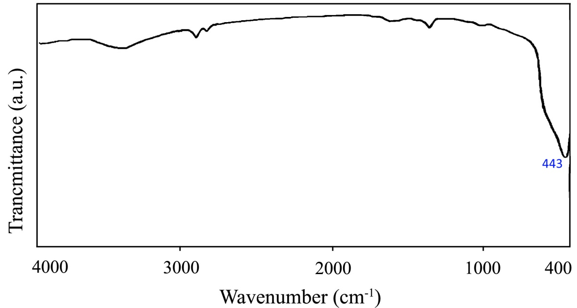
Figure 1. the FT-IR spectrum of the NiO nanoparticles

To observe the purity phase and local geometry of the crystalline scaffold of the synthesized NiO nanoparticles, X-Ray diffraction was provided. As can be observed, the whole Ni nanoparticles are oxidized to the NiO nanoparticles without showing any impurities and all the peaks are in good agreement with the cubic structure of the catalyst according to the library patterns (JCPDS No. 71-1179). The estimated size of nanoparticles by Debye-Scherrer equation was measured around 8.4 nm (Fig. 2).

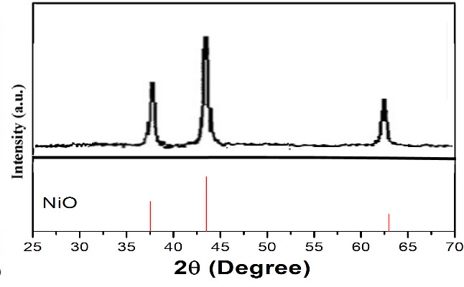
Figure 2. The XRD pattern of the NiO nanoparticles

To determine size, size distribution, and morphology employing various measurement techniques are required due to basic differences in each represented methods [39]. The SEM analysis of the synthesized catalyst exhibits that the NiO nanocrystal size are around 7-9 nm which confirms the XRD results (Fig. 3a). The SEM image of the NiO ultrasmall nanoparticles were provided. As can be seen, the NiO nanoparticles are spherical and possessing high uniformity (Fig. 3).

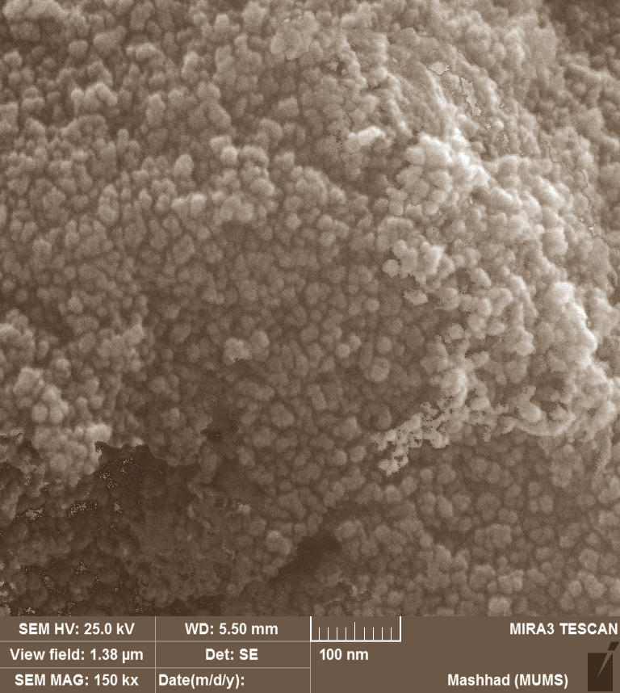
Figure 3. The SEM image of the NiO nanocrystals

In accordance with the SEM image of the NiO nanoparticles, the particle size distribution histogram was provided by DLS technique and as shown in Figure 4, the dispersion nanoparticles size are not scattered and the mean value and standard deviation could be estimated 7.9 ± 1 nm according to the provided size distribution histogram.
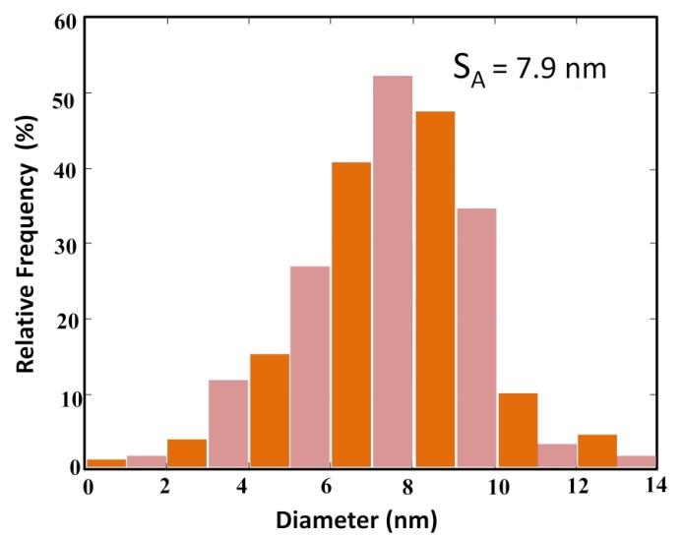
Figure 4. Histogram showing the particle size and size distribution of US-NiO nanocrystals

The single point BET analysis was used to determine the specific surface area of the NiO NPs. The surface area of NPs was found to be 33.7 m²/g and a mean particle size of 8.7 nanometers was calculated from the d_{BET}=6000/ñS equation (S is specific surface area in m²g-1, d is the diameter in nanometer, and ñ is the theoretical density in g cm-3). This value is close to that obtained by SEM and XRD image and indicates that the powder consists of mono-dispersed solid crystals; also agglomeration and heaping of nanoparticles does not happen.
The EDX micrograph was also provided to prove the existence of nickel elements in the prepared nanoparticles (Figure 5). According to the graph, no other peaks in the spectrum from elements except Ni were observed which confirms that the NiO nanoparticles are pure.

Fig. 5. The energy dispersive X-Ray analyzer of the NiO NPs

The uv-vis diffuse reflectance spectroscopy (DRS) measurement which is dispersed in ethanol was performed to achieve the optical property and consequently crystallinity of the nanoparticles (Figure 6). A strong absorption band has been observed in UV gamut (360 nm) which is attributed to the nanoparticles absorption in ratio of their crack bonds’ absorption.

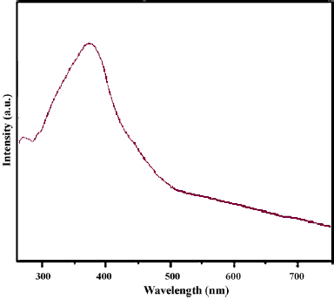
Figure 6. uv-vis DRS of the US-NiO nanoparticles
3.2. Reaction optimization
The prepared ultra-small nanocrystals of NiO were used as a catalyst in the A3-coupling reaction of aromatic and aliphatic aldehydes, secondary amines, and phenylacetylene as the terminal alkyne (Scheme 1).
Scheme 1 general procedure of the reaction

In continuum of our research, our first efforts were devoted to optimize reaction condition. Therefore, the optimization was examined for solvent, temperature and catalyst. To put the purpose in action, the reaction among benzaldehyde (1 mmol), morpholine (1.1 mmol) and phenyl acetylene (1.2 mmol) was selected as model reaction in the presence of the synthesized NiO nanoparticles as a reusable and heterogeneous catalyst. As depicted in table 1, for solvent optimization, various protic and aprotic solvent comprising toluene, DMF, DMSO, THF, CH₂Cl₂, MeCN, H₂O, and MeOH under different temperatures, also reflux condition were investigated. It is obvious that consuming aprotic solvents with various conditions have given favorable data. Hence, Utilizing protic solvents were not encouraged. According to the outputs, when dicholoromethane was employed (entry 10) propitious yield was obtained while using MeOH as a protic solvent represented good yield (entry 8). The highest yield was achieved under solvent-free conditions at 80 °C bath of paraffin with the shortest reaction time (entry 12).
Table 1 The effects of various solvents and temperature on model reaction using NiO nanoparticles catalystª
Entry | Solvent | Temperature[°C] | Time[h] | Yield^{b} [%]
1 | MeCN | Reflux | 10 | 54
2 | DMF | 100 | 10 | 52
3 | DMSO | 100 | 10 | 65
4 | Toluene | Reflux | 10 | 69
5 | H₂O | Reflux | 10 | 18
6 | H₂O | 90 | 10 | 12
7 | MeOH | Reflux | 10 | 28
8 | MeOH | 40 | 10 | 20
9 | THF | Reflux | 10 | 38
10 | CH₂Cl₂ | 38 | 6 | 44
11 | Solvent-free | r.t | 10 | 54
12 | Solvent-free | 80 | 3 | 96
13 | Solvent-free | 60 | 5 | 80
14 | Solvent-free | 100 | 3 | 95
ª Reaction condition: benzaldehyde (1.0 mmol), phenylacetylene (1.2 mmol), morpholine (1.1 mmol), NiO nanoparticles (0.03 mmol, 2.3 mg). ^{b} Based on isolated yields. ^{c} The bold character show the best conditions.

According to Table 2, entries 11-14, temperature optimization for the solvent free condition was in demand. The best result for solvent-free temperature optimization was obtained at 80 °C (entries 11-14) which is evidence that further augmentation or decreases in the temperature, did not lead to any distinguishable alteration.
The amount of catalyst is a crucial player factor in the yield of the reaction. A glance at Table 3 reveals that in the absence of the catalyst (entry 1) merely a negligible amount of product achieved which this result pointed that using the catalyst is an obligatory factor for the progression of the reaction. Additionally, the best result was achieved when 2.3 mg of the catalyst loaded into the reaction chamber (entry 3). It was monitored that further addition of catalyst amount did not affect the reaction yield percentage.
Table 3. Optimization of the catalyst amount of NiO nanoparticles on model reaction ª
Entry | X [mg] NiO | Time | Yield^{b} [%]
1 | 0 (0 mol %) | 24 | trace
2 | 0.7 (1 mol %) | 8 | 48
3^{c} | 2.3 (3 mol %) | 3 | 96
4 | 3.7 (5 mol %) | 3 | 96
5 | 7.5 (10 mol %) | 3 | 96
ª Reaction condition: benzaldehyde (1.0 mmol), phenylacetylene (1.2 mmol), morpholine (1.1 mmol). ^{b} Based on isolated yields. ^{c} The bold character show the best conditions.

After optimization of the reaction conditions, the next step of our study was based on determination the scope and limitation of the current protocol with the ultrasmall NiO nanoparticles as heterogeneous. Therefore, a number of different propargylamines were synthesized with applying various initial moieties including disparate aldehydes owning electron withdrawing and electron donating functional groups, along with morpholine and pyridine as the secondary amines, also phenyl acetylene as a fixed compartment of the reaction. The information regarding synthesized propargylamines is summarized in table 4. Apparently, the reactions accomplished productively with good to high yields and in a short period of the reaction time for all the acquired products. Furthermore, it is highly important to be pointed that the desired products involving benzaldehyde derivatives with an electron-withdrawing group exhibited excellent yields (4c, 4g and 4h compounds), whereas benzaldehyde with an electron donating group shows lower yields (4b and 4d compounds).

Table 4 NiO nanoparticles catalyzed three-component synthesis of propargylaminesª
4a: 3 h, 96%  TON: 36  TOF (h⁻¹): 341  Ref: 40 | 4b: 3 h, 96%  TON: 35  TOF (h⁻¹): 387  Ref: 41 | 4c: 3 h, 96%  TON: 36  TOF (h⁻¹): 405  Ref: 41
4d: 3 h, 96%  TON: 34  TOF (h⁻¹): 392  Ref: 42 | 4e: 3 h, 96%  TON: 35  TOF (h⁻¹): 386  Ref: 43 | 4f: 3 h, 96%  TON: 36  TOF (h⁻¹): 350  Ref: 43
4g: 3 h, 96%  TON: 37  TOF (h⁻¹): 414  Ref: 44 | 4h: 3 h, 96%  TON: 36  TOF (h⁻¹): 391  Ref: 44 | 4i: 3 h, 96%  TON: 33  TOF (h⁻¹): 405  Ref: 45
4j: 3 h, 96%  TON: 33  TOF (h⁻¹): 363  Ref: 45 | 4k: 3 h, 96%  TON: 35  TOF (h⁻¹): 341  Ref: 46 | 4l: 3 h, 96%  TON: 37  TOF (h⁻¹): 382  Ref: 47
ªReaction condition: aldehyde (1.0 mmol), phenylacetylene (1.20 mmol), secondary amine (1.1 mmol), NiO nanoparticles as catalyst (2.3 mg) under solvent-free conditions at 80 °C.
^{b}Based on isolated yields.

The proposed reaction mechanism for the catalytic reaction in the presence of US-NiO NPs is shown in Scheme 5. The first step is the C-H activation of the alkyne moiety via adsorption on the surface of the catalyst and produces alkynyl-[NiO] complex. Then, the aromatic or aliphatic aldehydes are activated by catalyst through van der Waals interactions between ion pair of the oxygen atom from carbonyl and the Ni atom on the catalyst. Nucleophilic attack of the alkynyl-[NiO] complex upon iminium ion formed from the reaction of aldehyde and amine, produces the desired propargylamine and releases the NiO catalyst for the next catalytic runs.

Scheme 2. Proposed reaction mechanism for the catalytic reaction

We also investigated the catalyst leaching study in this method. After the reaction was run, in half of the time of the reaction completion, the NiO catalyst was separated by centrifuge from the reaction media and the solution phase was subjected without any fresh catalyst under the same reaction conditions. The reaction was monitored after 8 h and the result was shown that there was no further conversion of substrates to desired propargylamine. This means that any solid nanoparticles or active metal leached from solid nanocatalyst to remains in the filtrate.
In green chemistry, an essential matter to express environmentally friendly methods is recovery and reusability of the catalyst. Hence, after reaction completion, the NiO nanocatalyst was separated by centrifuge method. The recovered catalyst was thoroughly washed with CH₂Cl₂ (3×5 ml) and dried at 80 °C for 10 h, and then it was used for consecutive reaction without adding any fresh catalyst. As can be seen in Figure 7, the results show NiO nanoparticles can be used at least for 12 sequential runs without important changes in its activity.

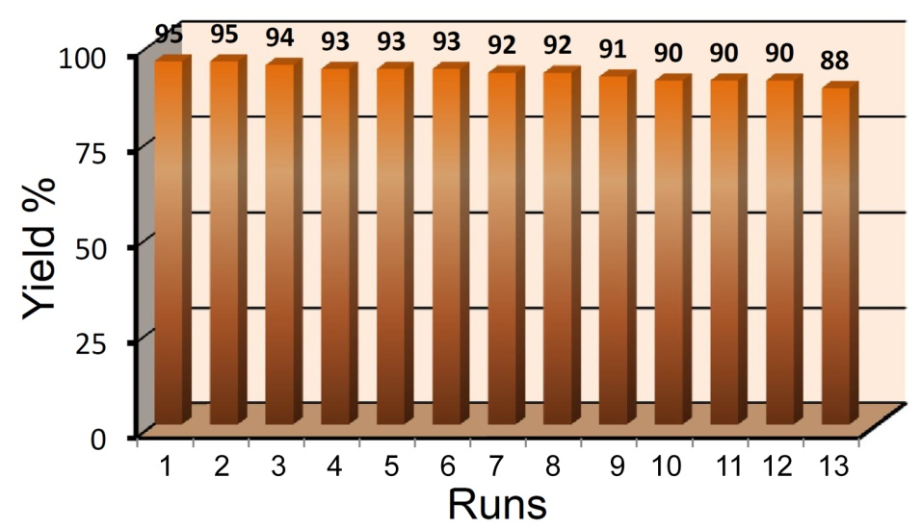
Figure 7. Reusability of ultrasmall NiO NPs in the synthesis of compound 4a.

4. Conclusion
To recapitulate, in this paper NiO nanoparticles were used for the first time as a green and efficient heterogeneous catalyst for successful preparation of propargylamines through A³-coupling reaction under solvent free condition at 80 °C temperature. Ease of preparation, reusability, facile work-up, high activity, stability, applicability to a wide variety of substrates, and being cheap are the catalyst advantages. The catalyst can be applied for seven successful runs of propargylamines preparation with high yields. Thereafter the aforementioned questions which were addressed by this papers were answered properly.
ACKNOWLEDGMENTS
The authors are grateful to University of Kashan for supporting this work.
CONFLICT OF INTEREST
The authors declare that there is no conflict of interests regarding the publication of this manuscript.
5. Reference
1. C. Wei, Z. Li, C.-J. Li, Org. Lett. 2003, 5, 4473-4475.
2. W.-W. Chen, R. V. Nguyen, C.-J. Li, Tetrahedron Lett. 2009, 50, 2895–2898.
3. M.K. Patil, M. Keller, B.M. Reddy, P. Pale, J. Sommer, Eur. J. Org. Chem. 2008, 4440-4445.
4. M. J. Aliaga, D. J. Ramon, M. Yus, Org. Biomol. Chem. 2010, 8, 43–46.
5. J.-N. Mo, J. Su, J. Zhao, Molecules 2019, 24, 1216-1225.
6. Z. Xu, H. Wu, H. Li, Z. Du, Y. Fu, ChemistrySelect 2018, 3, 13629-13631.
7. E. Ramu, R. Varala, N. Sreelatha, S.R. Adapa, Tetrahedron Lett. 2007, 48, 7184–7190.
8. H.-B. Chen, Y. Zhaoa, Y. Liao, RSC Adv. 2015, 5, 37737-37741.
9. J. Clayden, (Ed) Tetrahedron Organic Chemistry Series, Organolithiums: Selectivity for Synthesis, Elsevier, Ltd., 2002. 383 p.
10. B. J. Wakefield, Organomagnesium Methods in Organic Synthesis, Academic Press, London, 1988, 249 p.
11. E. Erdik, Organozinc reagents in organic chemistry, CRC Press, London, 1996, 432 p.
12. V. A. Peshkov, O. P. Pereshivko, E. V. Van der Eycken, Chem. Soc. Rev. 2012, 41, 3790–3807.
13. C. J. Li C. M. Wei, Chem. Commun. 2002, 268-269.
14. J. R. Cammarata, R. Rivera, F. Fuentes, Y. Otero, E. O-Mavárez, A. Arce, J. M. Garcia, Tetrahedron Lett. 2017, 58, 4078–4081.
15. P. Torabi, M. Moradian, J. Nanostruct. 2019, 3, 478-488.
16. J.-L. Huang, D. G. Gray, C.-J. Li, Beilstein J. Org. Chem. 2013, 9, 1388–1396.
17. H. Alinezhad, K. Pakzad, M. Nasrollahzadeh, Appl. Organomet. Chem. 2020, 34, e5473; Doi:10.1002/aoc.5473.
18. S. Sakaguchi, T. Mizuta, M. Furuwan, T. Kubo, J. Org. Chem. 2004, 35, 1638-1639.
19. Y. Zhang, P. Li, M. Wang, L. Wang, J. Org. Chem. 2009, 74, 4364–4367.
20. M. L. Kantam, V. Balasubrahmanyam, K. B. S. Kumar, G. T. Venkanna, Tetrahedron Lett. 2007, 48, 7332–7334.
21. S. Chandra, A. Kumar, P. K. Tomar, J. Saudi Chem. Soc. 2014, 18, 149-153.
22. S. Navalón H. García, Nanomaterials 2016, 6, 123-125.
23. B. H. Kim, M. J. Hackett, J. Park, T. Hyeon, Chem. Mater. 2014, 26, 59–71.
24. N. Narayan, A. Meiyazhagan, R. Vajtai, Materials 2019, 12, 3602-3609.
25. M. Kidwai, V. Bansal, N. K. Mishra, A. Kumar, S. Mozumdar, Synlett. 2007, 10, 1581-1584.
26. M. Mirabedini, E. Motamedi, M. Z. Kassaee, Chin. Chem. Lett. 2015, 26, 1085-1090.
27. H. Veisi, M. Farokhi, M. Hamelian, S. Hemmati, RSC Adv. 2018, 8, 38186-38195.
28. Y. Uozumi, K. Kim, Synfacts. 2019, 15, 0408-0408.
29. X. Y. Dong, Z. W. Gao, K. F. Yang, W. Q. Zhang, L. W. Xu, Catal. Sci. Technol. 2013, 1, 1-3.
30. W. Yan, R. Wang, Z. Xu, J. Xu, L, Lin, Z. Shen, Y. Zhou, J. Mol. Catal. Chem. 2006, 255, 81-85.
31. B. Sreedhar, A. S. Kumar, P. S. Reddy, Tetrahedron Lett. 2010, 51, 1891–1895.
32. S. Samai, G. C. Nandi, M. S. Singh, Tetrahedron Lett. 2010, 51, 5555–5558.
33. M. Tajbakhsh, M. Farhang, S. M. Baghbanian, R. Hosseinzadeh, M. Tajbakhsh, New J. Chem., 2015, 39, 1827-1839.
34. G. H. Dang, D. T. Nguyen, D. T. Le, T. Truong, N. T.S. Phan, J Molecular Catal. A: Chem., 2014, 395, 300-306.
35. J. Safaei-Ghomi, S. H. Nazemzadeh, Catal. Lett. 2017, 147, 1696–1703.
36. S. V. Katkar, R. V. Jayaram, RSC Adv. 2014, 4, 47958.
37. M. Daryanavard, A. Ataei, P. G. Sheykhabadi, E. Rafiee, M. Joshaghani, ChemistrySelect, 2020, 5, 18-27.
38. J. Park, K. An, Y. Hwang, J. G. Park, H. J. Noh, J. Y. Kim, J. H. Park, N. M. Hwang, T. Hyeon, Nature Mater. 2004, 3, 891–895.
39. J. Park, E. Kang, S. U. Son, H. M. Park, J. Kim, K. W. Kim, H. J. Noh, J. H. Park, C. J. Bae, J. G. Park, T. Hyeon, Adv. Mater. 2005, 17, 429-434.
40. H. Eshghi, G. H. Zohuri, S. Damavandi, Eur. J. Chem. 2011, 2, 100‐103.
41. K. M. Reddy, N. S. Babu, I. Suryanarayana, P. S. S. Prasad, N. Lingaiah, Tetrahedron Lett. 2006, 47, 7563-7566.
42. P. Li, L. Wang, Tetrahedron. 2007, 63, 5455-5459.
43. K. Namitharan, K. Pitchumani, Eur. J. Org. Chem. 2010, 2010, 411-415.
44. M. L. Kantam, S. Laha, J. Yadav, S. Bhargava, Tetrahedron Lett. 2008, 49, 3083-3086.
45. M. Rahman, A. K. Bagdi, A. Majee, A. Hajra, Tetrahedron Lett. 2011, 52, 4437-4439.
46. A. Weissberg, B. Halak, M. Portnoy, J. Org. Chem. 2005, 70, 4556-4559.
47. B. Huang, X. Yao, C-J. Li, Adv. Synth. Catal. 2006, 348, 1528-1532.

