Catecholase-like activity and theoretical study in solid state of a new Ru(III)-Schiff base complex

Niladri Biswas¹, Sandeepta Saha^{1,2}, Ennio Zangrando³, Antonio Frontera⁴, and Chirantan Roy Choudhury¹*

¹Department of Chemistry, West Bengal State University, Barasat, Kolkata-700126, India
²Sripur High School, Madhyamgram Bazar, Madhyamgram, Kolkata – 700130, India
³Department of Chemical and Pharmaceutical Sciences, University of Trieste, Via L. Giorgieri 1, 34127 Trieste, Italy
⁴Departament de Química, Universitat de les Illes Balears, Crta. De Valldemossa km 7.5, 07122 Palma de Mallorca, Baleares, Spain

* Corresponding author:
Tel: + 91-9836306502
Fax: +91-33-2524-1577
Email: crchoudhury2000@yahoo.com

Supplementary information
Fig. S1. Infrared spectrum of complex 1.
Fig. S2. UV-Vis spectrum of complex 1 in Tris-HCl buffer medium. The inset shows d-d transition bands.
Fig. S3. Cyclic voltammogram of complex 1 10⁻³ (M) in Tris-HCl buffer containing 0.1 M TBAP.
Fig. S4. Mass spectrum of complex 1.
Fig. S5. Packing diagram of complex 1 viewed down crystallographic axis b (H atoms are omitted for clarity).
Fig. S6. Absorption spectrum of 3,5-DTBC without catalyst: no significant changes was observed in the absorption peak of 3,5-DTBC after 12 successive hours.
Table T1. Crystallographic data and details of structural refinement for complex 1.
Table T2. Selected bond lengths (Å) and angles (°) for complex 1.
Table T3. Complexes having lower Turn Over Number (T.O.N) in comparison with 1.

Fig. S1. Infrared spectrum of complex 1.

Fig. S2. UV-Vis spectrum of complex 1 in Tris-HCl buffer medium. The inset shows d-d transition bands.

Fig. S3. Cyclic voltammogram of complex 1 10⁻³ (M) in Tris-HCl buffer containing 0.1 M TBAP.
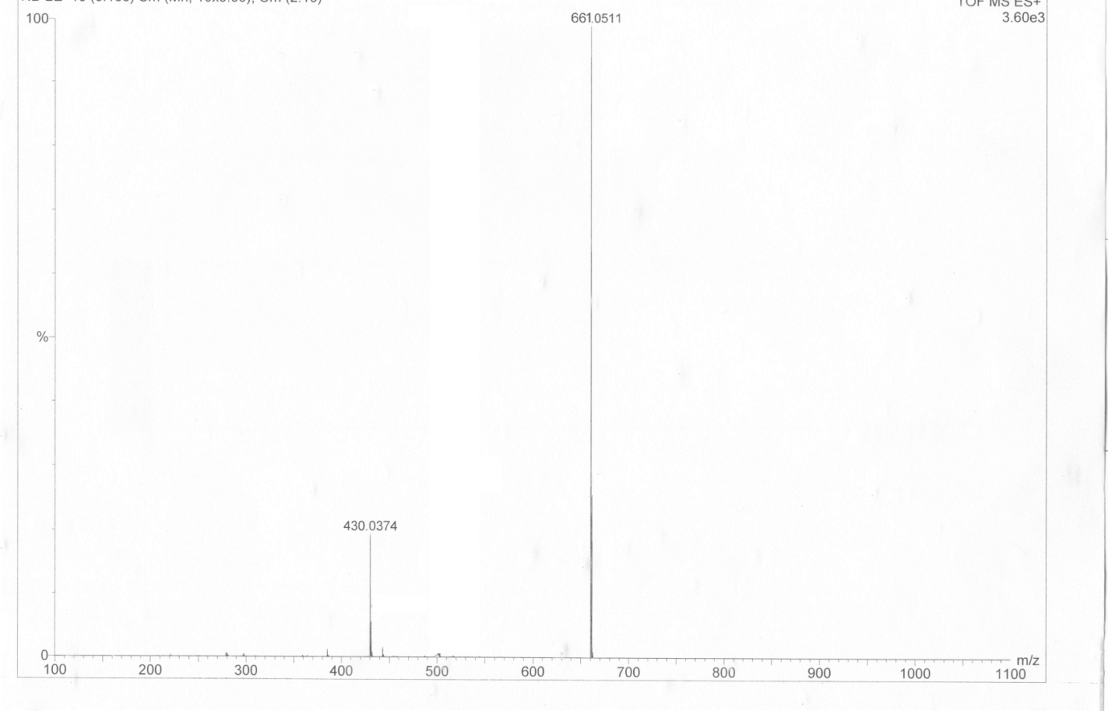
Fig. S4. Mass spectrum of complex 1. The ESI mass spectrum was carried out on an Aglient 6520 Q-Tof spectrophotometer in aqueous medium to confirm the integrity of complex 1, shows a molecular ion peak at m/Z 661.0511. Calculatedm/Z = 659.93.
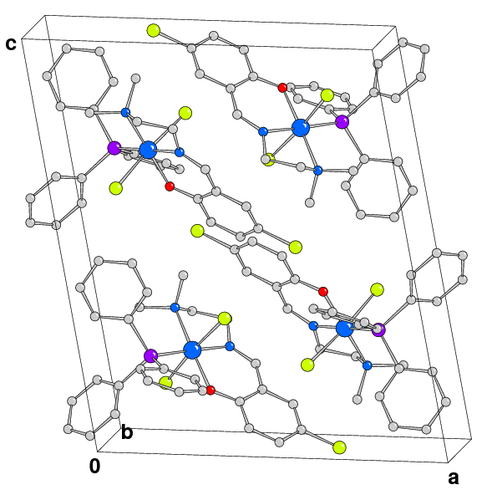

Fig. S5. Packing diagram of complex 1 viewed down crystallographic axis b (H atoms are omitted for clarity).

Fig. S6. Absorption spectrum of 3,5-DTBC without catalyst: no significant change was observed in the absorption peak of 3,5-DTBC after 12 successive hours.
Table T1. Crystallographic data and details of structural refinement for complex 1.

empirical formula | C₂₉H₂₉Cl₃N₂OPRu
formula weight (g mol⁻¹) | 659.93
temperature | 100(2)
crystal system | Monoclinic
space group | P 2₁/c
a (Å) | 14.5360(11)
b (Å) | 11.1820(9)
c (Å) | 17.3610(12)
β (deg) | 101.778(5)
V(Å³) | 2762.5(4)
Z | 4
d_{calc} (g cm⁻³) | 1.587
μ (mm⁻¹) | 0.892
F(000) | 1340
crystal size (mm³) | 0.35 x 0.20 x 0.12
θrange (deg) | 1.43-30.49
collected reflections | 43507
independent reflections | 8321
R(int) | 0.037
reflections [I> 2σ(I)] | 7747
parameters refined | 337
goodness-of-fit on F² | 1.202
final R indices[I>2σ(I)] | R1=0.0321, wR²= 0.0900
R indices (all data) | R1=0.0344, wR²= 0.0914
Δρ_{min} and Δρ_{max}(e Å⁻³) | -0.641, 0.732

Table T2. Selected bond lengths (Å) and angles (°) for complex 1.

Selected bond lengths (Å) |  | Selected bond angles (⁰)
Ru-Cl(1) | 2.3485(5) | Cl(2)-Ru-P(1) | 91.737(16)
Ru-Cl(2) | 2.3569(5) | O(1)-Ru-N(1) | 92.09(6)
Ru-O(1) | 1.9757(13) | O(1)-Ru-N(2) | 172.03(6)
Ru-N(1) | 2.0384(15) | O(1)-Ru-P(1) | 84.63(4)
Ru-N(2) | 2.2141(16) | N(1)-Ru-N(2) | 81.25(6)
Ru-P(1) | 2.4058(5) | N(1)-Ru-P(1) | 175.82(5)
 |  | N(2)-Ru-P(1) | 102.22(4)
 |  | Cl(1)-Ru-Cl(2) | 173.472(16)
 |  | Cl(1)-Ru-O(1) | 87.87(4)
 |  | Cl(1)-Ru-N(1) | 88.05(5)
 |  | Cl(1)-Ru-N(2) | 87.54(4)
 |  | Cl(1)-Ru-P(1) | 94.406(17)
 |  | Cl(2)-Ru-O(1) | 90.51(4)
 |  | Cl(2)-Ru-N(1) | 85.69(5)
 |  | Cl(2)-Ru-N(2) | 93.32(4)

Table T3. Complexes having lower Turn Over Number (T.O.N) in comparison with 1.

Complex | T.O.N (K_{cat}) (h⁻¹) | Reference
1. [RuCl(CO)(PPh₃)₂L₁] | 105 | 60
2. [RuCl(CO)(PPh₃)₂L₂] | 104 | 60
3. [Ru(PPh₃)Cl₂(L)] | 2.346 × 10³ | this paper

