Figures:

Scheme 1. Synthesis of the Schiff base ligand (HL) and complex 1.

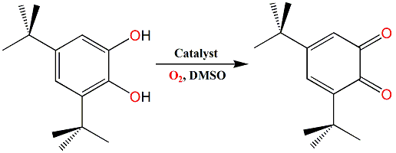
Scheme 2. Oxidation process of 3,5-DTBC to 3,5-DTBQ.

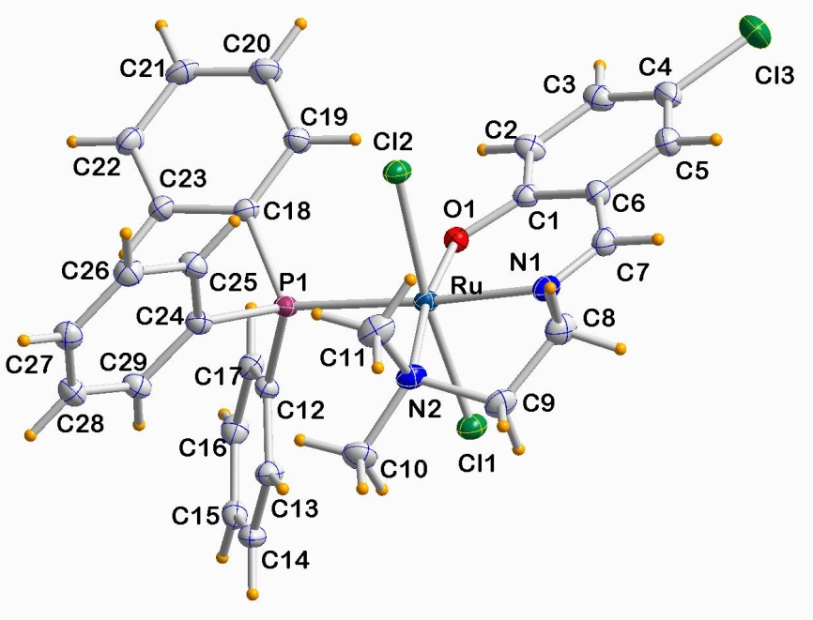

Fig. 1. ORTEP view of complex 1 with displacement ellipsoids drawn at 50% probability level.
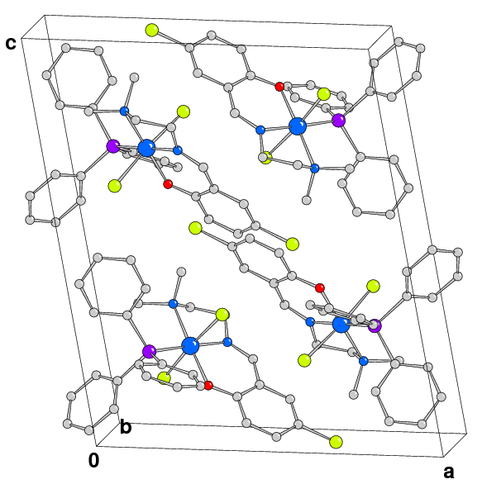

Fig. 2. Packing diagram of complex 1 viewed down crystallographic axis b (H atoms are omitted for clarity).

Fig. 3. MEP surface (isodensity = 0.002 a.u.) of compound 1. The values are selected points of the surface are indicated. Negative values are in red and positive in blue colour.
.

Fig. 4. Spin density plot of compound 1. Isodensity = 0.004 a.u.

Fig. 5. (a) Detail of the crystal packing of 1. (b,c) Theoretical models used to evaluate the interaction energies. Distances in Å. (d) NCI surface of the assembly present in compound 1. The gradient cut-off is s = 0.35 a.u., and the color scale is −0.04 <ρ< 0.04 a.u.

Fig. 6. Increase of the 3,5-DTBQ absorbance band at 393 nm after addition of 1 × 10⁻⁴ M DMSO solution of complex 1 to 100 equivalents of 3,5-DTBC at various intervals from 10 to 160 mins. Inset shows the UV-Vis spectrum of 1 in DMSO at room temperature.

Fig. 7. Plot of absorbance difference (ΔA) vs. time to determine the initial rate of the catalytic oxidation of 3,5-DTBC by complex 1 in DMSO.

Fig. 8. Change in absorption maxima at 393 nm with time after incremental addition of DMSO solution 1×10⁻⁴ M of complex 1 to 100 equivalents of 3,5-DTBC.

Fig. 9. Plot of initial rate versus substrate concentration [3,5-DTBC] for the catalytic oxidation reaction by complex 1. The inset shows the Lineweaver -Burk plot for 1.

