Supporting Information
CO₂ Improved the Synthesis of Benzimidazole with the Catalysis of a New 4-Amino-3-Hydroxybenzoic Acid Complex

Ruoxuan Gao, Yuanyuan Gao, Ning Zhu, Limin Han*
Chemical Engineering College, Inner Mongolia University of Technology, Hohhot, PR China

Table of Contents
1 NMR data of isolated benzimidazole products………………………………………….S2
2 FT-IR data of isolated benzimidazole products………………………………………….S3
3 UV-Vis data of isolated benzimidazole products………………………………………….S3
4 X-ray structure data of the complex……………………………………………………….S4
5 The molecular structure of the benzoate calcium………………………………………….S6
6 The molecular structure of the benzene-1,3,5-tricarboxylic acid calcium complex………………………………………………………………………………………….S6

- NMR data of isolated benzimidazole products
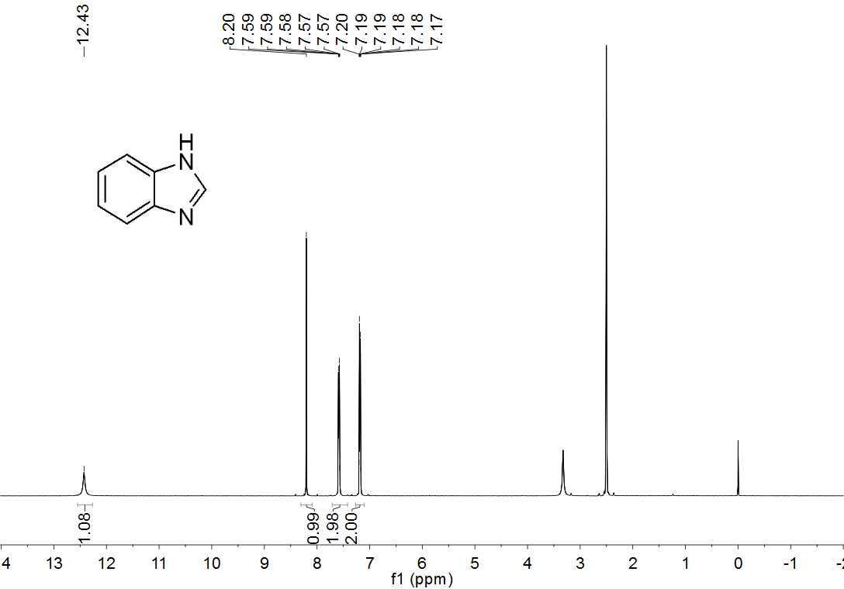
Figure S1. ¹H NMR of benzimidazole in DMSO-d6.
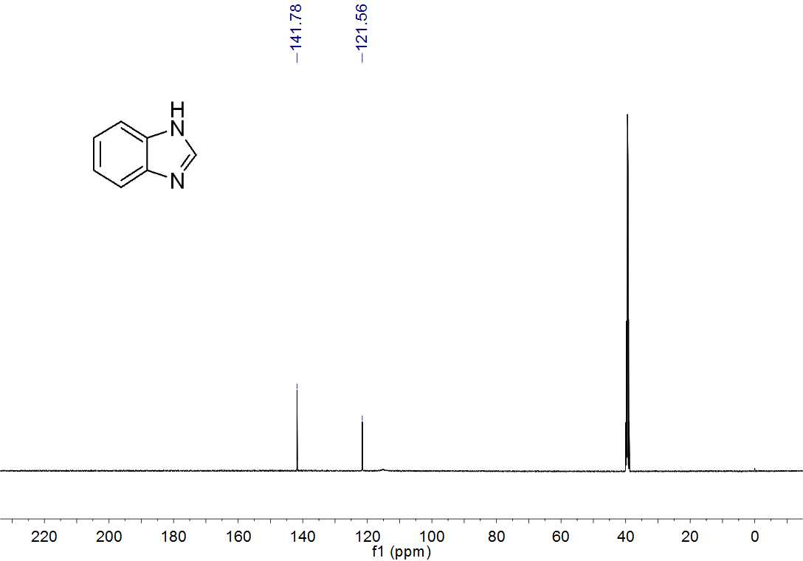
Figure S2. ¹³C NMR of benzimidazole in DMSO-d6.

- FT-IR data of isolated benzimidazole products
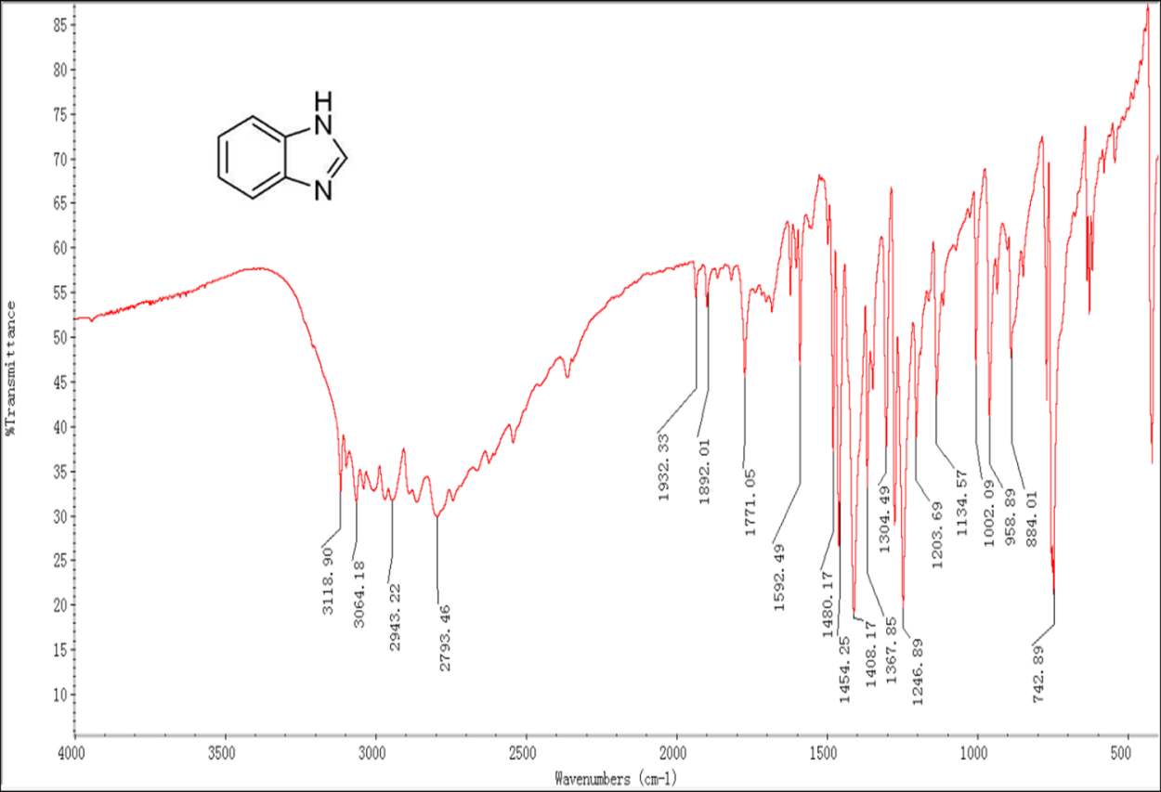
Figure S3. FT-IR spectrum of benzimidazole.
- UV-Vis data of isolated benzimidazole products
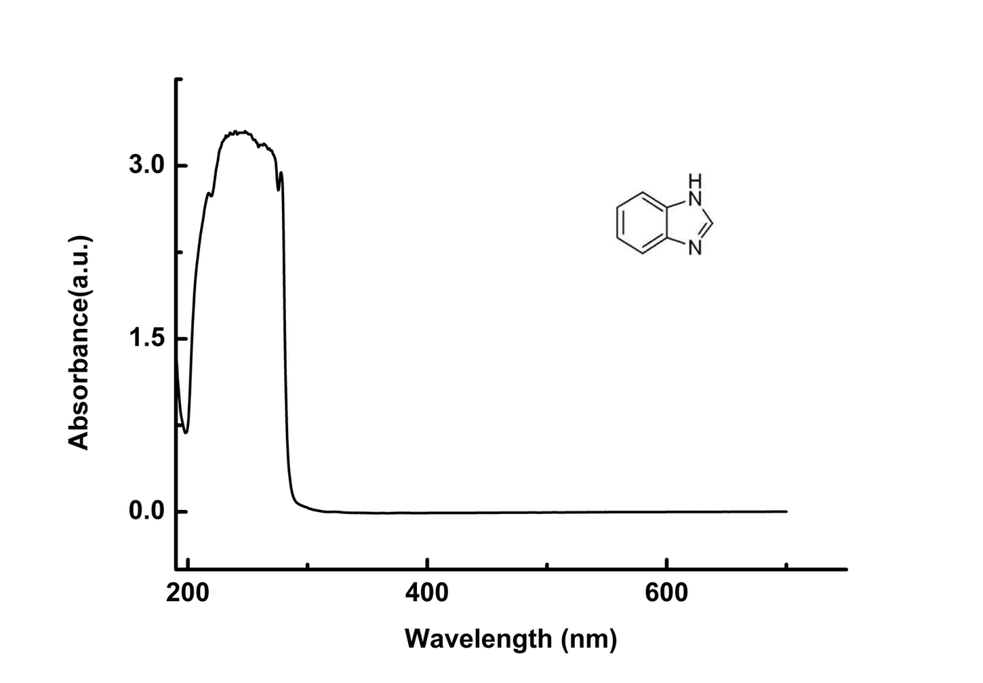
Figure S4. UV-Vis spectrum of benzimidazole in CH₃OH.

- X-ray structure data of the complex
Table S1 Crystal Data and Structure Refinement Parameters for complex (1)-(3)
complex
Empirical formula  Formula weight  Temperature (K)  Wavelength (Å)  Crystal system  Space group  a (Å)  b (Å)  c (Å)  α (°)  β (°)  γ (°)  Calculated density (Mg/m³)  µ(mm⁻¹)  F(000)  θ range (°)  Limiting indices  Reflections collected  Independent eflections  Completeness to  Data/restraints/Parameters  Goodness-of-fiton F²  Final Rindices[I > 2σ(I)]  R indices (all data) | C₁₆H₂₀CaN₂O₈  408.42  273(2)  0.71073  Monoclinic  C2/c  29.045(4)  8.2636(10)  7.7063(8)  90  96.624(6)  90  1.476  0.389  856  2.82 to 28.34  -38<=h<=38, -11<=k<=11, -10<=l<=10  40146  2292 [R(int) = 0.0279]  99.9%  2292 / 2 / 129  1.104  R₁=0.0516,wR₂=0.1510  R₁=0.0563, wR₂=0.1557
Symmetry operations used to generate equivalent atoms: (i)-x+1,y,-z+3/2 (ii)x,-y+1,z+1/2 (iii)-x+1,-y+1,-z+1 (iv)-x+1,-y+1,-z+2
Table S2 The selected bond lengths (Å), bond angles (º) of complex (1)
Bond | Dist. | Bond | Dist. | Bond | Dist.
Ca(1)-O(3)#1 | 2.3842(16) | N(1)-C(1) | 1.364(2) | C(3)-C(4) | 1.395(3)
Ca(1)-O(3) | 2.3842(16) | O(2)-C(5) | 1.252(3) | C(3)-H(3) | 0.9300
Ca(1)-O(1)#1 | 2.401(2) | O(3)-C(5) | 1.260(3) | C(4)-C(8) | 1.390(3)
Ca(1)-O(1) | 2.401(2) | O(1)-C(6) | 1.381(4) | C(4)-C(5) | 1.500(3)
Ca(1)-O(3)#2 | 2.5046(16) | O(1)-H(1) | 0.845(10) | C(6)-H(6A) | 0.9600
Ca(1)-O(3)#3 | 2.5047(16) | O(4)-C(2) | 1.419(3) | C(6)-H(6B) | 0.9600
Ca(1)-O(2)#3 | 2.5172(18) | O(4)-H(4) | 0.8200 | C(6)-H(6C) | 0.9600
Ca(1)-O(2)#2 | 2.5173(18) | C(1)-C(7) | 1.389(3) | C(7)-C(8) | 1.392(3)
N(1)-H(1A) | 0.8619 | C(1)-C(2) | 1.402(3) | C(7)-H(7) | 0.9300
N(1)-H(1B) | 0.8620 | C(2)-C(3) | 1.389(3) | C(8)-H(8) | 0.9300
Angle | (°) | Angle | (°) | Angle | (°)
O(3)#1-Ca(1)-O(3) | 155.90(10) | O(3)#3-Ca(1)-O(2)#3 | 51.84(5) | C(2)-C(3)-H(3) | 119.5
O(3)#1-Ca(1)-O(1)#1 | 78.90(8) | O(3)#1-Ca(1)-O(2)#2 | 123.59(6) | C(4)-C(3)-H(3) | 119.5
O(3)-Ca(1)-O(1)#1 | 84.39(7) | O(3)-Ca(1)-O(2)#2 | 75.37(6) | C(8)-C(4)-C(3) | 119.29(19)
O(3)#1-Ca(1)-O(1) | 84.39(7) | O(1)#1-Ca(1)-O(2)#2 | 96.87(9) | C(8)-C(4)-C(5) | 121.18(19)
O(3)-Ca(1)-O(1) | 78.90(8) | O(1)-Ca(1)-O(2)#2 | 151.77(6) | C(3)-C(4)-C(5) | 119.52(19)
O(1)#1-Ca(1)-O(1) | 91.93(14) | O(3)#2-Ca(1)-O(2)#2 | 51.84(5) | O(2)-C(5)-O(3) | 121.86(19)
O(3)#1-Ca(1)-O(3)#2 | 74.41(6) | O(3)#3-Ca(1)-O(2)#2 | 90.36(6) | O(2)-C(5)-C(4) | 119.27(19)
O(3)-Ca(1)-O(3)#2 | 116.50(7) | O(2)#3-Ca(1)-O(2)#2 | 87.92(9) | O(3)-C(5)-C(4) | 118.80(18)
O(1)#1-Ca(1)-O(3)#2 | 71.55(8) | C(1)-N(1)-H(1A) | 109.1 | O(1)-C(6)-H(6A) | 109.5
O(1)-Ca(1)-O(3)#2 | 155.10(6) | C(1)-N(1)-H(1B) | 110.0 | O(1)-C(6)-H(6B) | 109.5
O(3)#1-Ca(1)-O(3)#3 | 116.50(7) | H(1A)-N(1)-H(1B) | 109.1 | H(6A)-C(6)-H(6B) | 109.5
O(3)-Ca(1)-O(3)#3 | 74.41(6) | C(6)-O(1)-H(1) | 109.7(19) | O(1)-C(6)-H(6C) | 109.5
O(1)#1-Ca(1)-O(3)#3 | 155.11(6) | C(2)-O(4)-H(4) | 109.5 | H(6A)-C(6)-H(6C) | 109.5
O(1)-Ca(1)-O(3)#3 | 71.55(8) | N(1)-C(1)-C(7) | 123.2(2) | H(6B)-C(6)-H(6C) | 109.5
O(3)#2-Ca(1)-O(3)#3 | 129.71(9) | N(1)-C(1)-C(2) | 116.6(2) | C(1)-C(7)-C(8) | 120.1(2)
O(3)#1-Ca(1)-O(2)#3 | 75.37(6) | C(7)-C(1)-C(2) | 120.21(19) | C(1)-C(7)-H(7) | 120.0
O(3)-Ca(1)-O(2)#3 | 123.59(6) | C(3)-C(2)-C(1) | 118.9(2) | C(8)-C(7)-H(7) | 120.0
O(1)#1-Ca(1)-O(2)#3 | 151.77(6) | C(3)-C(2)-O(4) | 121.4(2) | C(4)-C(8)-C(7) | 120.2(2)
O(1)-Ca(1)-O(2)#3 | 96.87(9) | C(1)-C(2)-O(4) | 119.55(19) | C(4)-C(8)-H(8) | 119.9
O(3)#2-Ca(1)-O(2)#3 | 90.35(6) | C(2)-C(3)-C(4) | 121.1(2) | C(7)-C(8)-H(8) | 119.9

- The molecular structure of the benzoate calcium
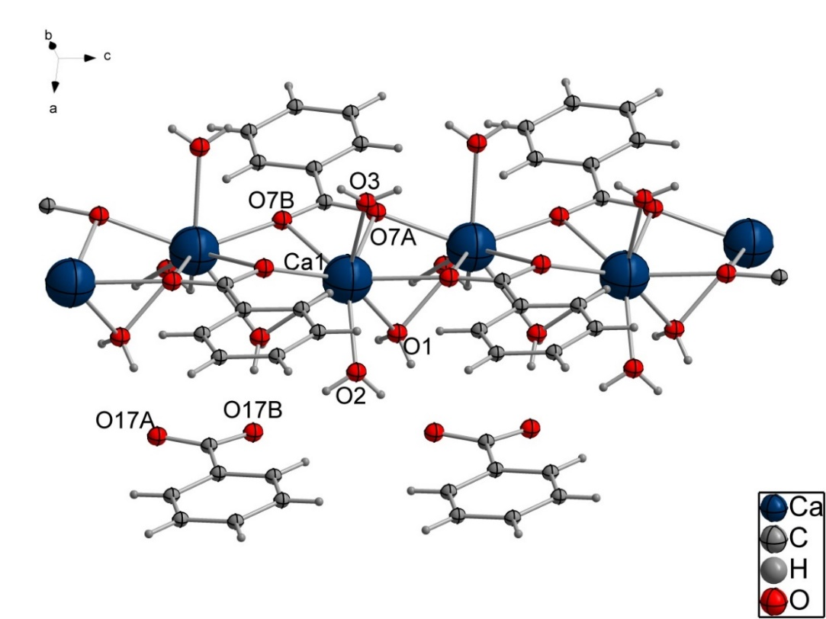
Figure S5. The molecular structure of the benzoate calcium.
- The molecular structure of the benzene-1,3,5-tricarboxylic acid calcium complex

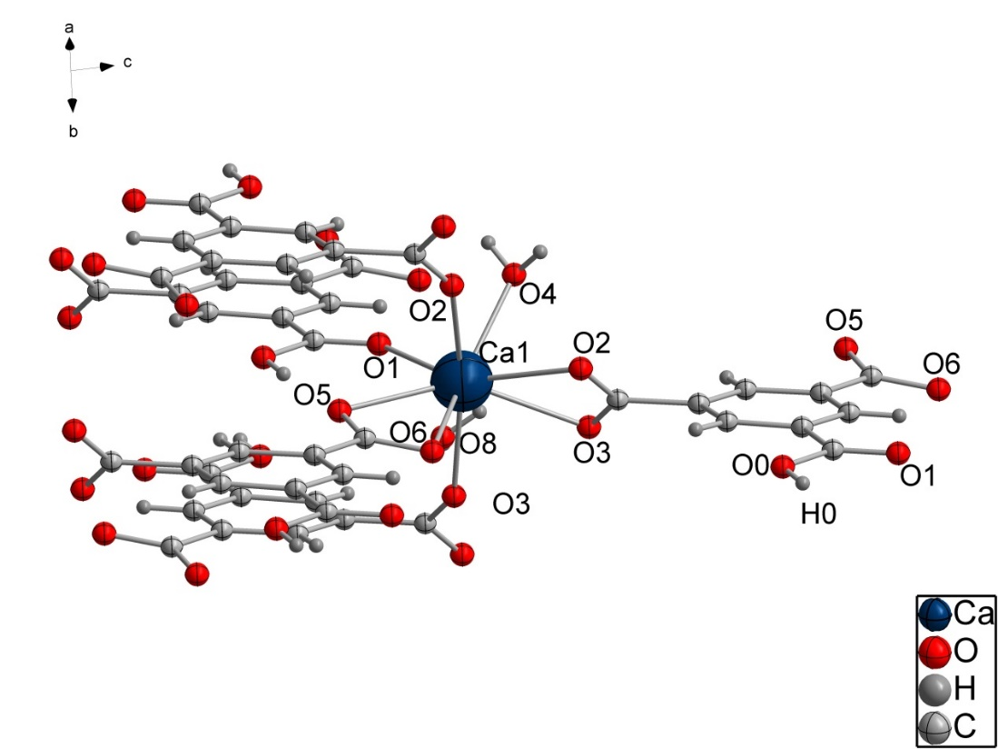
Figure S6. The molecular structure of the benzene-1,3,5-tricarboxylic acid calcium complex.

