Manganese(II) β-diketonate complexes with pyridin-4-one, 3-hydroxypyridin-2-one and 1-fluoropyridine ligands: molecular structures and hydrogen-bonded networks

Anže Čavić, Franc Perdih*

Faculty of Chemistry and Chemical Technology, University of Ljubljana, Večna pot 113, P. O. Box 537, SI-1000 Ljubljana, Slovenia

* Corresponding author: E-mail: franc.perdih@fkkt.uni-lj.si

Abstract
Manganese(II) bis(4,4,4-trifluoro-1-phenylbutane-1,3-dionate) complexes with pyridin-4-one (pyon), 3-hydroxypyridin-2-one (hpyon), 1-fluoropyridine (pyF) and methanol were prepared and the solid-state structures were determined by single-crystal X-ray analysis. The coordination of the metal center in all complexes is octahedral. In compounds [Mn(tfpb)₂(pyon)₂] (1) and [Mn(tfpb)₂(hpyon)₂] (2) extended hydrogen bonding is present facilitating the formation of three-dimensional supramolecular structure in 1 and layered structure in 2 through N–H···O hydrogen bonding enhanced by C–H···O interactions as well as C–F···π interactions. In [Mn(tfpb)₂(pyF)₂] (3) layered structure is formed through C–H···O and C–H···F interactions as well as π···π and C–F···π interactions. In [Mn(tfpb)₂(MeOH)₂] (4) a layered structure is formed through a combination of O–H···O and C–F···π interactions.

Keywords: β-Diketonates, Manganese, Pyridones, Crystal structure, π···π interaction

1. Introduction
Inorganic–organic hybrids, metal–organic coordination polymers and especially metal–organic frameworks (MOFs) are currently an extremely important topic and an active area of research because of their intriguing architectures and topologies,^{1,2} as well as due to their potential applications in catalysis, chemical separation processes, wastewater treatment, gas storage, magnetism and as sensors.³ Control of the solid-state arrangement of molecules within a crystal is the central challenge of materials chemistry. In metal–organic frameworks and coordination polymers, covalent bonding using bridging organic ligands for creation of robust polymeric structures is of prime importance. Different kinds of these materials have been designed with special attention dedicated to the geometry of the metal ions as well as flexibility, bridging potential and coordination preferences of different organic linkers.¹ On the other hand, in inorganic–organic hybrids non-covalent bonds adjust the dimensionality and enable new topologies to arise. Non-covalent forces, such as hydrogen bonding, C–H···π/F interactions, π···π stacking, and halogen bonding are much weaker compared to covalent bonds, however, their multiplicity makes them a powerful tool in the crystal engineering. Also, a great variety of non-covalent donors–acceptors and their numbers, their unique directionality and simple introduction into structures make them a particularly good choice for the construction of self-assemblies.
We report here the influence of pyridin-4-one (4-pyridone; pyon), 3-hydroxypyridin-2-one (hpyon), and 1-fluoropyridine (pyF) ligands on molecular and supramolecular structure in the cases of the [Mn(tfpb)₂(pyon)₂] (1), [Mn(tfpb)₂(hpyon)₂] (2), [Mn(tfpb)₂(pyF)₂] (3) complexes as well as the structure of [Mn(tfpb)₂(MeOH)₂] (4), where tfpb is the 4,4,4-trifluoro-1-phenylbutane-1,3-dionate (or 4,4,4-trifluoro-3-oxo-1-phenylbutan-1-olate) ligand. The tfpb ligand was selected because it is not symmetric and possesses phenyl and trifluoromethyl groups enabling also the formation of C−H···F, F···F and C−F···π interactions besides the π···π and C−H···π interactions.⁴ Pyridin-4-on and 3-hydroxypyridin-2-one were selected since the tautomeric equilibrium between the lactam and lactim forms enables different coordination modes and also due to their different hydrogen bond formation abilities when coordinated in lactam/lactim form. On the other hand, 1-fluoropyridine was selected in order to study the influence of an additional fluorine substituent on the formation of supramolecular aggregation in the absence of the competing strong hydrogen bond donors.

2. Experimental
2.1. Materials and Characterization
Reagents and chemicals were obtained as reagent grade from commercial sources and were used as purchased without any further purification. [Mn(tfpb)₂(H₂O)₂] was prepared according to the literature procedure.⁵ Infrared (IR) spectra (4000–600 cm⁻¹) of the samples were recorded using a Perkin–Elmer Spectrum 100, equipped with a Specac Golden Gate Diamond ATR as a solid sample support. Elemental (C, H, N) analyses were obtained using a Perkin–Elmer 2400 Series II CHNS/O Elemental Analyzer.

2.2. Synthesis
Synthesis of [Mn(tfpb)₂(pyon)₂] (1)
[Mn(tfpb)₂(H₂O)₂] (0.065 g, 0.125 mmol) was dissolved in acetone (8 mL) and then pyon (0.024 g, 0.250 mmol) was added. The reaction mixture was stirred for 15 min at ~50 °C and then allowed to stand at room temperature. Orange crystals suitable for X-ray analysis were obtained after slow evaporation of the solvent over few days. Yield: 0.036 g, 43%. Anal. Calcd. [Mn(tfpb)₂(pyon)₂] (C₃₀H₂₂F₆MnN₂O₆) (MW = 675.44): C 53.35, H 3.28, N 4.15; Found C 52.92, H 2.90, N 4.06. IR (ATR, cm^{–1}): 3244w, 3080w, 2663w, 1606s, 1597m, 1573m, 1527m, 1501m, 1471s, 1374m, 1315m, 1283s, 1248m, 1179s, 1127s, 1072m, 1025m, 996m, 939m, 831m, 763m, 717m, 697s, 635m.
Synthesis of [Mn(tfpb)₂(hpyon)₂] (2)
[Mn(tfpb)₂(H₂O)₂] (0.065 g, 0.125 mmol) was dissolved in warm ethanol (12 mL) and then hpyon (0.028 g, 0.250 mmol) was added. The reaction mixture was stirred for 15 min at ~60 °C and then allowed to stand at room temperature. Orange crystals suitable for X-ray analysis were obtained after slow evaporation of the solvent over few days. Yield: 0.058 g, 66%. Anal. Calcd. [Mn(tfpb)₂(hpyon)₂] (C₃₀H₂₂F₆MnN₂O₈) (MW = 707.44): C 50.91, H 3.14, N 3.96; Found C 50.72, H 3.14, N 3.90. IR (ATR, cm^{–1}): 3251w, 3120w, 2958w, 1605m, 1596m, 1570s, 1543m, 1529m, 1491m, 1471m, 1456m, 1419m, 1377m, 1284s, 1251m, 1187s, 1134s, 1058m, 937m, 885m, 761s, 717m, 699s, 635m.
Synthesis of [Mn(tfpb)₂(pyF)₂] (3)
[Mn(tfpb)₂(H₂O)₂] (0.065 g, 0.125 mmol) was dissolved in pyF (2 mL). The reaction mixture was stirred for 15 min at ~60 °C and then allowed to stand at room temperature. Orange crystals suitable for X-ray analysis were obtained after slow evaporation of the solvent over few days. Yield: 0.045 g, 53%. Anal. Calcd. [Mn(tfpb)₂(pyF)₂] (C₃₀H₂₀F₈MnN₂O₄) (MW = 679.42): C 53.02, H 2.97, N 4.12; Found C 52.55, H 2.81, N 3.99. IR (ATR, cm^{–1}): 3381br, 1609s, 1597m, 1574s, 1532m, 1490m, 1458m, 1318m, 1281s, 1248m, 1182s, 1129s, 1096m, 1075m, 1025w, 941w, 798w, 768m, 718m, 699s, 635s.
Synthesis of [Mn(tfpb)₂(H₂O)₂] (4)
[Mn(tfpb)₂(H₂O)₂] (0.065 g, 0.125 mmol) was dissolved in warm methanol (12 mL) and then pyon (0.024 g, 0.250 mmol) was added. The reaction mixture was stirred for 15 min at ~60 °C and then allowed to stand at room temperature. Orange crystals suitable for X-ray analysis were obtained after slow evaporation of the solvent over few days. Yield: 0.040 g, 58%. Anal. Calcd. [Mn(tfpb)₂(H₂O)₂] (C₂₂H₂₀F₆MnO₆) (MW = 549.32): C 48.10, H 3.67; Found C 47.94, H 3.38. IR (ATR, cm^{–1}): 2538br, 2421br, 1928w, 1876w, 1644m, 1602m, 1574m, 1350s, 1321m, 1259m, 1228m, 1191s, 1134m, 995s, 934s, 821s, 811s, 748w, 635s.

2.3. X-ray Crystallography
Single-crystal X-ray diffraction data were collected at room temperature (1, 2, 4) or 150 K (3) on a Nonius Kappa CCD diffractometer or an Agilent Technologies SuperNova Dual diffractometer with an Atlas detector using monochromated Mo-K_{α} radiation (λ = 0.71073 Å). The data were processed using DENZO⁶ or CrysAlis Pro.⁷ The structures were solved by direct methods implemented in SHELXS⁸ and SIR-97⁹ and refined by a full-matrix least-squares procedure based on F² with SHELXL.⁸ All the non-hydrogen atoms were refined anisotropically. All H atoms were initially located in a difference Fourier maps. The hydrogen atoms on carbon atoms were treated as riding atoms in geometrically idealized positions. Hydrogen atoms attached to nitrogen and oxygen atoms were refined fixing the bond lengths and isotropic temperature factors as U_{iso}(H) = kU_{eq}(N,O), where k = 1.5 for OH groups, and 1.2 for NH groups. In 1 and 4 the CF₃ groups is disordered over two positions in 0.76(2):0.24(2) and 0.71(3):0.29(3) (in 1) and 0.66(3):0.34(3) (in 4) ratio. In 1 a possible pseudo-translation was detected, however, no additional space group could be found using the Platon program. The crystallographic data are listed in Table 1.

Table 1. Crystallographic and refinement data for 1–4.
Parameter | [Mn(tfpb)₂(pyon)₂] (1) | [Mn(tfpb)₂(hpyon)₂]  (2) | [Mn(tfpb)₂(pyF)₂]  (3) | [Mn(tfpb)₂(MeOH)₂] (4)
Formula | C₃₀H₂₂F₆MnN₂O₆ | C₃₀H₂₂F₆MnN₂O₈ | C₃₀H₂₀F₈MnN₂O₄ | C₂₂H₂₀F₆MnO₆
M_{r} | 675.43 | 707.43 | 679.42 | 549.32
T (K) | 293(2) | 293(2) | 150(2) | 293(2)
Crystal system | Monoclinic | Triclinic | Monoclinic | Triclinic
Space group | P2₁/n | P–1 | P2₁/c | P–1
a (Å) | 16.1805(3) | 7.3146(2) | 11.8720(3) | 10.4921(4)
b (Å) | 10.5318(2) | 9.9367(2) | 8.8105(2) | 10.5763(4)
c (Å) | 17.8217(3) | 10.7440(2) | 14.5507(4) | 12.4197(5)
α(°) | 90 | 108.132(2) | 90 | 70.893(2)
β (°) | 91.558(2) | 100.589(2) | 108.628(3) | 66.685(2)
γ (°) | 90 | 91.833(2) | 90 | 82.624(2)
Volume (Å³) | 3035.87(10) | 726.16(3) | 1442.24(7) | 1195.92(8)
Z | 4 | 1 | 2 | 2
D_{calc} (Mg/m³) | 1.478 | 1.618 | 1.565 | 1.525
μ (mm^{–1}) | 0.517 | 0.549 | 0.549 | 0.634
F(000) | 1372.0 | 359.0 | 686.0 | 558.0
Crystal size (mm) | 0.5 × 0.2 × 0.1 | 0.6 × 0.6 × 0.5 | 0.2 × 0.2 × 0.05 | 0.25 × 0.1 × 0.03
Reflections collected | 28841 | 5959 | 13789 | 9395
Data/restraints/parameters | 6949/2/471 | 3298/2/220 | 3311/0/205 | 5457/2/353
R_{int} | 0.0322 | 0.0133 | 0.0333 | 0.0291
R, wR₂ [I>2σ(I)]ª | 0.0416, 0.1040 | 0.0328, 0.0882 | 0.0399, 0.0961 | 0.0459, 0.1073
R, wR₂ (all data)^{b} | 0.0650, 0.1162 | 0.0352, 0.0904 | 0.0529, 0.1037 | 0.0812, 0.1264
GOF, S^{c} | 1.051 | 1.074 | 1.044 | 1.012
Max/min Δρ (e/ Å³) | 0.21/–0.21 | 0.31/–0.34 | 0.83/–0.27 | 0.32/–0.27
ª R = ∑||F_{o}| – |F_{c}||/∑|F_{o}|. ^{b} wR₂ = {∑[w(F_{o}² – F_{c}²)²]/∑[w(F_{o}²)²]}^{1/2}. ^{c} S = {∑[(F_{o}² – F_{c}²)²]/(n/p)}^{1/2} where n is the number of reflections and p is the total number of parameters refined.

3. Results and Discussion
Initial attempts to prepare 1 using methanol as a solvent gave 4 as the sole product. Thus, in the subsequent synthesis other solvents were used instead. Compounds 1 and 2 were obtained by the reaction of [Mn(tfpb)₂(H₂O)₂] and the corresponding heteroaromatic ligands pyridine-4-on (pyon) and 3-hydroxypyridine-2-on (hpyon) in 1:2 molar ratio in warm ethanol or acetone, respectively. Compound 3 was prepared by the reaction of [Mn(tfpb)₂(H₂O)₂] in warm 1-fluoropyridine (pyF) acting as a solvent and as a ligand. Crystals suitable for X-ray analyses were obtained over few days after slow evaporation of the solvent at room temperature. The IR spectrum of 1 shows two bands at 3244 and 3080 cm^{–1} and the spectrum of 2 two bands at 3251 and 3120 cm^{–1} that suggest the involvement of the O–H and N–H groups of pyridone ligands in strong hydrogen bonding. The spectrum of 4 shows one broad band at 3381 cm^{–1} that suggests the involvement of the O–H groups of methanol ligands in strong hydrogen bonding. In all four compounds, there are bands in the frequency range 1609–1527 cm^{–1} characteristic for the ν(C=O) and ν(C=C) stretching of the tfpb ligand.
Compound 1 crystallizes in the monoclinic P2₁/c space group. Selected bond distances and angles of 1 are summarized in Table 2. The asymmetric unit contains two crystallographically independent half-molecules (A and B), with both independent Mn^{II} ions sitting on the inversion centers. Both manganese(II) ions are octahedrally coordinated (Fig. 1). In the equatorial plane, both metal centers are surrounded by four oxygen atoms of two chelating tfpb ligands in a trans arrangement, with Mn–O distances 2.1365(14) and 2.1233(13) Å (for A) and 2.1245(13) and 2.1467(13) Å (for B). The Mn(tfpb)₂ fragments deviate from planarity, the angle between the mean plane formed by the equatorial MnO₄ core and that of the tfpb chelate C₃O₂ moiety being 14.48(6) and 16.47(6)°. In both complexes the axial positions are occupied by two pyon ligands bonded to the metal center through the O atom, with Mn1–O3 distance of 2.2358(12) Å and Mn1–O3–C23 angle of 131.10(11)° and Mn2–O6 distance of 2.2035(12) Å and Mn2–O6–C28 angle of 126.58(11)°. These distances are similar as in the three known Mn complexes with tfpb.¹⁰ The pyon ligands are inclined toward the tfpb moiety. The angle between the plane of the pyon ring and the plane of the equatorial MnO₄ core deviates from 90° being 78.60(5)° (for A) and as small as 44.51(5)° (for B). Superposition of both complexes shows that pyon ligands are oriented in the opposite direction (Fig. 2) with pyon ring in complex B inclined toward the phenyl ring of the tfpb ligand. Complex A is stabilized by an intramolecular C22–H22···O2^{i} interaction between pyon and tfpb ligand (Table 3) and C1–F3a/b···π interactions between –CF₃ group and pyon ring with F···Cg3 distances of 3.769(10) and 3.82(4) Å and C–F···Cg3 angles of 130.4(5) and 128(3)°, respectively, where Cg3 is N1/C21–C25 ring centroid (Fig. 3). Complex B is stabilized by an intramolecular C27–H27···O4^{ii} interaction between pyon and tfpb ligand. The NH groups of the pyon ligands of both independent complexes act as a hydrogen-bond donor interacting with the tfpb carbonyl oxygens of the adjacent complexes, facilitating the formation of hydrogen-bonded tree-dimensional supramolecular structure (Fig. 3). Complex A interacts with two complexes B through N1–H1···O6^{iii} bonding enabling the formation of ABAB chain. Complex B interacts with two complexes A through N2–H2···O3 bonding enhanced by C26–H26···O1^{i} interaction with R²₂(7) ring motif¹¹ enabling the formation of ABAB chain in the second dimension. Furthermore, complex B interacts with two adjacent complexes B through the centrosymmetric C29–H29···F6a^{iv} interactions with R²₂(18) ring motif forming the BBB chain in the third dimension (Table 3). Supramolecular structure is further supported also by C11–F4a···π interaction between –CF₃ group of complex B and pyon ring of complex A with F···Cg3 distance of 3.806(11) Å and C–F···Cg3 angle of 139.1(5)°, where Cg3 is N1/C21–C25 ring centroid.

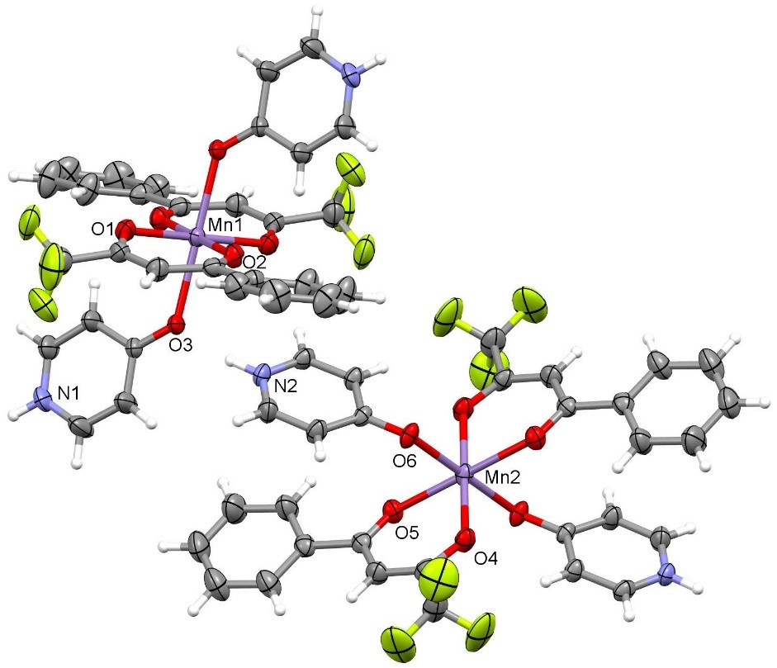
Figure 1. Crystallographically independent molecules in 1. Disorder on CF₃ groups has been omitted for clarity. Displacement ellipsoids are drawn at the 30% probability level.

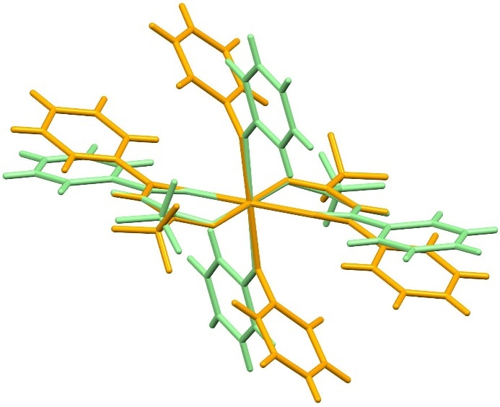
Figure 2. Superposition of crystallographically independent molecules A (green) and B (orange) in 1. Disorder on CF₃ groups has been omitted for clarity.

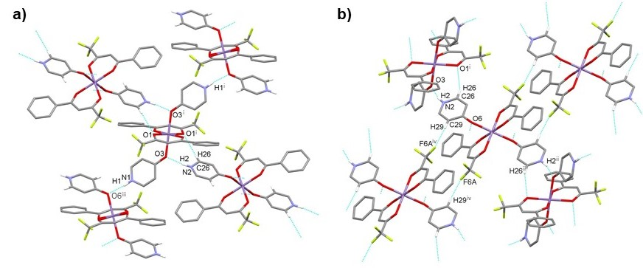
Figure 3. Three-dimensional supramolecular structure in 1 is achieved by hydrogen bonding around a) molecule A and b) molecule B through a series of N1–H1···O6^{iii}, N2–H2···O3, C26–H26···O1^{i} and C29–H29···F6a^{iv} interactions. Blue dashed lines indicate hydrogen bonds. For the sake of clarity, intramolecular interactions, disorder on CF₃ groups and H atoms not involved in the motif shown have been omitted. For symmetry codes see Table 3.

Table 2. Selected bond distances and angles for 1.
Distance | (Å)
Mn1–O1 | 2.1365(14) | Mn2–O4 | 2.1245(13)
Mn1–O2 | 2.1233(13) | Mn2–O5 | 2.1467(13)
Mn1–O3 | 2.2358(12) | Mn2–O6 | 2.2035(12)
Angle | (°)
O1–Mn1–O2 | 84.10(5) | O4–Mn2–O5 | 85.38(5)
O1–Mn1–O2^{i} | 95.90(5) | O4–Mn2–O5^{ii} | 94.62(5)
O1–Mn1–O3 | 85.43(5) | O4–Mn2–O6 | 85.82(5)
O1–Mn1–O3^{i} | 94.57(5) | O4–Mn2–O6^{ii} | 94.18(5)
O2–Mn1–O3 | 86.91(5) | O5–Mn2–O6 | 85.20(5)
O2–Mn1–O3^{i} | 93.09(5) | O5–Mn2–O6^{ii} | 94.80(5)
Symmetry codes: (i) 1 – x, –y, –z; (ii) 1 – x, –y, 1 – z.

Table 3. Hydrogen bonds for 1–4 [Å and °]
D–H···A | d(D–H) | d(H···A) | d(D···A) | <(DHA)
1
N1–H1···O6^{iii} | 0.872(17) | 1.854(17) | 2.720(2) | 172(3)
N2–H2···O3 | 0.888(16) | 1.859(17) | 2.723(2) | 164(2)
C22–H22···O2^{i} | 0.93 | 2.36 | 3.119(3) | 139.1
C26–H26···O1^{i} | 0.93 | 2.48 | 3.322(2) | 151.1
C27–H27···O4^{ii} | 0.93 | 2.47 | 3.206(2) | 136.6
C29–H29···F6a^{iv} | 0.93 | 2.47 | 3.394(7) | 175.7
2
O4–H4···O1^{i} | 0.814(17) | 1.952(18) | 2.7495(16) | 166(3)
O4–H4···O3 | 0.814(17) | 2.50(3) | 2.8375(14) | 106(2)
N1–H1···O3^{ii} | 0.882(14) | 2.009(15) | 2.8829(15) | 170.2(18)
C13–H13···O4^{iii} | 0.93 | 2.58 | 3.4770(19) | 162.9
C15–H15···O2^{iv} | 0.93 | 2.42 | 3.2428(19) | 147.3
3
C13–H13···F2^{ii} | 0.95 | 2.42 | 3.287(3) | 151.6
C14–H14···O1^{iii} | 0.95 | 2.58 | 3.493(3) | 161.3
4
O5–H5···O1^{i} | 0.822(10) | 1.966(14) | 2.772(2) | 167(4)
O6–H6···O3^{ii} | 0.813(10) | 2.001(13) | 2.801(2) | 168(4)
Symmetry codes for 1: (i) 1 – x, –y, –z; (ii) 1 – x, –y, 1 – z; (iii) –½ + x, ½ – y, –½ + z; (iv) 1 – x, 1 – y, 1 – z; for 2: (i) 2 – x, 2 – y, –z; (ii) 1 – x, 2 – y, –z; (iii) 2 – x, 2 – y, 1 – z; (iv) –1 + x, y, z; for 3: (ii) –x, 1 – y, –z; (iii) x, ½ – y, ½ + z; for 4: (i) 2 – x, 1 – y, 1 – z; (ii) 2 – x, –y, 1 – z.

Compound 2 crystallizes in the triclinic P–1 space group. Selected bond distances and angles are summarized in Table 4. The asymmetric unit contains one half of the complex, with the Mn^{II} ion sitting on the inversion center. Octahedrally coordinated manganese(II) ion is surrounded in the equatorial plane by four oxygen atoms of two chelating tfpb ligands in a trans arrangement, with Mn–O distances 2.1132(10) and 2.1218(9) Å (Fig. 4). The Mn(tfpb)₂ fragment deviates from planarity, the angle between the mean plane formed by the equatorial MnO₄ core and that of the tfpb chelate C₃O₂ moiety being 15.91(4)°. The axial positions are occupied by two hpyon ligands bonded to the metal center through the O3 atom, with Mn1–O3 distance of 2.2768(10) Å and Mn1–O3–C11 angle of 128.19(9)°. The hpyon ligand is inclined toward the tfpb moiety, with the angle between the plane of the hpyon ring and that of the equatorial MnO₄ core being 43.25(6)°. The hydroxy group of the hpyon ligand is involved in intramolecular bifurcated hydrogen bonding with the tfpb ligand through O4–H4···O1^{i} interaction and with the carbonyl O atom of the hpyon ligand through O4–H4···O3 interaction (Table 3). The NH group of the hpyon ligand acts as a hydrogen bond donor, facilitating the formation of a centrosymmetric hydrogen-bonded motif via N1–H1···O3^{ii} interactions with the ligated carbonyl O3 atom enhanced by C15–H15···O2^{iv} interactions with the graph-set motifs R²₂(8) and R²₂(7), respectively (Fig. 5 and Table 3). This interaction is further supported also by C1–F3···π interaction between CF₃ group and the hpyon ring with d(F3···Cg3) = 3.2278(17) Å and <(C1–F3···Cg3) = 135.64(11)°, where Cg3 is N1/C11–C15 ring centroid. Consequently, a chain is formed along the a axis. The chains are further connected into layers along the ac plane via centrosymmetric C13–H13···O4^{iii} hydrogen bonding between hpyon CH moiety and the hydroxy group of the adjacent molecule (Fig. 5). There are no significant π···π interactions.
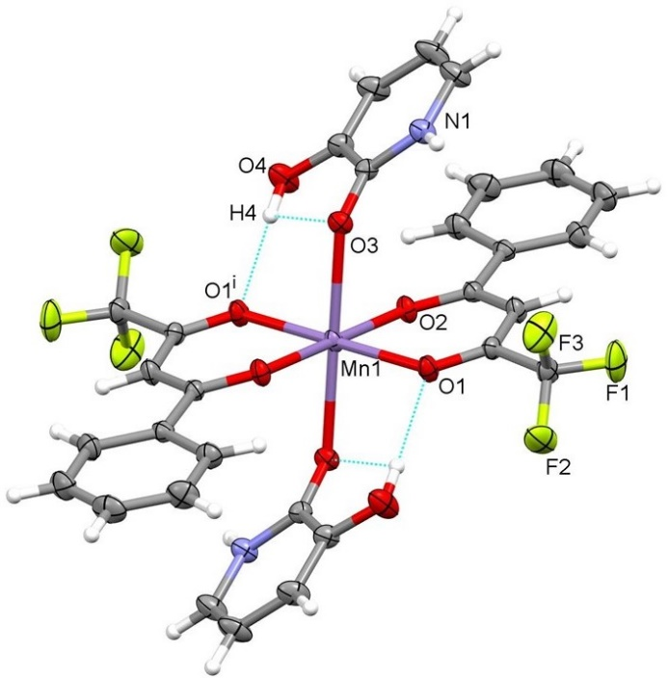
Figure 4. Structure of 2. Displacement ellipsoids are drawn at the 30% probability level. Intramolecular hydrogen bonding is presented by dashed blue lines.

Table 4. Selected bond distances and angles for 2.
Distance | (Å)
Mn1–O1 | 2.1132(10) | Mn1–O2 | 2.1218(9)
Mn1–O3 | 2.2768(10)
Angle | (°)
O1–Mn1–O2 | 84.24(4) | O1–Mn1–O2^{i} | 95.76(4)
O1–Mn1–O3 | 92.67(4) | O1–Mn1–O3^{i} | 87.33(4)
O2–Mn1–O3 | 84.40(4) | O2–Mn1–O3^{i} | 95.60(4)
Symmetry code: (i) 2 – x, 2 – y, –z.

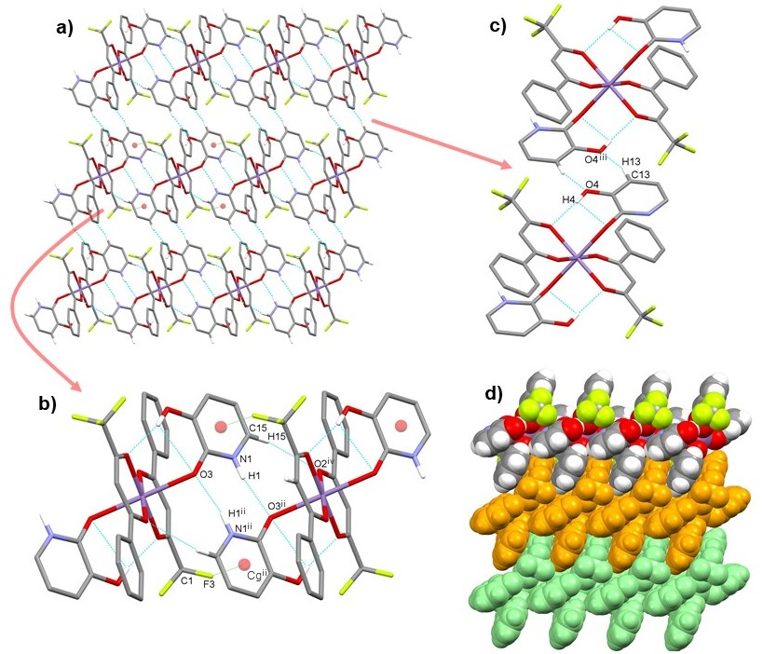
Figure 5. a) Hydrogen-bonded layer along the ac plane in 2 is formed by b) centrosymmetric N1–H1···O3^{ii}, C15–H15···O2^{iv} and C1–F3···Cg3^{ii} interactions and c) C13–H13···O4^{iii} interactions; d) packing of layers (arbitrary colours). Blue and green dashed lines indicate hydrogen bonds and C–F···π interactions, respectively. For the sake of clarity, H atoms not involved in the motif shown have been omitted. For symmetry codes see Table 3.

In the solid state, pyridin-4-one and 3-hydroxypyridin-2-one are in the lactam form.^{12,13} Also in metal complexes the lactam form of both predominates. As revealed by a search of the Cambridge Structural Database (CSD, Version 5.41, plus updates),¹⁴ pyridin-4-one possesses in metal complexes a lactam form bonded via O atom in 26 entries¹⁵ as observed also in complex 1. However, 9 entries with the lactim form (as 4-hydroxypyridine) bonded via N atom were found in the CSD with Re, Ir, Pt, and Ag¹⁶ as well as Cu and Fe.¹⁷ This observation can be explained by the Pearson HSAB (hard–soft acid–base) concept¹⁸ since soft acids, such as Re, Ir, Pt, and Ag, show a preference for bonding via pyridine N atom (an intermediate base) as opposed to the –OH group (hard base). Additionally, 3 entries with the lactim form bonded via OH group were also found with Nd, Tb, Dy.¹⁹ In metal complexes with 3-hydroxypyridin-2-on lactam form was found in 9 entries with monodentate ligation via O atom^{20,21} as observed also in complex 2 while 3 entries were found with O,O'-chelating ligation.^{21,22} However, no entries were found with lactim form (as 2,3-dihydroxypyridine) bonded to the metal center. For comparison, metal complexes with pyridine-2-one were more often investigated than complexes with pyridin-4-one and 3-hydroxypyridin-2-one and variety of coordination modes can be observed.^{21,23,24}
Compound 3 crystallizes in the monoclinic P2₁/c space group. Selected bond distances and angles of 3 are summarized in Table 5. Initial attempts to collect XRD data at room temperature failed due to slow crystal decomposition when exposed to air. Most probably 1-fluoropyridine moiety leaves the complex and crystal lattice. Similar loss of pyridine bonded in zinc picolinato complexes has been previously observed.^{61,62} The asymmetric unit contains one half of the complex, with the Mn^{II} ion sitting on the inversion center. The manganese(II) atom in compound 3 is octahedrally coordinated (Fig. 6). In the equatorial plane, Mn^{II} ion surrounded by the four oxygen atoms of two chelating tfpb ligands in a trans arrangement, with Mn–O distances 2.1415(14) and 2.1337(14) Å. The Mn(tfpb)₂ fragment deviates from planarity, the angle between the mean plane formed by the MnO₄ core and that of the tfpb chelate C₃O₂ moiety being 18.00(7)°. The axial positions are occupied by two pyF ligands bonded to the metal center through the N1 atom, with Mn1–N1 distance of 2.3425(17) Å. PyF ligand plays the main role in the formation of layered structure due to the absence of the competing strong hydrogen bond donors. As a hydrogen bond donor is involved in C13–H13···O1^{iii} and in centrosymmetric C14–H14···F2^{ii} interactions with carbonyl oxygen atom and fluorine atom of –CF₃ group of tfpb ligands of the adjacent complexes, respectively (Fig. 7 and Table 3). Thus, each complex is involved in eight hydrogen bonds with six adjacent complexes forming layered structure. 2D structure is supported by centrosymmetric π···π interactions between adjacent pyF rings with centroid-to-centroid distance of 3.9403(14) Å, perpendicular distance between rings of 3.2624(10) Å and ring slippage of 2.210 Å. Layered structure is further supported also by C–F···π interactions between pyF fluorine atom and pyF aromatic ring with d(F4···Cg3) = 3.6714(19) Å and <(C11–F4···Cg3) = 75.63(13)° as well as between –CF₃ group and benzene ring of tfpb ligand with d(F2···Cg4) = 3.715(2) Å and <(C1–F2···Cg4) = 126.72(15)°, where Cg3 and Cg4 are N1/C11–C15 and C5–C10 ring centroids, respectively (Fig. 7).

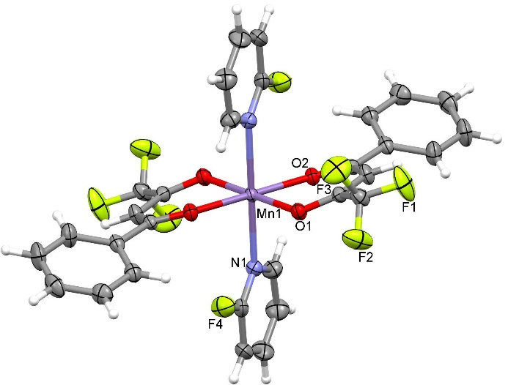
Figure 6. Structure of 3. Displacement ellipsoids are drawn at the 50% probability level.

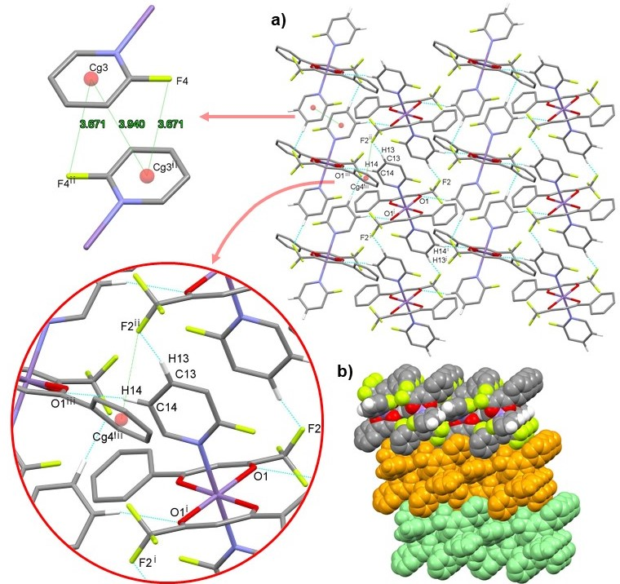
Figure 7. a) Hydrogen-bonded layer along the ac plane in 3 is formed by C13–H13···O1^{iii} and centrosymmetric C14–H14···F2^{ii} interactions as well as centrosymmetric π···π interactions and C–F···π interactions; b) packing of layers (arbitrary colors). Blue and green dashed lines indicate hydrogen bonds and π···π and C–F···π interactions, respectively. For the sake of clarity, H atoms not involved in the motif shown have been omitted. For symmetry codes see Table 3.

Table 5. Selected bond distances and angles for 3.
Distance | (Å)
Mn1–N1 | 2.3425(17) | Mn1–O1 | 2.1415(14)
Mn1–O2 | 2.1337(14)
Angle | (°)
N1–Mn1–O1 | 94.36(6) | N1–Mn1–O1^{i} | 85.64(6)
N1–Mn1–O2 | 88.31(6) | N1–Mn1–O2^{i} | 91.69(6)
O1–Mn1–O2 | 85.12(5) | O1–Mn1–O2^{i} | 94.88(5)
Symmetry code: (i) –x, –y, –z.

The inclination of pyon and hpyon ligands toward the tfpb moiety in 1 and 2 is best compared with the compound 3 since the ligation of pyF via N atom cannot enable much deviation in comparison to the pyon and hpyon ligands bonded via O atom. Superposition of both crystallographically independent molecules in 1 as well as molecules 2 and 3 is presented in Fig. 8. Pyon and hpyon ligands are inclined toward the tfpb moiety by 78.60(5)° (molecule A in 1), 44.51(5)° (molecule B in 1) and 43.25(6)° (2) representing a substantial deviation from 90°. However, in the case of molecule B in 1 and molecule 2 also the phenyl rings of tfpb are evidently inclined toward pyridone moieties.

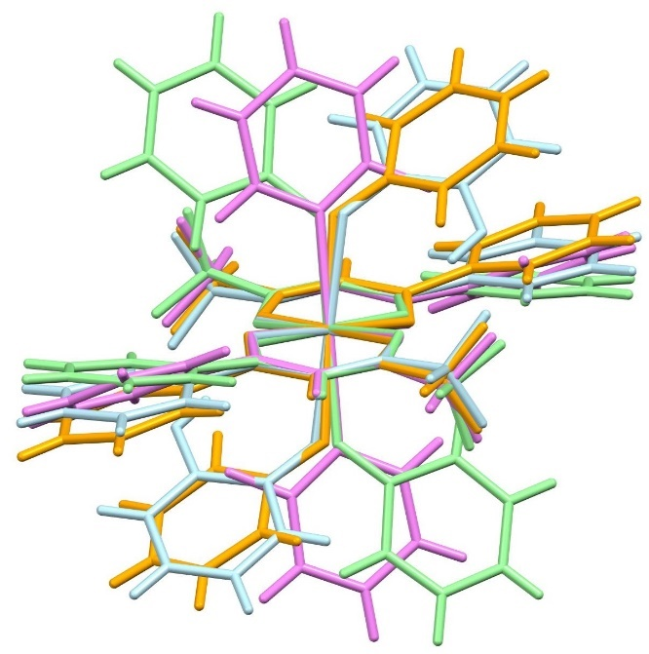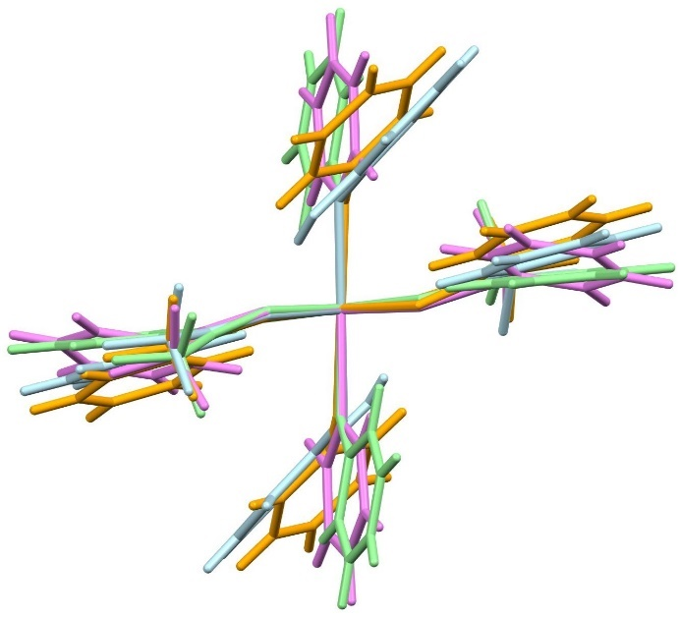
Figure 8. Two views on superposition of crystallographically independent molecules A (green) and B (orange) in 1, 2 (blue) and 3 (violet). Disorder on CF₃ groups has been omitted for clarity.

Compound 4 crystallizes in the triclinic P–1 space group. Selected bond distances and angles of 4 are summarized in Table 6. The asymmetric unit contains one complex molecule with cis-octahedral arrangement of methanol ligands on the manganese(II) central ion (Fig. 9). Two methanol ligands are bonded to the metal center with Mn1–O5 and Mn1–O6 distances of 2.1714(18) and 2.173(2) Å and O5–Mn1–O6 angle of 88.54(8)°. The Mn1–O bond lengths with four oxygen atoms of two chelating tfpb ligands are asymmetric with the longer ones of 2.1821(18) and 2.1751(17) Å at the trifluoromethyl substituent and the shorter one of 2.1266(18) and 2.1315(18) Å at the phenyl substituent. The Mn(tfpb) fragments deviate from planarity, the tfpb ligands being inclined by 25.94(8) and 23.51(8)°. Each methanol ligand is involved in a centrosymmetric hydrogen-bonded motif via O5–H5···O1^{i} and O6–H6···O3^{ii} interactions with the carbonyl oxygen atom at the trifluoromethyl substituent of the adjacent complex. Both centrosymmetric hydrogen bonds have the graph-set motif R²₂(8) (Fig. 10 and Table 3) and enable the formation of a hydrogen-bonded chain along the b axis. Centrosymmetric C1–F3···π interaction between CF₃ group and the benzene ring of tfpb ligand of the adjacent molecule is present with d(F3···Cg3) = 3.661(4) Å and <(C1–F3···Cg3) = 121.9(3)°, where Cg3 is C5–C10 ring centroid, connecting chains into layer along the bc plane (Fig. 10). There are no significant π···π interactions.

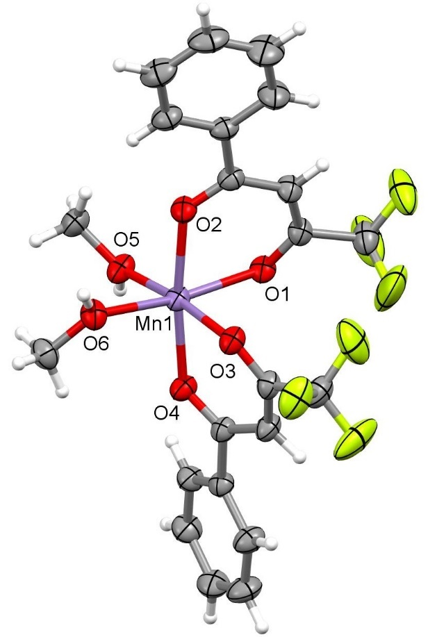
Figure 9. Structure of 4. Disorder on both CF₃ groups has been omitted for clarity. Displacement ellipsoids are drawn at the 30% probability level.

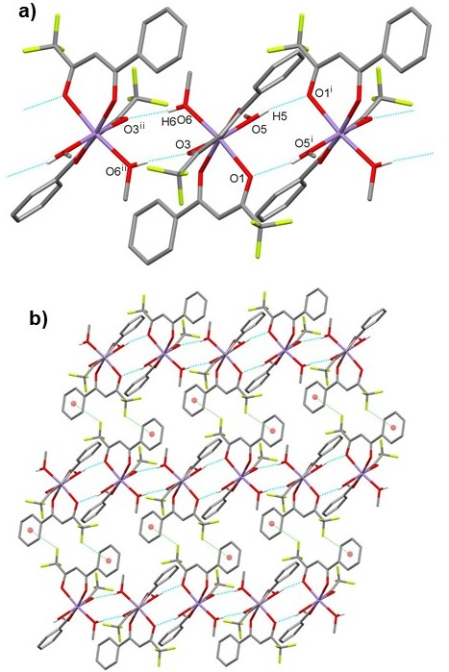
Figure 10. a) Hydrogen-bonded chain along b axis in 4 formed by centrosymmetric O5–H5···O1^{i} and O6–H6···O3^{ii} interactions; b) chains are linked into a layer through C–F···π interactions. Blue and green dashed lines indicate hydrogen bonds and C–F···π interactions, respectively. For the sake of clarity, H atoms not involved in the motif shown have been omitted. For symmetry codes see Table 3.

Table 6. Selected bond distances and angles for 4.
Distance | (Å)
Mn1–O1 | 2.1821(18) | Mn1–O2 | 2.1266(18)
Mn1–O3 | 2.1751(17) | Mn1–O4 | 2.1315(18)
Mn1–O5 | 2.1714(18) | Mn1–O6 | 2.173(2)
Angle | (°)
O1–Mn1–O2 | 82.45(7) | O1–Mn1–O3 | 89.13(7)
O1–Mn1–O4 | 91.80(7) | O1–Mn1–O5 | 92.79(7)
O1–Mn1–O6 | 171.30(7) | O2–Mn1–O3 | 92.40(7)
O2–Mn1–O4 | 172.98(7) | O2–Mn1–O5 | 94.84(8)
O2–Mn1–O6 | 88.87(7) | O3–Mn1–O4 | 83.46(7)
O3–Mn1–O5 | 172.69(7) | O3–Mn1–O6 | 90.62(7)
O4–Mn1–O5 | 89.43(7) | O4–Mn1–O6 | 96.81(8)
O5–Mn1–O6 | 88.54(8)

4. Conclusion
We have prepared and structurally characterized four manganese(II) bis(4,4,4-trifluoro-1-phenylbutane-1,3-dionate) complexes with pyon, hpyon, pyF and methanol. In all prepared compounds the coordination of the metal center is octahedral. Complexes 1–3 possess trans arrangement of ligands while in complex 4 the arrangement is cis. In 1–3 the Mn(tfpb)₂ fragments deviate from planarity, the angles between the mean planes formed by the equatorial MnO₄ cores and that of the tfpb chelate C₃O₂ moieties being in the range 14.48(6)–18.00(7)°. In 1 and 2 the axial positions are occupied by two pyon and hpyon ligands, respectively, bonded to the metal center through the O atom. Pyon and hpyon ligands are inclined toward the tfpb moiety by 78.60(5)° (molecule A in 1), 44.51(5)° (molecule B in 1) and 43.25(6)° (2) representing a substantial deviation from 90°. Extended hydrogen bonding is present in 1 and 2 facilitating the formation of three-dimensional supramolecular structure in 1 and layered structure in 2 through N–H···O hydrogen bonding enhanced by C–H···O interactions as well as C–F···π interactions. In 3 pyF ligand plays the main role in the formation of crystal aggregation due to the absence of the competing strong hydrogen bond donors. Layered structure is formed through C–H···O and C–H···F interactions as well as π···π and C–F···π interactions. In 4 a layered structure is formed through a combination of O–H···O and C–F···π interactions.

Supplementary Material
CCDC 2024368–2024371 (1–4) contain the supplementary crystallographic data for this paper. These data can be obtained free of charge from The Cambridge Crystallographic Data Centre via www.ccdc.cam.ac.uk/data_request/cif.

Acknowledgment
Financial support from the Slovenian Research Agency through the grant P1–0230–0175 is gratefully acknowledged. We thank EN–FIST Centre of Excellence, Dunajska cesta 156, 1000 Ljubljana, Slovenia for using the Supernova diffractometer.

References
1. C. B. Aakeröy, N. R. Champness, C. Janiak, CrystEngComm 2010, 12, 22–43.
2. M. G. Goesten, F. Kapteijn, J. Gascon, CrystEngComm 2013, 15, 9249–9257.
3. (a) J. Liu, L. Chen, H. Cui, J. Zhang, L. Zhang, C.-Y. Su, Chem. Soc. Rev. 2014, 43, 6011–6061; (b) A. Dhakshinamoorthy, H. Garcia, Chem. Soc. Rev. 2014, 43, 5750–5765; (c) A. Herbst, C. Janiak, CrystEngComm 2017, 19, 4092–4117; (d) M. D. Allendorf, V. Stavila, CrystEngComm 2014, 17, 229–246; (e) T. Stolar, K. Užarević, CrystEngComm 2020, 22, 4511–4525; (f) A. Dhakshinamoorthy, A. M. Asiri, H. García, Angew. Chem. Int. Ed. 2016, 55, 5414–5445; (g) Z. Ajoyan, P. Marino, A. J. Howarth, CrystEngComm 2018, 20, 5899–5912; (h) H. Li, K. Wang, Y. Sun, C. T. Lollar, J. Li, H.-C. Zhou, Mater. Today 2018, 21, 108–121; (i) A. J. Howarth, Y. Liu, J. T. Hupp, O. K. Farha, CrystEngComm 2015, 17, 7245–7253; (j) P. A. Kobielska, A. J. Howarth, O. K. Farha, S. Nayak, Coord. Chem. Rev. 2018, 358, 92–107; (k) M. M. Sadiq, K. Suzuki, M. R. Hill, Chem. Commun., 2018, 54, 2825–2837.
4. (a) T. Koleša-Dobravc, A. Meden, F. Perdih, Acta Chim. Slov. 2015, 62, 261–271; (b) F. Perdih, Acta Crystallogr. 2012, C68, m64–m68; (c) F. Perdih, J. Coord. Chem. 2012, 65, 1580–1591; (d) F. Perdih, Struct. Chem. 2014, 25, 809–819; (e) F. Perdih, Monatshefte Chem. 2012, 143, 1011–1017; (f) T. Koleša-Dobravc, A. Meden, F. Perdih, New J. Chem. 2015, 39, 4265–4277; (g) T. Koleša-Dobravc, A. Meden, F. Perdih, Monatshefte Chem. 2014, 145, 1263–1275; (h) L. Bejaoui, J. Rohlíček, V. Eigner, A. Ismail, M. E. Bour, R. B. Hassen, Acta Chim. Slov. 2019, 66, 603–613; (i) R. Vafazadeh, Z. Mansouri, A. C. Willis, Acta Chim. Slov. 2020, 67, 516–521; (j) R. Vafazadeh, A. Kazemi-nasab, A. C. Willis, Acta Chim. Slov. 2019, 66, 1010–1018.
5. (a) E. W. Berg, J. T. Truemper, J. Phys. Chem. 1960, 64, 487–490; (b) G. S. Shephard, D. A. Thornton, J. Mol. Struct. 1976, 34, 83–91; (c) M. A. Al-Anber, H. Daoud, Orient. J. Chem. 2013, 29, 905–909.
6. Z. Otwinowski, W. Minor, Methods Enzymol. 1997, 276, 307–326.
7. Rigaku Oxford Diffraction, CrysAlis PRO, Rigaku Corporation, Tokyo, Japan, 2015.
8. G. M. Sheldrick, Acta Crystallogr. 2015, C71, 3–8.
9. A. Altomare, M. C. Burla, M. Camalli, G. L. Cascarano, C. Giacovazzo, A. Guagliardi, A. G. G. Moliterni, G. Polidori, R. Spagna, J. Appl. Crystallogr. 1999, 32, 115–119.
10. (a) M. H. Dickman, Acta Crystallogr. 1999, C55, IUC9900146. DOI:10.1107/S0108270199098558; (b) D. A. Souza, A. S. Florencio, J. W. de M. Carneiro, S. S. Soriano, C. B. Pinheiro, M. A. Novak, M. G. F. Vaz, Inorg. Chim. Acta 2008, 361, 4024–4030; (c) C. Benelli, A. Caneschi, D. Gatteschi, M. C. Melandri, P. Rey, Inorg. Chim. Acta 1990, 172, 137–139.
11. J. Bernstein, R. E. Davis, L. Shimoni, N.-L. Chang, Angew. Chem. Int. Ed. Engl. 1995, 34, 1555–1573.
12. A. Tyl, M. Nowak, J. Kusz, Acta Crystallogr. 2008, C64, o661–o664.
13. V. M. Deflon, K. E. Bessler, M. Kretschmar, U. Abram, Z. Anorg. Allg. Chem. 2000, 626, 1545–1549.
14. C. R. Groom, I. J. Bruno, M. P. Lightfoot, S. C. Ward, Acta Crystallogr. 2016, B72, 171–179.
15. See, for example: (a) K. D. Hughey, N. C. Harms, K. R. O’Neal, A. J. Clune, J. C. Monroe, A. L. Blockmon, C. P. Landee, Z. Liu, M. Ozerov, J. L. Musfeldt, Inorg. Chem. 2020, 59, 2127–2135; (b) R. B. P. Pesci, E. J. de Souza, E. Niquet, O. R. Nascimento, R. B. Viana, V. M. Deflon, J. Mol. Struct. 2019, 1194, 104–111; (c) F. A. Mautner, C. Berger, C. Gspan, B. Sudy, R. C. Fischer, S. S. Massoud, Polyhedron 2017, 130, 136–144; (d) L.-F. Wang, J.-Z. Qiu, Y.-C. Chen, J.-L. Liu, Q.-W. Li, J.-H. Jia, M.-L. Tong, Inorg. Chem. Front. 2017, 4, 1311–1318; (e) B. Zhou, D. Yan, Angew. Chem. Int. Ed. 2019, 58, 15128–15135.
16. See, for example: (a) T. R. Hayes, P. A. Lyon, C. L. Barnes, S. Trabue, P. D. Benny, Inorg. Chem. 2015, 54, 1528–1534; (b) D. Septiadi, A. Aliprandi, M. Mauro, L. D. Cola, RSC Adv. 2014, 4, 25709–25718.
17. (a) N. Uzun, A. T. Çolak, F. M. Emen, G. Kismali, O. Meral, M. Alpay, G. K. Çılgı, E. Şahin, J. Coord. Chem. 2015, 68, 949–967; (b) H. M. Kieler, M. J. Bierman, I. A. Guzei, P. J. Liska, R. W. McGaff, Chem. Commun. 2006, 3326–3328.
18. (a) R. G. Pearson, J. Am. Chem. Soc. 1963, 85, 3533–3539; (b) R. G. Parr, R. G. Pearson, J. Am. Chem. Soc. 1983, 105, 7512–7516.
19. (a) K. Kumar, S. Chorazy, K. Nakabayashi, H. Sato, B. Sieklucka, S. Ohkoshi, J. Mater. Chem. C 2018, 6, 8372–8384; (b) K. Kumar, D. Abe, K. Komori-Orisaku, O. Stefańczyk, K. Nakabayashi, J. R. Shakirova, S. P. Tunik, S. Ohkoshi, RSC Adv. 2019, 9, 23444–23449; (c) S. Chorazy, J. Wang, S. Ohkoshi, Chem. Commun. 2016, 52, 10795–10798.
20. F. Perdih, Acta Crystallogr. 2017, C73, 960–967.
21. S. Petriček, Polyhedron 2019, 167, 11–25.
22. A. A. Dar, S. Sen, S. K. Gupta, G. N. Patwari, R. Murugavel, Inorg. Chem. 2015, 54, 9458–9469.
23. J. M. Rawson, R. E. P. Winpenny, Coord. Chem. Rev. 1995, 139, 313–374.
24. S. Petriček, Molecules, 2020, 25, 846.
25. (a) T. Koleša-Dobravc, K. Maejima, Y. Yoshikawa, A. Meden, H. Yasui, F. Perdih, New J Chem 2017, 41, 735–746; (b) T. Koleša-Dobravc, K. Maejima, Y. Yoshikawa, A. Meden, H. Yasui, F. Perdih, New J. Chem. 2018, 42, 3619–3632.

Povzetek
Sintetizirali smo manganove(II) bis(4,4,4-trifluoro-1-fenilbutan-1,3-dionato) komplekse s piridin-4-onom (pyon), 3-hidroksipiridin-2-onom (hpyon), 1-fluoropiridinom (pyF) in metanolom ter določili strukture z monokristalno rentgensko difrakcijo. V vseh kompleksih je koordinacija kovinskega centra oktaedrična. Pri spojinah [Mn(tfpb)₂(pyon)₂] (1) in [Mn(tfpb)₂(hpyon)₂] (2) so prisotne številne vodikove vezi, ki omogočajo tvorbo tridimenzionalne supramolekularne strukture v 1 in plastovite strukture v 2 z N–H···O vodikovimi vezmi ojačane z C–H···O interakcijami ter tudi C–F···π interakcije. Pri [Mn(tfpb)₂(pyF)₂] (3) je prisotna plastovita struktura z C–H···O in C–H···F interakcijami ter tudi z π···π in C–F···π interakcijami. Pri [Mn(tfpb)₂(MeOH)₂] (4) je prisotna plastovita struktura s kombinacijo O–H···O in C–F···π interakcij.

