Benzothiazolylhydrazone-based turn-on fluorescent probe
for detecting Cu²⁺: S-donor as a Cu²⁺-induced
fluorescence quenching inhibitor

Qiao Li¹ and Enju Wang^{1,}*

¹ Key Laboratory of Tropical Medicinal Resource Chemistry of Ministry of Education, Key Laboratory of Tropical Medicinal Plant Chemistry of Hainan Province, College of Chemistry & Chemical Engineering, Hainan Normal University, Haikou, 571158, China

* Corresponding author: Email: enjuwang@163.com

Abstract
The fluorescent turn-on detection of metal ions is highly desirable for public health and environmental security. Herein, we report a rationally designed fluorescent probe (1) for the detection of Cu²⁺ synthesized by integrating 2-hydrazinylbenzothiazole with 3-acetyl-7-hydroxycoumarin. The probe alone is non-fluorescent due to the isomerization of C=N in the excited state. The addition of Cu²⁺ can cause a delayed fluorescence enhancement. A comparative study of 1 and its analogues indicated that the turn-on fluorescence response was thanks to the sulfur atom coordinating to Cu²⁺. The response delay of 1 in sensing Cu²⁺ was ascribed to the gradual transition from N-coordination to S-coordination (N and S in thiazole moiety). The proposed new function of S-donor would provide a new approach for the turn-on fluorescence sensation of Cu²⁺.
Keywords: Fluorescent probe; Coumarin; Benzothiazole; Cupric ion; S-donor
- Introduction
Copper is an essential trace element important for the function of enzymes. It plays a pivotal role in cell physiology as a catalytic cofactor in the cellular redox reactions. Nevertheless, excess copper is implicated in various neurodegenerative disorders, such as Wilson's and Alzheimer's diseases.¹ In addition, Copper is an environmental pollutant having highly toxic effect on aquatic organisms, especially on algaes.² Thus, the convenient and fast methods for the detection of trace amounts of cupric ion are significant not only for public health, but also for environmental security. Fluorescent probes are a powerful tool for the detection of metal ions, especially for biomonitoring owing to their non-invasiveness, visualization and real-time.
The turn-on fluorescence probes allow detection with less false positives, providing a better opportunity to accurately monitor the target object than the turn-off fluorescence probe. However, it is difficult to achieve turn-on fluorescent sensing of cupric ion due to its paramagnetic nature which leads to vigorous fluorescence quenching.^{3–8} During the course of our ongoing efforts to develop fluorescent probes for mental ions⁹⁻¹¹, we have firstly found that some probes containing S-donor show turn on fluorescence responses to Cu²⁺, and so the S-donor may play an important role in protecting from Cu²⁺-induced fluorescence quenching.¹²⁻¹⁴ Following this idea, a rationally designed fluorescent probe containing S-donor (1) was synthesized by incorporating 3-acetyl-7-hydroxycoumarin and 2-hydrazinylbenzo[d]thiazole for the fluorescence turn-on detection of cupric ion in the present work (Scheme 1). The binding mode between 1 and Cu²⁺ was determined by ESI-MS. The function of S-donor in protecting from fluorescence quenching was affirmed by control experiments using the analogues of 1 (2a and 2b in Scheme 1). Besides preventing from fluorescence quenching, S-donor should be helpful for the improvement of Cu²⁺-selective binding.¹⁵
Scheme 1. Synthesis of 1 and its analogues 2a and 2b.

- Experimental Section
All chemicals were obtained from commercial suppliers and used without further purification. Analytical grade acetonitrile and deionised water were used as solvents for all spectral measurements. The metal nitrates were used for the fluorescence sensing of metal ions. ¹H NMR and ¹³C NMR spectra were recorded on a Bruker Av400 NMR spectrometer. ESI-MS spectra were performed on a Bruker Esquire HCT mass spectrometer. Fluorescence spectra were taken on a Hitachi F-7000 fluorescence spectrometer. The synthetic routes of 1, 2a and 2b were illustrated in Scheme 1. ¹H NMR, ¹³C NMR and ESI-MS spectra of them were provided in the supporting information (Fig. S1-9).
3-(1-(2-(benzo[d]thiazol-2-yl)hydrazono)ethyl)-7-hydroxycoumarin (1):
3-acetyl-7-hydroxycoumarin (408 mg, 2.0 mmol), 2-hydrazinylbenzo[d]thiazole (330 mg, 2.0 mmol) and a catalytic amount of formic acid were added into 20 mL absolute ethanol and then refluxed for 3 h. A yellow solid precipitated out. The precipitate was collected by filtration and washed several times with ethanol to afford 1 (550 mg, 78 %). ¹H NMR (400 MHz, DMSO-d₆) δ 11.73 (s, 1H), 10.75 (s, 1H), 8.11 (s, 1H), 7.70 (s, 1H), 6.69 (d, 1H, J = 8.4 Hz), 7.35 (s, 1H), 7.29 (t, 1H, J = 7.6 Hz), 7.09 (t, 1H, J = 7.6 Hz), 6.84 (d, 1H, J = 8.4 Hz). 6.78 (s, 1H), 2.31 (s, 1H). ¹³C NMR (100 MHz, DMSO-d₆) δ 168.4, 162.3, 160.1, 155.9, 141.6, 131.0, 126.5, 122.3, 122.2, 122.0, 114.1, 111.9, 102.3, 17.1. ESI-MS m/z calculated for [M+H]⁺ 352.08, found 351.9; calculated for [M-H]⁻ 350.06, found 349.8.
3-(1-(2-(pyridin-2-yl)hydrazono)ethyl)-7-diethylaminocoumarin (2a)
2a was synthesized according to the reported procedure¹⁶. Yield, 82%. ESI-MS m/z calculated for [M+H]⁺ 351.18, found 351.0; calculated for [M-H]⁻ 349.17, found 348.9.
3-(1-(3-methylbenzo[d]thiazol-2(3H)-ylidene)hydrazono)ethyl)-7-diethylaminocoumarin (2b):
3-acetyl-7-diethylaminocoumarin (519 mg, 2.0 mmol), 3-methyl-2-benzothiazolinone hydrazone hydrochloride (431 mg, 2.0 mmol) and triethylamine (274 μL, 2.0 mmol) were added into 20 mL absolute ethanol and then refluxed for 3 h. The resulting precipitation was collected by filtration to afford 2b (603 mg, 72 %). ¹H NMR (400 MHz, DMSO-d₆) δ 8.06 (s, 1H), 7.56–7.60 (m, 2H), 7.27–7.36 (m, 2H), 7.08 (t, 1H, J = 7.2 Hz), 6.74 (d, 1H, J = 7.2 Hz), 6.57 (s, 1H), 3.59 (s, 3H), 3.46 (q, 4H, J = 6.8 Hz), 2.51 (s, 1H). 1.14 (t, 6H, J = 6.8 Hz). ¹³C NMR (100 MHz, DMSO-d₆) δ 166.0, 160.6, 156.9, 156.4, 151.4, 141.9, 141.4, 130.7, 126.9, 124.1, 122.8, 122.1, 119.0, 110.4, 109.9, 108.3, 96.6, 44.6, 31.4, 17.4, 12.8. ESI-MS m/z calculated for [M+H]⁺ 421.17, found 421.0.
- Results and Discussion
3.1. Fluorescence Sensing of Cu²⁺
With the compound 1 in hand, its fluorescence responds to various metal ions, including Ba²⁺, Ca²⁺, Mg²⁺, K⁺, Al³⁺, Na⁺, Zn²⁺, Ag⁺, Fe³⁺, Mn²⁺, Cd²⁺, Ni²⁺, Pb²⁺, Co²⁺, Cr³⁺ and Hg²⁺, were examined. As shown in Fig. 1, Probe 1 alone in CH₃CN/H₂O (1/1) is nearly non-fluorescent due to the C=N isomerization which is a radiationless decay process of the excited states.^{16,17} Upon adding Cu²⁺ and then allowing to stand for some time, a fluorescence enhancement at 460 nm was observed when excited at 390 nm, which gives bright cyan luminescence. Ca²⁺ can also cause a little fluorescence enhancement at about 460 nm, but which is too negligible to cause visible fluorescence. At the same time, Hg²⁺, Fe³⁺ and Al³⁺ can induce distinct fluorescence quenching of 1. Other ions did not cause obvious fluorescence changes.
It is uncommon that the probe can not give an immediate fluorescence turn-on response to Cu²⁺. For the determination of the optimum incubation time, time-dependent fluorescence spectra were carried out (Fig. 2). It was found that the rate of the fluorescence enhancement correlates with temperature. The fluorescence intensities of the mixture of 1 and Cu²⁺ reached a plateau in 100 minutes at 30 °C. When the temperature is 40 °C, the fluorescence emission maximum was found in 40 minutes.

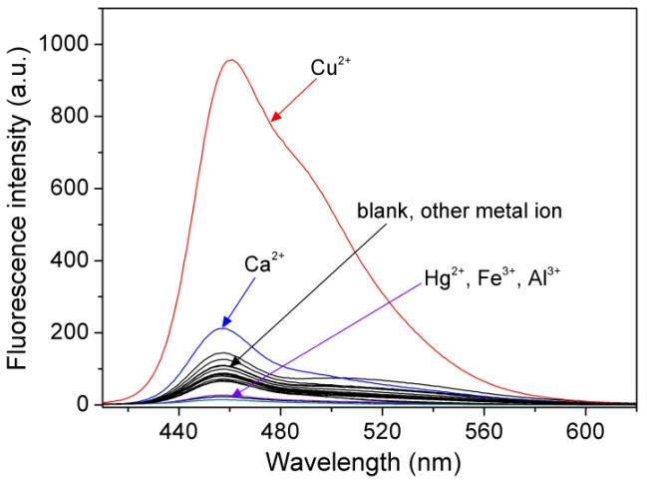
Figure 1. Fluorescence spectra of 1 (10 μM) in CH₃CN/H₂O (1/1) upon adding different metal ions (10 μM) and then allowing to stand for 2 hour at 30 °C when excited at 390 nm.

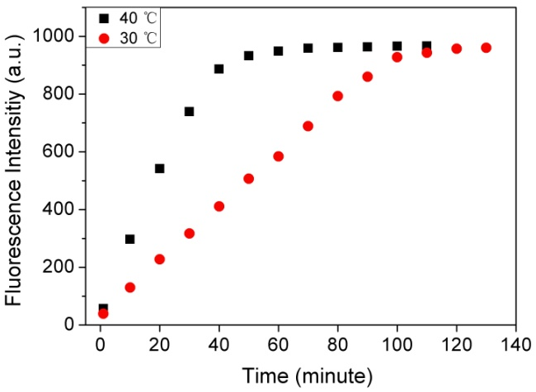
Figure 2. Time-dependent fluorescence responses of 1 (10 μM) to Cu²⁺ (10 μM).
The fluorescence titration of 1 with Cu²⁺ shows that the fluorescence emission maximum was observed when the Cu²⁺ reached 10 μmol/L (1 equiv), which suggested a high-affinity binding of Cu²⁺ to 1 with 1:1 stoichiometry (Fig. 3). The “turn-on” fluorescence response of 1 to Cu²⁺ should be ascribed to the coordination between them and the consequent restriction of the C=N isomerisation.¹⁶ For demonstrating the binding between 1 and Cu²⁺ , ESI-MS spectrum of 1 in the presence of Cu²⁺ were performed. The positive ion mode ESI-MS spectrum of the mixture of 1 and Cu(NO₃)₂ (1:1) in CH₃CN exhibits the base peak at m/z 412.9, which was assigned to [1-H+Cu]⁺. The observed and calculated isotopic patterns (calcd 413.0) agree well with each other (Fig. 4). This indicated the deprotonation of the secondary amino group (NH) upon coordination with Cu²⁺.
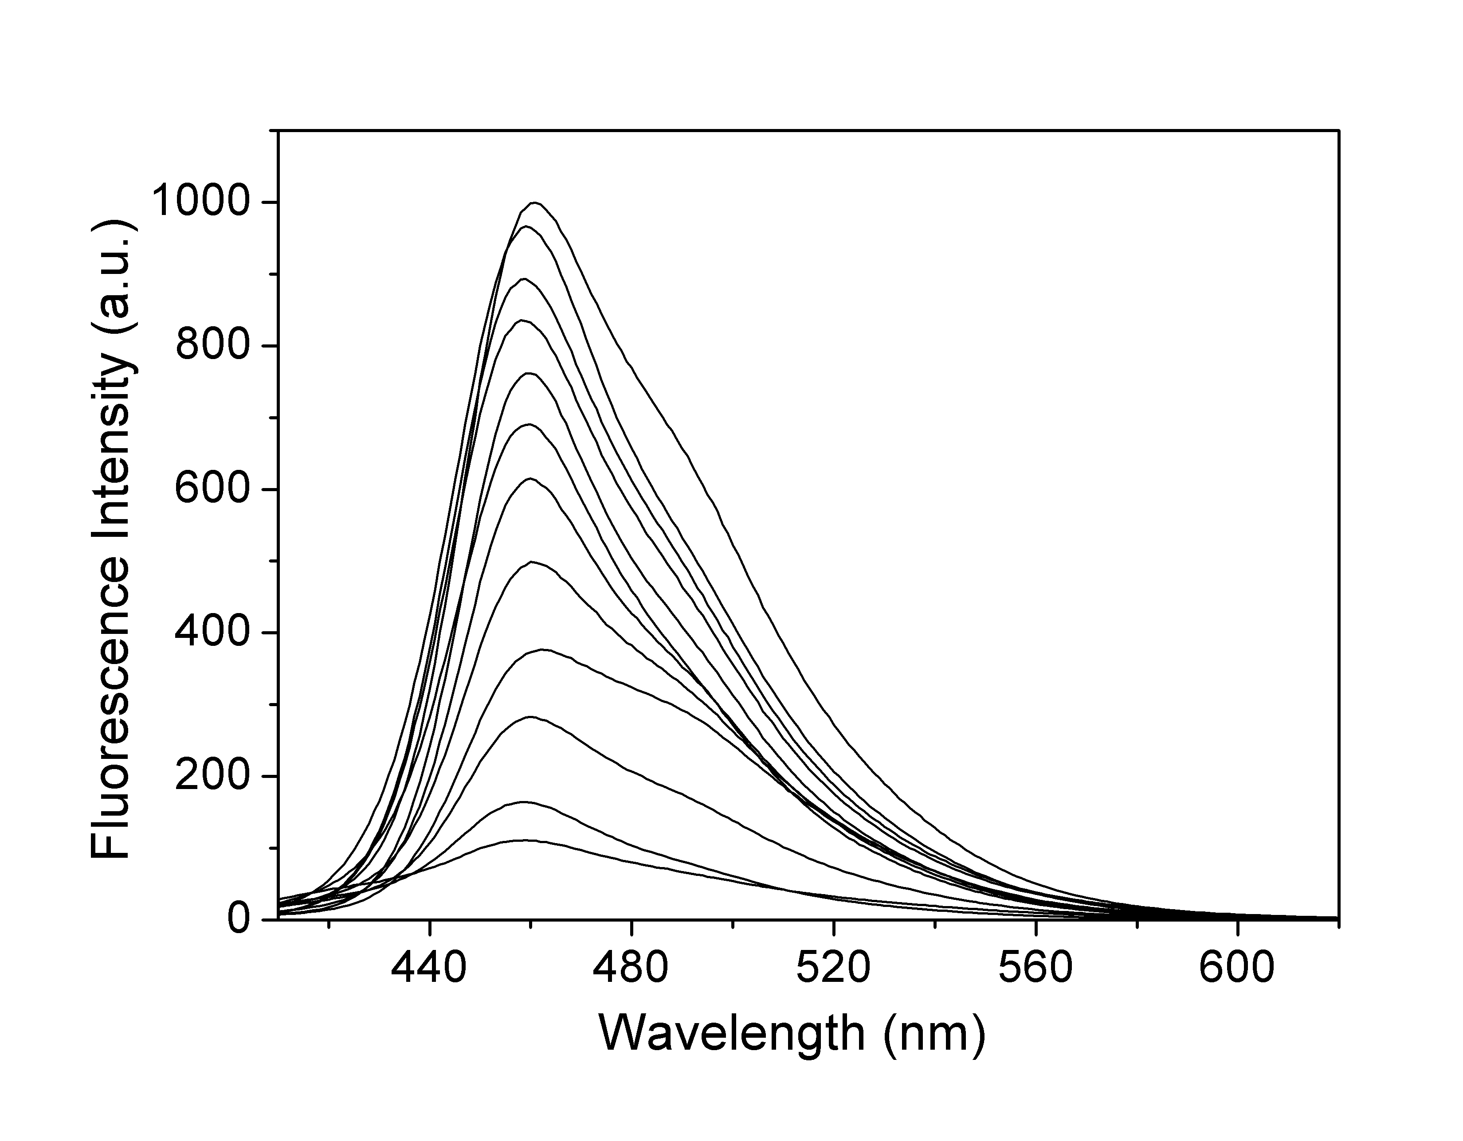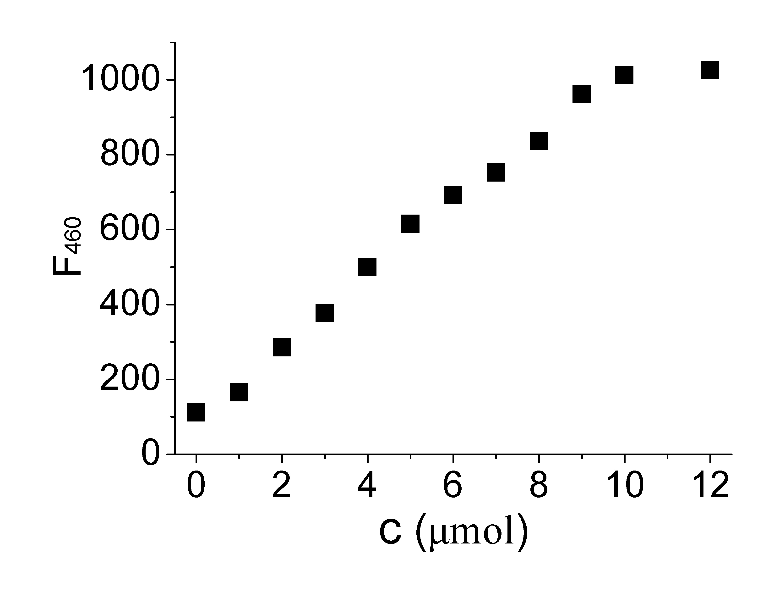
Figure 3. Fluorescence spectra of 1 (10 μM) in CH₃CN /H₂O (1/1) upon adding different concentrations of Cu²⁺ and then allowing to stand for 2 hour. The inset shows the emission intensities of 1 (10 μM) at 460 nm as a function of Cu²⁺ concentration.

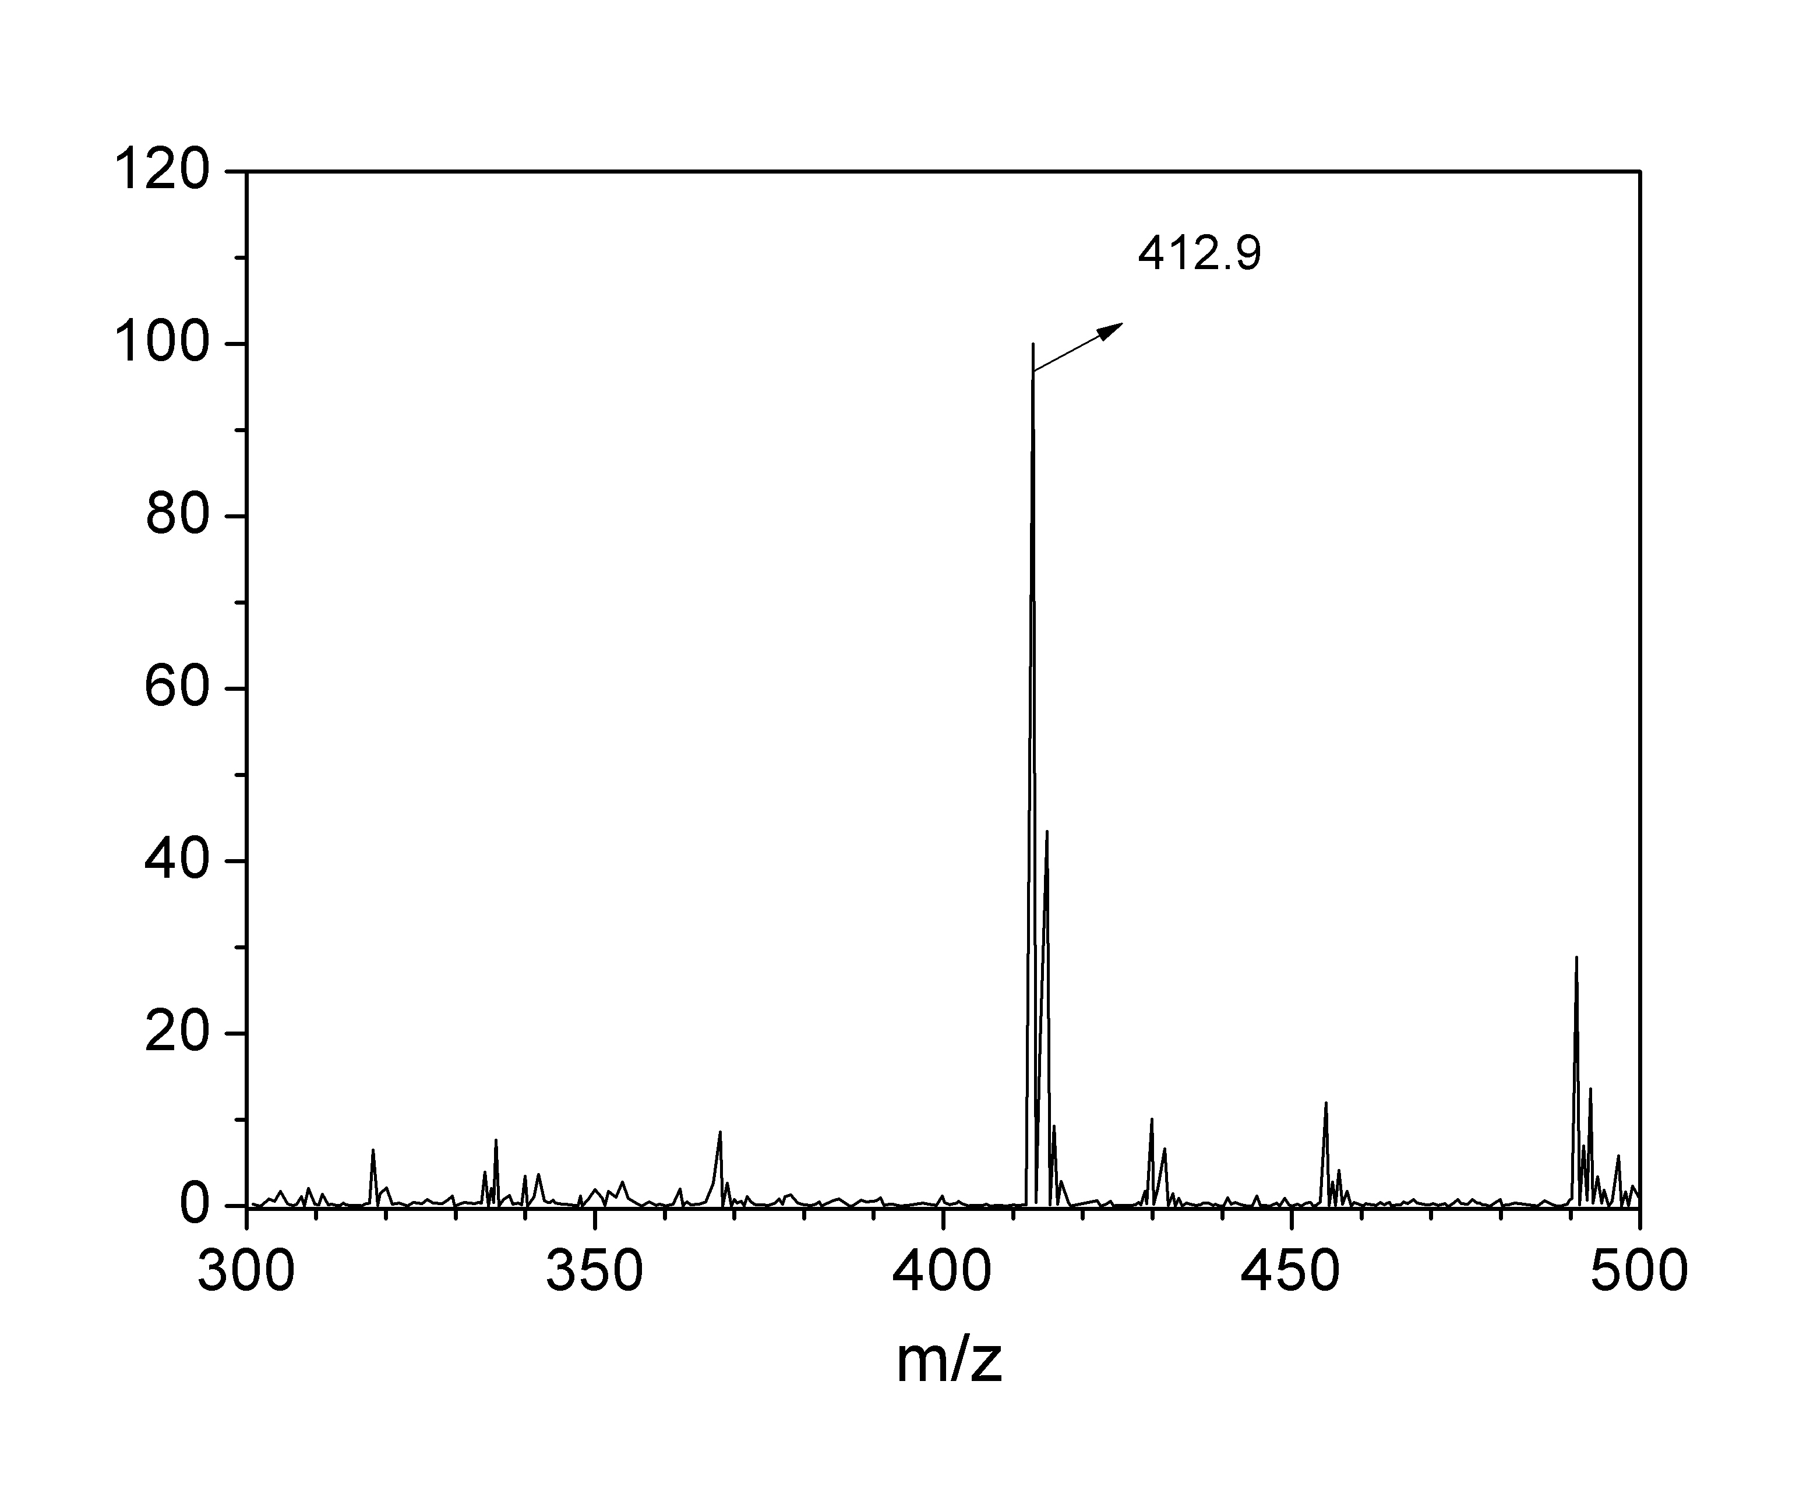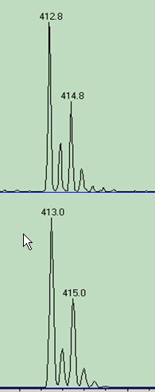
Figure 4. ESI-MS spectra of 1 in the presence of Cu²⁺. The inset shows the observed (upper) and calculated (under) isotopic patterns.
For further evaluating the effects of common metal ions on the selectivity of 1 for Cu²⁺, competition experiments were carried out by measuring the fluorescence response of 1 to Cu²⁺ in the presence of various foreign metal ions including Co²⁺, Ni²⁺, Zn²⁺, Cd²⁺, Fe³⁺, Hg²⁺ and so on. As illustrated in Fig. 5, when adding the mixtures of Cu²⁺ and various foreign metal ions to the solution of 1 and then allowing it to stand for 2 h, the fluorescence intensities at 460 nm is similar to that upon the addition of only Cu²⁺ except for Hg²⁺, which can partly quench the Cu²⁺-induced fluorescence. These results suggested the high selectivity of 1 as an efficient probe for the detection of Cu²⁺.

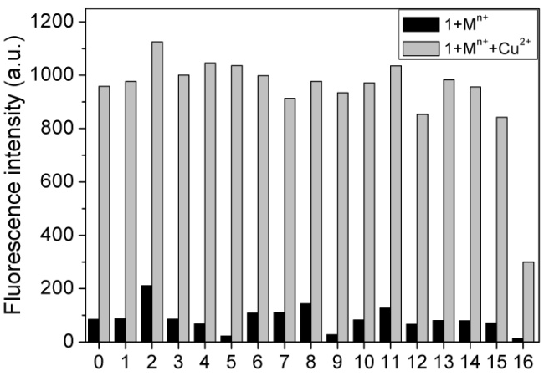
Figure 5. Selective fluorescence responses of 1 (10 μM) to Cu²⁺ (10 μM) in the presence of various foreign ions (10 μM). 0: blank; 1: Ba²⁺; 2: Ca²⁺; 3: Mg²⁺; 4: K⁺; 5: Al³⁺; 6: Na⁺; 7: Zn²⁺; 8: Ag⁺; 9: Fe³⁺; 10: Mn²⁺; 11: Cd²⁺; 12: Ni²⁺; 13: Pb²⁺; 14: Co²⁺; 15: Cr³⁺; 16: Hg²⁺.

  - Sensing mechanism
It is well-known that Cu²⁺ is the most vigorous quencher among transition metal ions, which has been found for some reported probes with similar structures.^{16,17} To explore the reason for the unusual fluorescence turn-on response of 1 to Cu²⁺, the sensing reversibility was checked by the addition of a competing ligand (EDTA) to the fluorescence solution. As seen in Fig. 6, the Cu²⁺-induced fluorescence was suppressed by the addition of EDTA, and then recovered by further addition of Cu²⁺, which suggested the reversible coordination interaction between 1 and Cu²⁺. The complex between 1 and Cu²⁺ has been further confirmed by ESI-MS (Fig. 4). The thiazole moiety of the probe molecule has two potential coordination atoms (S and N atom), which results in two possible binding models in which N or S of thiazole moiety serves as donor atom respectively. In order to determine the binding model, two analogues of 1 (2a and 2b) were synthesized for the control experiments. Sulfur-free 2a provides a NNO donor set, but 2b can only provides a NOS donor set, which correspond to the two possible binding models between 1 and Cu²⁺. The fluorescence properties of 2a and 2b were illustrated in Fig 7. 2a is non-fluorescent both in the presence and absence of Cu²⁺. In contrast, 2b gives an immediate turn-on fluorescence response to Cu²⁺, which should be thanks to the S-donor. The similar phenomenon can been found in the other S-containing probe developed by Lee.¹⁵ With this in mind, we can reasonably expect that the S-donor should be responsible for the fluorescence turn-on response of 1 to Cu²⁺. The delayed fluorescence of 1 in sensing Cu²⁺ might be ascribed to the gradual formation of the 1-Cu²⁺ complex with S-donor, that is, Cu(II) complex with NNO donor sites formed first, then gradually changed to the complex with NOS donor sites. On the basis of above discussion and the MS analysis (Fig. 4), the schematic diagram was proposed for illustrating the delayed fluorescence response of 1 to Cu²⁺ and the possible interaction between them as shown in Scheme 2.

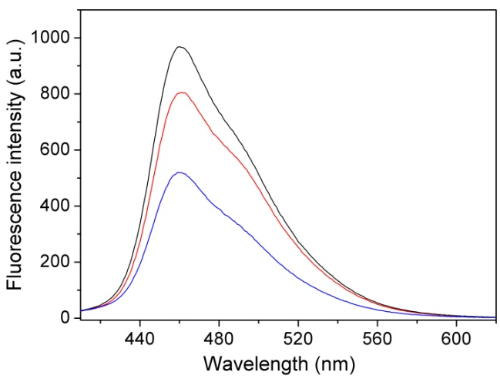
Figure 6. Fluorescence spectra of 1 (10 μM) upon successive addition of Cu²⁺ ( blank), EDTA (blue) and then Cu²⁺ (red).

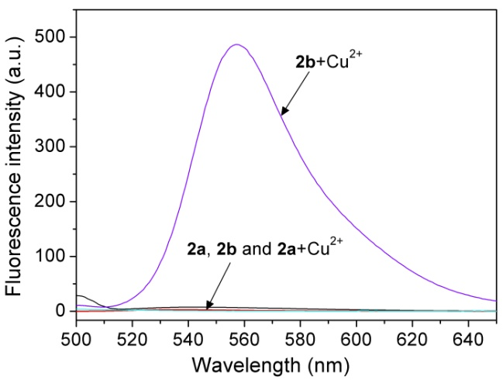
Figure 7. Fluorescence spectra of 2a and 2b (10 μM) in the absence and presence of Cu²⁺ (10 μM)

Scheme 2. Delayed fluorescence response of 1 to Cu²⁺ resulting from slowly transition from the NNO coordination to the NOS coordination

- Conclusion
In conclusion, a rationally designed turn-on fluorescent probe has been developed for the detection of Cu²⁺ which is the most vigorous fluorescence quencher among transition metal ions. The S-donor in the 1-Cu²⁺complex plays a crucial role for the turn-on fluorescence. The delay of the fluorescence response should be ascribed to the transition from the complex with NNO donor sites to the complex with NOS donor sites. We believe that the new proposed fluorescence turn-on mechanism would show great potential in fluorescence sensing of Cu²⁺.

- References
- H. Tapiero, D. M. Townsend and K. D. Tew, Biomed. Pharmacother. 2003, 57, 386-398.
doi.org/10.1016/S0753-3322(03)00012-X
- C. Barranguet, F. P. Van den Ende, M. Rutgers, A. M. Breure, M. Greijdanus, J. J. Sinke and W. Admiraal, Environ. Toxicol. Chem. 2003, 22, 1340-1349.
doi.org/10.1002/etc.5620220622
- T. S. Reddy and A. R. Reddy, Spectrochim. Acta A 2014, 128, 880-886.
doi.org/10.1016/j.saa.2014.02.120
- J. H. Jang, S. Bhuniya, J. Kang, A. Yeom, K. S. Hong and J. S. Kim, Org. Lett. 2013, 15, 4702-4705.
doi.org/10.1021/ol4025293
- X. Tian, Z. Dong, J. Hou, R. Wang and J. Ma, J. Lumin. 2014, 145, 459-465.
doi.org/10.1016/j.jlumin.2013.07.006
- J. Yang, N. Song, X. Lv and Q. Jia, Sens. Actuators B 2018, 259, 226-232.
doi.org/10.1016/j.snb.2017.12.045
- S. Anbu, R. Ravishankaran, M. F. C. Guedes da Silva, A. A. Karande and A. J. L. Pombeiro, Inorg. Chem. 2014, 53, 6655-6664.
doi.org/10.1021/ic500313m
- N. Wang, Y. Liu, Y. Li, Q. Liu and M. Xie, Sens. Actuators B 2018, 55, 78-86.
doi.org/10.1016/j.snb.2017.08.035
- J. Chen, W. Su and E. Wang, Chem. Res. Chin. Univ. 2016, 32, 742-745.
doi.org/10.1007/s40242-016-6001-1
- W. Su, S. Yuan and E. Wang, J. Fluoresc. 2017, 27, 1871-1875.
doi.org/10.1007/s10895-017-2124-0
- S. Yuan, W. Su and E. Wang, Acta Chim. Slov. 2017, 64, 638-643.
doi.org/10.17344/acsi.2017.3442
- J. Chen, W. Su and E. Wang, Y. Liu, J. Lumin. 2016, 180, 301-305.
doi.org/10.1016/j.jlumin.2016.08.040
- Z. Zhang, S. Yuan and E. Wang, J. Fluoresc. 2018, 28, 1115-1119.
doi.org/10.1007/s10895-018-2274-8
- Z. Zhang, Y Liu and E. Wang, Dyes Pigments 2019, 163 , 533-537.
doi.org/10.1016/j.dyepig.2018.12.039
- K. C. Ko, J. S. Wu, H. J. Kim, P. S. Kwon, J. W. Kim, P. A. Bartsch, J. Y. Lee and J. S. Kim, Chem. Commun. 2011, 47, 3165-3167.
doi.org/10.1039/C0CC05421F
- J. Wu, R. Sheng, W. Liu, P. Wang, H. Zhang and J. Ma, Tetrahedron 2012, 68, 5458-5463.
doi.org/10.1016/j.tet.2012.04.090
- J. S. Wu, W. M. Liu, X. Q. Zhuang, F. Wang, P. F. Wang, S. L. Tao, X. H. Zhang, S. K. Wu and S. T. Lee, Org. Lett., 2007, 9, 33-36.
doi.org/ 10.1021/ol062518z

