Methylene blue dye removal from aqueous media using activated carbon prepared by lotus leaves: kinetic, equilibrium and thermodynamic study
Roya Salahshour¹, Mehdi Shanbedi¹, Hossein Esmaeili²*
¹Department of Chemical Engineering, School of Chemical Engineering, Kherad Institute of Higher Education, Bushehr, Iran
²Department of Chemical Engineering, Bushehr Branch, Islamic Azad University, Bushehr, Iran
Abstract
In the present work, methylene blue was eliminated from aqueous solution using activated carbon prepared by lotus leaves. To perform the experiments, batch method was applied. Also, several analyses such as SEM, FTIR, EDAX and BET were done to determine the surface properties of the activated carbon. The results showed that the maximum sorption efficiency of 97.59% was obtained in initial dye concentration of 10 mg/L, pH of 9, adsorbent dosage of 4 g/L, temperature of 25 °C, contact time of 60 min and mixture speed of 400 rpm. Furthermore, the maximum adsorption capacity was determined 80 mg/g, which was a significant value. The experimental data was analyzed using pseudo-first order, pseudo-second order and intra-particle diffusion kinetic models, which the results showed that the pseudo-second order kinetic model could better describe the kinetic behavior of the sorption process. Moreover, the adsorption equilibrium was well described using Freundlich isotherm model. Furthermore, the thermodynamic studies indicated that the sorption process of methylene blue dye using the activated carbon was spontaneous and exothermic.
Keyword: Methylene blue dye, synthetic wastewater, removal, activated carbon, lotus leaves.

1. Introduction
Environmental pollution is currently a global problem.¹ Because of the population growth, the expansion of industry and agriculture and the shortage of fresh water in the world, the need for treatment and recovery of wastewater has become critical in recent years.^{2,3} Among the various industries, the textile industry has expanded rapidly both in the world and our country and dyeing units in the textile industry are the main environmental pollutants due to the consumption of thousands types of dye chemicals. Textile effluents usually contain a wide range of different chemical compounds. The biggest problem with these effluents is the presence of dyes and biodegradable chemicals. The most obvious characteristic of textile industry effluents is that it is colored and the two main stages of dyeing and finishing in the textile industry produce a large volume of effluent with high dye concentration.⁴
These dyes not only give undesirable colors to water, but in some cases are themselves harmful compounds and can produce other toxic products by oxidation, hydrolysis, or other chemical reactions that take place in water. Dyes are one of the most dangerous groups of chemical compounds found in industrial effluents that are of considerable importance due to the reduction of light permeability and thus disrupting the process of photosynthesis in water sources.⁵
These compounds also have an aesthetic negative effect on water quality for drinking and other uses⁴ and at the same time, they cause allergies, dermatitis, irritation,⁶ cancer⁷ as well as genetic mutations in humans.⁸ Methylene blue is the most common dye compound used for cotton, wool and silk coloring. Inhalation of this compound can cause respiratory disorders and direct exposure to it can cause permanent damage to the eyes of humans and animals, local burns, nausea and vomiting, increased sweating, mental disorders and methemoglobinemia.^{7,9}
Improper treatment and disposal of synthetic wastewater from the textile, dyeing, printing, and related industries has caused many environmental problems around the world.¹⁰ Dye removal from wastewater is usually done by physical, physicochemical, biological or chemical methods.^{11,12} The most efficient way to remove synthetic dyes from industrial effluents is the adsorption process, because the dye compounds in the effluent are easily transferred to the solid phase. Besides, the adsorbent used can be regenerated and used in the adsorption process or stored after use in a dry place without direct contact with the environment.⁸ Also, it has been proven that the adsorption process is a safe treatment solution due to its minimal investment cost, ease of design and operation, and insensitivity to toxic compounds. But at the same time, the use of adsorbents can be a limiting factor, because some adsorbents are expensive. To reduce the cost of preparation, the use of inexpensive materials (such as agricultural and industrial residues) for the production of activated carbon is a good option.^{13,14} In addition to reducing costs, converting agricultural waste into inexpensive adsorbents and solving the problem of biomass disposal has increased the value of agricultural waste even more. Carbon from agricultural wastes has advantages such as low ash content, reasonable hardness, high cross section, and a porous structure.^{4,13}
The aim of this study was to eliminate methylene blue dye from synthetic effluent using activated carbon. To this end, the impact of various parameters on the methylene blue dye removal efficiency was investigated. The structural properties of activated carbon prepared from the lotus leaves were analyzed using BET, SEM, FTIR, and EDAX analyses. Also, the kinetic, equilibrium, and thermodynamic behavior of the adsorption process were thoroughly investigated.
2. Materials and Methods
2.1. Materials
In this study, sodium hydroxide and Hydrochloric acid (Merck, Germany) were used to adjust the pH of the solutions. Also, methylene blue dye (Merck, Germany) was used to prepare stock solutions.
2.2. Preparation of methylene blue stock solution
To prepare the stock solution, one gram of methylene blue was dissolved in 1000 ml of water to prepare a solution of methylene blue dye at a concentration of 1000 ppm. To prepare solutions with lower concentrations, distillation of the initial stock solution was diluted twice using water.
2.3. Preparation of activated carbon from Lotus leaves
To prepare activated carbon, we first collected the lotus leaves and washed it several times with water to remove the dust. After washing, the leaves are placed in an oven (dryer) at 105 ̊C for 2 hours to dry completely. The dried lotus leaves are placed in a furnace at 700ºC for 2 hours to produce carbon. The activated carbon is then pulverized using a grinder and granulated by sieve No. 25 (ASTM 11) and stored in plastic bottles at room temperature. They can be used as adsorbents to recover and remove methylene blue dye.
2.4. Adsorption tests
The methylene blue dye adsorption test was performed discontinuously in 200 ml Erlenmeyer flasks containing 100 ml of methylene blue dye solution. Methylene blue stock solution was first prepared. To adjust the initial pH of the solutions, sodium hydroxide and hydrochloric acid solutions with a concentration of 0.1 M were used. To investigate the effect of pH on the absorption of methylene blue dye, experiments were performed in the pH range of 3-11. Other conditions including initial concentration of 10 ppm, contact time of 40 min, temperature of 25 ̊C, adsorbent dose of 1.5 g/L and mixing speed of 400 rpm were considered constant. To mix, the sample was placed on a heater. Then the mixing temperature and speed were adjusted and the samples were mixed for a contact time of 40 min. At the end of this time, the sample was filtered using a funnel equipped with Whatman 42 filter paper, and the residual methylene blue dye in the solution was measured by a UV-vis spectrophotometer. The removal efficiency and adsorption capacity were then calculated. To evaluate the effect of other parameters such as temperature (25-50 ̊C), adsorbent dose (0.5-1 g/L), contact time (5-200 minutes) and dye concentration (10-100 mg/L), one of the parameters was changed and the rest of the parameters were considered constant. Also, the optimized values ​​of the parameters in the previous step were used to investigate the effect of another parameter.
The adsorption capacity and removal efficiency of methylene blue dye were determined after determining the secondary concentration and having the primary concentration. Adsorption efficiency (R%) and adsorption capacity (q_{e}) of activated carbon adsorbent are obtained by the following equations:
$$R\left(\%\right)=\left({\left(C_{i}-C_{o}\right)}/{C_{i}}\right)×100 \left(1\right)$$
$$q_{e}=\left({C_{i}-C_{o}}/M\right)×V (2)$$
2.5. Equilibrium behavior
The adsorption isotherm is important for describing the adsorption of molecular or ionic contaminants to the active sites of the adsorbent surface. The use of adsorbents is also critical for optimization.^{15,16} In this study, three models of Langmuir, Freundlich and Dabinin Radesh-Kuich isotherms are used for the obtained laboratory data.
The Langmuir isotherm is based on the assumption that all adsorption sites are the same and that the adsorption of the contaminant on the adsorbent surface is monolayer. The linear form of the Langmuir isotherm is shown in Equation (3):¹⁷
$$\frac{C_{e}}{q_{e}}=\frac{1}{q_{max}K_{L}}+\frac{C_{e}}{q_{max}} (3)$$
Where, K_{L} is the Langmuir isotherm constant corresponding to the junction sites. Also, q_{max} determines the maximum adsorption capacity of activated carbon. To determine K_{L} and q_{max}, the slope and width are used from the origin of the q_{e}/C_{e} diagram versus C_{e}.¹⁶
To know the feasibility of the adsorption process, the separation or equilibrium parameter R_{L} is expressed, which is obtained from the following relation:
$$R_{L}=\frac{1}{1+{K_{L}C}_{o}} (4)$$
If the value of R_{L} is greater than one, equal to one, between zero and one, and less than one, it indicates that the adsorption process is undesirable, linear, desirable, and irreversible.¹⁶
Also, the Freundlich isotherm is an experimental model that expresses adsorption on inhomogeneous surfaces. The linear form of the Freundlich isotherm is expressed as the following relation:^{16,17}
$$\ln{q_{e}}=\ln{{ K}_{F}+}\left(\frac{1}{n}\right)\ln{C_{e}} (5)$$
Here, K_{F} (mg/g (L/mg)^{1/n}) is indicator of constant relative adsorption capacity of the bond energy, and n is related to the adsorption capacity and heterogeneity of the adsorbent surface sites. A value of $\frac{1}{n}$ indicates the desirability of adsorption. Values ​​of n > 1 indicate that the adsorption process is desirable. The constants K_{F} and $\frac{1}{n}$ are calculated from ln q_{e} versus ln C_{e}.
Another popular equation for the analysis of isotherms, which has a high order, has been proposed by Dabinin. They reported that the absorption characteristic curve is related to the porous structure of the adsorbent.¹⁸ The Dabinin Radesh-Kuich isotherm is generally used to express the adsorption mechanism by distributing Gaussian energy on a heterogeneous surface. This isotherm is determined by Equations 6 and 7:
$$q_{e}=q_{D}\exp\left(-β_{D}ε_{D}^{2}\right) (6)$$
$$ε_{D}=-RT \ln\left(1+\frac{1}{C_{i}}\right) (7)$$
Here, q_{D} is the saturation capacity of the theoretical isotherm (Dabinin Radesh-Kuich model constant (mg/g)), Q_{e} is the equilibrium of the adsorbed pollutants on the adsorbent (mg/g), $β_{D}$ is Dabinin Radesh-Kuich isotherm model constant (mol²/KJ²), and $ε_{D}$ is the Polanyi potential. E is the absorption energy calculated by the mathematical relation (8):
$$E=\frac{1}{\sqrt{2β_{D}}} (8)$$
The value of E is useful for estimating the type of adsorption reaction (Dada et al., 2006). If the value of E is less than 8 KJ/mol, the adsorption process is physical. For values ​​between 8 and 16 KJ/mol the adsorption is chemical. And for values ​​greater than 16 KJ/mol the adsorption mechanism is intraparticle diffusion.¹⁸
2.6. Kinetics of adsorption
Kinetic models were used to investigate and determine the control rate of methylene blue dye adsorption speed. To determine the adsorption kinetics of methylene blue dye with activated carbon adsorbent, three models of pseudo-first order kinetics, pseudo-second order kinetics, and intraparticle diffusion were used.
The pseudo-first order kinetics are based on solid (adsorbent) capacity.^{15,16} The pseudo-first order kinetics are generally described by Equation 9:
$$Ln\left(q_{e}-q_{t}\right)= Lnq_{e}- K_{1}t (9)$$
Here, q_{e} is the amount of adsorption capacity of adsorbed pollutants per unit weight of adsorbent in equilibrium (mg/g), q_{t} is the adsorption capacity of adsorbed pollutants at time t (mg/g), and K₁ is the pseudo-first order kinetics velocity constant in adsorption (min⁻¹).^{15,16}
The linear form of the pseudo-second order kinetics model is also expressed as follows:
$$\frac{t}{q_{t}}=\frac{1}{K_{2}q_{e}^{2}}+\frac{t}{q_{e}} (10)$$
In Equation (10), K₂ is the pseudo-second order kinetics constant in adsorption (mg mol⁻¹ min⁻¹).
Another kinetic model is the intraparticle diffusion model. The adsorption process on a porous adsorbent is generally described by four steps. These steps are described as mass diffusion, film diffusion, intraparticle diffusion, and finally adsorption of contaminants on the adsorbent surface. The intraparticle diffusion model can be expressed as the following relation:
$$q_{t}=K_{id}t^{1/2} (11)$$
Here, $K_{id}$ (mg g⁻¹ min^{-1/2}) is the intraparticle diffusion rate constant. Plotting $q_{t}$ versus t^{1/2}, the constant value of diffusion rate $K_{id}$ is calculated.¹⁹
2.7. Adsorption thermodynamics
Changes in the rate of adsorption with respect to temperature are explained based on thermodynamic parameters such as change in enthalpy (∆H°), change in entropy (∆S°) and Gibbs free energy change (∆G°), which are obtained by using equations 12 and 13:^{20,21}
$${∆G}^{0}=-RT\ln{K_{c}} (12)$$
$$\ln{K_{c}}=\frac{{∆S}^{0}}{R}-\frac{{∆H}^{0}}{RT} (13)$$
The change in Gibbs free energy in the process depends on the quantity of equilibrium constant K_{c}, which is expressed as follow:
$$K_{c}=\frac{C_{Ae}}{C_{e}} (14)$$
In Equation (14), K_{c} is the equilibrium constant and C_{Ae} is the equilibrium concentration in the solid phase (mg/L).
The amount ​​of changes in enthalpy (∆H°) and entropy (∆S°) are obtained by plotting $\ln{K_{c}}$ versus 1/T.
3. Results and Discussion
3.1. Determining the properties of activated carbon
Various analyses including SEM, FTIR, EDAX, and BET were used to determine the physical properties of activated carbon adsorbent obtained from the lotus leaves. Figure 1 shows the SEM analysis of the activated carbon surface prepared from the lotus leaves, before and after the adsorption of methylene blue dye. Figure 1(a) shows that the activated carbon prepared from the lotus leaves before absorbing the methylene blue dye has uneven structure and a large number of adsorption channels. Then, Figure 1(b) shows the activated carbon prepared from the lotus leaves after adsorption of methylene blue dye. The adsorbent surface is uniform and the adsorption channels have disappeared. This uniformity and disappearance of adsorption channels in Figure 1(b) indicates the adsorption of methylene blue dye on the activated carbon adsorbent.
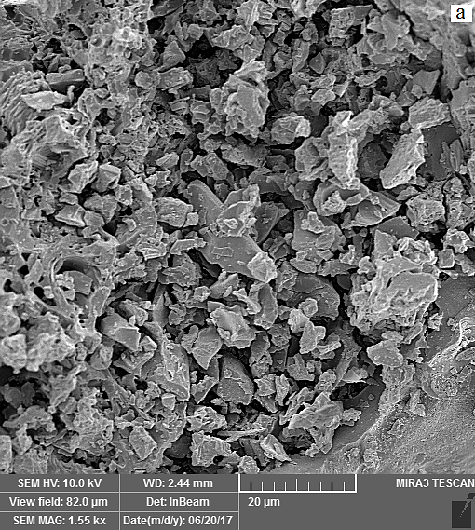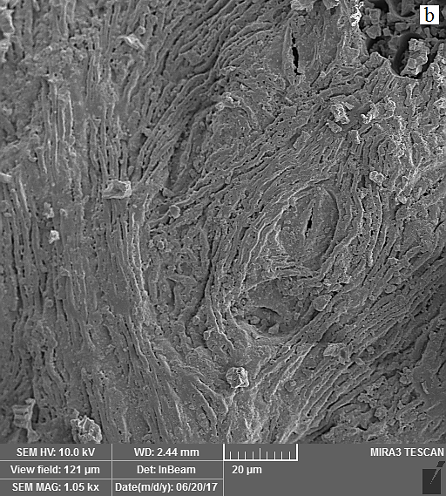
Figure 1. SEM images (a) activated carbon, (b) activated carbon after adsorption of methylene blue dye.
To evaluate the functional groups on the surface of activated carbon adsorbent, FTIR analysis was used, which is shown in Figure 2. FTIR analysis has identified groups in different ranges. There are several peaks at 3847.08, 3739.92, 3429.81, 3064.81, 2929.39, 1614.74 , 1395.49, 1318.25, 778.03, 664.03, and 516.29, which are attributed to the functional groups of O-H, O-H, O-H, C-H, C-H, C-C, O-H, O-H, C-Cl, C-Cl, and C-I, respectively.^{14, 16}
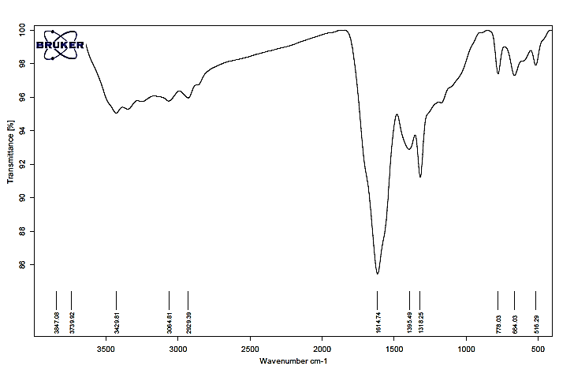
Figure 2. FTIR analysis of activated carbon prepared from lotus leaves.
Also, the EDAX analysis of activated carbon prepared from the lotus leaves before and after the methylene blue dye adsorption process is shown in Figure (3). According to Figure 3(b), before the adsorption process, activated carbon contains elements such as carbon (72.45%), oxygen (13.6%), silicon (1%) and sulfur (12.96%). After the methylene blue dye adsorption process, the amount of these elements changed, which includes carbon (60.62%), oxygen (32.61%), silicon (0.5%), and sulfur (6.27%). Changes in the amounts of activated carbon constituents before and after the methylene blue dye adsorption process can be due to the adsorption of the dye by activated carbon.²²
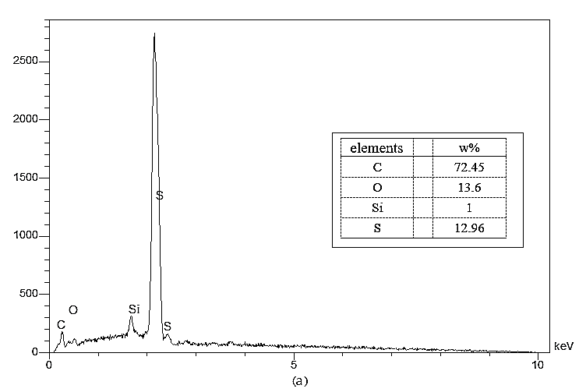
(a)
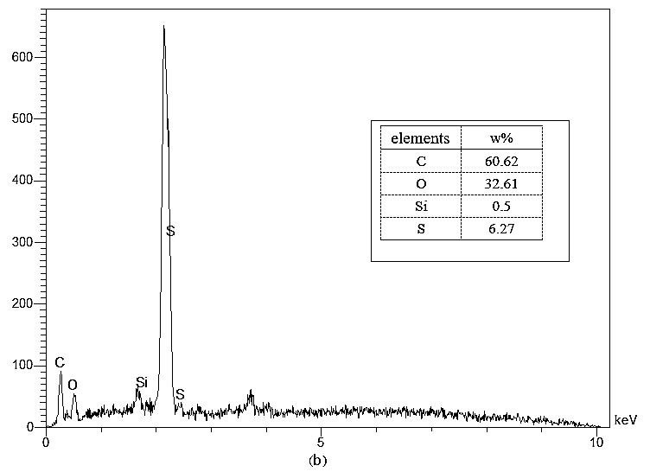
(b)
Figure 3. EDAX analysis (a) Activated carbon produced from lotus leaves before the adsorption process and (b) Activated carbon after the sorption of methylene blue dye
Properties such as specific surface area, average pore volume, and pore diameter are determined using BET analysis and the results are presented in Table 1. According to the results, the specific surface area of ​​activated carbon, the average pore volume and the pore diameter obtained from BET analysis were determined 64.415 gr/m², 0.056948 gr/cm³ and 35.3633 ºA, respectively. These values ​​indicate that the activated carbon prepared from the lotus leaves has a good specific surface area and pore volume. Also, the average pore diameter indicates that the activated carbon has a mesoporous structure, because the pore diameter is in the range of 20 to 500 ºA.
Table 1. Surface properties of activated carbon prepared from the lotus leaves using BET analysis.
Properties | Values
Analyzed activated carbon mass | 0.5588 gr
Specific surface area | 64.4152 gr/m²
Average pore volume | 0.056948 gr/cm³
Average pore diameter | 35.3633 ºA
3.2. The effect of different parameters on the adsorption process
3.2.1. pH effect
Solution pH is one of the most important and effective parameters in controlling the adsorption process. The effect of pH on the adsorption efficiency of methylene blue dye by using carbon prepared from the lotus leaves is shown in Figure 4. The results show that by increasing the initial pH, the methylene blue dye adsorption efficiency is increased and the maximum yield is obtained approximately at the initial pH of 9. This result can be described according to the cationic properties of methylene blue dye. At low initial pHs (pH<5), the adsorption efficiency of methylene blue dye using a prepared adsorbent is low, indicating that acidic pHs are not suitable for adsorption of methylene blue dye. This is because at acidic pHs the adsorbent surface is positively charged and, as a result, the methylene blue cationic dye is repelled by the positively charged adsorbent surface. Also, by increasing the initial pH, the percentage of methylene blue dye adsorption using the adsorbent produced increases, because by increasing pH, the negative charge on the adsorbent surface increases and an electrostatic force of gravity type is created between the adsorbent surface and the cationic dye.²³

Figure 4. Effect of pH on methylene blue dye removal efficiency (adsorbent dose 1.5 g/L, contact time 40 min, initial dye concentration 10 ppm, temperature 25 °C and mixing speed 400 rpm).
3.2.2. Effect of temperature and contact time
The effect of different contact times (5-200 min) at 25, 35, 45 and 55 °C on the removal efficiency of methylene blue dye by activated carbon is shown in Figure 5. The results show that during the initial contact time (5 min), the adsorption of methylene blue dye was high at 25 °C, which is equal to 43.63%. By increasing the temperature up to 55 °C, the removal efficiency decreases and reaches 34.64%. Thus, by increasing the temperature, the adsorption efficiency decreased, which indicates that the adsorption process is exothermic. The decrease in removal efficiency with increasing temperature is due to the weakening of the adsorption forces between the active sites of the activated carbon adsorbent and the methylene blue dye. In this case, methylene blue dyes are released in the solution phase. Thus, the removal efficiency decreases. However, by increasing the contact time, the removal efficiency increased and reached equilibrium during the 60 min call time. Methylene blue dye adsorption efficiency remained uniform after 60 min. Because in this case, the adsorption sites on the adsorbent surface are saturated and it is observed that the removal efficiency has not changed much. Therefore, the maximum methylene blue dye removal efficiency was obtained at a contact time of 60 min and a temperature of 25 °C. Under these conditions, the adsorption efficiency of methylene blue dye was 93.67%.

Figure 5. Effect of temperature and contact time on the removal efficiency of methylene blue dye by activated carbon (conditions: pH of 9, adsorbent dose of 1.5 g/L, initial dye concentration of 10 ppm, and mixing speed of 400 rpm).
3.2.3. Effect of initial concentration of methylene blue dye
The effect of methylene blue dye concentration on removal efficiency and adsorption capacity at constant pH of 9, adsorbent dose 1.5 g/L, contact time of 60 min, temperature 25 °C, and mixing speed 400 rpm are shown in Figure 6. The effect of methylene blue dye concentration in the range of 10-100 ppm has been selected.
As shown in the figure, by increasing the concentration from 10 to 100 ppm, the removal efficiency decreases. To check the initial concentration parameter, the amount of concentrations is different and the amount of absorbent dose is constant. In this case, by increasing dye concentration, the amount of methylene blue dye in the aqueous solution increases relative to the adsorbent dose and there are fewer adsorption sites for methylene blue dyes to be placed on the adsorbent surface, and as a result, the removal efficiency is decreased.
On the other hand, in Figure 6, by increasing the concentration from 10 to 100 ppm, the adsorption capacity is increasing. As the concentration of methylene blue dye in aqueous solution increases, the desired amount of contaminant increases. As a result, the contact of methylene blue dyes increases, which causes the methylene blue dye to be adsorbed more on the activated carbon sites, thus increasing the adsorption capacity.

Figure 6. Effect of initial methylene blue dye concentration on removal efficiency and adsorption capacity of methylene blue dye (pH equal to 9, adsorbent dose 1.5 g/L, contact time 60 min, temperature 25 °C and mixing speed 400 rpm).
3.2.4. Effect of activated carbon adsorbent dose
The values ​​of adsorption capacity and methylene blue dye removal efficiency at different doses of activated carbon are shown in Figure 7. By increasing the dose of activated carbon adsorbent from 0.5 to 10 g/L, the removal efficiency has increased from 82.84% to 98.032%, while adsorption capacity (q_{e}) presents an inverse trend. Increasing the removal efficiency is due to the increase in surface area and the increase in adsorption sites available for methylene blue dye.
The decrease of adsorption capacity (q_{e}) from 16.568 to 0.98032 mg/g is observed with increasing the adsorbent dose from 0.5 to 10 g/L, which is due to the competition between contaminants and adsorbents.²⁴ By increasing the adsorbent dose, the adsorbent surface becomes saturated and reduces the adsorption capacity (q_{e}).
When the dose of activated carbon adsorbent from the lotus leaves was 4 g/L, the removal efficiency and adsorption capacity (q_{e}) were 97.59% and 2.439 mg/g, respectively. At adsorbent dose of above 4 g/L, there was no significant increase in methylene blue removal efficiency and the diagram is almost constant and the adsorption capacity (q_{e}) is also reduced. Therefore, according to the adsorption capacity (q_{e}) and removal efficiency, the adsorbent dose of 4 g/L was determined as the optimal value.

Figure 7. Effect of activated carbon adsorbent dose on removal efficiency and adsorption capacity of methylene blue dye (pH equal to 9, initial concentration 10 ppm, contact time 60 min, temperature 25 °C and mixing speed 400 rpm).
3.3. Equilibrium study of absorption process
Three models of Langmuir, Freundlich, and Dubinin Radushkevitch (D-R) isotherms were used to remove the methylene blue dye by activated carbon adsorbent prepared from the lotus leaves to study the adsorption isotherm. Isothermal relationships were investigated at different concentrations of 10-100 ppm with a constant pH of 9, contact time of 60 min, temperature 25 °C, adsorbent dose of 1.5 g/L, and mixing speed of 400 rpm.
The Langmuir, Freundlich, and Dubinin Radushkevitch (D-R) isotherms are plotted in Figure 8, and the constant values ​​obtained from the isotherms are shown in Table 2. According to the Langmuir isotherm, the R_{L} value was in the range of 0.729-0.44, which indicates that the process of removing methylene blue dye with activated carbon adsorbent is desirable. Also, the maximum adsorption capacity of this model was 80 mg/g. In addition, according to the values ​​of correlation coefficient obtained for all three isotherms, Freundlich isotherm model was better than other isotherms in showing the equilibrium behavior of methylene blue dye adsorption process by activated carbon. Also, the value of parameter n using Freundlich isotherm was equal to 1.514, which indicates that the adsorption process is optimal. Also, according to the amount of energy E obtained using the Dubinin Radushkevitch isotherm model (1.207 KJ/mol), the mechanism of removal of methylene blue dye with adsorbent carbon is physical. Saturation absorption capacity was also obtained using the D-R isotherm equal to 34.622 mg/g.

Figure 8. Langmuir (a), Freundlich (b) and D-R (c) isotherms for the uptake of methylene blue dye using the activated carbon
Table 2. Values ​​and constants of adsorption isotherms.
Isothermal models | Quantities | Methyl violet dye
Langmuir | q_{max}(mg/g) | 80
Langmuir | K_{L} (L/mg) | 0.127
Langmuir | R² | 0.9837
Langmuir | R_{L} | 0.729 – 0.44
Freundlich | n | 1.514
Freundlich | K_{f} (mg/g(L/mg)^{1/n}) | 9.5496
Freundlich | R² | 0.9843
(D-R) Dubinin Radushkevitch | E (KJ/mol) | 1.207
(D-R) Dubinin Radushkevitch | q_{D} (mg/g) | 34.622
(D-R) Dubinin Radushkevitch | βx10⁻⁶(mol²/J²) | 0.343
(D-R) Dubinin Radushkevitch | R² | 0.816

The maximum sorption capacity obtained in this research for the sorption of methylene blue was compared to previous studies and the results are presented in Table 3. According to this table, the maximum sorption capacity of the activated carbon used in this study was obtained 80 mg/g, which was comparable with other adsorbents in removing methylene blue from aqueous media.
Table 3. Comparing the maximum sorption capacity of different adsorbents in the removal of methylene blue from aqueous media
Adsorbent | Maximum sorption capacity (mg/g) | Ref.
Palm tree sawdust | 54 | ⁴
Sour lemon sawdust | 52.4 | ⁴
Eucalyptus sawdust | 53.5 | ⁴
Kaolin/CuFe₂O₄ nanocomposite | 120.48 | ¹⁶
activated carbon prepared by Ficus caricabast | 47.62 | ²⁵
magnetic cellulose/graphene oxide composite | 70.03 | ²⁶
Activated carbon | 1.23 | ²⁷
Activated carbon prepared by lotus leaves | 80 | Present study
3.4. Kinetic study of adsorption
Figure 9 illustrates pseudo-first order, pseudo-second order, and intraparticle diffusion kinetic models. The graphs drawn include the linear equation and the correlation coefficient (R²). The amounts of models were calculated from the obtained linear equations and the results are reported in Table 4. The constant rate of pseudo-first order kinetics (k₁), the constant rate of pseudo-second order kinetics (k₂), the constant rate of intraparticle diffusion kinetics (K_{dif}), and the equilibrium adsorption capacity (q_{e.theoretical}) were calculated for all temperatures.
The calculated absorption capacity values ​​(q_{e.theoretical}) using the pseudo-first order kinetic model are very different from the laboratory absorption capacity values ​​(q_{e.exp}). Whereas, the calculated absorption capacity values ​​(q_{e.theoretical}) are very close to the laboratory absorption capacity values ​​(q_{e.exp}) of the pseudo-second order kinetic model. In addition, the correlation coefficient (R²) values ​​of the pseudo-first order kinetic models and intraparticle diffusion are lower than the pseudo-second order kinetic model. Also, the constant rate of pseudo-first order kinetics (k₁) and the constant velocity of intraparticle diffusion kinetics (K_{dif}) at all temperatures are less than the constant rate of pseudo-first order kinetics (k₂). Therefore, it can be concluded that the pseudo-second order kinetic model is more suitable for the mechanism of adsorption of methylene blue dye with activated carbon adsorbent prepared from lotus leaves.

Figure 9. Pseudo-first order, pseudo-second order and intraparticle diffusion kinetics at different temperatures and times.
Table 4. Values ​​of kinetic models at different temperatures and times.
kinetic models | Parameter | Temperature 328 K | Temperature 318 K | Temperature 308 K | Temperature 298 K
pseudo-first order | R² | 0.9348 | 0.9116 | 0.9129 | 0.8784
pseudo-first order | K₁ (min⁻¹) | 0.0319 | 0.0311 | 0.0334 | 0.0322
pseudo-first order | q_{e.theoretical}) mg/g( | 2.6564 | 2.3094 | 2.1593 | 1.7550
pseudo-first order | q_{e.exp} )mg/g( | 6.078 | 6.178 | 6.256 | 6.364
pseudo-second order | R² | 0.9995 | 0.9996 | 0.9992 | 0.9995
pseudo-second order | K₂ (g/mg.min) | 0.0218 | 0.0254 | 0.0242 | 0.0345
pseudo-second order | q_{e.theoretical})mg/g( | 6.3451 | 6.4061 | 6.4977 | 6.5402
pseudo-second order | q_{e.exp})mg/g( | 6.078 | 6.178 | 6.256 | 6.364
intraparticle diffusion | R² | 0.6972 | 0.6726 | 0.6407 | 0.5963
intraparticle diffusion | K_{diff}(mg/gmin^{1/2}( | 0.2712 | 0.2563 | 0.2475 | 0.2323
3.5. Study of thermodynamics of absorption process
Table 5 lists the values ​​of ΔG°, ΔH° and ΔS° at different temperatures. Figure 10 also shows LnK_{D} versus 1/T for the sorption of methylene blue dye using activated carbon at different temperatures.
ΔG° value at 25 ºC was -5.673 KJ/mol, and enthalpy change in the range of 25-55 ºC was -19.671 KJ/mol, which indicates that the methylene blue dye removal process was spontaneous and exothermic. Also, the value of ΔS° in the temperature range of 25-55 ºC was equal to -47.207 KJ/mol, which shows the irregularity and randomness of the methylene blue dye adsorption process and shows the physical nature of the methylene blue dye removal process with activated carbon adsorbent.

Figure 10. LnK_{D} versus 1/T diagram for the sorption of methylene blue dye with activated carbon at different temperatures
Table 5. Values ​​of thermodynamic parameters of methylene blue dye adsorption by activated carbon at different temperatures.
Temperature | K_{D} | ΔG° (KJ/moL) | ΔH° (KJ/moL) | ΔS° (KJ/moL)
25 ºC | 9.864 | -5.673 | -19.671 | -47.207
35 ºC | 7.194 | -5.055 | -19.671 | -47.207
45 ºC | 5.575 | -4.545 | -19.671 | -47.207
55 ºC | 4.802 | -4.28 | -19.671 | -47.207
4. Conclusion
In this study, the adsorption process of methylene blue dye by activated carbon prepared from the lotus leaves was performed discontinuously, and the effect of various parameters such as pH, initial concentration, adsorbent dose, mixing speed, contact time, and temperature on the adsorption process were investigated. In all parameters the mixing speed of 400 rpm was considered constant. To prepare activated carbon adsorbent, lotus leaves were used and SEM, FTIR, EDAX, and BET analyses were presented before and after removal of methylene blue dye with activated carbon adsorbent. BET analysis showed that the specific surface area of ​​activated carbon adsorbent was high. The adsorption results showed that the highest adsorption efficiency was obtained at pH 9, 10 ppm dye concentration, 60 min duration, and 25 °C, in which the adsorption efficiency was 97.59%. Experimental results showed that by increasing solution temperature the removal efficiency decreases, and this indicates that the adsorption of methylene blue dye with activated carbon adsorbent is exothermic.
Among the pseudo-first order, pseudo-second order, and intraparticle diffusion models, the pseudo-second order kinetic model better described the mechanism of the methylene blue dye removal process by the adsorbent prepared from the lotus leaves, and was a suitable model for this sorption process. Also, three isotherm models including Langmuir, Freundlich, and Dubinin Radushkevitch (D-R) isotherms were investigated. Among these models, the Freundlich isotherm with a higher correlation coefficient was able to better express the equilibrium behavior of the adsorption process. Also, the highest adsorption capacity of methylene blue dye was obtained by activated carbon 80 mg/g. In addition, thermodynamic relationships such as Gibbs free energy changes, enthalpy changes, and entropy changes were calculated. The results showed that the adsorption process of methylene blue dye by activated carbon is exothermic and spontaneous.
Conflict of Interests Statement
The authors declare that there is no conflict of interests.

5. References
1. J. Paul, K. P. Rawat, K. S. S. Sarma, S. Sabharwal, Appl. Radiat. Isot. 2011, 69, 982-987. DOI: 10.1016/j.apradiso.2011.03.009
2. S. Tamjidi, H. Esmaeili, B. K. Moghadas, Mater. Res. Express. 2019, 6, 102004. DOI: 10.1088/2053-1591/ab3ffb
3. I. Khoshkerdar, H. Esmaeili, Acta Chim. Slov. 2019, 66, 208-216. DOI: 10.17344/acsi.2018.4795
4. H. Esmaeili, R. Foroutan, J. Dispers. Sci. Technol. 2019, 40, 990-999. DOI: 10.1080/01932691.2018.1489828
5. D. Prahas, Y. Kartika, N. Indraswati, S. Ismadji, Chem. Eng. J. 2008, 140, 32-42. DOI: 10.1016/j.cej.2007.08.032
6. B. Andre, D. Santos, J. Francisco, B. Jules, V. Lier, Bioresour. Technol. 2007, 98, 2369-2385. DOI: 10.1016/j.biortech.2006.11.013
7. B. Royer, N. F. Cardoso, E. C. Lima, J. C. P. Vaghetti, N. M. Simon, T. Calvete, R. C. Veses, J. Hazard. Mater. 2009, 164, 1213-1222. DOI: 10.1016/j.jhazmat.2008.09.028
8. E. C. Lima, B. Royer, J. C. P. Vaghetti, N. M. Simon, B. M. Cunha, F. A. Pavan, E. V. Benvenutti, R. CatalunaVeses, C. Airoldi, J. Hazard. Mater. 2008, 155, 536-550. DOI: 10.1016/j.jhazmat.2007.11.101
9. D. S. Brookstein, Dermatol. Clin. 2009, 27, 309-322. DOI: 10.1016/j.det.2009.05.001
10. R. O. A. de Lima, A. P. Bazo, D. M. F. Salvadori, C. M. Rech, D. de Palma Oliveira, G. de Aragão Umbuzeiro, Mutat. Res. 2007, 626, 53-60. DOI: 10.1016/j.mrgentox.2006.08.002
11. C. Namasivayam, D. Kavitha, Dyes Pigm. 2002, 54, 47-58. DOI: 10.1016/S0143-7208(02)00025-6
12. K. Vijayaraghavan, Y. S. Yun, Dyes Pigm. 2008, 76, 726- 732. DOI: 10.1016/j.dyepig.2007.01.013
13. A. Bhatnagar, M. Sillanpää, Chem. Eng. J. 2010, 157, 277-296. DOI: 10.1016/j.cej.2010.01.007
14. S. Abbasi, R. Foroutan, H. Esmaeili, F. Esmaeilzadeh, Desalin. Water Treat. 2019, 141, 269-278. DOI: 10.5004/dwt.2019.23569
15. K. S. Tong, M. Jain Kassim, A. Azraa, Chem. Eng. J. 2011, 170, 145-153. DOI: 10.1016/j.cej.2011.03.044
16. M. M. Boushehrian, H. Esmaeili, R. Foroutan, J. Environ. Chem. Eng. 2020, 8, 103869. DOI: 10.1016/j.jece.2020.103869
17. S. M. Mousavi, S. A. Hashemi, A. M. Amani, H. Esmaeili, Y. Ghasemi, A. Babapoor, F. Mojoudi, O. Arjomand, Phys. Chem. Res. 2018, 6, 759-771. DOI: 0.22036/PCR.2018.133392.1490
18. K. Vijayaraghavan, T. V. N. Padmesh, K. Palanivelu, M. Velan, J. Hazard. Mater. 2006, 133, 304-308. DOI: 10.1016/j.jhazmat.2005.10.016
19. N. Ünlü, M. Ersoz, J. Hazard. Mater. 2006, 136, 272-280. DOI: 10.1016/j.jhazmat.2005.12.013
20. F. Takmil, H. Esmaeili, S. M. Mousavi, S. A. Hashemi, Adv. Powder Technol. 2020. DOI: 10.1016/j.apt.2020.06.015
21. H. Esmaeili, S. Tamjidi, Environ. Sci. Pollut. Res. 2020. DOI: 10.1007/s11356-020-09448-y
22. U. A. Guler, M. Ersan, E. Tuncel, F. Dügenci, Process Saf. Environ. Prot. 2016, 99, 194-206. DOI: 10.1016/j.psep.2015.11.006
23. H. S. Jamwal, S. Kumari, G. S. Chauhan, N. S. Reddy, J. H. Ahn, J. Environ. Chem. Eng. 2017, 5, 103-113. DOI: 10.1016/j.jece.2016.11.029
24. H. Esmaeili, R. Foroutan, D. Jafari, M. Aghil Rezaei, Korean J. Chem. Eng. 2020, 37, 804-814. DOI: 10.1007/s11814-020-0493-6
25. D. Pathania, S. Sharma, P. Singh, Arab. J. Chem. 2017, 10, 1445-1451. DOI: 10.1016/j.arabjc.2013.04.021
26. H. Shi, W. Li, L. Zhong, C. Xu, Ind. Eng. Chem. Res. 2014, 53, 1108-1118. DOI: 10.1021/ie4027154
27. C. O. Ijagbemi, J. I. Chun, D. H. Han, H. Y. Cho, S. J. O, D. S. Kim, J. Environ. Sci. Heal. A. 2010, 45, 958-967. DOI: 10.1080/10934521003772378

* Corresponding author: E-mail: esmaeili.hossein@gmail.com esmaeili.hossein@iaubushehr.ac.ir

