ELECTRODEPOSITION AND GROWTH OF IRON (III) FROM AN ETHYLENE GLYCOL SOLUTION
Vusala Asim Majidzade,^{1,}* Akif Shikhan Aliyev, ¹ Mahmoud El-rouby, ² Dunya Mahammad Babanly, ^{1,3} Dilgam Babir Tagiyev¹
¹ Institute of Catalysis and Inorganic Chemistry named after M.Nagiyev,
Azerbaijan National Academy of Sciences, AZ1143, H.Javid 113
²Chemistry Department, Faculty of Science, Sohag University, 82524 Sohag, Egypt
³French Azerbaijani University (UFAZ), AZ1010, Baku, Nizami 189

Vusala Asim Majidzade – corresponding author, E-mail: vuska_80@mail.ru

Abstract
Electrochemical reduction of iron (III) ions from an ethylene glycol solution was studied. The kinetics and mechanism of the electroreduction process were investigated by cyclic and linear polarization curves. The effect of temperature, potential sweep, and the concentration of iron (III) ions on the electroreduction process was also studied. By calculating the effective activation energy, it was revealed that the investigated electroreduction process is accompanied by mixed kinetics. Furthermore, the results of SEM and X-ray diffraction analysis confirm the deposition of thin Fe films under the conditions in consideration.
Key words: polarization curves; chronoamperometry; iron ions; electroreduction; ethylene glycol.

- INTRODUCTION
The intense use of the solar energy has increased interest in obtaining thin-film materials with high physical and optical properties in the last decade. As known, most of these materials are semiconductors with a large variety in electrical and physical properties, as well as in chemical composition.¹⁻⁷ Currently, due to the decrease in natural energy sources, the use of environmentally friendly solar energies is very important.⁸⁻¹⁰ The demand for chalcogenide semiconductor films is fairly increased due to their use in solar converters. Thin chalcogenide films are used to convert energy in solar cells, both as photocathodes and photoanodes. The thickness of the active part of these films should not exceed 3 microns.
Iron disulfide (FeS₂) belongs to the class of chalcogenides, which are used in high-frequency detectors, rectifiers, transistors, etc. due to their layered structure. It is a non-toxic material and, thanks to its wide distribution on Earth, has the prospect of becoming an inexpensive alternative for creating highly efficient solar cells.¹¹⁻¹⁶ This is facilitated both by its environmental friendliness and optical properties close for efficient conversion of radiation energy: band gap energy of 0.95 eV and optical absorption coefficient greater than 10⁵ cm⁻¹ at an energy of hν > 1.4 eV. In the manufacture of iron and sulfur films, sulfides with different stoichiometric composition and structure affecting the properties of the material can form. Taking into account the complex band structure, thin FeS₂ films with a wide range of intrinsic absorption (from 1 to 3.8 eV) are obtained. Depending on optical properties, they can be used in solar cells as a photoactive absorbing layer or as a frontal translucent layer in heterostructures.¹⁷ Preparation of these films is carried out in various ways. We have used a more optimal, simple and cheap method - electrochemical deposition.
As known, for the co-deposition of two or more components, firstly the electrochemical reduction of each component is studied individually. Therefore, the aim of this work is to study the electrochemical reduction of iron ions, the kinetics and mechanism of the process in a non-aqueous solution of ethylene glycol.
There are some information on the electroreduction and electrodeposition of iron ions in the literature.¹⁸⁻²⁴
The experimental results presented in¹⁸ show that the electrodeposition of iron in an acidic sulfate medium occurs in at least three adsorbed intermediates. On the nonlinear part of the polarization curves, electrodeposition of iron occurs with a very low efficiency. In this area, the main cathodic reaction is the reduction of hydrogen, and a low-efficient electrodeposition of iron occurs by two intermediate compounds. One of these adsorbed species catalyzes the reduction of hydrogen, while the other blocks this process. The third intermediate form appears only in the potential region corresponding to the linear part of the polarization curves. The concentration at the surface thus strongly depends on the electrode potential.
The authors of ¹⁹ deposited metallic Fe films onto a copper substrate from the mixture of ChCl / urea / FeCl₃. It was found that the use of direct current coating technology makes it possible to obtain uniform, dense, gray, dull and pure iron coatings. Exposed to the ambient atmosphere, produced iron films showed no visible corrosion products on the surface after several weeks. The surface morphology of the obtained iron films was also studied depending on the density of the applied current. As a result, fine-grained and microcrystalline iron precipitation without defects was electrodeposited.
The role of ammonium ion in the deposition of iron from the iron sulfate bath was studied by the authors.²⁰ During cathodic polarization in a solution of 0.02 M FeSO₄ at pH = 3, measurements of the quartz crystals’ microbalance showed that the presence of ammonium sulfate leads to an increase in the mass of Fe metal on the surface of the cathode. The surface pH was measured by placing a flat bottom stainless steel electrode behind the cathode grid. The pH-E curves showed that in the presence of ammonium sulfate, the pH rises to alkaline levels. These two sets of results (i.e., the rate of mass growth of metallic iron and surface pH results) suggest that ammonium ion makes possible the formation of ferrous iron (e.g., Fe(NH₃)₂²⁺ and Fe(NH₃)₄²⁺).
This prevents the deposition of Fe(OH)₂ on the electrode, which can lead to passivation of the surface and, therefore, to a limited deposition of Fe metal.
Nanocrystalline iron were electrodeposited from the 1-butyl-1-methylpyrrolidinium bis (trifluoromethylsulfonyl) amide ([Py1,4] TFSA) ionic liquid at 100 °C.²¹ For the electrodeposition of iron from ([Py1,4] TFSA), two different sources of iron (II) were used – Fe (TfO)₂ and FeCl₂. Cyclic voltammetry was used to evaluate the electrochemical behavior of FeCl₂, Fe(TfO)₂ and (FeCl₂+AlCl₃) in the present ionic liquid. Thick iron precipitates were obtained from FeCl₂ / [Py1,4] TfO at 100 °C.
Iron films were electrodeposited on copper substrates by the galvanostatic method at various pH, temperature, and current density from weak acidic (pH = 5.7) solutions containing iron sulfate and sodium gluconate.²² The influence of various factors on the process was studied. It was found that the optimal conditions for obtaining stable Fe films are: 0.038 mol·dm³ Fe₂(SO₄)₃ · 7H₂O + 0.14 mol·dm³ sodium gluconate, current density j = 0.33 A / dm², pH =5.7, and temperature 25 °C. Obtained Fe films from this electrolyte have a single-phase crystal structure.
The study of partial polarization curves for the discharge of iron and hydrogen ions during the electrolysis of sulfate solutions with various concentrations of aminoacetic acid shows that the presence of glycine in the electrolyte inhibits both processes.²³ Obtained results show that the dependence of the efficiency of the iron current upon the concentration of glycine passes through a maximum. The influence of other factors (pH and temperature) on the quality of the coating was also investigated. To obtain high-quality deposit, the following conditions are recommended: sulfate electrolyte containing 0.1-0.15 M glycine, pH = 1.9-0.1, temperature 20 °C, current density i = 20 mA / cm². The addition of glycine to a sulfate electrolyte increases its buffer capacity, as well as working ability.
The electrodeposition of iron (Fe) was also studied from an ether solution.²⁴ The electrodeposition bath consisted of iron (II) chloride (FeCl₂), diglyme (G2) and aluminum chloride (AlCl₃), in which iron particles exist as [Fe(G2)₂]²⁺ complex cations. The effect of hydrogen gas evolution on the morphology of iron sediments was determined comparing conventional aqueous electrolytes. A thin Fe film was fabricated using FeCl₂ –G₂ – AlCl₃ without the effect of hydrogen gas evolution and the nucleation of iron is explained by the instant nucleation mechanism. As a result, the surface morphology of the thin Fe film was compact and smooth compared to the cases of aqueous and other nonaqueous electrolytes.
According to the literature analysis, the kinetics and mechanism of the electrochemical reduction of iron ions are studied mainly from different aqueous electrolytes. Therefore, the aim of our work is to study the kinetics and mechanism of the electroreduction of iron ions from non-aqueous electrolytes (using ethylene glycol as an example). Current distribution is from a series of our works on the electrochemical preparation of chalcogenide compounds.^{4, 5, 25-33}

- EXPERIMENTAL PART
The electrolyte for the electrochemical reduction of iron (III) ions was prepared as follows: 0.1 M Fe(NO₃)₃·9H₂O was dissolved in ethylene glycol by stirring at 313-323 K temperature. Polarization and chrono-amperometric curves were taken in a potentiostat IVIUMSTAT Electrochemical Interface. An electrochemical three-electrode cell with a capacity of 100 ml was used. A Pt electrode with an area of 3×10⁻³ dm² and a Ni electrode with an area of 2 cm² served as a working electrode. The silver chloride electrode served as a reference electrode, and the platinum plate with an area of 4 cm² - as an auxiliary electrode. The UTU - 4 universal ultra-thermostat was used to regulate the temperature in the electrolytic cell.
The phase composition of the obtained thin layers was studied using a Bruker D2 Phaser X-ray diffractometer (CuK_{α}; Ni filter). The morphology and chemical elemental composition of the samples was analyzed by Carel Zeiss Sigma scanning electron microscopy (SEM).
For experiments, platinum electrodes need periodic cleaning. At the beginning of the experiments, Pt electrodes were purified in concentrated nitric acid, and then washed with bidistilled water. Furtherly they were kept in boiling nitric acid, which contains a small amount of ferric chloride for 30 minutes. Later they were washed thoroughly with ordinary water, and then with distilled water, and finally rinsed with alcohol or acetone. And Ni electrodes were subjected to electrochemical polishing in a solution that consists of H₂SO₄, H₃PO₄ and citric acid (T = 293-303K, i = 50 A/dm², τ = 180 seconds) and were washed with bidistilled water.

- RESULTS AND DISCUSSION
The study of electroreduction of iron ions (III) from non-aqueous solutions was carried out by potentiodynamic method.
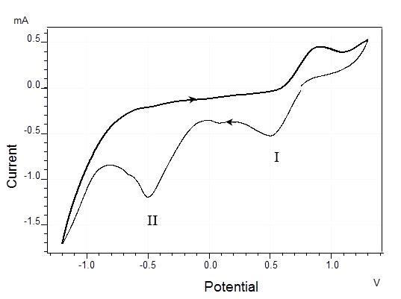
As can be seen from Figure 1, the electrochemical recovery of iron ions (III) at the cathode occurs in stages at 0.8 - (-1.2) V potential intervals. The first stage (I) at 0.8 - (-0.36) V potentials shows the reduction of Fe (III) to Fe (II) by the following reaction: Fe³⁺ + e⁻ = Fe²⁺.

Fig. 1. Cyclic current-voltage curves of the electroreduction of iron (III) ions on a Pt electrode in a non-aqueous medium. Electrolyte (M): 0.1 М Fe(NO₃)₃·9H₂O + CH₂OH-CH₂OH; Т = 293 К, Е_{V}=0.02 V/s.

The second peak corresponds to the reduction of Fe (II) to atomic iron at the -0.36- (-0.8) V potential, which coincides with.³⁴ After -0.8 V potential value, iron is deposited on the substrate.
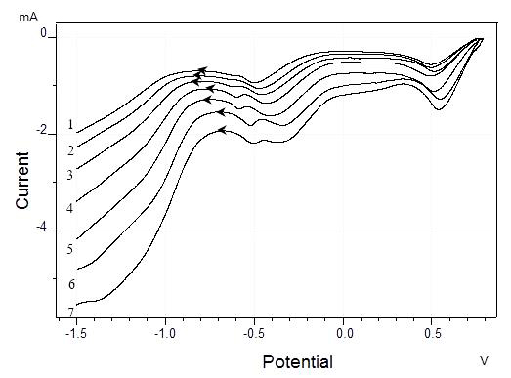

Fig. 2. The effect of temperature on the electroreduction of iron (III) ions. Electrolyte (M): 0.1 Fe(NO₃)₃·9H₂O + CH₂OH-CH₂OH; Т (К): 1- 288; 2- 298; 3- 308; 4- 318; 5- 328; 6- 338; 7- 348. Е_{V}=0.02 V/s

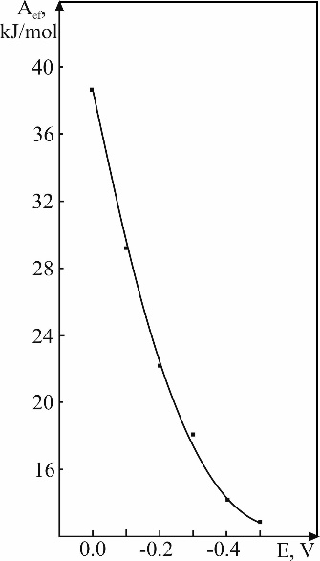
To study the kinetics of the electroreduction of iron (III) ions, polarization curves of a linear nature were recorded depending on the temperature at the 288-348 K temperature range. As can be seen from the Fig. 2, the potential of the electroreduction of iron (III) ions moves towards positive direction, and the current increases due to ion mobility with increase in temperature. With the help of these polarizing curves, the dependence of lgi_{k} – 1 / T at the 0.0 - (-0.5) V potential interval was constructed (Fig. 3 a) and tgα was calculated from the obtained graph. The value of the effective activation energy calculated using А_{eff.} = 2.3Rtgα equation shows that the electroreduction of iron ions (III) from non-aqueous electrolytes is accompanied by mixed kinetics. That is, in the 0.0 - (-0.2) V potential range the process flows electrochemically, and after -0.2 V by concentration polarization (Fig. 3 b).

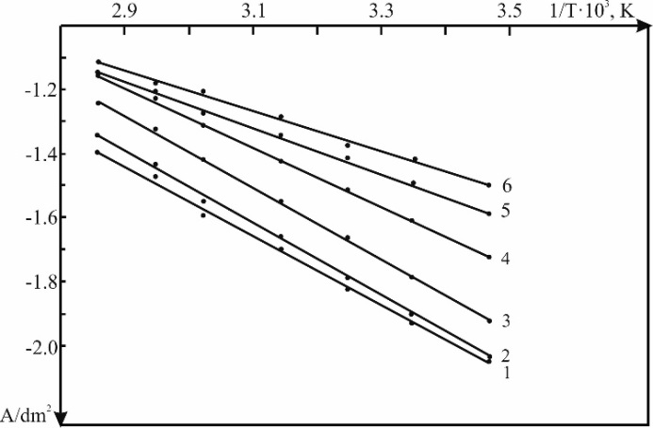

(a) (b)

Fig. 3. (a) lgi_{k} – 1/T dependence E(V) = 1- 0.0; 2- (-0.1); 3- (-0.2); 4- (-0.3); 5- (-0.4); 6- (-0.5). (b) Dependence of the activation energy upon electrode potential.

The effect of certain factors on the electroreduction of iron (III) ions has also been studied.
Polarization curves taken at various concentrations of iron (III) ions are presented in the Fig. 4. As can be seen from the curves, the rate of iron evolution at the cathode increases from -0.2 to -4.1 mA with increase in concentration of Fe³⁺ in the electrolyte. And the reduction potential shifts to the positive direction up to 0.05 V. This is due to the fact that, with an increase in the concentration of iron (III) ions in the electrolyte, the rate of approach of these ions to the electrode increases and electroreduction occurs earlier than the previous concentration.
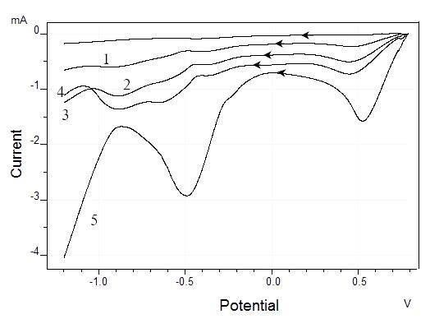

Fig. 4. The influence of the concentration of iron (III) ions on the electroreduction on the Pt electrode. Electrolyte (M): Fe(NO₃)₃·9H₂O + CH₂OH-CH₂OH; 1-0.005; 2- 0.05; 3- 0.1; 4- 0.15; 5- 0.2. Т = 293 К. Е_{V}=0.02 V/s

The influence of the scanrate on the electroreduction of iron (III) ions was also studied. Fig. 5 shows the cathodic potentiodynamic polarization curves of the process. As can be seen from the Fig. 5, with an increase in the scanrate, the current spent on the electroreduction of iron (III) ions increases. Hence, the current is - 9.112⋅10⁻⁴ А at 0.005 V / s, whereas - 2,76⋅10⁻³ А at 0.1 V / s.
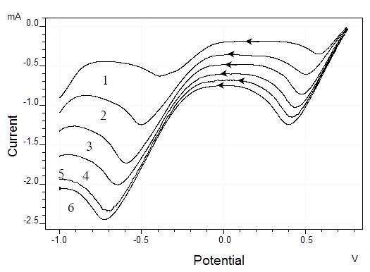

Fig. 5. The effect of the potential sweep on the electroreduction of iron (III) ions. Electrolyte (M): 0,1 Fe(NO₃)₃·9H₂O + CH₂OH-CH₂OH. Scanrate (V/s): 1-0,005; 2- 0,02; 3- 0,04; 4- 0,06; 5- 0,08; 6- 0,1. Т = 293 К.

The chronoamperometric (CA) method can be easily used for more precise information about the electrochemical deposition process, at which the potential can be stopped at the deposition potential (from CV). Mechanisms of the nucleation and growth of the electrodeposited particles can be studied via CA method. Current-time curves were carried out at different applied potentials of -0.4; -0.45; –0.5; –0.55; and –0.6 V at room temperature as shown in Fig. 6. It seems from the shown figure that the initial regime of the current-time curve is characterized by a sudden decrease in the current under application of the deposition potential. This can be attributed to the presence of the double-layer between the surface of the substrate and the ions of the solution, which lead to the formation of an immediate nucleation of iron in all cases (Fig. 6).
This sudden decrease is followed by a little increase in the resultant current. This is due to an increase in the electroactive surface area associated with the crystal growth. Note that, during electrodeposition, in all cases the current density increases by increasing the deposition potential. The mechanism of crystal nucleation and growth can be determined by the analysis of the obtained current-time curves.
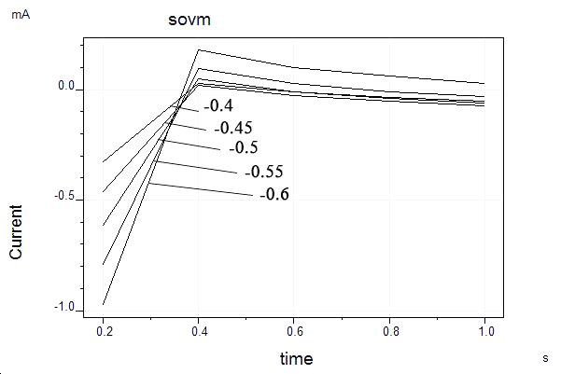

Fig. 6. Current-time curves of the electrodeposition of iron on Pt in the electrolyte of the 0.1 Fe(NO₃)₃·9H₂O + CH₂OH-CH₂OH composition at room temperature and at different deposition potentials: -0.4; -0.45; –0.5; –0.55; and –0.6 V vs. Ag/AgCl.

The analysis of these curves can be achieved by applying the two equations of Scharifker-Hills³⁵ comparing with the experimental calculated data as shown in Fig. 7 (a-e). The models of the theoretical transients for the instantaneous and the progressive 3D nucleation are given by equations (1) and (2), respectively:

$$\frac{I{\left(t\right)}^{2}}{I_{max}}= \frac{1.9542}{t/{t_{max}}} {\left\{1-exp\left[-1.2564\left[\frac{t}{t_{max}}\right]\right]\right\}}^{2} (1)$$

$$\frac{I{\left(t\right)}^{2}}{I_{max}}= \frac{1.2254}{t/{t_{max}}} {\left\{1-exp\left[-2.3367{\left[\frac{t}{t_{max}}\right]}^{2}\right]\right\}}^{2} (2)$$

Fig. 7 (a-e) shows the nondimensional I²/I²_{max} vs. t/t_{max} plots of the CA data at different conditions as in the Fig. 6. The solid lines of black and red color are the theoretical transients of the instantaneous and the progressive nucleation, and blue lines - for the experimental data. The nucleation and growth processes of iron at these conditions can be predicted from Fig. 7 (a-e). At the early stage, the experimental curve fits well with the curve of the progressive nucleation model by which the iron nucleation occurred on many active sites of Pt substrates. Subsequently, the deposition deviates from the instantaneous nucleation as shown in Fig. 7 (a, b, c, and d). The deviation from the ideal assumption of the Scharifker model may be attributed to that the nuclei grow under diffusion control at these conditions.
In fact, through time the nuclei growth and the electrodeposition of iron will be under mixed control (diffusion and charge transfer). The deviation can be also interpreted as due to the hydrogen reduction during the formation of nuclei which causes the morphology change of the nucleus. But, the experimental data for Fig. 7 e are in a good agreement with the theoretical model of the progressive nucleation and growth at -0.6 V deposition potential. Further information for the growth mechanism can be obtained by calculating the density of actives sites for nucleation (N₀);

$N_{0}$=0.065${\left(\frac{8CM}{}\right)}^{-1/2}{\left(\frac{zfC}{t_{max}i_{max}}\right)}^{2} (3)$

where, C the bulk concentration in mol cm^{–3}, zf the molar charge of electrodepositing species, M and ρ in g cm^{–3} are the molar mass and the density of the deposited material, respectively. The diffusion coefficient D of the active species in the electrolyte can be calculated via the chronoamperometric method. According to the theoretical nucleation model, the D is related to the i_{max} and the t_{max}^{35, 36} by the following equation;

D=$\frac{{ i_{max}}^{2}t_{max}}{0.1629(zfC)} (4)$

The values of i_{max}, t_{max}, D, and N₀ at different deposition potentials and temperatures are shown in the Table 1. The D values at these conditions of the electroactive species are very small due to the high relative density of the electrolyte and the high relative diameter of iron ions. The value of D is affected by the polarization potential as seen in Table 1.

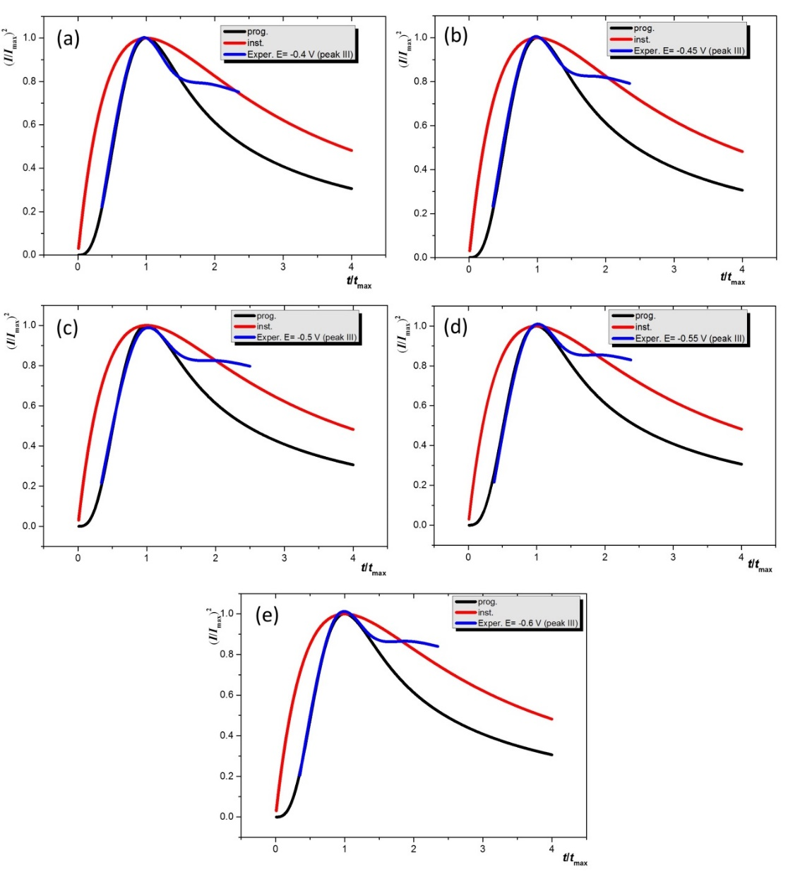

Fig. 7. Comparison of the theoretical non-dimensional (I / I_{max})² vs (t / t_{max}) plots for instantaneous (red) and progressive (black) nucleation with experimental data (blue) of potentiostatic transients from of 0.1 Fe(NO₃)₃·9H₂O + CH₂OH-CH₂OH at different constant potentials: (a) -0.4, (b) -0.45, (c) -0.50, (d) -0.55 and (e)-0.6 V

It is noted from the table that nuclei densities N₀ decrease significantly with the increase of the deposition potential. This decrease with the applied deposition potential is generally understood as the decrease of the activation of the nucleation sites at higher potentials, which deviates from the classical nucleation models as confirmed by Fig. 6. This deviation can also be explained as, by increasing the deposition potential the polarization of the working electrodes increases but the diffusion of the active species is still slow because of the high density of surrounding media which hinder the diffusion of the active species.

Table 1. Experimental data on the electrodeposition of Fe on a Pt electrode

E, V | D, cm² s⁻¹ | N_{o}, cm²
-0.40 | 1.429×10⁻¹⁷ | 5.00×10¹⁵
-0.45 | 6.556×10⁻¹⁸ | 10.09×10¹⁵
-0.50 | 3.619×10⁻¹⁷ | 1.98×10¹⁵
-0.55 | 1.468×10⁻¹⁶ | 0.49×10¹⁵
-0.60 | 5.240×10⁻¹⁶ | 0.14×10¹⁵

Using the data of XRD (Fig. 8) and SEM (Fig. 9) analyzes of the obtained films on the Ni electrode, the deposition of iron (III) was confirmed.
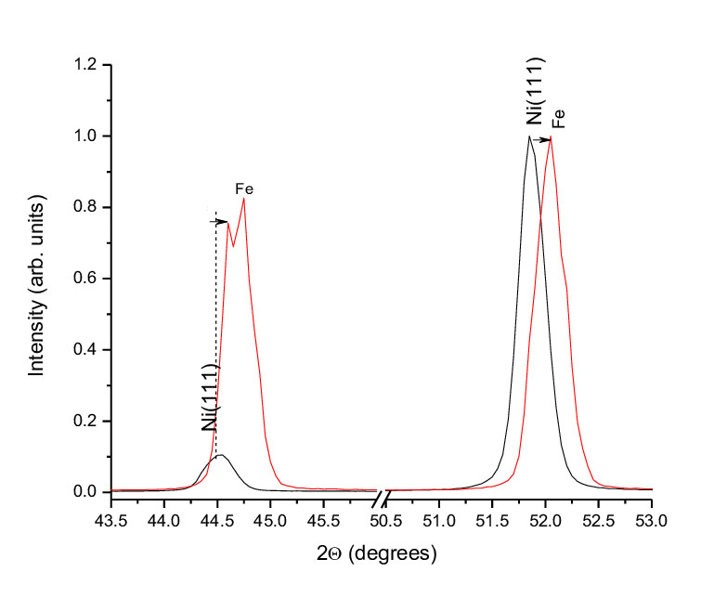

Fig. 8. The results of XRD analysis of electrodeposited iron from the 0.1 М Fe (NO₃)₃ × 9H₂O + CH₂OH electrolyte on the Ni electrode. E_{V} = 0.02 V / s, T = 293 K.

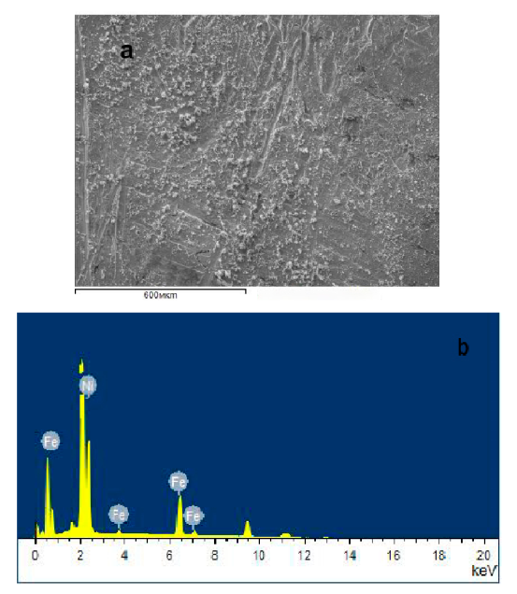

Fig. 9. The results of SEM analysis of electrodeposited iron from the 0.1 М Fe (NO₃)₃ × 9H₂O + CH₂OH electrolyte on the Ni electrode. E_{V} = 0.02 V / s, T = 293 K.

SEM images show that nickel substrates are coated. They are relatively homogeneous and have few cracks (Fig. 9). However, judging by the X-ray, these coatings are very thin (Fig. 8). Nickel peaks are also shifted towards large diffraction angles 2θ. This is because of a slight contraction of the crystal lattice due to the incorporation of iron atoms into the nickel lattice. All experimental results show that in order to carry out the process and obtain compact, smooth precipitation, an efficient electrolyte composition is 0.1 М Fe (NO₃)₃ $·$ 9H₂O + CH₂OH-CH₂OH at 293 K and a potential range of 0.6 - (- 0.9) V.
- CONCLUSION
Electrochemical reduction of iron (III) ions on Pt electrodes from ethylene glycol solution was studied by the potentiodynamic method. During the study of kinetics and mechanism of the process by the cyclic and linear polarization curves, it was revealed that the nature of polarization is accompanied by mixed kinetics. Being that, at the 0.0 - (-0.2)V potential interval, the process proceeds electrochemically, whereas after -0.2 V - by concentration polarization.
Obtained experimental results show that the electroreduction of iron (III) ions is affected by the concentration of the same ions, temperature, etc. Using these results, we selected the optimal mode and composition of the electrolyte for preparation of the compact and smooth iron films since at these conditions, SEM and XRD data confirm the deposition of thin Fe films.

5. REFERENCES

1. MdA Hossain, BA Merzougui, FH Alharbi, N Tabet, Sol. Energy Mater. Sol. Cells 2018, 186, 165-174. DOI: 10.1016/j.solmat.2018.06.026
2. B Altiokka, AK Yildirim, J. Korean Phys. Soc. 2018, 72, 687-691. DOI: 10.3938/jkps.72.687
3. GM Huseynov, NA Mammadova, HA Imanov, Chemical Problems. 2017, 15, 329-334. DOI: 10.32737/2221-8688-2017-3-329-334
4. VA Majidzade, Chemical Problems. 2018, 3, 331-336. DOI: 10.32737/2221-8688-2018-3-331-336
5. ASh Aliyev, VA Majidzade, NSh Soltanova, DB Tagiyev, VN Fateev, Chemical Problems. 2018, 2, 178-185. DOI: 10.32737/2221-8688-2018-2-178-185
6. P Prabukanthan, R Lakshmi, TR Kumar, S Thamaraiselvi, G Harichandran, Adv. Mater. Proc. 2017, 8, 521-525. DOI: 10.5185/amp.2017/811
7. MR Palacín, P Simon, JM Tarascon, Acta Chim. Slov. 2016, 63, 417-423. DOI: 10.17344/acsi.2016.2314
8. VN Fateev, OK Alexeeva, SV Korobtsev, EA Seregina, TV Fateeva, AS Grigoriev, ASh Aliyev, Chemical Problems. 2018, 4, 453-483. DOI:10.32737/2221-8688-2018-4-453-483
9. TL Kulova, II Nikolaev, VN Fateev, ASh Aliyev, Chemical Problems. 2018, 1, 9-34. DOI: 10.32737/2221-8688-2018-1-9-34
10. VN Fateev, TL Kulova, EA Seregina, NA Ivanova, DD Spasov, Chemical Problems. 2019, 3, 349-357. DOI: 10.32737/2221-8688-2019-3-349-357
11. V Aluri, KTR Reddy, YM Reddy, Nanotechnol. Rev. 2015, 4, 469-472. DOI: 10.1515/ntrev-2014-0043
12. X Wang, G Wang, J Chen, X Zhu, J Tian, C Jiang, Y Zhang, X Liu, R Wang, Mater. Lett. 2013, 110, 144-147. DOI: 10.1016/j.matlet.2013.07.107
13. A Gomes, JR Ares, IJ Ferrer, MI da Silva Pereira, C Sanchez, Mater. Res. Bull. 2003, 38, 1123-1133. DOI: 10.1016/S0025-5408(03)00116-8
14. YZ Dong, YF Zheng, H Duan, YF Sun, YH Chen, Mater. Lett. 2005, 59, 2398-2402. DOI: 10.1016/j.matlet.2005.03.025
15. YZ Dong, YF Zheng, XG Zhang, H Duan, YF Sun, YH Chen, Sci. China Technol. Sci. 2005, 48, 601-611. DOI: 10.1360/102004-32
16. S Nakamura, A Yamamoto, Sol. Energy Mater. Sol. Cells. 2001, 65, 79-85. DOI: 10.1016/S0927-0248(00)00080-5
17. IG Orletskii, PD Mar’yanchuk, EV Maistruk, MN Solovan, VV Brus, Phys. Solid State. 2016, 58, 37-41. DOI: 10.1134/S1063783416010224
18. SL D´ıaz, JA Caldero´n, OE Barcia, OR Mattos, Electrochim. Acta. 2008, 53, 7426-7435. DOI: 10.1016/j.electacta.2008.01.015
19. R Böck, S-E Wulf, Trans. Jnst. Met. Fin. 2009, 87, 28-32. DOI: 10.1179/174591908X379601
20. M Deelo, K Weil, KA Osseo-Asare, In Electrochem. in Miner. Metal Proc. VII. 2006, 293-303. DOI: 10.1179/174591908X379601
21. P Giridhar, B Weidenfeller, El Abedin S Zein, F Endres, Phys. Chem. Chem. Phys. 2014, 16, 9317-9326. DOI: 10.1039/C4CP00613E
22. SS Abd El Rehin, EA Abd El Meguid, EM Moustafa, Trans. Jns. Met. Fin. 2003, 81, 79-82.
23. NV Evreinova, IA Shoshina, VN Naraev, KI Tikhonov, Russ. J. of Appl. Chem. 2008, 81, 1180-1183. DOI: 10.1134/S1070427208070100
24. Z Zhang, A Kitada, K Fukami, Z Yao, K Murase, Electrochim. Acta. 2020, 348, 136289. DOI:10.1016/j.electacta.2020.136289
25. VA Majidzade, ASh Aliyev, I Qasimogli, PH Quliyev, DB Tagiyev, Inorg. Mater. 2019, 55, 979-983. DOI: 10.1134/S0020168519100108
26. VA Majidzade, ASh Aliyev, PH Guliyev, DM Babanly, J. Electrochem. Sci. Eng. 2020, 1, 1-9. DOI:.5599/jese.676
27. VA Majidzade, Chemical Problems. 2020, 18, 181-198. DOI: 10.32737/2221-8688-2020-2-181-198
28. ASh Aliyev, M Elrouby, SF Cafarova, Mater. Sci. Semicond. Proces. 2015, 32, 31-39. DOI: 10.1016/j.mssp.2015.01.006
29. VA Majidzade, SF Cafarova, ASh Aliyev, NB Farhatova, YA Nuriyev, DB Tagiyev, Azerbaijan Chemical Journal. 2019, 1, 6-13. DOI: 10.32737/0005-2531-2019-1-6-13
30. VA Majidzade, SF Cafarova, ASh Aliyev, DB Tagiyev, Azerbaijan Chemical Journal. 2018, 3, 6-10. DOI: 10.32737/0005-2531-2018-3-6-10
31. АSh Aliyev, ShО Eminov, NSh Sultanova, VА Mejidzadeh, DА Kuliyev, D Jalilova, DB Tagiyev, Chemical Problems. 2016, 14, 139-145.
32. VA Majidzade, PH Guliyev, ASh Aliyev, M Elrouby, DB Tagiyev, J. Mol. Struc. 2017, 1136, 7-13. DOI: 10.1016/j.molstruc.2017.01.082
33. VA Majidzade, ASh Aliyev, DM Babanly, M Elrouby, DB Tagiyev, Acta Chim. Slov. 2019, 66, 155–162. DOI: 10.17344/acsi.2018.4733
34. AA Sukhotin (Ed): Handbook of Electrochemistry, Chemistry, Leningrad, Russian, 1981, p. 488.
35. B Scharifker, G Hills, Electrochim. Acta. 1983, 28, 7, 879– 889. DOI:10.1016/0013-4686(83)85163-9
36. MR Khelladi, L Mentar, A Azizi, A Sahari, A Kahoul, Mater. Chem. Phys. 2009, 115, 385-390. DOI:10.1016/j.matchemphys.2008.12.017

