Application of Chemically Modified Industrial Slag to As(III) Adsorption from Wastewater: Kinetics and Mass Transfer Analysis

Arijit Dutta Gupta¹, Vivek Jaiswal², Vivek Bhadauria³, and Harinder Singh^{1*}

¹Department of Chemical Engineering, Motilal Nehru National Institute of Technology Allahabad, Prayagraj - 211004, India
²Department of Chemical Engineering & Technology, Indian Institute of Technology (BHU), Varanasi – 221005, India
³Department of Chemistry, Ewing Christian College, Prayagraj – 211003, India

*Corresponding author
Email:- harinderpdfb@gmail.com
Mob. No.:- +91-9936393111

Abstract
Presence of low concentration (1-5 mg/L) As(III) in water presents a challenging problem in its removal. In the present study, brick kiln slag (BKS) has been utilized for low concentration As(III) adsorption in batch mode. BKS was modified with H₂SO₄ (SA) and NaOH (SB) for enhancing As(III) uptake capacity. Maximum adsorption capacity (13.7 mg/g) was observed for SA at 298 K, pH = 7.0, adsorbent dose = 0.3 g and time = 70 min which was 1.4 times higher than that of SB. Adsorption data modelled into Freundlich isotherm and pseudo second order kinetics. Mass transfer coefficients decreased with increase in As(III) concentration. Film diffusion significantly dominated the adsorption of As(III) ions irrespective of the initial concentration. Dimensionless Sherwood number (Sh) interrelated As(III) concentration (C_{o}) as Sh = 2.97(C_{o})^{-0.376}, Sh = 4.12(C_{o})^{-0.215}, Sh = 4.83(C_{o})^{-0.588}, respectively, for SA, SB and BKS. Low temperature (298 K) favoured As(III) adsorption (based on ∆G° value). Therefore, the modified slag can be used as an effective adsorbent for As(III) remediation from groundwater.

Keywords: - As(III) adsorption; Industrial slag; Mass Transfer; Film diffusion; Sherwood number.

Introduction
In the recent years, rapid industrialization has led to an alarming increase in the contamination of heavy metals in soil and water bodies due to accumulation of various pollutants discharged from the industrial waste water. Imprudent use of such metalloids and heavy metals causes to concentrate in aquatic flora and fauna via discharge in water bodies. Arsenic is a metalloid with atomic number 33. The earth’s crust comprises of about 0.00005% of arsenic. Rocks and other minerals contain about 0.5-2.5 mg/kg and usually occur in combination with other metals or non-metals, sulphur and phosphorites.¹⁻³ Mobilization of arsenic takes place either in the form of natural phenomena such as weathering, volcanic eruptions, mining of gold, combustion of fossil fuels, smelting processes, agricultural pesticides or leaching of synthetic arsenic pollutants via soil.⁴ Long term exposure to arsenic in drinking water causes lung, kidney and skin cancer, disordering of bone marrow and cartilages, neurological disorders, cardiovascular diseases, abdominal pain and gastrointestinal diseases. Based on the toxicity level of arsenic in drinking water, World Health Organization (WHO), 0.01- 0.05 mg/L is recommended as maximum permissible arsenic concentration in drinking water.¹
Adsorption is a time dependent separation process. The transport of As(III) from the adsorbate (liquid phase) to the adsorbent (solid phase) is typically carried out by mass transfer operation due to the presence of concentration gradient between the adsorbate and the adsorbent. The slowest of these steps is the rate-determining step and is said to control the overall adsorption process. Moreover, in a well agitated solid-liquid co-current or counter current adsorber, liquid mixing is quite rapid. Therefore, a uniform concentration is assumed between the adsorbate concentration and the solute particles within the system. This step is also referred as the equilibrium step, because the equilibrium between the solute in the bulk adsorbate and the solute on the film of the adsorbent is achieved instantaneously. Therefore, adsorption process mainly constitutes two types of mass transfer resistances i.e. external and internal diffusion resistances. The rate limiting step depends on various physical factors such as size of the adsorbent particle, solute affinity for the particular adsorbent and the degree of mixing.^{5,6}
Difference in chemical potential acts as the driving force for any mass transfer operation which is well defined through their thermodynamic gradients. For any mass transfer operation or any separation processes, theoretical extent of a given separation depends on the position of thermodynamic equilibrium, while the actual rate of separation depends on the rate of mass transfer which is manifested by additional parameters such as flow patterns and diffusivities of the given species in a particular phase.⁶ The actual rate of mass transfer is quantified through the application of various mass transfer coefficients. Such mass transfer coefficients are generally represented in terms of dimensionless numbers such as Sherwood numbers, Transport numbers etc.⁷
Various chemically modified adsorbents for As(III) adsorption have been reported in literature. As(III) adsorption using chemically modified activated carbon was reported to show an adsorption capacity of around 8.7 mg/g.⁸ Chemical modification of water melon rind showed a maximum arsenic removal percentage of around 94%.⁹ Arsenic removal using stainless steel slag was found to show an adsorption capacity of 13.7 mg/g.¹⁰ Chemical modification of pine wood biochar by the researchers Wang et al., 2015 was found to exhibit maximum arsenic capacity of 5.0 mg/g.¹¹ Iron ore scrap exhibited an As(III) adsorption capacity of 0.74 mg/g.¹² However, these studies dealt with high initial concentration of As(III) ions which required a large mass transfer driving force.
The objective of the present study is to determine the applicability of brick kiln slag, as an industrial waste as an adsorbent for low concentration As(III) ions from wastewater. Chemical modification of the slag has been done in order to increase the increase the affinity for As(III) adsorption. Mass transfer coefficients have been evaluated through the use of various mass transfer models to determine the rate controlling step for adsorption of As(III) using native and chemically modified brick kiln slag. Since the study of mass transfer analysis for adsorption of As(III) adsorption is limited in the literature, this work is being reported for the first time in literature wherein the rate-limiting steps have been determined through various mass transfer models and dimensionless Sherwood number for batch adsorption of As(III) ions.

Materials and Methods
All chemicals were of AR grade without further purification. Sulphuric acid (H₂SO₄), hydrogen peroxide (H₂O₂) and sodium hydroxide (NaOH) were purchased from Merck. The glass wares were cleaned with potassium dichromate 1% and HNO₃ solution and rinsed several times with distilled water before use.

Preparation of Adsorbents
The brick kiln slag (BKS) was collected from a local brick kiln from Prayagraj District, India. Prior to chemical modification, the brick kiln slag was passed through 200 mesh screen to obtain uniform sized particles and washed several times with double distilled water to remove the suspended impurities thereafter chemical activation was done using 10% (v/v) hydrogen peroxide (H₂O₂) and subsequently dried in a hot air oven at 100°C for 24 h. The obtained kiln slag was modified with 0.5 M solution of H₂SO₄ and NaOH at room temperature followed by stirring for another 6 h. The obtained adsorbents were the sonicated for another 30 min at 30°C to prevent agglomeration of flocs. The mixture was then centrifuged and washed several times with distilled water and ethanol till the pH of the supernatant was neutral. The adsorbent samples were then dried in a hot air oven at 120°C overnight and stored in desiccators for further use. The synthesised adsorbents were labelled as SN, SA and SB respectively, for native, acid modified and alkali modified slag. The physical properties of the native and the chemically modified adsorbents have been summarised in Table 1.
Table 1 Physical properties of the native and chemically modified brick kiln slag (BKS)
Properties | Native BKS | H₂SO₄ modified BKS | NaOH modified BKS
Bulk density (g/cm³) | 1.78 | 1.82 | 1.84
Particle size (µm) | 10.05 | 9.34 | 9.45
Porosity | 0.231 | 0.265 | 0.248
Point of zero charge (pH_{zpc}) | 9.1 | 8.21 | 8. 15
Surface area per unit volume of the particle (m⁻¹) | 12685.6 | 12795.5 | 12845.7

Batch Adsorption Experiment
Batch adsorption experiments were carried out by varying the initial adsorbate concentration from 1 to 5 mg/L at pH = 7.0. Adsorption was carried out using 100 mL of As(III) solution containing the adsorbent by stirring (200 rpm) at room temperature (25 ± 2°C). Presence of As(III) in solution was determined by variamine oxidation method.¹³ The As(III) ions capacity at equilibrium was determined from the Eq. (1):
$q_{e}=\frac{\left(C_{i}-C_{e}\right)}{m}×V$ (1)
The removal percentage was calculated from the Eq. (2):
$\%Removal=\frac{(C_{i}-C_{e})}{C_{i}}×100$ (2)
where q_{e} is the adsorption capacity at equilibrium (mg/g), C_{i} and C_{e} are the initial and equilibrium adsorbate concentration (mg/L), m is the adsorbate mass (g), V is the volume of the solution (L).

Adsorbent Characterizations
The adsorbent samples were washed with acetone, dried in hot air oven, pulverised and then subjected to gold coating in a vacuum sputtering unit for 15 min to increase the conductivity of the samples. SEM analysis of the adsorbent samples was done using Zeiss Evo MA-15 scanning electron microscope. The adsorbent samples were dried in an oven to remove any residual moisture and FTIR Analysis was performed using PerkinElmer Spectrum Version 10.03.06. X-Ray Diffraction analysis was carried out using Rigaku Smart Lab 3KW X-Ray diffractometer at 2θ = 5°- 70° with a step size of 0.02° using Cu-Kα radiation at 50kV voltage and 40mA current.

Theoretical Mass Transfer Models
In any adsorption process, the transfer of adsorbate from the bulk solution to the solid adsorbent takes place either due to film diffusion or internal pore diffusion. The rate limiting step is determined from the slowest of these steps. Therefore, in order to determine the rate controlling step, various theoretical mass transfer models and some dimensionless numbers have been analyzed in the present study.
External Diffusion Model
Liquid film diffusion or external diffusion model plays an important role in adsorption, when there is transfer of molecules from the bulk adsorbate solution to the solid phase adsorbent boundary. This model assumes the fact that the adsorbate concentration at the solid adsorbent’s surface tends to zero or intraparticle diffusion resistance is negligible and thus it can be neglected at the initial contact times. This model is derived based on Fick’s first law of diffusion expressing difference in solute concentrations in the bulk adsorbate and that at the adsorbent’s interface as a function of time.¹⁴ The change in the solute concentration as a function of time can be written as in Eq. (3):
$\frac{dC}{dt}=-k_{f}A(C-C_{o})$ (3)
The above equation may be simplified as:-
${\left[\frac{d(\frac{C}{C_{o}})}{dt}\right]}_{t→0}=-k_{f}A$ (4)
where C is the bulk adsorbate concentration in mg/L at any time t, C_{o} is the initial adsorbate concentration in mg/L, k_{f} is the external mass transfer coefficient in m/s and A is the surface area per unit volume (m⁻¹). It is given by Eq. (5):
$A=\frac{6M}{Vd_{p}ρ(1-ε)}$ (5)
where V is the adsorbate volume in L, M is the mass of the adsorbent in g, d_{p} is the particle diameter in m, ε is the particle porosity and ρ is the bulk density of the adsorbent in g/cm³. External mass transfer coefficient k_{f} can be determined from the slope of the dimensionless cure of C/C_{o} vs time (t).
Boyd Model
An exact mechanism of As(III) adsorption mechanism is easier to predict by examining the differences between the intraparticle and external diffusion model. The equation for Boyd mass transfer model is represented in Eq. (6):
$F=1-\frac{6}{π^{2}}exp⁡(-Bt)$ (6)
$F\left(t\right)=\frac{q_{t}}{q_{e}}$ (7)
where F(t) is the fraction of As(III) ions adsorbed at any time t and Bt is a mathematical function of F. The simplified way of writing the above equation is represented in Eq. (8):
$Bt=[-0.4977-\ln\left(1-F\right)]$ (8)
For the adsorption process to be controlled by film diffusion, the plot of [-0.4977-ln(1-F)] against t should not pass through origin.

McKay et al. Model
This model is used to analyse the effect of mass transfer resistance on the rate of adsorption. The mass transfer coefficient β_{L} in m/s of As(III) at the adsorbate-adsorbent interface can be determined by Eq. (9):
$ln\left(\frac{C}{C_{o}}-\frac{1}{1+mK}\right)=ln\left(\frac{mK}{1+mK}\right)-\left(\frac{1+mK}{mK}\right)β_{L}At$ (9)
$K=q_{m}×k_{L}$ (10)
where q_{m} is the maximum adsorption capacity in mg/g and k_{L} is the Langmuir constant in L/mg. β_{L} is calculated from the slope of the linear plot of ln((C/C_{o}) – 1/(1+ mk_{L})) vs time (t).

Dimensionless Numbers
Sherwood Number
Sherwood Number (Sh) relates the rate of adsorption process as a function of adsorbate concentration. A relation between external and internal mass transfer resistance is expressed in terms of Sherwood number. It is the ratio of rate of solute transfer across the adsorbate (liquid) surface to the rate of intraparticle mass transport. It is expressed in the form of Eq. (11):
$Sh=\left(\frac{k_{f}}{D_{e}}\right)\left(\frac{d}{ρ}\right)\left(\frac{C_{o}}{q_{m}}\right)$ (11)
where ρ is he particle density in g/cm³ and q_{m} is the maximum adsorption capacity in mg/g (calculated from Langmuir isotherm model). The conventional form of Sherwood Number may be expressed in the form of Eq. (12):
$Sh=\frac{k_{f}d}{D_{e}}$ (12)
The process is film diffusion controlled if Sh < 1.0, while Sh > 1.0 infers intraparticle diffusion as the rate-limiting step.

Transport Number
Transport Number (n) is used to determine the mode of diffusion. It is given by Eq. (13):
$\frac{q_{t}}{q_{e}}=K_{m}t^{n}$ (13)
where K_{m} is the adsorbent-adsorbate interaction constant and n is the transport number. A plot of log (q_{t}/q_{e}) vs. log t yields a straight line from which K_{m} and n can be calculated from the y-intercept and slope respectively. If n = 1, non-Fickian mechanism is inferred while n = 0.5, represents Fickian (surface) mechanism.
Results and Discussion
Adsorbent Characterizations
Fourier Transform Infrared Spectroscopy (FTIR)
The FTIR spectra of the native and modified adsorbents have been presented in Fig. 3(a). The sharp peak around 3500 cm⁻¹ corresponding to H-O-H stretching was due to the presence of moisture in the samples. The major peak corresponding to 1050 cm⁻¹ was attributed to asymmetric stretching of Si-O-T (T = Si or Al). The peak intensity was found to be relatively less in SA adsorbent as compared to SN and SB. This may be due to the reaction between silicon (II) oxide and sulphuric acid resulting in the formation of sulphur dioxide and water.¹⁵ Another sharp peak was observed around 1490 cm⁻¹ in the FTIR spectra of acid modified slag (SA). This was due to the presence of stretched vibrations of O-C-O bond of CO₃²⁻ which may be attributed to carbonation reaction to form carbonates and bicarbonates. The peak corresponding to wavenumber 870 cm⁻¹ which was present in all adsorbent samples was attributed to the asymmetric stretched vibrations of tetrahedral aluminium ions which confirmed the presence of structures of AlO₄ and SiO₄ in different configurations.¹⁶ The absorption bands of slag consisting of clay showed stretching and bending of Si-O as well as bending of O-H groups in the wavenumbers ranging from 1300-1450 cm⁻¹ were seen in all the adsorbent samples. A peak around 750-780 cm⁻¹ may be attributed to presence of vibrational Si-O-Al bonds suggesting the presence of feldspar in all the samples. The bands around 500-550 cm⁻¹ were assigned to octahedral Si-O-Al and Si-O-Si respectively. A small peak around 790 cm⁻¹ which was present in all adsorbents was attributed to the presence of quartz.¹⁷
X-Ray Diffraction Analysis (XRD)
Fig. 3(b) shows the XRD diffraction patterns of the native and modified slag. The presence of sharp peak around 2θ = 25° in the acid and alkali modified slag indicated greater crystallinity as compared to native slag. The small peak around 2θ = 20° was attributed to the presence of feldspars in the adsorbent samples.¹⁸ However, the intensity of these peaks in the modified adsorbents has been reduced as compared to the native adsorbent. Reaction between acid in SA and alkali in SB adsorbents and sodium silicate in slag resulting in the formation of insoluble precipitated silica may be attributed as one of the reason for this decrease in peak intensity. Presence of cristobalite in all adsorbent samples is confirmed by the presence of minute peaks occurring in 2θ = 30-60°. Cristobalite is found in may clays such as bentonite, diatomite and has been reported to show adsorption characteristics.¹⁹
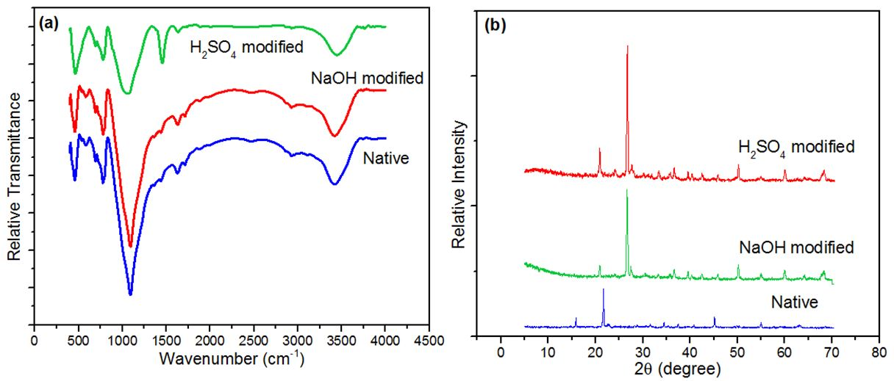
Fig. 1 (a) FTIR spectra and (b) XRD patterns of the native and chemically modified slag
Scanning Electron Microscopy (SEM)
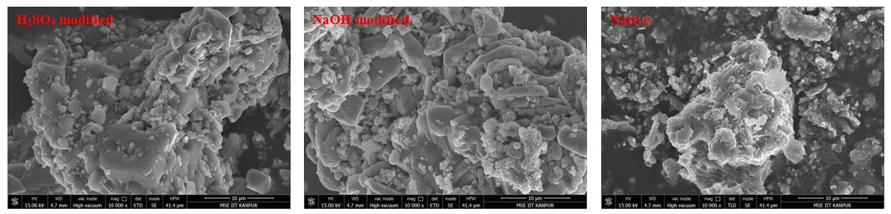
The SEM micrographs of the native and modified adsorbents have been shown in Fig. 2. Relatively thick and homogeneous morphology resulting from processing of bricks at high temperature was seen in all the adsorbent samples. The modified slag samples represented relatively high porosity as compared to the native. The acid modified adsorbent sample was observed to have porous surface morphology with minute cracks generation. These cracks may have been created due to elevated oxidizing property of H₂SO₄ that breaks down the crystal lattice of the calcined clay. However, soluble sodium silicate was formed when the adsorbent was treated with alkali which was washed out with water thus resulting in equal and lesser porosity of the NaOH modified adsorbent as compared to native.²⁰

Fig. 2 SEM micrographs of the native and chemically modified slag
Adsorption Study
Effect of Contact Time
In order to investigate the effect of time on the adsorption, the study was performed using 100 mL of 1 mg/L of As(III) ions solution using 0.25 g of each adsorbent. It was observed that the relative removal percentage of As(III) ions increased with contact time with saturation occurring after 75 and 120 min respectively for acid and alkali modified and native slag (Fig. 3(a)). Presence of the concentration gradient between those of the adsorbed and the unadsorbed molecules and the availability of vacant sites provided the necessary driving force for increase in adsorption capacity over time.²¹ Greater number of As(III) ions were adsorbed at the onset of adsorption due to greater number of available active sites. It was also observed that the SB adsorbent exhibited the lesser adsorption capacity than the acid modified slag with the same saturation time. This was probably due to oxidising tendency and greater porosity of the SA adsorbent than that of native. Saturation of the active sites may be ascribed to the presence of repulsive forces between the adsorbed As(III) ions and the bulk adsorbate concentration.
Effect of Adsorbent Dose
The effect of adsorbent dose on removal percentage of As(III) ions has been shown in Fig. 3(b). Adsorbent dose was increased from 0.1 to 0.9 g/100 mL at pH = 7.0 in order to study its effect on adsorption. Initially the removal percentage of As(III) ions was found to increase with adsorbent dose with saturation reaching at 0.3 and 0.6 g/100 mL respectively for acid and alkali modified and native furnace slag respectively. Decrease in removal capacity of As(III) ions beyond the equilibrium may be probably due to increase in mass transfer resistance which decreased the relative uptake capacity of As(III) ions from its aqueous solution.²² It can also be inferred from Fig. 3(b) that acid modified slag showed greater adsorption capacity than alkali modified slag with the same adsorbent dose due to the oxidising tendency of acid than alkali. Another reason may be attributed to the presence of surface charge resulting in increase of binding tendency of As(III) ions on the surface of the acid modified adsorbent. Lower removal percentage for alkali modified slag than that of acid modified with same adsorbent dose may be due to the reaction of alkali and silica in slag resulting in the formation of some insoluble precipitates of silicates which hindered the adsorption capacity of As(III) ions.²⁰
Effect of pH
The pH of the adsorbate was varied from 2.0 to 10.0 at a fixed adsorbate concentration in order to study its effect on the adsorption capacity of As(III) ions. It was observed from Fig. 3(c) that the adsorption capacity was minimum at acidic pH. The maximum adsorption took place at pH = 7.0 (> 95%) while at alkaline pH the removal capacity of As(III) ions decreased steeply irrespective of the nature of the adsorbent. As(III) ions are predominantly available as H₃AsO₃ and H₂AsO₃⁻ in the pH range of 4.0-9.0. Moreover at neutral pH, H₃AsO₃ species are predominant while on further increasing the pH, these species are reduced to negatively charged ions such as H₂AsO₃⁻ and H₂AsO₃²⁻. As the surface of all the adsorbents is positively charged up to pH_{ZPC}, As(III) ions can be adsorbed by electrostatic force of attraction between the neutral species from the positively charged surface of the adsorbent. The maximum removal percentage at neutral pH may be due to the Van-der-wall’s forces of attraction between H₃AsO₃ (neutral) and the adsorbent’s surface. This may result in the binding tendency of these neutral species to the available positively charged surface of the adsorbent. At alkaline pH, the dominating negatively charged species are formed resulting in electrostatic repulsion between the negatively charged surface of the adsorbent and such negatively charged ions thereby reducing the relative uptake capacity of As(III) ions from its aqueous solution at higher pH.²³ Under optimised condition of pH (~7.0), As(III) ions are capable of bonding with sulphate ions on the surface of the acid modified slag releasing a water molecule as a by-product while arsenate ions can bind with the hydrogen ions forming weak arsenious acid. In the case of alkali modified slag, arsenic (III) oxides have the tendency to bind the sodium ions forming sodium arsenite.²⁴ The probable mechanism has been illustrated in Scheme1.
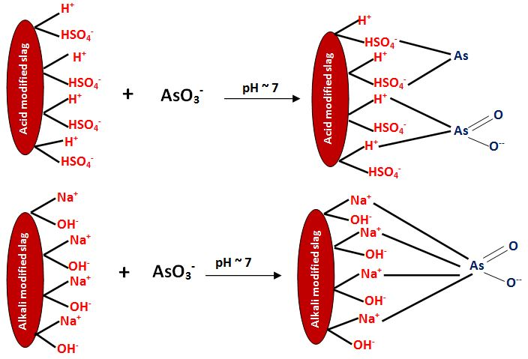
Scheme 1 Schematic representation of the proposed mechanism for As(III) ions adsorption using acid and alkali modified industrial slag at pH = 7.0 and temperature = 298 K
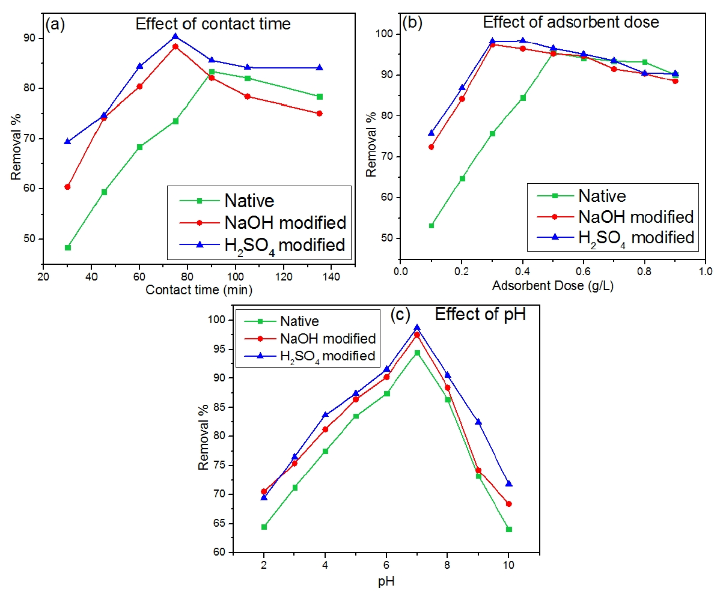
Fig. 3 Influence of (a) Contact time; (b) Adsorbent dose; (c) pH on the adsorption of As(III) using native and modified brick kiln slag at 298 K

Adsorption Kinetics
Kinetics of adsorption dictates the dependence of adsorption capacity with time. Adsorption experiments were performed using 0.3 g each of SA and SB and 0.6 g of SN at pH = 7.0 and temperature = 298 K. Acid and alkali modified slag exhibited a rapid uptake time for the first 75 min and then the rate of adsorption decreased and equilibrium was attained in 100 min. In the present study, three kinetic models (pseudo first order kinetic, pseudo second order kinetic and intraparticle diffusion models) have been employed to study the behaviour of experimental adsorption capacity with time.
Pseudo first order kinetic model is represented in Eq. (14):
$\ln\left(q_{e}-q_{t}\right)=lnq_{e}-k_{1}t$ (14)
Pseudo second order kinetic model can be represented in Eq. (15):
$\frac{t}{q_{t}}=\frac{1}{k_{2}q_{e}^{2}}+\frac{t}{q_{e}}$ (15)
where q_{e} and q_{t} represents the equilibrium and instantaneous adsorption capacities in mg/g, k₁ and k₂ are the first and second order rate constants respectively. Intraparticle diffusion model is represented in Eq. (16):
$q_{t}=K_{id}t^{1/2}$+C (16)
where K_{id} is the intraparticle rate constant in mg/g.min^{1/2} and C is the y-intercept.
The kinetic plots for As(III) adsorption using native and modified slag has been presented in Fig. 4 and the parameters are tabulated in Table 2. It can be seen from the table that the R² values obtained from the pseudo first order kinetic model was significantly low irrespective of the nature of the adsorbent. The obtained values of rate constants (k₁) were 0.033, 0.028 and 0.035 min⁻¹ respectively, for H₂SO₄ modified, NaOH modified and native. The theoretically obtained values of q_{e} were 8.2, 3.2 and 1.2 mg/g respectively which were observed to be much lower than the values obtained from the experiments (14.2, 12.05 and 7.32 mg/g). Thus it can be inferred that pseudo first order kinetic model did not give a good correlation with the experimental values irrespective of the type of modification. The rate constant values (k₂) obtained from the pseudo second order kinetic plots were 6.6 × 10⁻⁵, 3.1 × 10⁻⁴ and 2.6 × 10⁻³ g(mg.min)⁻¹. The values of the initial rate constant (h = k₂.q_{e}²) were 7.4 × 10⁻³, 0.012 and 0.031 mg/g.min and were observed to be significantly higher than the rate k₂ values. This showed that As(III) adsorption over native and modified slag was quite rapid at the onset of adsorption process.²⁴ Moreover, the R² values obtained from pseudo second order kinetic model showed its goodness of fit with the adsorption data. Thus the adsorption mechanism was predominantly chemisorption.²⁵ From the intratparticle diffusion plots (Fig. 6(c)), it can be ascertained that the plots does not passes through origin indicating that intraparticle diffusion was not solely the rate controlling mechanism and some degree of film diffusion was expected to occur for As(III) adsorption. In order to have a clear picture of the rate controlling mechanism, mass transfer studies have been carried out.
Table 2 Estimated kinetic parameters for As(III) adsorption using native and chemically modified slag
Adsorbents | Pseudo First order kinetics |  |  | Pseudo Second order kinetics |  |  | Intraparticle Diffusion model
 | q_{e} (mg/g) | k₁  (min⁻¹) | R² | q_{e} (mg/g) | k₂ (g(mg.min)⁻¹) | R² | K_{id} (mg/g.min^{1/2}) | C | R²
Acid modified BKS | 8.21 | 0.033 | 0.832 | 10.64 | 6.61 × 10⁻⁵ | 0.985 | 0.033 | 0.241 | 0.842
Alkali modified BKS | 3.24 | 0.028 | 0.715 | 5.72 | 3.11 × 10⁻⁴ | 0.988 | 0.034 | 0.145 | 0.854
Native | 1.12 | 0.036 | 0.851 | 2.25 | 2.41 × 10⁻³ | 0.974 | 0.024 | 0.041 | 0.889

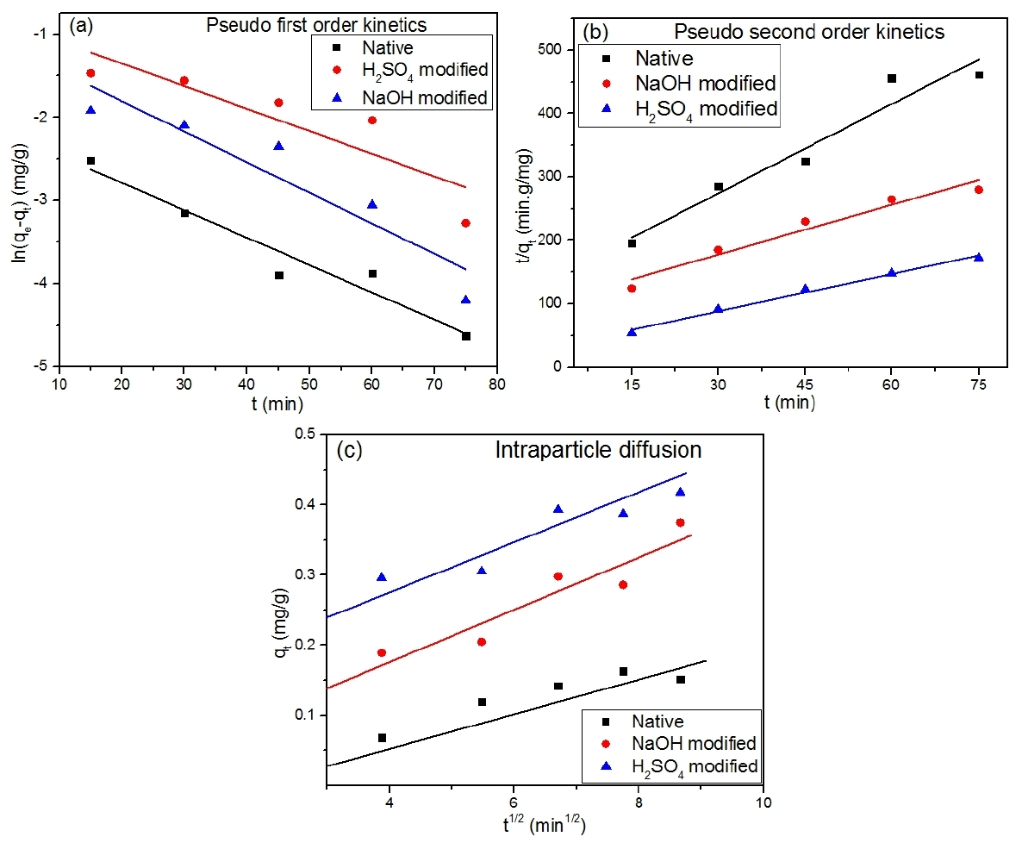
Fig. 4 Kinetic plots for As(III) adsorption using native and chemically modified brick kiln slag at 298 K and pH = 7.0

Mass Transfer Models
External Diffusion Model
It was observed that the mass transfer coefficient decreased as the concentration of As(III) ions increased as shown in Table 3. Driving force for adsorption is directly proportional to the adsorbate concentration. As the number of active sites on the adsorbent’s surface was fixed, the mass transfer coefficient decreased as the adsorbate concentration increased. Another reason for this behaviour may be attributed from the adsorption equilibrium theory. Since the external mass transfer coefficient is inversely proportional to the slope of operating lines at equilibrium, the values of external mass transfer coefficient decreased with increase in initial As(III) ions concentration in bulk solution. The external mass transfer is also said to be the controlling variable when the model is linear. Increase in contact time decreased the strength of boundary layer resistance which significantly increased the mobility of As(III) ions during the initial stages of adsorption. Thus external mass transfer coefficient cannot be neglected even during the initial stages of adsorption.²⁶
Table 3 External Diffusion Model Mass Transfer Coefficients for As(III) adsorption
C_{o} (mg/L) | Native |  | H₂SO₄ modified |  | NaOH modified
 | k_{f} (m/s) | R² | k_{f} (m/s) | R² | k_{f} (m/s) | R²
1 | 1.15 × 10⁻¹⁰ | 0.982 | 1.49 × 10⁻¹⁰ | 0.972 | 1.30 × 10⁻¹⁰ | 0.964
2 | 0.85 × 10⁻¹⁰ | 0.964 | 1.38 × 10⁻¹⁰ | 0.982 | 1.21 × 10⁻¹⁰ | 0.976
3 | 0.65 × 10⁻¹⁰ | 0.971 | 1.25 × 10⁻¹⁰ | 0.958 | 1.12 × 10⁻¹⁰ | 0.963
4 | 0.51 × 10⁻¹⁰ | 0.975 | 1.07 × 10⁻¹⁰ | 0.964 | 1.02 × 10⁻¹⁰ | 0.975
5 | 0.39 × 10⁻¹⁰ | 0.961 | 0.95 × 10⁻¹⁰ | 0.955 | 0.85 × 10⁻¹⁰ | 0.985

Boyd Model
A clear difference between the intraparticle and film diffusion helps to understand the exact rate determining step for As(III) adsorption using native and modified slag. The linear plot of [-0.4977-ln(1-F)] versus time has been shown in Fig. 5. The plots does not passes through origin which in as indicative of the film diffusion to be the rate determining step in As(III) adsorption using native and modified brick kiln slag. The R² values obtained from intraparticle diffusion (R² = 0.85) was significantly lower than those obtained from the Boyd plots (R² = 0.96). This further confirmed the possibility of film diffusion at the onset of adsorption and thereafter intraparticle diffusion followed. The obtained B values from the linear plots in Fig. 5 have been used to estimate the effective diffusivity values (D_{i}) in m/s. It is represented as in Eq. (17):
$B=\frac{D_{i}π^{2}}{r^{2}}$ (17)
where r is the radius of the adsorbent particle in m. The estimated D_{i} values were: 0.18 × 10⁻¹⁰, 0.25 10⁻¹⁰ and 0.27 10⁻¹⁰ m/s respectively for native, NaOH and H₂SO₄ modified slag. These values almost show a similar trend irrespective of the nature of the adsorbent. However, the D_{i} value of H₂SO₄ modified slag was slightly higher than NaOH modified slag. This further confirmed the ease of mobility of As(III) ions from the bulk solution to the H₂SO₄ modified slag. These findings clearly showed that the adsorption of As(III) ions using native, H₂SO₄ and NaOH modified slag was merely controlled by film diffusion or surface diffusion.
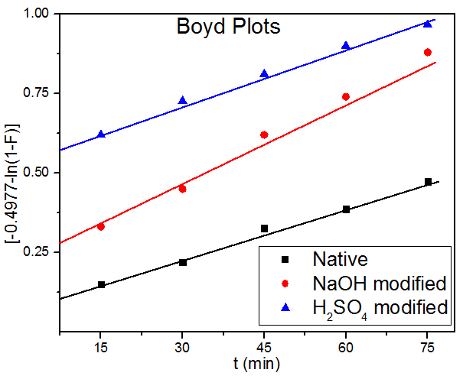
Fig. 5 Boyd Mass plots for As(III) adsorption using native and chemically modified brick kiln slag

McKay et al Model
The plots of the experimental adsorption data for As(III) adsorption using native and modified slag at different initial concentrations has been shown in Fig. 6 and the estimated mass transfer coefficients (β_{L}) from this model has been summarised in Table 4. It can be clearly observed that β_{L} decreased with increase in initial As(III) concentration irrespective of the type of adsorbent. The values for β_{L} showed that the velocity of the As(III) ions to migrate from the bulk liquid phase to the solid adsorbent’s surface.²⁷ The values of β_{L} obtained were observed to be much higher than that estimated from the external diffusion model. Moreover, from the linear regression values (R² < 0.9), this model indicated that the ease of migration of As(III) ions from the bulk adsorbate solution was significantly high and thus cannot be inferred as the rate controlling mechanism.
Table 4 Estimated values of mass transfer coefficients (β_{L}) from McKay et al model
C_{o} (mg/L) |  | Native |  | H₂SO₄ modified |  | NaOH modified
 | β_{L} (m/s) |  | R² | β_{L} (m/s) | R² | β_{L} (m/s) | R²
1 | 2.12 × 10⁻⁷ |  | 0.705 | 5.26 × 10⁻⁷ | 0.605 | 4.21 × 10⁻⁷ | 0.634
2 | 2.05 × 10⁻⁷ |  | 0.635 | 4.15 × 10⁻⁷ | 0.648 | 3.15 × 10⁻⁷ | 0.607
3 | 1.25 × 10⁻⁷ |  | 0.715 | 3.02 × 10⁻⁷ | 0.705 | 2.02 × 10⁻⁷ | 0.615
4 | 0.82 × 10⁻⁷ |  | 0.698 | 2.12 × 10⁻⁷ | 0.687 | 1.11 × 10⁻⁷ | 0.708
5 | 0.65 × 10⁻⁷ |  | 0.714 | 1.08 × 10⁻⁷ | 0.713 | 0.93 × 10⁻⁷ | 0.652
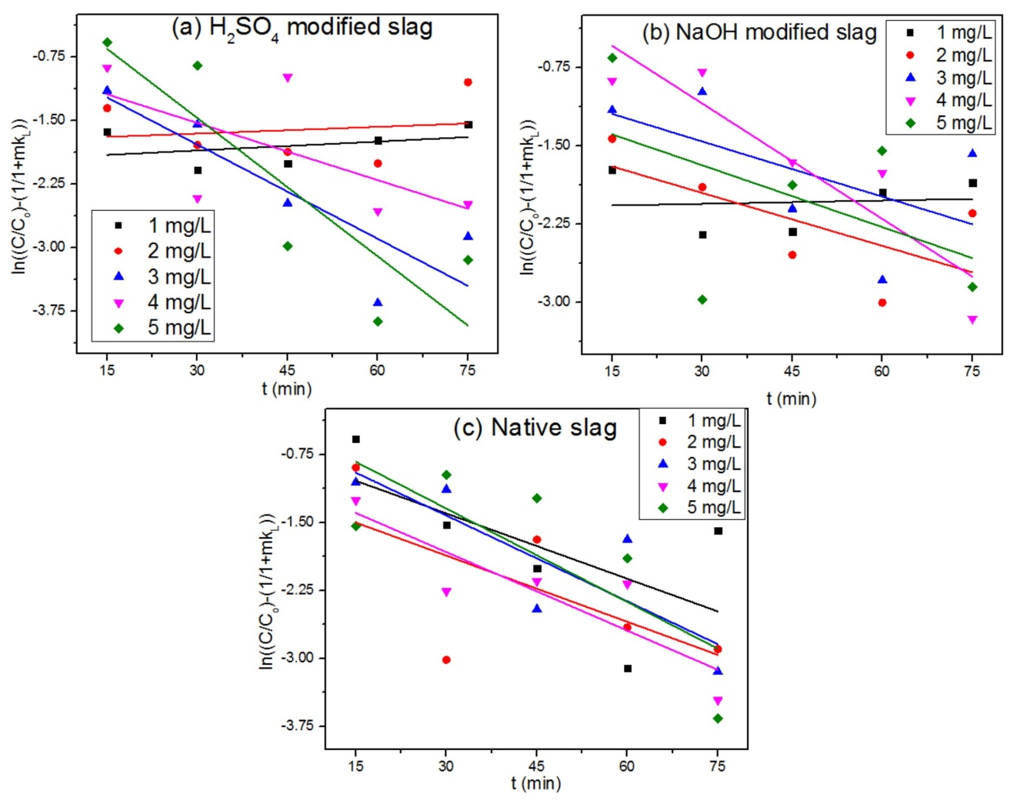

Fig. 6 McKay et al mass transfer plots for native and modified slag at different initial As(III) concentrations
Dimensionless Numbers
Sherwood Number
The influence of initial concentration of As(III) ions on the Sherwood number is shown in Fig. 7. The values of the dimensionless number were less than 1.0 indicating the rate of adsorption of As(III) ions on to the native and modified adsorbents was controlled by film mass transfer or surface diffusion. Based on the linearity of the plot, Eqs. (18) - (20) have been obtained for the adsorbent samples modified with H₂SO₄, NaOH and native respectively. It was observed that Sherwood number decreased with the increase in initial concentration of As(III) ions in the bulk adsorbate phase. Thus one can infer that the rate of mass transfer for adsorption of As(III) ions increased with decreasing bulk adsorbate concentration.
$Sh={2.97(C_{o})}^{-0.376}$ (18)
$Sh={4.12(C_{o})}^{-0.215}$ (19)
$Sh={4.83(C_{o})}^{-0.588}$ (20)
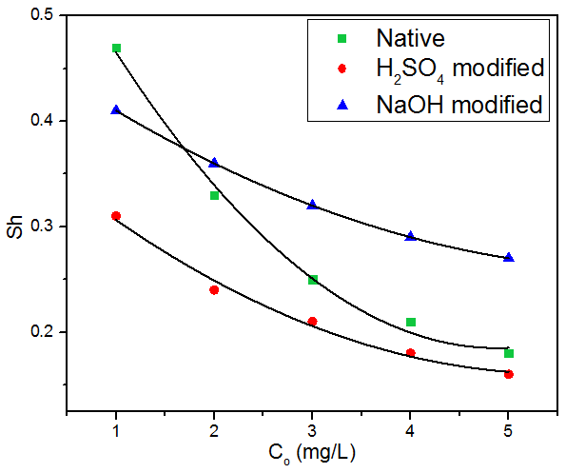
Fig. 7 Influence of Sherwood number on initial As(III) concentration using native and chemically modified brick kiln slag

Transport number
The variation of Transport number with respect to initial As(III) ions concentration has been shown in Table 5. It was observed that the value of Transport number (n) was almost equal to 0.5 thus showing Fickian diffusion or surface diffusion. This was probably due to interaction of As(III) ions with the surface of the adsorbent through the external film of adsorbate or boundary layer surrounding the adsorbent particle.²⁸ Thus in the present research, it can be inferred that external mass transfer had a dominating effect than intraparticle diffusion. This may be attributed to the rate of adsorptive mass transfer taking place through the stagnant film of the adsorbate which was caused by laminar motion (as the fluid transport takes place without the aid of any external agent) of the bulk liquid phase due to the effect of agitation during batch adsorption experiments. It was also observed that the value of transport number remained constant irrespective of the bulk adsorbate concentration showing that the initial adsorbate concentration had no effect on transport number.
Table 5 Estimated Transport number at various initial concentration of As(III) ions
C_{o} (mg/L) | Native |  | H₂SO₄ modified |  | NaOH modified
 | n | k_{m} | n | k_{m} | n | k_{m}
1 | 0.524 | 0.758 | 0.547 | 0.775 | 0.522 | 0.755
2 | 0.498 | 0.697 | 0.559 | 0.749 | 0.517 | 0.849
3 | 0.517 | 0.847 | 0.568 | 0.687 | 0.567 | 0.825
4 | 0.589 | 0.719 | 0.497 | 0.682 | 0.529 | 0.715
5 | 0.510 | 0.729 | 0.518 | 0.798 | 0.579 | 0.709

Adsorption Isotherms
Adsorption isotherms are used to describe the metal uptake capacity at fixed temperature. Adsorption of As(III) ions was performed at 298 K and 7.0 pH at different adsorbent doses (0.2 – 1.0 g). In the present study, three isotherms (Langmuir, Freundlich and Temkin isotherms) have been used to study the As(III) adsorption behaviour with native and modified slag. The linearized model for Langmuir isotherm is represented in Eq. (21):
$\frac{C_{e}}{q_{e}}=\frac{C_{e}}{q_{m}}+\frac{1}{k_{L}q_{m}}$ (21)
where q_{m} is the maximum adsorption capacity (mg/g), k_{L} is the Langmuir constant (L/g). Separation factor (R_{L}) is used to determine the feasibility of the process and is given by Eq. (22):
$R_{L}=\frac{1}{k_{L}C_{i}+1}$ (22)
The isotherm is considered to be favourable if 0 < R_{L} < 1. The Freundlich isotherm is represented in Eq. (23):
${logq}_{e}=\left(\frac{1}{n}\right){logC}_{e}+{logk}_{f}$ (23)
where k_{f} and n are Freundlich constants. The extent of feasibility of the adsorption of As(III) ions can be determined from the value of n. For a favourable process, (1/n) < 1. Temkin isotherm is represented in Eq. (24):
$q_{e}={BlnC}_{e}+B{lnA}_{T}$ (24)
$B=\frac{RT}{b}$ (25)
where b is the Temkin constant (J/mol), A_{T} is the equilibrium binding constant (L/g), R is universal gas constant (8.314 J/mol.K), T is the absolute temperature (K).
The adsorption isotherm plots are shown in Fig. 8 and the evaluated parameters are shown in Table 6. Based on the value of linear regression coefficient (R²), it was observed that adsorption of As(III) ions on native and modified brick kiln slag followed Freundlich isotherm indicating multilayer adsorption and heterogeneous nature of the adsorbent. The acid modified slag (SA) was observed to show a maximum As(III) uptake capacity of 13.6 mg/g which was observed to be 1.4 times that of SB and 2.1 times that of BKS. This value was observed to be quite competitive with the values reported in the recent literature. The n values from Freundlich isotherm indicated a good adsorption affinity towards As(III) ions. Linear nature of Temkin isotherm plots further confirmed chemisorption as the As(III) adsorption mechanism.²⁹ The obtained A_{T} values from the Temkin isotherm were found to decrease to in the order of: SA > SB > Native. This further confirmed the ease of As(III) adsorption towards acid modified slag. The b values were almost same irrespective of the type of adsorbent which showed less variation in heat of adsorption. HNO₃ modified activated carbon fibres showed a maximum uptake capacity of 8.65 mg/g where Langmuir isotherm was observed to show the best correlation coefficient.⁸ Iron scrap slag was found to show adsorption capacity of 13.7 mg/g.¹⁰ Thus, the adsorbent used in the present study can be used to remove As(III) from groundwater without any energy expense.

Table 6 Isotherm Parameters for As(III) ions adsorption using native and chemically modified slag
Adsorbents | Langmuir Isotherm parameters |  |  |  | Freundlich Isotherm parameters |  |  | Temkin Isotherm parameters
 | q_{m} (mg/g) | k_{L} (L/mg) | R_{L} | R² | k_{f} (mg/g) | (1/n) | R² | A_{T} (L/g) | b (J/mol) | R²
Acid modified BKS | 13.57 | 3.58 | 0.252 | 0.875 | 8.57 | 0.18 | 0.974 | 8.86 | 95.08 | 0.954
Alkali modified BKS | 10.34 | 2.79 | 0.207 | 0.864 | 6.48 | 0.21 | 0.965 | 7.38 | 93.08 | 0.951
Native | 6.48 | 2.08 | 0.184 | 0.887 | 3.27 | 0.11 | 0.979 | 5.89 | 92.19 | 0.937

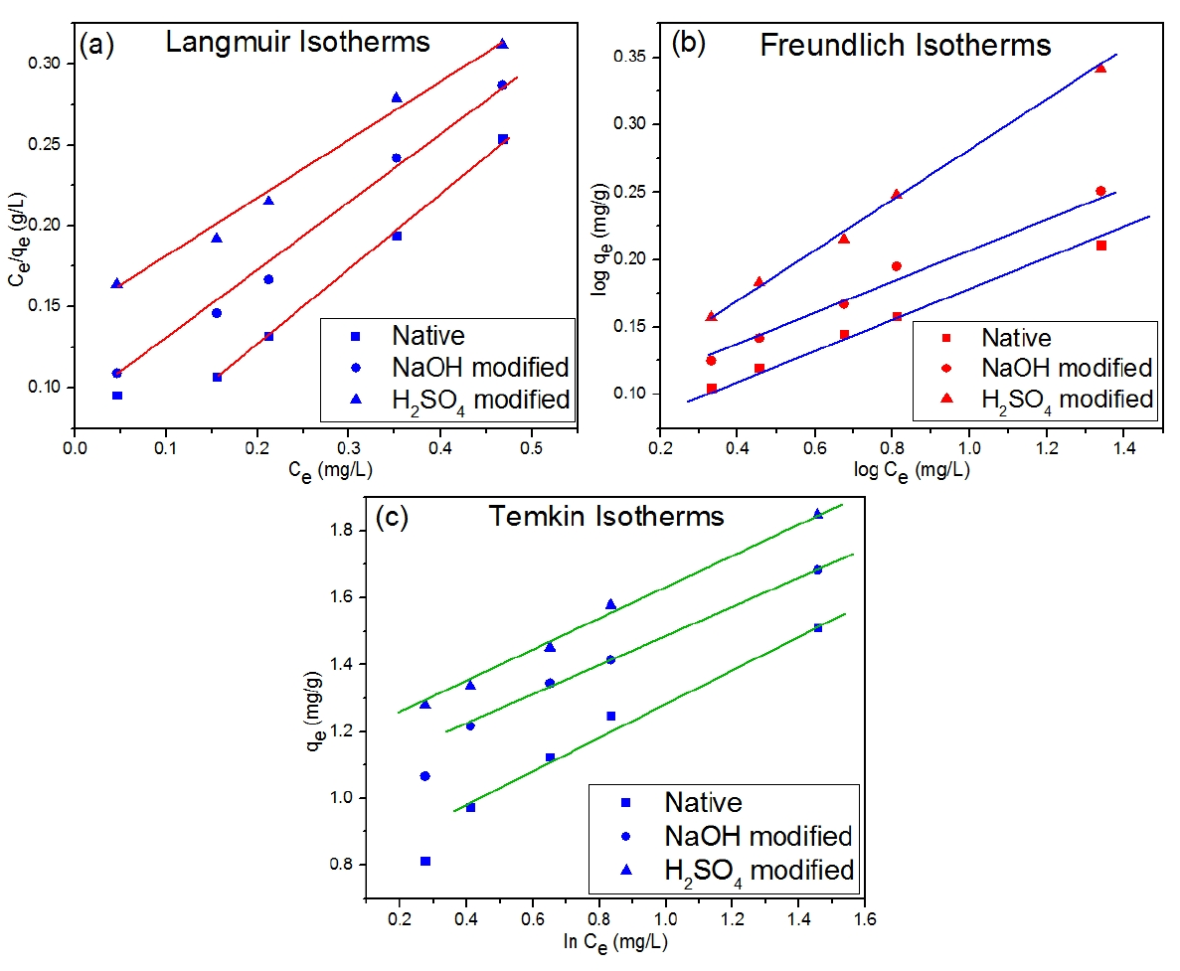
Fig. 8 (a) Langmuir; (b) Freundlich; (c) Temkin isotherms at 298 K and 7.0 pH for As(III) adsorption using native and chemically modified brick kiln slag

Adsorption Thermodynamics
Adsorption thermodynamics expresses the removal capacity as a function of its absolute temperature. Thermodynamic parameters were evaluated at pH = 7.0 using 0.3 g each of SA and SB and 0.6 g of BKS at different temperatures (298 – 313 K). This is generally expressed in the form of change in Gibb’s Free energy (∆G°) which is represented in Eq. (26):
$∆G°=-RTlnK_{c}$ (26)
For a favourable and spontaneous process, ∆G° < 0. Distribution coefficient (K_{c}) is represented in Eq. (27):
$K_{c}=\frac{q_{e}}{C_{e}}$ (27)
${lnK}_{c}=\frac{∆S}{R}+\frac{∆H}{RT}$ (28)
Entropy (∆S) and enthalpy (∆H) was calculated from the linear plot of lnK_{c} versus (1/T). The evaluated thermodynamic parameters are shown in Table 7. From the Table 7, it can be observed that the values of Gibb’s free energy change (∆G°) are negative in nature thus indicating the feasibility of the adsorption of As(III) ions over the native and modified slag. Gibb’s free energy change is said to be an important thermodynamic parameter reflecting the spontaneity of the adsorption process. A higher value of ∆G° is an indicative of more energetically favoured adsorption. The adsorption is said to occur favourably and spontaneously if the value of ∆G° is negative. Thus from Table 7, it can be inferred that the adsorption of As(III) ions over native and modified slag was favourable and spontaneous at all temperatures. However, maximum negative values of ∆G° was observed at 298 K which was an indicative of maximum As(III) adsorption capacity at this temperature.
Negative values of enthalpy (∆H) showed the liberation of energy during the adsorption of As(III) ions i.e. the process is exothermic. Moreover, the calculated values of enthalpy change suggested that the adsorption of As(III) ions on the native and modified slag corresponded to physical adsorption since the obtained values were < 40 kJ/mol.²⁴ Positive values of entropy showed the increase in the disorderness of the adsorbate-adsorbent interface due to adsorption of As(III) ions which was supposed to be less ordered than that in the bulk solution and thus reflected the affinity of the adsorbent towards As(III) ions in the bulk solution.³⁰
Table 7 Estimated Thermodynamic Parameters for As(III) ions adsorption
Adsorbents | ∆G° (kJ/mol) |  |  |  | ∆H (kJ/mol) | ∆S (J/molK)
 | 298 K | 303 K | 308 K | 313 K
Acid modified BKS | -6.52 | -4.74 | -1.85 | -0.85 | -20.17 | 41.28
Alkali modified BKS | -6.15 | -3.75 | -1.43 | -0.73 | -17.58 | 35.76
Native | -4.52 | -2.15 | -0.87 | -0.64 | -10.49 | 21.28

Conclusions
Acid modified brick kiln slag (SA) showed the maximum rate of adsorption followed by alkali modified (SB) and native slag (SN). Mass transfer coefficients calculated were in the order of 10⁻¹⁰ m/s for all the adsorbents which decreased with increasing concentration of As(III) ions in the bulk solution indicating that the driving force for mass transfer was inversely proportional to the As(III) concentration. Maximum value of mass transfer coefficients was obtained for the slag modified with H₂SO₄ thus showing its fairly good adsorption capacity over a particular temperature range.
Maximum adsorption occurred at pH = 7.0 due to electrostatic attraction phenomena. Fruendlich adsorption described the adsorption process indicating multilayer formation. Sherwood number interrelated initial concentration of As(III) ions according to Power Law model and were less than 1.0 for all the adsorbents showing that the mass transfer was limited by film diffusion. Thermodynamic evaluation showed that the adsorption was feasible at all temperatures with maximum adsorption taking place at 25°C (298 K). Transport numbers obtained were independent of initial concentration of As(III) ions and the values were almost equal to 0.5 indicating Fickian mechanism or surface diffusion. This mass transfer study can be extensively used for the design of batch adsorbers to find the effect of various mass transfer parameters on the adsorption capacity and to determine the rate controlling mechanism.
Conflict of Interests
The authors declare no conflict of interests regarding the publication of this paper.
Acknowledgement
The authors are thankful to Technical Education Quality Improvement Programme (TEQIP-III) for proving the required funding to carry out the experiments and Centre for Interdisciplinary Research (CIR) of MNNIT Allahabad for allowing us to carry out sample characterizations.

References
1. D. Mohan, C.U. Pittman, Arsenic removal from water/wastewater using adsorbents-A critical review, J. Hazard. Mater. 2007,142, 1-53. DOI:10.1016/j.jhazmat.2007.01.006.
2. S. Verma, P.K. Verma, D. Chakrabarty, Arsenic Bio-volatilization by Engineered Yeast Promotes Rice Growth and Reduces Arsenic Accumulation in Grains, Int. J. Environ. Res. 2019, 13, 475-485. DOI:10.1007/s41742-019-00188-7.
3. S. Shevade, R.G. Ford, Use of synthetic zeolites for arsenate removal from pollutant water, Water Res. 2004, 38, 3197-3204. DOI:10.1016/j.watres.2004.04.026.
4. T.S.Y. Choong, T.G. Chuah, Y. Robiah, F.L. Gregory Koay, I. Azni, Arsenic toxicity, health hazards and removal techniques from water: an overview, Desalination. 2007, 217, 139-166. DOI:10.1016/j.desal.2007.01.015.
5. V.P. Mulgundmath, R.A. Jones, F.H. Tezel, J. Thibault, Fixed bed adsorption for the removal of carbon dioxide from nitrogen: Breakthrough behaviour and modelling for heat and mass transfer, Sep. Purif. Technol. 2012, 85, 17-27. DOI:10.1016/j.seppur.2011.07.038.
.6 E. Torrik, M. Soleimani, M.T. Ravanchi, Application of Kinetic Models for Heavy Metal Adsorption in the Single and Multicomponent Adsorption System, Int. J. Environ. Res. 2019, 13, 813-828. DOI:10.1007/s41742-019-00219-3.
7. C.J. Geankoplis, Transport Processes and Separation Process Principles: Includes Unit Operations, Transp. Process. Sep. Process Princ. (Includes Unit Oper. (2003).
8. J. Shi, Z. Zhao, J. Zhou, T. Sun, Z. Liang, Enhanced adsorption of As(III) on chemically modified activated carbon fibers, Appl. Water Sci. 2019, 9, 41. DOI:10.1007/s13201-019-0919-7.
9. M.B. Shakoor, N.K. Niazi, I. Bibi, M. Shahid, F. Sharif, S. Bashir, S.M. Shaheen, H. Wang, D.C.W. Tsang, Y.S. Ok, J. Rinklebe, Arsenic removal by natural and chemically modified water melon rind in aqueous solutions and groundwater, Sci. Total Environ. 2018, 645, 1444-1455. DOI:10.1016/j.scitotenv.2018.07.218.
10. V. Liem-Nguyen, V. Sjöberg, N.P. Dinh, D.H. Huy, S. Karlsson, Removal mechanism of arsenic (V) by stainless steel slags obtained from scrap metal recycling, J. Environ. Chem. Eng. 2020, 8, 103833. DOI:10.1016/j.jece.2020.103833.
11. S. Wang, B. Gao, Y. Li, A. Mosa, A.R. Zimmerman, L.Q. Ma, W.G. Harris, K.W. Migliaccio, Manganese oxide-modified biochars: Preparation, characterization, and sorption of arsenate and lead, Bioresour. Technol. 2015, 181, 13-17. DOI:10.1016/j.biortech.2015.01.044.
12. T.V. Nguyen, T.V.T. Nguyen, T.L. Pham, S. Vigneswaran, H.H. Ngo, J. Kandasamy, H.K. Nguyen, D.T. Nguyen, Adsorption and removal of arsenic from water by iron ore mining waste, Water Sci. Technol. 2009, 60, 2301-2308. DOI:10.2166/wst.2009.667.
13. B. Narayana, T. Cherian, M. Mathew, C. Pasha, Spectrophotometric determination of arsenic in environmental and biological samples, Indian J. Chem. Technol. 2006, 13, 36-40. DOI: http://hdl.handle.net/123456789/6993.
14. M. Jansson-Charrier, E. Guibal, J. Roussy, B. Delanghe, P. Le Cloirec, Vanadium (IV) sorption by chitosan: Kinetics and equilibrium, Water Res. 1996, 30, 465-475. DOI:10.1016/0043-1354(95)00154-9.
15. F. Matalkah, M. Mahmoud, A.G.N.D. Darsanasiri, N. Abdol, P. Soroushian, A.M. Balachandra, High-recycled-content hydraulic cements of alternative chemistry for concrete production, Int. J. Sustain. Eng. 2018, 11, 282-291. DOI:10.1080/19397038.2018.1431973.
16. M.L. Granizo, M.T. Blanco-Varela, S. Martínez-Ramírez, Alkali activation of metakaolins: Parameters affecting mechanical, structural and microstructural properties, J. Mater. Sci. 2007, 42, 2934-2943. DOI:10.1007/s10853-006-0565-y.
17. J. Ojima, Determining of crystalline silica in respirable dust samples by Infrared Spectrophotometry in the presence of interferences, J. Occup. Health. 2003, 45, 94-103. DOI:10.1539/joh.45.94.
18. A. Soultana, A. Valouma, G. Bartzas, K. Komnitsas, Properties of inorganic polymers produced from brick waste and metallurgical slag, Minerals. 2019, 9, 551. DOI:10.3390/min9090551.
19. B.R. Berger, P.M. Bethke, The Behavior of Silica in Hydrothermal Solutions, in: Geol. Geochemistry Ep. Syst., 2020. DOI:10.5382/rev.02.03.
20. L. Shrestha, M. Thapa, R. Shrestha, S. Maji, R. Pradhananga, K. Ariga, Rice Husk-Derived High Surface Area Nanoporous Carbon Materials with Excellent Iodine and Methylene Blue Adsorption Properties, Carbon. 2019, 5, 10. DOI:10.3390/c5010010.
21. A.D. Gupta, S. Pandey, V.K. Jaiswal, V. Bhadauria, H. Singh, Simultaneous oxidation and esterification of cellulose for use in treatment of water containing Cu(II) ions, Carbohydr. Polym. 2019, 222, 114964. DOI:10.1016/j.carbpol.2019.06.003.
22. S. Rahdar, M. Taghavi, R. Khaksefidi, S. Ahmadi, Adsorption of arsenic (V) from aqueous solution using modified saxaul ash: isotherm and thermodynamic study, Appl. Water Sci. 2019, 9, 87. DOI:10.1007/s13201-019-0974-0.
23. K. Yang, W. Qin, W. Liu, Extraction of metal arsenic from waste sodium arsenate by roasting with charcoal powder, Metals. 2018, 8, 542. DOI:10.3390/met8070542.
24. S. Ghosh, R. Prabhakar, S.R. Samadder, Performance of γ-aluminium oxide nanoparticles for arsenic removal from groundwater, Clean Technol. Environ. Policy. 2019, 121-138. DOI:10.1007/s10098-018-1622-3.
25. Z. Peng, X. Liu, H. Chen, Q. Liu, J. Tang, Characterization of ultraviolet-modified biochar from different feedstocks for enhanced removal of hexavalent chromium from water, Water Sci. Technol. 2019, 1705-1716. DOI:10.2166/wst.2019.170.
26. Z. Aksu, I.A. Isoglu, Use of agricultural waste sugar beet pulp for the removal of Gemazol turquoise blue-G reactive dye from aqueous solution, J. Hazard. Mater. 2006, 137, 418-430. DOI:10.1016/j.jhazmat.2006.02.019.
27. D. Fu, Y. Zhang, F. Lv, P.K. Chu, J. Shang, Removal of organic materials from TNT red water by Bamboo Charcoal adsorption, Chem. Eng. J. 2012, 193, 39-49. DOI:10.1016/j.cej.2012.03.039.
28. C.R. Girish, V.R. Murthy, Mass Transfer studies on Adsorption of Phenolfrom Wastewater using Lantana Camara , Forest Waste, Int. J. Chem. Eng. 2016, 2016, 5809505. DOI: http://dx.doi.org/10.1155/2016/5809505.
29. İ. Şentürk, M. Alzein, Adsorption of Acid Violet 7 onto Acid-Activated Pistachio Shell: Isotherm, Kinetic and Thermodynamic Studies, Acta Chim. Slov. 2020, 67, 55-69. DOI: 10.17344/acsi.2019.5195.
30. P.M. Carijo, G.S. dos Reis, É.C. Lima, M.L.S. Oliveira, G.L. Dotto, Functionalization of corn stover with 3-aminopropyltrietoxysilane to uptake Reactive Red 141 from aqueous solutions, Environ. Sci. Pollut. Res. 2019, 26, 32198-32208. DOI:10.1007/s11356-019-06386-2.

