EFFICIENT AQUEOUS MANGANESE (II) CATIONS REMOVAL BY
ACTIVATED OPUNTIA FICUS INDICA: ADSORPTION
PERFORMANCE AND MECHANISM

Boutheina Djobbi,¹ Ghofrane Lassoued Ben Miled,¹ Hatem Raddadi,² Rached Ben Hassen^{1,*}
¹Laboratoire des Matériaux et de l'Environnement pour le Développement Durable, LR18ES10, Université de Tunis El Manar, ISSBAT, 9, Avenue Dr. Zoheir Safi, 1006 Tunis, Tunisie.
²Office National d’assainissement Direction D’épuration Grand Tunis, Rue Sidi Salah, Chotrana, Ariana. Tunisie

*Corresponding author’s email: rached.benhassen@issbat.utm.tn

Abstract
The adsorption of manganese ions from aqueous solutions by pure and acid-treated Opuntia ficus indica as natural low-cost and eco-friendly Tunisian adsorbents was investigated. The adsorbents’ structures were characterized by powder X-Ray Diffraction and Infrared Spectroscopy. B.E.T surface areas were determined. The study was carried out under various parameters influencing the removal efficiency such as pH, temperature, adsorbent dose and initial concentration of manganese ion. The Langmuir, Freundlich and Temkin isotherms equations were tested and the best fit was obtained by the Langmuir model for both adsorbents. The thermodynamic study shows that chemisorption is the main adsorption mechanism for the activated adsorbent while physisorption is the main adsorption mechanism for the pure adsorbent. The IR spectrum and the X-ray diffraction pattern of the treated opuntia ficus indica, registered after adsorption indicate the appearance of MnOx oxides on the cellulose fibers. The adsorption mechanism consists of an electrostatic interaction followed by oxidation of the Mn (II) to higher degrees, then probably a maintaining on the surface of the adsorbent by different C-O-MnOx bonds.

Keywords: Adsorption mechanism; Manganese; Removal efficiency; Opuntia ficus indica; Environmental.

- Introduction

Unlike organic pollutants, which are mostly affected by biological degradation, the risk of heavy metals is related to their inability to degrade into non-harmful end products. It can cause acute and chronic damage to various organisms when present. Therefore, the removal of heavy metals from water and wastewater is very important to protect the health of living things. Heavy metals are naturally present in the ecosystem, and their recent increase is attributed to the effluents of many industries, such as metal plating facilities, mining operations and tanneries. Manganese is the second most abundant metal in nature and one of the most common pollutants found in surface water and groundwater.¹⁻⁵ It is widely used such as in the manufacture of iron, manganese and steel alloys, in ceramics, dry battery cells, electrical coils and as a component in several products.^{1,6} Exposure to air of manganese-contaminated water enhances the oxidation of Mn (II) to Mn (IV). The Mn (IV) precipitate can stain hold utensils and clothes,⁷ and can give the water an unpleasant metallic taste and odor, an increased turbidity and a biofouling of pipelines.^{2,8}
Manganese acts mainly on the brain and heart and can cause damage to nervous system,⁹ kidney, liver and anemia in low dose.¹⁰ Several physicochemical methods for manganese elimination evolve in order to search the best fit between efficiency, affordability and ease-of-use. Among these techniques, one can quote aeration, filtration, ion exchange and settling.¹¹⁻¹³ During these last few years, the adsorption technique has been considered one of the most preferred methods for removing traces of heavy metals from water and wastewater due to its high efficiency, ease of handling and the availability of various adsorbents. This physicochemical process is a sustainable cost-effective alternative process in the environment.¹⁴ A number of studies were carried out using different adsorbents for manganese removal such as activated carbon,¹ Moringa oleifera leaf, Borassus flabellifer, Mangifera indica,¹⁵ Pithecellobium dulce carbon,¹⁶ palm fruit bunch, date stones or maize cobs.¹⁷ Several parameters are important for comparing adsorbents such as local availability and the degree of treatment required, but there is one parameter whose consistent information is rarely reported, and that is the cost.¹⁸ Plant materials, which are mainly composed of cellulosic materials, can adsorb micropollutants in aqueous medium such as heavy metal cations.¹⁹ In the same context, Cactus cladodes from Opuntia ficus indica are composed primarily of water, carbohydrates (starch, cellulose, hemicellulose, pectin and chlorophyll), proteins, lignin, and lipids (carotene).²⁰ This has led to interest in its use as sorbent-coagulant.²¹ Then we started to develop the study of the removal of heavy metals using cladodes powder. Preliminary results indicate low removal extents, less than 10 mg/g related to the very low specific surface area which is probably related to the covering of their surface by an excess of natural minerals, mainly the Ca(C₂O₄).H₂O (whewellite).²² For a better improvement of the performances of this process, new by-products have been produced in our lab by modification of the surface of the natural Tunisian Opuntia ficus indica. In this framework, we aim in this research to develop a new adsorbent product by acid activation of a crude Tunisian opuntia ficus indica and to compare its manganese ions adsorption properties with literature. The structures of the adsorbents as prepared (crude cactus and activated one) were identified by X-ray diffraction and Infrared spectroscopy analysis. The influence of several parameters for manganese ions adsorption, such as pH, adsorbent dose, initial concentration and temperature were assessed. The adsorption equilibrium isotherm was fitted to Langmuir, Freundlich and Temkin models. The thermodynamic variables were calculated in order to verify the adsorption process. The adsorption mechanism was elucidated for the activated adsorbent using IR spectroscopy and X-ray diffraction analysis.
2. Materials and Methods
2.1. Materials and Reagents
The cladodes of Opuntia ficus indica were collected during July, in a plantation located in the region of Djebba in the north of Tunisia. Hydrochloric acid (Scharlau) was purchased from Scharlau Chemie S.A.
2.2. Methods
2.2.1. Preparation of Opuntia ficus indica powder
Cladodes of Opuntia ficus indica were repeatedly washed with tap water to remove dust and extraneous material and then rinsed with distilled water. The pads were cut into small pieces of 1cm width to facilitate drying and followed by oven-drying at 333 K for 48 hours. The pads were then ground into a ﬁne powder in the size range of 40 to 80 µm using a laboratory mill (Fisher Bioblock Scientific). Finally, the obtained adsorbent was stored in a clean and dry plastic vials for further use.
2.2.2. Synthesis of the activated Opuntia ficus indica
The treatment of Opuntia ficus indica powder with a hydrochloric acid aqueous solution at a concentration of 1M was undertaken to ensure the removal of excess of natural minerals such as whewellite and CaCO₃ from its surface. The suspension was stirred until it was homogenized for about 4 h, after which the solution was filtered and washed with distilled water until the pH of the water was neutral. Finally, the chemically treated powder was dried overnight in an electric oven at 333 K, ground, stored in plastic containers. The adsorbents were named OFIP (the non-treated material), Ac-OFIP (the material treated with hydrochloric acid).
2.2.3. Characterization of OFIP and Ac-OFIP
All characterizations were carried out at the Materials and Environment Laboratory for Sustainable Development, LR18ES10. A PANalytical X'pert Powder X-ray diffractometer was used to collect data, which works with a flat rotated sample holder and a 1 D-PIXcell detector.
With a Micromeritics ASAP 2020 sorptometer using N₂ adsorption at 77 K, the specific surface area based on the Brunauer–Emmett–Teller-theory (BET measurements) of the materials, were determined.
The vibration properties as well as the chemical bonds present in the materials were analyzed by KBr pellet technique on a Bruker FT-IR spectrophotometer ‘Tensor 27’. Measurements were done in the range 400-4000 cm⁻¹.
2.2.4 Chemical Analysis and Batch Adsorption Experiment
The manganese concentrations were determined by inductively coupled plasma optical emission spectroscopy ICP (ISO 11885: 2007) and results were expressed as mg/L. The solution pH was determined using a pH meter (BANTE Instruments). Batch adsorption experiments were carried out in conical flasks, with a mass of adsorbent, pH, temperature and initial concentration of Mn(II) are known. The flasks were then placed on an orbital laboratory shaker (Heidolph), at a constant speed of 100 rpm. Supernatant liquid was collected and filtered through a Whatman filter paper before chemical analysis to remove the adsorbent materials particles that may be present in the supernatant.
2.2.5 Significance of thermodynamic parameters for the adsorption process
The maximum amount adsorbed at equilibrium Qe of manganese by OFIP and Ac-OFIP was calculated using the Equation:
$Qe =(\left(C_{i}-C_{e}\right) ×V/m)$ Eq. 1
Where Qe is the adsorption capacity at equilibrium (mg/g), C_{i} and C_{e} are the solution manganese concentrations at the initial and at equilibrium (mg/L), V is the volume of the solution (L) and m is the adsorbent mass added to the solutions (g).
The studies on the adsorption isotherm are of fundamental importance to determine the adsorption capacity of Mn(II) on the adsorbents and to develop an equation which accurately represents the results, and which could be used for the purposes of design. The models used in this process of fixing metal ions in solution on the two adsorbents are the Langmuir equation, the Freundlich equation and the Temkin equation.
The Langmuir isotherm involves adsorption on a single layer of the adsorbent and supposes three conditions: (a) the number of adsorption sites on the surface of the solid is fixed and the recovery of the surface of the solid in monolayer -molecular, (b) the enthalpy of adsorption is identical for each adsorption site and (c) no interaction between the adsorbed molecules.
The linear form of the Langmuir isotherm model can be described by:
$\frac{C_{e}}{Q_{e}} = \frac{1}{Q_{max }× K_{L}}+\frac{C_{e}}{Q_{max}}$ Eq. 2
Where Q_{max} (mg. g⁻¹) and K_{L} are the Langmuir parameters related to adsorption capacity and the adsorption energy, respectively. The essential characteristics of the Langmuir isotherm can be expressed by the ratio R_{L} which is a unitless magnitude called separation factor or equilibrium parameter, defined by Weber et al., as:²³
$R_{L} =\frac{1}{1+K_{L} ×C_{i}}$ Eq. 3
K_{L}, the Langmuir constant and C_{i}, initial concentration value. When RL> 1, the isotherm is unfavorable, when it is equal to 1, it is linear. It is favorable if 0 <RL <1 and irreversible if it takes the value zero. Unlike Langmuir, who assumes that the enthalpy of adsorption of fluids on solids is a constant with respect to the recovery rate of the solid surface, Freundlich assumes a logarithmic variation of this enthalpy as a function of the recovery rate. The log form of the Freundlich isotherm is expressed as follows: When R_{L}> 1, the isotherm is unfavorable, when it is equal to 1, it is linear. It is favorable if 0< R_{L}<1 and is irreversible if it takes the value zero. Contrary to Langmuir, who supposes that the enthalpy of adsorption of fluids on solids is a constant with respect to the recovery rate of the surface of the solid, Freundlich supposes a logarithmic variation of this enthalpy according to the rate of recovery. The logarithmic form of the Freundlich isotherm is uttered as:
$ln Q_{e }=lnK_{F }+\frac{1}{n} ln C_{e}$ Eq. 4
KF (mg. g⁻¹) and n are Freundlich constants. The Temkin model is based on the fact that the heat of adsorption varies linearly with the degree of recovery; this variation can be related to the heterogeneity of the surface, or to lateral interactions between adsorbed molecules. The Temkin’s relationship in linear form is expressed as follows:
$Q_{e }=B ln K_{T }+B ln C_{e}$ Eq. 5
B (J.mol⁻¹), the Temkin constant relative to the heat of adsorption and K_{T} (L.g⁻¹), the equilibrium adsorption constant corresponding to the maximum binding energy.
The variations of the standard enthalpy ΔHº, the standard entropy ΔSº and the Gibbs free energy ΔGº during the adsorption of manganese by OFIP and Ac-OFIP can be evaluated from the following equations:
${ΔG}^{°}=-RTlnK_{C}$Eq. 6
with
$K_{C} = \frac{Q_{e}}{C_{e}}$Eq. 7
ΔG° is also linked to ΔH° and ΔS° by :
${ΔG}^{°}={ΔH}^{°}-{TΔS}^{°}$Eq. 8
R is the gas constant with a value of 8.314 J.mol⁻¹.K⁻¹ and T is the absolute temperature (K).
Substituting Eq. (6) into Eq. (8) gives:
${\ln{K}}_{C}=-\frac{{ΔH}^{°}}{RT}+\frac{{ΔS}^{°}}{R}$Eq. 9
The thermodynamic properties of an adsorption process are necessary to determine whether the process is favorable or not. They can also help to understand the binding mechanisms of metals on adsorbents and show whether the process follows physisorption or chemisorption.²⁴ In physisorption, the adsorbate (metal ion) is fixed to the surface of the solid (adsorbent) by weak Van der Waals attractions and by a low heat of adsorption of approximately 20 to 40 kJ.mol⁻¹, consequently, the process is rapid and reversible in nature.²⁵ However, we are talking about chemisorption when chemical bonds form between the surface of the solid (adsorbent) and the adsorbate (metal ion) and with high heat of adsorption (40–400 kJmol⁻¹). In this case, it is difficult to remove the adsorbed heavy metal from the adsorbent; therefore, chemisorption is slow and irreversible in nature.²⁶

3. Results and Discussion
In this study, manganese adsorption onto OFIP and Ac-OFIP was investigated as a function of solution pH, adsorbent dosage, initial concentration of Mn(II) and temperature.
3.1 Analysis of the biosorbents
3.1.1 XRD characterization
The structure analysis of the opuntia ficus indica powder by X-ray diffraction prior and after treatment (OFIP / Ac-OFIP) are presented in Fig.1, in order to identify the crystalline and amorphous regions present in these samples. The X-ray pattern of OFIP powder shows strong crystalline peaks characteristic for calcium oxalate monohydrate (whewellite) at 14-15° and 24-25° (2θ), which was identified with the PDF # 20–0231 of ICDD-JCPDS database. This result is in agreement with that reported by Monje and Baran²⁷ and Contreras-Padilla et al.,²² who identified the presence of calcium oxalate in different Cactaceae species belonging to the Opuntioideae subfamily, including opuntia ficus indica. Furthermore, we report three Bragg reflections located at 29-30, 39-40 and 45-50 ° (2θ) in the pattern which are indicative of the presence of calcium carbonate CaCO₃ (PDF # 47-1743).
The x-ray pattern of Ac-OFIP powder (Fig. 1 ) is typical for cellulose I, with the four crystal peaks which are well defined and observed around 2θ = 15°, 16.5°, 22° and 35°assigned to (1–10), (110), (200) and (004),respectively.²⁸ Unlike hemicellulose and lignin, which are amorphous in nature, cellulose has a crystal structure due to hydrogen bonding interactions and Van der Waals forces between adjacent molecules.²⁹ The crystallinity of the fibers of opuntia ficus indica powder after treatment is well assessed. The treatment had effectively influenced the crystallinity of cellulose as reported by Mwaikambo and Ansell³⁰ that the alkaline chemical treatment on vegetable fibers increases their rigidity because the impurities present in them can be eliminated during this treatment. Therefore, the crystallinity of the Ac-OFIP powder can be determined and compared to the untreated OFIP powder to gain access to the effectiveness and importance of the activation process.
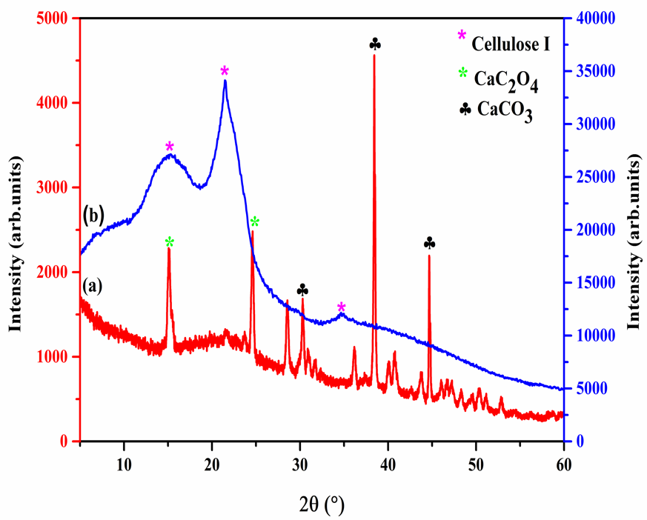
Fig. 1. XRD patterns of OFIP (a) and Ac-OFIP (b)
3.1.2 FT-IR measurements
The spectra of OFIP and Ac-OFIP (Fig.2) were investigated to obtain information on the nature of functional groups at the surface of the adsorbents. The infrared (IR) spectrum of OFIP shows broad, strong and superimposed bands in the 3600-3200 cm⁻¹ region due to the elongation of the O-H bonds. The bands at 2928 cm⁻¹, 2858 cm⁻¹ (different C-H vibrations), 1613.96 cm⁻¹, 1414.56 cm⁻¹ and 780 cm⁻¹ (different vibrations and deformation of the carboxylic groups) are characteristic of OFIP powder with the presence of calcium oxalate monohydrate (whewellite) and carbonates according to Contreras-Padilla et al.²² Absorption peaks in the region of wavenumbers lower than 800 cm⁻¹ could be attributed to N-containing bioligands as mentioned in related literature.³¹Due to OFIP's activation process with the acid treatment, a lot of FT-IR peaks have shifted in the Ac-OFIP spectrum. Thus, the intensity of the band linked to –OH (3600–3200 cm⁻¹) decreased after activation, which indicates that the treatment with acid leads to the breaking of weak bonds, and the band around between 1500-1750 cm⁻¹ attributed to vibrations of carbonyl bonds C = O becomes more resolved and intense around 1740 cm⁻¹. The peaks at 1613.9 cm⁻¹, 1414.5 cm⁻¹,780 cm⁻¹and near the region 800 cm⁻¹ have completely disappeared in Ac-OFIP spectrum due to the elimination of calcium oxalate and carbonate and N-containing bioligands.
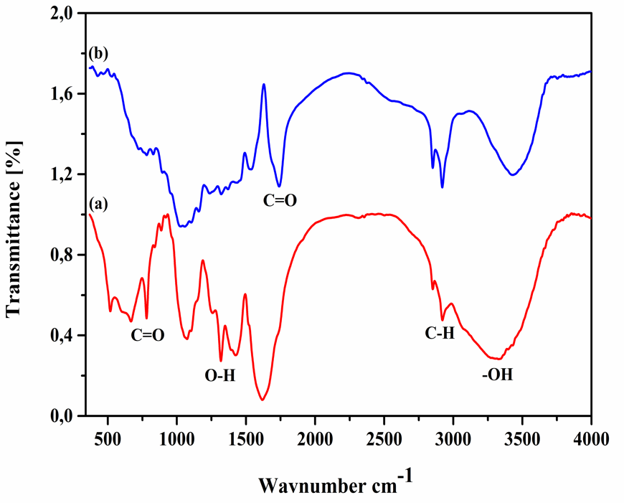
Fig. 2. FT-IR spectra of OFIP (a) and Ac-OFIP (b).
3.1.3 B.E.T. surface areas
The specific surfaces of the two adsorbents Ac-OFIP and OFIP were determined by BET and the values obtained indicate a very small specific surface for the untreated cactus powder. Barka et al. have already reported similar values in their study of the B.E.T surfaces of the Moroccan biosorbent opuntia ficus indica.³¹ They linked this result to the fact that the OFI can be considered as a non-porous material with no defined opening on their morphology and therefore without internal surface. In our opinion, the main reason should be the agglomeration of well crystallized minerals (CaCO₃, CaC₂O₄. H₂O) on the surface of the cladodes, characterized by XRD measurement and IR spectroscopy (this work, Monje and Baran²⁷) which contributes to the reduction of the porous surface and therefore to the specific surface. The BET surface area is 1.6 m²/g for OFIP, while that of Ac-OFIP is significantly larger, 12.4 m²/g. The increase in the BET surface area of OFIP after treatment could be attributed to the removal of whewellite particles, carbonates and other impurities from OFIP. All these characterization results confirmed the successful synthesis of Ac-OFIP.
3.2.1 Effect of pH
The pH of the aqueous solution is an important variable, which can have a significantly effects on the extent of adsorption, because, it influences on the surface properties of the adsorbent.³²⁻³⁴ In addition, it influences on the degree of ionization of metals in solution.³⁵⁻³⁷ Manganese adsorption onto OFIP and Ac-OFIP was studied against at initial pH range of 4 -8 and the results are shown in Fig. 3. All the other factors were kept constant that is: temperature at 298 K, adsorbent dosage at 0.4 g/L, contact time of 24 h, agitation speed was kept at 100 rpm and Mn(II) initial concentration of 27.75 mg/L. From the fig. 3, it was observed that the percentage removal of Mn(II) depends greatly on pH for the Ac-OFIP powder. It is found, first, that the percentage removal increased gradually with the increase of pH up to 5 for the OFIP and there is no considerable change after the pH 5. Secondly, for the adsorbent treated Ac-OFIP, the percentage removal of Mn(II) ion increases with increase in the pH from 4 to 7 and it is almost constant up to pH 8.The results of the percentage of maximum elimination of the manganese ions are of the order of 35.5% and 91.6% respectively for OFIP and Ac-OFIP. The small metal adsorption at low pH values could be attributed to the competition of hydrogen ions with the manganese for the occupancy of the adsorption sites. Indeed, at low pH values a protonation of functional groups is produced on the adsorbent surface which limits the interaction between the positively charged metal ions and the two adsorbents due to repulsive forces; this reduces the Mn(II) adsorption capacity. There is a significant increase in the removal of metal ions at pH 5 for OFIP and 7 for Ac-OFIP, this can be explained by the fact that the adsorption sites are no longer affected by the pH variation. At a higher pH, the removal efficiency of Mn(II) ions gradually decreased with the two adsorbents. A pH greater than 8 has been neglected due to the precipitation of Mn(OH)₂ which could be formed with the increasing amount of OH⁻ in the solution, that which would be mistaken as adsorption due to the different powders. For subsequent investigations, pH 5 and 7 are appeared as the optimal conditions for OFIP and Ac-OFIP respectively.
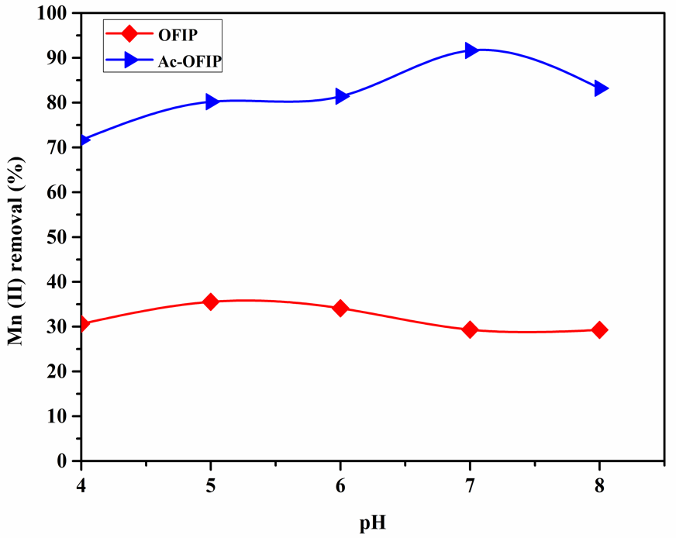
Fig. 3. Effect of pH on the adsorption of Mn(II) ions on OFIP and Ac-OFIP.
3.2.2 Effect of adsorbents dosage
The dependence of manganese adsorption on dose was studied at pH 5 for OFIP and pH 7 for Ac-OFIP. Initial concentration of Mn(II) was fixed at 27.75 mg/L and contact time at 24 h. All experiments were carried at ambient temperature. The adsorbent concentrations studied were 0.2 g/L to 1.3 g/L. The relationship between the Mn(II) removal percentage and the dose of two samples is shown in Fig. 4. The curves obtained show the great capacity of the material Ac-OFIP in the elimination of Mn(II) ions, which can reach approximately 99.6%, whereas it only reached 52% for OFIP. The results indicate that the removal rate of Mn(II) ions is increasing with the amounts of adsorbent in the solution up to an optimum dosage of 0.7 g/L for Ac-OFIP and 1.1g/L for OFIP, this trend in uptake is attributed to the increasing number of negatively charged active sites and surface area for Mn(II) binding on the adsorbent. After the optimum dosage, the elimination rate does not change almost, which corresponds to the saturation of the different types of adsorbent active sites by the adsorbate (ions of metals Mn(II) in the system).
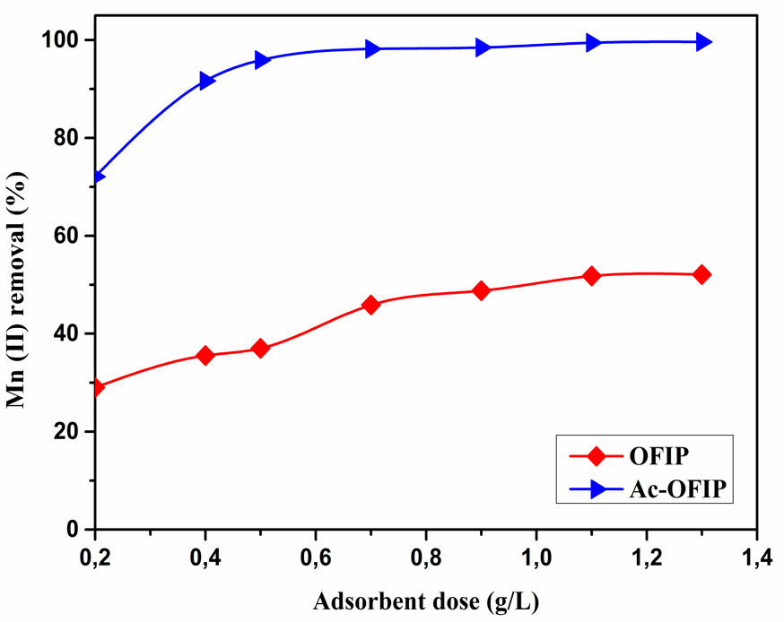
Fig. 4. Effect of adsorbent dose on the elimination of Mn(II) ions for OFIP and Ac-OFIP.

3.2.3 Effect of Mn(II) initial concentration
In order to evaluate the effect of Mn(II) ion concentration on the adsorption behavior of the two adsorbents (OFIP and Ac-OFIP), adsorption experiments with varying manganese concentrations of 2 mg. L⁻¹ to 85 mg. L⁻¹ were studied in the best experimental conditions :pH 5.0 for OFIP, pH 7.0 for Ac-OFIP and adsorbent concentration of 0.7 g. L⁻¹ for Ac-OFIP and 1.1 g. L⁻¹ for OFIP. Fig.5 shows the relationship between initial Mn(II) ion concentration and the percentage removal of Mn(II). The greatest values removal of Mn(II) ions are of the order of 99.99% and 89.9% for Ac-OFIP and OFIP, respectively. This lets us think that these materials have a high adsorption capacity at low concentrations. Moreover, the shape of curves shows a decrease in the percentage removal of Mn(II) ions with the increase in initial concentration of manganese solution and this is due to the fact that some manganese ions remained in solution due to the saturation of the active sites on the adsorption surface of the adsorbent materials and thus sites with high affinity are the first to be saturated. Subsequently, the affinity of the metal cations for the remaining sites becomes lower.
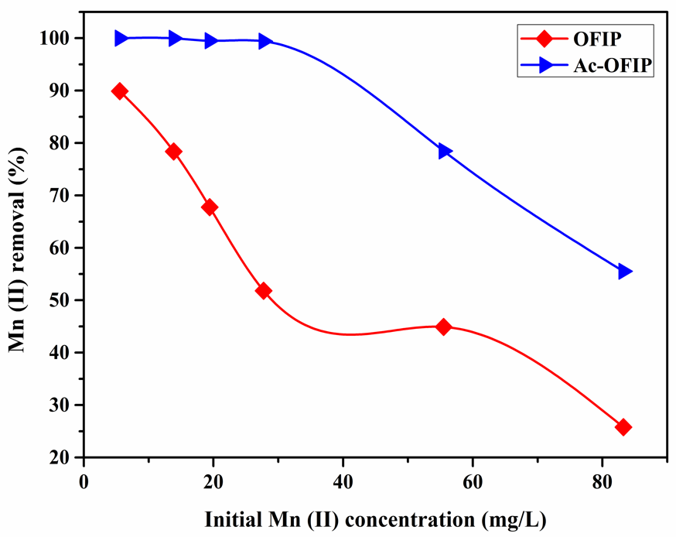
Fig. 5. Effect of Mn(II) concentration on removal rate for OFIP and Ac-OFIP.
3.3 Adsorptions isotherms
The application of Langmuir, Freundlich and of Temkin models on the results of the experiments was undertaken under our operating conditions (Vag: 100 rpm; Tmilieu: 298 K; pH milieu: 5 with OFIP, 7 with Ac-OFIP; and m_{(OFIPand Ac-OFIP)}: 1.1g.L⁻¹ and 0.7 g.L⁻¹).
Figs.6 (a) and 7 (a) show the linear plot of Ce/Qe as a function of Ce for OFIP and Ac-OFIP respectively. The values of Q_{max} and K_{L} were determined from slope and the ordinate at the origin of the linear regressions and they are given in Table 1. The R_{L} values calculated for this study are given in Table 2. Two plots of ln (Qe) as a function of ln (Ce) have been shown in Figures 6 (b) and 7 (b) for OFIP and Ac-OFIP respectively, where the values of K_{F}, n and the correlation coefficient R² for the Freundlich model are given in Table 1. Figures 6 (c) and 7(c) show plots of Qe as a function of ln (Ce), which make it possible to determine the isothermal
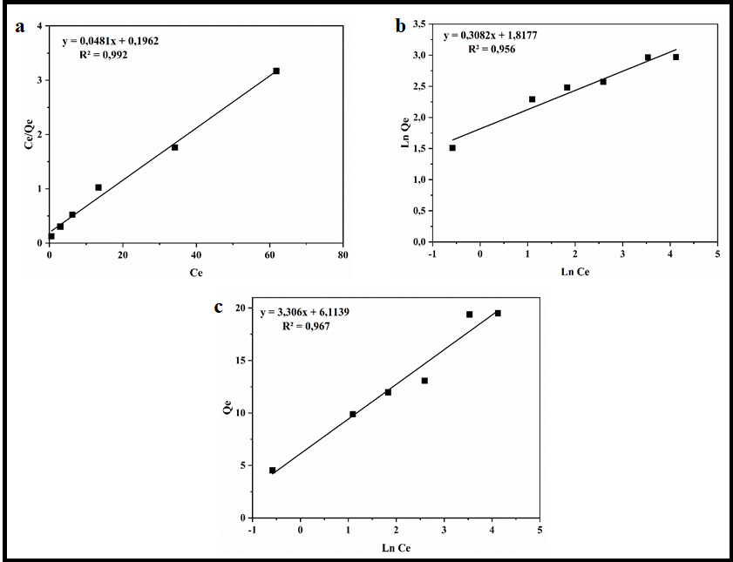
Fig. 6. Langmuir isotherm (a), Freundlich isotherm (b) and Temkin isotherm (c) for Mn(II) adsorption on OFIP adsorbent.
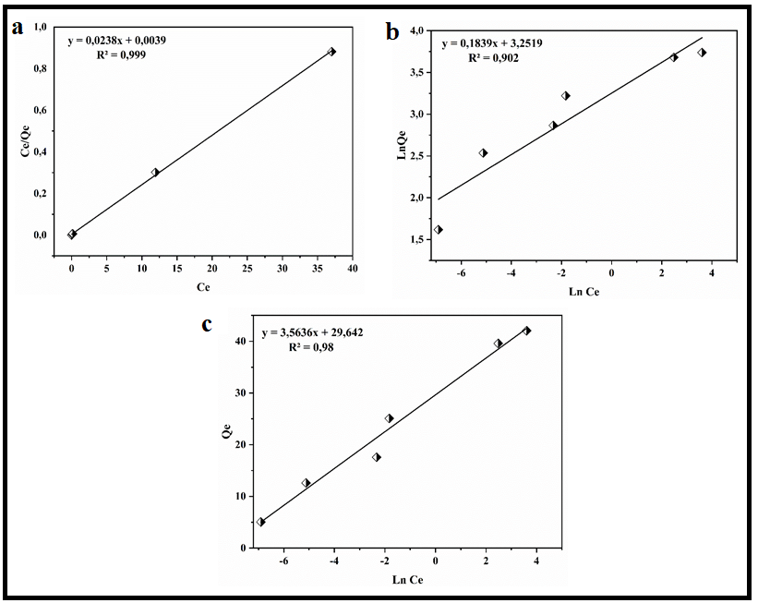
Fig. 7. Langmuir isotherm (a), Freundlich isotherm (b) and Temkin isotherm (c) for Mn(II) adsorption on Ac-OFIP adsorbent.
constants K_{T} and B. The values of K_{T}, B and the correlation coefficient R² for Temkin model are given in Table 1.
Table 1. Fitting parameters and goodness of fit for three different isotherm models (Langmuir, Freundlich and Temkin) applied to the experimental adsorption data
Adsorbents | Langmuir |  |  | Freundlich |  |  | Temkin
Adsorbents | Q _{max} (mg/g) | K_{L} | R² | n | K_{F} | R² | B | K_{T} | R²
OFIP | 20.8 | 0.245 | 0.99 | 3.244 | 6.157 | 0.95 | 3.306 | 6.36 | 0.96
Ac-OFIP | 42.02 | 6.102 | 0.99 | 5.437 | 25.84 | 0.90 | 3.563 | 8.32 | 0.98

Table 2. R_{L} as a function of the initial concentration of Manganese
C _{initial} (mg/l) | 5.55 | 13.875 | 19.425 | 27.75 | 55.5 | 83.25
R_{L} (OFIP) | 0.424 | 0.227 | 0.173 | 0.128 | 0.068 | 0.046
R_{L} (Ac-OFIP) | 0.028 | 0.011 | 0.008 | 0.005 | 0.002 | 0.001

The best data adjustments are obtained with the Langmuir isothermal model for the OFIP and Ac-OFIP. This observation is justified by the values of the regression coefficients which are better for the OFIP and Ac-OFIP with the Langmuir equation (R² Langmuir : 0.99). It is clear from Table 2 that the value of the R_{L} ratio decreases with the increase of the initial concentration for the two cases of adsorbents and remain between 0 and 1 suggesting a favorable significance for the Langmuir model.
3.4 Thermodynamics studies
The estimated thermodynamic parameters, ΔH°, ΔS° and ΔG° of the effect of the temperature on the adsorption of Mn(II) by pure and modified Opuntia ficus indica (OFIP/Ac-OFIP) are given in the Table 3.
All the values of free energies for the chosen temperature range (ΔG °> 0) reveal that the adsorption of Mn (II) by OFIP is not a spontaneous process, whereas for the adsorption of Mn(II) by Ac-OFIP, the free energy values show positive rates at low temperatures and tend towards the spontaneity of the adsorption process with increasing temperature. The adsorption of Mn (II) increases as the temperature increases in the range of 293 to 313 K, which implies that the process is more favorable at high temperatures.
Table 3. Values of the thermodynamic parameters of the manganese adsorption at different temperatures by OFIP and Ac-OFIP.
Adsorbent | Temperature/K | K_{F} | ΔG°/kJ.mol⁻¹ | ΔH°/kJ.mol⁻¹ | ΔS°/KJ.mol⁻¹. K⁻¹
OFIP | 293  298  303  308  313 | 0.2262  0.2670  0.3248  0.4248  0.3807 | 3.6210  3.2717  2.8330  2.1925  2.5128 | 26.30 | 0.077
Ac-OFIP | 293  298  303  308  313 |  | 0.4958  0.0998  -0.7845  -2.7530  -1.4961 | 54.79 | 0.183
  0.8158
  0.9605
  1.3654
  2.9303
  1.7770
A linear plot of ln KF against 1/T in the temperature range of 293 to 308 K was established and ΔH ° and ΔS ° were determined.
The calculated enthalpy values are greater than zero (ΔH °> 0) and have been found to be 26.30 and 54.79 kJ/mol respectively for OFIP and Ac-OFIP, which shows that this adsorption process is endothermic in nature. The enthalpy value ΔH ° is less than 40 kJ/mol for OFIP, which indicates that physisorption is the main adsorption mechanism, while it is greater than 40 kJ/mol for Ac-OFIP and this indicates in this case that chemisorption is the main mechanism of adsorption. The positive entropy values for the two adsorbents (ΔS° > 0) reflect a disorder in the system at the solid solution interface that occurred during adsorption.
3.5 Adsorption mechanisms of Mn (II)
3.5.1 XRD analysis
Figure 8 shows the XRD patterns of Ac-OFIP before and after the adsorption of Mn (II) ions. X-ray diffraction analysis was used to confirm the presence of Mn on the surface of the modified OFIP. Thanks to the appearance of new MnOx peaks, it is possible to probe their presence. As we mentioned in the previous sections, the adsorption of Mn (II) by Ac-OFIP is a chemisorption and a detailed inspection of the XRD diagram after the adsorption process could provide more information on the mechanism of adsorption. Compared to that of the pure Ac-OFIP pattern, new distinct peaks were observed on the Ac-OIFP diagram at 26.8°, 29.5°, 31.9° 2θ attributed to the typical peaks of MnOx oxides according to references from PDF-4 database (ICDD). No strong evolution of the XRD diagram was noted, the Bragg angles of the cellulosic diagram (diffraction peaks) remain essentially unchanged following the adsorption process of the Mn (II) cations. These results suggest that the grafting of different MnOx took place on the surface of the cellulose fibers, and the cellulose continues to maintain its crystal structure. These results suggest that the adsorbed Mn (II) was first oxidized to higher degrees, and then probably maintained on the surface of the adsorbent with different C-O-MnOx bonds.
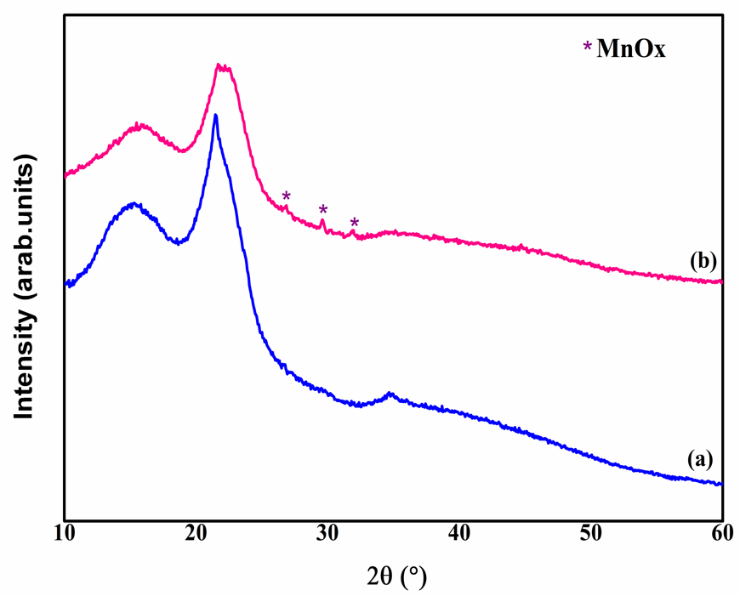
Fig. 8. Comparison in XRD patterns of Ac-OFIP (a) and Mn-Ac-OFIP (b).
3.5.2 Analysis for FT-IR Spectra
FT-IR spectra are also useful for judging the bonding states between functional groups of the adsorbent and the metal ion. The comparison of the IR spectra of pure Ac-OFIP and that after adsorption is well illustrated in Fig. 9. The appearance of an intense band at 620 cm⁻¹ and three minor bands at 437cm⁻¹, 536 cm⁻¹ and 474 cm⁻¹ demonstrated the presence of different oxides of MnOx on the adsorbent. In addition, the absorption bands of MnOx, in the region of low frequencies, are very broad; this is related to the crystalline and amorphous content and to the effect of the particle size on the spectral characteristics. Due to the interaction of the functional groups of the adsorbent with the Mn(II), FT-IR peaks can move towards lower or higher wave numbers after the loading of Mn(II) depending on bond strength between metal ions and adsorbent.³⁸ It can be deduced from Figure 9 that after the adsorption of Mn(II), there was a change in the peak of the carbonyl group C = O from 1737 cm⁻¹ to 1637 cm⁻¹, which may indicate that the carbonyl group is involved in the adsorption process. Furthermore, the appearance of a broad band at 2130 cm⁻¹ related to the carbonyl stretches for Mn(CO)_{n} on the surface after adsorption, indicates the important role that it plays in the chemisorption of Mn (II) on ligands. On surfaces, the geometric arrangement of the CO bond can be determined from the vibration frequency.^{39,40} The stretching of the free molecule C-O generally occurs at 2143cm⁻¹,^{39,41} far from most other molecular vibrations, it provides a practical and sensitive indicator of binding interactions. In “classic” carbonyls, the stretching frequency C-O(ν_{CO}) is lowered compared to its value in the free CO molecule due to a marked decrease in bonding electron density and an increase in antibonding electron density in the π*.
The majority of the transition metal carbonyl complexes exhibit a red shift resulting in stretching of the carbonyl. In our case the charge-induced reduction in π back-bonding leads to a decreased red-shift in Mn(CO)n (υ_{CO} = 2130 cm⁻¹).
No change in the frequency of the cellulosic bands was noted following the adsorption process, suggesting that chemisorption took place on the surface of the cellulosic fiber, and also that Ac-OFIP continued to maintain its crystal structure.
Fig. 9. Comparison in FT-IR spectra of Ac-OFIP (a) and Mn-Ac-OFIP (b).
3.6 Comparison with the other adsorbents
Some adsorbents used for the absorption of Mn(II) reported in the literature were compared with OFIP, and with Ac-OFIP as indicated in Table 4.The values obtained for the maximum adsorption capacity following the experiments presented in this study are much higher compared to other adsorbents (except the two studies 42 and 43). Therefore, it should be emphasized that the adsorbents used in this work can successfully compete with other absorbents materials.

Table 4. Comparison of the maximum Mn(II) adsorption capacities with other adsorbents.
Adsorbents | Capacity (mg/g) | Reference
Pecan nut shell | 103.8 | 42
Crab shell particles | 69.9 | 43
Ac-OFIP | 42.03 | This study
OFIP | 19.50 | This study
Natural zeolitic tuff | 10 | 44
Black carrot residues | 5.17 | 45
Activated carbon immobilized  Bytannic acid | 1.73 | 46
Kaolinite | 0.44 | 47
Pithacelobium dulce carbon | 0.41 | 16

Conclusions
In this study, Opuntia ficus indica with and without activation treatment (OFIP, Ac-OFIP) were used as an adsorbent in the removal of Mn(II) from aqueous solutions. The surface modifications of OFIP have been made to improve the selectivity of the by-products and thus have more affinity for the cations and improve the adsorption capacity. A very high percentage of manganese elimination was observed in the case of Ac-OFIP. In the study of factors affecting the adsorption process, the percentage of elimination of Mn(II) increased with the pH and the dose of adsorbents up to the optimum values and there are no considerable changes thereafter. The equilibrium absorption of the adsorbents has been found to decrease with the increase in the initial concentration of manganese ions in solution. The thermodynamic study shows that this process is endothermic in nature and with a positive change in entropy for the two adsorbents, suggesting the affinity of the metal ion for the adsorbents. Chemisorption is the main adsorption mechanism for Ac-OFIP while it is physisorption for OFIP. A study of experimental isotherms such as Langmuir, Freundlich and Temkin revealed that the best fit was obtained by the Langmuir model for OFIP and Ac-OFIP. For Ac-OFIP, the XRD and infrared characterizations confirmed that the process is chemisorption as suggested by the thermodynamic study. The adsorption mechanisms consisted of electrostatic interaction, oxidation of the adsorbed Mn (II) to higher degrees and then probably maintained on the surface of the adsorbent with different C-O-MnOx bonds. The results show that Ac-OFIP is an effective adsorbent of Mn(II) which needs to be further explored.

Acknowledgements
Financial support from the Ministry of Higher Education and Scientific Research of Tunisia is gratefully acknowledged.
Declaration of interest statement
We declare that we do not have any commercial or associative interest that represents a conflict of interest in connection with the work submitted.
References

- A. Omri, M. Benzina, Alex. Eng. J. 2012, 51, 343–350.
- H. A. Aziz, P. G. Smith, Wat. Res. 1996, 30, 489–492.
- D. L. Jensen, J. k. Boddum, S. Redemann, T. H. Christensen, Environ. Sci. Technol. 1998, 32, 2657–2664.
- G. R. Watzlaf, Chemical stability of manganese and other metals in acid mine drainage sludge. Bureau of Mines Information Circular 9183, Proceedings of the Mine Drainage and Surface Mining Restoration Conference, Pittsburgh, PA, USA, 1988, 17-22, 83-90.
- UNEP, North America’s Environment, A thirty-years State of the Environment and Policy Retrospective, UNEP, New York, 2002.
- P. Sarin, V. L. Snoeyink, J. Bebee, K. K. Jim, M. A. Beckett, W. M. Kriven, J.A. Clement, Water Res. 2004, 38, 1259–1269.
- B. Kwakye-Awuah, B. Sefa-Ntiri, E. Von-Kiti, I. Nkrumah, C. Williams, Water J. 2019, 11,1-19.
- K. Z. Al-Wakeel, H. A. Abd-El Monem, M. M. H. Khalil, Chem. Eng. J., 2015, 3, 179-186.
- M. Aschner, K. M. Erikson, E. H. Hernández, R. Tjalkens, Neuromolecular Med. 2009, 11, 252–266.
- A. Abdul kadir, N. Othman, N. A. Azmi, IJSCET. 2012, 3, 2180-3242.
- WHO, Guidelines for drinking-water quality, 2nd ed. WHO Press Geneva Switzerland, 2011, 1–21.
- J. B. Awuah, N. Dzade, R. Tia, E. Adei, B. Kwakye-Awuah, R. R. A. Catlow, N. H. De Leeuw, Phys. Chem. Chem. Phys. 2016, 18, 11297–11305.
- M. Ahmad, Iron and manganese removal from ground water: geochemical modeling of the vyredox method. Master Thesis, University of Oslo, Oslo, Norway, 2012.
- P. Marzal, A. Seco, C. Gabaldo, J. Ferrer, J. Chem. Technol. Biotechnol., 1996, 66, 279-285.
- A. Saranya, S. Sasikala, G. Muthuraman, Int. J. Recent Sci. Res. 2017, 8, 17867-17876.
- K. A. Emmanuel, A. Veerabhadra Rao, Rasayan J. Chem. 2008, 1, 840-852.
- M. M. Nassar, K. T. Ewida, E.E. Ebrahiem, Y. Magdy, M. H. Mheaedi, Adsorpt. Sci. Technol. 2004, 22, 25-37.
- S. E. Bailey, T. J. Olin, R.M. Bricka, D. D. Adrian, Water Res. 1999, 33, 2469-2479.
- G. Sun, W. Shi, Ind. Eng. Chem. Res.1998, 37, 1324-1328.
- M. A. Ayadi, W. Abdel maksoud, M. Ennouri, H. Attia, Ind. Crop. Prod. 2009, 30, 40–47.
- G. Lassoued Ben Miled, B. Djobbi, R. Ben Hassen, J. Water Chem. Techno. 2018, 40, 285–290.
- M. Contreras-Padilla, E.M. Rivera-Muñoz, E. Gutiérrez-Cortez, A. Del Real, M.E. Rodríguez-García, J. Biol. Phys. 2015, 41, 99 –112.
- T. W. Weber, R. K. Chakravorti, AIChE J. 1974, 20, 228-238.
- M. N. Sahmoune, Chem. Eng. Technol. 2016, 39, 1617-1628.
- M. T. Yagub, T. K. Sen, S. Afroze, H. M. Ang, Adv. Colloid. Interfac., 2014, 209, 172-184.
- O. Aksakal, H. Ucun, J. Hazard. Mater. 2010, 181, 666-672.
- P. Monje, E. Baran, J. Plant Physiol., 2004, 161, 121-123.
- D. Klemm, B. Heublein, H. P. Fink, A. Bohn, Angew. Chem. Int. Ed. 2005, 44, 3358–3393.
- Y. H. Zhang, L. R. Lynd, Biotechnol. Bioeng. 2004, 88, 797–824.
- L. Y. Mwaikambo, M. P. Ansell, J. Mater. Sci. 2006, 41, 2483–2496.
- N. Barka, K. Ouzaouit, M. Abdennouri, M. El Makhfouk, J. Taiwan Inst. Chem. E. 2013, 44, 52-60.
- A. F. Baybars, M. Korkmaz, C. Özmetin, J. Disper. Sci. Technol. 2016, 37, 991-1001.
- D. P. Tiwari, D. K. Singh, D. N. Saksena, J. Environ. Eng. 1995, 121, 479 – 481.
- H. A. Elliot, C. P. Huang, Water Res., 1981, 15, 849 – 855.
- Q. Du, Z. Sun, W. Forsling, H. Tang, J. Colloid. Interf. Sci. 1997, 187, 232-242.
- K. S. Hui, C. Y. H. Chao, S. C. Kot, J. Hazard. Mater. 2005, 127, 89-101.
- M. Fadel, M. N. Hassanein, M. M. Elshafei, A. H. Mostafa, M. A. Ahmed, H. M. Khater, HBRC. 2017, 13, 106-113.
- Y. Gutha, V. S. Munagapati, M. Naushad, K. Abburi, Desalin. Water Treat. 2014, 1-9.
- Z. D. Reed, M. A. Duncan, J. Am. Soc. Mass. Spectr. 2010, 21, 739–749.
- G. A. Somorjai, Introduction to Surface Chemistry and Catalysis. John Wiley and Sons, Inc., New York, 1994.
- K. P. Huber, G. Herzberg, Molecular Spectra and Molecular Structure IV. Constants of Diatomic Molecules. Van Nostrand Reinhold Company. New York, 1979.
- J. C. P. Vaghetti, E. C. Lima, B. Royer, B. M. da Cunha, N. F. Cardoso, J. L. Brasil, S. L. P. Dias, J. Hazard. Mater., 2009, 162, 270–280.
- K. Vijayaraghavan, H. Y. N. Winnie, R. Balasubramanian, Desalination. 2011, 266, 195–200.
- N. Rajic, D. Stojakovic, S. Jevtic, N. Zabukovec, J. Kovac, V. Kaucic, J. Hazard. Mater. 2009, 172, 1450–1457.
- F. Güzel, H. Yakut, G. Topal, J. Hazard. Mater. 2008, 153, 1275–1287.
- A. Uçer, A. Uyanik, S. F. Aygun, Sep. Purif. Technol. 2006, 47, 113–118.
- Ö. Yavuz, Y. Altunkaynak, F. Güzel, Water Res. 2003, 37, 948–952.

