Application of Silica Supported Calix[4]arene Derivative as Anti-reversion Agent in Tire Tread Formulation

Hediye Mohamadi¹, Fereshteh Motiee^{1,}*, Saeed Taghvaei-Ganjali¹ and Mandana Saber-Tehrani¹
Chemistry Department, IA-University, North Tehran Branch, Tehran 1651153311, Iran
* Corresponding author: E mail: f_motiee@iau-tnb.ac.ir
Phone: +9877009800

Abstract
In this research work the influence of the silica supported calix[4]arene derivative (SS-Calix) on the reversion resistance and mechanical properties of NR/BR tire tread formulation was evaluated by the oscillating disc rheometer, FTIR, TGA, and tensile testing. The results revealed that the reversion behavior of NR/BR vulcanizate are affected by SS-Calix. Based on the cure characteristics and thermal stability of vulcanized sample SS-Calix acts as an anti-reversion in the early stages of temperature rise for rubbery materials that are exposed to thermal shock. In addition, the presence of SS-Calix in compound cause to increase modulus and hardness but reduce elongation and resilience. The experimental data suggests that positive interactions between hydroxyl groups on the surface of calix with elastomer over cure conditions and they play an important role in maintaining the functional properties of vulcanizate based on natural rubber.

Key words: Mechanical properties; rubber; thermal properties; tire tread formulation; silica supported calix[4]arene; perkalink900.

1. Introduction
Reversion refers to the loss of crosslink density. It occurs especially in compound containing natural rubber (NR) and some synthetic rubber (IR) when polysulphidic crosslinks are exposed to temperature – time procedure which causes breakdown of polysulphidic crosslinks to di-sulfides and mono-sulfides crosslinks. This occurrence leads to a reduction in crosslink density and consequently loss of functional properties of rubber products.
The best method for evaluation of the reversion is based on rheometer torque curves. In this curves, the negative slope indicates the reversion phenomenon.^{1, 2} Since reversion decline modulus and mechanical properties of the compound, there are some approaches in the industry to reduce it. One of these methods is the applying of efficient (EV) and semi-efficient (Semi-EV) vulcanization systems. The crosslinks created by these curing systems are usually mono-sulfide and disulfide type which has a higher thermal stability compared to polysulfide crosslinks .³⁻⁵ Efficient (EV) and semi-efficient (Semi-EV) vulcanization systems improved mechanical properties and thermal aging characteristics, but because the length of the mono and disulfide bonds is less than the polysulfide, the flexibility and fatigue life of rubber compounds are reduced.^{6, 7} Also in such curing systems due to faster cure rates and lower total sulphur levels the adhesion of rubber to metal and rubber to fabric is very low.⁸ One of the approaches used to control the reversion phenomenon is the employing of anti-reversion agent. Perkalink900 (1, 3- bis-citraconimidomethyl benzene) is the most commonly used anti reversion agent in the rubber industry. Perkalink900 prevents loss crosslink density by creating new crosslinks through the well-known Diels-Alder reaction (Figure 1).⁹⁻¹¹
Figure 1. Creating new crosslinks by Perkalink900 ⁹
In recent years, there have been numerous studies on the reversion and its kinetic.¹²⁻¹⁴ In 2019, Nah et al. vulcanized chlorobutyl rubber and applied 4, 4’-bis (maleimido) diphenyl methane (BMDM) as a crosslinking agent. They examined rheometric curves and reported that BMDM significantly enhanced the reversion resistance.¹⁵ In 2016, they applied BMDM in NR vulcanized with sulphur and described that the presence of 5 phr of BMDM significantly improves reversion resistance without adversely affecting the scorch time and cure rate. It also enhancement crosslink density and drops compression set value.¹⁶ In 2017, Sousa et al. revealed that the presence of devulcanized rubber chain in the compound has a deleterious effect on the mechanical properties of curing blends.¹⁷ In 2015, Milani et al. invented new approach to determine reversion kinetic constants.¹⁸
Calixarenes are a class of macromolecules that prepared by reaction between an aldehyde and phenol derivatives under alkaline condition.¹⁹ Calixarenes and their derivatives have many applications in membrane electrodes, construction of polyurethane foams and composites, remove ions, sensors, catalyst, adsorption, binders, detection and extraction.²⁰⁻³⁰ In rubber industry, they used as filler ³¹, coupling agent ³², tackifier resin ³³, adsorbent of CBS, DPG ³⁴ and antioxidant.³⁵
Prevent the reversion phenomenon using anti-reversion agents has been investigated by different researchers, while the possible influence of calixarenes as anti-reversion element have not been properly studied in the existing literature. In this project, attempt has been made to investigate the role of silica supported calix[4]arene (SS-Calix) as an anti-reversion agent in tire tread formulation based on NR/BR blends. The SS-Calix was prepared according to available source ^{36, 31} and applied as an anti-reversion agent in rubber specimens. The anti-reversion value of vulcanized samples was assessed by comparing the rheometric curves of blends containing SS-Calix and Perkalink900.

2. Experimental
2. 1. Materials
NR (SMR-20) was provided from Teh Ah Yau Rubber Factory (Malaysia). BR (High Cis-96%) was purchased by Shazand Petrochemical Company (Iran). Carbon Black 660 was supplied by Doodeh Sanati Pars Company (Iran). The commercial Silica (Ultrasil VN3) was supplied by Evonik Company (Germany). Aromatic oil was purchased from Iranol Co. (Tehran, Iran). Silane (Si69) was supplied by Shin-Etsu (japan). ZnO was provided from Shokohiye zinc oxid (Iran). Stearic Acid was supplied by AcidChem Company (Malaysia). Sulfur (OT-20) and other ingredients including accelerators were purchased from Taizhou Huangyan Donghai Chemical Co., Ltd. (China). Wax was provided from behran Factory (Iran). Perkalink 900 was supplied by RheinChemie Company (Germany). 25, 26, 27, 28 - tetrahydroxy - 5, 11, 17, 23 – tetrakis [cholorosulfonyl] calix[4]arene (SS-Calix) was prepared according to the literature.³⁶ Para tert-butyl phenol, hydrochloric acid, diethyl ether, sodium hydroxide, chloro sulfonic acid, di chloro methane, di phenyl ether were provided from Merck company (Germany) and formaldehyde, acetic acid, ethyl acetate, xylene and acetone were purchased from Mojalali company (Iran).

2. 2. Preparation of rubber compounds
The tire tread formulation of the rubbery samples which has been used in this study is shown in Table 1. The SS-Calix was introduced to the blends as a novel anti-reversion agent, along with accelerated sulfur for the Semi-EV vulcanization of NR/BR compound. The compound that contains silica as filler, silane as coupling agent is designated as SP1. The specimen that contains silica as filler, silane as coupling agent and Perkalink900 as anti-reversion agent is designated as SP2. SS-Calix is introduce to SP3 compound as filler, coupling agent and anti-reversion agent.

Table 1. Compound Formulations
Ingredient  ( phr*) | Sample
Ingredient  ( phr*) | SP1 | SP2 | SP2
NR | 70 | 70 | 70
BR | 30 | 30 | 30
Carbon Black 660 | 46 | 46 | 46
Aromatic Oil | 15 | 15 | 15
ZnO | 3 | 3 | 3
Silica Ultrasil VN3 | 17 | 17 | -
Si69 | 0.5 | 0.5 | -
Perkalink900 | - | 1 | -
SS-Calix | - | - | 17
Stearic Acid | 1 | 1 | 1
TMQ | 1 | 1 | 1
6PPD | 1 | 1 | 1
Wax | 2 | 2 | 2
TBBS | 1.75 | 1.75 | 1.75
Sulphur | 1.4 | 1.4 | 1.4
*phr represented the mass parts per 100 mass parts of NR/BR blend
All of the specimens were prepared using a two-roll mill in two stages. In the first stage NR, BR, carbon black 660, silica or SS-Calix, aromatic oil, silane, ZnO, stearic acid and wax were mixed. In the second stage, sulfur, accelerators and Perkalink900 were added to the compounds. In each stage, the mixing time and temperature (70^{ᵒ}C-75^{ᵒ}C) was controlled. The time of blending was approximately 25-30 minutes. After mixing, in order to rest the compounds and control the expansion or shrinkage of polymer chain, samples were stored at room temperature for 24 h.

2. 3. Measurements
2. 3. 1. Cure characteristics
The curing behavior of specimens was investigated from the torque curves generated by a Monsanto Moving Die Rheometer HIWA900 MDR (HIWA, Iran) at 160°C. The cure rate index (CRI), the difference between maximum and minimum torque (ΔM=MH-ML), scorch time (ts₂) and optimum cure time (tc₉₀) are listed in Table 2. The start time of the reversion and its value at different times are reported in Table 3.
Table 2. The results of curing behavior of three different samples
 | Sample
 | SP1 | SP2 | SP3
ts₂(Min) | 6.69 | 7.09 | 7.55
tc₉₀ (Min) | 9.32 | 10.59 | 10.13
CRI | 35.52 | 28.58 | 7.59
ΔM | 7.59 | 7.59 | 8.01

Table 3. Time to start the reversion and the value of reversion at different times for three various samples
 | Sample
 | SP1 | SP2 | SP3
TSR* (min) | 14 | 15 | 15
Revt14 (dN.m) | 0.14 | 0.00 | 0.00
Revt15 (dN.m) | 0.28 | 0.14 | 0.14
Revt16 (dN.m) | 0.28 | 0.14 | 0.14
Revt17 (dN.m) | 0.42 | 0.28 | 0.14
Revt18 (dN.m) | 0.42 | 0.28 | 0.28
Revt20 (dN.m) | 0.69 | 0.28 | 0.42
Revt22 (dN.m) | 0.83 | 0.28 | 0.42
Revt24 (dN.m) | 0.97 | 0.41 | 0.56
Revt26 (dN.m) | 1.11 | 0.55 | 0.69
Revt28 (dN.m) | 1.11 | 0.55 | 0.69
Revt30 (dN.m) | 1.24 | 0.69 | 0.83
*TSR: The start time of Rev (min)

2. 3. 2. Mechanical properties
In Table 4 the influence of the type of anti-reversion agents on the mechanical properties of resulting materials is shown. Specimens were cut from vulcanized blends with 2 mm thickness. The tensile strength and tear resistance test were carried out by using a tensile tester (Testometric M350) at room temperature according to ISO37. Hardness of the vulcanized was determined according to the ASTM D2240 method by ShoreA (Bareiss, Germany). Resilience was measured by Hiwa300 (HIWA, Iran) according to DIN 53512.

Table 4. The results of tensile, hardness and resilience properties of three different samples
Sample | Tensile Strength (N/mm3) | Modulus100% (N/mm3) | Modulus300% (N/mm3) | Elongation (%) | Hardness (Shore A) | Resilience (%)
SP1 | 14.07 | 2.35 | 7.71 | 491 | 58 | 47
SP2 | 17.80 | 1.65 | 6.30 | 639 | 54 | 56
SP3 | 17.65 | 2.76 | 9.50 | 504 | 60 | 49

2. 3. 3. Thermal Gravimetric Analysis (TGA)
In order to understand the thermal stability of samples, thermo gravimetric analysis was performed on the TGA-SF1 (Mettler, Switzerland) apparatus using 15mg samples in the temperature range 25–800 °C and under nitrogen atmosphere, at a heating rate of 10 °C/min.
Figures 2-4 shows the TGA curves for all compounds.
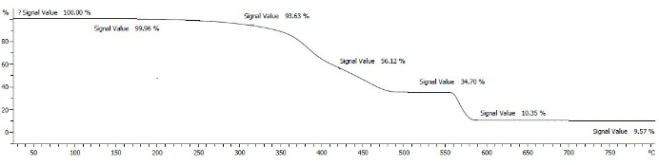
Figure 2. The weight loss behavior of SP1 specimen

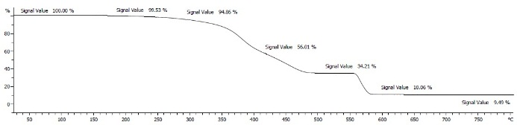
Figure 3. The weight loss behavior of SP2 specimen

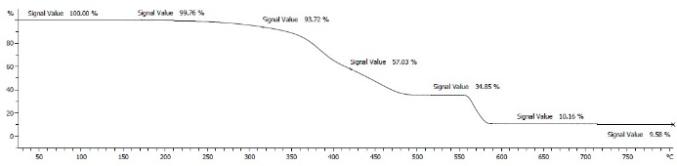
Figure 4. The weight loss behavior of SP3 specimen

2. 3. 4. Fourier Transform Infrared Spectroscopy (FTIR)
Fourier transform infrared spectroscopy (FTIR) was obtained by Bruker FTIR spectrometer (Germany). The FTIR for all compounds were showed in Figures 5-7.
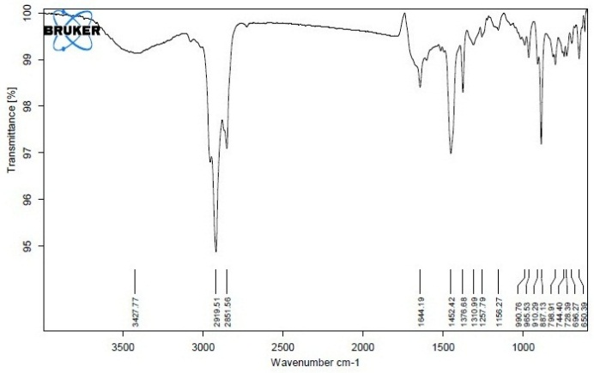
Figure 5. The FTIR for SP1 specimen

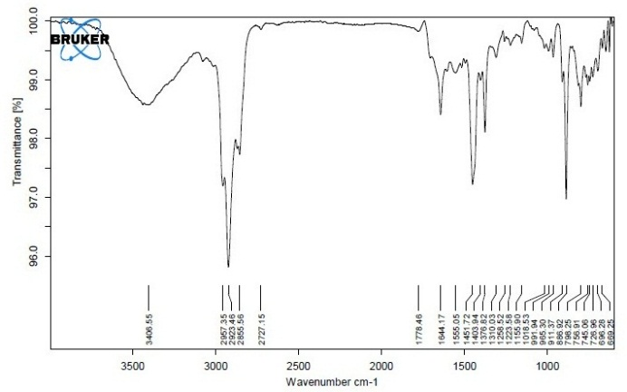
Figure 6. The FTIR for SP2 specimen

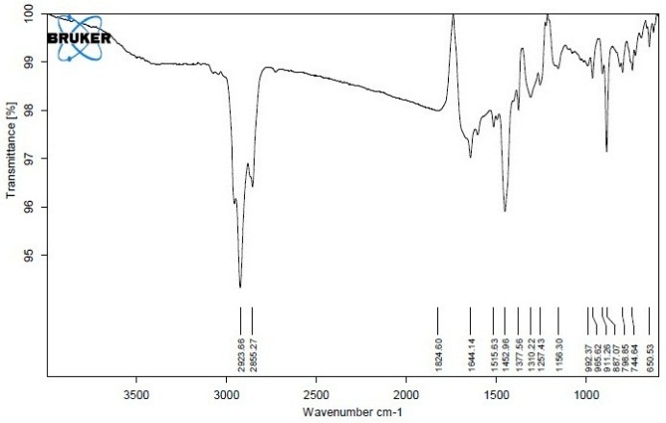
Figure 7. The FTIR for SP3 specimen

3. Result and Discussion
3. 1. Cure characteristics
The best well-known compounding method to minimize reversion is the application of anti-reversion agents, thereby diminishing the number of polysulphidic crosslinks and generating reversion resistant mono and disulphidic crosslinks. The curing behavior of three various resulting materials is displayed in Figure 8. The data observed for CRI, ∆M, ts₂, tc₉₀ and the value of reversion at different times are shown in Figures 9 and 10 respectively.
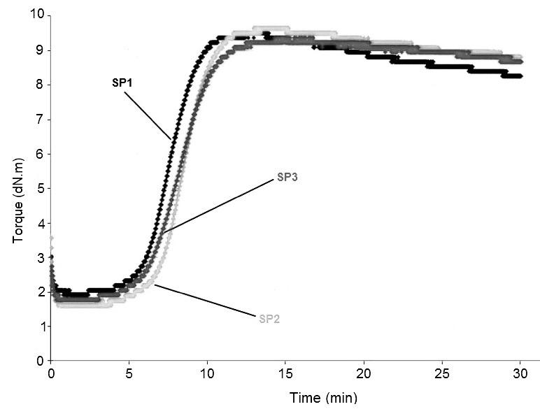
Figure 8. The curing curve of compounds based on NR/BR for SP1, SP2, and SP3

Figure 9. The curing characteristics of NR/BR blends

Figure 10. The reversion value of NR/BR blends at different times
The role of activators depends on the type of rubber and vulcanization accelerator. ZnO has the greater influence on the degree, while stearic acid has the greater influence on the rate of the crosslinking reaction. The time required to attain 10% of the maximum torque is termed the scorch time. Formation rate of zinc-accelerator complex determines scorch time of rubbery materials.¹ As shown in Figure 9, the maximum scorch time value is related to SP3 compound which treated by SS-Calix as an anti-reversion agents. The reason for this increase could be the physical interact of accelerators with the SS-Calix cavities.³¹ Because of this, the formation of zinc-accelerator complex has delay and it caused to increases the scorch time. Another result of the rheometer’s curve is 5% increase of ΔM in the SP3 specimen over the other two compounds and it indicates despite delayed, accelerator act its effect as good as before. ΔM indirectly indicates the crosslink density of rubber samples, an increase in ΔM in SP3 compound demonstrates an improvement in quality of the final product. As can be seen, the tc₉₀ in SP3 and SP1 compounds are approximately equal but in SP2 (contain Perkalink900), tc₉₀ has increased so the cure rate index (CRI) has drastically decreased. This decrement in curing rate can be attributed to the negative effect of Perkalink900 on the rate of vulcanization.
Another important and delicate point that can be considered from the torque curve of these three compounds is their reversion behavior which is significantly different at a certain time. The onset of reversion and its relationship with increasing curing time can be seen in Table 3 and Figure 10 for all samples.
As the rheometer curves displayed the onset of reversion in SP1 sample is earlier than two other samples. In SP2 and SP3, the reversion begins simultaneously, but then it behaves differently. As can be seen from the results, at t₁₇ of curing, the lowest amount of reversion (0.14 dN.m) is related to SP3. At the same time, the reversion of SP1 and SP2 is three times and twice that of SP3, respectively.
However, at t_{18,} reversion of SP1 and SP3 increases, but the value of this phenomenon in SP2 remains unchanged up to t₂₂. At this point SP2 and SP3 samples have the same reversion resistant. The reversion of SP1 and SP3 will be increased after t₂₀. The highest value of reversion is related to SP1 and the lowest is belonging to SP2 blends. This trend is continued and indicated the anti-reversion behavior of three samples as fallowed (Figure 10): SP2>SP3>SP1
As Figure 10 shows, the point to consider in this phenomenon is the performance of SS-Calix in SP3 blend as an anti-reversion agent in a certain curing temperature range (t₁₅-t₁₇). It seems that SS-Calix, in addition to being reinforcing filler that does not require a coupling agent ³¹, it can be act as anti-reversion agent in rubbery materials that exposed to thermal shock. In fact, it acts as an anti-reversion in the early stages of temperature rise for rubbery materials that are exposed to thermal shock.
It is predicted that at the first 2 minutes of reversion, the polymer chains which crosslinks have been broken and radicalized by the reversion phenomenon form new positive interaction with the radicals created in the SS-Calix. As a result, it reduces the reversion. Because a limited number of calix moieties are bonded to the silica surface, over time, the number of calixarenes radicals on the silica surface are finished and the radical reaction of SS-Calix with elastomer chains are quenched. As a result, the anti-reversion effect of SS-Calix decreases through the time. In general, it can be suggested that the ability of Perkalink900 as an anti-reversion is slightly higher than the SS-Calix agent.
The results of the tensile strength, modulus100%, modulus 300% are displayed in Figure 11a and the result of the elongation is shown in Figure 11b. Hardness and resilience tests for all compounds are shown in Figure 12.

Figure 11a. Results of tensile strength, modulus100% and modulus 300% for SP1, SP2 and SP3

Figure 11b. Results of the elongation for SP1, SP2 and SP3

Figure 12. Results of hardness and resilience for SP1, SP2 and SP3
As Figure 11a shows the tensile strength of both SP3 and SP2 compounds increase in comparison with SP1 and they are not significantly different from each other. So Perkalink900 and SS-Calix have the same effect on tensile strength of rubber products. It seems that due to the macromolecule structure of the SS-Calix and the presence of many hydroxyl groups and cavities in this system, polymer chains have been interacted with SS-Calix. As a result, the compound structure has become tighter, therefore the tensile strength has increased in comparison with SP1 compound. Figures 11a and 12 show that the highest modulus and hardness is related to SP3 rubbery compound and the lowest modulus and hardness is related to SP2 .In fact, Perkalink900 has a negative effect on modulus and hardness. The increase in modulus and hardness in SP3 blend is due to the increase in crosslink density in this compound. Increasing the density of crosslinks also reduces the elongation and resilience of SP3 (Figures 11b and 12). It should be noted that the crosslink density effect on the tensile strength, modulus, elongation at break, resilience and hardness.³⁷⁻⁴⁰

3. 2. The Thermal Gravimetric Analysis
In order to investigate the thermal resistance of three different compounds thermal gravimetric was performed (Figures 2-4). The data of thermal analysis for all samples are summarized in Table 5. The results show that the onset temperature of degradation of SP2 is lower than that of SP3 and this process continues up to 45% of degradation. After that, the destruction temperature of both samples up to 90% is almost the same. However, due to chemical and physical interactions between SS-Calix and SP3 blend it seems reasonable that the thermal resistance of SP3 is higher than that of SP2.
Table 5. The TG data for three different samples
 |  | Sample
 | SP1 | SP2 | SP3
T_{in} (°C) | 320 | 290 | 320
T_{5%} (°C) | 329 | 310 | 329
T_{15%} (°C) | 370 | 360 | 380
T_{25%} (°C) | 386 | 378 | 388
T_{35%} (°C) | 402 | 392 | 408
T_{45%} (°C) | 431 | 419 | 435
T_{50%} (°C) | 442 | 442 | 445
T_{55%} (°C) | 461 | 451 | 452
T_{65%} (°C) | 561 | 480 | 482
T_{75%} (°C) | 570 | 569 | 570
T_{85%} (°C) | 580 | 573 | 580
T_{95%} (°C) | 582 | 580 | 582
3. 3. Fourier Transform Infrared Spectroscopy (FTIR)
The Fourier transform infrared spectroscopy was performed to evaluate the anti-reversion behavior of SP3 blend. Since the interpretation of the FTIR spectrum of rubber samples is so complex, only strong bands were considered in this study.
The absorption curves of the SP3 blend showed that in addition to the bands characteristic for calix[4]arenes ³⁶, there is a broad peak around 1824 cm⁻¹ which is referred to C=O bond.⁴¹ As we know, the most important feature of SS-Calix is the position of the OH stretching bond in the 3100-3500 cm⁻¹ region. The considerably weaker C=O bond for SP1 and SP2 blends is attributed to the fact that the oxygen of hydroxyl groups of the calixarene surface forms a C=O with the carbon in the polymer chain.⁴²

3. 4. The conversion rate of vulcanization
By using equation (1), the conversion rate of vulcanization at various times had evaluated for all compounds (Table 6).⁴³
$Xt=\frac{Mt-ML}{MH-ML}$ Equation (1)
In this equation, Xt indicate the conversion rate at the given time t. Mt, MH, ML and MH-ML represent torque at the given time t, the maximum Torque, the Minimum Torque and the difference between maximum and minimum Torque, respectively.
Table 6. The conversion rate of vulcanization at various times for all compounds
 | Sample
 | SP1 | SP2 | SP3
X₅ | 0.05 | 0.05 | 0.03
X₁₀ | 0.95 | 0.85 | 0.86
X₁₃ | 1.00 | 0.98 | 1.00
X₁₄ | 0.98 | 1.00 | 1.00
X₁₅ | 0.96 | 0.98 | 0.98
X₁₆ | 0.96 | 0.98 | 0.98
X₁₇ | 0.94 | 0.96 | 0.98
X₁₈ | 0.94 | 0.96 | 0.96
X₂₀ | 0.91 | 0.96 | 0.95
X₂₂ | 0.89 | 0.96 | 0.95
X₂₄ | 0.87 | 0.94 | 0.93
X₂₆ | 0.85 | 0.93 | 0.91
X₂₈ | 0.85 | 0.93 | 0.91
X₃₀ | 0.84 | 0.91 | 0.90
The value of X₅ indicate the delay in scorch time for SP3 specimen compared to SP2. The conversion ratio of SP1 and SP3 at X₁₃ equaled 1, which revealed that Mt=MH and the 90% of curing is done, for SP2 sample it happened in the X₁₄, While for SP3 sample in X₁₄ still remains 1. The SP3 conversion rate up to X₁₇ almost is more than SP2 (Table 6). These findings predicted that;
I: The reversion resistance of SP3 up to about X₁₇ is more than SP2 and SP1.
II: The second important point is that after X₁₇ up to X₃₀, less reversion occurs for SP2.
III: The SP3 rubber sample exhibits high thermal resistance in a short time.
These outcomes confirm the result from curing behavior of three different samples.

4. Conclusion
Since the reversion has a negative effect on the performance properties of the rubber compounds, this study investigated the influence of the presence of SS-Calix on the reversion resistance of compound based on NR/BR. Its anti-reversion properties were also compared with perkalink900. Finally, the following results are obtained:
- The presence of SS-Calix in compound based on NR/BR increase the modulus and hardness also decrease the resilience and the elongation.
- In a few minutes after the start of reversion the reversion resistance effect of the SS-Calix was much better than perkalink900.
- The presence of SS-Calix increases the formation of C=O bonds in SP3 sample that cause to increase reversion resistance in the early minutes after the start of reversion.
- Application of the SS-Calix to NR/BR rubber products subject to thermal shock is recommended.
- In NR/BR rubber compound that contains SS-Calix the initial temperature degradation until T_{45%} are more than perkalink900.
Based on these findings, it can be predicted that this feature of calix[4]arene can be applied in the preparation of rubber products that must have high thermal resistance in a short time.

5. Reference
1. B. Rodgers, (Ed.): Rubber Compounding Chemistry and Application, Marcel Dekker, New York , 2004, p.512.
2. K. Boonkerd, CH. Deeprasertkul , K. Boonsomwong, Rubber. Chem. Technol. 2016, 89, 3, 450–464.
3. E. Leroy, A. Souid, A. Sarda, R. A. Deterre, Polym. Test. 2013, 32, 1, 9–14.
4. P. M Visakh, S. Thomas, A. K. Chandra, A. P. Mathew, (Ed.): Advances in Elastomers I Blends and Interpenetrating Networks, Springer, Heidelberg, New York Dordrecht London, 2013, pp. 121.
5. B. L. DeButts, N. Chauhan, J. R. Barone, J. Appl. Polym. Sci. 2019,136, 43.
6. S. Rabiei, A. Shojaei, Eur. Polym. 2016, 81, 98–113.
7. R. N. Datta, PROG. RUBBER. PLAST. RE. 2003, 19, 3.
8. N. R. Kumar, A. K. Chandra, R. Mukhopadhyay, J. Mater. Sc. 1997, 32, 3717-3725.
9. R. N. Datta, N. M. Huntink, S. Datta, A.G. Talma, Rubber. Chem. Technol. 2007, 80, 3, 436-480.
10. Sh. G. Sathi, J. Jeon, J. Won, Ch. Nah, J. Polym. Res. 2018, 25.
11. E. J. Blok, M. L. Kralevich, J. E. Varner, Rubber. Chem. Technol. 2000, 73, 1.

12. E. Leroy, A. Souid, R. Deterre, Polym. Test. 2013, 32, 3, 575–582.

13. G. Milani, E. Leroy, F. Milani, R. Deterre, Polym. Test. 2013, 32, 6, 1052–1063.
14. F. Ignatz-Hoover, F. A. LP, B. To, OH. Middlefield, E. Terrill, Rubber world. 2009, 75.
15. Sh. Gopisathi, Ch. Park, Y. I. Huh, J. Jeon, Ch. H. Yun, J. Won, K.U. Jeong, Ch. Nah, Rubber. Chem. Technol. 2019, 92, 1, 110–128.
16. G. S. Shibulal, J.Y. Jang, H. Ch. Yu, Y. I. Huh, Ch. Nah, J. Polym. Res. 2016, 23.
17. F. D. B. de Sousa, A. Zanchet, C. H. Scuracchio, J. Appl. Polym. Sci. 2017, 134, 41.
18. G. Milani, G. Milani, F. Milani, J. Math. Chem. 2015, 53, 1363–1379.
19. R. J. Sarma, J. B. Baruah, Dyes and Pigm. 2005, 64, 1, 91-92 .
20. S. Taghvaei-Ganjali, R. Zadmard, M. Zeyaei, K. Rahnama, F. Faridbod, M. R. Ganjali, Lett. Org. Chem. 2009.
21. M. Hosseini, M. Rahimi, H. Bagheri Sadeghi, S. Taghvaei- Ganjali, Sh. Dehghan Abkenar, M.R. Ganjali, Intern. J. Environ. Anal. Chem. 2009, 89, 6, 407–422.
22. M.S. Mirmoeini, M. M. Alavi Nikje, M. Rasouli-Saniabadi, S. Taghvaei-Ganjali, Macromol. Symp. 2017, 373.
23. S. Taghvaei-Ganjali, M. Rasouli-Saniabadi, M.S. Mirmoeini, J. Inc. Phenom. Macro. 2015, 83, 45–52.
24. M. Nouri, Sh. Mozafari, S. Taghvaei-Ganjali, Iran. JOC. 2011, 3, 4, 807–809.
25. A.K. Hassan, A.K. Ray, A.V. Nabok, F. Davis, Sens. Actuators. 2001, 77, 3, 638–641.
26. A. Bagheri Chenari, M. Saber-Tehrani, M. Mamaghani, M. Nikpass, J. Inc. Phenom. Macro. 2019, 94, 45–53.
27. H. Huang, C. Zhao, Y. Ji, R. Nie, P. Zhou, H. Zhang, J. Hazard. Mater. 2010, 178, 680–685.
28. K.D. Daze, C. E. Jones, B. J. Lilgert, C. S. Beshara, F. Hof, Can. J. Chem. 2013, 91 ,1072–1076.
29. T.T. Pang, L.M. Du, H.L. Liu, Y.L. Fu, Can. J. Chem. 2014, 92, 1139–1144.
30. F. Yang, Y. Wang, H. Guo, J. Xie, Z. Liu, Can. J. Chem. 2010, 88, 622-627.
31. H. Mohamadi, F. Motiee, M. Saber-Tehrani, S. Taghvaei-Ganjali, Russ. J. App. Chem. 2019, 92, 809−816.
32. M. Malekzadeh, H. Nouri, M. Farahani, JACR. 2010, 3, 41–45.
33. H. Margharian Pekachaki, S. Taghvaei-Ganjali, F. Motiee, M. Saber-Tehrani, Rubb. Chem. Technol. 2019, 92, 3, 467-480.
34. Z. Servati, M. Saber-Tehrani, S. Taghvaei-Ganjali, R. Zadmard, J. Porous. Mater. 2018, 25, 1463–1474 .
35. H. Li, Y. Zhong, W. Wu, L. Zhang, X. Lai, X. Zeng, J. Appl. Polym. Sci. 2017, 134, 31.
36. S. Taghvaei-Ganjali, R. Zadmard, M. Saber-Tehrani, Appl. Surf. Sci. 2012, 258, 16, 5925–5932.
37. M. Nasir, G. K. Teh, Eur. Polym. J. 1988, 24, 8, 733–736.
38. L. M. Polgar, G. Fortunato, R. Araya-Hermosilla, M. van Duin, A. Pucci, F. Picchioni, Eur. Polym. J. 2016, 82, 208–219.
39. S. S. Choi, H. M. Kwon, Y. Kim, E. Ko, K. S. Leeb, Polym. Int. 2018, 67, 3, 340–346.
40. I. Surya, H. Ismail, A.R. Azura, Polym. Test. 2015, 42, 208–214.
41. M. Fan, Y. Zhang, X. Li, B. Zeng, Sh. Chen, W. Zhu, Sh. Wang, J. Xu, N. Feng, Polym. Advan. Technol. 2019, 30, 5.
42. C. D. Gutsche, in: Calixarenes, Royal Society of chemistry, Cambridge, 2008, p.70.
43. K. Chawla, A. P. S. Chauhan, A. Pandey, Plast. Rubber. Compos. 2016, 45, 6.

