Ultrasound-Assisted Synthesis, Antioxidant Activity and Computational Study of 1,3,4-Oxadiazol-2-amines

Hamid Beyzaei,¹* Elahe Sargazi,² Ghodsieh Bagherzade,² Ashraf Moradi,¹ and Elahe Yarmohammadi¹

¹ Department of Chemistry, Faculty of Science, University of Zabol, Zabol, Iran
² Department of Chemistry, Faculty of Science, University of Birjand, Birjand, Iran

* Corresponding author: E-mail: hbeyzaei@yahoo.com and hbeyzaei@uoz.ac.ir
Tel: +98 5431232186 / Fax: +98 5431232180

Abstract

It was found that reversible dipole-dipole forces play a key role in most interactions. Development of synthetic procedures for the preparation of 1,3,4-oxadiazole derivatives has always been the interest of researchers as a result of their widespread biological activities. In this study, An ultrasound-assisted procedure was proposed for the synthesis of 1,3,4-oxadiazol-2-amines form the reaction of hydrazides and cyanogen bromide. They were efficiently produced in 81-93% yields in the presence ethanol and potassium bicarbonate as rection media and base, respectively. Their antioxidant properties were determined via DPPH free radical scavenging method as one of the most basic steps in identifying other related biological effects. IC₅₀ values were in the range of from 0.237 to 0.863 mM. The synthesized 1,3,4-oxadiazoles are protective agents against oxidative stress, and can be used in the treatment of cancer, candidiasis, diabetes, neurodegenerative and inflammatory diseases. Furthermore, bond dissociation energies (BDEs) and electron densities based NCI (non-covalent interactions) were calculated using density-functional theory (DFT) to understand the observed reactivities.

Keywords: 1,3,4-Oxadiazole; Antioxidant activity; DPPH; Ultrasound irradiation; NCI; DFT

1. Introduction

Antioxidant are synthetic or natural compounds that inhibit the oxidation reactions via free radical scavenging. Free radicals are unstable and reactive atoms or molecules containing one unpaired electron that can begin a propagation sequence in the chain reactions leading to cell damage.¹ Vitamins C and E as two essential nutrients are well known for being potent antioxidants. Ascorbic acid, known as vitamin C, is a water-soluble biologically active compound which should be provided to humans through food especially fresh vegetables and citrus fruits. Lack of vitamin C can result to scurvy disease.² At first it is accompanied by symptoms of weakness and fatigue while leads to anemia, hair loss, and bleeding gum and skin in the acute cases. Vitamin C is required for the proper functioning of some enzymes and immune system, tissue regeneration and the enzymatic production.³⁻⁵ Oil-soluble vitamin E includes four tocopherols as well as four tocotrienols. It is found in cereals, vegetable oils, meat, poultry, fruits and eggs, and its deficiency damages the nervous system.⁶
It has been understood that there is a significant relationship between the antioxidant capacity of compounds and some of their biological activities. Mendonca et al. were evaluated antioxidant and antiproliferative potentials of muscadine grape extracts on breast cancer cell lines; a strong positive correlation was observed between total phenolic content of extracts and their inhibitory activities against African American breast cancer cells.⁷ There are complex and often positive connections between oxidative stress with the inflammatory response given as a result of tissue injury and infection.⁸ Guava leaves are used as traditional medicines for the treatment of diabetes; they lowered levels of cholesterol, sugar, triglycerides, malonaldehyde and glycated serum protein in the blood of streptozotocin-induced diabetic mice according to their ABTS, OH and DPPH free radical scavenging capabilities.⁹ Reactive oxygen species are one of the main causes of Alzheimer disease, as a result, any agent that blocks their generation, can be useful in treating the disease.¹⁰
1,3,4-Oxadiazole derivatives have attracted a great deal of interest due to their diverse biological properties such as antioxidant, antiproliferative, anticonvulsants, antimicrobial and anti-Alzheimer.¹¹⁻¹⁵ Synthetic approaches of 1,3,4-oxadiazoles were reviewed in several literatures.¹⁶⁻¹⁸ Hypervalent iodine mediated reaction of N'-arylidene acetohydrazides, intracyclocondensation of thiosemicarbazides prepared from reaction of aryl hydrazides with ammonium thiocyanate using N,N,N′,N′-Tetramethyl-O-(benzotriazol-1-yl)uronium tetrafluoroborate (TBTU) or N,N'-diisopropylcarbodiimide (DIC), and simultaneous reaction of 1-chloroketones, N-isocyaniminotriphenylphosphorane and aryl carboxylic acids are examples of recent methods proposed to synthesize 1,3,4-oxadiazole derivatives.¹⁹⁻²¹
Theoretical calculations can be perform to justify experimental observations. However, it is possible that a logical relationship between experimental data and theoretical parameters cannot be found in all cases. Free radical scavenging thermodynamic of some 1,3,4-oxadiazole derivatives was studied by DFT method in gas and aqueous phases to predict their action mechanisms; it was found that the selected reaction pathway is completely dependent on the reaction medium.²²
It has been shown that phenolic compounds act as antioxidants in three ways:
Hydrogen Atom Transfer (HAT): ArOH → ArO• + H•
Single Electron Transfer Followed by Proton Transfer (SET-PT): (1) ArOH → [ArOH]^{•+} + e⁻ (2) [ArOH]^{•+} → ArO• + H⁺
Sequential Proton Loss Electron Transfer (SPLET): (1) ArOH → ArO⁻ + H⁺ (2) ArO⁻ → ArO• + e⁻
Computational studies calculate values of bond dissociation enthalpy; ionization potential and proton dissociation enthalpy; and proton affinity and electron transfer enthalpy to determine the predominant path.²³ DPPH free radical scavenging activity of some synthesized 1,2,4-triazole-3-thiones containing phenolic substituents was evaluated by Ivanović et al.; DFT calculations proved synergistic effects of 1,2,4-triazole-3-thione rings and predicted SPLET pathway as action mechanism in methanol.²³
In order to expand library of small organic biomolecules, some 5-alkyl/aryl/heteroaryl-1,3,4-oxadiazol-2-amine derivatives were synthesized via a new procedure under ultrasound irradiation. Antioxidant activities of the synthesized 1,3,4-oxadiazoles were assessed against DPPH to predict their other possible biological capabilities. Bond dissociation energy and electron density of all synthesized heterocycles were calculated to probably relate them to the observed antioxidant activities.

2. Experimental

2.1 Chemicals
All chemicals, solvents and aluminium thin-layer chromatography (TLC) plates pre-coated with silica gel containing ﬂuorescent indicator F254 were purchased from Merck and Sigma-Aldrich companies. The melting points were determined with Kruss KSP1N melting point apparatus, and are uncorrected. Bruker Tensor-27 FT-IR spectrometer was applied to record the FT-IR spectra of compounds. ¹H and ¹³C NMR spectra were registered using a Bruker 300 MHz-NMR spectrometer. Elemental analyses for C, H, N and S atoms were performed on a Termo Finnigan Flash EA microanalyzer. Ultrasonic irradiation was supplied by Backer vCLEAN1-L03 (40 kHz frequency and 100 W output power).

2.1.1 General procedure for the synthesis of 5-substituted 1,3,4-oxadiazol-2-amines 3a-h
A 25 ml round-bottom flask including 5 mmol of each hydrazides 1a-h, cyanogen bromide (2) (0.53 g) and potassium bicarbonate (0.50 g) in 10 ml absolute ethanol was subjected to an ultrasonic bath. The rection progress was checked by TLC with different volumetric ratios of methanol and dichloromethane as the desired mobile phase. The reaction content was added to 20 g crushed ice containing an excess of salt. The solid phase was filtered out, washed respectively with water (5 ml) and ethanol (5 ml), and oven-dried at 70 °C to give pure 1,3,4-oxadiazoles 3a-h.
2.1.1.1 5-Methyl-1,3,4-oxadiazol-2-amine (4a).
Yellow powder; IR (KBr) ν: 3420, 3352 (NH₂), 3120, 2359, 1666 (C=N), 1595, 1383, 1254, 1123 (C-O), 1005 (N-N), 781, 626 cm⁻¹; ¹H NMR (300 MHz, DMSO-d₆) δ: 6.85 (s, 2H, NH₂), 2.27 (s, 3H, CH₃) ppm; ¹³C NMR (75 MHz, DMSO-d₆) δ: 10.9 (CH₃), 156.6 (C-5 Oxadiazole), 164.0 (C-2 Oxadiazole) ppm; Anal. Calcd. for C₃H₅N₃O: C 36.36, H 5.09, N 42.41. Found: C 36.31, H 5.11, N 42.43.
2.1.1.2 5-Phenyl-1,3,4-oxadiazol-2-amine (4b).
White powder; IR (KBr) ν: 3476, 3413 (NH₂), 2924, 2358, 1613 (C=N), 1452, 1113 (C-O), 1027 (N-N), 620, 478 cm⁻¹; ¹H NMR (300 MHz, DMSO-d₆) δ: 7.25 (s, 2H, NH₂), 7.80-7.78 (m, 2H, H-2ʹ,6ʹ Ph), 7.51-7.49 (m, 3H, H-3ʹ,4ʹ,5ʹ Ph) ppm; ¹³C NMR (75 MHz, DMSO-d₆) δ: 124.8 (C-1ʹ Ph), 125.4 (C-2ʹ,6ʹ Ph), 129.6 (C-3ʹ,5ʹ Ph), 130.7 (C-4ʹ Ph), 157.8 (C-5 Oxadiazole), 164.3 (C-2 Oxadiazole) ppm; Anal. Calcd. for C₈H₇N₃O: C 59.62, H 4.38, N 26.07. Found: C 59.59, H 4.35, N 26.11.
2.1.1.3 5-(4-Nitrophenyl)-1,3,4-oxadiazol-2-amine (4c).
Yellow powder; IR (KBr) ν: 3436, 3375 (NH₂), 2924, 2358, 1652 (C=N), 1598 (N-O), 1527, 1389, 1344, 1116 (C-O), 1037 (N-N), 858, 620 cm⁻¹; ¹H NMR (300 MHz, DMSO-d₆) δ: 7.52 (br, 2H, NH₂), 8.32 (d, J = 8.7 Hz, 2H, H-3ʹ,5ʹ Ar), 7.98 (d, J = 8.7 Hz, 2H, H-2ʹ,6ʹ Ar) ppm; ¹³C NMR (75 MHz, DMSO-d₆) δ: 124.9 (C-3ʹ,5ʹ Ar), 126.4 (C-2ʹ,6ʹ Ar), 130.2 (C-1ʹ Ar), 148.3 (C-4ʹ Ar), 156.5 (C-5 Oxadiazole), 165.0 (C-2 Oxadiazole) ppm; Anal. Calcd. for C₈H₆N₄O₃: C 46.61, H 2.93, N 27.18. Found: C 46.66, H 2.93, N 27.15.
2.1.1.4 5-(4-(tert-Butyl)phenyl)-1,3,4-oxadiazol-2-amine (4d).
Pink powder; IR (KBr) ν: 3434, 3358 (NH₂), 3127, 2963, 2358, 1655 (C=N), 1609, 1391, 1118 (C-O), 1042 (N-N), 836, 621, 561 cm⁻¹; ¹H NMR (300 MHz, DMSO-d₆) δ: 7.55 (br, 2H, NH₂), 7.83 (d, J = 8.5 Hz, 2H, H-2ʹ,6ʹ Ar), 7.63 (d, J = 8.5 Hz, 2H, H-3ʹ,5ʹ Ar), 1.34 (s, 9H, 3 × CH₃) ppm; ¹³C NMR (75 MHz, DMSO-d₆) δ: 31.1 (C(CH₃)₃), 35.0 (C(CH₃)₃), 121.4 (C-3ʹ,5ʹ Ar), 125.0 (C-2ʹ,6ʹ Ar), 127.2 (C-1ʹ Ar), 152.6 (C-4ʹ Ar), 157.5 (C-5 Oxadiazole), 164.3 (C-2 Oxadiazole) ppm; Anal. Calcd. for C₁₂H₁₅N₃O: C 66.34, H 6.96, N 19.34. Found: C 66.30, H 6.98, N 19.36.
2.1.1.5 3-(5-Amino-1,3,4-oxadiazol-2-yl)phenol (4e).
White powder; IR (KBr) ν: 3554 (OH), 3458, 3413 (NH₂), 3145, 2924, 2360, 2341, 1643 (C=N), 1601, 1568, 1493, 1384, 1320, 1309, 1221, 1126 (C-O), 1064 (N-N), 1035, 994, 876, 799, 739, 701, 688, 669, 617, 450 cm⁻¹; ¹H NMR (300 MHz, DMSO-d₆) δ: 9.90 (s, 1H, OH), 7.35-7.26 (m, 5H, NH₂, H-2ʹ,5ʹ,6ʹ Ar), 6.91 (d, J = 6.9 Hz, 1H, H-4ʹ Ar) ppm; ¹³C NMR (75 MHz, DMSO-d₆) δ: 112.0 (C-2ʹ Ar), 116.3 (C-4ʹ Ar), 118.0 (C-6ʹ Ar), 125.8 (C-1ʹ Ar), 130.8 (C-5ʹ Ar), 157.9 (C-3ʹ Ar), 158.2 (C-5 Oxadiazole), 164.2 (C-2 Oxadiazole) ppm; Anal. Calcd. for C₈H₇N₃O₂: C 54.24, H 3.98, N 23.72. Found: C 54.19, H 3.96, N 23.75.
2.1.1.6 5-(3-Methoxyphenyl)-1,3,4-oxadiazol-2-amine (4f).
Yellow powder; IR (KBr) ν: 3415, 3386 (NH₂), 3109, 2359, 1654 (C=N), 1489, 1390, 1322, 1284, 1215, 1106 (C-O), 1040 (N-N), 875, 786, 748, 683, 621 cm⁻¹; ¹H NMR (300 MHz, DMSO-d₆) δ: 7.48-7.38 (m, 2H, H-5ʹ,6ʹ), 7.31-7.30 (m, 3H, NH₂, H-2ʹ Ar), 7.10 (d, J = 7.0 Hz, 1H, H-4ʹ Ar), 3.83 (s, 3H, CH₃) ppm; ¹³C NMR (75 MHz, DMSO-d₆) δ: 55.7 (CH₃), 110.3 (C-2ʹ Ar), 116.8 (C-4ʹ Ar), 117.8 (C-6ʹ Ar), 126.6 (C-1ʹ Ar), 130.9 (C-5ʹ Ar), 157.7 (C-3ʹ Ar), 160.0 (C-5 Oxadiazole), 164.3 (C-2 Oxadiazole) ppm; Anal. Calcd. for C₉H₉N₃O₂: C 56.54, H 4.75, N 21.98. Found: C 54.59, H 4.74, N 21.95.
2.1.1.7 5-(3-Bromophenyl)-1,3,4-oxadiazol-2-amine (4g).
White powder; IR (KBr) ν: 3451, 3413 (NH₂), 3116, 2358, 1654 (C=N), 1604, 1557, 1392, 1112 (C-O), 1044 (N-N), 794, 681 cm⁻¹; ¹H NMR (300 MHz, DMSO-d₆) δ: 7.91 (m, 1H, H-6ʹ), 7.80 (d, J = 7.8 Hz, 1H, H-4ʹ Ar), 7.71 (d, J = 7.7 Hz, 1H, H-2ʹ Ar), 7.50 (t, J = 7.5 Hz, 1H, H-5ʹ Ar), 7.38 (s, 2H, NH₂) ppm; ¹³C NMR (75 MHz, DMSO-d₆) δ: 122.7 (C-3ʹ Ar), 124.4 (C-6ʹ Ar), 126.9 (C-1ʹ Ar), 127.7 (C-4ʹ Ar), 131.9 (C-5ʹ Ar), 133.4 (C-2ʹ Ar), 156.4 (C-5 Oxadiazole), 164.5 (C-2 Oxadiazole) ppm; Anal. Calcd. for C₈H₆BrN₃O: C 40.03, H 2.52, N 17.50. Found: C 40.01, H 2.50, N 17.47.
2.1.1.8 5-(Pyridin-4-yl)-1,3,4-oxadiazol-2-amine (4h).
Brown powder; IR (KBr) ν: 3417, 3383 (NH₂), 2358, 1665 (C=N), 1538, 1391, 1340, 1123 (C-O), 1043 (N-N), 837, 682, 620 cm⁻¹; ¹H NMR (300 MHz, DMSO-d₆) δ: 8.74 (d, J = 7.7 Hz, 2H, H-2ʹ,6ʹ Ar), 7.71 (d, J = 7.7 Hz, 2H, H-3ʹ,5ʹ Ar), 7.58 (br, 2H, NH₂) ppm; ¹³C NMR (75 MHz, DMSO-d₆) δ: 119.2 (C-3ʹ,5ʹ Ar), 131.6 (C-4ʹ Ar), 151.1 (C-2ʹ,6ʹ Ar), 156.2 (C-5 Oxadiazole), 165.0 (C-2 Oxadiazole) ppm; Anal. Calcd. for C₇H₆N₄O: C 51.85, H 3.73, N 34.55. Found: C 51.89, H 3.75, N 34.51.
2.2 IC₅₀ (half maximal inhibitory concentration) identification
DPPH Free radical scavenging activities of prepared 1,3,4-oxadiazoles were evaluated and compared to those of ascorbic acid.²⁴ 1 ml of any oxadiazole at concentrations 25, 50, 75, and 100 µg ml⁻¹ in methanol was added to 4 ml of 0.004% (w/v) methanolic solution of DPPH. The mixed solutions were stored at room temperature for 30 min in darkness. Then, the absorbance of solutions was read against the blank at λ_{max} 517 nm. The inhibition percentage (I%) was calculated according to the following equation:
I% = [(A blank-A sample)/(A blank)] × 100
Where "A blank "and "A sample" are the absorbance of control and sample solutions, respectively. A graph of I% (y-axis) vs concentration (x-axis) was depicted. The IC₅₀ is "x" in equation of straight line y = mx + b while y = 50. Finally, the µg ml⁻¹ units were converted to the mM units.
2.3 Computational details
All the geometries were optimized in the gas phase and frequency calculations confirmed the nature of the stationary points. The methanol solvent was modelled using C-PCM as implemented in Gaussian 09 program package at the B3LYP level of density functional theory using the 6-311++G (d) basis set.²⁵⁻²⁸ NCI analysis was performed by the NCIPlot software.²⁹

3. Results and Discussion

3.1 Synthesis and spectroscopic characterization of 1,3,4-oxadoazol-2-amines 3a-h

5-Substituted 1,3,4-oxadoazol-2-amine derivatives 3a-h were synthesized via reaction of hydrazides 1a-h and cyanogen bromide (2) under ultrasonic irradiation (Scheme1). Potassium bicarbonate and absolute ethanol were applied as base and solvent, respectively.
Scheme 1. Schematic synthesis of 1,3,4-oxadoazol-2-amines 3a-h.
The interaction of 1 mmol of both benzhydrazide and cyanogen bromide was selected as model reaction for the preparation of 1,3,4-oxadiazoles (Table 1). Water and hydrous solvents were not used as a result of hydrolysis of cyanogen bromide to hypobromous acid and hydrogen cyanide. Absolute ethanol as a green, nontoxic, readily available, low-cost, water soluble, nonexplosive, easily removable, and recoverable solvent was selected and preferred than toxic methanol. 2 ml of ethanol was used in all processes as the minimum solvent required to dissolve the most reactants and perform the reaction. Only nucleophilic attack of NH₂ group of hydrazide to cyano group of cyanogen bromide occurred in room temperature (Entry 1). Intracyclization occurred at temperatures above 60 °C (Entry 2). The product yield and the reaction time were improved under refluxing conditions due to the increased solubility of the hydrazide and effective interactions between the reagents (Entry 3). Higher yields were achieved at similar times in the presence of bases such as potassium bicarbonate (1 mmol) and potassium carbonate (0.5 mmol); increasing basicities had no effect on yield and time. They only neutralized hydrogen bromide produced during the process so that it would not be reacted with the hydrazide. Relative cyanogen bromide cleavage was observed in the presence of potassium hydroxide. The reaction progress was checked in the presence of KHCO₃ as a nontoxic and inexpensive base under ultrasound irradiation. 1,3,4-Oxadiazole 3b was afforded in the shortest time with the highest yield under these conditions (Entry 7).
Table 1. Optimization of reaction conditions in the synthesis of 5-phenyl-1,3,4-oxadiazol-2-amine (3b).
Entry | Base | T (°C) | Time (h) | Yield (%)
1 | - | r.t. | 3 | -
2 | - | 60 | 9 | 68
3 | - | reflux | 7 | 72
4 | KHCO₃ | reflux | 5 | 81
5 | K₂CO₃ | reflux | 5 | 81
6 | KOH | reflux | 5 | 75
7 | KHCO₃ | ))) | 3.5 | 92

1,3,4-oxadiazoles 3a-h were synthesized under optimized conditions. The results are given in the Table 2.
Table 2. The data of ultrasonic-assisted reaction of hydrazides and cyanogen bromide in ethanol.
Product | Time (h) | Yield (%) | M.P. (°C)
 |  |  | Observed | Reported^{Ref.}
3a | 7 | 81 | 172-174 | 176-180³⁰
3b | 3.5 | 92 | 243-245 | 239-242³¹
3c | 4.5 | 88 | 265-267 | 267-270³¹
3d | 5 | 93 | 262-264 | 256-258³¹
3e | 6 | 83 | 240-242 | 244-245³²
3f | 6 | 90 | 193-194 | 192-195³³
3g | 3.5 | 92 | 246-248 | 240-243³³
3h | 2.5 | 84 | 260-261 | 262-264³¹

The chemical structure of all synthesized 1,3,4-oxadiazoles was characterized by spectral data. The absorption bands around 1120 and 1660 cm⁻¹ attributed respectively to C-O and C=N stretching vibrations were confirmed the formation of 1,3,4-oxadiazole rings. In ¹H NMR spectra, singlet or broads peaks in the range of 6.85 to 7.58 ppm belong to amino groups. In ¹³C NMR spectra, signals corresponded to asymmetric 2- and 5-carbons of 1,3,4-oxadiazole ring were appeared in the 156.2-165.0 ppm range.
The reaction between hydrazides and cyanogen bromide is a straightforward method to synthesize 1,3,4-oxadiazole derivatives. Several procedures were developed for this purpose. Faizi et al. prepared 1,3,4-oxadiazole 3b in 62% yield from reaction of benzhydrazide and a 1.22 molar excess of cyanogen bromide in boiling methanol for 4h.³⁴ Some 1,3,4-oxadiazol-2-amine derivatives were synthesized via the stirring of mixture including hydrazides and 1.5 molar excess of both cyanogen bromide and potassium bicarbonate in acetonitrile:water 6.25:93.75% (v/v) for 1 day at room temperature.³⁵ Katritzky et al. proposed a convenient method for the preparation of 1,3,4-oxadiazole 3b; the mixture of symmetric and asymmetric di(benzotriazolyl)methanimines prepared from 1,2,3-benzotriazole and cyanogen bromide was reacted with benzhydrazide in THF under reflux for 3 h to afford 3b in 94% yield.³⁶
3.2 Antioxidant evaluation of the synthesized compounds
Free radical scavenging activity of all 1,3,4-oxadiazoles was assessed against DPPH. The inhibitory effects were calculated as IC₅₀ values and reported in Table 3.
Table 3. Antioxidant activity of 1,3,4-oxadiazole derivatives 3a-h.
Products | 3a | 3b | 3c | 3d | 3e | 3f | 3g | 3h | Vitamin C
IC₅₀ (mM) | 0.237 | 0.306 | 0.114 | 0 | 0.273 | 0.284 | 0.863 | 0.222 | 0.022
1,3,4-oxadiazole derivatives 3a-h exhibited antioxidant activities in the following order: 3c ˃ 3h ˃ 3a ˃ 3e ˃ 3f ˃ 3b ˃ 3g > 3d which, were less than that of vitamin C. No antioxidant property was observed with derivative 3d congaing 5-(4-(tert-butyl)phenyl) substituent. Unlike 3-(5-amino-1,3,4-oxadiazol-2-yl)phenol (3e), 1,3,4-oxadiazoles 3c and 3h with electron-withdrawing nitro and pyridinyl groups exhibited significant effects. Methylation of hydroxy group of derivative 3e did not significantly alter its antioxidant properties; this probably indicates a lack of hydrogen-atom donation of OH substituent in 3e.
3.3 NCI analysis
We have also used NCI index, while it is a visualization index based on the electron density (ρ) and the reduced density gradient (s). It is based on the empirical observation that NCI can be associated with the regions of small reduced density gradient at low electronic densities. In quantum chemistry, the NCI index is used to visualize non-covalent interactions in three-dimensional space. Its visual representation arises from the isosurfaces of the reduced density gradient colored by a scale of strength. The strength is usually estimated through the product of the electron density and the second eigenvalue (λ_{H}) of the Hessian of the electron density at each point of the isosurface, with the attractive or repulsive character being determined by the sign of λ_{H}. This allows for a direct representation and characterization of non-covalent interactions in the three-dimensional space, including hydrogen bonds and steric clashes. Being based on the electron density and derived scalar fields, NCI indexes are invariant with respect to the transformation of molecular orbitals. Furthermore, the electron density of a system can be calculated by X-ray diffraction experiments as well as theoretical wavefunction calculations (Figure 1).³⁷⁻³⁹
The reduced density gradient (s) is a scalar field of the electron density (ρ) that can be defined as: s(r) = $\frac{|∇ρ(r)|}{{2({3π}^{2})}^{1/3} {ρ(r)}^{4/3} }$

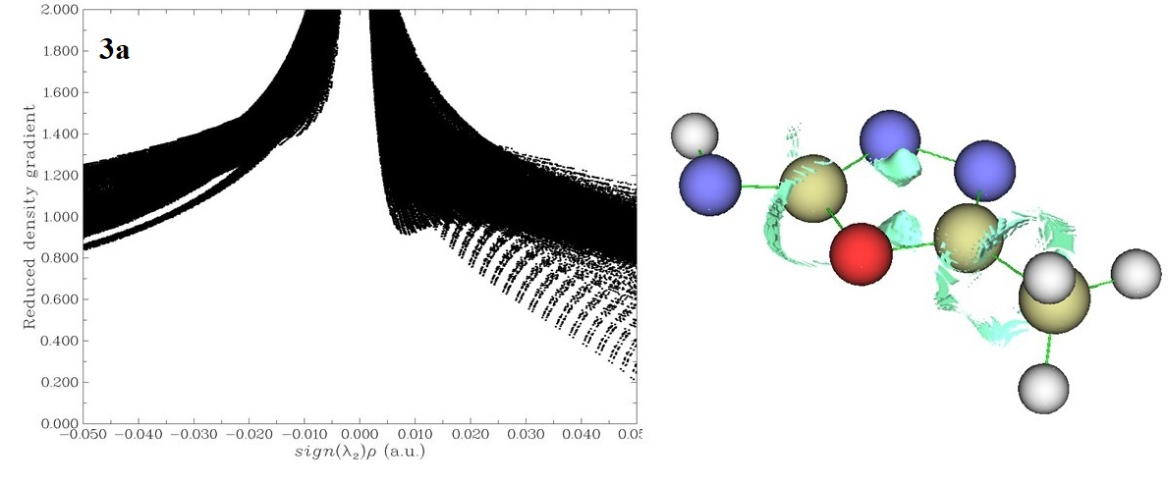
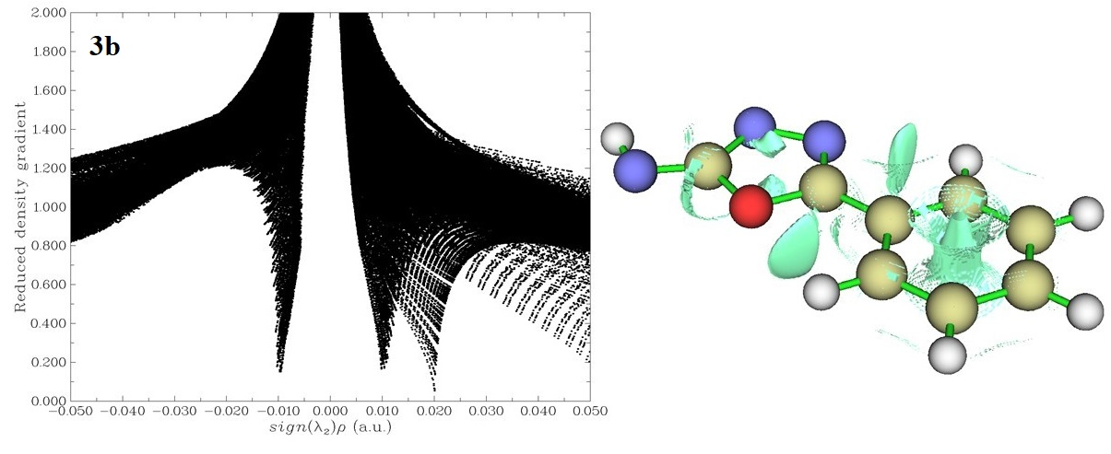
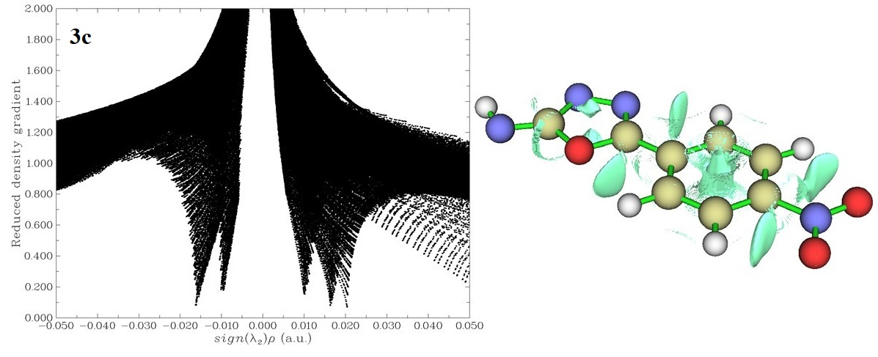
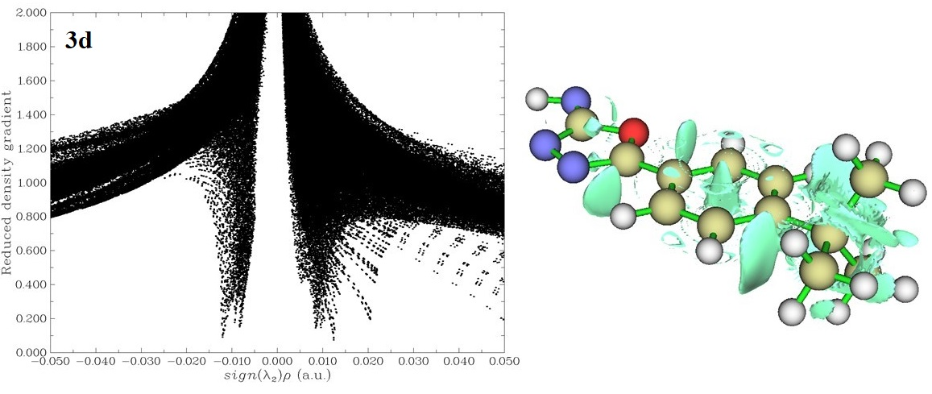
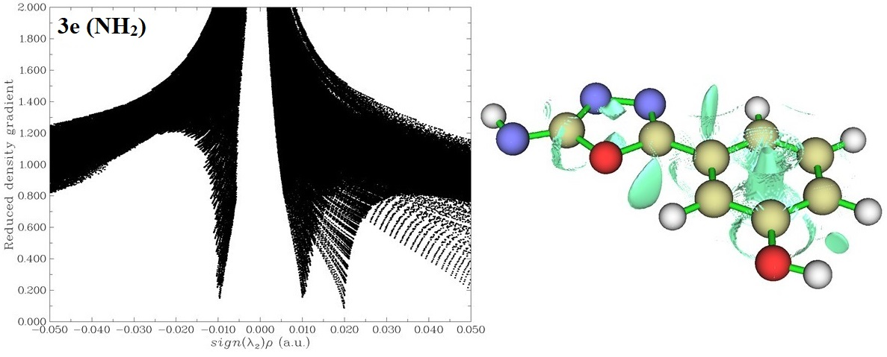
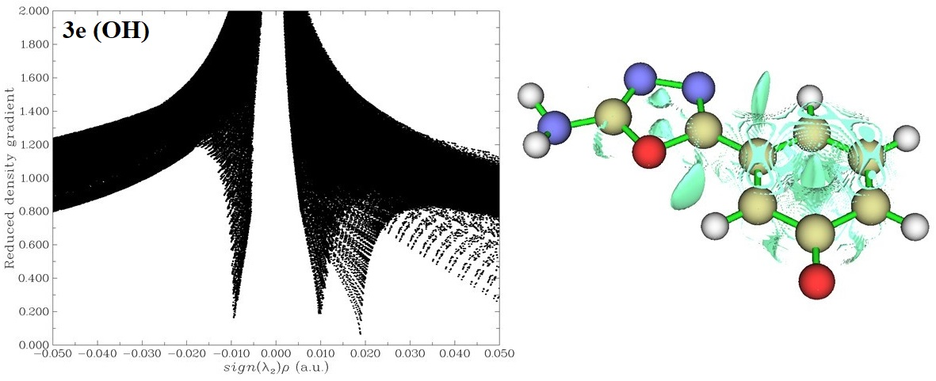
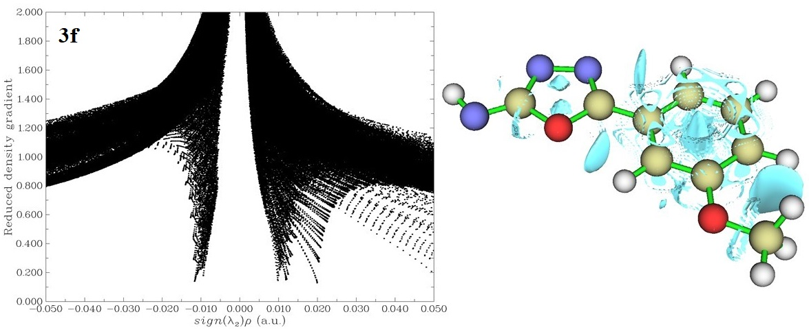
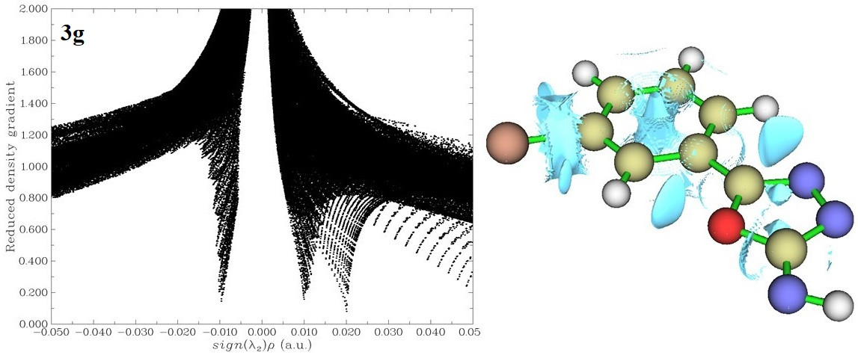
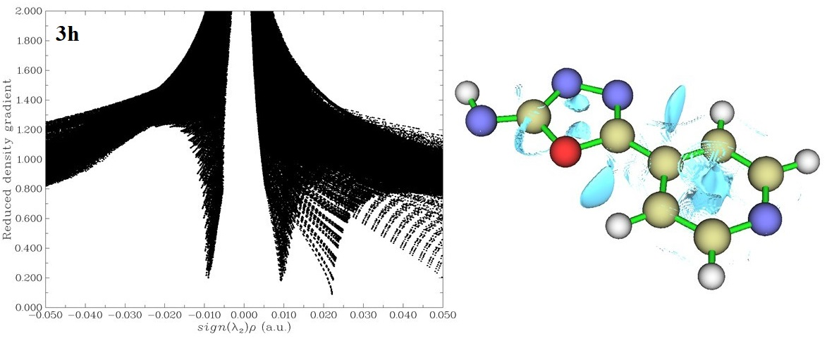Figure 1. Plots of the reduced density gradient (RDG) versus sign (λ₂ ρ and NCI isosurface (isovalue = 0.8 au) of compounds 3a-h.
3.4 Radicalization energy and BDE theory
The BDE of radicals generated from compounds 3a-h were calculated and reported in Table 4, they were arranged according to increasing BDEs in moving from the top to the bottom on this table. Based on calculations and BDE theory, the stability of free radicals decreases as we go from left to right across the periodic table.⁴⁰ Accordingly, the product 3e tends to form radical from nitrogen side; oxygen atom is more electronegative than nitrogen atom and its partially empty orbital is being held more closely to the positively charged nucleus. Thus, radical 3e (NH₂) is more stable than radical 3e (OH) by about 4 kcal mol⁻¹. Mesomeric and/or inductive electron-withdrawing groups such as nitro destabilize free radicals; as radical 3c is about 3 kcal mol⁻¹ less stable than radical 3b. Radical 3g containing 3-bromo phenyl substituent is about 1 mol⁻¹ more stable than radical 3b; this slight energy difference is due to may be due to the dual nature of the halogen atoms (electron-withdrawing inductive effects versus electron-donating mesomeric effects) Unexpectedly, the replacement of C-4 in benzene with one nitrogen atom (4-pyridyl ring instead of a phenyl ring) in 3h can increase the stability of corresponding radical.
Table 4. Calculation of energy opt + frq of compounds 3a-h using DFT method in 6-311++G (d) basis set.
Compounds | Reactants  (a.u.) | Radicals  (a.u) | BDE (kcal mol⁻¹)
3h | -564.5609986 | -563.9221562 | 400.88
3e (OH) | -623.7550404 | -623.1156937 | 401.20
3d | -705.7909084 | -705.1461778 | 404.57
3b | -548.5353695 | -547.8896743 | 405.18
3e (NH₂) | -623.7550392 | -623.1091857 | 405.28
3f | -663.0593888 | -662.4135282 | 405.28
3g | -3119.639242 | -3118.991964 | 406.17
3a | -356.7947813 | -356.1463463 | 406.90
3c | -753.0392 | -752.38958 | 407.64

4. Conclusions

In this study, a new and efficient procedure was proposed for the synthesis of 1,3,4-oxadiazol-2-amines. They were prepared in good to excellent yields under ultrasound irradiation as promotion of the reaction between hydrazides and cyanogen bromide. H-atom-donating abilities of all synthesized heterocycles were evaluated against DPPH radical. The acceptable to good antioxidant properties of the derivatives candidate them as potent antidiabetic, antiproliferative, anti-inflammatory and anti-neurodegenerative agents. The trend observed in the stability of radicals were not in complete agreement with the theoretical data suggesting that other mechanisms should be involved in the formation of all or some of them.

5. Acknowledgements
This study was funded by the University of Zabol (grant No. UOZ-GR-9618-10).

6. References

- S. Goodarzi, S. Rafiei, M. Javadi, H. Khadem Haghighian, S. Noroozi, J. Food Nutr. Sec. 2018, 3, 106-112.
- R. Gallizzi, M. Valenzise, S. Passanisi, G. B. Pajno, F. De Luca, G. Zirilli, J. Med. Case Rep. 2020, 14, 18. DOI:10.1186/s13256-020-2341-z
- P. Tozatti, E. J. Hopkins, C. Briggs, P. Hucl, M. T. Nickerson, Food Sci. Technol. Int. 2020. DOI:10.1177/1082013220915363
- T. Chaitrakoonthong, R. Ampornaramveth, P. Kamolratanakul, Int. J. Dent. 2020, 2020, 4706418. DOI:10.1155/2020/4706418
- A. Boretti, B. K. Banik, PharmaNutrition 2020, 12, 100190. DOI:10.1016/j.phanu.2020.100190
- Y. Baghcheghi, S. Mansouri, F. Beheshti, M. N. Shafei, H. Salmani, P. Reisi, A. Anaeigoudari, A. E. Bideskan, M. Hosseini, Int. J. Vitam. Nutr. Res. 2020, 90, 156-168. DOI:10.1024/0300-9831/a000533
- P. Mendonca, A. G. Darwish, V. Tsolova, I. El-Sharkawy, K. F. A. Soliman, Anticancer Res. 2019, 39, 4043-4053. DOI:10.21873/anticanres.13560
- M. Allegra, Antioxidants 2019, 8, 549. DOI:10.3390/antiox8110549
- Y. Luo, B. Peng, W. Wei, X. Tian, Z. Wu, Molecules 2019, 24, 1343. DOI:10.3390/molecules24071343
- A. Badrul, H. Ekramul, Iran. J. Pharm. Res. 2011, 7, 49-56.
- M. M. El Sadek, S. A. Magd, S. Y. Hassan, M. Mostafa, G. Yacouat, Iran. J. Chem. Chem. Eng. 2019, 38, 229-242.
- Z. M. M. Alzhrani, M. M. Alam, T. Neamatallah, S. Nazreen, J. Enzyme Inhib. Med. Chem. 2020 , 35, 1116-1123. DOI:10.1080/14756366.2020.1759581
- S. Nazar, N. Siddiqui, O. Alam, Arch. Pharm. (Weinheim) 2020, e1900342. DOI:10.1002/ardp.201900342
- D. Zeng, M. W. Wang, M. Xiang, L. W. Liu, P. Y. Wang, Z. Li, S. Yang, Pest. Manag. Sci. 2020. DOI:10.1002/ps.5814
- A. Tripathi, P. K. Choubey, P. Sharma, A. Seth, P. N. Tripathi, M. K. Tripathi, S. K. Prajapati, S. Krishnamurthy, S.K. Shrivastava, Eur. J. Med. Chem. 2019, 183, 111707. DOI:10.1016/j.ejmech.2019.111707
- C. S. De Oliveira, B. F. Lira, J. M. Barbosa-Filho, J. G. F. Lorenzo, P. F. De Athayde-Filho, Molecules 2012, 17, 10192-10231. DOI:10.3390/molecules170910192
- K. D. Patel, S. M. Prajapati, S. N. Panchal, H.D. Patel, Synth. Commun. 2014, 44, 1859-1875. DOI:10.1080/00397911.2013.879901
- P. N. Khatale, T. Sivakumar, Indian J. Heterocycl. Chem. 2014, 24, 47-50.
- J. Chauhan, M. K. Ravva, S. Sen, Org. Lett. 2019, 21, 6562-6565. DOI:10.1021/acs.orglett.9b02542
- F. Golmohammadi, S. Balalaie, F. Hamdan, S. Maghari, New J. Chem. 2018, 42, 4344-4351. DOI:10.1039/C7NJ04720G
- A. Ramazani, D. Zamanesazi, Y. Ahmadi, P. Azimzadeh Asiabi, A. Souldozi, S. J. Woo, J. Appl. Chem. Res. 2017, 11, 76-85.
- I. O. Alisi, A. Uzairu, S. E. Abechi, Helion 2020, 6, e03683. DOI:10.1016/j.heliyon.2020.e03683
- N. Ivanović, L. Jovanović, Z. Marković, V. Marković, M. D. Joksović, D. Milenković, P. T. Djurdjević, A. Ćirić, L. Joksović, ChemistrySelect 2016, 1, 3870-3878. DOI:10.1002/slct.201600738
- H. Beyzaei, M. Kamali Deljoo, R. Aryan, B. Ghasemi, M. M. Zahedi, M. Moghaddam-Manesh, Chem. Cent. J. 2018, 12, 114. DOI:10.1186/s13065-018-0488-0
- M. J. Frisch, G. W. Trucks, H. B. Schlegel, G. E. Scuseria, M. A. Robb, J. R. Cheeseman, G. Scalmani, V. Barone, B. Mennucci, G. A. Petersson, H. Nakatsuji, M. Caricato, X. Li, H. P. Hratchian, A. F. Izmaylov, J. Bloino, G. Zheng, J. L. Sonnenberg, M. Hada, M. Ehara, K. Toyota, R. Fukuda, J. Hasegawa, M. Ishida, T. Nakajima, Y. Honda, O. Kitao, H. Nakai, T. Vreven, J. A. Montgomery, J. E. Peralta, F. Ogliaro, M. Bearpark, J. J. Heyd, E. Brothers, K. N. Kudin, V. N. Staroverov, R. Kobayashi, J. Normand, K. Raghavachari, A. Rendell, J. C. Burant, S. S. Iyengar, J. Tomasi, M. Cossi, N. Rega, J. M. Millam, M. Klene, J. E. Knox, J. B. Cross, V. Bakken, C. Adamo, J. Jaramillo, R. Gomperts, R. E. Stratmann, O. Yazyev, A. J. Austin, R. Cammi, C. Pomelli, J. W. Ochterski, R. L. Martin, K. Morokuma, V. G. Zakrzewski, G. A. Voth, P. Salvador, J. J. Dannenberg, S. Dapprich, A. D. Daniels, O. Farkas, J. B.
Foresman, J. V. Ortiz, J. Cioslowski, D. J. Fox, Gaussian 09, Revision A 02, Gaussian, Inc., Wallingford CT, USA, 2009.
- S. J. A. Pople, J. Comput. Chem. 2004, 25, fmv-viii. DOI:10.1002/jcc.20049
- M. J. S. Dewar, E. G. Zoebisch, E. F. Healy, J. J. P. Stewart, J. Am. Chem. Soc. 1985, 107, 3902-3909. DOI:10.1021/ja00299a024
- J. J. P. Stewart, J. Comput. Chem. 1989, 10, 209-220. DOI:10.1002/jcc.540100208
- J. Contreras-García, E. R. Johnson, S. Keinan, R. Chaudret, J. P. Piquemal,
D. N. Beratan, W. Yang, J. Chem. Theory Comput. 2011, 7, 625-632. DOI:10.1021/ct100641a
- I. Pibiri, L. Lentini, R. Melfi, M. Tutone, S. Baldassano, P. Ricco Galluzzo, A. Di Leonardo, A. Pace, Eur. J. Med. Chem. 2018, 159, 126-142. DOI:10.1016/j.ejmech.2018.09.057
- R. Kapoorr, S. N. Singh, S. Tripathi, L. D. S. Yadav, Synlett 2015, 26, 1201-1206. DOI:10.1055/s-0034-1380493
- H. Rajak, B. Singh Thakur, A. Singh, K. Raghuvanshi, A. K. Sah, R. Veerasamy, P. C. Sharma, R. Singh Pawar, M. D. Kharya, Bioorg. Med. Chem. Lett. 2013, 23, 864-868. DOI:10.1016/j.bmcl.2012.11.051
- M. Zender, T. Klein, C. Henn, B. Kirsch, C. K. Maurer, D. Kail, C. Ritter, O. Dolezal, A. Steinbach, R. W. Hartmann, J. Med. Chem. 2013, 56, 6761-6774. DOI:10.1021/jm400830r
- M. Faizi, S. Dabirian, H. Tajali, F. Ahmadi, E. Rezaee Zavareh, S. Shahhosseini, S. A. Tabatabai. Bioorg. Med. Chem. 2015, 23, 480-487. DOI:10.1016/j.bmc.2014.12.016
- G. D. Fallon, C. L. Francis, K. Johansson, A. J. Liepa, R. C. J. Woodgate, Aust. J. Chem. 2005, 58, 891-900. DOI:10.1071/CH05070
- A. R. Katritzky, B. V. Rogovoy, V. Y. Vvedensky, K. Kovalenko, P. J. Steel, V. I. Markov, B. Forood, Synthesis 2001, 2001, 0897-0903. DOI:10.1055/s-2001-13400
- E. Pastorczak, C. Corminboeuf, J. Chem. Phys. 2017, 146, 120901. DOI:10.1063/1.4978951
- E. R. Johnson, S. Keinan, P. Mori-Sánchez, J. Contreras-García§, A. J. Cohen, W. Yang, J. Am. Chem. Soc. 2010, 132, 6498-6506. DOI:10.1021/ja100936w
- J. Contreras-García, W. Yang, E. R. Johnson, J. Phys. Chem. A 2011, 115, 12983-12990. DOI:10.1021/jp204278k
- I. Hamlaoui, R. Bencheraiet, R. Bensegueni, M. Bencharif, J. Mol. Struct. 2018, 1156, 385-389. DOI:10.1016/j.molstruc.2017.11.118

