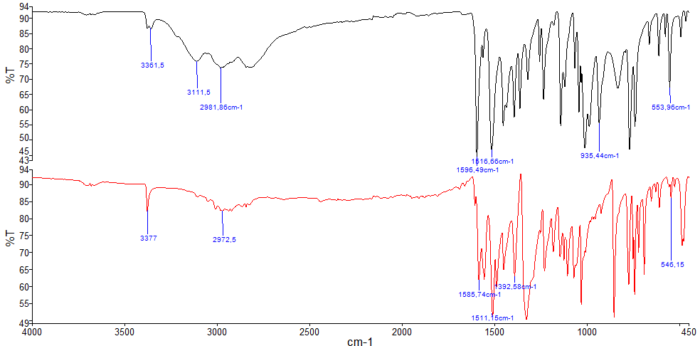
Figure 8. Infrared spectra of HL₁ black and HL₂ red.

