a)
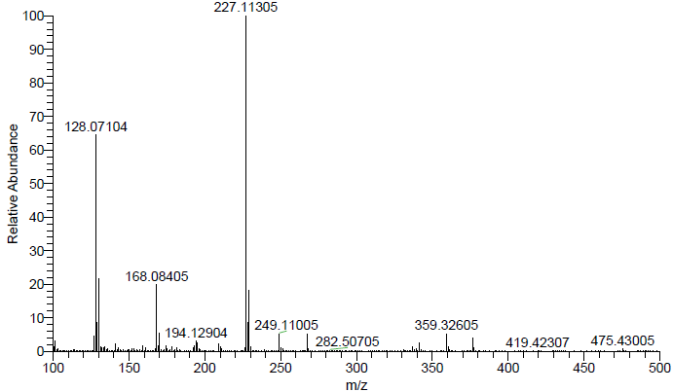
b)
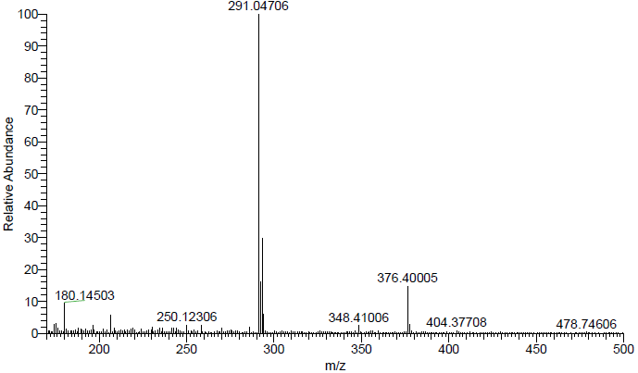
Figure 7. The Mass spectrum of a) HL₁ and b) HL₂.

