Synthesis, crystallographic structure, Hirshfeld surface analysis, drug-likeness properties and molecular docking studies of pyridine compounds

Tufan Topal^{1*}
¹Department of Chemistry, Pamukkale University, 20020, Denizli, Turkey,
*Correspondence author: E-mail: tufantopal@hotmail.com.tr
Phone: +90 258 2963457, fax: +90 258 2963535

ABSTRACT
A detailed description of the two new (2E,3Z)-3-[2-(3-chloropyridin-2-yl)hydrazinylidene]-N-hydroxybutan-2-imine and 3-chloro-2-{(2Z)-2-[1-(4 nitrophenyl)ethylidene]hydrazinyl}pyridine ligands are reported. The synthesized compounds were characterized by spektroskopic studies. New generation pyridine ligand of HL₂ was also determinated by single-crystal X-ray diffraction. Hirshfeld surface analysis with two-dimensional fingerprint plots was used to analyze intermolecular interactions in crystals. Molecular docking was performed to investigate the binding areas of chemical compounds. The results of molecular docking showed the inhibitory activity of the studied compounds against E. coli. The obtained results of the current study revealed the druglikeness and bioactivity properties of the ligands.

Graphical Abstract
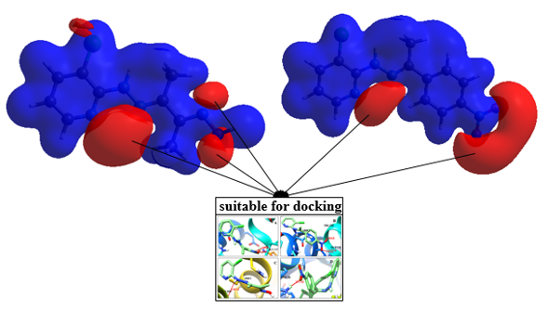

Keywords: Pyridine-oxime, molecular electrostatic potential (MEP), Drug-likeness, E. coli, Hirshfeld surface analysis, X-ray diffraction

- Introduction
For biological activities, pyridine compounds are widely used as antibacterial, antifungal, and anticancer agents. ^{1–3} There are several studies carried out on biological compounds in health journals and books. Accordingly, pyridine derivatives cause interactions with high binding capacity by targeting enzymes, proteins, and deoxyribonucleic acid (DNA) that create biological problems. ⁴ With the discovery of new compounds, several studies were performed in the last decade to inhibit antibacterial drug resistance and reduce associated adverse effects on human health. ⁵ It is obvious how new types of viruses and bacteria (e.g., Middle East respiratory syndrome coronavirus, severe acute respiratory syndrome coronavirus 2, and coronavirus disease 2019) affect the lives of humans around the world. Accordingly, this puts a great duty upon the shoulders of researchers and chemists who develop new materials to decrease the effects of viruses and bacteria as well as biologists and physicians who test the new compounds on animals and humans. Conducting in vitro studies is costly and time-consuming requiring extensive research; accordingly, one of the most important advantages of the current study was the contribution to perform in silico studies inactivating viruses, bacteria, and cancer cells by the production of ligands with medicinal potential. For instance, one of the biggest computer companies in the world has quickly identified and reported 77 medicinal compounds that could stop coronavirus from contaminating the host cells. These compounds activate the simulation of more than 8000 of medicinal compounds in their database on the dynamics of coronavirus protein. ⁶ Pyridine and oxime compounds have high interference of hydrogen bond in electrostatic potential capacity. Intramolecular and intermolecular hydrogen bonds play a major role in the interacting and binding of biological molecules. In addition, pyridine and oxime compounds have been selected, especially because they can easily transfer the electrons of nitrogen atoms participating in the aromatic ring and C=N groups into the donor-acceptor system. ^{7–12} Due to their high antibacterial properties and bioactive multizones, nitrogenous organic or inorganic compounds are reported with positive effects on Escherichia coli (E. coli). ¹³ The reason behind the investigation of E. coli pathogens in molecular docking studies is the resistance of this bacterium against some medications (particularly antibiotics) and its high binding capacity ⁵. Furthermore, E. coli, also known as the most common human pathogen, causes different types of infections, such as kidney, gallbladder, skin, and respiratory infections, in addition to meningitis in neonates. ^{14,15} The physicochemical properties of compounds affect bioavailability, including electrostatic potential, molar absorptivity, stability, solubility, structure, intracellular absorption, hydrogen bonds and bonding energy. ^{16,17} In the present study, oxime and pyridine derivative compounds were synthesized and characterized by X-ray and spectroscopic methods. In addition, the surface analysis was performed to analyze their chemical properties, and molecular electrostatic potential was calculated to determine the nucleophilic and electrophilic zones. Molecular docking was carried out to investigate the hydrogen binding interactions of E. coli DNA gyrase subunit B (GyrB) and E. coli beta-ketoacyl-acyl carrier protein synthase III (FabH) and determined pharmacokinetic and pharmacological properties.

2. Materials and methods
2.1 Materials and physical measurements
The chemicals and solvents: methanol, acetonitrile, 3-chloro-2-hydrazinopyridine, 2,3 butanedione monoxime, 4′-nitroacetophenone were obtained from Sigma–Aldrich. BRUKER BIOSPIN NMR AVANCE Spectrometer III 400MHz model spectrometer were used for ¹H-NMR and ¹³C-NMR analysis. Elemental analyses were determined using a Costech Elemental analyses device ECS 4010 Model analyzer. IR spectra were recorded in the 400-4000 cm⁻¹ on Perkin Elmer FTIR-Spectrometer Spectrum Two Model and Mass Spectra (ESI) on TSQ Fortis™ Triple Quadrupole Mass Spectrometer. Melting points of ligands were determined by Stuart SMP10. The mains water was passed through the Thermo Scientific Smart2pure device to make it pure water. Absorption spectra was carried out using Shimadzu UV-1800 UV-VIS spectrophotometer. Single-crystal X-ray structure was determined using an Agilent SuperNova Dual CCD detector diffractometer eguipped with graphite-monochromated MoKα radiation (λ= 0.71073 ˚A) at room temperature.

2.2 Synthesis of ligands (1), (2)
Chemical preparation of (2E,3Z)-3-[2-(3-chloropyridin-2-yl)hydrazinylidene]-N-hydroxybutan-2-imine (HL₁) (1) and 3-chloro-2-{(2Z)-2-[1-(4-nitrophenyl)ethylidene]hydrazinyl}pyridine (HL₂) (2).

3-chloro-2-hydrazinopyridine (1 mmol, 0.1435 g) in acetonitrile solution (10 ml) was added 2,3 butanedione monoxime (1 mmol, 0.1011 g) (1) and 4′-Nitroacetophenone (1 mmol, 0.1651 g) (2) in 10 ml of acetonitrile respectively. The both solution stirred for 24 h at room temperature and were kept aside for slow evaporation of solvent for about 5 days. The HL₂ ligand crystals was obtained from slow evaporation technique by dissolving the product in acetonitrile Fig.1.
C₉H₁₁ClN₄O (HL₁), Crem; Yield 87%. m.p.:194 ºC. ¹H-NMR (400 MHz, Chloroform-d₆, ppm): δ 9.83 (s, 1H, O-H), δ 8.45 (s, 1H, -NH), δ 8.37 (d, 1H, Ar-H), δ 7.62 (d, 1H, Ar-H), δ 6.84 (t, 1H, Ar-H), δ 2.34 (s, 3H, -CH₃), δ 2.23 (s, 3H, -CH₃). ¹³C-NMR (100 MHz, Chloroform-d₆, ppm): δ 157.39 (-C=N-OH), δ 157.32 (-C=N-), δ 150.00, 147.12, 137.32, 116.50, 115.35 (C-Ar_{pyridine}), δ 10.03 (-CH₃), δ 9.53 (-CH₃). ¹⁸ LC/MS-MS, (ESI) m/z= 226.66284 [M+1]⁺ (100%). Calcd. for C₉H₁₁ClN₄O: C, 47.69; H, 4.89; N, 24.72%; found: C, 47.71; H, 4.86; N, 24.69%. IR (KBr) cm⁻¹: 3357 (N-H), 3112 (O-H), 2981 (C-H_{Ar}), 1596 (C=N) _{pyridine}, 1561 (C=N)_{imine}, 1516 (C=N)_{oxime}, 935 (N-O). ^{19,20}

C₁₃H₁₁ClN₄O₂ (HL₂), Orange; Yield 86%. m.p.:169 ºC. ¹H-NMR (400 MHz, Chloroform-d₆, ppm): δ 8.48 (s, 1H, -NH), δ 8.30 (d, 1H, Ar-H), δ 8.20 (d, 2H, Ar-H), δ 8.01 (d, 2H, Ar-H), δ 7.61 (d, 1H, Ar-H), 6.84 (t, 1H, Ar-H), δ 2.38 (s, 3H, -CH₃), ¹³C-NMR (100 MHz, Chloroform-d₆, ppm): δ 149.92, δ 147.61 (C-Ar_{pyridine}), δ 147.17 (-C=N-), δ 144.49, 144.42 (C-Ar), δ 137.33 (C-Ar_{pyridine}), δ 126.89, 126.89, 123.64, 123.64 (C-Ar), δ 116.97, 115.49 (C-Ar_{pyridine}), δ 12.53 (-CH₃). LC/MS-MS, (ESI) m/z= 290.70558 [M+1]⁺ (100%). Calcd. for C₁₃H₁₁ClN₄O₂: C, 53.71; H, 3.81; N, 19.27%; found: C, 53.73; H, 3.79; N, 19.22%. IR (KBr) cm⁻¹: 3378 (N-H), 2922 (C-H_{Ar}), 1585 (C=N) _{pyridine}, 1557 (C=N)_{imine}, 1392 (NO₂). ²¹
a)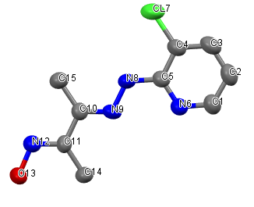b)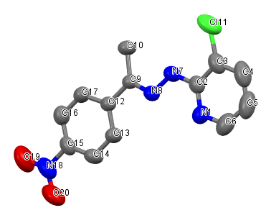
Fig. 1. Structure of compound a) compound (1) and b) (2).

2.3. X-ray crystallography analysis

Orange crystal of the C₁₃H₁₁ClN₄O₂ compound was obtained in acetonitrile solution through slow evaporation for 5 days at room temperature. The data set of reflections were collected using an Agilent SuperNova X-Ray diffractometer with MoKα (λ= 0.71073) at 293 K. The data reduction and data correction were performed by Olex2 software (version 1.3). ^{22,23} Refinements were obtained by the Full-Matrix method on F² using the Olex2 software, and crystal packing diagrams were created by Mercury 4.3.0 software. All the nonhydrogen atoms were anisotropically refined using the riding model approximation. ²⁴ Tables 1 and 2, a summary of the experimental details of HL_{2.} ^{25–27} CCDC DOI: 10.5517/ccdc.csd.cc24rlzh and number 1988897 contains the supplementary rystallographic data for this work. This data can be obtained from The Cambridge Crystallographic Data Centre via www.ccdc.cam.ac.uk/data_ request/cif.

Table 1 Crystal data and structure refinement for compound (2).
CCDC number | 1988897
Empirical formula | C₁₃H₁₁ClN₄O₂
Formula weight | 290.711
Temperature/K | 293(2)
Crystal system | monoclinic
Space group | P2₁/c
a/Å | 11.7767(7)
b/Å | 14.4529(7)
c/Å | 7.9073(4)
α/° | 90
β/° | 91.381(5)
γ/° | 90
Volume/Å³ | 1345.49(12)
Z | 4
ρ_{calc}g/cm³ | 1.435
μ/mm⁻¹ | 0.291
F(000) | 600.8
Crystal size/mm³ | 0.540 × 0.496 × 0.356
Radiation | Mo Kα (λ = 0.71073)
2Θ range for data collection/° | 6.76 to 55.62
Index ranges | -8 ≤ h ≤ 14, -17 ≤ k ≤ 17, -8 ≤ l ≤ 10
Reflections collected | 4639
Independent reflections | 2650 [R_{int} = 0.0162, R_{sigma} = 0.0324]
Data/restraints/parameters | 2650/0/182
Goodness-of-fit on F² | 1.055
Final R indexes [I>=2σ (I)] | R₁ = 0.0568, wR₂ = 0.1302
Final R indexes [all data] | R₁ = 0.0890, wR₂ = 0.1541
Largest diff. peak/hole / e Å⁻³ | 0.29/-0.56

3. Results and discussion

3.1. Description of the crystal structures and hydrogen bonding

Slow evaporation technique was used to make the sample suitable for X-ray structure analysis. The compound (2) crystallizes in the centrosymmetric space group P2₁/c of monoclinic system with a unit cell volume of 1345.49(12) Å³, the cell dimensions are: a= 11.7767 (7) Å, b= 14.4529 (7) Å, c= 7.9073 (4) Å, β= 91.381(5) ⁰ and Z=4. The full data collection was done for indices l, k and h with ranges of −8≤l≤10, −17≤k≤17, -8≤h≤14 and R value of R₁= 0.0568, wR₂=0.1302.Carbon and hydrogen atoms have been geometrically positioned.

Table 2 Selected Bond Lengths/Å, Angles/˚ and Torsion/˚ for compound (2).
Atom | Atom | Length | Atom | Atom | Atom | Angle | Atom | Atom | Atom | Atom | Torsion
N8 | N7 | 1.354(3) | C9 | N8 | N7 | 117.57(19) | N7 | N8 | C9 | C10 | -1.6(3)
N8 | C9 | 1.287(3) | C2 | N7 | N8 | 121.3(2) | N8 | N7 | C2 | N1 | -1.4(4)
N1 | C2 | 1.329(3) | C6 | N1 | C2 | 117.2(3) | C2 | N1 | C6 | H6 | -179.5(4)
N1 | C6 | 1.334(4) | C13 | C12 | C9 | 120.2(2) | C13 | C12 | C9 | N8 | 8.3(3)
C12 | C9 | 1.475(3) | C17 | C12 | C9 | 122.0(2) | C9 | N8 | N7 | H7 | -4.3(4)
C12 | C13 | 1.397(3) | C17 | C12 | C13 | 117.8(2) | C9 | N8 | N7 | C2 | 175.7(2)
C12 | C17 | 1.390(3) | C3 | C2 | N1 | 122.4(2) | C6 | N1 | C2 | N7 | -177.6(3)
C2 | C3 | 1.395(4) | C4 | C3 | C2 | 118.7(3) | C6 | N1 | C2 | C3 | 2.4(4)
C9 | C10 | 1.505(3) | C10 | C9 | C12 | 120.7(2) | C13 | C12 | C9 | C10 | -170.9(2)
C13 | C14 | 1.375(3) | C12 | C9 | N8 | 115.0(2) | C17 | C12 | C9 | N8 | -172.1(2)
C17 | C16 | 1.370(4) | C10 | C9 | N8 | 124.2(2) | C17 | C12 | C9 | C10 | 8.6(3)
C15 | C14 | 1.379(4) | C3 | C2 | N7 | 118.7(2) | N8 | C9 | C10 | 10HA | -54.4(7)
C3 | C4 | 1.374(4) | C16 | C17 | C12 | 122.0(2) | N8 | C9 | C10 | 10HB | 65.6(6)
C6 | C5 | 1.369(5) | N1 | C2 | N7 | 118.9(2) | N8 | C9 | C10 | 10HC | -174.4(7)
C4 | C5 | 1.372(5) | C5 | C6 | N1 | 124.2(3) | C12 | C9 | C10 | 10HA | 124.7(6)
N7 | C2 | 1.371(3) | C14 | C15 | N18 | 119.1(3) | C12 | C9 | C10 | 10HB | -115.3(6)
C15 | C16 | 1.361(4) | C14 | C13 | C12 | 120.6(2) | C12 | C9 | C10 | 10HC | 4.8(7)

While aromatic groups of C-H bonds distance of were 0.93 Å, the C10-H10A, C10-H10B, C10-H10C bond distance of CH₃ were observed as 0.96 Å. The bond lengths between the atoms N8=C9 1.287(3) Å, N8-N7 1.354(3) Å, C12-C9 1.475(3) Å, C12-C13 1.397(3) Å and C12-C17 1.390(3) Å and were found. In literature 1.28(14) Å, 1.35(3) Å, 1.49(14) Å, 1.39(15) Å and 1.38(16) Å are similar with our values of atomic lengths. ^{28–30} The N8=C9 bond was shorter than the N8-N7 bond and it confirms that N8=C9 shows a double bond character. In HL₂, pyridyl N1-C2 and N1-C6 bond distances were 1.329(3) and 1.334(4) Å, bond angle C6-N1-C2 117.2(3)º and torsion angle C2-N1-C6-H6 -179.5(4)º were found and this torsion value is competible with the expected 180 º. ^{12,31} Torsion angles of atoms between pyridyl and benzene ring have been observed C13-C12-C9-N8 8.3(3) º, N8-N7-C2-N1 -1.4(4)º and N7-N8-C9-C10 -1.6(3)º.
a)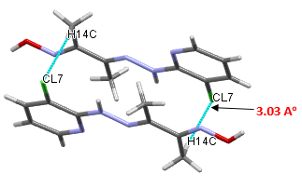b) 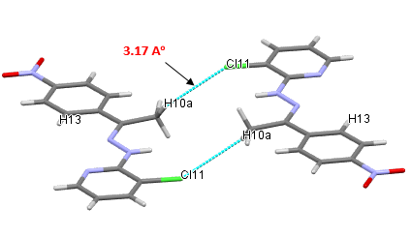
Fig. 2. A view down the ‘a’ and ‘c’ axes of one-dimensional sheets; a) C₉H₁₁ClN₄O; b) C₁₃H₁₁ClN₄O₂

(2E,3Z)-3-[2-(3-chloropyridin-2-yl)hydrazinylidene]-N-hydroxybutan-2-imine and 3-chloro-2-{(2Z)-2-[1-(4-nitrophenyl)ethylidene]hydrazinyl}pyridine are linked by strong hydrogen bonds. Hydrogen bonds are an important factor in the smooth and stable structure. ^{32,33} Basically 3 pairs of hydrogen bond interactions are observed in the structure, these are C-H‧‧‧O, C-H‧‧‧N and C-H‧‧‧Cl intramolecular and intermolecular hydrogen bonds. The C₉H₁₁ClN₄O and C₁₃H₁₁ClN₄O₂ compounds are connected via C(14)-H(14C)‧‧‧Cl(7) (1-x,2-y,1-z) and (10)-H(10A)‧‧‧Cl(11) (1-x,2-y,1-z) hydrogen bonds to form a capped stick style, publication management style, and packing one-dimensional chain along the a and c axes, respectively, illustrated in Figs. 2a and 2b. ³⁴ Selected hydrogen bond distances and angles are listed in Table 3. In HL₂, carbon atom C10 acts as a donor to N1 atom at C(10)-H(10A)‧‧‧N(1) (x,1.5-y,-1/2+z), developing the capped stick style and two-dimensional chain along the crystallographic axis as depicted in Fig. 3a.

Table 3 Selected hydrogen bond distances (Å), symmetry and angles (º) for ligands.
Comp. | D-H‧‧‧Å | d (D-H) | d (H‧‧‧Å) | d(D-H‧‧‧Å) | Symmetry codes | ∠D—H‧‧‧Å
HL₁ | C(14)-H(14C)‧‧‧Cl(7) | 0.960 | 3.039 | 3.977 | 1-x,2-y,1-z | 165.93
HL₂ | C(10)-H(10A)‧‧‧Cl(11) | 0.960 | 3.174 | 3.882 | 1-x,2-y,1-z | 131.90
HL₂ | C(10)-H(10A) ‧‧‧N(1) | 0.960 | 2.768 | 3.602 | x,1.5-y, -1/2+z | 145.68
HL₂ | C(5)-H(5)‧‧‧O(20) | 0.930 | 3.019 | 3.606 | 1-x,1-y,1-z | 122.57
HL₂ | C(10)-H(10C)‧‧‧O(19) | 0.960 | 2.730 | 3.417 | 2-x, -1/2+y,1/2-z | 129.08
HL₂ | C(17)-H(17)‧‧‧O(20) | 0.930 | 2.460 | 3.322 | 2-x, -1/2+y,1/2-z | 154.19
HL₂ | C(13)-H(13) ‧‧Cl(11) | 0.930 | 2.941 | 3.764 | 1-x,-1/2+y,1.5-z | 148.37
HL₂ | C(5)-H(5)···O(19) | 0.930 | 2.909 | 3.747 | -1+x,y,1+z | 150.54
HL₂ | C(10)-H(10C)···O(20) | 0.960 | 3.057 | 3.978 | 2-x, -1/2+y,1/2-z | 161.22

As illustrated in Fig. 3b, in HL₂, C-H‧‧‧O intermolecular hydrogen bonding interaction was used to generate a three-dimensional (3D) supramolecular network along the c axis. All the figures were drawn in Mercury software. Other hidrogen bonds were C(5)-H(5)‧‧‧O(20) (1-x,1-y,1-z), C(10)-H(10C)‧‧‧O(19) (2-x,-1/2+y,1/2-z), C(17)-H(17)‧‧‧O(20) (2-x,-1/2+y,1/2-z), C(5)-H(5)‧‧‧O(19) (-1+x,y,1+z), C(10)-H(10C)‧‧‧O(20) (2-x,-1/2+y,1/2-z), C(13)-H(13)‧‧‧Cl(11) (1-x,2-y,1-z). ³⁵

a)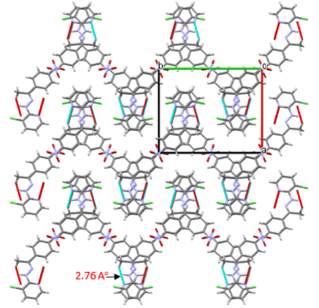b)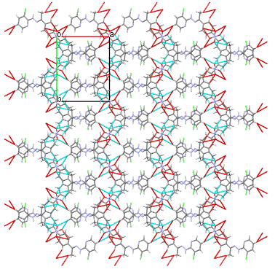
Fig. 3. a) Two-dimensional self-assembling; b) three-dimensional supramolecular frameworks of C₁₃H₁₁ClN₄O₂
and hydrogen bonds

3.2. ¹H NMR studies

¹H-NMR spectrum of HL₁ is shown in Fig. 4. ¹H-NMR spectrum of the HL₁ ligand oxime (N–OH) group of the proton (H13) was observed at δ=9.83 ppm as a singlet peak. The NH proton (H8) generated a signal at 8.45 ppm. The spectrum of the (2E,3Z)-3-[2-(3-chloropyridin-2-yl)hydrazinylidene]-N-hydroxybutan-2-imine ligand observed at singlet peaks 2.23 ppm (H14A, H14B, H14C) and 2.34 ppm (H15A, H15B, H15C) methylene group of protons. While H1 proton signal appeared at d 8.37 ppm, the signals at d 7.62 and d 6.84 ppm were due to H3 and H2 of pyridinium moiety, respectively. ³⁶ In HL₂, the NH proton (H7) generated a sharp signal at 8.48 ppm, as a singlet peak. The peaks were observed at range 8.30–6.84 ppm were assignable to the protons of aromatic rings as multiplet peaks. The spectrum of the 3-chloro-2-{(2Z)-2-[1-(4-nitrophenyl)ethylidene]hydrazinyl}pyridine ligand observed at singlet peaks 2.38 ppm (H10A, H10B, H10C) methylene group of protons. The signal at d 8.30 ppm was attributed at to (H6) aromatic proton of pyridine. The proton signal appearing at d 8.20 and d 8.01 ppm were due to (H13, H17, H16, H14) of aromatic moiety respectively, Aromatic protons of pyridine moiety produced a broad signal at d 7.61 and t 6.84 ppm (H5, H4). ^{12,19,37} It was observed that the obtained results were exactly compatible with the structure.

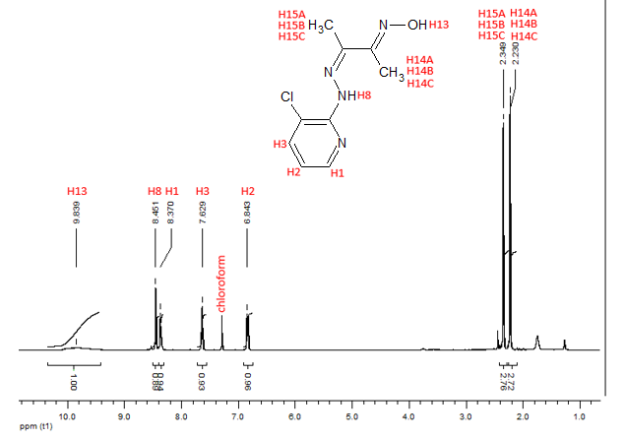
Fig. 4. ¹H-NMR spectrum of HL₁.

3.3. ¹³C NMR studies

¹³C-NMR spectrum of HL₁ is shown in Fig. 5. ¹³C-NMR spectrum HL₁ observed a single resonance at 157.39 and 157.32 ppm, respectively which showed that the oxime (C=NOH) and azomethine (-NHN=CH) (C11,C10) carbon atoms. All the signal in the 150.00-115.35 ppm range were assigned to the aromatic carbons (C1-C5) of the pyridine. The signals observed at 10.03 and 9.53 ppm are attributable to the carbon atom of methyl group (C15,C14). For HL₂, aromatic carbons of pyridine and benzene rings gave different signals in their resonance. Hence the signal at 149.92, 147.61, 137.33, 116.97, 115.49 ppm was due to carbon (C2-C6) while (C12-C17) presented in different signals at 144.49, 144.42, 126.89, 126.89, 123.64, 123.64 ppm in the aromatic moiety of ligand. Two equivalent para carbons (C13,C17) and (C14,C16) brought out a signal at d 126.89 and 123.64 ppm in the spectrum. The signal at 147.17 ppm was due to the (C9) carbon of the imine group of moiety. The signal observed at 12.53 ppm are attributable to the carbon atom of methyl group (C10). ^{28,36,37}

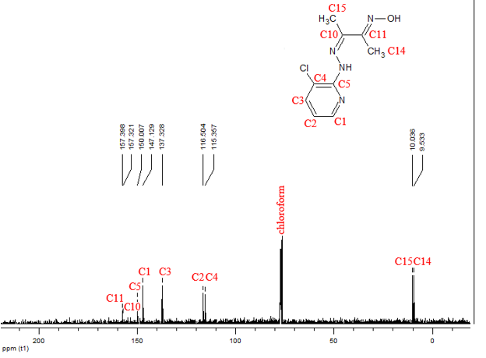
Fig. 5. ¹³C-NMR spectrum of HL₁.

3.4. Mass and UV-Vis absorption spectra

The electronic absorption spectra of the ligands, along with the molar extinction coefficient, were obtained in a 5×10⁻⁵ mol L⁻¹ chloroform solution in the wavelength zone (240-480 nm) using the spectroscopic method. ²⁶ The electron transition possibilities of different compounds were compared using ultraviolet-visible spectroscopy. When wavelength scanning was applied to the ligands 322 and 285 nm (ɛ=42800 and ɛ=41100 mol⁻¹ L cm⁻¹) as well as 362 and 312 nm (ɛ=34520 and ɛ=26300 mol⁻¹ L cm⁻¹), absorption peaks for HL₁ and HL₂ were obtained as depicted in Fig. 6. The additional molar absorptivity of the values was calculated in this regard. The electronic absorption spectra of the ligands were defined with two sharp absorption bands. These two bands were observed at 285-312 and 322-362 nm indicative of the π-π* and n-π* transitions, respectively. ³⁸ While the π-π* transitions of the ligands originated from the electrons of the pyridine ring, the n-π* band occurred due to azomethine groups (-NHN=CH) of atoms. ³⁹

Fig. 6. Ultraviolet-visible absorption spectra for compounds (1) and (2) in CH₂Cl_{2.}

Mass spectral datas of ligands were obtained by electrospray ionization (ESI) method. Figs. 7a and 7b spectrums show that the m/z ve % relative abundance of ligands. The mass exhibited the molecular ion at m/z 226.66284 [M+1]⁺ and 290.70558 [M+1]⁺ which indicated formation of the compounds (1) and (2). The moleculer peak of both ligands have a %100 relative abundance. Theoretical and experimental results showed good agreement with each other. ^{36,40}

a)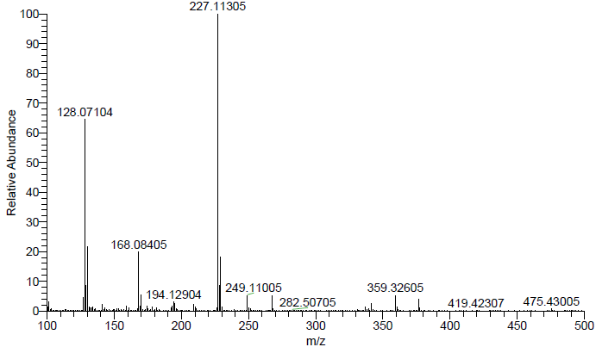

b) 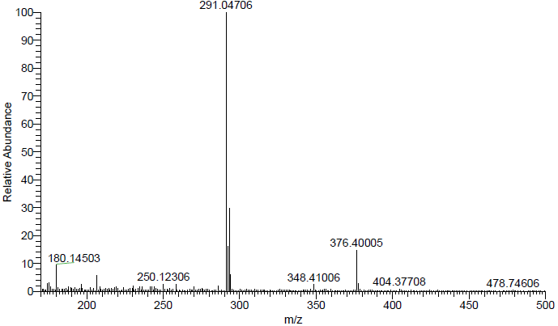
Fig. 7. The Mass spectrum of a) HL₁ and b) HL₂.

3.5. FT-IR spectra

Generally compunds are characterized by three IR absorption bands such as ν(O–H), ν(C=N) and ν(N–O) stretching vibrations. ⁴¹ FT-IR spectrum of the HL₁ ligand showed (C=N) imine (C=N) oxime peaks at 1596 cm⁻¹ and 1516 cm⁻¹. ⁴² The bands 3361 cm⁻¹ and 3377 cm⁻¹ were due to (N-H) vibrations for HL₁ and HL₂ respectively. Spectrums are shown in Fig.8. Also (O-H) band of oxime group peak was observed at 3111 cm⁻¹. ³⁷ But this peak was not seen at HL₂ ligand. At the same time, the bands at 935 cm⁻¹ and 1392 cm⁻¹ assignable to (N-O) and (NO₂) vibrations, respectively. The FT-IR spectrum of ligands displayed bands at 2981 cm⁻¹ and 2972 cm⁻¹ which assignable to (C-H_{Ar}) protons. The medium bands observed at 553 cm⁻¹ and 546 cm⁻¹ assigned to pyridyl rings. For compounds (1) and (2) the bands 1454-1451 cm⁻¹, 1394-1392 cm⁻¹, 1044-1032 cm⁻¹ and 1012-1032 cm⁻¹ assignable to the aromatic pyridine ring. ^{34,43–46} FT-IR analysis give us the preliminary information about whether this structure is formed or not. Our datas are in agreement with similar oxime and pyridine ligands in the literature. ⁴⁷
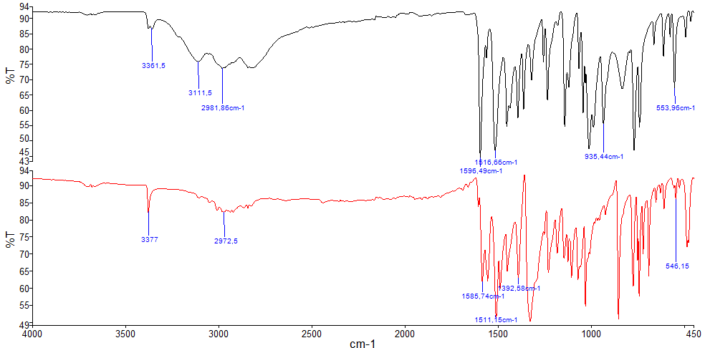
Fig. 8. Infrared spectra of compounds (1) black and (2) red.
3.6. Hirshfeld surface analysis

The surface analysis method is the best way to identify crystal packing and intermolecular interacting in a structure. For this reason, the Hirshfeld surface analysis was performed using CrystalExplorer software (version 17.5). ^{48,49} Accordingly, the close correlations between the fragments were quantitatively analyzed. Furthermore, it is one of the computer calculation programs to investigate the mechanism of molecular interactions in proteins and with which intermolecular interactions they could bond to a receptor. In addition, it helps to identify the intermolecular hydrogen bond as well as π-π, C-H‧‧‧X (X=halogens) interactions with great importance in crystal package arrangement and stabilization of the molecule. Therefore, C(17)-H(17)‧‧‧O(20) and C(13)-H(13)‧‧‧Cl(11) interactions are illustrated in Fig. 9.

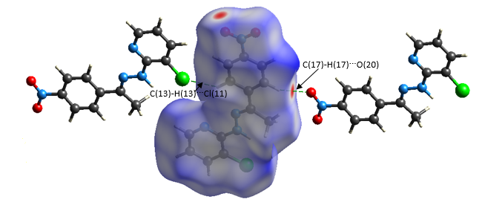

Fig. 9. Close contact of C(17)-H(17)‧‧‧O(20) and C(13)-H(13)‧‧‧Cl(11) interactions determined by Hirshfeld surface analysis over dnorm of HL₂

Ligands surface analyses were mapped in Curvedness, Shape Index, d_{norm}, d_{i} forms as shown in Fig. 10. d_{norm} surface was mapped for the HL₁ and HL₂ compounds ranging between (-1,3113 Å)-(1,6458 Å), (-0,2108 Å)-(1,3202 Å) and their surface volumes were 267,77 Å³, 329,70 Å³ respectively. ¹² Red spots in d_{norm} surface analysis shows O‧‧‧H interaction (short interaction), blue spots shows far interaction and white spots shows the circle of the Van der Waals interaction. N‧‧‧H interaction seem lighter and more transparent colored spots and this shows weak and long interaction. Red zone in d_{i} form defines hydrogen donor and hydrogen acceptors. Where the highlighted parts of the plain green surfaces with blue outlines in curvedness surface analysis are combined end to end with the red and blue colored conical shapes in shape index surface analysis shows π-π interactions. ⁵⁰ Intermolecular interactions of HL₂ ligand is presented in Fig. 11 as 2D fingerprints plot. ⁵¹ Blue zone shows intermolecular interaction areas whereas grey zone shows outside of the this interaction area. Ligands Cl‧‧‧H/H‧‧‧Cl, H‧‧‧H, N‧‧‧C/C‧‧‧N, N‧‧‧H/H‧‧‧N, O‧‧‧H/H‧‧‧O, Cl‧‧‧N/N‧‧‧ Cl, C‧‧‧C, C‧‧‧H/H‧‧‧C reciprocal influence were revealed. According to fingerplots studies results of for HL₁; Cl‧‧‧H 18,1%, H‧‧‧H 42,1%, N‧‧‧C 4,5%, N‧‧‧H 9,6%, O‧‧‧H 5,8%, Cl‧‧‧N 1,5%, C‧‧‧C 2,0%, C‧‧‧H 12,9%, for HL₂; Cl‧‧‧H 11,4%, H‧‧‧H 28,7%, N‧‧‧C 6,4%, N‧‧‧H 6,5%, O‧‧‧H 18,3%, Cl‧‧‧N 2,5%, C‧‧‧C 3,8%, C‧‧‧H 15,2%. ^{25–27}

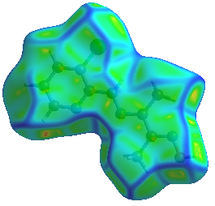 | 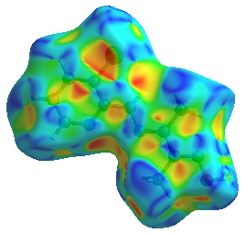 | 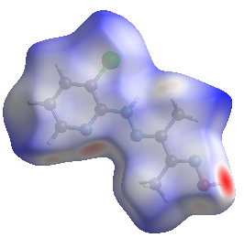 | 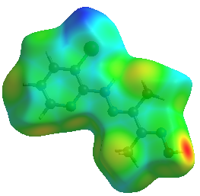
a) 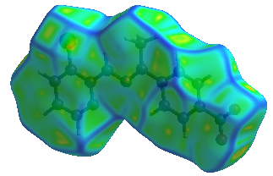 | b) 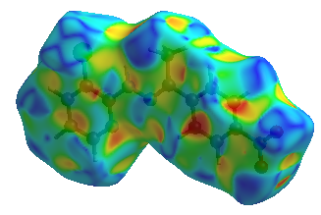 | c) 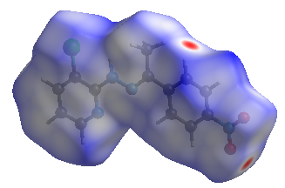 | d) 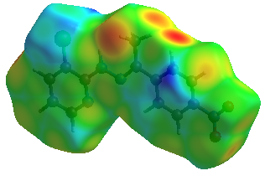
Fig. 10. Hirshfeld surfaces mapped with a) Curvedness, b) Shape Index, c)d_{norm}, d)d_{i} compound of (Above HL₁ and below HL₂).

Other bondings constituted all interactions by making small contributions on the surface. The H‧‧‧H interaction with the highest rate (42.1%, 28.7%) was shown to be derived from the abundance of the H‧‧‧H interactions in aromatic rings. The rates of O‧‧‧H molecular interactions were observed within the range of 5.8-18.3% for HL₁ and HL₂. This variation corroborates that HL₂ has higher bonding energy than HL₁ using protein binding analysis Table 4. In this regard, it was observed that HL₁ ligand made a strong hydrogen bond to 4WUB and 1HNJ proteins only over O13‧‧‧H and HL₂ ligand over O19‧‧‧H and O20‧‧‧H atoms. ⁴ In addition, this result is indicative of better molecular docking of HL₂ with a high hydrogen bond ratio.

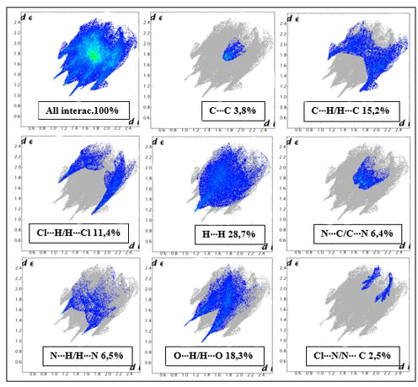
Fig. 11. The 2D fingerprint plos of the compound (2).

3.7. Molecular electrostatic potential analysis

Molecular electrostatic potential mapping is a method for the observation of the interactions of molecules with each other based on their charge distribution on 3D diagrams. This is an auxiliary method that estimates electrophilic and nucleophilic reactive sites of ligands leading to investigate protein binding and medicine developing by defining hydrogen bond interactions.^{4,52} Electrostatic potential (3D) diagrams of ligands were mapped using the Hartree-Fock theory Slater type orbital-3G base set of Hirshfeld surface analysis by CrystalExplorer software as depicted in Fig.12. The input file of the geometry was obtained using Tonto. ^{53,54} Surface qualification values were set -0,025-0,025 au and high resolution was selected. When it was performed, the molecule was taken to transparency mode and atoms were made clear. The red color represents the negative electrostatic potential regions and acceptor hydrogen bonds. Moreover, the blue color represents the positive electrostatic potential regions and donor hydrogen bonds. ^{55,56} In addition, blue-colored zones are the preferred regions for the nucleophilic attack, while red-colored negative zones are susceptible to electrophilic attack. ¹² Furthermore, red-colored regions have electron-rich atoms or atom groups; therefore, they can easily interact with amino acid residues. Based on the findings of molecular docking studies, hydrogen bond interactions between donor-acceptor confirmed the results of the electrostatic potential analysis as depicted in Fig. 14.
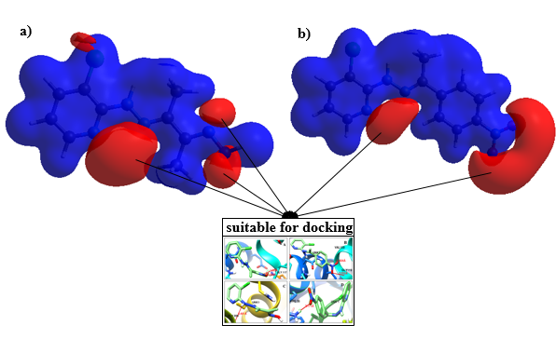
Fig. 12. Electrostatic potential maps of a) C₉H₁₁ClN₄O and b) C₁₃H₁₁ClN₄O₂

3.8. Molecular docking studies

In silico docking calculations are of great importance in drug design and medical chemistry fields. Molecular docking is commonly used in the studies carried out on target medicine designing by estimating the binding mechanisms of small molecules on target biologic proteins. ^{57,58} Donor-acceptor binding mechanisms create complexations with hydrophobic hydrogen bond and electrostatic interactions. ⁵⁹ The current study examined the ligands creating intramolecular hydrogen bonds by targeting the active zones of E. coli DNA GyrB (PDB Code:4WUB) and E.coli FabH (PDB Code:1HNJ) amino acid residues. The protein-related data were obtained from Research Collaboratory for Structural Bioinformatics Protein Data Bank https://www.pdb.org. Molecular docking studies analyzed binding energy, hydrogen bonding, and interactions between the ligands and bacteria. ^{60–63} Furthermore, by the calculation of the ligands’ lowest binding energy to aminoacids residues, it was determined that which structure has stronger hydrogen bonding and higher binding energy score. ⁶⁴ Ligands SMILES formats were created at page https://www.cheminfo.org; it is C/C(=N\O)/C(C)=N/Nc1ncccc1Cl for HL₁ and C/C(=N/Nc1ncccc1Cl)c2ccc(N(=O)=O)cc2 for HL₂.

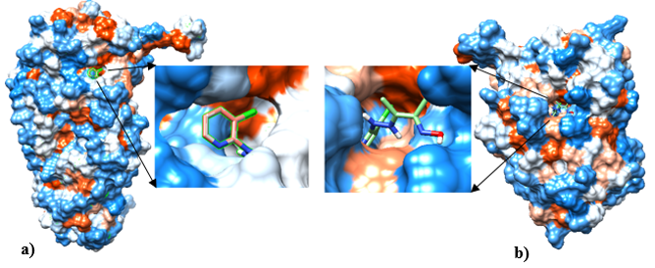
Fig.13. Illustration of hydrophobicity surface area of HL₁ inside a) gyrase subunit B and b) beta-ketoacyl-acyl carrier protein synthase III proteins

Molecular docking studies were performed Autodock vina program (https://www.vina.scripps.edu). Ligands were converted into mol2 format and prepared for molecular docking at Chimera software program with receptors (E.coli FabH and GyrB) (https://www.cgl.ucsf.edu/chimera/). ⁶⁵ In the Dock Prep method, firstly, all nonstandarts and solvents were selected and refined from receptors. Then, protein models were added by the selection of all hydrogen atoms (also considered H-bonds) and Gasteiger charges. Docking studies were conducted by targeting ligand receptors and binding the most convenient coordinates. ⁶⁶ While defining an approximate donor and acceptor binding zone in in-silico studies, docking parameters are of great importance. Different types of grid box values were applied for the best and most accurate binding. The application of target protein binding zones (as a great scale) in a cubic box resulted in the best binding; however, this method requires a long computer calculation. ^{67,68} The grid box values of ligands applied to E. coli GyrB receptor were 10, 25, -10 at the center with a grad spacing of 0.375 Å including default the sizes of 40, 40, 40 for HL₁ and HL₂. The same method was employed to E. coli FabH receptor reporting the values of 30, 15, 30 at the center with the sizes of 30, 30, 30 for HL₁ and HL₂. In addition, default values were used for other parameters. Root-mean-square deviation ​​were selected as minumum value. The binding energy values of -7.9 and -8.8 kcal/mol were applied by HL₁ and HL₂ ligands to the GyrB receptor, respectively. Fig. 13 illustrates the hydrophobicity surface area of compound (1) inside GyrB and FabH proteins. The binding energy values of -6.1 and -6.8 kcal/mol were applied by HL₁ and HL₂ ligands to the FabH receptor, respectively. The binding interactions and docking poses are depicted in Fig. 14. Since the ligands bind to the GyrB receptor with higher binding energy than that reported for the FabH receptor, there was a better docking to the ligands-GyrB complex. While there were two hydrogen bonds in the complex that ligands made with 4WUB protein, 1HNJ protein had one hydrogen bond. This finding proved that this effect increases the binding energy value. As the binding energy value enhances, the binding score increases indicating a better docking. ^{47,69} Therefore, the binding energy of HL₂ was higher than that reported for HL₁ which is considered a better docking. The other reason behind that is believed to be the electron density and unpaired electron couples of two oxygen atoms that bond to the nitrogen atom of HL_{2.} ⁷⁰ In a study carried out by Fathima et al. (2018), docking results were observed to be -8.4 and -8.5 kcal/mol for 2ABP2C-1HNJ and 2ABHB-1HNJ, respectively. ⁶¹

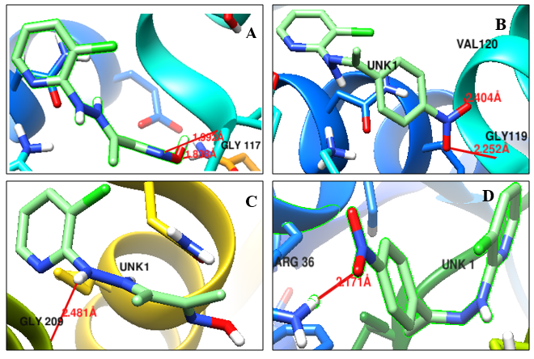
Fig. 14. Results of molecular docking for a) HL₁-gyrase subunit B (GyrB) (4WUB), b) HL₂-GyrB (4WUB), c) HL₁- beta-ketoacyl-acyl carrier protein synthase III (FabH) (1HNJ), and d) HL₁-FabH (1HNJ)

The HL₁ created a hydrogen bond to GLY 117 and GLN 335.A HE22 amino acid residues of 4WUB protein with N12 and O13 atoms and binding lengths were observed as 1.992 Å and 1.838 Å, respectively. The HL₂ bonded to GLY 119 and VAL 120 amino acid residues of 4WUB proteins with O19 and O20 atoms and binding lengths were observed as 2.252 Å and 2.404 Å. In another study conducted by Metelytsia et al. (2020), the binding of ligands to the regions of amino acid residues was reported as GLY 119 and His 116. This finding is similar to the results of docking investigations in the current study in terms of attachment regions. ⁵⁹ The HL₁ and HL₂ created a hydrogen bond to GLY 209, ARG 36.A HH22 amino acid residues of 1HNJ receptor with N8 and O19 atoms and binding lengths were observed as 2.481 Å and 2.171 Å, respectively. Donor and acceptor hydrogen binding interactions are shown as Table 4. ⁷¹ The findings of docking studies confirmed that the results and interactions of molecular electrostatic potential generally occur in red regions. The findings of docking studies also revealed that ligands are potential inhibitors against E. coli DNA GyrB and E. coli FabH. ⁷²

Table 4 AutoDock results showing Compound-Protein name, Binding site of protein, Binding site of Ligand, Type of interactions, Bond length, Binding energy.
Compound-Protein name | Binding site of protein | Binding site of Ligand | Type of interaction | Bond length (Å) | Binding energy (Kcal/Mol)
HL₁-4WUB | GLY 117 | UNK1-N12 atom | Hydrogen bond | 1.992 | -7.9
 | GLN 335.A HE22 | UNK1-O13 atom | Hydrogen bond | 1.838
HL₂-4WUB | GLY 119 | UNK1-O19 atom | Hydrogen bond | 2.252 | -8.8
 | VAL 120 | UNK1-O20 atom | Hydrogen bond | 2.404
HL₁- 1HNJ | GLY 209 | UNK1-N8 atom | Hydrogen bond | 2.481 | -6.1
HL₂- 1HNJ | ARG 36.A HH22 | UNK1-O19 atom | Hydrogen bond | 2.171 | -6.8

3.9 Drug-likeness and biological activity

Drug-likeness and bioactivity of ligands were obtained from molinspiration (https://www.molinspiration.com/cgi-bin/properties). Although the parameters of druglikeness cannot estimate the biological activity of each compound, it is one of the most successful and efficient methods for the analysis of compounds with medicinal potential through the determination of pharmacokinetic characteristics. Based on Table 5, the parameters of drug-likeness and biologic activity for the compounds in the present study (miLogP, TPSA, nAtoms, MW, nON, nOHNH, nviolations, and rotb) and (enzyme inhibitor, protease inhibitor, nuclear receptor ligand, kinase inhibitor, ion channel modulator, and GPRC ligand). The aforementioned findings have been the first obtained data regarding the medicinal potential of the compounds. ⁷³ The values of drug-likeness were determined in this study, and the ligands were examined regarding midicinal potential with the consideration of these values. In this sense, the miLogP parameter, which is the capacity of penetrating the cell membrane, is expected to be under 5. In this regard, the values of miLogP parameter were reported as 1.81 and 3.37 for HL₁ and HL₂, respectively. The polar surface area (TPSA) represents the hydrogen bonding potential of a compound. Accordingly, the TPSA values were observed as 69.88 and 83.11 A² for HL₁ and HL₂, respectively. These values were below the 160 A² limit defined for TPSA and at a good performance. ^{74–77} Although miLogP and TPSA are not sufficient criteria for the investigation of druglikeness, they are two important parameters to represent oral absorption in cells. ⁷⁸ The number of acceptor hydrogen bonds was set to nON ≤ 10, and the number of donor hydrogen bonds was set to nOHNH ≤ 5. In this study, the obtained results were below the aforementioned values. ⁷⁹ Low molecule weight is important in terms of easy transport, diffusion, and absorption of the molecule. The values of molecular weight are expected to be < 500 Da. In this study, the molecular weights of the ligands were lower than the aforementioned value. The ligands were reported with successful results according to Lipinski's rule of five. Based on Fig. 15, the red column shows Lipinski's rule of five, and the green and red columns depict the druglikeness score of the ligands.

Table 5 Calculated drug-likeness parametres and Bioactivity Score of ligands.
 | Compound (1) | Compound (2)
miLogP | 1.81 | 3.37
TPSA | 69.88 | 83.11
natoms | 15 | 20
MW | 226,67 | 290.71
nON | 5 | 6
nOHNH | 2 | 1
nviolations | 0 | 0
nrotb | 3 | 4
GPCR ligand | -0.78 | -0.70
Ion channel modulator | -0.62 | -0.70
Kinase inhibitor | -0.74 | -0.55
Nuclear receptor ligand | -1.32 | -0.94
Protease inhibitor | -1.32 | -1.02
Enzyme inhibitor | -0.43 | -0.49

If the value of violations equals 0, it shows that crystallized compounds can easily bond to the receptor. This value was reported as 0 for the compounds of the present study. The number of rotatable bonds is a simple topological value and measurement of flexibility. ⁸⁰ If the bioactivity results of the compounds are > 0, -5.0-0.0, and < -5.0, they are considered active, medium active, and not active, respectively. All the results of biological activity parameters were within the range of -5.0-0.0; therefore, the ligandswere regarded as medium active. ⁸¹ As a result, it was concluded that the ligands of the current study obtained satisfactory druglikeness scores and properties to be considered medicine potential agents.

Fig. 15. Druglikeness scores of ligands according to Lipinski's rule of five

4. Conclusion
In this work, the new (2E,3Z)-3-[2-(3-chloropyridin-2-yl)hydrazinylidene]-N-hydroxybutan-2-imine and 3-chloro-2-{(2Z)-2-[1-(4-nitrophenyl)ethylidene]hydrazinyl}pyridine ligands were synthesized and characterized by Elemental analysis, LC/MS-MS, FT-IR, ¹H-NMR, ¹³C-NMR and UV-Vis, XRD techniques. For HL₂ was also determinated by single-crystal X-ray diffraction (XRD) and crystallized in the space group P2₁/c of with Z=4 and were linked into (3-D) network by C-H‧‧‧O intermoleculer hydrogen bonding interactions. Ligands Cl‧‧‧H/H‧‧‧Cl, H‧‧‧H, N‧‧‧C/C‧‧‧N, N‧‧‧H/H‧‧‧N, O‧‧‧H/H‧‧‧O, Cl‧‧‧N/N‧‧‧ Cl, C‧‧‧C, C‧‧‧H/H‧‧‧C reciprocal influence were revealed by Hirshfeld Surface Analysis. H-H interactions of ligands were most frequently observed and as HL₁: 42,1% and HL₂: 28,7%. Mass spectra of the ligands showed main peaks corresponding to [M+1]⁺. Theoretical and experimental mass spectral datas results showed that good agreement with each other. UV-Vis studies showed that the π-π* and n-π* transitions appearing at 285, 312 nm and 322, 362 nm, respectively. The obtained experimental results of the present study were fully compatible with the theoretical results. The binding energy values of -7.9 and -8.8 kcal/mol were applied by HL₁ and HL₂ ligands to the GyrB receptor, respectively. Moreover, the binding energy values of -6.1 and -6.8 kcal/mol were applied by HL₁ and HL₂ ligands to the FabH receptor, respectively. As the binding energy value enhances, the binding score increases indicating a better docking. Therefore, the binding energy of HL₂ is higher than that reported for HL₁ which is considered a better docking. The ligands were reported with successful results according to Lipinski's rule of five demonstrating good drug-likeness scores. The bioactivity scores of the ligands were within the range of -5.0-0.0; consequently, the pharmacokinetic and pharmacological properties of the ligands are appropriate leading to be considered potential drug agents.

Acknowledgements
This research did not receive any specific grant from funding agencies in the public, commercial, or not-for-profit sectors.

Conflict of interest
The author declare that there are no conflicts of interest for this work.

References
1 H. Mansouri-Torshizi, M. Moghadam, A. Divsalar and A. Saboury, Acta Chim. Slov., 2011, 58, 811–822.
2 E. Gina Vasile Scăet, M. C. Chifiriuc, C. Bleotu, C. Kamerzan, T. Luminiţa Măru, C. G. Daniliuc, C. Maxim, L. Calu, R. Olar and M. Badea, Molecules, 2018, 23, 1–18.
3 B. A. V Lima, A. E. Graminha, A. Kuznetsov, J. Ellena, F. R. Pavan, C. Q. F. Leite and A. A. Batista, 2016, 27, 30–40.
4 M. Venkateshan, R. V. Priya, M. Muthu, J. Suresh and R. R. Kumar, Chem. Data Collect., 2019, 23, 100262.
5 L. Metelytsia, D. Hodyna, I. Dobrodub, I. Semenyuta, M. Zavhorodnii, V. Blagodatny, V. Kovalishyn and O. Brazhko, Comput. Biol. Chem., 2020, 85, 107224.
6 M. Smith and J. C. Smith, , DOI:10.26434/chemrxiv.11871402.v4.
7 S. S. Kumar, S. Athimoolam and B. Sridhar, Spectrochim. Acta. A. Mol. Biomol. Spectrosc., 2015, 146, 204—213.
8 A. M. Netto, S. M. C. M. Bicalho, C. L. Filgueiras and J. C. Machado, Chem. Phys. Lett., 1985, 119, 507–510.
9 N. Wazzan, Asian J. Chem., 2015, 27, 4641–4656.
10 G. Vadivelan, M. Saravanabhavan, V. Murugesan and M. Sekar, Spectrochim. Acta. A. Mol. Biomol. Spectrosc., 2015, 145, 461—466.
11 K. M, S. Saxena, R. S and V. R, Curr. Med. Chem. - Anti-Infective Agents, 2003, 2, 269–286.
12 S. Madhankumar, P. Muthuraja and M. Dhandapani, J. Mol. Struct., 2020, 1201, 127151.
13 M. Akram, S. Niaz, M. Adeel, M. N. Tahir, I. Ullah, M. A. Ullah, S. Subashchandrabose and G. Uddin, J. Mol. Struct., 2019, 127448.
14 L. K. McLellan and D. A. Hunstad, Trends Mol. Med., 2016, 22, 946–957.
15 V. L. Tchesnokova, L. L. Ottley, K. Sakamoto, J. Fierer, E. Sokurenko and M. A. Liss, Urology, 2015, 86, 1200—1205.
16 Y. Zhang, X. Zhang, L. Qiao, Z. Ding, X. Hang, B. Qin, J. Song and J. Huang, J. Mol. Struct., 2019, 1176, 335–345.
17 K. M. Hillgren, A. Kato and R. T. Borchardt, Med. Res. Rev., 1995, 15, 83–109.
18 N. Srinivasan, S. Thirumaran and S. Ciattini, J. Mol. Struct., 2009, 936, 234–238.
19 B. Guhathakurta, C. Biswas, J. P. Naskar, L. Lu and M. Zhu, J. Chem. Crystallogr., 2011, 41, 1355–1359.
20 E. M. In, 2005, 171–175.
21 B. Demirtas, 2002, 557–561.
22 O. V Dolomanov, L. J. Bourhis, R. J. Gildea, J. A. K. Howard and H. Puschmann, 2009, 2008–2010.
23 L. Palatinus, S. J. Prathapa and S. van Smaalen, J. Appl. Crystallogr., 2012, 45, 575–580.
24 C. F. Macrae, I. J. Bruno, J. A. Chisholm, P. R. Edgington, P. McCabe, E. Pidcock, L. Rodriguez-Monge, R. Taylor, J. Van De Streek and P. A. Wood, J. Appl. Crystallogr., 2008, 41, 466–470.
25 E. Matamala-Cea, F. Valenzuela-Godoy, D. González, R. Arancibia, V. Dorcet, J. R. Hamon and N. Novoa, J. Mol. Struct., , DOI:10.1016/j.molstruc.2019.127139.
26 Y. Y. Cai, L. Y. Xu, L. Q. Chai and Y. X. Li, J. Mol. Struct., 2020, 1204, 127552.
27 Q. Wu, Y. Tang and Q. Zi, Polyhedron, 2019, 166, 123–129.
28 N. Bandyopadhyay, A. B. Pradhan, S. Das, L. Lu, M. Zhu, S. Chowdhury and J. P. Naskar, J. Photochem. Photobiol. B Biol., 2016, 160, 336–346.
29 S. Chantrapromma, P. Jansrisewangwong and H.-K. Fun, Acta Crystallogr. Sect. E. Struct. Rep. Online, 2010, 66, o2994-5.
30 A. E. Üniversitesi, M.-M. Fakültesi and P. Mühendisliği, 2019, 505–514.
31 E. Szłyk, A. Wojtczak, A. Surdykowski and M. Goździkiewicz, Inorganica Chim. Acta, 2005, 358, 467–475.
32 L. Chai, Y. Zhang, J. Tong and G. Liu, 2013, 2–7.
33 P. Pattanayak, J. L. Pratihar, D. Patra, P. Brandão and V. Felix, Inorganica Chim. Acta, 2014, 418, 171–179.
34 Ş. Karadeniz, C. Y. Ataol, O. Şahin, Ö. İdil and H. Bati, J. Mol. Struct., 2018, 1161, 477–485.
35 H. Wang, H. Xiao, N. Liu, B. Zhang and Q. Shi, Open J. Inorg. Chem., 2015, 05, 63–73.
36 T. Topal, 2018, 5, 785–802.
37 T. Topal, H. H. Kart, P. Tunay Taşlı and E. Karapınar, Opt. Spectrosc. (English Transl. Opt. i Spektrosk., , DOI:10.1134/S0030400X15060223.
38 E. Erdem, M. Akarsu, R. Kılınçarslan, İ. Kayağil, İ. Kara and S. Söyleyici, 2016, 89, 55–64.
39 S. Shit, M. Nandy, C. Rizzoli and S. Mitra, 2016, 128, 913–920.
40 E. Karapinar, N. Karapinar and E. Özcan, 2006, 32, 885–890.
41 G. N. Schrauzer and J. Kohnle, Chem. Ber., 1964, 97, 3056–3064.
42 E. Karapinar, O. Karabulut and N. Karapinar, Hindawi Publishing CorporationJournal of Chemistry, 2013, 2013, http://dx.doi.org/10.1155/2013/256983
43 H. Briseño-Ortega, L. Juárez-Guerra, S. Rojas-Lima, L. H. Mendoza-Huizar, R. A. Vázquez-García, N. Farfán, R. Arcos-Ramos, R. Santillan and H. López-Ruiz, J. Mol. Struct., 2018, 1157, 119–126.
44 T. H. Rakha and M. M. Bekheit, Chem. Pharm. Bull. (Tokyo)., 2000, 48, 914–919.
45 D. P. Madden, M. M. da Mota and S. M. Nelson, J. Chem. Soc. A, 1970, 790–794.
46 K. Nakamoto, Infrared Spectra of Inorganic and Coordination Compounds, Wiley, 1970.
47 R. Mohamed Asath, R. Premkumar, T. Mathavan and A. Milton Franklin Benial, Spectrochim. Acta - Part A Mol. Biomol. Spectrosc., 2017, 175, 51–60.
48 P. Muthuraja, M. Sethuram, T. Shanmugavadivu and M. Dhandapani, J. Mol. Struct., 2016, 1122, 146–156.
49 M. A. Spackman and D. Jayatilaka, CrystEngComm, 2009, 11, 19–32.
50 S. K. Wolff, D. J. Grimwood, J. J. McKinnon, M. J. Turner, D. Jayatilaka and M. A. Spackman, University of Western Australia Crawley, Australia, 2012.
51 J. J. McKinnon, M. A. Spackman and A. S. Mitchell, Acta Crystallogr. Sect. B, 2004, 60, 627–668.
52 R. Daengngern and N. Kungwan, J. Lumin., 2015, 167, 132–139.
53 J. J. McKinnon, D. Jayatilaka and M. A. Spackman, Chem. Commun., 2007, 3814–3816.
54 D. Jayatilaka and D. J. Grimwood, in Computational Science --- ICCS 2003, eds. P. M. A. Sloot, D. Abramson, A. V Bogdanov, Y. E. Gorbachev, J. J. Dongarra and A. Y. Zomaya, Springer Berlin Heidelberg, Berlin, Heidelberg, 2003, pp. 142–151.
55 M. A. Spackman, J. J. McKinnon and D. Jayatilaka, CrystEngComm, 2008, 10, 377–388.
56 S. M. Kumar, B. C. Manjunath, G. S. Lingaraju, M. M. M. Abdoh and M. P. Sadashiva, 2013, 2013, 124–131.
57 S. Vilar, G. Cozza and S. Moro, Curr. Top. Med. Chem., 2008, 8, 1555–1572.
58 R. Thomsen and M. H. Christensen, J. Med. Chem., 2006, 49, 3315–3321.
59 P. Sjoberg and P. Politzer, J. Phys. Chem., 1990, 94, 3959–3961.
60 E. G. Sağlam, E. Bulat, C. T. Zeyrek, H. Dal and T. Hökelek, J. Mol. Struct., 2019, 1178, 112–125.
61 S. F. K., M. Sathiyendran and K. Anitha, Mater. Sci. Eng. C, 2018, 91, 103–114.
62 I. Ali, M. N. Lone, Z. A. Alothman and A. Alwarthan, J. Mol. Liq., 2017, 234, 391–402.
63 M. M. Silva, F. C. Savariz, E. F. Silva-JÃ\textordmasculinenior, T. M. de Aquino, M. H. Sarragiotto, J. C. C. Santos and I. M. Figueiredo, J. Braz. Chem. Soc., 2016, 27, 1558–1568.
64 M. K. Bhattacharyya, D. Dutta, S. M. Nashre-ul-Islam, A. Frontera, P. Sharma, A. K. Verma and A. Das, Inorganica Chim. Acta, 2020, 501, 119233.
65 R. S Soderquist and A. Eastman, Mol. Cancer Ther., 2016, 15, 2011–2017.
66 N. Shahabadi and M. Falsafi, Spectrochim. Acta - Part A Mol. Biomol. Spectrosc., 2014, 125, 154–159.
67 W. P. Feinstein and M. Brylinski, J. Cheminform., , DOI:10.1186/s13321-015-0067-5.
68 D. Plewczynski, M. Lazniewski, R. Augustyniak and K. Ginalski, J. Comput. Chem., 2011, 32, 742–755.
69 B. Kurt, H. Temel, M. Atlan and S. Kaya, J. Mol. Struct., DOI:10.1016/j.molstruc.2020.127928.
70 N. Das, P. K. Jena and S. K. Pradhan, Heliyon, 2020, 6, e02693.
71 A. De, H. P. Ray, P. Jain, H. Kaur and N. Singh, J. Mol. Struct., 2020, 1199, 126901.
72 M. Parveen, A. Aslam, A. Ahmad, M. Alam, M. R. Silva and P. S. P. Silva, J. Mol. Struct., 2020, 1200, 127067.
73 S. M. Hiremath, A. S. Patil, C. S. Hiremath, M. Basangouda, S. S. Khemalapure, N. R. Patil, S. B. Radder, S. J. Armaković and S. Armaković, J. Mol. Struct., 2019, 1178, 1–17.
74 C. A. Lipinski, F. Lombardo, B. W. Dominy and P. J. Feeney, Adv. Drug Deliv. Rev., 2001, 46, 3–26.
75 C. A. Lipinski, Drug Discov. Today. Technol., 2004, 1, 337–341.
76 A. Verma, Asian Pac. J. Trop. Biomed., 2012, 2, S1735–S1737.
77 P. Ertl, B. Rohde and P. Selzer, J. Med. Chem., 2000, 43, 3714–3717.
78 S. Nadeem, M. Sirajuddin, S. Ahmad, S. A. Tirmizi, M. I. Ali and A. Hameed, Alexandria J. Med., 2016, 52, 279–288.
79 S. Deswal, Naveen, R. K. Tittal, D. Ghule Vikas, K. Lal and A. Kumar, J. Mol. Struct., 2020, 1209, 127982.
80 D. F. Veber, S. R. Johnson, H.-Y. Cheng, B. R. Smith, K. W. Ward and K. D. Kopple, J. Med. Chem., 2002, 45, 2615–2623.
81 N. Dege, A. S. Aydın, E. Ağar, S. Kansız, S. JoseKavitha, K. BalaSubramani, M. Hemamalini and V. Rajakannan, Chem. Data Collect., , DOI:10.1016/j.cdc.2019.100320.

