Assessment of the Interaction of FAM222A Protein with Amyloid-Beta (Aβ) at the Molecular Level via In Silico Analysis

Nail BESLI, MSc¹ , Guven YENMIS, PhD^{2*}

¹Department of Medical Biology, Faculty of Medicine, University of Health Sciences, Istanbul, Turkey
²Department of Medical Biology, Faculty of Medicine, Biruni University, Istanbul, Turkey

*Corresponding Author: Guven YENMIS
E-mail : gyenmis@biruni.edıu.tr ; guvenyenmis@yahoo.com

Nail BEŞLİ: https://orcid.org/0000-0002-6174-915X
Guven Yenmis’s ORCID No:0000 -0002-6688-9725

Abstract

Alzheimer's disease is a prevalent and neurodegenerative illness that the molecular mechanism remains unclear, and its prevalence is increasing worldwide. There is some scientific evidence that the molecular complexity of Alzheimer's pathophysiology is associated with the formation of extracellular amyloid-beta plaques in the brain. A novel cross- phenotype association analysis of imaging genetics, reported a brain atrophy susceptibility gene that encoded by FAM222A. The protein encoded by FAM222A interactions with amyloid-beta(Aβ)-peptide (1-42) through its N-terminal Aβ binding domain and facilitates Aβ aggregation. The function of FAM222A protein is unknown and its three-dimensional structure has not been analyzed experimentally yet. Herein, our goal is to investigate the interaction of FAM222A with amyloid-beta(Aβ) by in silico analysis comprehensively, including the 3D structure prediction of FAM222A protein by homology modeling. This is the first attempt to demonstrate the interaction of FAM222A with the amyloid-beta(Aβ). Our analysis verified the interaction of the C-terminal domain of model protein with the N-terminal domain of Beta-amyloid. Our results confirmed in vitro and in vivo studies that claimed FAM222A helping to ease the aggregating of the Aβ-peptide.

KEYWORDS: Alzheimer's disease, Amyloid-Beta, FAM222A, Protein-peptide docking, Protein structure prediction

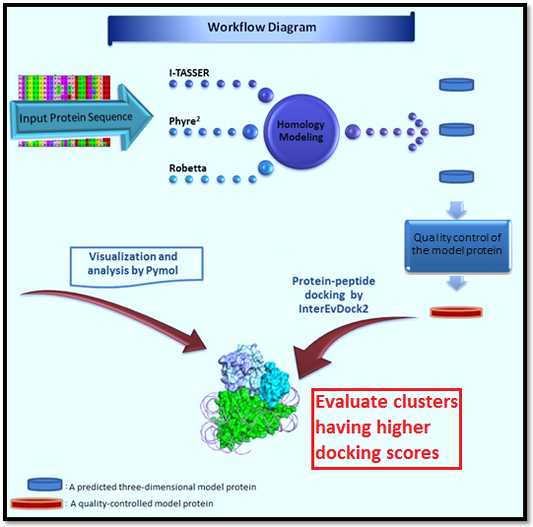

Figure 1: A pipeline of molecular docking of Aggregatin and Amyloid-beta(Aβ) peptide. There are four key steps in the pipeline. First, the prediction of the 3D structure of Aggregatin. Second, the model protein structure analysis for quality. Third, protein-peptide docking by InterEvDock2 server and analysis by the PyMOL software.

Introduction
Alzheimer's disease (AD) is observed as a widespread and incurable ailment worldwide due to an increase in the average human lifespan in recent years. Although the risk factors described as lifetime and aging the classic Mendel inheritance that autosomal dominant or multi-reason features have also suggested as another risk factor. The increase in AD patient numbers in the population has become a social and economic problem since they become dependent on another person.^{1,2} The global number of AD patients who lived dementia was estimated at 43·8 million worldwide ³ and more than 5 million in the USA. This number may dramatically increase to 13.8 million people living in America with Alzheimer's dementia until the middle of the century.⁴

The neuropathology indicator of AD, which causes dementia, is neurofibrillary tangles inside the cell and formation of beta-amyloid (Aβ) peptides out of the cell, resulting in cerebral atrophy.⁵ From one of these main pathologies characterizing AD, Aβ results in oligomeric Ab by processing a proteolytic of amyloid precursor protein (APP) in an inaccurate form and finally aggregates in Ab fibrils and plaques as a lesion intracellular.⁶ It is unclear what the function of APP is, However its role in cell growth and biological activities such as signaling and neuronal development has shown in several studies.⁷

Understanding the crucial patterns of origin of the Ab pathology is based on comprehending the mechanisms that show how the monomers that make up the Ab aggregates are formed and how oligomeric clusters form lesions. Many erroneous peptides formed by proteolytic processing of APP might be a significant effect on neuronal dysfunction in AD. These peptides are mostly encountered in the region of the hippocampus in the brain.⁸ Cleavage of APP may process into two alternative pathways as non-amyloidogenic and amyloidogenic. In the non-amyloidogenic proteolytic pathway, APP is normally processed through α-secretase and λ-secretase, producing soluble peptides, while it is forming indissoluble fragments as amyloid-beta peptides that aggregate in the amyloidogenic process.^{1,6} Further investigations are required to clarify the mechanisms associated with AD by aggregation of these peptides after proteolytic processing.

The amino acid sequence of Aβ42 from amyloid plaques was initially uncovered in the 1980s as the first time.⁹ Aβ is generally believed to be naturally unstructured and therefore might not be crystallized by standard techniques. Hence, various studies deduce on optimizing forms that can preserve Aβ peptides. The 3D structure of various the Aβ peptides was identified by experimental tool including nuclear magnetic resonance (NMR) and X-ray crystallography. As such, most information about the structure of Aβ was obtained from NMR and molecular dynamics.¹ Obtained models from NMR of the structure of Aβ peptide (1-28) demonstrate that folding into α-helix with β-sheet structure conversion taking place during the early stages of amyloid deposition in the AD.⁹ Aβ peptide (1-28) is the main part of the amyloid plaques in AD and histidine-13 and lysine-16 of its chains are locating on the same face of the helix. Also, Aβ(1-40) peptide in the physiological condition is an α-helical structure whilst amyloid fibrils by these proteins largely shaped β-sheet structures. This structural modulation from α-helix to β-sheet is proposed as the critical step in the formation of aggregation.¹⁰

It seems that most of the studies carried out in vivo and in vitro so far have been focused on elucidating their molecular complexity concerning the accumulation of amyloid-beta and the hyperphosphorylated microtubule protein tau in the pathology of Alzheimer. In a very recent study, Yan and et al. have reported that a brain atrophy susceptibility gene that encoded by FAM222A agglomerates in amyloid deposits, interacting by amyloid-β (Aβ) via its N-terminal Aβ binding domain. The protein encoded by FAM222A that termed as Aggregatin expression was mainly detected in the brain and spinal cord of the central nervous system (CNS) by using a specific antibody in vitro. The length of Aggregatin is 452aa long and its function is still indefinite. To comprehend its pathological role in AD, The research team observed FAM222A accumulation in the core of amyloid deposits. They indicated how it interacts physically with amyloid-β via its N-terminal Aβ binding domain. This is one of the significant studies performed on a patient with AD and in an AD mouse model that shed a light on the pathophysiology of AD. ⁵.

In the current study, we aimed at predicting the three-dimensional structure of Aggregatin using various approaches by considering the discoveries that show the interaction of the molecules of interest. The molecular docking was also performed under the inspiration of this founding. We used homology modeling for obtaining model proteins and then performed a protein-peptide docking study by many approaches. While the prediction of protein structure by homology modeling has been performed broadly for folding proteins in general, for misfolded protein and aggregates to implementation has been limited.

More mechanistic studies are obliged to obtain sufficient information about the 3D structure and function by associating the protein encoded by the FAM222A gene with lately Alzheimer's pathology. Considering the critical roles of Aggregatin, it is fundamental to point to its physicochemical characteristics at the atomic structure level. Our results obtained by the analysis of computational approaches will contribute information that provides an overview of the pathogenesis of AD and supports the elucidation of the protein, which is claimed to play a possible critical role in amyloidosis.
Materials and Methods
Prediction of the 3D structure of Aggregatin by Homology Modeling

All of the work-flow is summarized in Fig.1. We fetched the protein sequence encoded by Human FAM222A (Reference Sequence: NP_116218.2) from NCBI in FASTA format, used the PSIPRED¹¹ to predict the secondary structure of the Aggregatin. To have a tertiary structure of Aggregatin as a model, the amino acid sequence was subjected to I-TASSER¹², PHYRE² ¹³, Robetta^{14,15} that are commonly using based-homology modeling. To quality control of model proteins, we applied to the tool of Qualitative Model Energy Analysis (QMEANDisCo)¹⁶ and ProSAweb.¹⁷

Sequence Analysis
We performed pairwise in PSI-BLAST (Position-Specific Iterated BLAST) ¹⁸. All general and scoring parameters left as default settings including MATRIX: BLOSUM62 and the threshold value (0.005). We also analyzed the primary structure using predicting DomPred¹⁹ (Protein Domain Prediction) and interpreted the outputs in Jalview 2.11.0.²⁰

Visualization of Molecular docking
The primary structure of Aggregatin was visualized using Jalview 2.11. The PyMOL²¹ software was utilized for representing the tertiary structure proteins-peptides and analyzing the docking results at the atomic structure level. We retrieved the crystal structures of Amyloid Beta-Peptide (1-28 Aβ) (PDB ID:1AMB), and (1-42 Aβ) (PDB:1IYT) from PDB(Protein Data Bank) at http://www.rcsb.org/ to protein-peptide interaction study. To visualize the N-terminal and C- terminal domain of Amyloid-beta protein 42, we retrieved the Fig.3 from Protein Data Bank in Europe (PDBe) which is available at https://www.ebi.ac.uk/pdbe/. All docking simulations were conducted by InterEvDock2^{22–24} online server via using the FRODOCK2²⁵ and SOAP_PP.²⁶

Results and Discussion
In this paper, in silico analysis of the protein, which is termed Aggregatin, whose function and three-dimensional structure is not characterized yet and associated with Alzheimer's pathology by in vitro and in vivo investigations, is aimed. The Aggregatin interacting with Amyloid-beta and forming lesions together was determined as a result of extracellular aggregate formation observed in Alzheimer’s pathology.⁵ Even though Aggregatin is expressed in the nerve cells, it remains uncertain from which sort of the cell and compartment to release and how to form a core for extracellular amyloid-beta plaques. Yet, the in vitro studies carried out so far demonstrate that Aggregatin was approved to place in the nucleoplasm and plasma membrane of the cell parts as well as mitochondria and focal adhesion.²⁷

Protein structures may consist of multiple intense foldable parts named domains. These contain typical hydrophobic cores, can be folded freely of each other and frequently connected with distinct functions.²⁸ For this purpose, our first approach in this study was to predict the domain of the Aggregatin's amino acid sequence and to make sense of them if there is a potential significant aa sequence such as signal peptide, protein binding interfaces. In the domain prediction analysis with DomPred, which we have displayed in Fig.2, the parts to be localized in the transmembrane region in certain series domains were predicted as in represented the Kyte-Doolittle scale denotes hydrophobic amino acids. In the primary structure of the Aggregatin, the range 147-299 aa is a proline-rich and is bound by the membrane as a helix form, and the remainder part continuing as the extracellular part. Furthermore, its N-terminal part is in the cytoplasm, C-terminal is in the out of the cell and the range of 244-259 aa is pore-lining part in the membrane.

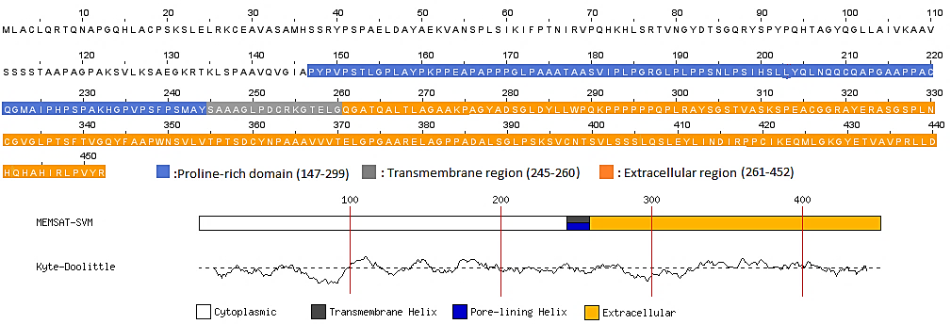

Figure 2: The primary structure of Aggregatin of encoded by FAM222A using domain prediction in PSIPRED. In the primary structure of Aggregatin protein, the cytoplasmic part is colorless, the proline-rich region(147-299) obtained from UniProt is navy blue. In this part, the transmembrane region (245-260 residues) is gray and the orange region (261-452) represents the extracellular part. MEMSAT-SVM shows the transmembrane helix topology. The Kyte-Doolittle scale indicates hydrophobic amino acids.

We also performed the domain prediction of the sequence of FAM222B protein, which we think would be a clue in the future in vitro studies. The related key between FAM222A and FAM222B share the same domain and in the same protein family, both of them are localized in the nucleoplasm and their alignments result in the blastp is per ident 49.04%. Although the FAM222B has been approved to be localized merely in the nucleoplasm by in vitro, its domains were predicted the transmembrane and extracellular part, the glycine-rich region, and the signal peptide part in the cell membrane.

To seek for both theoretical and experimental studies, domain prediction using sequence possesses significant consequences. In structural research implemented by experimental studies such as NMR or X-ray crystallography, it is generally to achieve more by single-domain proteins rather than full multi-domain proteins.²⁹ Thus, it might be more beneficial to partially analyze the primary structure of proteins. It would be more logical for structural biologists to categorize single-domain proteins exactly from multi-domain ones.

For seeking the interaction between β-Amyloid₄₂ peptide and Aggregatin at the atomic side level, we attained to the graph of Aβ₄₂ to identify which residues N or C- terminal domain from PDBe. According to this chart, the N-terminal domain of the Aβ₄₂ sequence is up to the 27th residue, thanks to data combined with several databases such as CATH ³⁰ and SCOPE ³¹ (See Fig.3).

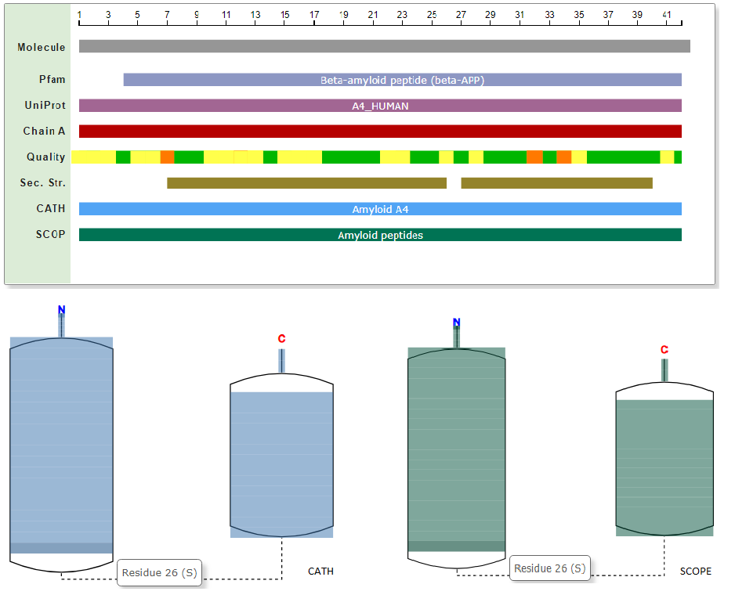
Figure 3: The chart represents the N-terminal and C- terminal domain of 1-42 Aβ peptide. According to some databases such as CATH, SCOPE, UniProt, 1-26 residues of Aβ peptide represent the N-terminal domain, 27-42 residues of Aβ peptide represent C- terminal domain( Protein Data Bank in Europe).

QMEAN tool was used to control the quality of the model protein to be subjected to the docking process and to determine the accuracy rate of the three bioinformatics tools selected for Aggregatin. As a result, the model protein from the Robetta was subjected to protein-peptide docking. Models obtained from the other tools were determined to be inapplicable for the docking process. Robetta is a protein structure prediction service that is continuously evaluated with CAMEO(Continuous Automated Model EvaluatiOn), which constantly assesses the accuracy and reliability of the prediction. Among other prediction tools at CAMEO, Robetta and QMEAN are the first-line by time-based statistical confidence and show reliable performance. We also used the ProSAweb to verify the quality of the model protein. The Z-score designates the entire model-quality as -6.15 in Fig.4.

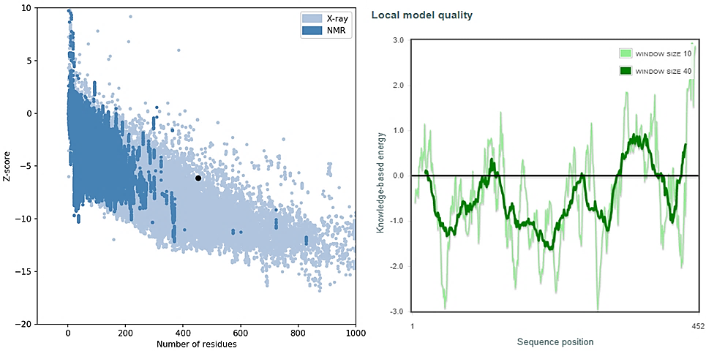

Figure 4: ProSA-web service analysis of Aggregatin. The black dot denotes that the input Aggregatin is in the range of Z-score values of experimental structures relative to several amino acid residues and Energy graph of the predicted Aggregatin. The Z-score designates the entire model-quality as -6.15 in the X-ray region in the plot. The other plot shows the local quality concerning the number of sequence positions.

The structural simulations of protein-protein interactions are fundamental to explain how each cell machinery assembles at the molecular level. It is very helpful to count on multiple sequence alignments and their structures and to recognize binding interfaces when neighbor proteins have possible homologous sequences. In the docking procedure of the current study, InterEvDock2 that is a free online tool, using for protein-protein docking operating the InterEvScore potential particularly produced to combine evolutionary information. The potential of InterEvScore has been developed for heteromeric protein interfaces and has integrated evolutionary information obtained from the multiple sequence alignments of each protein in the clusters with a residual-based multi-body statistical potential.

In this online server, docking searching is systematically implemented by using the FRODOCK2 and the results are re-calculated by InterEvScore²⁴ and SOAP_PP atom-based statistical potential to boost the confidence of the predictions.

As mentioned before, we predicted acceptable clusters using the InterEvDock2 server. This server predicts 10 top of consensus complexes for 239 out of 812 test cases. We selected from these clusters for each of Aggregatin-Aβ₄₂ peptide and Aβ₂₈ peptide in Table 1-2. Besides, the InterEvDock2 server predicts 5 top of residues interacting at the interface of a complex by the scoring system for the top10 clusters for 30 models obtained from InterEvDock2, FRODOCK2, and SOAP_PP.

Docking complexes | Residue number(Aβ₄₂) | Aggregatin | Docking score
IES1_A | HIS⁶ | TYR³⁰³ | 423.1
IES6_ B | HIS¹³, LEU¹⁷, PHE²⁰ | GLN⁴⁴², HIS⁴⁴³,ASP³⁵⁹ | 372.17
IES9_C | TYR¹⁰, HIS¹³ | ALA³⁶⁵, VAL³³³ | 360.15
SOAP_B | TYR¹⁰, VAL¹⁸ | LEU⁴⁴⁸, HIS⁴⁴³ | -16473.52
SOAP_A | HIS⁶, GLY⁹, GLY³⁷ | ARG⁴⁴⁷, HIS⁴⁴⁵, LEU³⁵³, | -16148.85
FRODOCK2_A | GLY²⁹, ILE³² | GLN⁴⁴² | 2267.23
FRODOCK4_B | ARG⁵, HIS¹³ | PRO¹⁴⁷, TYR³²¹ | 2062.62
FRODOCK1_C | GLU¹¹, LYS¹⁶, GLU²² ILE³¹, LEU³⁴ | TYR¹⁴⁸, ARG³¹⁹, SER³¹², SER²⁴¹ | 2290.05

Table 1: Probable interface residues on each protein between the model of Aggregatin and Aβ₄₂ peptide from amyloid plaques

Docking complexes | Residue number(Aβ₂₈) | Aggregatin | Docking score
FRODOCK2_A | ARG⁵, TYR¹⁰ | LYS¹³⁵, GLY¹⁵⁵ | 1727.14
FRODOCK4_B | HIS¹³, LYS¹⁶ | GLY⁴²⁹, ARG⁴⁴⁷ | 1699.13
FRODOCK8_C | TYR¹⁰ | HIS⁴⁴⁵ | 1646.18
SOAP_A₁ | LYS¹⁶ | (ASP²⁸⁴, TYR²⁸⁵,CYS³⁶⁰) | -15623.78
SOAP_A₂ | GLN¹⁵ | ASN¹⁹⁵ | -15795.12
IES2_B₁ | TYR¹⁰, HIS⁶ | LYS¹³⁵, ARG¹³³ | 236.81
IES3_B₂ | HIS¹³, LYS¹⁶ | ARG⁴⁴⁷, GLY⁴²⁹ | 226.48

Table 2: Possible interface residues on each protein between the model of Aggregatin and Aβ₂₈ peptide from amyloid plaques

Although the sequence per identity obtained using PSI-BLAST for homology modeling is 31-26%, there are sufficiently acceptable docking results as exhibited in Fig. 5-9. Even if the sequence similarity is under 30%, this does not mean that the model protein obtained by comparative analysis will have low reliability. Some primary sequences may have been conserved, and homology modeling can predict as accurately as experimentally obtained low-resolution models.³²
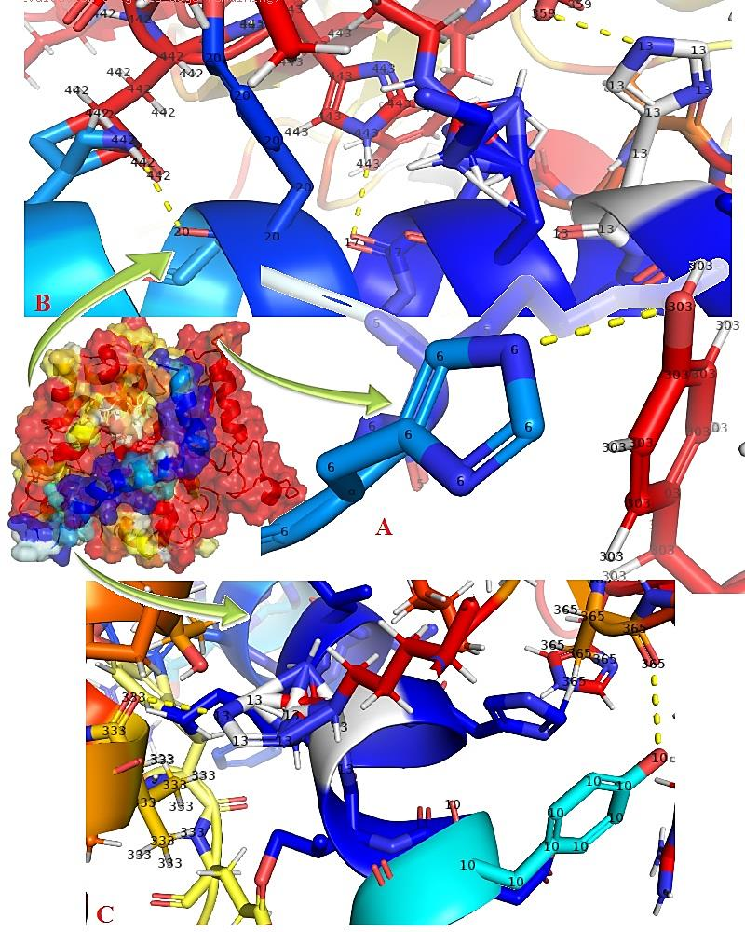
Figure 5: The model of Aggregatin and Aβ42 peptide of InterEvDock2 results. Aggregatin interacts with the residue of HIS⁶ (Section A), HIS¹³, LEU¹⁷, PHE²⁰ (Section B), TYR¹⁰, HIS¹³ (Section C) in N-terminal domain of Aβ1-42 peptide. The highest score belongs to the model in section A (See Table 1)
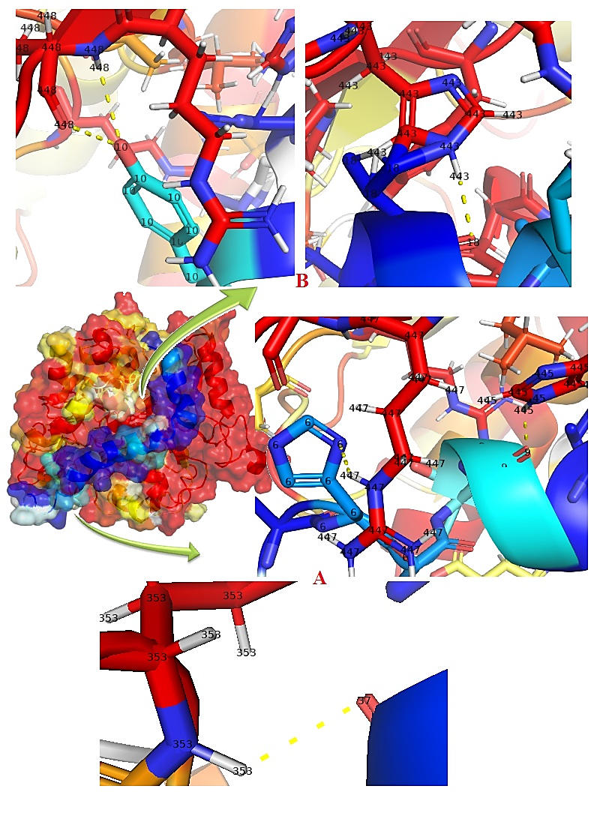
Figure 6: The model of Aggregatin and Aβ42 peptide of SOAP_PP results. Aggregatin interacts with the residue of HIS⁶, GLY⁹ (Section A), TYR¹⁰, VAL¹⁸ (Section B) in the N-terminal domain of Aβ₁₋₄₂ peptide but GLY³⁷ in section A is in the C-terminal domain of Aβ.
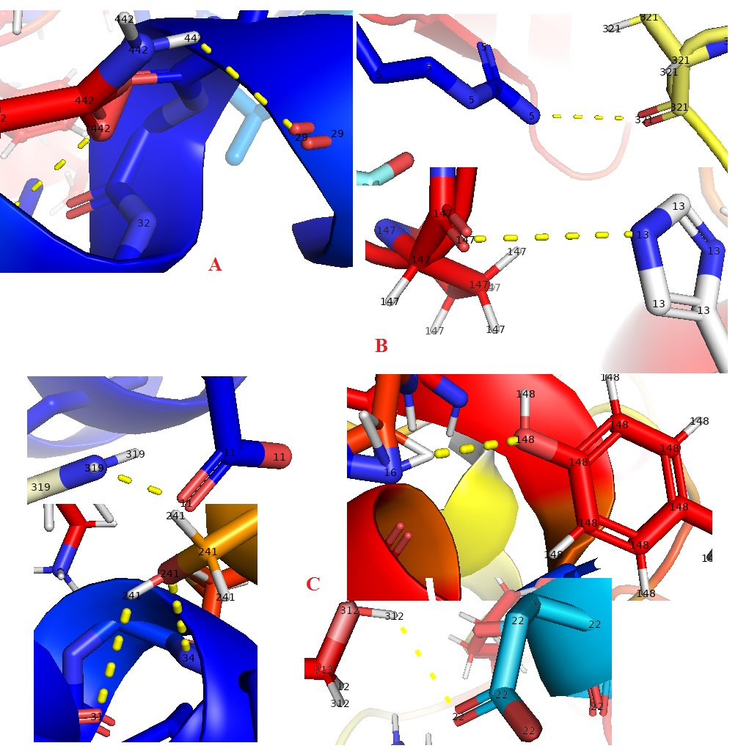
Figure 7: The model of Aggregatin and Aβ₄₂ peptide of FRODOCK2 results. Aggregatin interacts with the residue of ARG⁵, HIS¹³ (Section B), GLU¹¹, LYS¹⁶, GLU²² ILE³¹, LEU³⁴ (Section C) in N-terminal domain of Aβ1-42 peptide but GLY²⁹, ILE³² (Section A) and ILE³¹, LEU³⁴ (Section C) are C-terminal domain of Aβ₄₂.
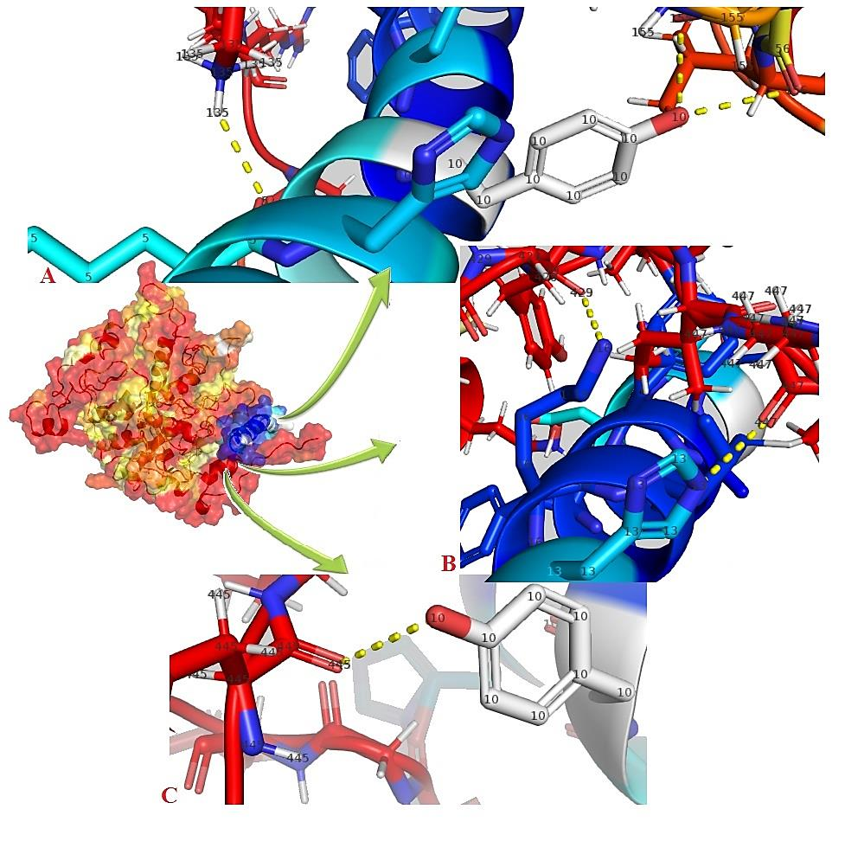
Figure 8: The model of Aggregatin and Aβ₂₈ peptide of FRODOCK2 results. Aggregatin interacts with the residue of ARG⁵, TYR¹⁰ (Section A), HIS¹³, LYS¹⁶ (Section B), TYR¹⁰(Section C) in Aβ₂₈ peptide. ARG⁵, TYR¹⁰ HIS¹³ residues are common both Aβ₂₈ and Aβ₄₂ in docking results.

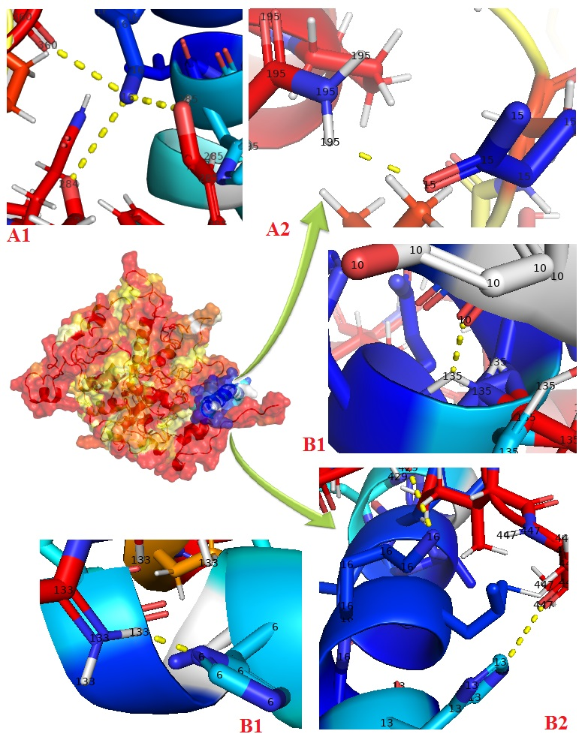
Figure 9: The model of Aggregatin and Aβ₂₈ peptide of SOAP and IES results. Aggregatin interacts with the residue of LYS¹⁶ and GLN¹⁵ (Section A₁ ve A₂), TYR¹⁰, HIS⁶ and HIS¹³, LYS¹⁶ (Section B₁ and B₂) in Aβ₂₈ peptide. TYR¹⁰, HIS¹³, LYS¹⁶, and HIS⁶ residues are common both Aβ₂₈ and Aβ₄₂ in docking results.

In our study, the docking of Aggregatin with both Aβ₄₂ and Aβ₂₈ peptides is since both peptides are involved in the amyloidosis process. Aβ₂₈ peptide is the main part of the amyloidosis procedures as deposits in AD, which might be taken place in the early phase of amyloidosis. Here, the side chains of HIS¹³ and LYS¹⁶ in the Aβ₂₈ localized on the same face of the helix. Interestingly, the docking process with HIS¹³ and LYS¹⁶ residues of the Aβ₂₈ peptide is among the highest binding energy results in Table 2. The interaction of Aβ₄₂ peptide with Aggregatin made with LYS¹⁶ HIS¹³ residues in FRODOCK2 outcomes also possesses higher binding energy in Table 1. Our expectation in the study was to question whether our docking results were compatible with the in vitro analysis by Yan et al. and that this Aggregatin binds to amyloid-beta from the N-terminal region. Along this way, as a result of scoring three programs in the docking process, we concluded that the models with the highest binding energy are the complexes that interact with residues (1-26) in the N-terminal region of the Amyloid beta.

CONCLUSION

Alzheimer's disease has no known specific remedy yet, but treatment to the patient may be contributed to slowing the progression of the disease and increase the quality of life. On the other hand, there is no only one predictable result for Alzheimer's patients. Some patients may experience the cognitive problem slightly; however, others may undergo a quicker onset of symptoms and faster disease progression. In this case, the strategies on how to implement the therapies have gained importance with molecular and cellular approaches. Here, we reported an in silico study explaining how Aggregatin protein at the molecular level facilitates the formation of amyloid-beta plaque. The domain analysis of Aggregatin supports its cell localization by confirmed in vitro. This study will help understand the possible conformational change in the three-dimensional structure of Aggregatin, which will be described in the future by experimental methods, for mutations such as deletions and SNP. From a future perspective, the results of the computational approaches we obtain support the Molecular dynamic simulation application to validate this study and increase its reliability. Our study might be a preliminary preparation for future drug discovery and development to examine the atomic level of a protein that facilitates the formation of amyloid-beta plaque, known as one of those responsible for Alzheimer's pathology.

DECLARATIONS
Funding: Not Applicable
Conflict Of Interest: We have no conflict of interest to declare.
Available of Data: Analysis data is ready to be shared upon request
Code Availability: Not Applicable
Authors Contributions: Both authors hypothesized the subject.Besli performed the analysis.Both authors evaluated the results and wrote the manuscript.

Reference

1. G. Chen, T. Xu, Y. Yan, Y. Zhou, Y. Jiang, K. Melcher, H. E. Xu, Acta Pharmacol. Sin. 2017, 38, 1205–1235.
2. R. E. Tanzi, Cold Spring Harb. Perspect. Med. 2012, 2, a006296.
3. E. Nichols, C. E. I. Szoeke, S. E. Vollset, N. Abbasi, F. Abd-Allah, J. Abdela, M. T. E. Aichour, R. O. Akinyemi, F. Alahdab, S. W. Asgedom, et al., Lancet Neurol. 2019, 18, 88–106.
4. A. Association, Alzheimer’s Dement. 2019, 15, 321–387.
5. T. Yan, J. Liang, J. Gao, L. Wang, H. Fujioka, X. Zhu, X. Wang, Nat. Commun. 2020, 11, 1–16.
6. D. J. Selkoe, Annu. Rev. Neurosci. 1994, 17, 489–517.
7. R. J. O’Brien, P. C. Wong, Annu. Rev. Neurosci. 2011, 34, 185–204.
8. A. Viswanathan, S. M. Greenberg, Ann. Neurol. 2011, 70, 871–880.
9. G. G. Glenner, C. W. Wong, Biochem. Biophys. Res. Commun. 1984, 120, 885–890.
10. J. Guo, C. K. Hall, Y. Xu, R. Wetzel, in Comput. Methods Protein Struct. Predict. Model., Springer, 2007, pp. 279–317.
11. D. T. Jones, J. Mol. Biol. 1999, 292, 195–202.
12. A. Roy, A. Kucukural, Y. Zhang, Nat. Protoc. 2010, 5, 725.
13. L. A. Kelley, S. Mezulis, C. M. Yates, M. N. Wass, M. J. E. Sternberg, Nat. Protoc. 2015, 10, 845.
14. Y. Song, F. DiMaio, R. Y.-R. Wang, D. Kim, C. Miles, T. J. Brunette, J. Thompson, D. Baker, Structure 2013, 21, 1735–1742.
15. S. Raman, R. Vernon, J. Thompson, M. Tyka, R. Sadreyev, J. Pei, D. Kim, E. Kellogg, F. DiMaio, O. Lange, et al., Proteins Struct. Funct. Bioinforma. 2009, 77, 89–99.
16. A. Waterhouse, M. Bertoni, S. Bienert, G. Studer, G. Tauriello, R. Gumienny, F. T. Heer, T. A. P. de Beer, C. Rempfer, L. Bordoli, et al., Nucleic Acids Res. 2018, 46, W296--W303.
17. M. Wiederstein, M. J. Sippl, Nucleic Acids Res. 2007, 35, W407--W410.
18. S. F. Altschul, T. L. Madden, A. A. Schäffer, J. Zhang, Z. Zhang, W. Miller, D. J. Lipman, Nucleic Acids Res. 1997, 25, 3389–3402.
19. D. T. Jones, D. Cozzetto, Bioinformatics 2015, 31, 857–863.
20. A. M. Waterhouse, J. B. Procter, D. M. A. Martin, M. Clamp, G. J. Barton, Bioinformatics 2009, 25, 1189–1191.
21. Schrödinger, LLC, The {PyMOL} Molecular Graphics System, Version~1.8, 2015.
22. C. Quignot, J. Rey, J. Yu, P. Tufféry, R. Guerois, J. Andreani, Nucleic Acids Res. 2018, 46, W408--W416.
23. J. Yu, M. Vavrusa, J. Andreani, J. Rey, P. Tufféry, R. Guerois, Nucleic Acids Res. 2016, 44, W542--W549.
24. J. Andreani, G. Faure, R. Guerois, Bioinformatics 2013, 29, 1742–1749.
25. E. Ram\’\irez-Aportela, J. R. López-Blanco, P. Chacón, Bioinformatics 2016, 32, 2386–2388.
26. G. Q. Dong, H. Fan, D. Schneidman-Duhovny, B. Webb, A. Sali, Bioinformatics 2013, 29, 3158–3166.
27. M. Uhlén, L. Fagerberg, B. M. Hallström, C. Lindskog, P. Oksvold, A. Mardinoglu, Å. Sivertsson, C. Kampf, E. Sjöstedt, A. Asplund, et al., Science (80-. ). 2015, 347, 1260419.
28. A. Vitali, Curr. Protein Pept. Sci. 2015, 16, 147–162.
29. K. Bryson, D. Cozzetto, D. T. Jones, Curr. Protein Pept. Sci. 2007, 8, 181–188.
30. T. E. Lewis, I. Sillitoe, N. Dawson, S. D. Lam, T. Clarke, D. Lee, C. Orengo, J. Lees, Nucleic Acids Res. 2017, 46, D435–D439.
31. N. K. Fox, S. E. Brenner, J.-M. Chandonia, Nucleic Acids Res. 2013, 42, D304–D309.
32. D. Petrey, Z. Xiang, C. L. Tang, L. Xie, M. Gimpelev, T. Mitros, C. S. Soto, S. Goldsmith-Fischman, A. Kernytsky, A. Schlessinger, et al., Proteins Struct. Funct. Bioinforma. 2003, 53, 430–435.

