Supplementary Material
Identification of phytochemicals from the water extract of Eurycoma longifolia roots using solid-liquid and liquid-liquid extraction based fractionation techniques
Lee Suan Chua^{a,b}*, Abirame Segaran^{a,b} and Hoi Jin Wong^{c}
ªInstitute of Bioproduct Development, Universiti Teknologi Malaysia, 81310 UTM Skudai, Johor Bahru, Johor, Malaysia.
^{b}Department of Bioprocess and Polymer Engineering, School of Chemical and Energy Engineering, Faculty of Engineering, Universiti Teknologi Malaysia, 81310 UTM Skudai, Johor Bahru, Johor, Malaysia.
^{c}Biotropics Malaysia Berhad, Lot 21, Jalan U1/19, Section U1, Hicom Glenmarie Industrial Park, 40150 Shah Alam, Selangor.

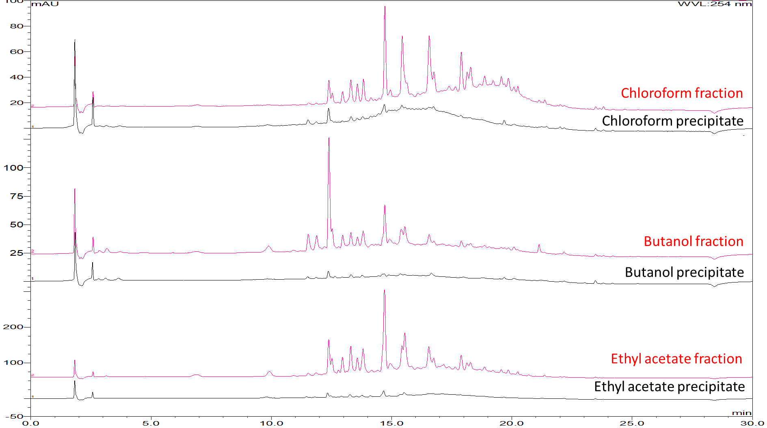
Figure S1. Chromatograms of organic fractions and their precipitates.

Table S1. Putative compounds detected in Eurycoma longifolia extract.
Peak | Retention time (min) | Positive ion (m/z) | Putative compound for positive mode | Ref. | Negative ion (m/z) | Putative compound for negative mode | Ref.
1 | 11.2 |  |  |  | 441/331/313/301(bp)/285/273/275/257 | 7,15- dihydroxy-4, 4, 14-trimethyl-3, 11-dioxochol-8-en-24-oic acid | [S7]
2 | 12.5 | 409/391/373/279/253 | eurycomanone | [S1] | S: 407/299/287(-120) | iriflophenone-3-C-glucoside | [S8]
 |  | 363/167(-196)/149 | 11-dehydroklaineanone | [S1] | S: 571/507(-64)/463(-108)/283 | eurycomanol-2-o-β-D-glycopyranoside | [S1]
 | 12.6 | 834/426(-408)/409/391 | eurycomanone dimer +NH₄ | [S1] | S: 575/529(-46, M)/511/493(-36)/367(162,bp)/349/331/313/287/269/251 | formylated 2,3-dehydro-4α-hydroxylongilactone glucoside | [S1]
 |  | 496/347(-149)/317(-179)/299/281/263/251/227/209/197/185/153/133 | laurycolactone B +179 | [S1] | 425/331(-94)/316(-15)/301(-15)/303/181(-120) | unknown
 |  | 462/445(-17)/427(-18)/409(-18)/391/373/317/299/269 | trihydroxyl eurycomanone | [S1]
 |  | S: 548/351(-197)/333/315/297/279/269/257/253/251/241/235/223/225/209 | eurycolactone E derivative | [S1]
 |  | S: 531/513(-18)/351(-162)/333/297/269(-80)/251/235/223 | glycosylated ebracteolatanolide B or glycosylated yuexiandujisu E | [S2, S3]
 |  | 369/351(-18)/333(-36)/315/297/241/223/137 | 2,3-dehydro-4α-hydroxylongilactone | [S1]
3 | 13.3 | S: 752/735(-17)/717(-18)/573(-162)/555(-18)/393(-162)/375/357/329/325/299/253 | (α/β-epoxide) hydroxyailanthone diglucoside
4 | 13.5 |  |  |  | S: 557/511(-46, HCOOH)/349(-162)/331(-18)/313(-18)/269(-44) | malvidin-3-glucoside (anthocyanidin) | [S9]
5 | 13.9 |  |  |  | S: 541/495(-46, HCOOH)/479(-62)/335/333(-208)/317(-162)/271 | hydroxymyricetin hexoside | [S10]
6 | 14 | 810/793(-17)/414/397(-17)/379/361/343/333/297/287 | 3,4ε-dihydrochaparrinone dimer +NH₄, dimer of m/z 414 | [S1]
 |  | 414/397(-17)/379(-18)/361(-18)/343(-18)/297/269/219 | β-sitosterol | [S4]
7 | 15 | 271/253(-18)/238(-15)/211(-27) | genistein | [S5] (PB000884) | S: 587/523(-64)/451(-72)/361(-162)/343/299/167 | glycosylated α-lupulic acid (humulone) | [S11]
 |  | 193/178(-15)/165(-13)/150/137/133/122/105 | scopoletin is a coumarin derivative in roots | [S6]
 |  |  |  |  | 789/275/197(bp)/183/153 | β,3,4-trihydroxy benzenepropanoic acid | [S12]
 |  | S: 808/791(-17)/659(-132)/641/623/593/563/497(-162)/475/461/445/427/415/317(-180)/313/295/277 | unknown
 |  | 223/207/190/179/162/149/107 | farnesol or nerolidol (plant hormone in roots) | [S5] (PR100374)
 |  | 481/297(-184)/285(-196)/265(-20)/137
 | 15.5 | 792/773(-19)/679(-94)/661(-18)/565/548/453/435/341/322/228/209/116 | formylated hexose trimer |  | 723/677(-46)/593/470/451(-226)/387/341/225/179 [3M + HCOOH - H]-
8 | 16.5 | 366/349/331/313/295/285/257/239/187 | hydroxy eurycomalide B | [S1] | 393/347(-46)/329/311/301/285/267/252 [M+HCOOH]- | (2aβ,3α,5aβ,6β,7α,8aα)-6-2-(3-furanyl)ethyl-2a,3,4,5,5a,6,7,8,8a,8b-decahydro-2a,3-dihydroxy-6,7,8b-trimethyl-2H-naphtho1,8-bc-furan-2-one | [S13]
 |  | 349/313/303/285/267/239 | eurycomalactone | [S1] | 395/349(-46)/331(-18)/277/259/241 | unknown
 |  | 368/351/333/315/297/287/241 | hydroxy eurycolactone B | [S1] | 187/125(-62) | azelaic acid (1,7-heptanedicarboxylic acid) | [S12]

References
S1. L.S. Chua, N.A. Amin, J.C. Neo, T.H. Lee, C.T. Lee, M.R. Sarmidi, R.A. Aziz, J. Chromatogr. B Analyt. Technol. Biomed. Life Sci. 2011, 879, 3909-3919.
S2. W.X. Wang, X.B. Ding, Acta Pharm. Sin. 1998, 33, 128-131.
S3. H.M. Shi, I.D. Williams, H.H.Y. Sung, H.X. Zhu, N.Y. Ip, Z.D. Min, Planta Med. 2005, 71, 349-354.
S4. A. Toiu, A. Mocan, L. Vlase, A.E. Parvu, D.C. Vodnar, A.M. Gheldiu, C. Moldovan, I. Oniga, Front. Pharm. 2018, 9, 252-266.
S5. https://massbank.eu/MassBank/Search (assessed on 23 January 2019).
S6. S. Wang, P. Qi, N. Zhou, M. Zhao, W. Ding, S. Li, M. Liu, Q. Wang, S. Jin, Anal. Bioanal. Chem. 2016, 408, 7423–7436.
S7. M. Yang, X. Wang, S. Guan, J. Xia, J. Sun, H. Guo, D. Guo, J. Am. Soc. Mass Spectr. 2007, 18, 927-939.
S8. T. Beelders, D. de Beer, A. Maria, Molecules 2014, 19, 11760-11790.
S9. E. Salas, H. Fulcrand, C. Poncet-LeGrand, E. Meudec, N. Köhler, P. Winterhalter, V. Cheynier, J. Chrom. Sci. 2005, 43, 488-493.
S10. V. Spínola, J. Pinto, P.C. Castilho, J. Funct. Foods 2018, 40, 595-605.
S11. L. Ceslová, M. Holcapek, M. Fidler, J. Drsticková, M. Lísa, J. Chrom. A 2009, 1216, 7249–7257.
S12. J. Kang, W. Price, J. Ashton, L. Tapsell, S. Johnson, Food Chem. 2016, 211, 215-226.
S13. L.L. Xu, F.X. Guo, S.S. Chi, Z.J. Wang, Y.Y. Jiang, B. Liu, J.Y. Zhang, Molecules 2017, 22, 912.

