Ammoniacal Carbonate Leaching: effect of dissolved sulfur in the distillation operation

*Armando Rojas Vargas^{1,2}, María Elena Trujillo Nieves³, Yudith González Diaz⁴

¹Empresa de Servicios Técnicos de Computación, Comunicaciones y Electrónica "Rafael Fausto Orejón Forment", Holguín, Cuba.
²Universidad de Holguín “Oscar Lucero Moya”, Holguín, Cuba.
³Centro de Investigaciones del Níquel “Alberto Fernández Monte de Oca”, Holguín, Cuba.
⁴Universidad de Oriente, Faculty of Chemical Engineering, Santiago de Cuba, Cuba
* Corresponding author: E-mail: arojas@eros.moa.minem.cu)
Tel: +53-24-51-6695

Abstract
The Liqueur Product distillation process in the ammoniacal carbonate leaching technology was studied. The dissolved-sulfur concentration effect over the Basic Nickel Carbonate (BNC) characteristics and the operation expenses were determined. When the Liquor Product that feeds to the steam-stripped columns possesses a carbonation according to the NH₃/CO₂ ratio between 1.60 and 1.80, to smaller [S] dissolved (g·L⁻¹) and the higher the Ni/S and Ni/[S_{x}O_{y}^{z-}] ratio, increase the carbon dioxide content and inversely decrease the sulfur in the BNC, those favors the subsequent processes, by diminishing of the filtration resistance, the cake humidity and the nickel leaching of the CBN. To a pH between 8.4 and 8.7 in the suspension effluent of the columns, the greatest economic benefit is obtained by diminishing the ammonia losses and the precipitation reagent consumption of dissolved nickel.

Key words: Basic Nickel Carbonate, steam-stripped columns, sulfur, leaching

1. Introduction
The ammoniacal carbonate leaching technology for the selective extraction of nickel and cobalt from lateritic minerals began the operations in the mid 1940´s in Cuba. The process consists of the fundamental stages: mineral benefit, crushing, drying, grinding, reduction in multiple-hearth roaster in a reducing atmosphere, ammonia carbonate leaching, separation of cobalt, Basic Nickel Carbonate (BNC) precipitation by steam-stripped, ammonia and carbon dioxide recovery by absorption, and thermal decomposition of BNC to obtain sintered nickel oxide.
From the leaching stage, the Liqueur Product is obtained, an ammoniacal carbonate solution enriched in nickel after cobalt precipitation. The Liquor Product flow is fed to the steam-stripped columns and descends by gravity, it is brought into direct contact and counter flow with the superheated steam in multiple bubble cap trays, and the volatiles compounds NH₃ and CO₂ evaporate, ascend and are separated by the top of the column; in turn, the BNC precipitates and it is obtained from the bottom in a suspension of concentration between 2,5 and 4,0% by weight and temperature of 80ºC to 90ºC, Eqs. (1), (2).
(1)
(2)
The suspension contain dissolved chemical species, of the system Ni(II)-NH₃-CO₂-SO₂-H₂O, in the proportions 1.5<NH₃/CO₂<2.0; 1,8<Ni/S<3.2; 10.4<CO₂/S<13.8. It possesses a high color content, total alkalinity, total dissolved solids, chlorides, moderately corrosive and severely encrusting characteristics according to the Langelier index and pH of 7.4 to 9.0. The ammonia constitutes a loss and the nickel precipitates with sulfhidric acid (H₂S) in a reactor of piston-flow type.^{1, 2}
The column operation is automated, the temperature and pressure profile is controlled taking advantage of the relative volatility and the tendency of dissolved components NH₃ and CO₂ to change phase. Several complementary control methods are applied such as: the sedimentation rate of the BNC suspension, the determination of the dissolved ammonia in the column control tray and the pH measurement in the effluent suspension, with the purpose of minimizing the expenses for ammonia losses and precipitation reagent consumption of dissolved nickel. ^{3,4,5}
To minimize the nickel concentration, it has been recommended to feed the columns a Liqueur Product with low sulfur concentration for a ratio Ni/S≥1.8 and a correct carbonation according to the NH₃/CO₂ ratio between 1.5 and 1.8; in addition, the pH of the BNC suspension must be between 8.3 and 8.7. If the pH>8.7, a sub-distillation occurs and it is characterized by low thermal profile, the dissolved NH₃ and Ni(II) concentration in the effluent is high, increasing the operation expenses. If the pH<8.3, an over-distillation of the Liquor Product occurs, which has been explained as the nickel leaching from the compounds contained in the BNC suspension: nickel carbonate [NiCO₃], nickel sulfate [NiSO₄] and nickel hydroxide [Ni(OH)₂], due to the formation of salts and coordination compounds. ^{4, 5}
Statistical models have been reported to estimate the concentration of nickel dissolved in the suspension, as well as the mathematical simulation of the chemical species concentration as a pH function, pH-potential and speciation diagrams, and the formulation of possible chemical reactions involved in the nickel leaching of the BNC, in contrast to the experimental results in a distillation minicolumn and on an industrial scale. ^{3,4,5,6}
The purpose of this work is to determine the dissolved-sulfur concentration effect in the Liquor Product, on the BNC characteristics, the expenses in the distillation process and determine the pH range for the greatest economic benefit.
2. Materials and methods
The evaluation was carried out in a distillation minicolumn (DCM) and on an industrial steam-stripped column. The DCM has 200 mm diameter, 1320 mm height, 2 separating trays at the top, 8 bubble cap trays, 1 cups/trays of 106 mm diameter. The trays have samplers, which allowed performing the concentration profile of dissolved chemical species. On the other hand, the industrial steam-stripped columns, in Nicaro, have 3.4 m diameter, 18.0 m height, 18 bubble cap trays, 24 cups/trays, operating pressure at the bottom of 127.5 MPa, it has samplers in the control trays and in the columns bottom. ⁴
The chemical analyzes were performed applying volumetric, gravimetric, potentiometric and Atomic Absorption Spectrophotometry methods. The pH was determined using a PHILIPS PW-9420 pH meter, 115-230 V, 50-60 Hz, at 25ºC.
Experimental runs were performed in three stages:
Stage 01. An experimental design 2^{k-1} was carried out at the DCM, with a central level and independent variables: temperature at the top: 80, 85 and 90ºC, and liquor flow: 12, 16 and 20 L·h⁻¹, 15 experiments in total with 2 h of duration each. The Liquor Product chemical composition remained fixed, it had a Ni/S ratio 2.66; Ni/[SO₄²⁻] 5.08, Ni/[S₂O₃²⁻] 3.11, y NH₃/CO₂ 1.73.
Stage 02. In the DCM, 6 experiments in total were carried out with and without feeding Liquor with high CO₂ by a side trays of the column, at a flow of 2 L·h⁻¹. The temperature at the top was 90ºC and the Liqueur Product flow of 20 L·h⁻¹. The Liquor chemical composition had a Ni/S ratio 3.32, Ni/[SO₄²⁻] 6.82, Ni/[S₂O₃²⁻] 4.25, y NH₃/CO₂ 1.78. The specific cake resistance and the medium resistance of filtration was realized, to a temperature of 80ºC, 16% in weight of solids and constant pressure drop of 37581.75 N/m², applying as membrane the Kraft paper. ⁷
Stage 03. Industrial scale evaluation. The sampling was carried out in the Nicaro production plant, Cuba, in several periods or campaigns to guarantee the representativeness in the ionic composition of the Liquors processed in the columns. It were fixed the variables Liquor Product flow (Qa) 56.4 m³·h⁻¹ (±4.5), temperature at the column top (Tp) 83.0ºC (±1.4), and quotient between Liquor flow and steam flow (Qa/Wv) 5.7 m³·kg⁻¹ (±1.2), these values were taken from the Supervisory Control and Data Acquisition EROS. The samples were taken in the Liqueur Product, in the control trays and in the BNC suspension, every 4 hours in 100 mL plastic bottles. The Liquor Product chemical composition was: 1.0≤Ni/S≤2.8, 1.8≤Ni/[SO₄²⁻]≤ 4.0, 1.2≤Ni/[S₂O₃²⁻]≤ 3.0, 1,60≤NH₃/CO₂≤1.94.
The BNC suspension samples were processed as follows: the aliquot needed to determine the suspension pH and the dissolved compounds concentration (g·L⁻¹) [NH₃], [CO₂], [Ni], [S], [SO₄²⁻], [S₂O₃²⁻] was taken; the rest was filtered in a Büchner funnel connected to a kitasate and a vacuum pump, the BNC was dried at 60°C and it was characterized according the concentration (%) of [Ni], [Co], [MgO], [CO₂], [S]. The real and apparent BNC density was determined.
The chemical analysis database was organized into dataset (j=1 to 10) according to the Ni/S and NH₃/CO₂ ratio in the Liqueur Product, maintaining a standard deviation approximately equal to 0.5 g·L⁻¹. The nickel concentration in the discharge of the columns was fitted to polynomial function and the ammonia to potential function, the best fitting was appreciates by the high coefficient of determination (R²), eq. (3), (4).
(3)
(4)
To perform the economic valuation, eq. (5) to (8) were applied.
(5)
(6)
(7)
(8)
The liquor flow in the columns effluent, Q_{l} (m³·h⁻¹), was determined in function of the density, ρ (kg/m³), corresponding to the solid (s), the liquid (l) and the suspension (p), Eq. (5).
In the interval 7.7≤pH≤8.9 and step 0.1, the operation expenses, G_{i} ($·m⁻³·h), was calculated using the prognostic models of [NH₃]_{i} and [Ni]_{i} concentration as a function of pH_{i} (where, i=1 to 13). The ammonia price (P₁) of 350 CUC·t⁻¹, nickel precipitation reagent (P₂) 740 CUC ·t⁻¹ and reagent consumption dose (d) 1.33 t·t⁻¹ of precipitated nickel were considered, Eqs. (6).
The operation global expenses, G ($·m⁻³·h) was calculated taking into consideration the frequency (f_{j}) at which each one of these dataset (j=10) was obtained, and the frequency (f_{i}) at which a pH_{i} value was determined in its respective dataset, Eq. (7).
The economic benefit, (A) ($·m⁻³·h), was calculated starting of the difference between the expense (Gj) and the expense average of a pH_{i} range, k, with step 0.4 (k=1 to 10). From this calculation, the pH range to operate at lowest expense (or the greatest economic benefit) was determined, Eq. (8).
3. Results and Discussion
3.1 pH interaction with dissolved nickel and ammonia
The nickel and ammonia profile (g·L⁻¹) as a function of the pH in the minicolumn (Stage 02) are shown in Fig. 1. Curve (I) refers to the Liqueur Product distillation with addition by a side tray, of dissolution with high concentration of carbon dioxide and the curve (II), without addition of said dissolution.
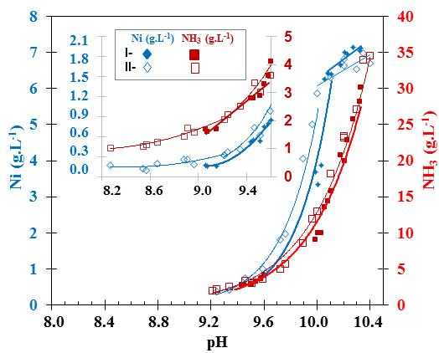
Figure 1. Nickel and ammonia dissolved profile as a function of pH at 25ºC in the in a steam-stripped minicolumn ^{I-} Liquor Product distillation with addition of solution with high CO₂ by a side trays ^{II-} Distillation without addition of solution with high CO₂.

At pH equal to 10.33, the precipitation of the BNC began, a linear decrease in nickel with slope m₁=2.8 and m₂=2.3 (denoted I and II respectively) was obtained, until reaching a [NH₃] concentration between 15 and 20 g·L⁻¹ and pH=10. From that pH, [Ni²⁺] precipitated intensely according to a potential function and exponents k₁=39.3 and k₂=36.7 with fit quality, R², 95% and 97% respectively, (Fig. 1).
At pH<9.6, a view of the interactions between the concentration of nickel and ammonia with the pH has been included, corresponding to the lower trays and the minicolumn discharge (Fig. 1). The concentration of both compound decreased. For the same pH value, the dissolved nickel had a tendency to be slightly lower with the feeding of high [CO₂] solution by a side trays, than when said solution was not supplied (k₁>k₂); and the ammonia concentration was similar in both experiments, keeping 90ºC in the top of the minicolumn.⁵
On the other hand, on an industrial scale (Stage 03), similar results were obtained as those obtained in the minicolumn. At pH<9.08, while the [NH₃] concentration decreased following a potential function (R² 96.8%), the [Ni²⁺] dissolved had a second-order polynomial tendency (R² 94.08%) and at a pH approximately lower than 8.5, the nickel concentration in the suspension began to increase, due to the [Ni²⁺] leaching of the BNC molecule (over-distillation), (Fig. 2). ^{3,4,5}

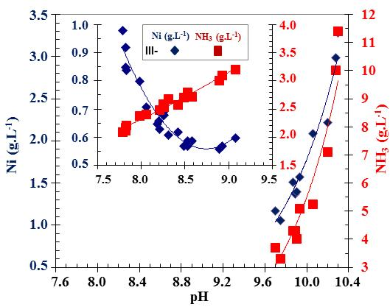
Figure 2. Nickel and ammonia dissolved profile as a function of pH at 25ºC in the steam-stripped column industrial, Stage 03, Ni/S 1.2, Ni/[SO₄²⁻] 2.5, Ni/[S₂O₃²⁻] 1.7, NH₃/CO₂ 1.63.
3.2 Effect of sulfur on the BNC chemical composition
The physical-chemical BNC characterization was performed, with regard to the nickel (Ni), cobalt (Co), magnesium expressed as magnesium oxide (MgO), carbon dioxide (CO₂), sulfur (S) concentration and the real and apparent density, the average values are shown in table 1. The mean diameter ranged from 19 to 32 μm.
Table 1. Characterization of Basic Nickel Carbonate
Experimental stage | Concentration (%) |  |  |  |  | Density (kg/m³)
Experimental stage | Ni | Co | MgO | CO₂ | S | real | apparent
01 | 47.1 | 0.38 | 0.20 | 7.38 | 3.04 | 2.98 | 0.40
02^{I} | 47.8 | 0.43 | 0.09 | 9.46 | 2.39 | 2.85 | 0.46
02^{II} | 47.4 | 0.40 | 0.07 | 7.45 | 4.12 | 2.86 | 0.39
03 | 48.5 | 0.35 | 0.28 | 3.34 | 5.96 | 2.89 | 0.59
^{I}Distillation of Liqueur Product and dissolution of high CO₂ ^{II}Distillation without dissolution of high CO₂

The interaction between sulfur (%) and carbon dioxide (%) concentration contained in the BNC molecule was determined. In the minicolumn, as the [CO₂] in the BNC increased, a tendency to decrease the [S] was obtained, with a second-order polynomial function and coefficient of determination, R², 92.1%, (Fig. 3).

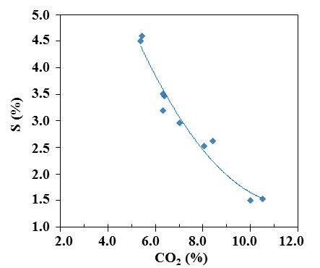
Figure 3. Interaction between the concentration of sulfur and carbon dioxide in the BNC, minicolumn, stage 01.

When dissolution of high CO₂ was fed by a side tray of the steam-stripped minicolumn, the CO₂ in the BNC molecule increased (table 1, stage 02) as well as the mean diameter from 24 to 32 μm. The specific resistance presented by the filter cake diminished from 20 to 5∙10⁶ m∙kg⁻¹ and the membrane resistance was constant equal to 1.5∙10⁹ kg⁻¹. The cake humidity decreased form 70% to 63%, which benefits the calcination subsequent process, by reducing energy consumption.^{7,8,9}
For the industrial process, in the period characterized by a carbonation of the Liqueur Product in the range 1.60≤NH₃/CO₂<1.80, it was obtained that when the [CO₂] in the BNC increased, the sulfur (S), although first it had a tendency to increase between 0.2% and 0.5%, later it decreased as a second-order polynomial function, a similar result to that obtained in the minicolumn. The lower [S] dissolved (g·L⁻¹) and the higher the Ni/S ratio in the Liqueur Product, the sulfur concentration (%) in the BNC was lower, (Fig. 4). For an [NH₃/CO₂] ratio greater than 1.80 in the Liquor, the [S] increased with a directly proportional relationship with the [CO₂] in the BNC, as opposed to the results in Fig. 4.

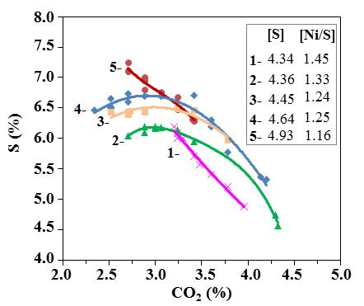
Figure 4. Interaction between the concentration of sulfur and carbon dioxide in the BNC, industrial process, stage 03, the [S] concentration (g∙L⁻¹) and the [Ni/S] ratio in the Liquor Product can be appreciated.

The interaction between the compounds [Ni], [CO₂] and [S] contained in the BNC was analyzed; and the relationship with the suspension pH. The BNC obtained in the minicolumn, had a higher nickel concentration when the sulfur decreased from 4.60% to 1.51% and the carbon dioxide increased from 5.38% to 10.51% (Fig. 5), with second-order polynomial tendency, R² equal to 92.1% and 93.24% respectively. Besides, sulfur decreased with the BNC suspension alkalinity increase (pH>7.8), whose tendency was also similar to that achieved with the BNC of the industrial process in Nicaro, (Fig. 6).

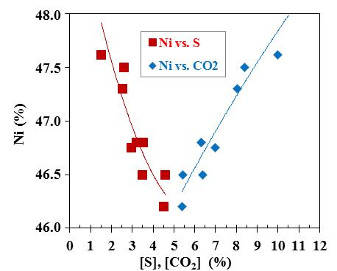
Figure 5. Interaction between the BNC components: nickel, sulfur and carbon dioxide, minicolumn, stage 01 b) Industrial process Stage 03.

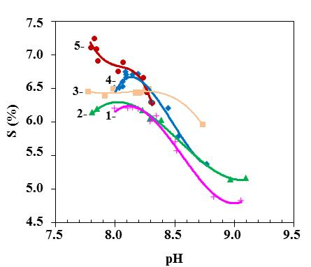
Figure 6. Interaction between the BNC components: sulfur and pH, industrial process, stage 03.

It should be noted that in the subsequent process, the reduction of BNC to NiO (and then to Ni) appears to depend largely on the characteristics of the starting materials, the process conditions and thermal history. A decreasing in the reduction rates in the temperature range of 700ºC to 900ºC is considered, due to surface segregation of sulfur, among other phenomena that occur simultaneously and contribute to the change the physical and chemical characteristics of the product, for which several recommendations have been reported. The sulfate decomposes in the last stage of the process and requires activation energy values higher than the rest of the stages, with a value of 324.4 +/-23.8 kJ·mol⁻¹.^{10,11,12}

Sulfur effect on the operating expenses
Expenses (G) were calculated in CUC·m⁻³·h of Liquor Product processed in steam-stripped columns, with 10 dataset and it were plotted as a function of pH. The average values ​​of sulfur concentration (g·L⁻¹), ratio Ni/S, Ni/[S₂O₃²⁻] and Ni/[SO₄²⁻] were included in the graph for the dataset that overlapped in the expense curve, in the interval 8.3≤pH≤8.7, (Fig. 7).

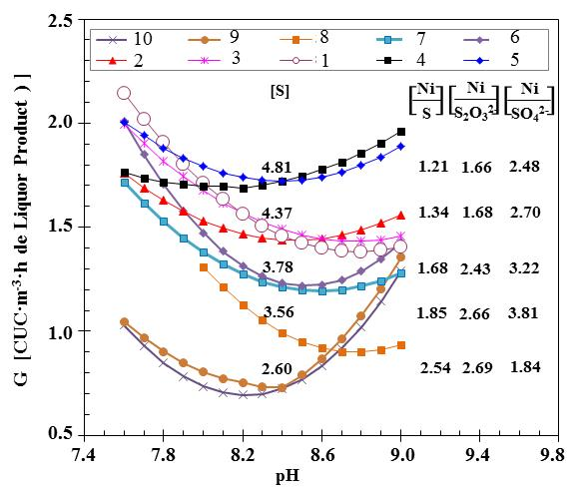
Figure 7. Interaction of suspension pH with the expenses (G, CUC·m⁻³·h of Liquor Product), 1.60≤NH₃/CO₂<1.80

In the range 8.3≤pH≤8.7, there are a directly proportional relationship between the expenses and sulfur concentration in the Liquor Product, and inversely proportional to the Ni/[S_{x}O_{y}^{z-}] ratio, that is, at lower sulfur and higher Ni/[S_{x}O_{y}^{z-}] ratio, decrease the expenses for ammonia losses and nickel precipitation reagent consumption. These tendencies were similar for the periods of operation characterized by carbonation according to 1.60≤NH₃/CO₂<1.80 and 1.80≤NH₃/CO₂≤2.0.⁵
The economic benefit (A) for several pH ranges were calculated, per m³·h⁻¹ of Liquor Product feeding to the steam-stripped columns. The greatest economic benefit of 0,125 CUC∙m⁻³∙h was obtained in the range 8.4≤pH≤8.7, (Fig. 8, curve A). The losses are represented to A≤0, that is to say, the operation for pH doesn't produce an economic benefit due to the high operation expenses, so, should be avoided operating in pH ranges less than 8.0 in the BNC suspension. The curve B was estimated by increasing ammonia and precipitation reagent prices by 70%; and the curve C, modifying only the ammonia price.

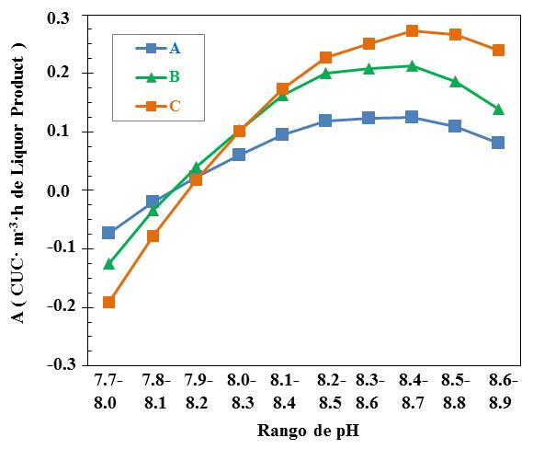
Figure 8. Interaction of suspension pH with the economic benefit (A, CUC·m⁻³·h), regarding ammonia losses and nickel precipitation reagent consumption.
3.3 Nickel leaching of BNC molecule by effect of dissolved sulfur
The nickel leaching of the Basic Nickel Carbonate in the distillation process occur by effect of the ionic species concentration, system Ni(II)-NH₃-CO₂-SO₂-H₂O, on dependence of suspension pH and the BNC molecule chemistry composition. The [S_{x}O_{y}^{z-}] ions will be present in the solution; these are incorporated to the previous process by the leaching of reduced ore with controlled aeration, which contain residual sulfur from the additive petroleum used in the reduction furnace. On the other hand, the equilibrium NH₄/NH₃ and HCO₃⁻/CO₃²⁻ depend on the suspension pH. The following reactions are proposed: Eqs. (9)- (13): ^{4,5,13,14}
(9)
(10)
(11)
(12)
(13)
When the sulfur concentration increases, and the Ni/S and Ni/[S_{x}O_{y}^{z-}] ratio decreases in the Liquor Product, the selectivity towards sulfate formation in the CBN molecule increases, while the carbonate formation decreases, (Fig. 3 and Fig. 4), this favors the nickel leaching and increases the operational costs, (Fig. 7).
The complex compounds concentration, simulating the species ionic in the steam-stripped columns discharge, were determined at [NH₃] 0.01M, [CO₃²⁻] 0.1M, [SO₄²⁻] 0.02M and [S₂O₃²⁻] 0.01M. In the measure that diminishes the pH in the BNC suspension in the columns effluents, the nickel cation concentration tend to decreasing coordinated with [NH₃] ligands with high coordination number, but tend to increasing with [S_{x}O_{y}] ligands, propitiating the nickel leaching of the BNC molecule, (Fig. 9). ⁵

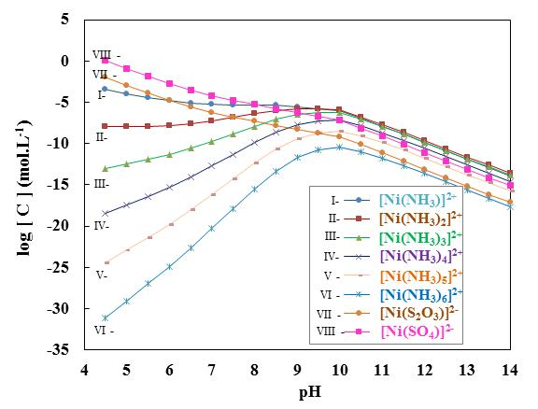
Figure 9. Log concentration of nickel complex compounds, [NH₃] 0.01M, [CO₃²⁻] 0.1M, [SO₄²⁻] 0.02M, [S₂O₃²⁻] 0.01M

The predominance area diagram, (Fig. 10), represent thermodynamic stability area of solid and aqueous species, in function of pH and [CO₃²⁻] anion concentration, under approximately the same conditions when the deep precipitation of BNC begin: pH<10.33, Ni(II) 0.14M, [NH₃] 1.2M, [SO₄²⁻] 0.03M and -0.7≤log[CO₃²⁻]≤-0.16. Based on this diagram, at higher carbonation of the Liquor Product, the thermodynamic stability area of NiCO₃ increases, while it decreases for the Ni(OH)₂; furthermore, it is important to control the pH, in order to reduce the tendency to NiSO₄ conversion, (Fig. 6). The experimental results have shown that when a Liquor Product is fed with low sulfur concentration, the highest Ni/S and Ni/[S_{x}O_{y}^{z-}] ratio, as well as a solution with high [CO₂] by a side trays of the columns, it is also favorable to reducing the dissolved nickel, improve the BNC composition and its physical-chemical properties, (Fig. 1 and Fig. 5). ^{4,5,15}

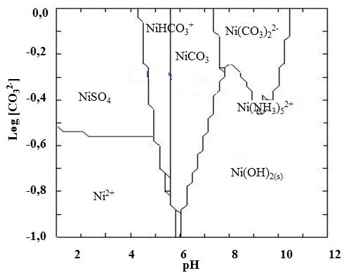
Figure 10. Predominance area diagram, Ni(II) 0.14M, [NH₃] 1.2M, [SO₄²⁻] 0.03M.

Using the complementary norm for the operation control by pH, it is possible to adjust the thermal profile in the steam-stripped columns, to reduce the nickel leaching in the suspension, the expenses for ammonia losses and chemical precipitation of nickel in the subsequent process, as well as improve the chemistry-physics properties of the BNC.
4. Conclusions
- The increasing of the sulfur concentration and the decreasing of the Ni/S ratio in the Liqueur Product fed in the steam-stripped columns, increases the selectivity towards sulfate formation in the molecule of Basic Nickel Carbonate, while the carbon dioxide and the nickel concentration decreases.
- Under the above conditions, the nickel leaching from the BNC and the expenses in the distillation operation increase, due to the ammonia losses and reagent consumption to precipitate nickel.
- Distillation costs are reduced and the greatest economic benefit is achieved, when operating in a pH range of 8.4 to 8.7.
5. Acknowledgment
Thanks to Maela Margarita Mariño-Pérez, Professor Associate University of Holguín; Georgina Aguilera Saborí, Professor Associate, University of Moa; Nélida Powery Evanks, NICAROTEC Co.; and colleagues of the Chemical Analysis Laboratory, CEDINIQ, Nicaro, Cuba, for their collaboration.

Conflict of Interest
The authors declare no conflict of interest

6. References
- P. A. García, A. V. Rojas, Tecnol. Quim. 2006, 26, 41-47.
- S. R. Rivas, G. V. Gerardo, A. R. Rómulo, Tecnol. Quim. 2016, 36, 145-153.
- M. E. H. Magaña, A. V. Rojas, Tecnol. Quim. 2013, 33, 200-205. DOI: https://doi.org/10.1590/2224-6185.2013.3.%25x
- A. V. Rojas, M. E. N. Trujillo, Tecnol. Quim. 2012, 32, 177-185. DOI: https://doi.org/10.1590/2224-6185.2012.2.%25x
- A. V. Rojas, M. E. H. Magaña, R. A. Ricardo, Rev. Metal. (Madrid, Spain). 2019, 55, 1-11 DOI:10.3989/revmetalm.149.
- X. Y. Guo, K. Huang, D. M. Zhang, Nonferr. Metal. Soc. China. 2014, 14, 1006-1011. DOI: 1003-6326(2004)05-1006-07.
- J. R. O. Gutiérrez, A. V. Rojas, Tecnol. Quim. 2018, 38, 24-35. DOI: https://doi.org/10.1590/2224-6185.2018.1.%25x
- Y. D. Gainza, M.E. Magaña, A. V. Rojas, C. G. Sánchez. Tecnol. Quim. 2016, 36, 407-416. DOI: https://doi.org/10.1590/2224-6185.2016.3.8
- A.R. C. Chang, R. H. Molina, E. R. Vega, M. R. Ortiz. Minería y Geología, 2003, 19, 59-64.
- T.A. Utigard, M. Wu, G. Plascencia, and T. Marin: Chem. Eng. Sci., 2005, 60, 2061–68.
- M.A. Rhamdhani. Metall. Trans. B., 2008, 39B, 234-245. DOI: 10.1007/s11663-008-9139-5
- M. M. R. Romero, J. C. Y. Llópiz. Minería y Geología, 1996, 13, 61-67.
- O. Söhnel, J. Mullin, Cryst. Res. Technol. 1979, 14, 217-228. DOI:10.1002/crat.19790140215.
- N. E. Kotelnikova, A.M., Mikhailidi. Cell. Chem. Technol. 2012, 46, 27-33.
- M. E. H. Magaña, Tecnol. Quim. 2016, 36, 36-48. DOI: https://doi.org/10.1590/2224-6185.2016.1.%25x

