Influence of TiO₂ on Mucosal Permeation of Aceclofenac: Analysis of Crystal Strain and Dislocation Density

Running Title: Influence of TiO2 on mucosal permeation

Abstract
Titanium dioxide can adhere with human epithelial cells and have good tolerability. Present work has been undertaken to explore the influence of TiO₂ on mucosal permeation of aceclofenac. Mucosal permeation of aeclofenac solution containing TiO₂ has been carried out. In FTIR study, the intensity of the peaks has decreased along with the increase of TiO₂ content in the formulation indicating a possible binding between drug and TiO₂. Melting enthalpy has been decreased with the increased content of TiO₂ in the solid. The status of crystal strain and dislocation density of TiO₂ and aceclofenac in the solid state formulation has also been evaluated from XRD data using Debye-Scherrer’s equation. Mucosal permeation of aceclofenac has shown sustained effect for more than 20 h in presence of titanium dioxide. Titanium dioxide could be used in designing formulation for sustaining mucosal aceclofenac delivery after performing risk assessment study.
Key words: Aceclofenac; titanium dioxide; mucosal permeation; crystal strain; dislocation density; in vitro diffusion.
1. INTRODUCTION
Titanium Dioxide is a biocompatible and stable material,¹ and has a wide range of application in various kinds of cosmetics. TiO₂ is accepted as food additive and also approved by FDA to be used in toothpaste, oral formulations etc.² Chen et al, 2011 described that TiO₂ is responsible for increasing intracellular Ca²⁺ concentration leading to elevated secretion of mucin.³ TiO₂ coating is very much useful to adhere on epithelial tissues.⁴ Masa and his colleagues, 2018 reported that TiO₂ has a property to attach with human epithelial cells along with a good tolerability.⁵ TiO₂ nanoparticles interact instantly with the buccal mucosa upon contact and show a long residence time in the oral cavity.⁶
Aceclofenac is a widely used BCS class II non-steroidal anti-inflammatory drug.⁷⁻⁹ It suffers from shorter elimination half-life and low oral bioavailability because of low aqueous solubility.¹⁰⁻¹² The toxic effects of this NSAID include gastric abnormalities like abdominal pain, gastric bleeding, dyspepsia etc. It is known that if the first pass metabolism is bypassed avoiding oral administration, improved bioavailability could be observed.¹³ Aceclofenac eye drop has shown a marked reduction in ocular inflammation in post-operative cases of cataract operation.¹⁴ Topical administration has been done frequently (2 hourly) for improved permeation through ocular mucosa. In vitro prolonged release has been studied for transmucosal delivery of aceclofenac using mucoadhesive dillenia fruit gum.¹⁵ Katara et al., prepared a nano particle formulation of aceclofenac and claimed that the drug efficacy in local action can be improved if residence time of the formulation is amplified.¹⁶
In this present study the influence of TiO₂ has been explored on the mucosal permeation of aceclofenac in liquid formulation. Solid state crystal strain and dislocation density have also been analysed.
2. Experimental
2.1. Materials
Aceclofenac was received from Mannequin Pharmaceuticals Pvt. Ltd., (Bhubaneswar, India) as a gift sample. Titanium Dioxidee was procured from Merck Specialities Pvt. Ltd, (Mumbai India).
2.2. Preparation of Aceclofenac TiO₂ Kneaded Mixture
Aceclofenac was dissolved in a minimal amount of acetone and a kneaded mixture was prepared with titanium dioxide at different ratios (Table 1). ^{17,18} The mass was dried at 50 °C until constant weight and preserved in a desiccator.
2.3. FTIR Study
KBR pellet method was used to carry out the FTIR study of pure drug and formulated powder.¹⁹ A mean of 80 times was taken to obtain the average FTIR spectrum from 400 to 4000 cm⁻¹ (Model: JASCO FTIR 4100 type A).
2.4. DSC Study
Differential scanning calorimetry cell was calibrated with Indium (melting point: 156.5 C, ΔH_{fus}= 28.54 J/g).²⁰ The thermogram was recorded under nitrogen atmosphere (50 ml/min) while taking a sample weighing between 4-6 mg in an aluminium crucible. The rate of heating was 10 C/min and the upper limit was set as 200 °C. ^{21,22}
2.5. XRD Study
X-ray diffraction pattern of pure aceclofenac and kneaded mixtures were subjected for XRD study. The scan was carried out at a speed of 1°/ min from 5-70° in Rigaku Ultima IV. CU was used as a source for Xray.
2.6. In vitro drug release study
In vitro drug diffusion study was done in both side open glass tube using dialysis membrane (HIMEDIA Dialysis Membrane-150) (surface area of diffusion = 1.54 cm²). Acurately weighed amount of the powder samples were taken inside the diffusion tube with 2 ml amount of fresh liquid medium. The dialysis tube was placed in vessel containing 200 ml phosphate buffer (pH 7.4 at 34±0.5 °C) under a paddle speed of 50 rpm.^{23,24} Aliquot of 10 ml was drawn at particular time intervals and replaced with same volume of fresh medium. The absorbance was checked in a UV-Visible spectrophotometer (JASCO V-630 UV-Visible spectrophotometer) at 274 nm.
2.7. Ex vivo permeation Study
The similar diffusion system was used to study drug permeation through the corneal mucosa. Whole fresh eye ball of goat was brought from the local butcher shop. The cornea was carefully separated out along with 2 to 4 mm of surrounding sclera tissue and washed thoroughly. The cornea was tied tightly with thread along the circumference of vertical cylindrical diffusion tube to prevent any kind of leakage. Powder samples were taken inside the tube with 2 ml amount of fresh liquid medium and the tube was placed in vessel containing 200 ml phosphate buffer (pH 7.4 at 34±0.5 °C) under a paddle speed of 50 rpm. Then the formulation were put inside the diffusion tube carefully so that it doesn’t stick to the wall. The tubes were attached with paddle using adhesive tapes and paddles were put down as the as the cornea just touches the dissolution medium. Samples (10ml) were withdrawn at 0.5, 1, 2, 3, 4, 5, 6, 7, 11, 20 h and replenished with 10ml of fresh medium. The samples were filtered through 0.45 µm syringe driven filter and analysed by UV-Visible spectrophotometer. The studies of all formulations were performed in triplicate.²⁵
3. Results and discussion
3.1. FTIR
As depicted in Figure 1, an intense peak was observed at 3317 cm⁻¹ may be due to the amine group.²⁶ Peaks at 1715 and 1771 cm⁻¹ may be formed due to stretching of two carbonyl (C=O) groups in the drug structure.^{27,28} The peak at 2969 cm⁻¹ may be because of symmetric stretching of CH2 in both pure drug and formulations.²⁹ In the formulations, the intensity of the peaks has decreased along with the increase of TiO₂ indicating a possible binding between drug and TiO₂.
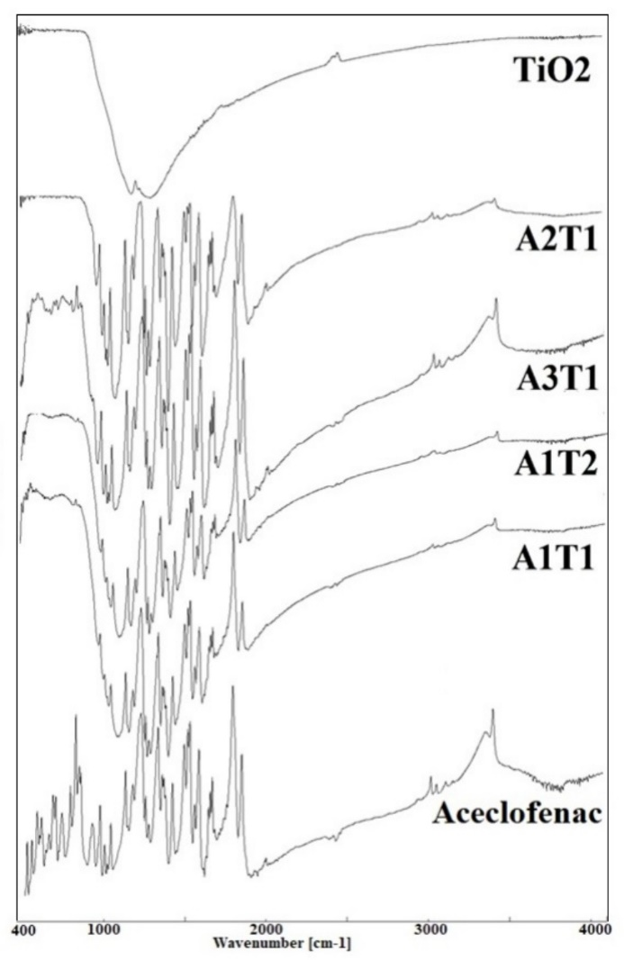
Figure 1. FTIR spectra of pure aceclofenac, TiO₂ and solid formulations.
3.2. DSC
The pure drug has shown a sharp melting point at 152.97 °C (Figure 2). The formulations have showed a ±2 °C shifting of melting point along with lower peak intensity comparing to the pure drug. The pure drug has the highest enthalpy of melting (-155.76 jg⁻¹), where the enthalpy has reduced along with the increase of the content of TiO2 (Table 1). Probably the bond formation between TiO2 and aceclofenac is the cause of the decreased enthalpy of the formulations.
Table 1. Thermal behaviour of TiO₂ kneaded aceclofenac formulation
Formulation Code  (Drug:TiO2) | Onset of Melting (°C) | Endset of Melting  (°C) | Melting Point (°C) | Enthalpy (jg⁻¹)
Aceclofenac | 152.01 | 156.77 | 152.97 | -155.76
A1T1 (1:1) | 149.50 | 156.44 | 153.73 | -62.11
A1T2 (1:2) | 147.15 | 155.02 | 151.57 | -32.23
A2T1 (2:1) | 149.07 | 157.31 | 153.83 | -66.67
A3T1 (3:1) | 150.81 | 155.83 | 153.16 | -153.09

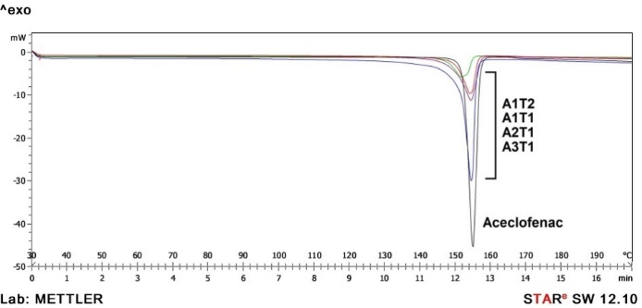
Figure 2. DSC Thermogram of aceclofenac and the formulations.
3.3. XRD Study
X ray diffraction data is portrayed in Figure 3. The TiO₂ as well as the formulations has shown a particular kind of diffraction pattern at 38.5° and 55° 2θ. The diffraction position and pattern proved that the TiO₂ anatase crystals has not changed in the formulations.³⁰ The most intense peaks then subjected to further calculation and an average value was taken as a representation for the whole formulation. The particle size was determined from the Debye-Scherrer’s equation.³¹
$$D=\frac{Kλ}{βCosθ}$$
Where, D is the crystal size (nm), K is a constant with a value of 0.9, λ is the wavelength of the Xray (0.1541 nm) and β is the value of FWHM (full width at half maxima) in radian.
Other characteristic properties of the formulations like, strain and dislocation density are tabulated in Table 2. Scherrer’s formula was employed for the determination of the particle size. Dislocation density can be described as the length of dislocation lines per unit volume of the crystals where a dislocation is a linear defect found in crystals. The untreated and treated pure TiO₂ has shown dislocation density of 0.80 and 0.71 respectively whereas the formulation with highest content of aceclofenac has shown almost 1.4 times higher dislocation lines per unit area. The similarity has also followed in the case of pure TiO₂ crystal strain (0.73) and the formulation, A3T1 has shown the highest strain. The above mentioned changes may have occurred due to the binding of aceclofenac with titanium dioxide.¹⁹ A similar phenomenon was noticeable in the case of aceclofenac where the dislocation density of A1T2 was higher than any other formulations or the pure drug itself. Particle size was found to be lowest in the case of the A1T2 formulation than the pure drug (98.08 nm).

Table 2. Solid state particle properties of aceclofenac-titanium kneaded product
Formulation Code | TiO₂ |  |  | Aceclofenac
Formulation Code | Particle Size (nm) | Strain | Dislocation Density*10⁻³ | Particle Size (nm) | Strain | Dislocation Density *10⁻³
Aceclofenac | -- | -- | -- | 98.08±16.5 | 0.114±0.014 | 0.44±0.10
T1 (untreated TiO₂) | 70.89±3.64 | 0.073±0.016 | 0.80±0.088 | -- | -- | --
T2 (Acetone treated TiO₂) | 74.87±1.60 | 0.068±0.012 | 0.71±0.030 | -- | -- | --
A1T1 | 68.65±0.84 | 0.075±0.013 | 0.84±0.021 | 73.47±19.46 | 0.157±0.037 | 0.90±0.50
A1T2 | 64.44±1.34 | 0.079±0.015 | 0.96±0.040 | 59.67±11.56 | 0.132±0.054 | 1.22±0.40
A2T1 | 65.88±3.15 | 0.077±0.010 | 0.92±0.092 | 71.09±14.81 | 0.158±0.054 | 0.98±0.40
A3T1 | 63.01±1.25 | 0.081±0.013 | 1.00±0.041 | 70.88±14.58 | 0.149±0.036 | 0.87±0.30

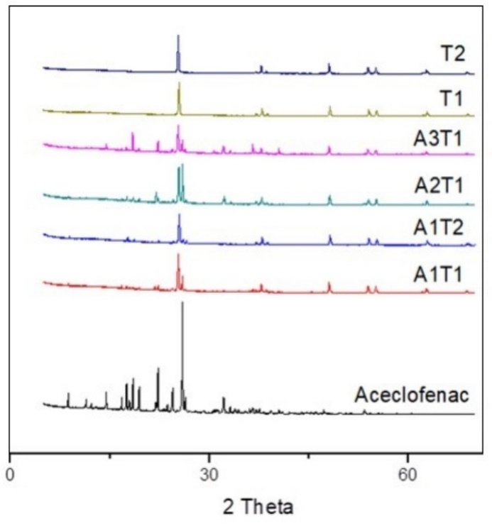
Figure 3. Powder Xray diffraction overlay of pure drug, formulation, untreated and treated titanium dioxide (T1 and T2 respectively).
3.4. In vitro diffusion study
The observation was replicated in triplicate and the mean value is used to prepare the time vs cumulative percent release in Figure 3. The highest release was found in the case of A2T1 (89.88%) at 2 hours followed by A1T1 (89.13%). The formulation containing highest amount of TiO2 (A1T2) has shown lowest amount of drug release 82.55% in contrast to others at 120 mins.
Figure 4. In vitro drug diffusion profile of the formulation
3.5. Ex vivo permeation Study
The data was presented as a plot of time vs percentage permeated in Figure 4. The highest release was found in the case of A3T1 (45.29%) at 20 hours followed by A1T1 (42.40%). In all of the formulations the permeation was continued up to 20 hours while maintaining an increasing order.

Figure 5. Ex vivo permeation study of the formulations through goat corneal mucosa
4. Conclusion
Influence of titanium dioxide on mucosal permeation of aceclofenac has been carried out in aqueous state. FTIR results revealed the decreased intensity of some characteristic peaks of aceclofenac in the formulation with the increased content of TiO₂ indicating possible binding between drug and TiO₂. Thermal analysis has also exhibited decreased melting enthalpy as the TiO₂ content increased in the solid. The change in crystal strain and dislocation density of TiO₂ and aceclofenac in the solid formulation has been noticed. Sustained mucosal permeation of aceclofenac has been observed for more than 20 h in presence of titanium dioxide. Titanium dioxide could be used in designing formulation for sustaining and controlling mucosal delivery of aceclofenac after assessing risk factor associated with TiO₂.
Acknowledgement
The authors are grateful to Dr. Monojranjan Nayak, President, Siksha ‘O’Anusandhan University for financial support and laboratory facility. We are also grateful to receive Aceclofenac as gift sample from Mannequin Pharmaceuticals Pvt. Ltd., Bhubaneswar, Odisha.
Conflict of interest
The authors declare no conflict of interests.
5. References
- H. M. A. Shawish, H. Tamous, S. Saadeh, A. Tbaza, Acta Chim. Slov. 2018, 65, 811-822.
- M. Skocaj, M. Filipic, J. Petkovic, S. Novak, Radiol. Oncol. 2011, 45, 227-247.
- E. Y. Chen, M. Garnica, Y. C. Wang, C. S. Chen, W. C. Chin, PloS one. 2011, 6, e16198.
- S. Riivari, K. Shahramian, I. Kangasniemi, J. Willberg, T. O. Närhi, Int. J. Oral Maxillofac. Implants. 2019, 34, 313-319.
- R. Masa, Á. Deák, G. Braunitzer, Z. Tóth, J. Kopniczky, I. Pelsőczi-Kovács, K. Ungvári, I. Dékány, K. Turzó, J. Nanosci. Nanotechnol. 2018, 18, 3916-3924.
- B. J. Teubl, G. Leitinger, M. Schneider, C. M. Lehr, E. Fröhlich, A. Zimmer, E. Roblegg, Nanotoxicology, 2015, 9, 253-261.
- T. Soni, C. Nagda, T. Gandhi, N. P.Chotai, Dissolut. Technol. 2008, 15, 31-35.
- M. Grau, J. Guasch, J. L. Montero, A. Felipe, E. Carrasco, S. Juliá, Arzneim-Forsch Drug Res, 1991, 41, 1265-1276.
- N. Sethuraman, S. Shanmuganathan, K. Sandhya, B. Anbarasan, Indian J. Pharm. Educ. 2018, 52, 581-586.
- R. Raj, P. Mongia, A. Ram, N. K. Jain, Artif Cells Nanomed. Biotechnol. 2016, 44, 1434-1439.
- https://pubchem.ncbi.nlm.nih.gov/compound/Aceclofenac#section=Melting-Point
- B. Tubić, A. Uzunović, S. Pilipović, Ž. Gagić, Acta Chim. Slov. 2016, 63, 193-9.
- S. Korani, M. Korani, S. Bahrami, T. P. Johnston, A. E. Butler, M. Banach, A. Sahebkar, Drug Discov. Today. 2019, 24, 567-574.
- V. Dave, S. Paliwal, Saudi Pharm. J. 2014, 22, 240-245.
- M. S. Hasnain, P. Rishishwar, S. Ali, A. K. Nayak, SN App. Sci. 2020, 2, 1-8.
- R. Katara, D. K. Majumdar, Colloid Surface B. 2013, 103, 455-462.
- A. Modi, P. Tayade, AAPS PharmSciTech. 2006, 7, E87.
- S. Nandi, S. A. Mishra, R. N. Sahoo, R. Swain, S. Mallick, Indian J. Pharm. Educ. 2020, 54, 68-72.
- M. Starsinic, R. L. Taylor, P. L. Walker Jr, P. C.Painter, Carbon. 1982, 21, 69-74.
- G. Vanden, V. B. F.Mathot, Thermochim. Acta. 2006, 446, 41–54.
- R. N. Sahoo, A. Nanda, A. Pramanik, S. Nandi, R. Swain, S. K. Pradhan, S. Mallick, Acta Chim. Slov. 2019, 66, 923-933.
- M. Acharya, S. Mishra, R. N. Sahoo, S. Mallick, Acta Chim. Slov. 2017, 64, 45-54.
- S. A. Agnihotri, T. M. Aminabhavi, J. Control. Release. 2004, 96, 245–259.
- M. S. Bhandari, S. M. Wairkar, U. S. Patil, N. R. Jadhav, Acta Chim. Slov, 2018, 65, 492-501.
- M. S. Kaynak, M. Celebier, S. Sahin, S. Altinöz, Rev. Chim. (Bucharest). 2013, 64, 27-30.
- R. Mohapatra, S. Senapati, C. Sahoo, S. Mallick, Farmacia. 2016, 64, 72-81.
- C. Y. Won, C. C. Chu, J. D. Lee, Polymer, 1998, 39, 6677-6681.
- W. J. Ray, J. E. Katon, B. Phillips, J. Mol. Struct. 1981, 74, 75–84.
- P. S. Thomas, J. Guerbois, G. F. Russell, B. J.Briscoe, J. Therm. Anal. Cal. 2001, 64, 501–508.
- A. Di Paola, M. Bellardita, B. Megna, F. Parrino, L. Palmisano, Catal. Today. 2015, 252, 195-200.
- W. Anku, S. O. Oppong, S. K. Shukla, P. P. Govender, Acta Chim. Slov. 2016, 63, 380-391.

